Lab 5: LATCHES AND FLIP-FLOPS

ITI 1100C - Digital Systems
Winter 2018 School of Electrical Engineering and Computer Science University of Ottawa

Course Coordinator: Dr. Ahmed Karmouch
Teaching Assistants: Heli
Jay
Mitchel
Jaafreh
Hala
Khaki

Group #23

Student Name and number: Georgio Karnabi 8166995
Student Name and number: Marco Borg | 300034912
Experiment Date: 20/03/2018
Submission Date: 27/03/2018

Objectives
- Provide insight into the characteristics of several important latches and flip-flops.
- Build latches and flip-flops from basic gates.
- Explain concepts of latching and edge-triggering.
- Test latches and flip-flops to understand their operation

Equipment & Components
- Quartus II 13.0 Service-Pack 1
- Altera DE2-115 circuit board
- Dell PC

Circuit Diagram
Part I – SR Latch
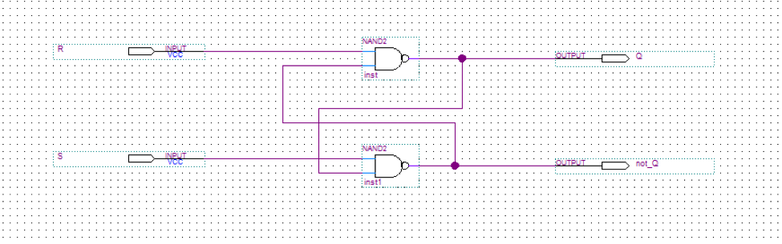

Full Adder Logic Diagram

Part II – D Latch
Circuit Diagram
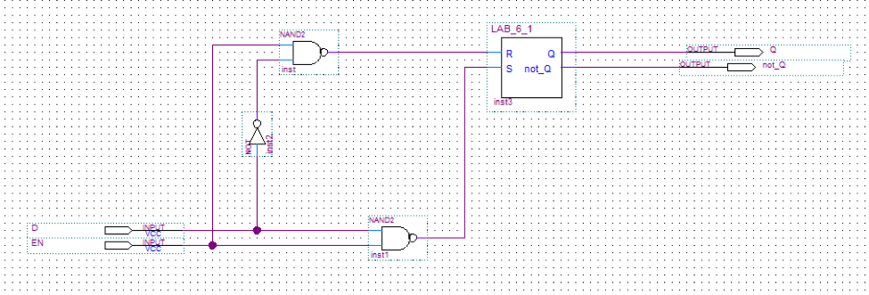

Part III – D Flip-Flop
Circuit Diagram
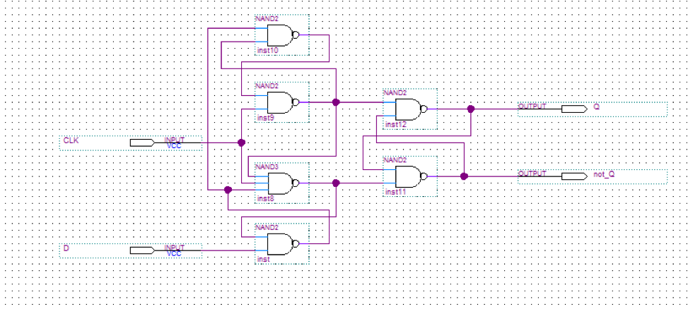

Part IV – T Flip-Flop
Circuit Diagram

Experimental Data and Data Processing
Part I – SR Latch
SR latch implemented with NOR gates

Table 1 : Experimental data observed from the circuit board (For output: 1 means the light flashed, 0 means the light did not flash):

Input |  | Observed Output from LED’s
S | R | Q | not_Q
0 | 0 | 1 | 1
0 | 1 | 0 | 1
1 | 0 | 1 | 0
1 | 1 | 1 | 0

Part II – D Latch
D latch implemented with a SR latch

Table 2 : Experimental data observed from the circuit board (For output: 1 means the light flashed, 0 means the light did not flash):

Input |  | Observed Output from LED’s
EN | D | Q | not_Q
0 | 0 | 0 | 1
0 | 1 | 0 | 1
1 | 0 | 1 | 0
1 | 1 | 0 | 1
0 | 0 | 0 | 1
0 | 1 | 0 | 1
1 | 0 | 1 | 0
1 | 1 | 0 | 1

Part III – D Flip-Flop
D flip-flop

Table 3 : Experimental data observed from the circuit board (For output: 1 means the light flashed, 0 means the light did not flash):

Input |  | Observed Output from LED’s
CLK | D | Q | not_Q
0 | 0 | 1 | 0
0 | 1 | 1 | 0
1 | 0 | 0 | 1
1 | 1 | 1 | 0

Part IV – T Flip-Flop
T flip-flop

Table 4 : Experimental data observed from the circuit board (For output: 1 means the light flashed, 0 means the light did not flash):

Input |  | Observed Output from LED’s
CLK | T | Q | not_Q
0 | 0 | 1 | 0
0 | 1 | 1 | 0
1 | 0 | 1 | 0
1 | 1 | 1 | 0

Comparison of Theoretical Data and Experimental Data
Part I – SR Latch
SR latch implemented with NOR gates

Table 5 : Comparison of theoretical data and experimental data for the SR Latch

Input |  | Expected  Results |  | Actual  Results
S | R | Q | not_Q | Q | not_Q
0 | 0 | 1 | 1 | 1 | 1
0 | 1 | 0 | 1 | 0 | 1
1 | 0 | 1 | 0 | 1 | 0
1 | 1 | 1 | 0 | 1 | 0

The results observed experimentally for the SR Latch circuit are the exact same as the theoretical results.

Part II – D Latch
D latch implemented with a SR latch

Table 6: Comparison of theoretical data and experimental data for the D Latch circuit

Input |  | Expected  Results |  | Actual  Results
EN | D | Q | not_Q | Q | not_Q
0 | 0 | 0 | 1 | 0 | 1
0 | 1 | 0 | 1 | 0 | 1
1 | 0 | 0 | 1 | 1 | 0
1 | 1 | 1 | 0 | 0 | 1
0 | 0 | 0 | 1 | 0 | 1
0 | 1 | 0 | 1 | 0 | 1
1 | 0 | 0 | 1 | 1 | 0
1 | 1 | 1 | 0 | 0 | 1

The results observed experimentally for the D Latch circuit are not the same as the theoretical results. By comparing the expected results and actual results of the truth table, you can see that the values for Q and not_Q are the exact opposite. The reason for them being the exact opposite can be simply due to inverting the pin assignment during the experiment on the altera board.

Part III – D Flip-Flop
D flip-flop

Table 7 : Comparison of theoretical data and experimental data for the D flip-flop circuit

Input |  | Expected  Results |  | Actual  Results
CLK | D | Q | not_Q | Q | not_Q
0 | 0 | 1 | 0 | 1 | 0
0 | 1 | 1 | 0 | 1 | 0
1 | 0 | 0 | 1 | 0 | 1
1 | 1 | 1 | 0 | 1 | 0

The results observed experimentally for the D Flip-Flop circuit are the exact same as the theoretical results.

Part IV – T Flip-Flop

T flip-flop

Table 8 : Comparison of theoretical data and experimental data for the T flip flop circuit

Input |  | Expected  Results |  | Actual  Results
CLK | T | Q | not_Q | Q | not_Q
0 | 0 | 1 | 0 | 1 | 0
0 | 1 | 1 | 0 | 1 | 0
1 | 0 | 1 | 0 | 1 | 0
1 | 1 | 1 | 0 | 1 | 0
The results observed experimentally for the T Flip-Flop circuit are the exact same as the theoretical results.

Discussion & Conclusions

Lab 5 is based around the use of sequential circuits specifically flip-flops and latches. These types of circuits depend on the current inputs and the inputs that previously existed in the circuit.
In part 1 we created what is called an SR Latch. This type of circuit uses two asynchronous inputs and two complementary outputs which remain stable when the states of the two outputs are opposite (1 and 0, or 0 and 1).

In Part 2, we used the quartus software to create the D latch. This latch stores the current data in the circuit when the EN is active. The ENABLE input controls the two operating modes the the latch presents.

Part 3 required us to create a D Flip flop. This flip flop is edge sensitive where the output changes whenever there is an edge detected by the clock.

Using D flip-flops we then create what is called a T Flip-Flop. The output of a T flip-flop changes between 1 and 0 whenever there is a pulse and the the T is high.

By the end of this lab we experimented with 4 different latches and flip flops learning the functions of each one and the differences between them. We also used techniques from prvious labs such as creating a symbol for a previous logic diagram and using it to construct a bigger logic circuit. This technique is very useful as it cuts the time to create the circuit in half.

