Lab 4: ARITHMETIC CIRCUITS

ITI 1100C - Digital Systems
Winter 2018 School of Electrical Engineering and Computer Science University of Ottawa

Course Coordinator: Dr. Ahmed Karmouch
Teaching Assistants: Heli
Jay
Mitchel
Jaafreh
Hala
Khaki

Group #23

Student Name and number: Georgio Karnabi 8166995
Student Name and number: Marco Borg | 300034912
Experiment Date: 13/03/2018
Submission Date: 20/03/2018

Objectives
- Create and simulate a full adder, assign pins to the design, and test it on the Altera
- DE2-115 circuit board.
- Use a full adder as a component in an 8-bit adder/subtractor.
- Create a hierarchical design, including components for full adders and seven-segment
- decoders, using the QUARTUS II graphic editor.
- Design an overflow detector for use in a two’s complement adder/subtractor.

Equipment & Components
- Quartus II 13.0 Service-Pack 1
- Altera DE2-115 circuit board
- Dell PC

Circuit Diagram
Part I - Full Adders
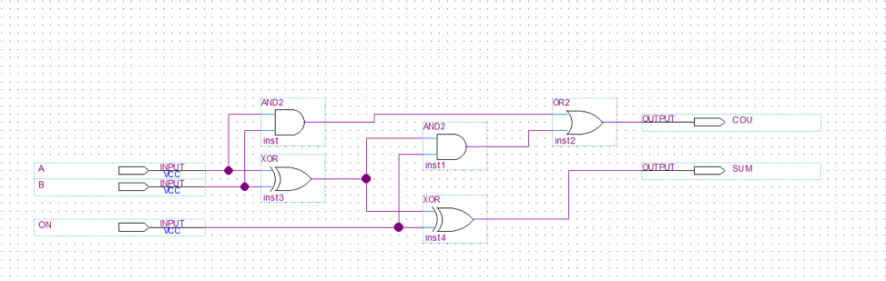
Full Adder Logic Diagram

Part II – Parallel Adder
Circuit Diagram
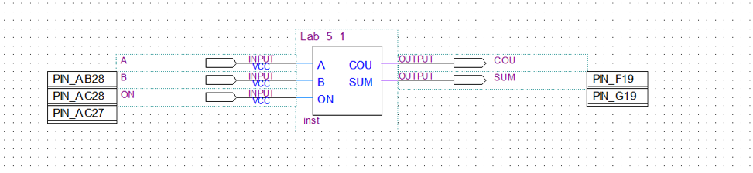
Full Adder reduced to a Parallel Adder
Experimental Data and Data Processing
Part I - Full Adders
Full adder circuit

Table 1 : Experimental data observed from the circuit board (For output: 1 means the light flashed, 0 means the light did not flash):

Input |  |  | Observed Output from LED’s
A | B | CIN | COUT | SUM
0 | 0 | 0 | 0 | 0
0 | 0 | 1 | 0 | 1
0 | 1 | 0 | 0 | 1
0 | 1 | 1 | 1 | 0
1 | 0 | 0 | 0 | 1
1 | 0 | 1 | 1 | 0
1 | 1 | 0 | 1 | 0
1 | 1 | 1 | 1 | 1

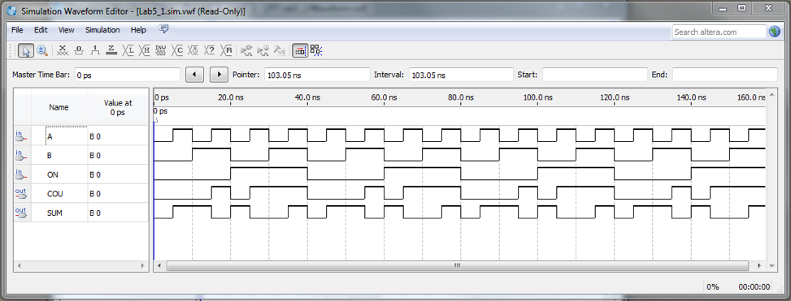
Simulation Output for a Full adder

Part II – Parallel Adder
Sample Sums for an 8-bit parallel adder

Table 2 : Experimental data observed from the circuit board (For output: 1 means the light flashed, 0 means the light did not flash):

Binary Input | Observed Output from LED’s (Carry) | Observed Output from LED’s (Sum)
A₇A₆A₅A₄A₃A₂A₁A₀ + B₇B₆B₅B₄B₃B₂B₁B₀ | - | S₇S₆S₅S₄S₃S₂S₁S₀
01111111+00000001 | 0 | 10000000
11111111+00000001 | 1 | 00000000
11000000+01000000 | 1 | 00000000
11000000+10000000 | 1 | 01000000

Comparison of Theoretical Data and Experimental Data
Part I - Full Adders
Full adder circuit

Table 3 : Comparison of theoretical data and experimental data for the full adder circuit

Input |  |  | Expected Results |  | Actual Results
A | B | CIN | COUT | SUM | COUT | SUM
0 | 0 | 0 | 0 | 0 | 0 | 0
0 | 0 | 1 | 0 | 1 | 0 | 1
0 | 1 | 0 | 0 | 1 | 0 | 1
0 | 1 | 1 | 1 | 0 | 1 | 0
1 | 0 | 0 | 0 | 1 | 0 | 1
1 | 0 | 1 | 1 | 0 | 1 | 0
1 | 1 | 0 | 1 | 0 | 1 | 0
1 | 1 | 1 | 1 | 1 | 1 | 1

The results observed experimentally for the full adder circuit are the exact same as the theoretical results.

Part II – Parallel Adder
Sample Sums for an 8-bit parallel adder

Table 4 : Comparison of theoretical data and experimental data for the parallel adder

Binary Input | Expected Results |  | Actual Results
A₇A₆A₅A₄A₃A₂A₁A₀ + B₇B₆B₅B₄B₃B₂B₁B₀ | - | S₇S₆S₅S₄S₃S₂S₁S₀ | - | S₇S₆S₅S₄S₃S₂S₁S₀
01111111+00000001 | 0 | 10000000 | 0 | 10000000
11111111+00000001 | 1 | 100000000 | 1 | 00000000
11000000+01000000 | 1 | 100000000 | 1 | 00000000
11000000+10000000 | 1 | 101000000 | 1 | 01000000

The results observed experimentally for the parallel adder circuit are essentially the same as the theoretical results. To note, the only difference for the expected results were that the carry were kept in the answer when indicating the sum. Therefore, the results are still the same, but they were just expressed differently.

Discussion & Conclusions

This Laboratory focuses on the use of logic circuits to perform arithmetic operations, specifically addition operations. In summary using techniques learned in class we will create logic circuits that will perform the addition operation when inputting two different numbers in binary numbers.

In part one we create what is called a full adder. A full adder takes three one-bit inputs (one of these bits being a carry), and provides an output that is two one-bit numbers (in binary). This represents the sum of the two inputted numbers and the third one-bit output represents the carry. These components are usually used in a longer chain of the same components in order to add larger sized numbers such as 8, 16… bit numbers as shown in part 2.

In part 2 we reduce the logic circuit in part one to one component. In theory you can combine multiple circuits in part one to add larger sized numbers. Within the quartus software we were able to save the logic circuit created in part one to the logic circuit in part 2. These 2 circuits do the exact same thing. One of the main reasons we reduce the circuit into a smaller size is that this component is usually added to a larger circuit with many of the same parts. Creating the logic circuit in the first part of the lab multiple times would be a very tedious process and in addition would look very unorganized. Reducing the circuit to the look of the part 2 diagram saves the user a lot of time and allows the programmer to keep his work organized and easy to track.

Part 2 of the lab is very important for future applications as it shows us how to reduce circuits to take up less space while keeping its functionality. As logic circuits become more complex we will need to keep them as organized and small as possible. Being able to reduce the size of a circuit will save a lot of time in the future.

