Lab 3: Decoders, Displays, and Multiplexers

ITI 1100C - Digital Systems
Winter 2018 School of Electrical Engineering and Computer Science University of Ottawa

Course Coordinator: Dr. Ahmed Karmouch
Teaching Assistants: Heli
Jay
Mitchel
Jaafreh
Hala
Khaki

Group #23

Student Name and number: Georgio Karnabi 8166995
Student Name and number: Marco Borg | 300034912
Experiment Date: 27/02/2018
Submission Date: 13/03/2018

Objectives
- Analyze, construct and test a simple 2-to-4 decoder
- Construct and test a seven-segment decoder display

Equipment & Components
- Quartus II 13.0 Service-Pack 1
- Altera DE2-115 circuit board
- Dell PC

Circuit Diagram
Part I - A 2-to-4 Decoder

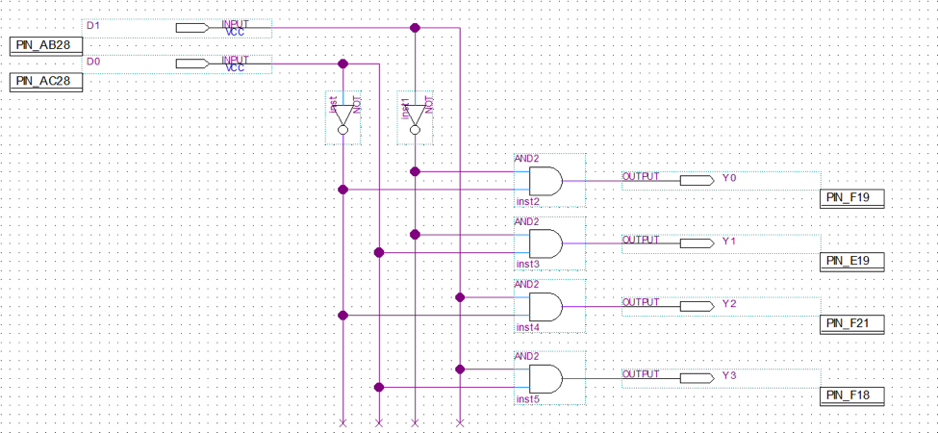
Figure 1: Circuit Diagram of a 2-to-4 Decoder

Part II – Decoder and 7 Segment Display
Circuit Diagram

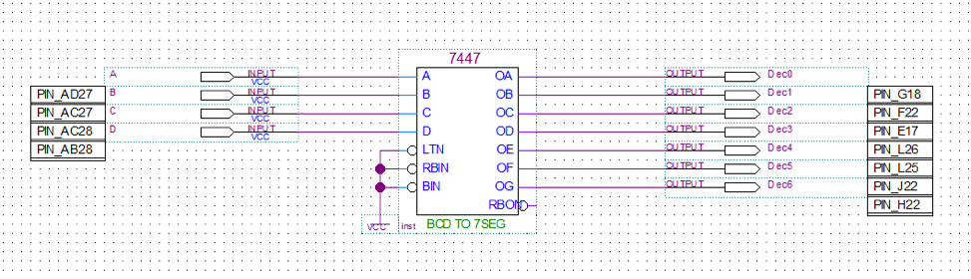
Figure 3: Standard decoder and 7 segment LED display circuit

Part III - Multiplexers
Circuit Diagram
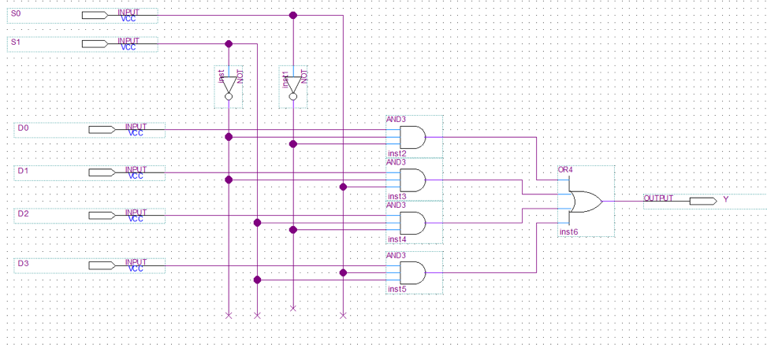
Figure 4: 4-1 MUX circuit

Experimental Data and Data Processing
Part I - A 2-to-4 Decoder
Circuit Diagram of a 2-to-4 Decoder

Table 1 : Experimental data observed from the circuit board (For output: 1 means the light flashed, 0 means the light did not flash):

Input |  | Observed Output from LED’s
D0 | D1 | Y0 | Y1 | Y2 | Y3
0 | 0 | 1 | 0 | 0 | 0
0 | 1 | 0 | 0 | 1 | 0
1 | 0 | 0 | 1 | 0 | 0
1 | 1 | 0 | 0 | 0 | 1

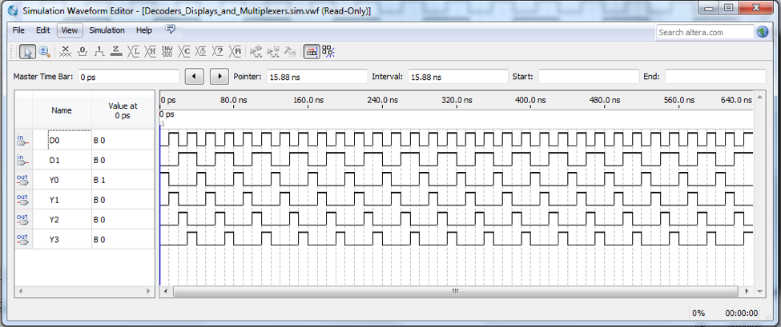
Figure 2: Simulation output waveform of 2-to-4 decoder

Part II – Decoder and Seven Segment Display
Display corresponding to 0-9 digits

Table 2 : Experimental data observed from the circuit board (For output: 1 means the light flashed, 0 means the light did not flash):

Input |  |  |  | Observed Output from LED’s
D3 | D2 | D1 | D0 | Corresponding Display
0 | 0 | 0 | 0 | 0
0 | 0 | 1 | 0 | 2
0 | 1 | 0 | 0 | 4
0 | 1 | 1 | 0 | 6
1 | 0 | 0 | 0 | 8
0 | 0 | 0 | 1 | 1
0 | 0 | 1 | 1 | 3
0 | 1 | 0 | 1 | 5
0 | 1 | 1 | 1 | 7
1 | 0 | 0 | 1 | 9

Part III - Multiplexers
Multiplexer Circuit

Table 3 : Experimental data observed from the circuit board (For output: 1 means the light flashed, 0 means the light did not flash):

Selection Inputs |  | Data Inputs |  |  |  | Observed Output from LED’s
S1 | S0 | D3 | D2 | D1 | D0 | Y
0 | 0 | X | X | X | 1 | 1
0 | 1 | X | X | 1 | X | 1
1 | 0 | X | 1 | X | X | 1
1 | 1 | 1 | X | X | X | 1

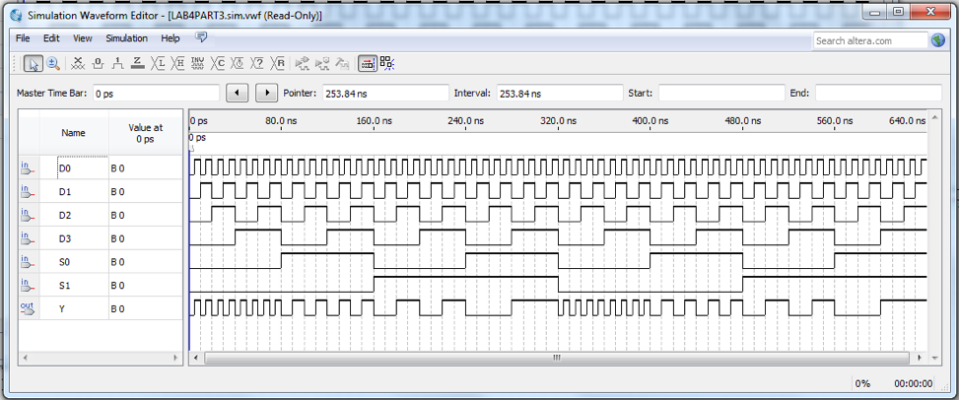
Figure 5: Simulation output for multiplexer.

Comparison of Theoretical Data and Experimental Data
Part I - A 2-to-4 Decoder
Circuit Diagram of a 2-to-4 Decoder

Table 4 : Comparison of theoretical data and experimental data for the 2-to-4 Decoder

Input |  | Expected Results |  |  |  | Actual Results
D0 | D1 | Y0 | Y1 | Y2 | Y3 | Y0 | Y1 | Y2 | Y3
0 | 0 | 1 | 0 | 0 | 0 | 1 | 0 | 0 | 0
0 | 1 | 0 | 0 | 1 | 0 | 0 | 0 | 1 | 0
1 | 0 | 0 | 1 | 0 | 0 | 0 | 1 | 0 | 0
1 | 1 | 0 | 0 | 0 | 1 | 0 | 0 | 0 | 1

The results observed experimentally for the 2-to-4 decoder are the exact same as the theoretical results.

Part II – Decoder and Seven Segment Display
Display corresponding to 0-9 digits

Table 5 : Comparison of theoretical data and experimental data for the seven segment display

Input |  |  |  | Corresponding Display
D3 | D2 | D1 | D0 | Expected Results | Actual  Results
0 | 0 | 0 | 0 | 0 | 0
0 | 0 | 1 | 0 | 2 | 2
0 | 1 | 0 | 0 | 4 | 4
0 | 1 | 1 | 0 | 6 | 6
1 | 0 | 0 | 0 | 8 | 8
0 | 0 | 0 | 1 | 1 | 1
0 | 0 | 1 | 1 | 3 | 3
0 | 1 | 0 | 1 | 5 | 5
0 | 1 | 1 | 1 | 7 | 7
1 | 0 | 0 | 1 | 9 | 9

The results observed experimentally for the decoder and seven segment are the exact same as the theoretical results.

Part III - Multiplexers
Multiplexer Circuit

Table 6 : Comparison of theoretical data and experimental data for the multiplexer circuit

Selection Inputs |  | Data Inputs |  |  |  | Expected  Results | Actual Results
S1 | S0 | D3 | D2 | D1 | D0 | Y | Y
0 | 0 | X | X | X | 1 | 1 | 1
0 | 1 | X | X | 1 | X | 1 | 1
1 | 0 | X | 1 | X | X | 1 | 1
1 | 1 | 1 | X | X | X | 1 | 1

The results observed experimentally for the multiplexer circuit are the exact same as the theoretical results.

Discussion & Conclusions

In this lab we experimented with decoders, multiplexers. In part 2 we show a simple real life example of this using the seven segment LED display.

In part 1 we are asked to construct a 2-to-4 decoder. This is a logical circuit where there can be more than 1 output based on the unique binary input that is registered onto the circuit. Based of the theoretical and experimental results ( Table 1). You can see that each possible combination (0-3, 4 possible combinations) sets one of the 4 outputs to true.

Part 2 shows a real life application used on almost all digital clocks around the world. Using 4 inputs allows each input combination to set off different individual segments of the 1 number (8). In our case, each combination put into the 4 inputs displayed a different number from 0-9. In this decoder, each input selects a different set of outputs unlike part one where each combination would only select one specific output.

The final part involves a 4-1 MUX circuit which is known as a multiplexer. This allows the user to switch specific inputs into an output while influenced by another set of inputs. Changing the inputs known as ‘s’ from the diagrams will result in a change of output with the same ‘D’ level input entries.

In conclusion Decoders and multiplexers are more complex logic circuits that allow the user to manipulate there outputs in special ways that would be too difficult and complicated using earlier logic circuits. Decoders and Multiplexers can be used in real life with things such as digital clocks as shown in part 2 of the laboratory. As the class goes on we will see more application of how these logic circuits are used.

