Lab 2: Boolean Logic

ITI 1100C - Digital Systems
Winter 2018 School of Electrical Engineering and Computer Science University of Ottawa

Course Coordinator: Dr. Ahmed Karmouch
Teaching Assistants: Heli
Jay
Mitchel
Jaafreh
Hala
Khaki

Group #23

Student Name and number: Georgio Karnabi 8166995
Student Name and number: Marco Borg | 300034912
Experiment Date: 02/13/2018
Submission Date: 02/27/2018
Objectives
- Simplify logic functions from their logic truth tables or Boolean expressions.
- Synthesize, implement and test minimized combinational circuits.
- Devise and design combinational logic circuits from specifications.
- Implement combinational circuits using any type of available logic gates.
- Implement combinational circuits using NAND gates only

Equipment and Components
- Quatrus II 13.0 Service-Pack 1
- Altera DE2-115 circuit board

Circuit Diagrams

Part 1 - Combinational Logic Circuits minimization by Boolean Algebra
Logic Circuit I
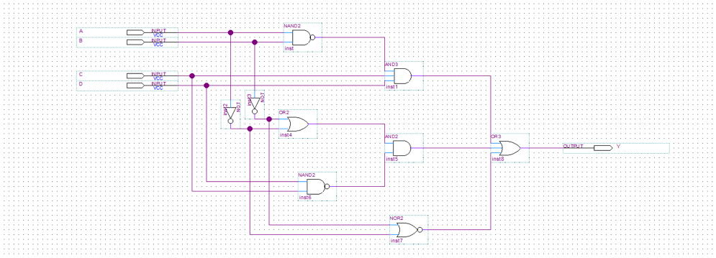
Figure 1: Logic Circuit for Part 1 (Y = (AB)’CD + (A’ + B’)(CD)’ + (A’ + B’)’)

Part II – Combinational Logic Circuits minimization by the Karnaugh Map Method

Logic Circuit II

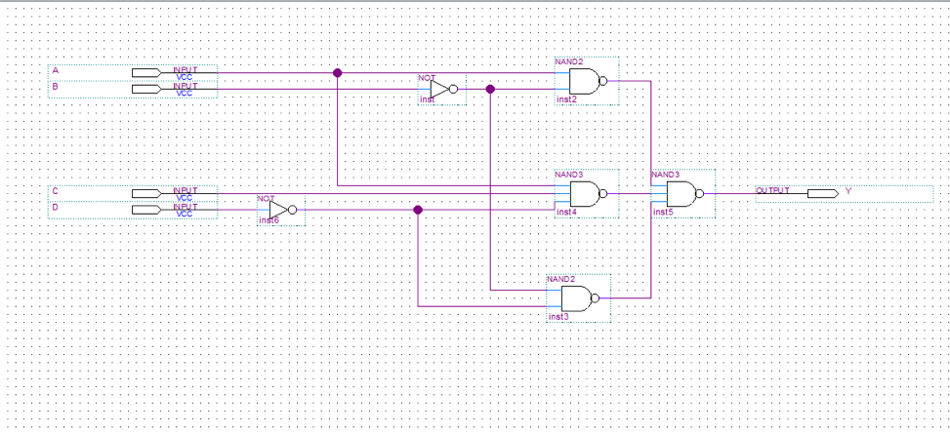
Figure 2: SOP minimized circuit with NAND gates (Y = (A’B)’ + (BD)’ + (A’C’D)’)

Table 1: Karnaugh map of the SOP expression Y based on the truth table (Table 5.2.1. of Lab Manual)
Y | 00 | 01 | 11 | 10
00 | 1 | 0 | 0 | 1
01 | 0 | 0 | 0 | 0
11 | 0 | 0 | 0 | 1
10 | 1 | 1 | 1 | 1

Logic Circuit III
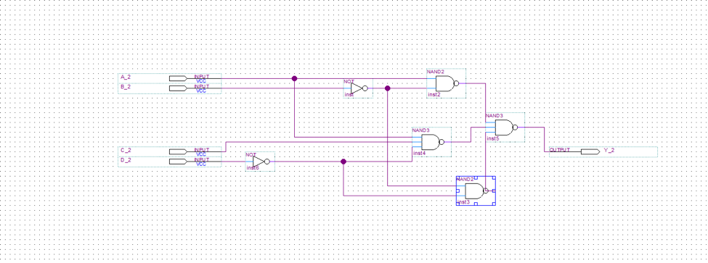
Figure 3: POS minimized circuit with NAND gates (Y = (A + B’)(A + D’)(B’ + C)(B’ + D’)

Table 2: Karnaugh map of the POS expression Y based on the truth table (Table 5.2.1. of Lab Manual)
Y | 00 | 01 | 11 | 10
00 | 1 | 0 | 0 | 1
01 | 0 | 0 | 0 | 0
11 | 0 | 0 | 0 | 1
10 | 1 | 1 | 1 | 1

Part III – Design of Combinational Logic Circuits
Logic Circuit IV
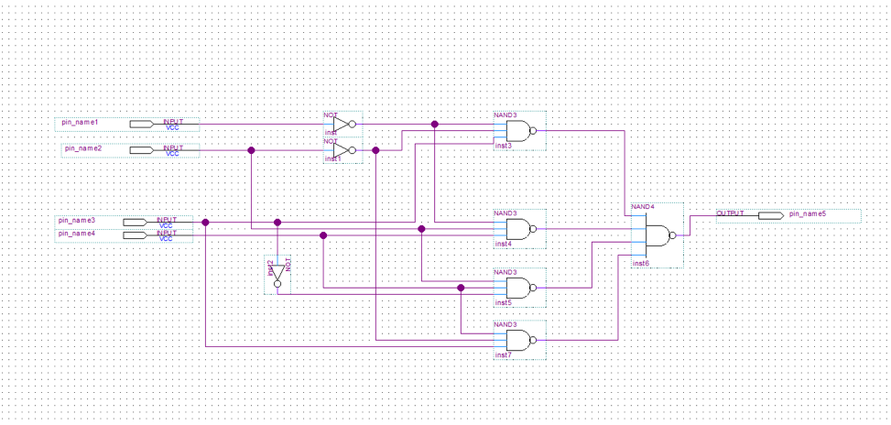
Figure 4: SOP minimized circuit with NAND gates (P = (D₃D₂D₁’)’ + (D₃D₂’D₀’)’ + (D₂’D₁D₀’)’ + (D₂D₁’D₀’)’

Table 3: Karnaugh map of the SOP expression P based on the truth table (Table 5.2.2. of Lab Manual)
P | 00 | 01 | 11 | 10
00 | 0 | 0 | 1 | 1
01 | 0 | 1 | 1 | 0
11 | 0 | 1 | 0 | 0
10 | 0 | 0 | 1 | 0

Logic Circuit V
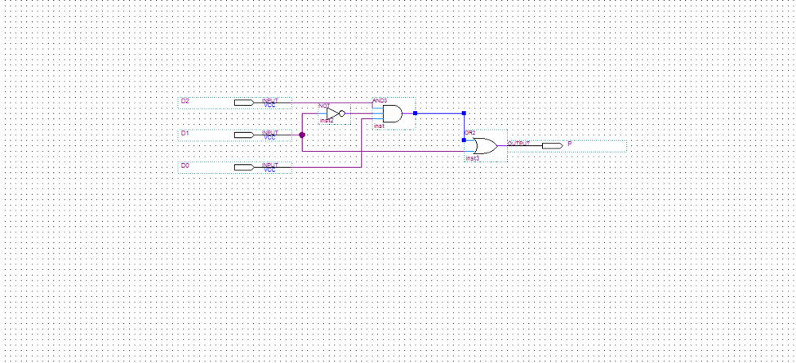
Figure 5: Image of Logic Circuit V

Experimental Data and Data Processing
Part 1 - Combinational Logic Circuits minimization by Boolean Algebra
Logic Circuit I
Table 4 : Experimental data observed from the circuit board (For output: 1 means the light flashed, 0 means the light did not flash):

Input |  |  |  | Observed Output from LED’s
A | B | C | D | Y
0 | 0 | 0 | 0 | 1
0 | 0 | 0 | 1 | 1
0 | 0 | 1 | 0 | 1
0 | 0 | 1 | 1 | 1
0 | 1 | 0 | 0 | 1
0 | 1 | 0 | 1 | 1
0 | 1 | 1 | 0 | 1
0 | 1 | 1 | 1 | 1
1 | 0 | 0 | 0 | 1
1 | 0 | 0 | 1 | 1
1 | 0 | 1 | 0 | 1
1 | 0 | 1 | 1 | 1
1 | 1 | 0 | 0 | 1
1 | 1 | 0 | 1 | 1
1 | 1 | 1 | 0 | 1
1 | 1 | 1 | 1 | 1

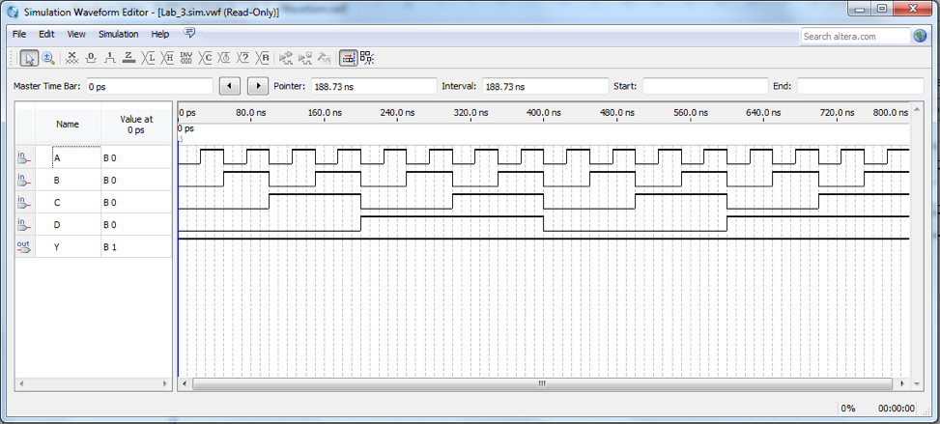
Figure 6: Simulation output waveform of logic circuit based on the Boolean expression

Part II – Combinational Logic Circuits minimization by the Karnaugh Map Method
Logic Circuit II

Table 5 : Experimental data observed from the circuit board (For output: 1 means the light flashed, 0 means the light did not flash):

Input |  |  |  | Observed Output from LED’s
A_1 | B_1 | C_1 | D_1 | Y_1
0 | 0 | 0 | 0 | 1
0 | 0 | 0 | 1 | 0
0 | 0 | 1 | 0 | 1
0 | 0 | 1 | 1 | 0
0 | 1 | 0 | 0 | 0
0 | 1 | 0 | 1 | 0
0 | 1 | 1 | 0 | 0
0 | 1 | 1 | 1 | 0
1 | 0 | 0 | 0 | 1
1 | 0 | 0 | 1 | 1
1 | 0 | 1 | 0 | 1
1 | 0 | 1 | 1 | 1
1 | 1 | 0 | 0 | 0
1 | 1 | 0 | 1 | 0
1 | 1 | 1 | 0 | 1
1 | 1 | 1 | 1 | 0

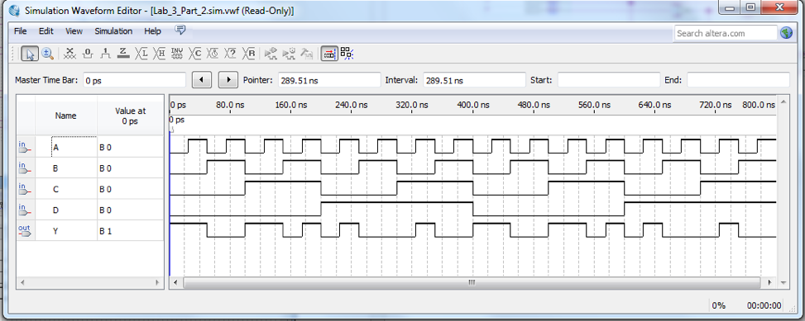
Figure 7: Simulation output waveform of logic circuit based on the Boolean expression

Logic Circuit III

Table 6 : Experimental data observed from the circuit board (For output: 1 means the light flashed, 0 means the light did not flash):

Input |  |  |  | Observed Output from LED’s
A_2 | B_2 | C_2 | D_2 | Y_2
0 | 0 | 0 | 0 | 1
0 | 0 | 0 | 1 | 0
0 | 0 | 1 | 0 | 1
0 | 0 | 1 | 1 | 0
0 | 1 | 0 | 0 | 0
0 | 1 | 0 | 1 | 0
0 | 1 | 1 | 0 | 0
0 | 1 | 1 | 1 | 0
1 | 0 | 0 | 0 | 1
1 | 0 | 0 | 1 | 1
1 | 0 | 1 | 0 | 1
1 | 0 | 1 | 1 | 1
1 | 1 | 0 | 0 | 0
1 | 1 | 0 | 1 | 0
1 | 1 | 1 | 0 | 1
1 | 1 | 1 | 1 | 0
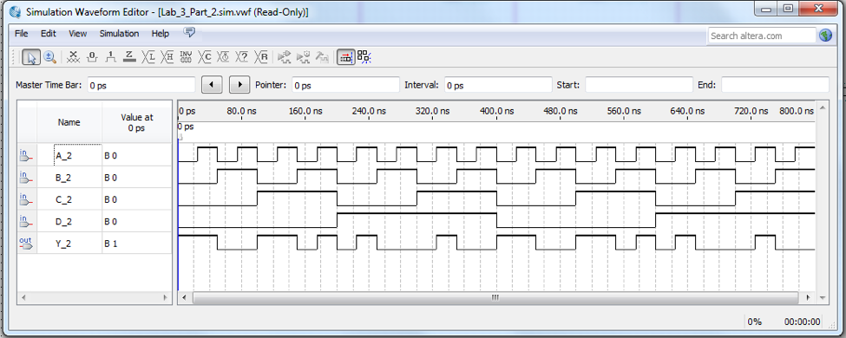
Figure 8: Simulation output waveform of logic circuit based on the Boolean expression

Part III – Design of Combinational Logic Circuits

Logic Circuit IV

Table 7 : Experimental data observed from the circuit board (For output: 1 means the light flashed, 0 means the light did not flash):

Input |  |  |  |  | Observed Output from LED’s
N | D3_1 | D2_1 | D1_1 | D0_1 | P_1
0 | 0 | 0 | 0 | 0 | 0
1 | 0 | 0 | 0 | 1 | 0
2 | 0 | 0 | 1 | 0 | 1
3 | 0 | 0 | 1 | 1 | 1
4 | 0 | 1 | 0 | 0 | 0
5 | 0 | 1 | 0 | 1 | 1
6 | 0 | 1 | 1 | 0 | 0
7 | 0 | 1 | 1 | 1 | 1
8 | 1 | 0 | 0 | 0 | 0
9 | 1 | 0 | 0 | 1 | 0
10 | 1 | 0 | 1 | 0 | 0
11 | 1 | 0 | 1 | 1 | 1
12 | 1 | 1 | 0 | 0 | 0
13 | 1 | 1 | 0 | 1 | 1
14 | 1 | 1 | 1 | 0 | 0
15 | 1 | 1 | 1 | 1 | 0
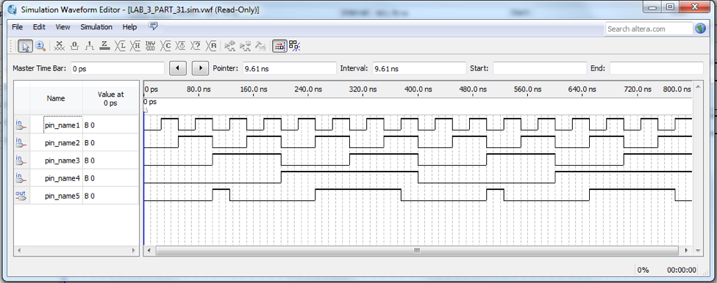
Figure 9: Simulation output waveform of logic circuit based on the Boolean expression

Logic Circuit V

Table 8 : Experimental data observed from the circuit board (For output: 1 means the light flashed, 0 means the light did not flash):

Input |  |  |  |  | Observed Output from LED’s
N | D3_2 | D2_2 | D1_2 | D0_2 | P_2
0 | 0 | 0 | 0 | 0 | 0
1 | 0 | 0 | 0 | 1 | 0
2 | 0 | 0 | 1 | 0 | 1
3 | 0 | 0 | 1 | 1 | 1
4 | 0 | 1 | 0 | 0 | 0
5 | 0 | 1 | 0 | 1 | 1
6 | 0 | 1 | 1 | 0 | 0
7 | 0 | 1 | 1 | 1 | 1
8 | 1 | 0 | 0 | 0 | 0
9 | 1 | 0 | 0 | 1 | 0
10 | 1 | 0 | 1 | 0 | 0
11 | 1 | 0 | 1 | 1 | 1
12 | 1 | 1 | 0 | 0 | 0
13 | 1 | 1 | 0 | 1 | 1
14 | 1 | 1 | 1 | 0 | 0
15 | 1 | 1 | 1 | 1 | 0

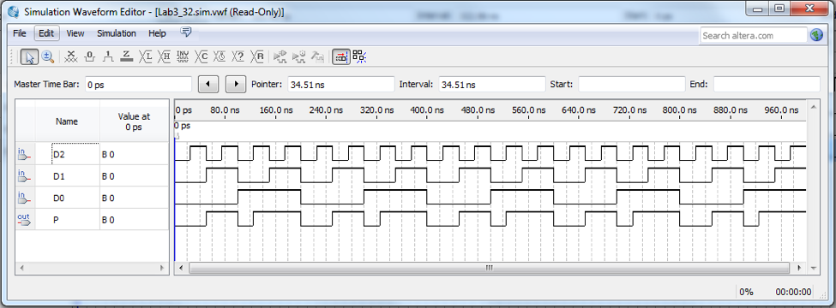
Figure 10: Simulation output waveform of logic circuit based on the Boolean expression

Comparison of Theoretical Data and Experimental Data

Part 1 - Combinational Logic Circuits minimization by Boolean Algebra

Logic Circuit I

Table 9 : Comparison of theoretical data and experimental data for Logic Circuit I

Input |  |  |  | Expected  Results | Actual  Results
A | B | C | D | Y | Y
0 | 0 | 0 | 0 | 1 | 1
0 | 0 | 0 | 1 | 1 | 1
0 | 0 | 1 | 0 | 1 | 1
0 | 0 | 1 | 1 | 1 | 1
0 | 1 | 0 | 0 | 0 | 1
0 | 1 | 0 | 1 | 0 | 1
0 | 1 | 1 | 0 | 0 | 1
0 | 1 | 1 | 1 | 1 | 1
1 | 0 | 0 | 0 | 0 | 1
1 | 0 | 0 | 1 | 0 | 1
1 | 0 | 1 | 0 | 0 | 1
1 | 0 | 1 | 1 | 1 | 1
1 | 1 | 0 | 0 | 1 | 1
1 | 1 | 0 | 1 | 1 | 1
1 | 1 | 1 | 0 | 1 | 1
1 | 1 | 1 | 1 | 1 | 1

The results observed experimentally for the logic circuit I are not the same as the theoretical results. The experimental results are correct, therefore the output should be true. There can be many reasons for these errors; however, the most probable mistake would be the misinterpretation of the boolean equation, Y = (AB)’CD + (A’ + B’)(CD)’ + (A’ + B’)’. Thus, the expected values ended up wrong.

Part II – Combinational Logic Circuits minimization by the Karnaugh Map Method
Logic Circuit II

Table 10 : Comparison of theoretical data and experimental data for Logic Circuit II

Input |  |  |  | Expected  Results | Actual  Results
A_1 | B_1 | C_1 | D_1 | Y_1 | Y_1
0 | 0 | 0 | 0 | 1 | 1
0 | 0 | 0 | 1 | 0 | 0
0 | 0 | 1 | 0 | 1 | 1
0 | 0 | 1 | 1 | 0 | 0
0 | 1 | 0 | 0 | 0 | 0
0 | 1 | 0 | 1 | 0 | 0
0 | 1 | 1 | 0 | 0 | 0
0 | 1 | 1 | 1 | 0 | 0
1 | 0 | 0 | 0 | 1 | 1
1 | 0 | 0 | 1 | 1 | 1
1 | 0 | 1 | 0 | 1 | 1
1 | 0 | 1 | 1 | 1 | 1
1 | 1 | 0 | 0 | 0 | 0
1 | 1 | 0 | 1 | 0 | 0
1 | 1 | 1 | 0 | 1 | 1
1 | 1 | 1 | 1 | 0 | 0

The results observed experimentally for the logic circuit II are the exact same as the theoretical results.

Logic Circuit III

Table 11 : Comparison of theoretical data and experimental data for Logic Circuit III

Input |  |  |  | Expected  Results | Actual  Results
A_2 | B_2 | C_2 | D_2 | Y_2 | Y_2
0 | 0 | 0 | 0 | 1 | 1
0 | 0 | 0 | 1 | 0 | 0
0 | 0 | 1 | 0 | 1 | 1
0 | 0 | 1 | 1 | 0 | 0
0 | 1 | 0 | 0 | 0 | 0
0 | 1 | 0 | 1 | 0 | 0
0 | 1 | 1 | 0 | 0 | 0
0 | 1 | 1 | 1 | 0 | 0
1 | 0 | 0 | 0 | 1 | 1
1 | 0 | 0 | 1 | 1 | 1
1 | 0 | 1 | 0 | 1 | 1
1 | 0 | 1 | 1 | 1 | 1
1 | 1 | 0 | 0 | 0 | 0
1 | 1 | 0 | 1 | 0 | 0
1 | 1 | 1 | 0 | 1 | 1
1 | 1 | 1 | 1 | 0 | 0

The results observed experimentally for the logic circuit II are the exact same as the theoretical results.

Part III – Design of Combinational Logic Circuits
Logic Circuit IV

Table 12 : Comparison of theoretical data and experimental data for Logic Circuit IV

Input |  |  |  |  | Expected Results | Actual  Results
N | D3 | D2 | D1 | D0 | P | P
0 | 0 | 0 | 0 | 0 | 0 | 0
1 | 0 | 0 | 0 | 1 | 1 | 0
2 | 0 | 0 | 1 | 0 | 1 | 1
3 | 0 | 0 | 1 | 1 | 1 | 1
4 | 0 | 1 | 0 | 0 | 0 | 0
5 | 0 | 1 | 0 | 1 | 1 | 1
6 | 0 | 1 | 1 | 0 | 0 | 0
7 | 0 | 1 | 1 | 1 | 1 | 1
8 | 1 | 0 | 0 | 0 | 0 | 0
9 | 1 | 0 | 0 | 1 | 0 | 0
10 | 1 | 0 | 1 | 0 | 0 | 0
11 | 1 | 0 | 1 | 1 | 1 | 1
12 | 1 | 1 | 0 | 0 | 0 | 0
13 | 1 | 1 | 0 | 1 | 1 | 1
14 | 1 | 1 | 1 | 0 | 0 | 0
15 | 1 | 1 | 1 | 1 | 0 | 0

The results observed experimentally for the logic circuit III are the very similar as the theoretical results except on line 1. The difference in results could be due to many reasons; however, the experimental results are correct which would mean the 1 error is indicative of human error.

Discussion & Conclusions

This experiment is mainly to teach students the tools of boolean algebra such as DeMorgan’s Laws, Sum of Product (SOP), Product of Sums (SOP), and the negation law. It allows us to see that a Boolean function can be manipulated to result in smaller circuits, less expensive logic gates, and at the same time have the same results as the original boolean function.

In Part I, a Boolean expression was given and a truth table was created from this expression. In Part II, the logic expression was obtained by the provided truth table and simplified to the SOP and POS, which were both attained by a Karnaugh map. In Part III, the output of the given truth table was 1 when N was a prime number and 0 otherwise.

Also, to implement the logic expressions using NAND gates, we needed to use DeMorgan’s laws and the negation law , in which the negation law proved useful in converting a SOP expression into its equivalent form with NAND gates.

In conclusion, the implementation of combinational circuits using any type of available logic gates was proven to have identical outputs as the logically equivalent circuits using only NAND gates. Proving that there are several ways of representing the same boolean function through combinational circuits and that the SOP and its simplified form with NAND gates are equivalent after applying DeMorgan’s Laws.

