Lab 1: Logic Gates

ITI 1100C - Digital Systems
Winter 2018 School of Electrical Engineering and Computer Science University of Ottawa

Course Coordinator: Dr. Ahmed Karmouch
Teaching Assistants: Heli
Jay
Mitchel
Jaafreh
Hala
Khaki

Group #23

Student Name and number: Georgio Karnabi 8166995
Student Name and number: Marco Borg | 300034912
Experiment Date: 30/01/2018
Submission Date: 13/01/2018

Objectives
- Construct simple combinational logic circuits from a schematic.
- Experimentally determine the functional operation of simple combinational logic circuits.
- Identify equivalent logic gates to those produced by various circuit configurations from the resulting truth table.
- Connect various gates together to create simple logic functions.
- Analyse combinational logic circuits and predict their operation.
- Construct and test more complex combinational logic circuits.

Equipment & Components
- Quartus II 13.0 Service-Pack 1
- Altera DE2-115 card
- Dell PC

Circuit Diagrams

Part I – Combinational Logic Circuits Construction
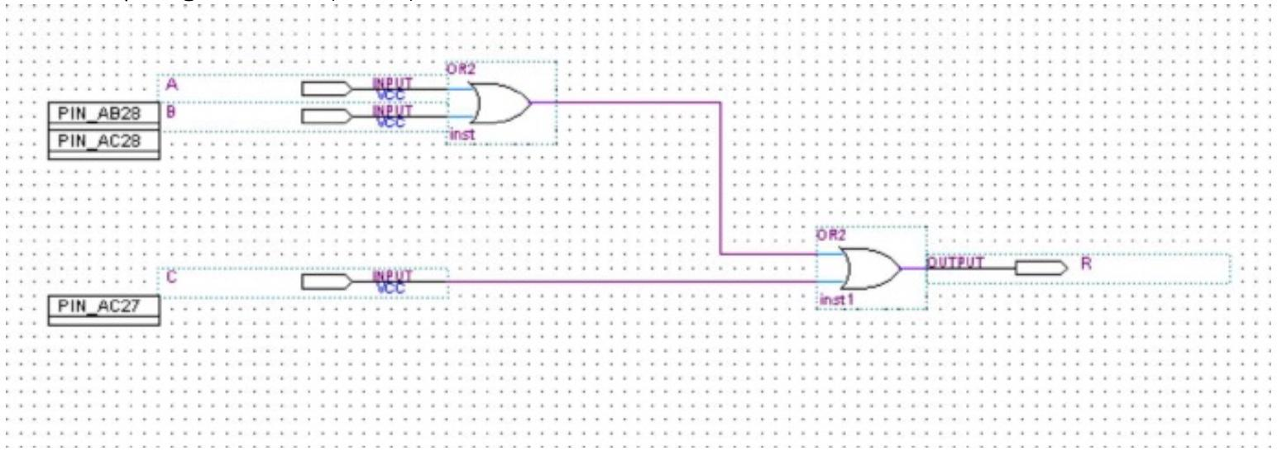
Figure 1: Screenshot of one-chip logic circuit diagram (Figure 5.1.1 of Lab Manual)

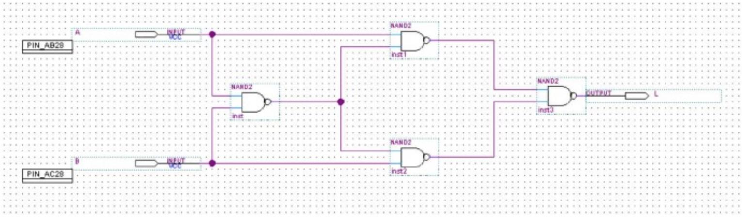
Figure 2: Screenshot of exclusive OR circuit diagram (Figure 5.1.5 of Lab Manual)

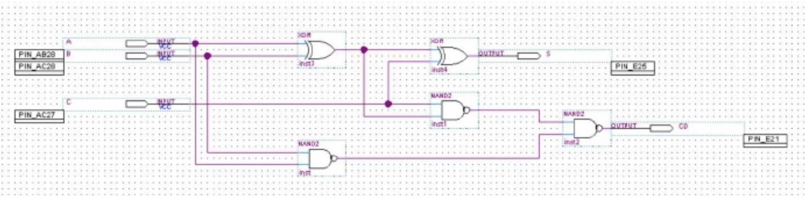
Figure 3: Screenshot of multiple output circuit diagram (Figure 5.1.8 of Lab Manual)

Experimental Data and Data Processing
Part I – Combinational Logic Circuits Construction

One Chip Logic Circuit

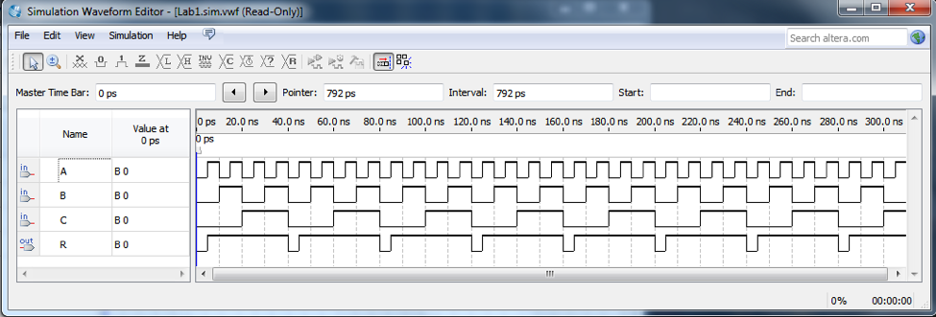
Figure 4: Simulation output waveform of one chip logic circuit (Figure 5.1.1 of Lab Manual)

Table 1 : Experimental data observed from the circuit board (For output: 1 means the light flashed, 0 means the light did not flash):

Input  Logic Expression: (A + B) + C = R |  |  | Observed Output from LED’s
A | B | C | R
0 | 0 | 0 | 1
0 | 0 | 1 | 0
0 | 1 | 0 | 0
0 | 1 | 1 | 0
1 | 0 | 0 | 0
1 | 0 | 1 | 0
1 | 1 | 0 | 0
1 | 1 | 1 | 0

Part II – Combinational Logic Circuits Analysis
Exclusive OR circuit

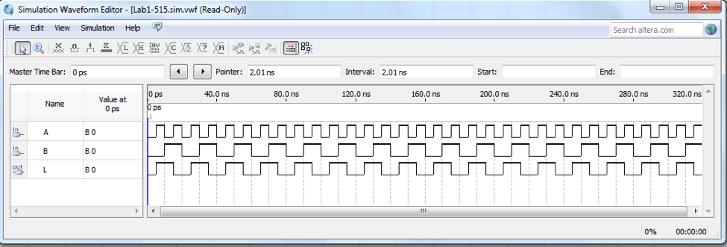
Figure 5: Simulation output waveform of exclusive OR circuit (Figure 5.1.5 of Lab Manual)

Table 2 : Experimental data observed from the circuit board (For output: 1 means the light flashed, 0 means the light did not flash):

Input  Logic Expression: (((A·B)’ · A)’ · ((A·B)’ · B)’)’ = L |  | Observed Output from LED’s
A | B | L
0 | 0 | 0
0 | 1 | 1
1 | 0 | 1
1 | 1 | 0

Multiple output circuit

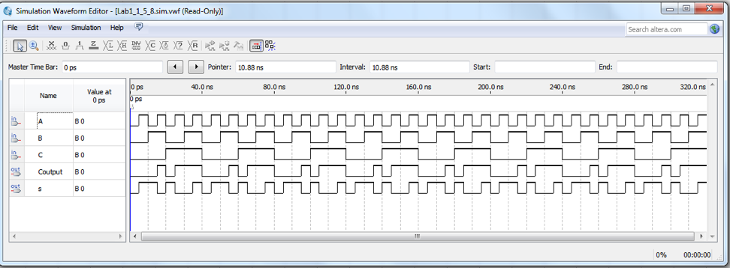
Figure 6: Simulation output waveform of multiple output circuit (Figure 5.1.8 of Lab Manual)

Table 3 : Experimental data observed from the circuit board (For Output: 1 means the light flashed, 0 means the light did not flash):

Input  Logic Expressions: ((A·B)’·((A⊕B)·C)’)’ = C0  ((A⊕B)⊕ C) = S |  |  | Observed Output from LED’s
A | B | C | S | C
0 | 0 | 0 | 0 | 0
0 | 0 | 1 | 1 | 0
0 | 1 | 0 | 1 | 0
0 | 1 | 1 | 0 | 1
1 | 0 | 0 | 1 | 0
1 | 0 | 1 | 0 | 1
1 | 1 | 0 | 0 | 1
1 | 1 | 1 | 1 | 1

Comparison of Theoretical Data and Experimental Data

Part I – Combinational Logic Circuits Construction

One Chip Logic Circuit

Table 4 : Comparison of Theoretical and Experimental results for one chip logic circuit

Input |  |  | Expected Results | Actual Results
A | B | C | R | R
0 | 0 | 0 | 0 | 1
0 | 0 | 1 | 1 | 0
0 | 1 | 0 | 1 | 0
0 | 1 | 1 | 1 | 0
1 | 0 | 0 | 1 | 0
1 | 0 | 1 | 1 | 0
1 | 1 | 0 | 1 | 0
1 | 1 | 1 | 1 | 0

When comparing the difference between the expected results and actual results for the one chip logic circuit, we can clearly see that the results are the opposite of each other. Examining the logical equation of A+B+C, indicates that the output R should only be false if and only if all inputs are false. Therefore, the experimental results are technically wrong. However, this mistake could have arose by assigning wrong inputs on the circuit board.

Part II – Combinational Logic Circuits Analysis

Exclusive OR circuit

Table 5 : Comparison of Theoretical and Experimental results for exclusive OR circuit

Input |  | Expected Results | Actual Results
A | B | L | L
0 | 0 | 0 | 0
0 | 1 | 1 | 1
1 | 0 | 1 | 1
1 | 1 | 0 | 0

The results observed experimentally for the exclusive OR circuit are the exact same as the theoretical results. Examining the logic equation of (((A·B)’ · A)’ · ((A·B)’ · B)’)’, indicates that the output is false if and only if both truth values are the same.

Multiple output circuit

Table 6 : Comparison of Theoretical and Experimental results for Multiple output circuit

Input |  |  | Expected Results |  | Actual Results
A | B | C | S | C | S | C
0 | 0 | 0 | 0 | 0 | 0 | 0
0 | 0 | 1 | 1 | 0 | 1 | 0
0 | 1 | 0 | 1 | 0 | 1 | 0
0 | 1 | 1 | 0 | 1 | 0 | 1
1 | 0 | 0 | 1 | 0 | 1 | 0
1 | 0 | 1 | 0 | 1 | 0 | 1
1 | 1 | 0 | 0 | 1 | 0 | 1
1 | 1 | 1 | 1 | 1 | 1 | 1

The results observed experimentally for the multiple output circuit are the exact same as the theoretical results. Examining the logic equation for S, ((A⊕B)⊕ C), indicates that the output S is true only if one of C or (A⊕B) is true, but not both. Also, the equation for C, ((A·B)’·((A⊕B)·C)’)’, indicates that the output is true if at least two of the three inputs are true.

Discussion & Conclusions

Experiment one is mainly for participants to understand the basics of logic circuits and boolean algebra. Given a circuit logic diagram we need to obtain a logic expression that represents the circuit, we then need to predict all possible outputs of the circuits using simple binary logic. After recreating the circuit on Quatrus we compared the experimental results to our predictions and analyze again why our prediction was right or figure out the mistakes we made that gave us the wrong result. Doing so improves our knowledge in Binary Logic. In addition, this experiment teaches us the basics of using the Quartus software to create logic circuits and testing them which will be crucial in further parts of the course and our program.

Many small problems occured due to the lack of experience in logic circuits and the Quatrus software. Some of these problems were not understanding the meaning of certain symbols, trouble in compiling the circuit to the Altera board, and determining some of the outputs from the binary logic. These issues were resolved by carefully re-reading instructions and repetitive practice. In some cases we needed to ask the TA for assistance where they point us into the right direction of the solution to our problem. In one case we lost the data of our logic circuit due to improper saving techniques; reading instructions and asking peers for assistance let us learn how to properly save the data.

By performing this experiment we are verifying the laws of binary logic. Through the logic circuits we obtain expressions that will represent the result from the inputs. If we go through the logic correctly we will obtain the correct result. For example in Table 4 our expected results contradict our actual results because we were unable to process the logic properly. But in the other circuits we successfully predicted the outputs of the logic circuit because we properly processed the logical expression represented by the circuit.

In conclusion, it is important to derive the proper logical expressions from the circuit in order to predict the right outputs. This experiment teaches us good habits to obtain while working with binary logic and circuits such as carefully following the circuit and being aware of all possible inputs for each circuit. It also teaches us good practices when using Quartus such as saving the file properly and labelling the circuit diagram properly.

