ADMN 2336 – Organizational Behavior
McGraw Hill Connect
Check Brightspace in next few days to get access

Organizational Behavior: field of study devoted to understanding, explaining, and improving behavior of individuals and groups within an organization

Organizational Behavior – Job Performance: Chapter 2
How do we define job performance?
- Results/Metrics: Objective measures of outcomes
- Behavior: Specific behaviors

Pros and Cons of Results-based Job Performance:
Pros: easy to implement, objective/comparable
Cons: Doesn’t capture beyond the ‘bottom line’ (money only), not always controllable (interpersonal conflicts), no focus on improvement

Job Performance: Employee behaviors that contribute either positively, or negatively to organizational goals
Total (Behavior) Performance
- Task performance (in-role) – Three subtypes
  - Routine (habitual responses to predictable tasks)
  - Adaptive (thoughtful responses to unpredictable tasks)
  - Creative (novel and useful ideas)
- Citizenship behavior (extra-role) - Discretionary behaviors that contribute to achieving organizational goals (can be interpersonal or organizational)
  - Helping (interpersonal) – provide advice, direction etc.
  - Courtesy (interpersonal) – clean up, make it easy for others
  - Sportsmanship (interpersonal)
  - Voice (organizational) – speak up, propose new ideas, suggestions
  - Civic virtue (organizational) – attend meetings, training
  - Boosterism (organizational) – boost the image of the organization, don’t bad mouth
- Counter-productive behavior (extra-role) – Discretionary behaviors that hinder organizational goals (can be interpersonal or organizational)
  - Production deviance: wasting resources (organizational)
  - Property deviance: sabotage, theft (organizational)
  - Political deviance: gossiping, incivility (interpersonal)
  - Personal aggression: harassment, abuse (interpersonal)

Sample Multiple Choice Question 1
Q: True or False: Survey study results have shown that there is a strong correlation between job satisfaction and performance. Therefore, one can conclude that job satisfaction is a cause of job performance.
A: False, correlation is not causation. A correlation can be caused by other variables.
Sample Multiple Choice Question 2
Q: Watching an expressionless flight attendant robotically demonstrate how to insert the seatbelt before the flight is an example of:
A: Routine task performance

Organizational Commitment – Chapter 3
- It’s not enough to have talented employees, you have to be able to retain them
  - Costs .5 times the salary/benefits to replace hourly worker
  - 1.5 times to replace salaried employee
  - 5 times to replace an executive
- Organizational commitment: the desire on the part of an employee to remain a member of the organization. Organizational commitment influences whether an employee stays a member of the organization (is retained) or leaves to pursue another job (turns over).
- Withdrawal behavior: a set of actions that employees perform to avoid the work situation, behaviors that may ultimately culminate in leaving the organization.
Forms of Commitment
Affective: an employee’s desire to remain a member of an organization due to a feeling of emotional attachment
  - Employees who are affectively committed to their employer tend to engage in more interpersonal and organizational citizenship behaviors
  - Affective commitment illustrates an emotional bond to the organization
Continuance: an employee’s desire to remain a member of an organization due to an awareness of the costs of leaving
  - Lack of employment alternatives increase continuance commitment
  - Continuance commitment creates passive loyalty
  - Embeddedness: an employee’s connection to and sense of fit in the organization and community (family roots, lots of friends nearby, worked here for a long time, I have responsibility in the company)
Normative: An employee’s desire to remain a member of an organization due to a feeling of obligation
  - Based on a feeling of being in debt to the company (training, relocation)
  - Becoming charitable can increase normative commitment
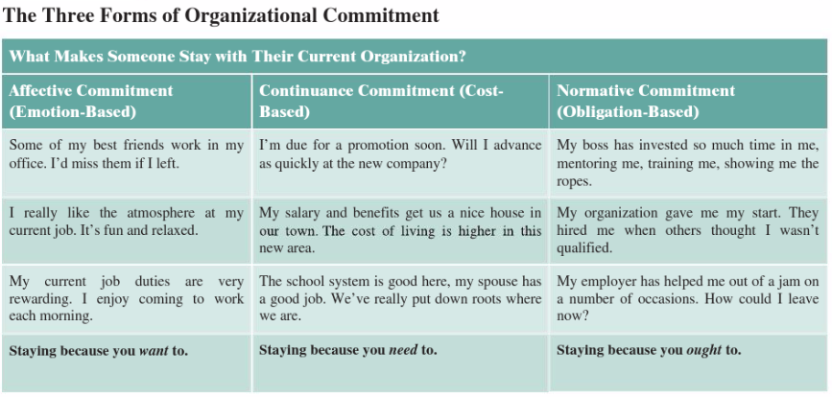
Focus of commitment: The people, places, and things that inspire a desire to remain a member of an organization
Erosion model: A model that suggests that employees with fewer bonds with co-workers are more likely to quit the organization
Social influence model: suggests that employees with direct linkages to co-workers who leave the organization will themselves be more likely to leave
Withdrawal Behavior
Social Loafing: one person allows others to do the work
Exit: An active response to a negative work event in which one ends or restricts organizational membership
Loyalty: A passive response to a negative work event in which one publicly supports the situation but privately hopes for improvement
Neglect: A passive, destructive response to a negative work event in which one’s interest and effort in the job declines
- Two forms of withdrawal
- Psychological and physical
Psychological withdrawal: Actions that provide a mental escape from work
  - Daydreaming: random thoughts that interrupt work
  - Socializing: verbally chatting with co-workers
  - Looking busy: an attempt to look as if you are consumed with work
  - Moonlighting: using work time to do non-work related activites
  - Cyberloafing: using facebook, email, YouTube etc.
Physical withdrawal: A physical escape from work
  - Tardiness: arriving late or leaving early
  - Long Breaks
  - Missing meetings
  - Absenteeism: missing whole day(s)
  - Quitting: voluntarily leaving the organization
Independent forms model: a model that predicts that the various withdrawal behaviors are uncorrelated, so that engaging in one type as little bearing on any other
Compensatory forms model: indicates that the various behaviors are negatively correlated, so that engaging in one makes on less likely to engage in another
Progression model: indicates that the various behaviors are positively correlated, so that engaging in one makes one more likely to engage in other types

Trends that Affect Commitment
- Diversity of the workforce
- More women
- Aging workers
- Remaining a member of a workforce is actually beneficial for older people’s health
The Changing Employee-Employer Relationship
Psychological contracts: employee beliefs about what they owe the organization and what the organization owes them
Transactional contracts: psychological contracts that focus on a narrow set of specific monetary obligations
Relational contracts: focus on a broad set of open-ended and subjective obligations
Perceived Organizational support: the degree to which employees believe that the organization values their contributions and cares about their well-being

Chapter 4 + Lecture 3
Personality, Values, and Abilities
Sept 21
How can we describe employees what can do? (ABILITY) How can we describe what employees are like? (PERSONALITY)
- Personality + Cultural values = what employees are like
PERSONALITY
- Captures what people are like (thought, emotion, behavior)
- Categorized by the Big Five
Personality: The structures and propensities inside a person that explain his or her characteristic patterns of thought, emotion, and behavior; personality reflects what people are like and creates their social reputation.
Traits: Recurring trends in people’s responses to their environment
Cultural values: Shared beliefs about desirable end states or modes of conduct in a given culture that influence the expression of traits.
Ability: Relatively stable capabilities of people for performing a particular range of related activities.
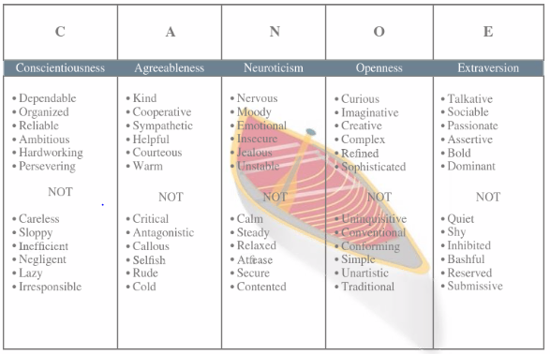

BIG FIVE
Conscientiousness: Dimension of personality-reflecting traits like being dependable, organized, reliable, ambitious, hard-working, and persevering
Accomplishment Striving: a strong desire to accomplish task-related goals as a means of expressing one’s personality
Agreeableness: kind, cooperative, sympathetic, helpful, courteous, and warm
Communion striving: a strong desire to obtain acceptance in personal relationships as a means of expressing one’s personality
Neuroticism: nervous, moody, emotional, insecure, jealous, and unstable
Synonymous with negative affectivity (tendency to experience unpleasant moods)
Openness to experience: curious, imaginative, creative, complex, refined, and sophisticated
Extraversion: talkative, sociable, passionate, assertive, bold, and dominant
Easy to judge extraversion in zero acquaintance situations (when two people have first met)
Extraverted people prioritize status striving (a strong desire to obtain power and influence)
Extraverted employees tend to be high in positive affectivity (a dispositional tendency to experience pleasant, engaging moods)
OTHER PERSONALITY TRAITS
Locus of control: one’s tendency to view the cause of events and personal outcomes as internally or externally controlled (belief about what causes experiences in life)
Self-monitoring: observing and regulating your own behavior in social settings
CULTURE
Culture: the shared values, beliefs, motives, identities, and interpretations that result from common experiences of members of a society and are transmitted across generations
Individualism-collectivism: the degree to which a culture has loosely knit social framework or a tight one
Power distance: the degree to which a culture prefers equal (low power distance) power distribution or unequal (high power distance) power distribution
Uncertainty avoidance: the degree to which a culture tolerates ambiguous situations (low) or feels threatened by them (high)
Masculinity-femininity: the degree to which a culture values stereotypically male or female attributes
Short vs. long-term orientation: the degree to which a culture stresses values that are past, present or future oriented.
Ethnocentrism: a propensity to view one’s own cultural values as right and those of other cultures as wrong
EMPLOYEE ABILITY
- Cognitive, emotional, and physical
- Ability: the relatively stable capabilities people have, to perform a particular range of different but related activities
- Different from skills, skills are more trainable
Cognitive ability: capabilities related to the use of knowledge to make decisions and solve problems (referred to as general intelligence)
Verbal ability: capabilities associated with understanding and expressing oral and written communication
Quantitative ability: capabilities associated with doing basic mathematical operations and selecting and applying formulas to solve problems
Reasoning ability: a diverse set of abilities associated with sensing and solving problems using insight, rules, and logic
Spatial ability: associated with visual and mental representation and manipulation of objects in space (two types; spatial orientation and visualization)
Perceptual ability: the capacity to perceive, understand, and recall patterns of information
General cognitive ability (g factor): the general level of cognitive ability that plays an important role in determining more narrow cognitive abilities
Emotional Ability
Emotional intelligence: abilities related to the understanding and use of emotions that affect social functioning (sometimes called emotional quotient or EQ)
Self-awareness: the ability to recognize and understand emotion in oneself
Other awareness: the ability to recognize and understand emotion that other people are feeling
Emotional regulation: the ability to quickly recover from emotional experiences
Use of emotions: the degree to which people can harness emotions and employ them to improve their chances of being successful in whatever they’re seeking to do
Physical Ability
Strength (static, explosive, dynamic): the degree to which the body is capable of exerting force
Stamina: the ability of a person’s lungs to work efficiently while he/she is engaging in prolonged physical activity
Flexibility and coordination: the ability to stretch/the quality of physical movement in terms of synchronization of movements and balance
Psychomotor ability: associated with manipulating and controlling objects
Sensory ability: associated with hearing and vision
EMPLOYEE ABILITY: SUMMARY
Typical performance: performance in routine conditions that surround daily job tasks
Maximum performance: performance in brief, special circumstances that demand a person’s best effort
Situational strength: the degree to which situations have clear behavioral expectations, incentives, or instructions that make differences between individuals less important
Trait activation: the degree to which situations provide cues that trigger the expression of a given personality trait
- Personality and intelligence are highly stable human characteristics
- Personality and intelligence is related to job performance
- Each can be measured and used as hiring criteria
- If you want the right person you only measure the dimensions that you want

Chapter 5 – Lecture 4
JOB SATISFACTION
Job satisfaction: a pleasurable emotional state resulting from the appraisal of one’s job or job experiences
- Leads to performance, and organizational commitment
- Important for managers to help cultivate job satisfaction
- Job satisfaction is essential if employees are to achieve their highest levels, and citizenship behavior
Values: things that people consciously or unconsciously want to seek or attain
- People look at job satisfaction through the lens of their values
- Does my job satisfy my values?
*LIKELY EXAM TOPIC* Value-percept theory: argues that job satisfaction depends on whether the employee perceives that his or her job supplies those things that he or she values
- Dissatisfaction = (Vwant – Vhave) x (Vimportance)
- Vwant = how much of a value an employee wants
- Vhave = how much of that value the job supplies
- Negative = dissatisfaction, positive = satisfaction
TYPES OF SATISFACTION
Pay satisfaction: employees’ feelings about compensation for their jobs
Promotion satisfaction: feelings about how the company handles promotions
Supervision satisfaction: feelings about their boss, including his or her competency, communication, and personality
Co-worker satisfaction: feelings about co-workers, including their abilities, and personalities
HOW CAN WE TRACK JOB SATISFACTION?
- Job descriptive index
  - i.e. people on your job are…
    - stimulated, boring, slow, etc.
- Strengths analysis
HOW CAN WORK BE SATISFYING?
Satisfaction with work itself: feelings about actual job tasks
- Meaningfulness: argues that job satisfaction depends on whether the employee perceives that his or her job supplies those things that he or she values
- Responsibility for outcomes: argues that job satisfaction depends on whether the employee perceives that his or her job supplies those things that he or she values
- Knowledge of results: argues that job satisfaction depends on whether the employee perceives that his or her job supplies those things that he or she values
Job characteristics theory: argues five core characteristics (variety, identity, significance, autonomy, and feedback) combine to result in higher levels of job satisfaction
Variety: the degree to which a job requires different activities and skills
Identity: the degree to which a job offers completion of a whole, identifiable piece of work
Significance: the degree to which a job really matters and impacts society
Autonomy: the degree to which a job provides freedom, independence, and discretion to perform work tasks
Feedback: the degree to which the job itself provides information about how well the job holder is doing
Knowledge and skill: the degree to which employees have the aptitude and competence needed to succeed on their job
Growth need strength: the degree to which employees’ desire to develop themselves further
Job enrichment: when job duties and responsibilities are expanded to provide increased levels of core job characteristics
Job crafting: when employees shape, mold, and redefine their job in a proactive way
EMOTIONS AND MOODS
- They fluctuate daily
Moods: states of feeling that are mild in intensity, last for an extended period of time, and are not directed at anything
Pleasantness: the degree to which an employee is in a good mood versus a bad mood
Activation: the degree to which moods are aroused and active, as opposed to unaroused and inactive
Flow: a state in which employees feel a total immersion in the task at hand, sometimes losing track of how much time has passed
Affective events theory: a theory that describes how workplace events can generate emotional reactions that impact work behaviors
Emotions: intense feelings, often lasting for a short duration, that are clearly directed at someone or some circumstance
Positive emotions: joy, pride, relief, hope, love, compassion
Negative emotions: fear, guilt, shame, sadness, envy disgust
Emotional labor: the management of emotions that employees must do to complete job duties successfully
Emotional contagion: the idea that emotions can be transferred from one person to another
HOW IMPORTANT IS JOB SATISFACTION?
Life satisfaction: the degree to which employees feel a sense of happiness with their lives in general
- Job satisfaction is more likely to increase affective and normative commitment rather than other forms of commitment
Chapter 6 – Stress
Stress: the psychological response to demands when there is something at stake for the individual, and when coping with these demands would tax or exceed the individual’s capacity or resources
Stressors: demands the cause stress to occur
Strains: negative consequences of stress
Transactional Theory of Stress: a theory that explains how stressful demands are perceived and appraised, as well as how people respond to the perceptions of appraisals
Primary appraisal: evaluation of whether a demand is stressful and, if it is, the implications of the stressor in terms of personal goals and well-being
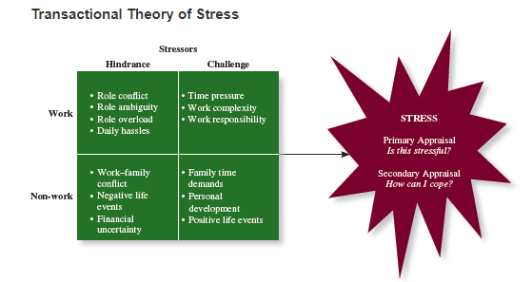
Benign job demands: job demands that are appraised as being not stressful
Types of stressors:
Hindrance: stressors that tend to be appraised as thwarting progress toward growth and achievement
Role conflict: others having different expectations
Role ambiguity: a lack of direction and information
Role overload: excess demands
Daily hassles: minor day-to-day demands that interfere
Challenge: stressors that tend to be appraised as opportunities for growth and achievement
Time pressure: not enough time to complete tasks
Work complexity: the degree to which the job exceeds employee skills
Work responsibility: the number and importance of obligations
Non-work Hindrance stressors:
Work-family conflict: obvious
Negative life events: divorce, family death
Financial uncertainty: loss of money
Non-work challenge stressors:
Family time demands
Personal development
Positive life events
HOW DO PEOPLE COPE WITH STRESS
Secondary appraisal: when people determine how to cope with the various stressors they face
Coping: behaviors and thoughts used to manage stressful demands and the emotions associated with the stressful demands
Behavioral coping: physical activities used to deal with a stressful situation
Cognitive coping: thoughts used to deal with a stressful situation
Problem-focused coping: behaviors and cognitions of an individual intended to manage the stressful situation itself
Emotion-focused coping: behaviors and cognitions of an individual intended to help manage emotional reactions to the stressful demands
THE EXPERIENCE OF STRAIN
Physiological strain: reactions to stress that harm the body
Psychological strain: negative psychological reactions from stress (depression, anger, anxiety)
Behavioral strain: patterns of negative behaviors associated with other strains (alcohol and drug use, compulsive eating etc.)
Burnout: the emotional, mental, and physical exhaustion from coping with stressful demands on a continuing basis
ACCOUNTING FOR INDIVIDUALS WITH STRESS
Type A behavioral pattern: a type of behavior exhibited by people who tend to experience more stressors, to appraise more demands as stressful, and to be prone to experiencing more strain than others
Social support: help received from other people when confronted with stressful demands
Instrumental support: the help received that can be used to address the stressful demand directly
Emotional support: the empathy and understanding people receive from others that can help alleviate emotional stress
HOW IMPORTANT IS STRESS?
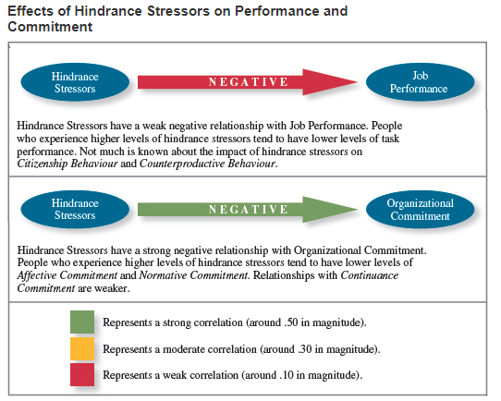
STRESS MANAGEMENT
- First step is to do an assessment
  - Stress audit: an assessment of the sources of stress in the workplace
- Then you can look to reduce the number and magnitude of stressors
  - Job sharing: two people sharing the responsibilities of one job
- Provide resources
  - Training interventions: practices that increase employees’ competencies and skills
  - Supportive practices: ways in which organizations help employees manage and balance their demands
- Reduce strains
  - Relaxation techniques (yoga, meditation, sports)
  - Cognitive-behavioral techniques: various practices that help workers cope with stressors in a rational manner
  - Health and wellness programs
Chapter 7 – Motivation
Motivation: a set of energetic forces that determine the direction, intensity, and persistence of an employees work ethic
Direction: Are you working on the right thing?
Intensity: Are you working hard?
Persistence: Will you work even when it’s hard?
Engagement: a high level of intensity and persistence in work effort
- Only 30% of employees are engaged
- Low levels can be contagious
WHY ARE SOME EMPLOYEES MORE MOTIVATED THAN OTHERS?
DIRECTION OF EFFORT THEORY
Expectancy theory: the cognitive process employees go through to make choices among different voluntary responses
- People are more motivated to perform activities they can accomplish, and ones that will lead to valued outcomes
- Some outcomes are more valued than others because people have different needs
- Anticipated outcomes can either have intrinsic or extrinsic value
- Intrinsic: motivated by work itself (enjoyment, learning, accomplishment)
- Extrinsic: motivated by the reward performance can lead to (money, promotion, praise, free time)
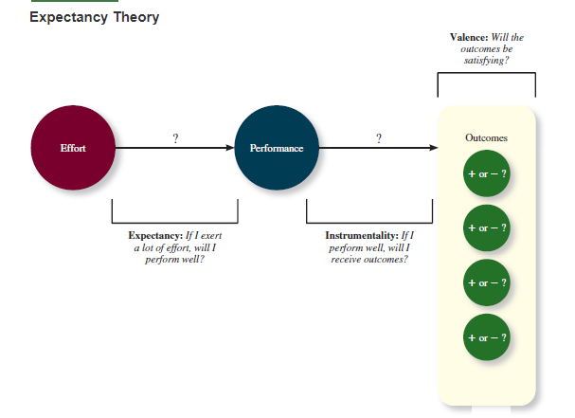

INTENSITY AND PERSISTENCE THEORIES
Goal setting theory: views goals as the primary drivers of the intensity and persistence of effort
- Goals are more motivating when; they are specific and challenging, when people commit to them, and when goal-setters receive feedback
- SMART goals (specific, measurable, achievable, results-based, time-sensitive)
Equity theory: suggests that employees create a mental ledger of the outcomes they receive for their job inputs, relative to others
- Comparing your ratio of inputs and outcomes with someone else’s
  - Inputs and outcomes considered
    - Inputs: effort, performance, experience, seniority
    - Outcomes: pay, benefits, supervision, perks
Psychological empowerment: an intrinsic form of motivation derived from the belief that one’s work contribute to a bigger purpose
- Meaningfulness, self-determination, competence, impact
MOTIVATION
- motivation leads to better job performance and organizational commitment

Chapter 8 – Trust, Justice, and Ethics
Reputation: the prominence of an organization’s brand in the minds of the public and the perceived quality of its goods and services
- One of a company’s most prized possessions
- Can take a long time to build, and a second to destroy
Trust: the willingness to be vulnerable to an authority because of positive expectations about the authority’s actions and intentions
Justice: the perceived fairness of an authority’s decision making
Ethics: the degree to which the behaviors of an authority are in accordance with generally accepted moral norms
FACTORS THAT INFLUENCE TRUST LEVELS
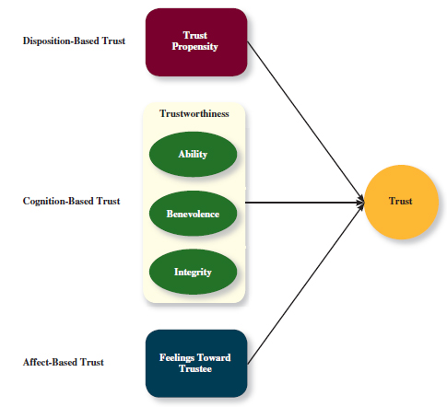
Disposition based trust: trust rooted in one’s own personality, as opposed to a careful assessment of the trustee’s trustworthiness
- Less to do with the authority and more to do with the trustor
- Guides us in cases in which don’t have enough data about the authority
- Trust propensity: a general expectation that the words, promises, and statements of individuals can be relied upon

Cognition based trust: trust rooted in a rational assessment of the authority’s trustworthiness
- Based on the authority’s trustworthiness
- Trustworthiness: characteristics or attributes of a person that inspire trust, including perceptions of ability, benevolence, and integrity
  - Ability (dimension of trustworthiness): the skills, competencies, and areas of expertise that enable an authority to be successful in some specific area
  - Benevolence: the belief that an authority wants to do good for a trustor, apart from any selfish or profit-centered motives
  - Integrity: the perception that an authority adheres to a set of values and principles that the trustor finds acceptable
Affect based trust: trust dependent on feelings toward the authority that go beyond any rational assessment of trustworthiness
- Develops more over time
- Acts as a supplement to the two other types of trust
- More emotional than rational
- i.e. we have a close bond, we have invested a lot into this relationship
These three taken together provide different sources of trust
THE FOUR DIMENSIONS OF JUSTICE
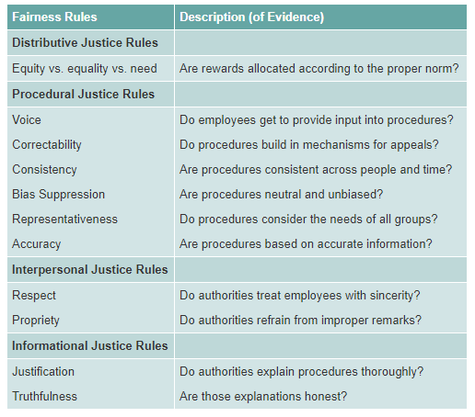

Distributive justice: the perceived fairness of decision-making outcomes
Procedural justice: the perceived fairness of decision-making process (review the factors)
- Voice
- Correctability
- Consistency
- Bias suppression
- Representativeness
- Accuracy
Interpersonal justice: the perceived fairness of the interpersonal treatment received by employees from authorities
Abusive supervision: the sustained display of hostile verbal and nonverbal behaviors, excluding physical contact by a supervisor
- How fairly am I treated?
- People want respect and propriety
Informational justice: the perceived fairness of the communications provided to employees from authorities
- Justification
- truthfulness
Being treated fairly (just) increases trust in the other party
ETHICS
Whistle-blowing: employees’ exposing illegal or immoral actions by their employer
Four-component model
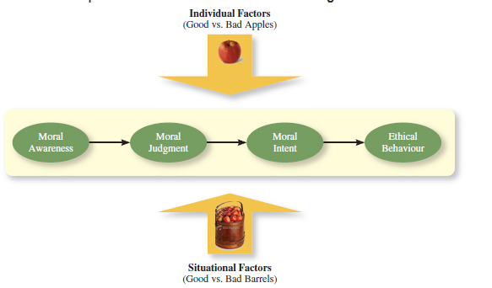

Moral awareness: recognition by an authority that a moral issue exists in a situation
Moral intensity: the degree to which an issue has ethical urgency
Moral attentiveness: the degree to which people chronically perceive and consider issues of morality during their experiences
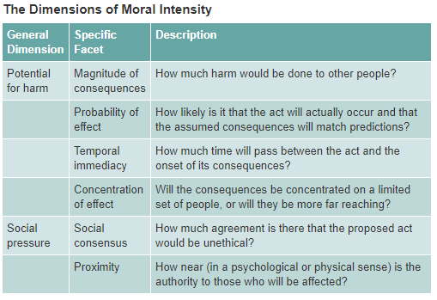
Moral judgement: the process people use to determine whether a particular course of action is ethical or unethical
Cognitive moral development: people’s movement through several states of moral development, each more mature and sophisticated than the prior state
Moral principles: prescriptive guides for making moral judgements
Moral intent: an authority’s degree of commitment to the moral course of action
Moral identity: the degree to which a person views himself or herself as a moral person
HOW IMPORTANT IS TRUST?
- Trust can be a significant predictor of employees’ ability to focus
- Trust has a strong correlation with organizational commitment
- Trust as a moderate correlation with job performance
- Trust can encourage citizenship and counter-productive behavior
  - Economic exchange: work relationships that resemble a contractual agreement by which employees fulfill job duties in exchange for money
  - Social exchange: work relationships characterized by mutual investment, with employees willing to go the extra mile because they trust there behavior will be rewarded
Corporate Social Responsibility: a perspective that acknowledges that the responsibility of a business encompasses the economic, legal, ethical, and citizenship expectations of society
Chapter 9 – Learning and Decision Making
Learning: a relatively permanent change in an employee’s knowledge or skill that results from experience
Decision making: The process of generating and choosing from a set of alternatives to solve the problem
WHY DO SOME EMPLOYEES MAKE BETTER DECISIONS?
Expertise: the knowledge and skills that distinguish experts from novice
TYPES OF KNOWLEDGE
Explicit knowledge: knowledge that is easily communicated and available to everyone
Tacit knowledge: knowledge that employees can only gain from experience
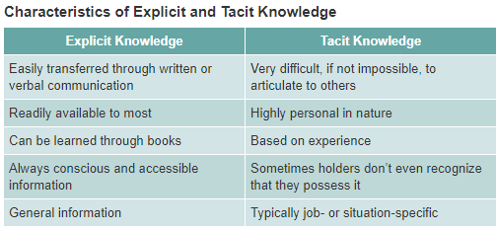
METHODS OF LEARNING
Reinforcement
- Managers use various methods of reinforcement to induce desirable or reduce undesirable behaviours
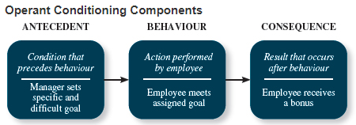

Contingencies of Reinforcement: Four specific consequences used by organizations to modify employee behavior
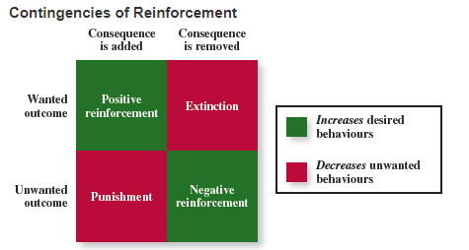
Positive reinforcement: a reinforcement contingency in which a positive outcome follows a desired behavior
Negative reinforcement: a reinforcement contingency in which an unwanted outcome is removed following a desired behavior
Punishment: an unwanted outcome that follows an unwanted behavior
Extinction: the removal of a positive outcome following an unwanted behavior
Schedules of reinforcement: the timing of when contingencies are applied or removed
Continuous reinforcement: a schedule of reinforcement in which a specific consequence follows each and every occurrence of a certain behavior
Fixed-interval schedule: a schedule whereby reinforcement occurs at fixed time periods
Variable-interval schedule: a schedule whereby reinforcement occurs at random periods of time
Fixed-ratio schedule: a schedule whereby reinforcement occurs following a fixed number of desirable behaviors
Variable-ratio behaviors: a schedule whereby behaviors are reinforced after a varying number of them have been exhibited
Observation
Social learning theory: theory that argues that people in organizations learn by observing others
Behavioral modelling: employees’ observing that actions of others, learning from what they observe, and then repeating the observed behavior
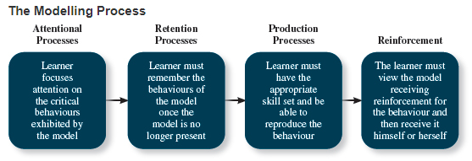
Goal Orientation
Learning orientation: a predisposition or attitude according to which building competence is deemed more important by an employee than demonstrating competence
Performance-prove orientation: a predisposition or attitude according to which building competence is deemed more important by an employee than demonstrating competence
Performance-avoid orientation: a predisposition or attitude according to which building competence is deemed more important by an employee than demonstrating competence
Methods of Decision Making
Programmed decisions: decisions that are somewhat automatic because the decision maker’s knowledge allows him or her to recognize the situation and the course of action to be taken
Intuition: an emotional judgment based on quick, unconscious gut feelings
Crisis situation: a change—sudden or evolving—that results in an urgent problem that must be addressed immediately
Nonprogrammed decision: one made by employees when a problem is new, complex, or not recognized
Rational decision-making model: a step-by-step approach to making decisions that is designed to maximize outcomes by examining all available alternatives
Decision Making Problems
- Most employees perceive themselves as rational decision makers, but they are all subject to bounded rationality
Bounded rationality: the notion that people do not have the ability or resources to process all available information and alternatives when making a decision
Satisficing: what a decision maker is doing who chooses the first acceptable alternative considered
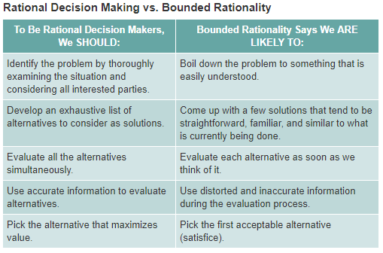
Faulty Perceptions
Selective perception: the tendency for people to see their environment only as it affects them and as it is consistent with their expectations
Projection bias: the faulty perception by decision makers that others think, feel, and act as they do
Social identity theory: a theory that people identify themselves according to the various groups to which they belong and judge others according to the groups they associate with
Stereotype: assumptions made about others based on their social group membership
Heuristics: simple and efficient rules of thumb that allow one to make decisions more easily
Availability bias: The tendency for people to base their judgments on information that is easier to recall
Faulty Attributions
Fundamental attribution error: the tendency for people to judge others’ behaviours as being due to internal factors such as ability, motivation, or attitudes
Self-serving bias: when one attributes one’s own failures to external factors and success to internal factors
Consensus: used by decision makers to attribute cause; whether other individuals behave the same way under similar circumstances
Distinctiveness: used by decision makers to attribute cause; whether the person being judged acts in a similar fashion under different circumstances
Consistency: used by decision makers to attribute cause; whether this individual has behaved this way before under similar circumstances
Escalation of Commitment: a common decision-making error, in which the decision maker continues to follow a failing course of action
HOW IMPORTANT IS LEARNING?
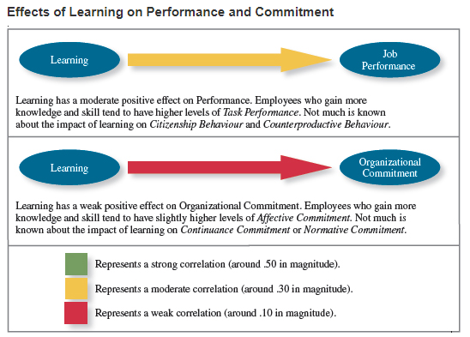
TRAINING
Training: a systematic effort by organizations to facilitate the learning of job-related knowledge and behaviour
Knowledge transfer: the exchange of knowledge between employees
Behavior modelling training: when employees observe the actions of others, learn from what they observe, and then repeat the observed behaviour
Communities of practice: groups of employees who learn from one another through collaboration over an extended period of time
Transfer of training: occurs when employees retain and demonstrate the knowledge, skills, and behaviours required for their job after training ends
Climate for transfer: an organizational environment that supports the use of new skills

Chapter 10 & 14
Chapter 10: Communication
Communication: the process by which information and meaning is transferred from a sender to a receiver
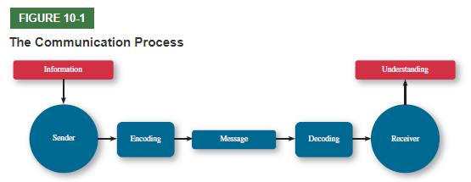
COMMUNICATION TYPES
Face to Face: this is effective for verbal and nonverbal messages
Computer-mediated: this is only effective for verbal messages that are explicit, nonverbal cues and subtext can not be transmitted this way.
THE COMMUNICATION PROCESS: ISSUES
Communicator competence: the ability of the communicators to encode and interpret messages
Noise: disturbing or distracting stimuli that block or interfere with the transmission of a message
Information richness: the amount and depth transmitted in a message
Gender differences: different ways men and women tend to process and interpret information and communicate with others
Privacy: a state in which individuals can express themselves freely without oversight from authorized or unauthorized parties

COMMUNICATION NETWORKS
Formal Communication Network Structures
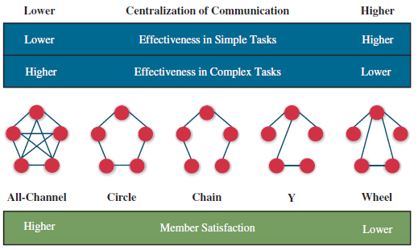
All-Channel: any member can send and receive messages from any other
Circle: members can only send messages to those immediately adjacent to them
Chain: information is passed from one member to the next
Y: one member controls the flow of information between one set of members
Wheel: all communication is controlled by one member
Formal Communication Types
Downward: when messages are sent down a vertical hierarchy, used by managers to rely information, instructions, goals etc.
Upward: when messages are sent up a vertical hierarchy, used by employees to rely feedback, suggestions, and personal information/requests
Horizontal: when messages flow through members on the same hierarchal level
Informal Communication
Definition: spontaneous patterns of communication that result from the choices of individuals
Types
- Grapevine: the primary informal communication network in an organization, where people talk about work or personal matters
- Rumors and gossip
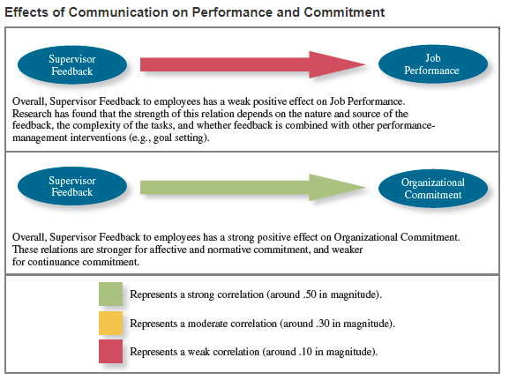
Chapter 14: Organizational Structure
Definition: the formal structure that dictates how jobs and tasks are divided and coordinated between individuals and groups in an organization
Elements of Organizational Structure
- Work specialization: the degree to which work is separated
- Chain of command: who reports to whom
- Span of control: how much responsibility a manager has
- Centralization: refers to where decisions are made
- Formalization: represents the level of standardization of behaviors
The combinations of these elements lead to two broad characterizations of structure…
- Mechanistic organizations: efficient, rigid, predictable, and standardized organizations that thrive in stable environments
- Organic organizations: flexible, adaptable, outward-focused organizations that thrive in dynamic environments
ORGANIZATIONAL DESIGN
Definition: the process of creating, selecting, or changing the structure of an organization
A number of factors influence this design process…
- Business environment: customers, competitors, supply chain members, government etc.
- Company strategy: goals and objectives, products, assets, how the company makes money
- Technology: the method by which an organization terms inputs to outputs
- Company size: how many employees, how many locations
COMMON STRUCTURES
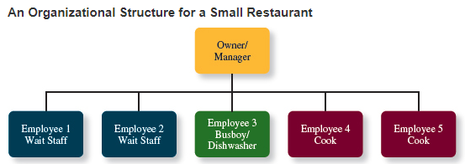
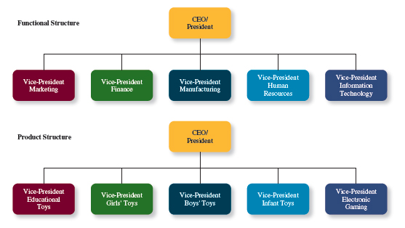
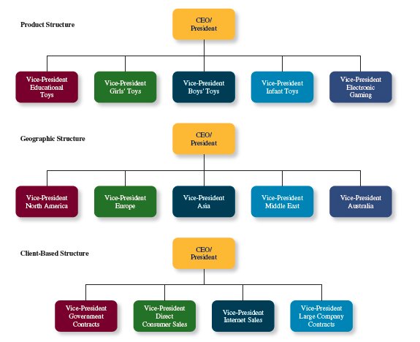
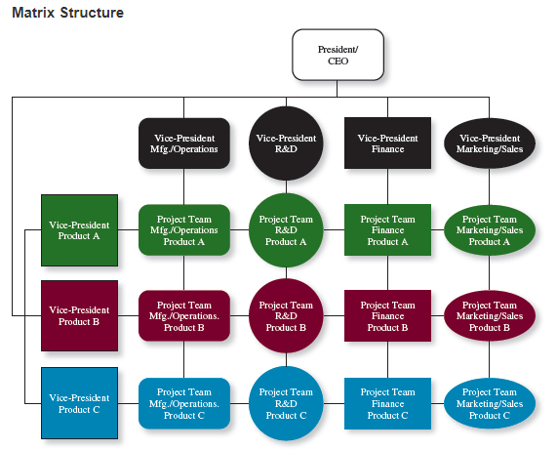
Definition: a complex form of organization structure that combines functional and multi-functional grouping
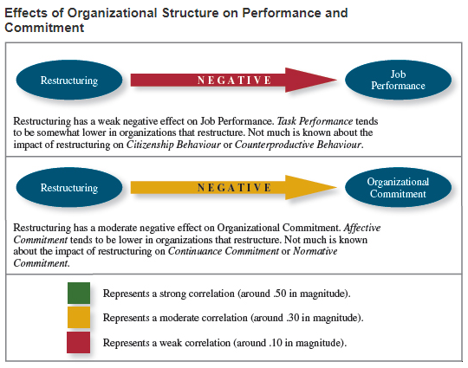
Chapter 11 – Teams
TEAM CHARACTERISTICS
Team: two or more people who work independently over some time period to accomplish common goals related to some task-oriented purpose
TYPES OF TEAMS
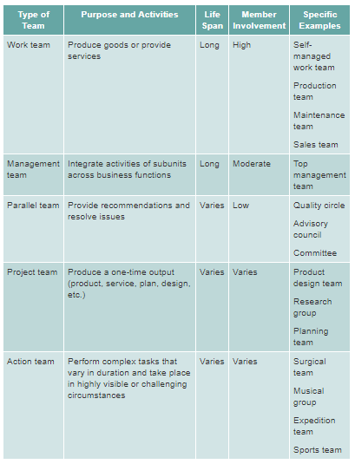
Work teams: relatively permanent teams in which members work together to produce goods/services
- Produce goods and services
Management teams: relatively permanent team that participates in managerial-level tasks that affect the entire organization
- Integrate activities across business functions

Parallel teams: teams composed of members from various jobs within the organization that meet to provide recommendations about important issues
- Provide recommendations and resolve issues
Project teams: teams formed to take on one-time tasks, most of which tend to be complex and require input from members in different functional areas
- One-time project output
Action teams: teams of limited duration that performs complex tasks in contexts that tend to be highly visible and challenging
- Complex tasks, vary in duration, highly challenging work
Virtual teams: a team in which the members are geographically dispersed, and interdependent activity occurs through the use of communication technology
TEAM DEVELOPMENT
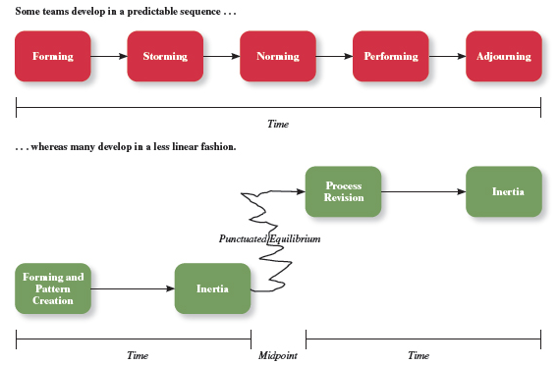
- There are other types of team development
  - Punctuated equilibrium: a sequence where not much gets done until the halfway point of the project, after which, team makes necessary adjustments and completes the work
TEAM INTERDEPENDENCE
Task interdependence: the degree to which team members interact with and rely on other team members to accomplish work
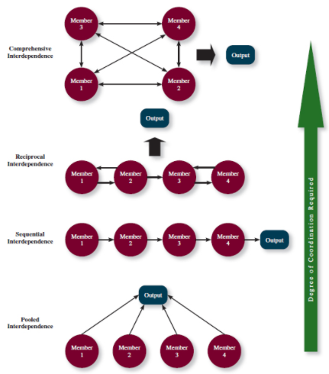
Goal interdependence: the degree to which team members have a shared goal and align their individual goals to that greater goal
Outcome interdependence: the degree to which team members share equally in the feedback and rewards that result from a team achieving their goals
FIVE ASPECTS OF TEAM COMPOSITION
Team composition: the mix of various characteristics that describe the individuals who work in the team
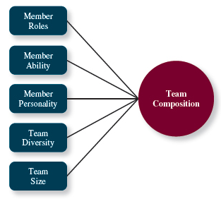
Member roles
- Task team roles
- Team-building roles
- Individualistic roles
Member personality
- Conscientiousness
- Agreeableness
- Extraversion
Team Diversity
- Value in diversity problem-solving approach
  - Diversity gives more knowledge/info etc.
- Similarity-attraction approach
  - Diversity can be counter-productive because avoid interacting with others unlike them
- Two types: surface level and deep level
TEAM STATES:
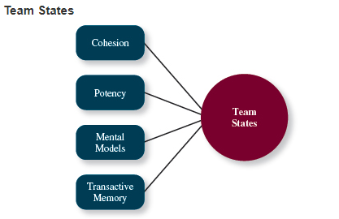
Team cohesion: exists when members of teams develop strong emotional bonds
- Depends on the team’s norm
- Productive norms lead to higher task performance
- High cohesion can lead to lower task performance if norms are bad (groupthink can take over)
Potency: a team state reflecting the degree of confidence among team members that the team can be effective
Mental models: the degree to which team members have a shared understanding of important aspects of the team and its task
Transactive memory: the degree to which member knowledge is integrated into team memory
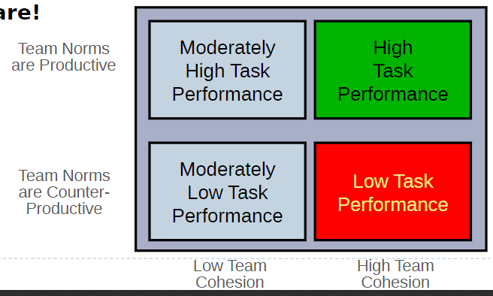
TEAM PROCESSES
Team process: the different types of activities and interactions that occur within a team as a team works toward its goals
WHY ARE SOME TEAMS BETTER THAN OTHERS?
Process gain: achievement of team outcomes greater than those one would expect on the basis of the capabilities of the individual members
Process loss: achievement of team outcomes less than those one would expect on the basis of the capabilities of the individual members
TASKWORK PROCESSES: activities of the team members that lead to accomplishment of goals
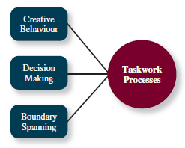
- 3 types of tasks
  - Additive, conjuctive, and disjunctive (ADD THESE DEFINITIONS)
TEAMWORK PROCCESSES: the interpersonal activities that promote accomplishment of team tasks but do not lead to task accomplishment directly
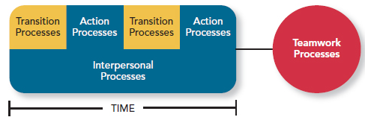
Transition processes: activities like planning that focus on the future
Action processes: activities like helping and coordination that aid while work is actually taking place
Interpersonal processes: activities like motivating and confidence building that focuses on the management of team relationships
TEAM PROCESSES SUMMARY
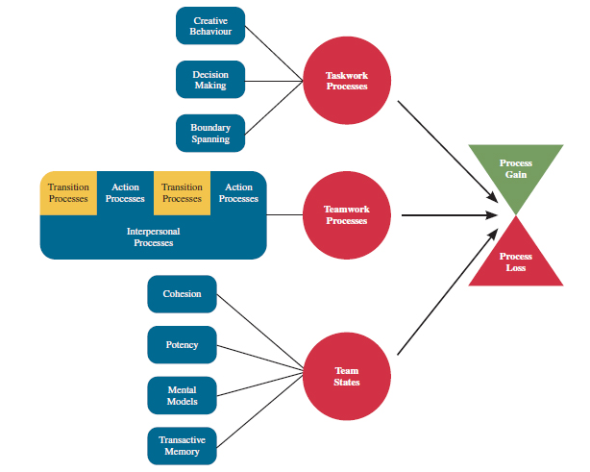
HOW IMPORTANT ARE TEAM CHARACTERISTICS AND PROCESSES?
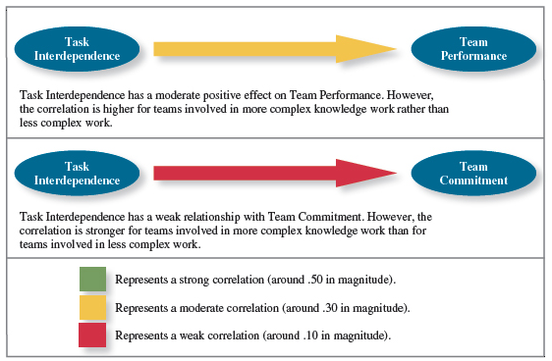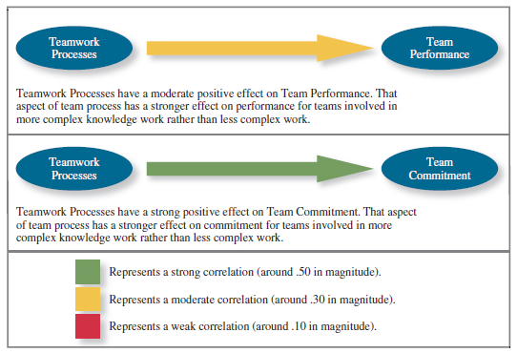
Chapter 12 – Power, Influence, and Negotiation
Power: the ability to influence the behavior of others and resist unwanted influence in return
TYPES OF POWER
- Two main types
  - Organizational
    - Legitimate: a form of organizational power based on authority or position
      - Be polite
      - Don’t exceed the scope of your authority
      - Insist on compliance
    - Reward: a form of organizational power based on the control of resources or benefits
      - Offer rewards people desire
      - Don’t promise what you can’t deliver
      - Don’t use rewards to manipulate
    - Coercive: a form of organizational power based on the ability to hand out punishment
      - Explain rules and standards
      - Provide warnings
      - Respond quickly and without favouritism
  - Personal
    - Expert: a form of organizational power based on expertise or knowledge
      - Provide evidence for requests
      - Don’t make inconsistent statements
      - Don’t exaggerate
      - Do extraordinary work
    - Referent: a form of organizational power based on the attractiveness and charisma of the leader
      - Show acceptance
      - Be supportive
      - Defend people
      - Do unsolicited favours
      - Build charisma
THE CONTINGENCIES OF POWER
Substitutability: the degree to which people have alternatives in accessing resources that a leader controls
Discretion: the degree to which managers have the right to make decisions on their own
Centrality: how important a person’s job is and how many people depend on that person to accomplish their tasks
Visibility: How aware others are of a leader and the resources that the leader controls
- Leaders are better when they have…
  - Low substitutability
  - High discretion
  - High centrality
  - High visibility
USING INFLUENCE
Influence: the use of behaviours to cause behavioural or attitudinal changes in others
Influence Tactics
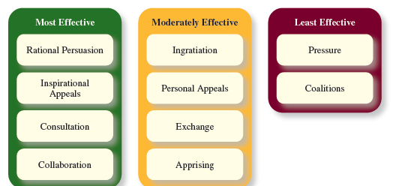
- Apprising: when the requestor clearly explains why performing the request will benefit the target personally
- Inspirational appeals: designed to appeal to one’s values and ideals, thereby creating an emotional or attitudinal reaction
Responses to Influence Tactics
Internalization: a response in which the target agrees with and becomes committed to the request
Compliance: a response in which the target is willing to do what the leader asks but does it with a degree of ambivalence
Resistance: a response in which the target refuses to perform the request and tries to avoid it
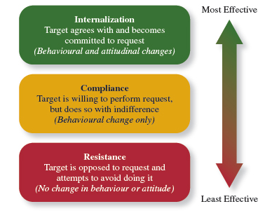
POWER AND INFLUENCE IN ACTION
Organizational politics: individual actions directed towards a goal
Political skill: the ability to understand others and the use of that knowledge to influence them to further personal or organizational objectives
- How to navigate…
  - Social astuteness
  - Interpersonal influence
  - Networking
  - Apparent sincerity
- An important part of getting necessary resources and completing projects
- Power is used for…
  - Navigating the political environment
  - Resolving conflicts
  - Negotiations
THE CAUSES AND CONSEQUENCES OF ORGANIZATIONAL POLITICS
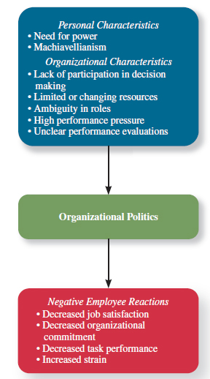
- Power can be used for organizational politics and conflict resolution

Conflict Resolution
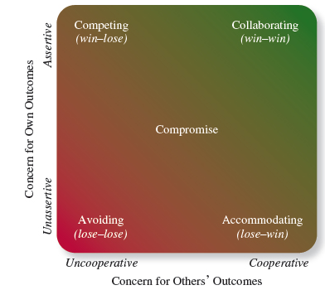
Competing: when one party attempts to get his or her own goals met without concern for others
- Use when immediate action is needed
- When you know you’re right
Avoiding: when one party wants to remain neutral, stay away from conflict, or postpone conflict to let things cool down
- When an issue is trivial
- When disruption outweighs resolution
- When others can resolve issues more effectively
Accommodating: when one party gives in to the other and acts in an unselfish way
- When you find you are wrong
- To build social credit
- To minimize loss when you are outmatched
Collaboration: when both parties work together to maximize outcomes
- When your objective is to learn
- To merge insights
Compromise: when conflict is resolved through give-and-take concessions
- When you have mutually exclusive goals
- To achieve temporary settlements to complex issues
- As a backup to collaboration
NEGOTIATIONS
Negotiation: a process in which two or more individual parties discuss and attempt to reach an agreement about their differences
BATNA: Best alternative to a negotiated agreement
Negotiation Strategies
Distributive bargaining: a strategy in which one person gains and the other person loses
Integrative bargaining: achieves an outcome that is beneficial for both parties
Negotiation Stages
- Preparation
- Exchanging information
- Bargaining
- Closing and commitment
Negotiator Biases
- Perceived power relationship
- Negotiator emotion
  - Emotion plays a huge role in negotiation
HOW IMPORTANT IS POWER?
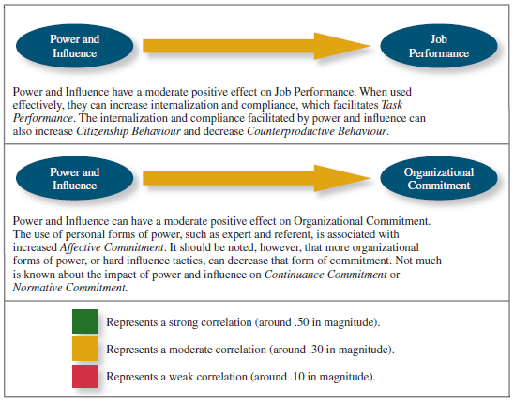

Chapter 13 – Leadership
STYLES AND BEHAVIOURS
Leadership: the use of power and influence to direct the activities of followers towards goal achievement
- Characterized by…
  - Traits
  - Decision-making styles
  - Behaviors
  - Effectiveness
Leader-member exchange theory: a theory describing how leader-member relationships develop over time on a dyadic basis
Role taking: the phase where a leader provides an employee with job expectations and the employee attempts to meet them
Role making: the phase where a follower voices his or her own expectations for the relationship, resulting in a free-flowing exchange of opportunities and resources for activities and effort
WHY ARE SOME LEADERS MORE EFFECTIVE THAN OTHERS?
Leader effectiveness: the degree to which a leader’s actions result in goal achievement, continued employee commitment, and strong leader-member relationships
Leader emergence: the process of becoming a leader in the first place
LEADER DECISION-MAKING STYLES
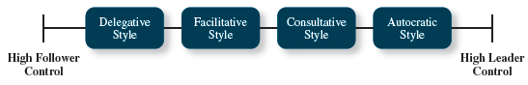
Autocratic: a style in which the leader makes decisions alone without asking for opinions or suggestions
- Appropriate when decisions are not significant
- When employee commitment is less important
- When leader has more expertise
Consultative: a style in which the leader presents the problem to employees asking for their opinions and suggestions before ultimately making the decision themselves
Facilitative: a style in which the leader presents the problem to employees and looks for a consensus (focused on equal weight of all opinions)

Delegative: a style in which the leader gives the employee responsibility for making decisions within some boundary
- When decisions are more important
- Employee commitment is more important
- When employees work well as a team
MANAGING DECISION-MAKING STYLES
Time-driven model of leadership: a model that displays what style is best when (has 7 factors)
- Decision significance
- Importance of commitment
- Leader expertise
- Likelihood of commitment
- Shared objectives
- Employee expertise
- Teamwork skills
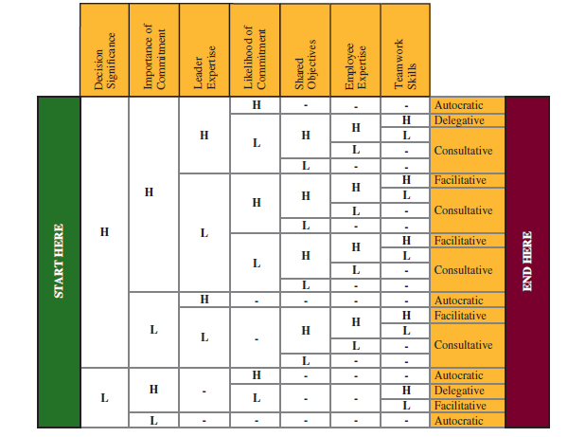

DAY-TO-DAY LEADERSHIP BEHAVIOURS
Initiating structure: a pattern of behavior in which the leader defines and structures the roles of he employees in pursuit of goal achievement
- Directive
- Task-oriented
Consideration: a pattern of behaviour in which the leader creates job relationships characterized by mutual trust, respect, and consideration of employee feelings
- Show support
- Relations-oriented
Life cycle theory of leadership: states that the optimal combination initiating structure and consideration depends on the readiness of the employees work unit
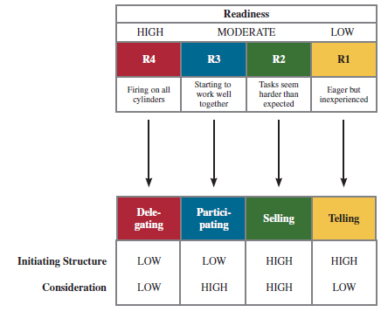
Readiness: the degree to which employees have the ability and the willingness to accomplish specific tasks
TRANSFORMATIONAL LEADERSHIP BEHAVIORS
Transformational leadership: behavior that inspires followers to commit to a shared vision that provides meaning to work, and helps followers develop their potential (4 types)
- Idealized influence
  - Highly moral
- Inspirational motivation
  - Champions collective goals/vision
- Intellectual stimulation
  - Challenges others to innovate
- Individualization consideration
  - Helps individuals grow/develop
Transactional leadership: when the leader rewards or disciplines based on performance (4 types)
- Contingent reward and punishment
  - Most effective
  - Uses rewards and punishment to guide behavior

- Management by exception (active)
  - Sometime necessary
  - When there is constant involvement
- Management by exception (passive)
  - Not good
  - Involvement after an issue arises
- Laissez-Faire
  - Not good
  - Hands-off approach
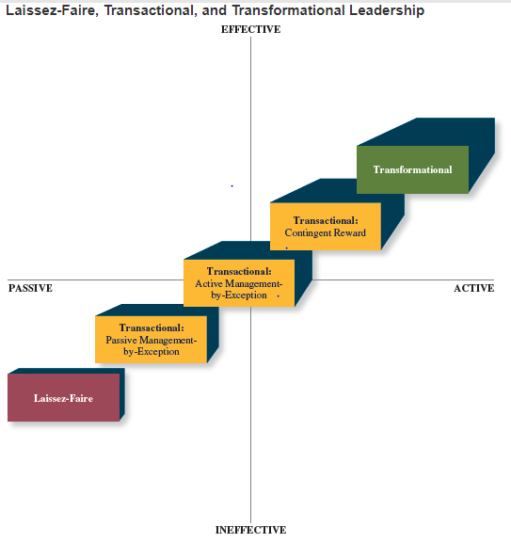
- Transformational leadership are more effective when employees are highly insecure
- Transactional leadership is more effective when employees need recognition
WHY ARE SOME LEADERS MORE EFFECTIVE?
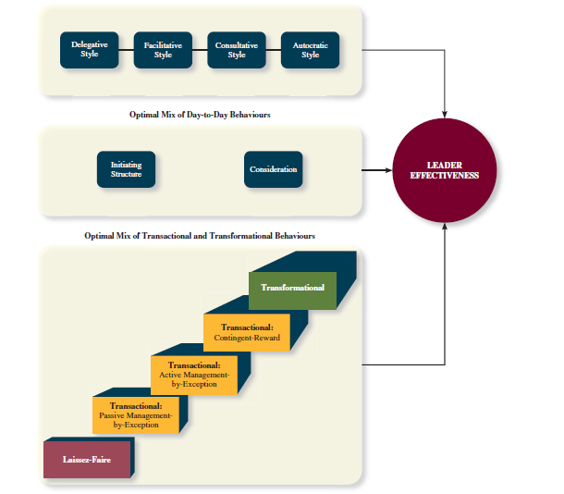
HOW IMPORTANT IS TRANSFORMATIONAL LEADERSHIP?


