Assignment 4 : Graphics
Cyriac George

The Alcatel-Lucent 7750 Service Router (SR) is a high-performance, multiservice edge router designed for the concurrent delivery of advanced residential, business and mobile services on a common IP edge platform. (See Figure 1).

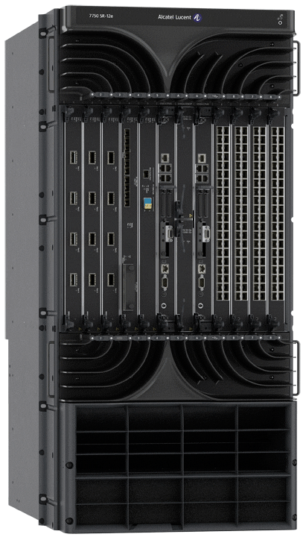

Figure 1: Alcatel-Lucent Service Router 7750 [1]

References

[1] | "www.alcatel-lucent.com," Alcatel-Lucent, [Online]. Available: http://www.alcatel-lucent.com/products/7750-service-router. [Accessed 14 october 2014].

