ECONOMICS: MIDTERM NUMBER 1

AGGREGATE DEMAND (AD): TOTAL SPENDING ON G&S
- THE FORMULA GDP= C+I+G+NX
GDP HAD FOUR COMPONENTS:
- MARKET VALUE
- OF FINAL G&S
- PRODUCED WITHIN A COUNTRY
- IN A GIVEN PERIOD OF TIME
CONSUMER’S EXPENDITURE ON G&S:
- ALSO KNOWN AS CONSUMPTION, THIS INCLUDES DEMAND FOR DURABLES E.G. AUDIO-VISUAL EQUIPMENT AND VEHICLES & NON-DURABLE GOODS SUCH AS FOOD AND DRINKS WHICH ARE CONSUMED AND MUST BE RE-PURCHASED
INVESTMENT (CAPITAL): SPENDING ON CAPITAL G&S
- SUCH AS PLANT AND EQUIPMENT AND NEW BUILDINGS TO PRODUCE MORE CONSUMER GOODS IN THE FUTURE. INVESTMNT INCLUDES SPENDING ON WORKING CAPITAL SUCH AS STOCKS OF FINISHED AND SEMI-FINISHED GOODS
- SMALL PART OF INVESTMENT SPENDING IS THE CHANGE IN THE VALUE OF STOCKS. PRODUCERS MAY FIND EITHER THAT DEMAND IS RUNNING HIGHER THAN OUTPUT (IE STOCKS FALL) OR THAT DEMAND IS WEAKER THAN EXPECTED AND BELOW CURRENT OUTPUT (IE STOCKS RISE)
GOVERNMENT SPENDING: SPENDING ON STATE PROVIDED G&S
- INCLUDES PUBLIC GOODS AND MERIT GOODS
- DECISIONS ON HOW MUCH THE GOVT WILL SPEND EACH YEAR ARE AFFECTED BY DEVELOPMENTS IN THE ECONOMY AND THE POLITICAL PRIORITIES OF THE GOVERNMENT
XPORTS OF G&S: EXPERTS SOLD OVERSEAS ARE AN INFLOW OF DEMAND (AN INJECTION) INTO OUR CIRCULAR FLOW OF INCOME AND SPENDING ADDING TO AGGREGATE DEMAND
MPORTS OF G&S: IMPORTS ARE WITHDRAWAL OF DEMAND (A LEAKAGE) FROM THE CIRCULAR FLOW OF INCOME AND SPENDING

PRIMARY MARKETS FOR MACROECONOMICS
- OUTPUT MARKETS FOR G&S
- PART OF THE REAL ECONOMY
  - CONSISTS OF CONCRETE, TANGIBLE G&S
- Q IS GDP
  - GROSS DOMESTIC PRODUCT, THE $VALUE OF ALL FINAL GOODS AND SERVICES PRODUCED OVER A GIVEN INTERVAL
- P IS THE COMPOSITE PRICE LEVEL
  - INFLATE RATE MEASURE THE CHANGE IN THEP RICE LEVEL OVER TIME
- MONEY MARKETS
- Q IS THE QUANTITY OF MONEY CIRCULATING IN THE MACROECONOMY
  - INCLUDES CURRENCY, DEPOSITS, AND CREDIT
- P IS INFLATION RATE AND THE FOREIGN EXCHNAGE RATE
- NOT PART OF THE REAL ECONOMY
  - MONEY IS JUST A MEDIUM OF EXCHANGE
    - A MEANS TO THE END OF PRODUCING AND CONSUMIMING REAL GOODS AN SERVICES

- EMPLOYMENT MARKETS
- ALSO PART OG THE REAL ECONOMY
- Q IS EMPLOYMENT
  - UNEMPLOYMENT RATE IS ONE MEASURE OF EMPLOYMENT CONDITIONS
- P IS THE WAGE LEVEL
  - WAGE INFLATION RATE MEASURES THE CHANGE IN THE WAGE LEVEL OVER TIME

A GROWTH RATE= CHANGE IN THE LEVEL/LEVEL
- ALWAYS EXPRESSED AS A %
- A RATIO QUANTITY = LEVEL/ LEVEL (UNITS ARE CRUCIAL)
- REAL GDP GROWTH OVER TIME IS USED AS AN INDICATOR OF ECONOMIC ACTIVITY
REAL GDP GROWTH OVER TIME IS USED AS AN INDICATOR OF ECONOMIC ACTIVITY
- WHEN GROWTH IS NEGATIVE, THE ECONOMY IS SHRINKING- RECESSION
- WHEN GDP GROWTH EXEEDS 2% UNEMPLOYMENT SHOULD FALL, OTHERWISE IT WILL RISE
-REAL GDP LEVELS ARE A MEASURE OF ECONOMIC WELL-BEING, OR LIVING STANDARDS
-CURRENTLY ECONOMY IS OPERATING AT ABOUT 3% BELOW ITS ESTIMATED CAPACITY

THE MONEY MARKET
- THE P VARIABLES ARE THE INTEREST RATE AND THE EXCHANGE RATE FOR THE DOLLAR
  - BANK OF CANADA TARGET RATE = 1.0%
  - LAST YEAR AT THIS TIME IS WAS 0.5%
- PRIME RATE= 3.3%
  - IN 2007 IT WAS 6%
  - IN 1980 IT WAS GREATER THAN 20%
WHY ARE INTEREST RATES AND EXCHANGE RATES SO VOLATILE?
- CURRENT INTEREST RATES ARE LOW BY HISTORICAL STANDARDS

FOR INTEREST RATES, IT IS SUPPLY AND DEMAND FOR LAONABLE FUNDS, ESPECIALLY THE FORMER
- UNCERTAINTY CAUSES SUPPLY TO FALL, PUSHING UP THE INTEREST RATE
  - SUBPRIME MORTGAGE CRISIS IN USA CAUSED WORLD CREDIT MARKETS TO FREEZE
  - EURO CRISIS HAS THE POTENTIAL TO DO THE SAME
- BETWEEN LATE 2008 AND 2016, CENTRAL BANKS HAVE BEEN EXPANDING THE SUPPLY OF MONEY LIKE NEVER BEFORE
  - QUANTATIVE EASING POLICY
FOR EXCHANGE RATES, IT IS SUPPLY AND DEMAND FOR THE CANADIAN $, ESPECIALLY THE LATTER
- DURING THE PERIOD OF WEAKNESS, LOW DEMAND RELATIVE
  - WE ARE PERCEIVED AS A RESOURCE INTENSIVE ECONOMY, AND MOST OF THOSE MARKETS ARE WEAK
CHAPTER SEVEN: MEASURING THE WEALTH OF NATIONS
THE CIRCULAR FLOW MODEL
- GIVES THE STRUCTURE, OR THE SKELETON, OF THE MACROECONOMY
- A FLOW QUANTITY IS AN AMOUNT PER UNIT OF TIME, LIKE A CURRENT OF WATER PASSING THROUGH
- A STOCK IS AN AMOUNT OBSERVED AT A POINT IN TIME, LIKE THE VOLUME OF WATER IN A TANK
  - THINK OF A SNAPSHOT
  - NO TIME FRAME
- VALUE OF STOCK AT A TIME
  - = VALUE OF STOCK AT TIME T-1 VALUE OF INFLOW – VALUE OF OUTFLOW
    - LEAKAGES AND INJECTIONS ARE BOTH FLOW QUANTITIES
WHAT IS IT?
- HOUSEHOLDS BUY GOODS AND SERVICES FROM FIRMS; THESE EXEPENDITURES FLOW THROUGH THE MARKETS FOR G&S. THE FIRMS IN TURN USE THE MONEY THEY RECEIVE FROM SALES TO PAY WORKERS’ WAGES, LANDOWNERS’ RENT, AND FIRM OWNERS’ PROFIT; THIS INCOME FLOWS THROUGH THE MARKETS FOR THE FACTORS OF PRODUCTION. IN THIS ECONOMY, MONEY FLOWS FROM HOUSEHOLDS TO FIRMS AND THEN BACK TO HOUSEHOLDS.
NOT INCLUDED IN GDP:
UNDERGROUND WORK – THINGS MADE/GROWN AT HOME – MARRIED CPLS N SERVICES @ HOME – USED ITEMS – INTERMEDIATE GOODS
INTERMEDIATE GOODS: NOT INCLUDED – THINGS THAT GO INTO PRODUCTION OF ANOTHER ITEM
FINAL GOOD: THE FINISH PRODUCT THAT’S INCLUDED IN THE MARKETS GDP

*SEASONAL CYCLE (DECEMBER SHOPPING) IS ADJUSTED FOR IN GDP COUNT
- AVOID COUNTING INTERMEDIATE GOODS IN ORDER TO AVOID DOUBLE COUNTING

GDP VS GNP
GDP: DOMESTIC= VALUE OF EVERYTHING THAT HAPPENS WITHIN THE COUNTRY ECONOMICALLY
GNP: FLAGS= VALUE OF ALL ECONOMIC ACTIVITY W THE SAME FLAG WHEREVER THEY ARE

NET EXPORTS = EXPORTS – IMPORTS
(IF EXPORTS ARE HIGHER THAN IMPORTS, NX BE + IF IMPORTS ARE HIGHER THAN EXPORTS, NX BE -)

EXPENDITURE= C + I + G + NX = PRODUCTION
INCOME APPROACH= WAGES + INTEREST + RENTAL INCOME + PROFITS

: based on current prices
REAL
NOMINAL

: adjusted for inflation/ calculated with constant prices

THE GDP DEFLATOR

NOMINAL GDP
REAL GDP

100
GROWTH RATE CALCULATION
%CHANGE IN REAL GDP

(%CHANGE = ENDING – BEGINNING
X 100
BEGINNING

GDP PER CAPITA FLAWS:
- AVERAGE INCOME- DOESN’T MENTION HOW INCOME IS DISTRIBUTED
- DOESN’T TELL US $ WORTH (WHAT YOU CAN BUY WITH THAT MONEY IN A COUNTRY)

GRAY ECONOMY: STUFF NOT RE8PORTED TO CANADIAN REVENUE
GREEN GDP: POSITIVE OUTPUTS USUALLY IN GDP – ENVIROMENTAL COST OF PRODUCTION

CHAPTER EIGHT: THE COST OF LIVING

A MARKET BASKET: A SHOPPING LIST OF THINGS THE AVG. PPL BUY
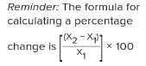
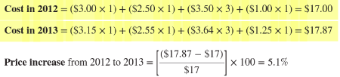
A MARKET BASKET

(^ THE BASKET APPROACH)

CONSUMER PRICE INDEX: HOW MUCH THE BASKET HAS RISEN OR FALLEN RELATIVE TO A BASE PERIOD (LOCATION OR TIME)

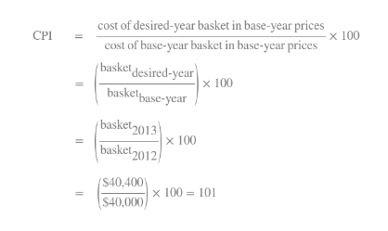

WHICH GOODS GO INTO THE BASKET?
- URBAN CUSTOMERS (POP. 100 000 PPL OR MORE)
SUBSTITUTION: CONSUMERS CAN SWITCH BETWEEN SIMILAR GOODS OFFERED
INNOVATION: WHEN NEW GOODS AND SERVICES ARE OFFERED TO CONSUMERS

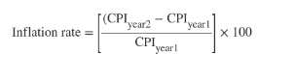

ALL ITEMS INFLATION: MEASURES ALL ITEMS IN THE BASKET FOR INFLATION (MEASURED USING CPI)
CORE INFLATION: MEASURES EIGHT MOST IMPORTANT ITEMS IN THE BASKET (FOOD &ENERGY)

PPI: LIKE THE CPI BUT CONTAINS ITEMS IN BASKET THAT DIFFER FROM THE AVG. PERSON (MACHINE)
DEFLATING NOMINAL VALUES

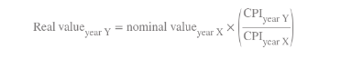

INDEXING: PENSION PLANS FOR EXAMPLE- 2% PER YEAR TO ADJUST FOR INFLATION

C O L A: COST OF LIVING ADJUSTMENT

PURCHASING POWER PAIRITY: WHY NOT TRAVEL ELSEWHERE TO BUY AN ITEM FOR LESS $?
- TRANSPORTATION COSTS
- NON TRADABLES
- TRADE RESTRICTIONS

CHAPTER NINE: ECONOMIC GROWTH

REAL GDP PER CAPITA GROWTH RATE= NOMINAL GDP GROWTH RATE- INFLATION- POP. GROWTH RATE

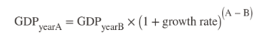

((((((NEED HELP ^))))))))
THE RULE OF SEVEN: A SHORT CUT TO THAT ^
- THE NUMER OF YEARS IT WILL TAKE FOR INCOME TO DOUBLE AT THE CURRENT REAL GROWTH RATE IS APPROX. EQUAL TO 70 DIVIDED BY THE GROWTH RATE

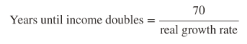

PRODUCTIVITY DRIVES GROWTH
- OUTPUT PER WORKER = PRODUCTIVITY
- STANDARD OF LIVING IN A COUNTRY IS DRIVEN BY AVERAGE PRODUCTIVITY OF ITS PPL
- INCREASES IN PRODUCTIVITY PER PERSON LEAD TO INCREASE IN PER CAPITA INCOME

PHYSICAL CAPITAL: THINGS THAT AID IN THE EFFICIENCY OF PRODUCTION (MACHINES)
- HOUSEHOLD SAVINGS ACCOUNT FOR THE ABILITY TO PURCHASE SUCH GOODS
HUMAN CAPITAL: SKILLS KNOWLEDGE AND ABILITY THAT AIDS IN PRODUCTION (EDUCATION)
- LOW GDP IS OFTENTIMES CAUSED BY LOW SCHOOLING
TECHNOLOGY: ADVANCEMENTS IN A FIELD THAT WILL MAKE PRODUCTION MORE EFFICIENT
NATURAL RESOURCES: THINGS THAT ARE OFFERED IN A CERTAIN GEOGRAPHIC LOCATION
- EITHER RENEWABLE OR NONRENEWABLE

©ONVERGANCE THEORY: (THE CATCH-UP EFFECT)
- POOR COUNTRIES WILL GROW FASTER THAN RICH ONES UNTIL THEY CATCH UP AND THEN CONVERGE
INVESTMENT TRADE OFF: A REDUCTION IN CURRENT CONSUMPTION TO PAY FOR THE INVESTMENT IN CAPITAL INTENDED TO INCREASE FUTURE PRODUCTION

DOMESTIC SAVINGS
DOMESTIC INCOME – CONSUMPTION SPENDING

FOREIGN DIRECT INVESTMENT: RUNS PARTIAL OPERATIONS ABROAD OR INVESTS ABROAD
- BUILDS CAPITAL STOCK WHEN DOMESTIC FUNDS RUN SHORT
- FOREIGN COMPANIES CAN TRANSFER HUMAN CAPITAL
- COMPETING GOVTS TO GET THE INVESTMENT OF THE FOREIGNER
- DEMAND SPECIAL BENEFITS LIKE TAX BREAKS AND EXCEMTIONS

CHAPTER 10: UNEMPLOYMENT AND THE DEMAND FOR LABOUR
UNEMPLOYMENT:
- WANTS TO WORK BUT CANNOT FIND A JOB
- THEY WEREN’T WORKING AT ALL PRIOR TO THE WEEK IN Q
- THEY WERE ABLE TO WORK HAD THEY BEEN OFFERED A JOB
- THEY WERE MAKING EFFORTS TO LOOK FOR A JOB
LABOUR FORCE:
- WORKING AGE POP. EITHER EMPLOYED OR UNEMPLOYED

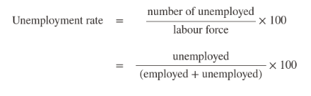

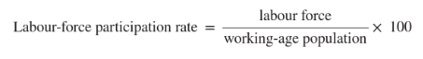

^THIS FIGURE SHOWS US THE FRACTION WANTING TO WORK WHETHER THEY HAVE A JOB OR NOT

DISCOURAGED WORKERS: THOSE WHO HAVE LOOKED FOR WORK IN THE PAST YR BUT GAVE UP
UNDEREMPLOYED: PART TIME WORKERS SEEKIGN FULL TIME POSITIONS

NATURAL RATE OF UNEMPLOYMENT: AN ECONOMY WILL NEVER HAVE AN UNEMPLOYMENT OF 0
CONTRIBUTORS TO THIS:
- FRICTIONAL UNEMPLOYMENT- CAUSED BY PPL WHO MOVE OR CAREERS
- STRUCTURAL UNEMPLOYMENT: MISMATCH BETWEEN SKILLS OFFERED N THOSE NEEDED
- REAL WAGE OR CLASSICAL UNEMPLOYMENT: WAGES OVER MARKET CLEARING LEVEL
CYCLICAL UNEMPLOYMENT: CAUSED BY SHORT TERM ECONOMIC FLUCTUATIONS

EFFICIENCY WAGE: WE PAY YOU MORE SO YOU WORK HARDER AND APPRECIATE US MORE

NOTES FROM MUSINGS

CHAPTER SEVEN
You should know which flows are the injections and which flows are the leakages.

GDP = C + I + G + X - Im. Import expenditures are entered with a negative sign because those imported goods and services are already included in C.

aggregate income = wages + interest + rental income + profits + indirect taxes + depreciation charge

real GDP = (nominal GDP / deflator) * 100

The growth rate of real GDP over a given time period = (the CHANGE in the LEVEL of real GDP over this time period) / the LEVEL of real GDP during the earlier period.

CHAPTER EIGHT
I mentioned how my former employer, Giant Eagle supermarkets, would determine how many hours of labour to schedule for a given month based on the projected sales volume in physical terms, which means the number of kilos of food sold (perhaps they would also consider the # of customers served, which is also a real quantity). Since sales were measured in terms of nominal dollars, it was appropriate for them to deflate rising sales levels by the component that was attributable only to rising prices. If they have correctly measured the rise in prices, the residual reflects only changes in volume. The amount of labour that they hire should depend on that. They should have used a deflator based on a market basket of lunch meat and cheese items because I worked in the delicatessen department. Whether they correctly ascertained changes in the volume of sales, which is what they claimed to be doing, I do not know. I do know that my hours were cut.

WHAT IS PPP ADJUSTMENT USED FOR?

i) encouraging saving and investment, ii) encouraging investment of capital from abroad, iii) improving the quality of education, training, and health, iv) enforcing property rights and ensuring political stability, v) promoting free trade (they label this point 'economic openness', and vi) encouraging research and development (R & D).

NAME 3-4 POLICY MEASURES THAT ARE SAID TO BOOST PRODUCTIVITY

CHAPTER 11: AGGREGATE DEMAND AND AGGREGATE SUPPLY

ASSET PRICE BUBBLE: PEOPLE BUY ASSESTS FOR NO OTHER REASON THAN THEY THINK THE PRICE WILL ^

AGGREGATE SUPPLY AND AGGREGATE DEMAND SHOW HOW
- OUTPUT
- PRICES
- EMPLOYMENT
ARE TIED TOGETHER AS PART OF A SINGLE ECOOMIC EQUILIBRIUM

THE AGGREGATE DEMAND CURVE:
- SHOWS THE RELATIONSHIP BETWEEN THE OVERALL PRICE LEVEL AND THE LEVEL OF TOTAL DEMAND IN THE ECONOMY
CONSUMPTION:
- THUS, INCREASES IN IN THE OVERALL PRICE LEVEL REDUCE PEOPLE’S WEALTH IN TERMS OF REAL PURCHASING POWER
- WHEN PPL ARE LESS WEALTHY, THEY SPEND LESS WHICH CREATES A NEGATIVE RELATIONSHIP BETWEEN OVERALL PRICE LEVEL AND CONSUMPTION SPENDING
- ^THE WEALTH EFFECT
- IF WAGES ROSE THE EXACT SAME AS PRICES THAN THE RELATIONSHIP WILL REMAIN THE SAME
INVESTMENT:
- WHEN PRICES RISE, TYPICALLY, SO DOES THE COST OF BORROWING
- THEREFORE COMPANIES WANT TO INVEST LESS IN PHYSICAL CAPITAL
- INCREASED BORROWING CREATE AN INDIRECT NEGATIVE RELATIONSHIP BETWEEN PRIE LEVEL AND INVESTMENT SPENDING
GOVT SPENDING:
- DOES NOT CONTRIBUTE TO DOWNWARD SOPING DEMAND AS GOVT CANT RLLY CHANGE WHAT THEY SPEND
NET EXPORTS:
- WHEN PRICE LEVELS INCREASE, NET EXPORTS SHOULD DECREASE BCOZ WHEN PRICES HERE GO UP IT IS OFTENTIMES CHEAPER TO BUY IMPORTED GOODS

SHIFTING THE AGGREGATE DEMAND
-PRICE CHANGES SHIFT ALONG DEMAND
-THE ENTIRE CURVE CAN SHIFT IN RESPONSE TO NON PRICE CHANGES IN ANY 4 AG COMPONENTS
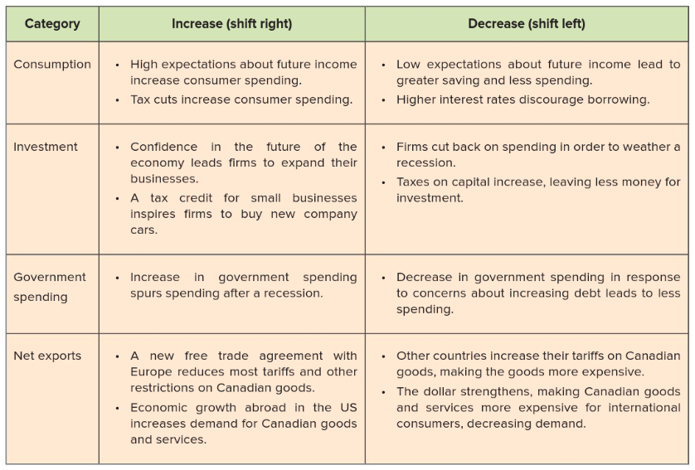

THE AGGREGATE SUPPLY CURVE:
- TECHNOLOGY, CAPITAL AND LABOUR
- SHOWS THE RELATIONSHIP BETWEEN THE OVERALL PRICE LEVEL IN THE ECONOMY AND TOTAL PRODUCTION BY FIRMS
DIFFERENCE BETWEEN THE SHORT RUN AND LONG RUN AS

SHORT RUN:
- HOURLY, DAILY, WEEKLY DECISIONS FIRMS HAVE TO MAKE
- SLOPES UPWARDS BCOZ AS OVERALL PRICE LEVELS INCREASE, FIRMS ARE WILLING TO PRODUCE MORE
- WHY? BCOZ PRICES OF FINAL GOODS TEND TO INCREASE QUICKR THAN INPUTS
- STICKY PRICES: PRICES THAT ADGUS SLOWLY TO IN RESPONSE TO CHANGES IN THE ECONOMY
- WAGES ARE A GOOD EXAMPLE OF STICKY
- WAGES ARE ONLY CHANGED ANNUALLY
LONG RUN:
- HOWEVER LONG IT TAKES TO ADGUST THINGS
- LONG RUN AGGREGATE SUPPLY REPRESENTS POTENTIAL OUTPUT
- CHANGED IN THE LRAS ARE CAUSED BY CHANGES IN THE WAY SOCITY’S RESOURCES CREATE OUTPUT

BUSINESS CYCLE: WHETHER MORE OR LESS OUTPUT IS PRODUCED
- IN THE SHORT RUN, PRODUCTION CAN BE EXPANDED AS BEYOND LONG-RUN POTENTIAL BY PRESSING ALL OF THE FACTORS OF PRODUCTION BEYOND THEIR NORMAL CAPACITY
- WHEN FIRM IS OVER CAPACOTY PRICES WILL BE DRIVEN UPWARD
SHIFTS IN THE SRAS:
- IF COST OF PRODUCTION (INPUTS) GOES UP
- SUPPLY SHOCKS: EVENTS THAT DIRECTLY AFFECT PRODUCTION
- EX. FIRMS ANTICIPATING PRICES TO GO UP
SHIFTS IN THE LRAS:
- ANYTHING THAT AFFECTS PRODUCTION
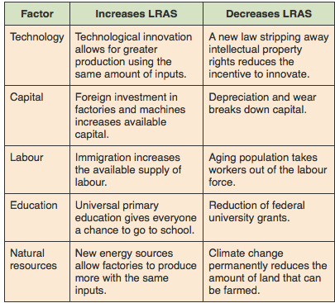

*EVERYTHING THAT SHIFTS LRAS WILL SHIFT SRAS
-BCOZ TECHNOLOGY AND SUCH SPREAD SHORT RUN SUPPLY
*EXPECTED CHANGES ONLY AFFECT SRAS AND NOT LRAS
-EXPECTED PRICES ONLY AFFECT THE SHIFT IN THE SHORT RUN

ECONOMIC FLUCTUATIONS:
youtube video

- LONG RUN EQUILLIBRIUM IS DETERMINED BY PRODUCTIVE FACTORS
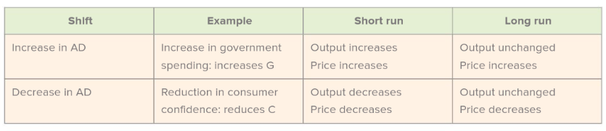

STAGFLATION
-OUTPUT DECREASES WHILE PRICES INCREASE
SUPPLY AND DEMAND SHOCKS:
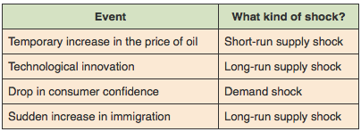
DEMAND SIDE SHOCKS WILL CAUSE A CHANGE TO THE PRICE LEVEL IN THE LONG RUN, SINCE THE SHORT RUN SUPPLY CURVE WILL SHIFT IN TO RESTORE THE LONG RUN EQUILIBRIUM OUTPUT. FOR A SUPPLY SIDE SHOCK, THERE ARE NO LONG RUN CHANGES TO THE PRICE LEVEL. IF THE SHORT RUN SUPPLY CURVE INITIALLY SHIFTS TO THE EFT, FOR EXAMPLE, PRICES WILL ADJUST TO RESTORE THE LONG RUN EQUILIBRIUM.
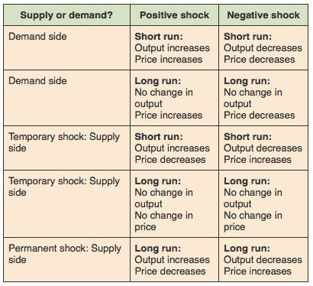

CHAPTER 12: FISCAL POLICY
PUBLIC SPENDING + TAXATION IS FISCAL POLICY
FISCAL POLICY EFFECTS AGGREGATE DEMAND IN TWO CHANNELS
- GOVERNMENT SPENDING (G IN EQUATION) *ALSO INDIRECT THROUGH C AND I
- TAX POLICY (C IN AGGREGATE DEMAND) *ALSO INDIRECT EFFECT I
EXPANSIONARY FISCAL POLICY: SHIFTS DEMAND TO THE RIGHT AS THEY LOWER TAXES + ^ GOVT SPEND
CONTRACTIONARY FISCAL POLICY: SHIFT DEMAND LEFT AS DOWN GOVT SPENDING +HIGH TAXES
(KEYNASION) SPENDING MORE OR TAXING LESS- NAMED AFERJOHN MAYNARD KEYNES
KEYNASION: EXPANSIONARY WHER GOVT SPENDS MOR N TAXES LESS

LAGS INPOLICY MAKING PROCESS: 3 MAIN SOURCES

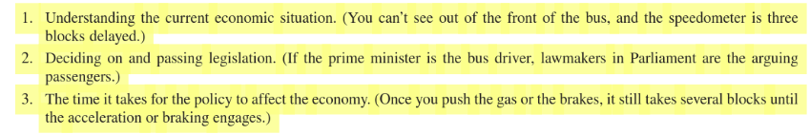

- INFORMATION: COULD TAKE TIME TO GET INFO (STATS, GDP EVERY 3 MNTHS- TAKES TIME FOR ACCURACY)
- FORMULATION: TIME IS TAKES TO PASS LEGISLATION: TAKES TIME FOR PARLIAMENT TO AGREE
- IMPLEMENTATION: TAKES TIME TO COME INTO EFFECT

AUTOMATIC STABALIZERS –REQUIRED TO PAY IN RELATION TO HOW MUCH YOU MAKE
DISCRETIONARY: CHANGING TAX RATES (AUTOMATIC HELP WHEN THESE TAKE TOO LONG)

WHEN ECONOMY IS HITS A RECESSION, FISCAL POLICY AUTOMATICALLY BECOMES EXPANSIONARY BCOZ TAXES GO DOWNN AND GOVT SPENDING ON WELFARE ^. IN BOOMING ECONOMY FISCAL POLICY AUTOMATICALLY BECOMES CONTRACTIONARY AS TAX REVENUES RISE AND WELFARE PAYMENTS FALL.

IN SUM....

RICCARDIAN EQUIVALENCE
IS WHEN THEY CU TAXES BECAUSE RECESSION BUT WILL THEN RAISE THEM, SO PEOPLE DON’T CHANG THEIR BEHAVIOUR WHEN TAXES ARE CUT

:MEASURES EFFECT OF GOVT SPENDING OR TAX CUTS ON INCOME
MULTIPLIER

MULTIPILLER EFFECT: THE RIPPLE OF BUYING ONE THING FROM SOMEONE AND THAT MONEY-MAKING OTHERS BUY STUFF
MARGINAL PROPENSITY TO CONSUME: AMOUNT WHICH CONSUMPTION INCREASES WHEN AFTER-TAX INCOME INCREASES

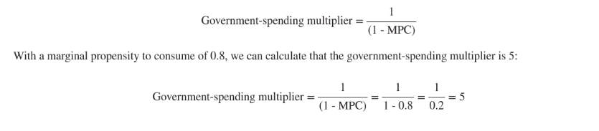

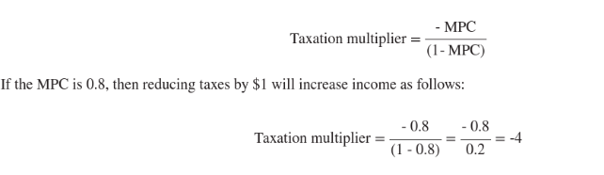

THE COST OF BORROWING & INTEREST RATE GO UP, FIRMS CHOOSE TO INVEST LESS- DECREASING GDP
CROWDING OUT

DEFICIT: AMOUNT GOVT SPENDS ABOVE THEIR REVENUE
SURPLUS: AMOUNT GOVT BRINGS IN BEYOND WHAT THEY SPEND

DIFFERENCE BETWEEN DEBT AND DEFICIT:
DEFICIT TELLS US HOW MUCH THE GOVT FALLS SHORT ON SPENDING EACH YEAR
DEBT IS TOTAL AMOUNT GOVT OWES (DEBT IS CUMULATIVE SUM OF DEFICITS N SURPLUSSES)
- BENEFITS TO GOVT DEBT
EMERGENCY RELIEF
PAY FOR INVESTMENTS THAT LEAD TO GROWTH

CHAPTER 13: THE BASICS OF FINANCE

FINANCIAL MARKET
A BANKS ASSISTANCE:
- INTERMEDIARY: BANK HAS WIDE RANGE OF PPL TO HELP U W UR BORROWING NEEDS
- LIQUIDITY: HAVING CASH EASILY AVAILABLE WHEN U WANT IT
- DIVERSIFY RISK: NO INDIVIDUAL WILL BEAR THE BURDEN OF THE ENTIRE FAILED INVESTMENT
(DIVERSIFICATION PROCESS WHERE RISKS ARE SHARED AMONGST MANY SO THE BURDEN DOESN’T FALL HEAVILY ON ONE PERSON)
INTERMEDIATE, PROVIDE LIQUIDITY, DIVERSIFY RISK

MARKET FOR LOANABLE FUNDS- WHERE SAVERS, WHO HAVE MONY TO LEND, SUPPLY FUNDS FOR THOSE WHO WANT TO BORROW FOR THEIR INVESTMENT &SPENDING NEEDS

LOANABLE FUNDS ARE THE $ THAT ARE AVAILABLE FOR BORROWING FROM THE SAVERS
SAVINGS VS INVESTMENTS
SAVINGS: PORTION OF INCOME THAT IS NOT IMMEDIATELY SPENT ON CONSUMPTION
INVESTMENTS: SPENDING ON PRODUCTIVE INPUTS SUCH AS MACHINERY, FACTORIS, ETC.
SUPPLY FOR LOANABLE FUNDS COMES FROM SAVINGS &DEMAND FOR LOANABLE FUNDS FROM INVESTMENT

UPWARD SLOWING MARKET FOR LOANABLE FUNDS SUPPLY CURVE BECAUSE:
- AMOUNT OF PPL WILLING TO SAVE INCREASES AS THE INTEREST RATE INCREASES
- IN THE MARKET- THE HIGHER THE PRICE, THE MORE PPL WILL FIND LENDING MORE PROFITABLE
- OPPORTUNITY COST OF SAVING, SAVING MEANS U CANT CONSUME MUCH RN

DOWNWARD SLOPING MARKET FOR LOANABLE FUNDS SUPPLY CURVE BECAUSE:
- COST OF BORROWING DECREASES AS THE INTEREST RATE DECREASES MAKING MORE OPPORTUNITY FOR PPL TO INVEST

IF THE BENEFIT OF BORROWING IS LOWER THAN THE COST OF BORROWING, THE INVESTOR WILL LOSE MONEY ON NET AFTER PAYING BACK THE LOAN

FACTORS THAT DRIVE THE SUPPLY AND SAVINGS BOTH OVER TIME AND ACROSS COUNTRIES:
CULTURE- SOCIAL WELFARE POLICIES- WEALTH-CURRENT ECONOMIC CONDITIONS- EXPECTATIONS ABOUT FUTURE ECONOMIIC CONDITIONS

“WHEN GOVT BORROW MORE IT CAN CROWD OUT PRIVATE INVESTMENT”

CROWDING OUT:
REDUCTION IN PRIVATE BORROWING THAT IS CAUSED BY AN INCREASE IN GOVT BORROWING.
WHEN COST OF BORROWING GOES UP, THE DESIRE TO BORROW GOES DOWN.

TERMS AND SUCH
EQUITY
- OWNING A PART OF A COMPANY IN SHARES
STOCKS
- FINANCIAL ASSET THAT REPRESENTS PARTIAL OWNERSHIP
DIVIDEND
- PAYMENT MADE PERIDOICALLY, TYPICALLY ANNUALLY OR QUARTERLY 2 ALL SHAREHOLDERS
DEBT
- ALT TO EQUITY
LOAN
- BORROWER GETS MONEY FROM LENDER WITH A PROMISE TO REPAY
BOND
- TO MAKE A LOAN MORE LIQUID
- PROMISE BY THE BOND ISSUER TO REPAY THE LOAN AT SET DATES AND EXPECTED TO BE PAID IN VARIABLE OR FIXED INTEREST RATES
DERIVATIVES
- ASSET WHOSE VALUE IS BASED ON THE VALUE OF ANOTHER ASSET, SUCH AS A HOME LOAN, STOCK, BOND OR BARREL OF OIL
- FUTURES CONTRACT IS AN EXAMPLE OF THIS, BUYER AGREES TO PAY THE SELLER BASED ON THE FUTURE PRICE OF SOME ASSET
- DERIVATIVES ARE MEANT TO TRANSFER RISK TO PPL WHO ARE MORE WILLING TO BEAR IT

TYPES OF PENSION FUNDS
- DEFINED BENEFIT PLANS GUARANTEE A FIXED PAYOUT TO EMPLOYEES WHO HAVE MET CERTAIN ENTRY REQUIREMENTS, SUCH AS WORKING A CERTAIN AMOUNT OF YEARS
- DEFINED CONTRIBUTION PLANS DO NOT GUARANTEE RETIREES A DEFINED LEVEL OF PENSION. EMPLOYEES PAY IN A CERTAIN AMOUNT EACH YEAR AND THEIR EMPLOYERS MAY MATCH SOME PORTION OF THAT CONTRIBUTION
MUTUAL FUNDS- MANY INDIVIDUALS POOL MONEY TOGETHER TO BUY THINGS THAT WILL MAKE $
MARKET RISK (SYSTEMATIC RISK)
- ANY RISK THAT IS BROADLY SHARED BY THE ENIRE MARKET OR ECONOMY
IDIOSYNCRATIC RISKS
- RISK THAT A PARTICULAR COMPANY WILL MAKE A BAD DECISION THAT CAUSES A FALL

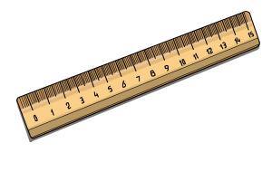
MEASURING RISKS: STANDARD DEVIATION (CHECHKING OUT HOW IT’S DONE IN THE PAST

PREDICTING RETURNS:
- (FIRST) GUESS HOW MUCH PROFIT A COMPANY WILL MAKE IN THE FUURE AND USE THAT AS A BASIS FOR CALCULATING HOW MUCH THE COMPANY IS WORTH NOW
- USE INTEREST RATES TO TRANSLATE BETWEEN THE PRESENT VALUE AND FUTURE VALUE OF MONEY
- IF U PREDICT THE FUTURE VALUES OF COMPANY U CAN TRANSLATE IT INTO THE COMPANYS NET PRESENT VALUE
  - NPV IS A MEASURE OF THE CURRENT VALUE OF A STREAM OF CASH FLOWS EXCEPED IN THE FUTURE
- DONE THROUGH FUNDAMENTAL ANALYSIS: EXTENSIVE RESEARCH DONE ON A COMPANY
- (SECOND) TECHNICAL ANALYSIS ANALYZES PAST MOVEMENTS OF STOCKS PRICE TO TRY N PREDICT FUTURE MOVEMENTS
- EFFIFCIENT MARKEY HYPOTHESIS (EENIE MEENIE MINE MOH)

THE SAVINGS – INVESTMENT IDENTITY

INCOME = CONSUMPTION + SAVINGS
- IN THIS SIMPLE ECONOMY, ALL SAVINGS ARE PRIVATE SAVINGS

CONSUMPTION + INVESTMENT = INCOME

CONSUMPTION + SAVINGS = INCOME = CONSUMPTION + INVSTMENT
OR
SAVINGS = INVESTMENT

PUBLIC SAVINGS, PRIVATE SAVINGS &CAPITAL FLOW

PUBLIC SAVINGS = TAXES –GOVT SPENDING
- + PUBLIC SAVINGS TO PRIVATE SAVINGS WE GET NATIONAL SAVINGS

INCOME = CONSUMPTION + PRIVATE SAVINGS

CONSUMPTION + INVESTMENT + GOVT SPENDING = INCOME

IN. = CONS. + PRIV. SAVINGS + TAXES = CONS. + IN. + GOVT SPENDING

PRIVATE SAVINGS + TAXES – INVESTMENTS + GOVT SPENDING

INVESTMENT = PRIVATE SAVINGS + PUBLIC SAVINGS

INVESMENT = NATIONAL SAVINGS

^ ONLY HOLDS IN A CLOSED ECONOMY- NO INTERACTION WITH OTHER COUNTRIES

- DIFFERENCE BETWEEN OUTFLOW (MONEY INVESTED IN OUR COUNTRY TO FINANCE DOMESTIC INVEST MENTS) AND IFLOW (MONEY SAVED DOMESTICALLY INVESTED IN ANOTHER COUNTRY) IS NET CAPITAL FLOW
- NET CAPITAL INFLOW OCCURS WHEN COUNTRIES INVESTMENT IS HIGHER THAN NAT. SAVINGS
- NET CAPITAL OUTFLOW WHEN COUNTRIES NAT. SAVINGS IS HIGHER THAN DOM. INVESTMENT
REVIEW W DAVEY BABY

WHAT WILL GOVT DO TO FIX THIS? EXPANSONARY FISCAL POLICY
- GOVT SPENDING (LEFT WING)
- TAX CUT (RIGHT WING)
- THIS WILL CAUSE AD TO EXPAND
- IF PRICE LEVEL IS HIGH LOW OR MEDIUM- THERE IS GREATER SPENDING PRESSURE
- GREATER SPENDING WILL PUT UPWARD PRESSURE ON PRICES

LR EQUIL
AD’
RECESSIONARY CONDITIONS
NEGATIVE OUTPUT GAP
SR EQUIL
LRAS
AD
SRAS
P
GDP

ALTERNATIVE TO ALL OF THAT ^
- LAISSEZ FAIRE (LET IT B)
- RECESSIONARY CONDITIONS CAUSE DOWNWARD PRESSURE ON FACTOR PRICES
- IF FACTOR PRICES GO DOWN, SO DO PRODUCCTION COSTS
- PROFITS RISE WHEN PRODUCTION COSTS FALL
- SHORT RUN AGGREGATE SUPPLY EXPANDS
- WHY DOES SRAS SHIFT RIGHT?
  - BCOZ ALL PRICES GO DOWN AT EACH LEVEL, SO PRODUCERS CAN PRODUCE MORE
- WHEN THIS SHIFT HAPPENS- WE END UP AT POTENTIAL GDP- NATURAL RATE OF PRODUCTION!!!
DIFFERENCES BETWEEN THE TWO:

- BOTH OF THEM BRING BACK TO FULL EMPLOYMENT BUT W EXPANSIONARY W HAVE INFLATION WHEREAS LAISSEZ FAIR GIVES US DELATION
- THE FISCAL POLICY IS MORE POLITICALLY POPULAR BUT LAISSEZ FAIRE TAKES YRS
A GOVT PUTS A STIMULATIVE FISCAL POLICY
P

POSITIVE OUTPUT GAP
AD’
LR EQUIL
GDP
AD
LRAS
SRAS

- THIS BRINGS ABOUT INFLATION ^
- THE NEW SR EQUIL IS UNSUSTAINABLE
  - THE INFLATION CAUSES THIS: PRICES ARE GOING UP (FACTOR HOLDERS ARE GETTING SQUEEZED BY RISING LIVING COSTS) –THEY’RE DEMANDING RAISES. FACTOR PRICES THEN GO UP TO CHASE THE OUTPUT PRICES TO MAINTAIN LIVING STANDARDS. WHEN FACTOR PRICES GO UP SRAS GOES LEFT.
- WITH THE NEW LR EQUIL, THERE’S A SECOND DOSE OF INFLATION AND GDP FALLS BACK TO FULL EMPLOYMENT

CROWDING OUT: LOANABLE FUNDS MARKET (SAVINGS = INVESTMENT) GOVT DOES THE CROWDING

