Student Name and Number: Polina Levin (300008837)

CHM 1321 – Section C02

TA: Yiran Li

Experiment 3. Extraction

Due Date: Feb 27, 2018

University of Ottawa
Faculty of Chemistry

Procedure: (See laboratory manual pages 32-33)

Observations:

Part A:
- Methylene blue is an opaque royal blue odourless liquid
- Methyl red is an opaque brown odourless liquid
- The ether is a clear colourless liquid with a strong smell
- In the mixture of methylene blue, ether and water, the separation is visible as follows: an opaque royal blue layer at the bottom and a clear colourless layer at the top
- In the mixture of methyl red, ether and water, the separation is visible as follows: a clear colourless layer at the bottom and a translucent yellow/brown layer at the top

The salting out effect:
- Before the addition of NaCl, mixture of water, 1-butanol and crystal violet is uniform in colour - dark purple, opaque
- After the addition of Nacl, separation of this mixture is visible as follows: a clear colourless layer at the bottom (the significantly larger layer) and an opaque dark purple layer at the rim

Part B:
- Unknown sample 1 is a white crystalline solid (measured mass is 0.99 g)
- Dichloromethane is a clear colourless liquid with a strong odour
- Sodium hydroxide solution is a clear colourless liquid
- Mixture in separatory funnel (unknown sample, dichloromethane and NaOH) is visibly separated into two phases after shaking: the layer on top is a clear, cloudy liquid and the layer at the bottom is a clear, transparent liquid
- The addition of 118 drops of HCl solution to the aqueous layer (the bottom layer) resulted in the formation of a white solid precipitate
- Solid product collected by suction filtration is a white solid with a crystallized appearance (measured mass is 0.18 g)

TLC’s:
Figure 1: TLC of unknown and organic phase using EtOAc: Hexane (2:8) solvent system
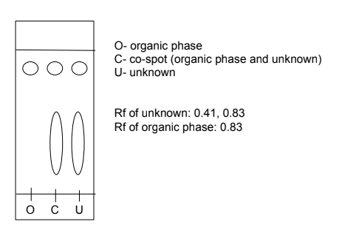

- Rf’s of the co-spot lane are the same as the Rf’s of the unknown (0.41, 0.83)

Figure 2: TLC of unknown and aqueous phase using EtOAc: Hexane (2:8) solvent system

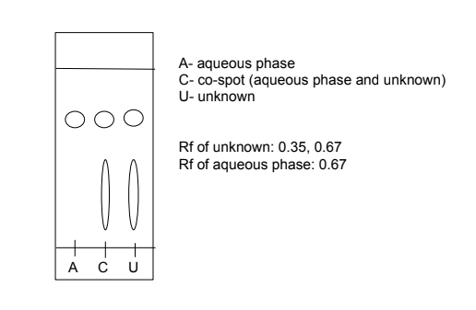
- Rf’s of the co-spot lane are the same as the Rf’s of the unknown (0.35, 0.67)

*** The TLC plate above does not reflect the results that should have been obtained (benzoic acid - the more polar substance- should be in the aqueous phase). Instead, the aqueous lane shows the benzophenone, which should have been eliminated. Sources of error are explained in the discussion. The approximate outline for the correct TLC plate should look like this:
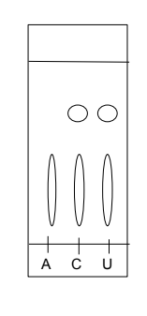
Figure 3: TLC of biphenyl, benzophenone and unknown using EtOAc: Hexane (2:8) solvent system

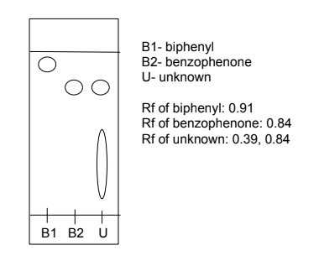

Flow chart:
Figure 4: A reactive extraction
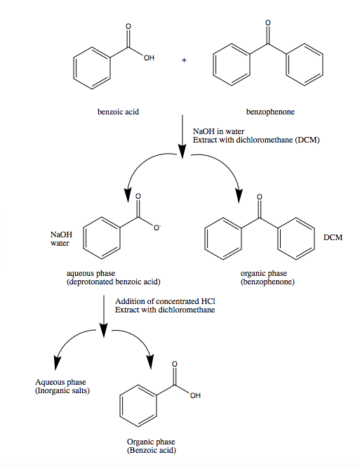
- The process of a reactive extraction is explained further in the discussion under protocol justification and analysis.
Results:

Unknown sample number | 1
Initial mass of unknown sample | 0.99g
Mass of benzoic acid obtained | 0.18g
Composition of unknown | Benzophenone and benzoic acid
Composition % (percent yield) | 18.2 %

Calculations:

Sample Rf calculation (TLC plate in figure 3):

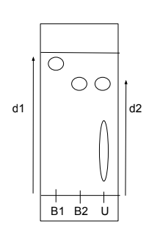
*Note that the d2 measurement is dependent on the point of which the Rf is being determined
d1 – distance travelled by solvent front- 4.4 cm
d2- distance travelled by biphenyl- 4.0 cm
d2- distance travelled by benzophenone - 3.7 cm
d2- distance travelled by unknown (less polar substance)- 3.7 cm
d2- distance travelled by unknown (more polar substance)- 1.7 cm

Rf= d2/d1
Rf (biphenyl)= 4.0/4.4 = 0.91
Rf (benzophenone)= 3.7/4.4 = 0.84
Rf (unknown)= 3.7/4.4 = 0.84 and 1.7/4.4= 0.39

Composition % calculation:

Composition % = mass of benzoic acid obtained/ initial mass of unknown x 100
= 0.18 g/ 0.99g x 100
≈18.2 %

Discussion:

Protocol justification:
- Extraction is a process of separating compounds in a mixture due to differing solubilities of the compounds in two different solvents. The two solvents should be immiscible, and therefore one solvent (also called a phase) acts as the aqueous phase, and the other solvent acts as the organic phase. The aqueous phase dissolves charged, polar compounds while the organic phases dissolves neutral, uncharged compounds. During and extraction the desired compound moves from one phase to the other and can then be, as the name implies, extracted.
- Whether or not the upper phase is organic or aqueous is determined by the relative densities of the two solvents, with the higher density solvent as the lower phase.
- This experiment involves multiple extractions, of which include the extraction of water soluble dyes in part A and the separation of a mixture with reactive extraction in part B.
- In part A, methylene blue was a compound mixed with two immiscible solvents (ether and water). The phase in which the methylene blue ended up (organic or aqueous) indicated its properties as a compound. Methyl red was another compound mixed with ether and water, for the same purpose. The combination of the two mixtures (methylene blue mixture and methyl red mixture) was used to determine whether or not an extraction between ether and water would be a good way to separate the two compounds.
- To demonstrate the salting out effect, aqueous crystal violet was mixed with two solvents, followed by the addition of NaCl. The NaCl was used to saturate the aqueous layer, so that organic compounds slightly soluble in the aqueous phase would be pushed towards the organic phase.
- In part B, an unknown mixture of two compounds was dissolved in dichloromethane (an organic solvent) in order to perform a reactive extraction. Dichloromethane was a good solvent choice for this lab because it cannot mix with water, but can dissolve a wide range of organic compounds.
- This extraction was termed a reactive extraction because NaOH was added in order to deprotonate one of the compounds and give it a charge, thus increasing its solubility in the aqueous phase. Without the NaOH, both compounds would dissolve equally in the dichloromethane and extraction would not be possible. The extraction was performed 3 times in order to maximize the purity of the isolated compound. After draining the lower phase, the remaining aqueous layer was mixed with HCl in order to re-protonate the charged compound, allowing its precipitation and filtration from the aqueous layer. The solid is collected via suction filtration, which is a technique that allows for a greater rate of filtration because a pressure gradient acts as the force that brings the liquid through the filter paper.
- Both the unknown sample and the resultant extracted solid were weighed in order to determine the percent composition of the unknown (since the extracted solid contained only the benzoic acid)
- TLC plates were used to compare the compounds in the unknown and in the organic phase, the unknown and the aqueous phase, and to determine if the second compound in the unknown mixture was biphenyl or benzophenone

Analysis:
In part A, the ether (less dense than water) was used as the organic solvent, meaning that the upper phase was organic. Methylene blue moved to the aqueous phase (as seen with a clear colourless upper layer and a dark blue bottom layer of the test tube), indicating that it is a polar/ charged compound due to its ability to readily dissolve in water. Methylene blue does in fact exist as a charged species, as seen in figure 5. Conversely, the methyl red moved to the organic phase (as seen with the yellow brown tinted upper layer and colourless bottom layer of the test tube). Methyl red is a nonpolar substance, which was able to dissolve in the organic layer. The mixture of methyl red and methylene blue along with the two immiscible solvents further displayed the two compounds differing properties and solubilities in the ether and water. Since methylene blue moved to the lower aqueous phase, and methyl red moved to the upper organic phase, a clear separation of the compounds was evident, indicating that an extraction between either and water was effective at separating the two compounds.
Furthermore, the aqueous crystal violet moved up to the organic phase (as seen with the dark purple rim and clear lower layer of the test tube), indicating that the addition of NaCl to produce the salting effect was successful. The NaCl effectively saturated the aqueous layer, pushing the crystal violet up to the organic phase. The NaCl also increases the ionic strength of the water, which also helped to push out the organic compound from the aqueous phase.

Figure 5. Chemical structure of methylene blue dye
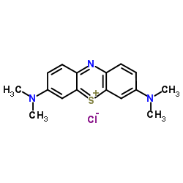
In part B, the results of the TLC indicate whether or not the separation was successful. Since dichloromethane is denser than water, the organic phase was the lower layer and the aqueous phase was the upper layer. In a successful separation, the biphenyl/ benzophenone remains neutral and dissolves in the organic phase, while the deprotonated, charged benzoic acid dissolves in the aqueous phase. Thus, benzoic acid (an acidic compound) and benzophenone (an organic compound) are clearly distinct, due to the acids ability to react. The reaction of NaOH with benzoic acid yields the conjugate base sodium benzoate, which has a partial negative charge on the oxygen. This ionic property allows it to react favourably with the aqueous phase.

TLC 1: The unknown lane had two resulting spots:
- that with the higher Rf is the biphenyl/ benzophenone (since the organic compound travels further due to lack of affinity with the silica gel- less polarity)
- That with the lower Rf is the benzoic acid (much greater affinity with silica gel to due increased hydrogen bonding- greater polarity)
The organic phase lane had only one resulting spot: the one with the higher Rf that matched the same spot in the unknown lane. This indicates that only the biphenyl/ benzophenone was present in the organic phase, as expected with a successful extraction.

TLC 2: Again, the unknown lane had the same two resulting spots as in TLC 1.
The aqueous phase lane had only one resulting spot: the one with the higher Rf that matched the same spot in the unknown lane. Again, this indicated that only the biphenyl or benzophenone was present in the aqueous phase. However, benzoic acid was the compound that should have moved to the aqueous phase. The presence of the benzophenone in the aqueous layer is a sign that the extraction was not complete, or perhaps more likely, that the TLC plates were not developed correctly.

TLC 3: Again, the unknown lane had the same two resulting spots as in TLC 1.
The lane with benzophenone had a spot of slightly lower Rf value than that of biphenyl. The spot with the higher Rf value in the unknown compound displayed the same Rf as the spot in the benzophenone lane. This indicates that the other compound in the unknown mixture is benzophenone.

The percent composition of the unknown sample was determined to be 18.2% benzoic acid. Therefore, the unknown mixture contained a much greater proportion of benzophenone.

Questions:

1. It would be difficult to perform an extraction using ethanol and water because both are polar solvents. For an effective extraction, immiscible solvents should always be used.

- Adding NaCl to a test tube containing water, ether and methylene blue would decrease the amount of dye in the aqueous layer. This is because less dye can be dissolved in the aqueous layer as it becomes saturated by the NaCl. Instead some dye will be pushed into the organic layer, as observed in the salting out effect.

- Compound Y: solubility of 2.0 g/100 ml in water and 20.0 g/ 100 mL in ether
Mass of compound Y removed from a solution of 1.8 g of Y in 100 mL of water by a single extraction with 100 mL ether?

In other words, we want to find the mass of the compound Y that will move from the aqueous phase to the organic phase.

K_{D}= [A]_{organic} / [A]_{aqueous}

[A]_{organic} = solubility of compound in organic phase= 0.2g/mL
[A]_{aqueous}= solubility of compound in aqueous phase= 0.02g/mL
K_{D} = 0.2/0.02 = 10

If x is the mass of the compound Y that will move from the aqueous phase to the organic phase, then:

10= x g/100 mL ÷ (1.8-x) g/100 mL
10 = x/(1.8-x)
18-10x = x
18 =11x
x =18/11
x ≈1.6g
Therefore, mass of compound Y that will move to organic phase is approximately 1.6 g

4. Mass of compound Y that would be removed from the original water solution in question 3 by two extractions using 50 mL of ether each time?

K_{D} = 10

If a is the mass of the compound Y that will move from the aqueous phase to the organic phase after the first extraction then,

10= a g/50 mL ÷ (1.8-a) g/100 mL
10= 2a/(1.8-a)
18= 10a =2a
18= 12a
a= 18/12
a=1.5g

Therefore, mass of compound Y that would be removed from the original water solution after first extraction is 1.5 g.

1.8g- 1.5g= 0.3 g left in the aqueous layer

If b is the mass of the compound Y that will move from the aqueous phase to the organic phase after the second extraction then,

10= b g/50 mL ÷ (0.3g-b) g/100 mL
10= 2b/0.3-b
3-10b= 2b
3= 12b
b= 3/12
b= 0.25g

Therefore, mass of compound Y that would be removed after the second extraction is 0.25 g.

5. To determine which layer is the aqueous phase (if a student loses track of which layer is the organic layer), the student can add drops of water to the mixture. The aqueous phase is that with which the water mixes.

6. To separate a mixture of benzyl amine and naphthalene (two compounds insoluble in water but soluble in ether), one can add HCl to react with the benzyl amine (an organic base). This would form a salt that would dissolve in the aqueous phase. Once the aqueous layer is removed, the addition of NaOH would cause a reaction with the salt to produce benzyl amine once more. The final step would be to filter this mixture through suction filtration and dry it to obtain the isolated compound.

Sources of error:
- Measuring the mass of precipitate (benzoic acid)- minor quantities of the solid were left stuck to the filter paper or washing apparatus. Thus, percent composition is likely higher than noted.
- Improbability of obtaining a 100% pure sample of the benzoic acid and/or organic phase. This includes an inaccurate separation of the liquid layers in the separatory funnel. The stopcock may have been closed slightly earlier or later than necessary since the separation was observed by the eye. Slight contamination in both phases from the wrong compounds would have influenced the resulting Rf values on the TLC plate, as well as the measured percent composition. In this case, there may have been major contamination because the spot for benzophenone appeared in the aqueous layer lane. It is rather odd that there was no spot at all for benzoic acid in this lane.
- TLC specific errors could have contributed to this inaccuracy as well- solvent surpassing the base line, contamination of the capillaries etc.

Raw data:
TLC plate pictures:


