Experiment 2. Purifying Chemicals by Distillation

For the course, CHM1321

2018/02/06
Department of Chemistry and Molecular Science
Faculty of Science
University of Ottawa

Introduction
Procedure
As described in the lab manual (CHM1321 Organic Chemistry Laboratory Manual 2018, Dr. Tony Durst, Dr. Tito Scaiano, Dr. William Ogilvie, Dr. Alison Flynn, 2018, Exp. 20, p. 17).
Observations
Table 1. Observations prior, during, and post experiment
 | Before | During | After
Part A. Simple Distillation | - 50:50 mixture of 2-propanol and 1-butanol was clear, colourless, liquid, and smelled like gasoline  - Initial temperature was 23.2C | - First drop collected at 59.9C  - With every drop, a denser substance is apparent; a hazy film forms very briefly before dispersing  - There is some adherence of a thicker substance on walls | - The mixture collected in the receiving flask is clear, colourless, and liquid
Part B. Fractional Distillation |  | - First drop collected around 60C  - A transparent, hazy film of one or two millimeters in thickness accumulates approximately when 10 mL of substance is collected  - A sudden increase in temperature seen around 10 mL

Tables
Table 2. Millimeters of distillated compound collected and temperature change in a Simple Distillation
Total amount of compound collected in the receiving flask (mL) | Temperature °C
1 | 63.9
2 | 66.8
3 | 68.1
4 | 69.9
5 | 70.3
6 | 70.6
7 | 71.3
8 | 71.9
9 | 72.1
10 | 72.4
11 | 73.3
12 | 74.1
13 | 75.4
14 | 79.1
15 | 82.5
16 | 87.0
17 | 89.7
18 | 92.1
19 | 92.9
20 | 92.2
21 | 91.7
22 | 91.2

Table 3. Millimeters of distillated compound collected and temperature change in a Fractional Distillation
Total amount of compound collected in the receiving flask (mL) | Temperature °C
1 | 80.2
2 | 80.9
3 | 81.4
4 | 82.0
5 | 82.5
6 | 83.0
7 | 84.1
8 | 85.6
9 | 87.0
10 | 92.6
11 | 112.7
12 | 116.1
13 | 116.4
14 | 116.6
15 | 116.7
16 | 116.7
17 | 116.7
18 | 116.7
19 | 105.6

Graphics
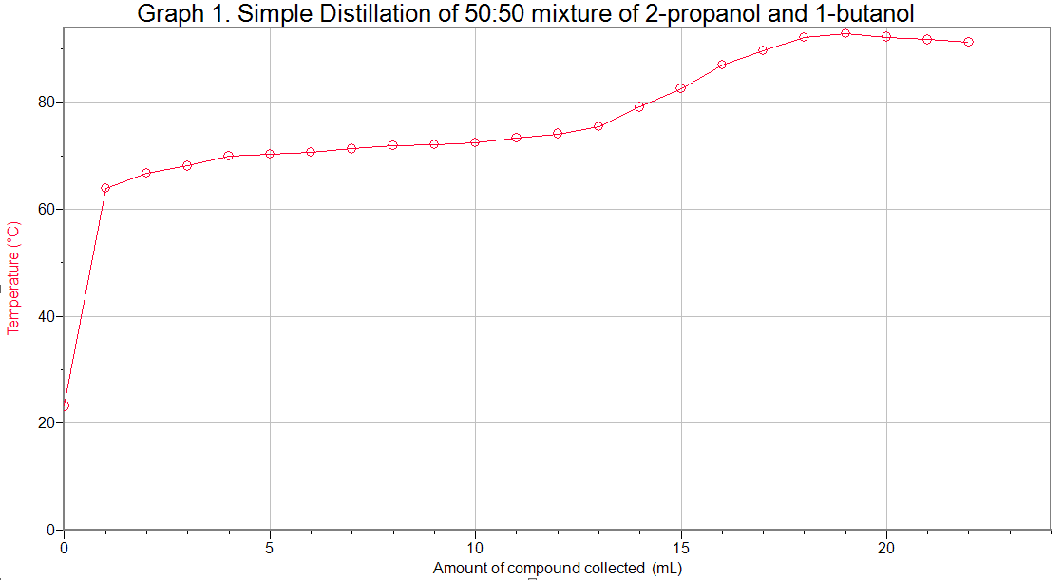
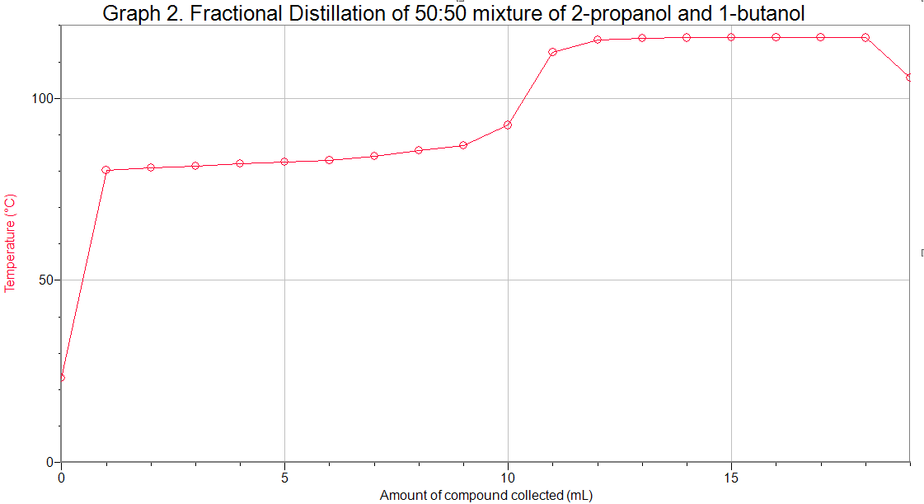
Discussion
- Procedure was thorough and described the set up in such a way that would be the safest and most efficient for one to try
  - Minimized any human error that would lead to imprecise experimentation
    - E.g.: greased the joints and connected the rubber hose correctly to ensure vaporization and condensation of compounds could follow through
    - However, did not mention insulating the distillations using aluminum foil; the TA brought it over and then gave directions
- In Graph 1 depicting the results of the simple distillation, there is a gradual increase in both temperature and amount of distillate collected in the graduated cylinder
  - Shows that the more volatile compound (one with lower boiling point), 2-propanol, is distilled first and then as the line grows steeper, indicates the evaporation, condensation, and collection of the compound with a higher boiling point, 1-butanol
    - However, this is not a good separation as it is difficult to discern where exactly does the evaporation of 2-propanol stops because there is none left, and where the evaporation and collection of 1-propanol commences
      - The delineation could be anywhere from 10 to 14 mL
        - Imprecise
        - yet, the results of the experiment are as predicted as the efficiency of the separation is limited by the fact that the composition of the vapour rising and condensing varies continuously
- In Graph 2 depicting the results of the fractional distillation, the first couple millimeters of distillate collected appears to all around the same temperature and the line looks stagnant, with the barest hints of an inclination
  - However, what make Graph 2 a good separation is the sudden, stark jump in temperatures around 9-10mL
    - This is a clear indication that the 2-propanol has completely evaporated and now in order for 1-butanol to be distilled and collected, the temperature rises significantly in a clear and distinguishable growth
      - This distillation is more accurate than the simple distillation
        - this is due to the increased surface area that the fractionating column provides, which maximizes efficient separation
        - as vapour rises, it becomes enriched in the lower boiling component and the liquid that condenses and falls back into the distilling flask is gradually enriched in the higher boiling component (1-butanol)
          - thus, as each cycle progresses, the more effective the separation gets in contrast to the simple distillation
        - the stark delineation of temperature change evident on the graph demonstrates this
- Sources of error and/or amelioration
  - Human error when noting down the temperature and the amount of distillate collected in the graduated cylinder (e.g.: reading the temperature just as it changes or spotting the meniscus higher or lower than it actually is)
    - Accuracy and precision can be improved by using electronic time-keeping devices or computerized monitoring of temperature
  - Unclean distillation apparatus parts
    - Addressed by having stricter handling policies and cleaning equipment more thoroughly
      - Additionally, even though it was mentioned in the procedure, there was no grease available to apply onto the joint and thus vapors of the compounds may have inadvertently escaped
  - Contamination and measurement of the 50:50 mix of 2-propanol to 1-butanol
    - Clean glassware more thoroughly and use a more accurate measuring device
- Note that not all of the compound in the distilling flask was evaporated completely
  - See Table 2 and Table 3, only 22mL and 23 mL of distillate respectively were collected instead of the recommended 25 mL
    - This was due to the fact that the TA warned of overheating the glassware when there was very little or no substance left in the distilling flask
      - While the experiment was almost finished and the trend of the graphs appear to have stagnated by the end, it is still important to have a full collection of detailed data
Questions
- Liquid must flow back into the fractionating column to allow more of the lower boiling component – in this case, the 2-propanol – to be vaporized
  - As the cycle of condensation-vaporization is repeated over time, all the 2-propanol will be vaporized and collected, leaving only the 1-butanol in the distilling flask
    - This results in an effective and efficient separation of compound

- Temperature gradient should be uniform in order to ensure a smooth and accurate distillation
- If the temperature fluctuates and grows too high at one point, more of the compound with the higher boiling point (1-butanol) will vaporize and collect in the receiving flask
- However, if the temperature fluctuates in a way that decreases, it is likely that not all of the compound with the lower boiling point (2-propanol) will completely evaporate
- Additionally, if the data collected is compared with another reference data set, there will be significant variances in points of distillation

- The boiling point of a pure liquid is defined as the temperature at which the vapour pressure of the liquid is equal to the pressure applied to the solution
  - Thus, as the atmospheric pressure is 1.04 atm or 760 torr, that is the vapor pressure of benzene at 81C

- An increase in atmospheric pressure results in a higher boiling point for liquid as pressure and boiling points are directly proportional to each other

- If cooling water enters from the top and exits from the bottom, the condenser will not fill with water and the vapours exiting the distillation head will not condense and fall into the receiving flask.
- Additionally, if it did, the water would create an uneven temperature gradient along the condenser as water entering the top would be cooler than the water exiting at the bottom, possibly influencing the efficiency of distillation

- Raoult’s Law states that the partial vapor pressure of each component of an ideal mixture of liquids equals the product of the vapor pressure of the pure component and its mole fraction in the mixture
Mole fraction of A = ¾ = 0.75
Mole fraction of B = ¼ = 0.25
Partial Pressure of A = (mole fraction of A)x(vapor pressure of A)
= (0.75)(350mmHg)
= 262.5 mmHg
Partial Pressure of B = (mole fraction of B)x(vapor pressure of B)
= (0.25)(150mmHg)
= 37.5 mmHg
Vapour pressure of the mixture = P_{a}X_{a} + P_{b}X_{b}
= 262.5mmHg + 37.5 mmHg
= 300 mmHg
Therefore, the total vapour pressure of a 3:1 mixture of A to B at 95C is 300mmHg

Raw Data:

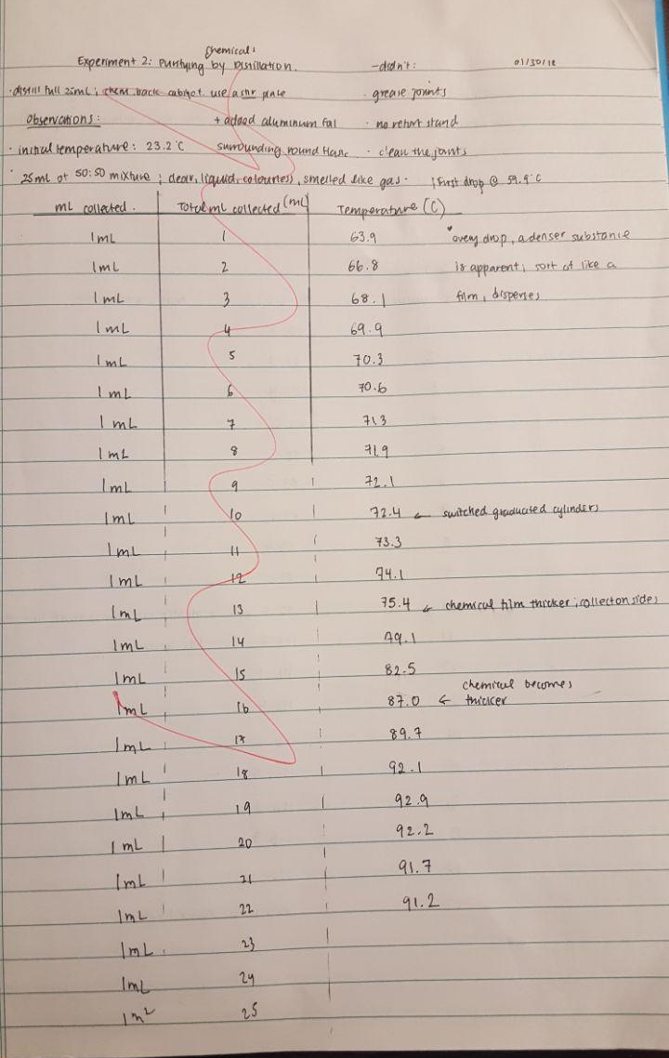
Figure 1. Photo of raw data (Part A: Simple Distillation) from the lab book
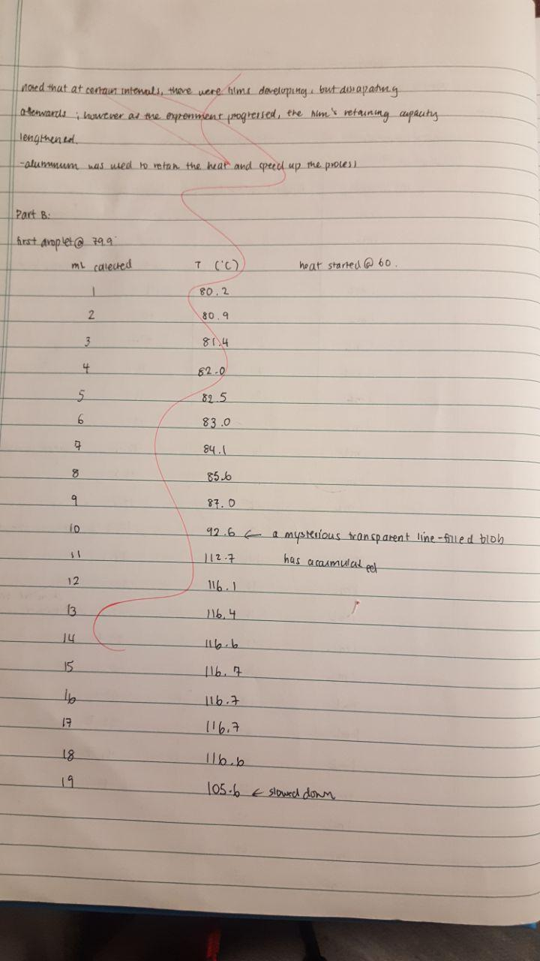
Figure 2. Photo of raw data (Part B – Fractional Distillation) from the lab book

