Purification of Chemicals by Distillation
Experiment 2

CHM1321 Section C07

University of Ottawa

TA: Yixin Zhang & Yiran Li

Ny Ako Ndrianjasoazanany – 300013993

February 1st, 2018

Procedure
See laboratory manual page 25 to 27
Observations
- Distillate is clear and viscous
- Strong odor in liquid solution
- Vapors condense quickly
- Slight bubbling occurs in the distilling flask
- Aluminum is used to insulate fractional distillation
Data
Table 1: Results from Simple Distillation
Distillate Volume (mL) | Temperature (°C)
1 | 91.1
2 | 92.0
3 | 92.7
4 | 93.6
5 | 94.5
6 | 95.5
7 | 96.9
8 | 97.4
9 | 98.7
10 | 100.1
11 | 102.3
12 | 103.6
13 | 105.2
14 | 107.3
15 | 108.9
16 | 111.1
17 | 113.5
18 | 114.8
19 | 116.5
20 | 117.5
21 | 117.7
22 | 118.2

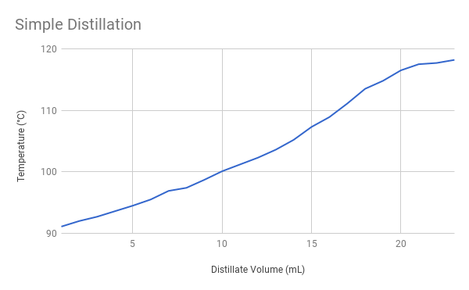
Table 2: Results from Fractional Distillation
Distillate Volume (mL) | Temperature (°C)
1 | 81.9
2 | 82.8
3 | 83.2
4 | 83.5
5 | 84.1
6 | 85.5
7 | 86.5
8 | 87.3
9 | 88.1
10 | 89.2
11 | 92.4
12 | 94.9
13 | 97.9
14 | 101.6
15 | 106.4
16 | 111.7
17 | 114.3
18 | 116.5
19 | 117.1
20 | 117.4

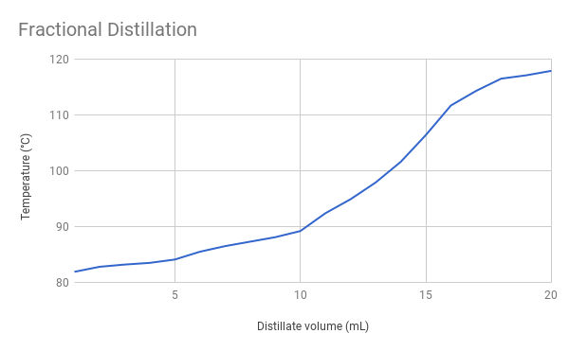
Discussion
Through completing the experiment, the separation of the mixture is dependent on the boiling point of each compound. The entire system of distillation requires a medium of evaporation and condensation. Notably, the setup includes a condenser and two distinct flasks; one receiving condensed vapors and the other having liquid that will be vaporized. Cooling the vapors from the boiling mixture is what creates condensation. In simple distillation, the system is completely sealed and the vapors will condense from cold water at the bottom of the condenser. In fractional distillation, the liquid will vaporize and condense within an open system of the fractioning column; the vapors will reach cooler temperatures as it rises to the top and condense. As shown in the tables, the separation in fractional distillation is more noticeable because the compounds within the mixture share similar boiling points. The precision of fractional distillation comes from boiling the liquid in the fractioning column; the metal sponge refines the process of several re-evaporation and condensation by increasing the surface area that the vapor will come in contact with and condenses into liquid which flows back in the fractioning column. From each graph, the compound having the lowest boiling point evaporates first, shown by the starting portion of the graph; the end bounds get further apart as the tangent gets steeper. Since the base of the graph is the compound that boils out of the solution first the graph gets steeper quickly. The part of the mixture with the higher boiling point condenses below the part with the lower boiling point on the way to the top because the vapors will ultimately be more concentrated with the lower boiling point compound. Raoult’s Law governs the behavior of vapor pressure, lower boiling points also means higher volatility; the partial pressure of both liquids will equal the total pressure exerted by the system.
As atoms gain and lose kinetic energy, the distribution of molecules creates pressure between the surface of the liquid and the atmosphere it is in. In simple distillation, the closed system forces the vapor molecules to condense as much as possible only once; vapors prefer to condense in an area of greater surface area than an area of low surface area. Thus, if the boiling points do not differ by a large amount, simple distillation is not an efficient way of separating the compounds in the mixture, because of this, the graph is almost linear.
Finally, any increase in surface area will decrease the strength of intermolecular forces intending to keep atoms within close proximity; the molecules become much more volatile and willing to vaporize into the condenser. The data also shows that separation is successful because there is a clear distinction in temperature increase once the first compound. To improve the experiment, we can increase the surface area of the fractioning column to ensure that more vapors will condense back into a liquid; this is possible by making the fractioning column longer or having the metal sponge cover more space inside. Also, increasing the temperature at a slower rate will give a more accurate reading of the boiling points. Overall, the phase change between liquid and vapor occurs according to the boiling point of each compound as it is being purified through distillation.
End of Report Questions
- Explain why you must have liquid flowing back through the fractionating column in order to get separation of the components during a fractional distillation.
In fractional distillation, the more volatile (lower boiling point) component of the mixture will condense as it moves up the fractional and therefore becomes pure before the less volatile (higher boiling point) component. By the time the vapor reaches the top after numerous re-evaporation and condensation, it will only contain the part of the mixture with the lowest boiling point. As the condensed vapor comes back down, it will be in contact with new vapors that are rising which cause it to re-evaporate. In order for this separation to occur, each re-evaporation of the condensed liquid dripping back down from the top will increasingly contain more of the less volatile component. Eventually, the part of the mixture with a higher boiling point will be abundant as a liquid leaving the part of the mixture with the lower boiling point be abundant in the form of vapors.
- Fractionating columns normally work better if they are insulated in order to maintain a smooth temperature gradient in the column. Why is it important to maintain a uniform temperature gradient in a fractionating column?
Insulation is used to make sure the entire column is operating under a relatively balanced temperature gradient so vapors can reach the end of the column and condense.
- The boiling point of benzene is 81 °C. What is the vapor pressure of benzene at this temperature?
Newton’s Third Law states that every action there is an equal and opposite reaction. The vapor pressure of benzene is 1 atm because the pressure of the atmosphere is counteracted by the pressure of the vapors at the surface it is being exerted on, with respect to Newton’s Third Law.
- What effect does an increase in atmospheric pressure have on the boiling point of a liquid?
Increasing atmospheric pressure will proportionally increase the boiling point of a liquid because the liquid will require more energy to convert into a gas.
- Why is it important to have cooling water enter the bottom of the condenser and not the top?
Cooling water from the bottom ensures that the rest of the condenser is filled with water as pressure pushes towards the top.
- Compound A has a vapor pressure of 350 mm Hg at 95 °C whereas compound B has a vapor pressure of 150 mm Hg at the same temperature. If A and B are miscible, what is the vapor pressure of a 3:1 mixture of A and B at 95 °C?
$$P_{vapor}=\left(X_{a}*P_{a}\right)+\left(X_{b}*P_{b}\right) \\ P_{vapor}=\left(0.75*350 mmHg\right)+(0.25*150 mmHg) \\ P_{vapor}=300 mmHg$$
Bibliography
Clark, Jim. "FRACTIONAL DISTILLATION OF IDEAL MIXTURES OF LIQUIDS." Chemguide. N.p., 2014. Web. 01 Feb. 2018.
https://www.chemguide.co.uk/physical/phaseeqia/idealfract.html

Dr. Saig, Avi "What Are the Requirements for a Successful Distillation? Ariel." Davidson Institute of Science Education. N.p., 17 Jan. 2017. Web. 01 Feb. 2018.
https://davidson.weizmann.ac.il/en/online/askexpert/physics/What-are-the-requirements-for-a-successful-distillation

"How Does Fractional Distillation Work?" Sciencing. N.p., n.d. Web.
https://sciencing.com/fractional-distillation-work-6310159.html


