ADM 3301 N Operations Management

Assignment 1

Problem #1
a) Naive Method
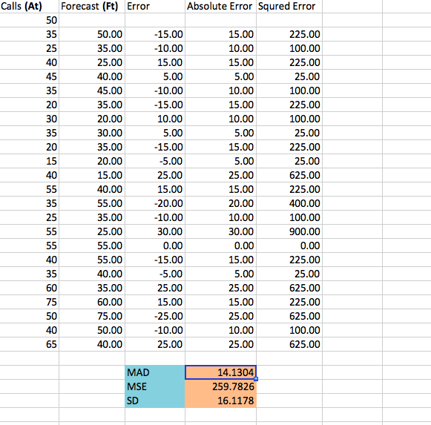
b) Four-Week Moving Average

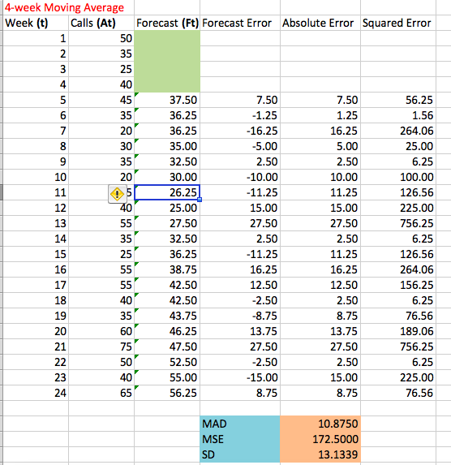

c)
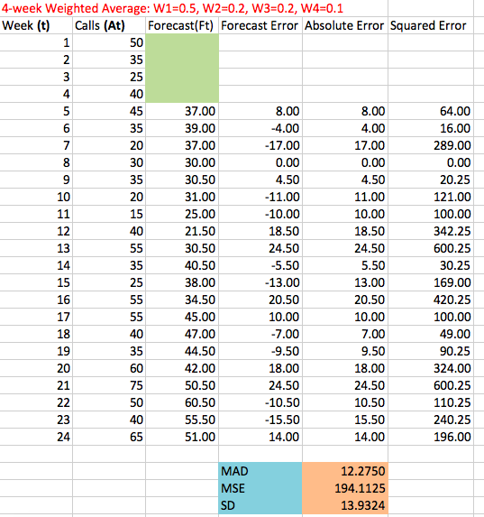
d)Exponentially smoothed forecast
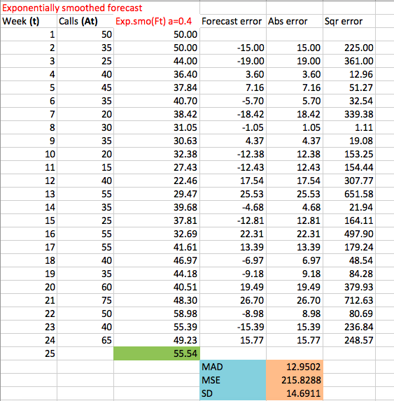
Forecast for period 25 = 55.54 when a=0.4.

e)
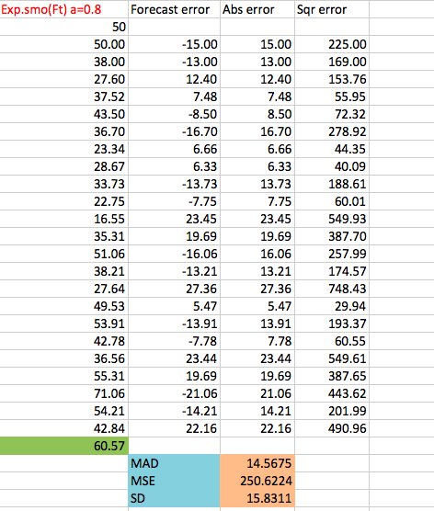
Forecast for period 25 = 60.57 when using a=0.8.

f) Compared with the above methods, the simple four-week moving average would be the best option, because it has the lowest MAD which means the more relevant is the mean as indicator of the values within the set.

g) when A(25)=85,
 | $$α=0.4$$ | $α$=0.8
Sum(error) | 43.31 | 37.64
Mean | 1.80 | 1.57
MAD | 13.64 | 14.98

Since the forecast error of $α$=0.8 is lower than $α$=0.4, so when $α$=0.8 of smoothing model provides a superior forecast.

h)
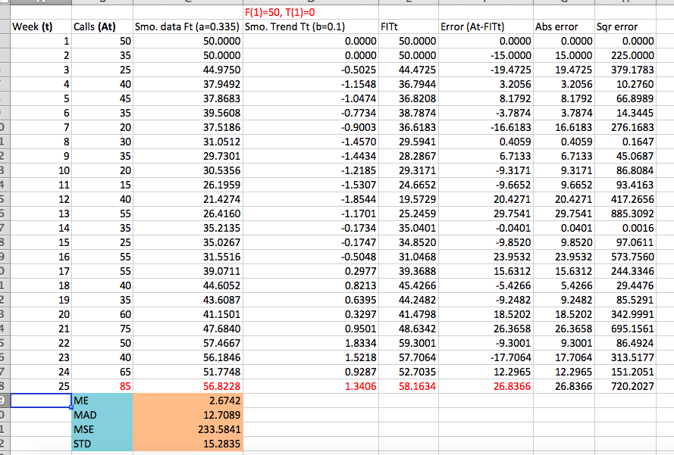

i) Compared with part d) and e), the MAD of double exponential smoothing model is lower than d) and e), so double exponential smoothing model is better and useful for further improvement.

Problem #2

- According to the Chart, which is a positive linear, so we will choose regression model: this is the forecasting technique by showing relationship between the dependent variable and independent variable. So let the production rating (Y) is a dependent variable and the test score(X) is an independent variable, so that the linear regression equation would be Y=a+bX.
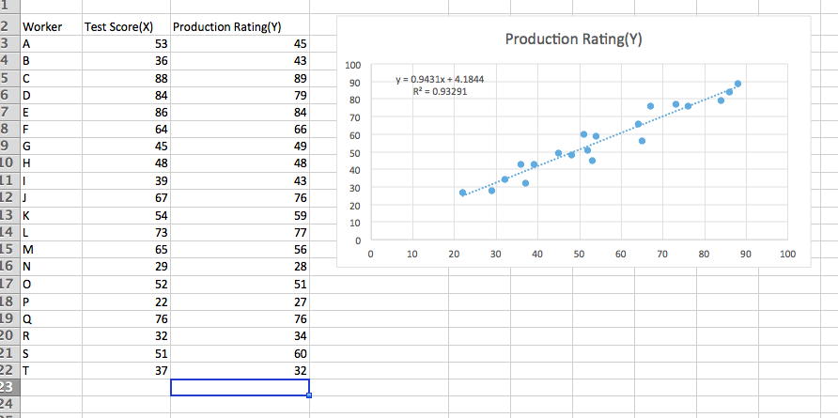

b)
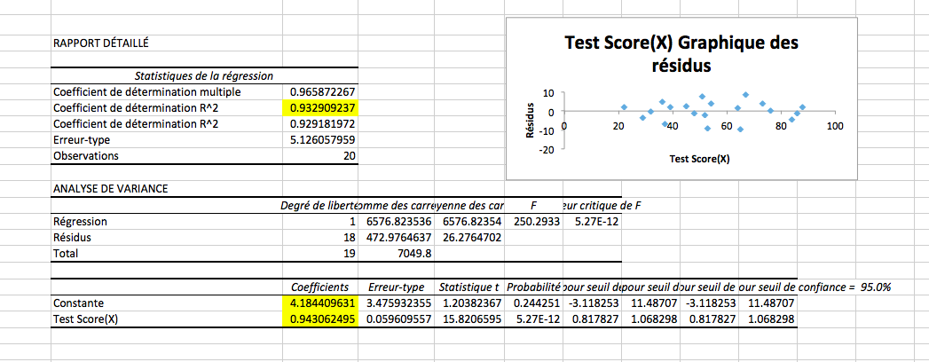

Therefore, the linear equation would be Y=4.1844+0.943X. When test score (X) =80, the forecasting production rating (Y)=4.1844+0.943*80=79.62941, round up to be 79.63.

c) As requested, let the test score to be zero, the forecasting production rating would be 4.1844+0.943*0 =4.1844, as a point (0, 4.1844) is the Y-intercept, and the result of equation is equally to the description statistics, so we can place confidence in this forecasting.

d)
Standard Error | 5.1261
Correlation Coefficient | 0.9659
Coefficient of Determination | 0.9329

Standard error is a measure of the statistical accuracy of an estimate, equal to the standard deviation of the theoretical distribution of a large population of such estimates. And correlation explains how strong is the linear relationship between the variables, and correlation coefficient measures the degree of association, correlation coefficient relates to two variables which may be the set of observations,(sample) or two components of am multivariate random variable with a known distribution. Fore coefficient of determination, r^2, is showing how well the regression line approximates the real data points. therefore, for this problem, both data are almost close to 1, so the strength of the relationship between the test scores and production rating is pretty strong.

Problem #3

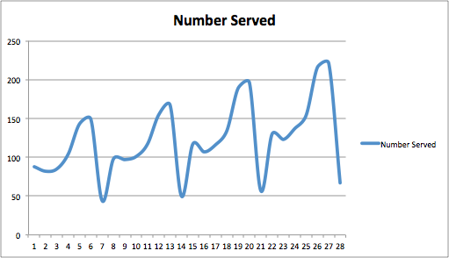
According to the plot, it shows the observed series, the smoothed trend line, the seasonal pattern and the random part of the series. And the seasonal pattern is a regularly repeating pattern, so we have to use multiplicative decomposition model.

b) Because the number of seasons is an odd, so we start MA calculation in period = ROUND UP 7/2$=$4
Adjusted Seasonal Indices (Day) | Adj S
1 | 0.9371
2 | 0.8658
3 | 0.9097
4 | 1.0337
5 | 1.3890
6 | 1.4463
7 | 0.4183
Intercept | 87.7548
Slope | 2.4294
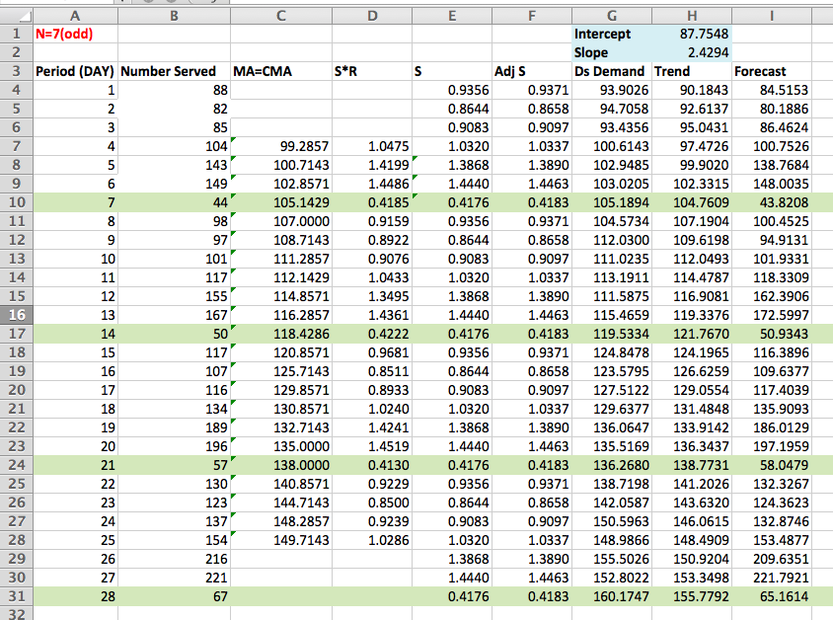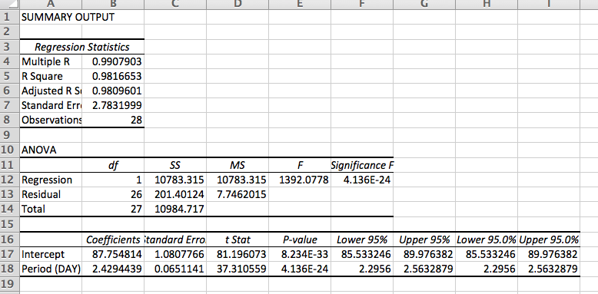
c)
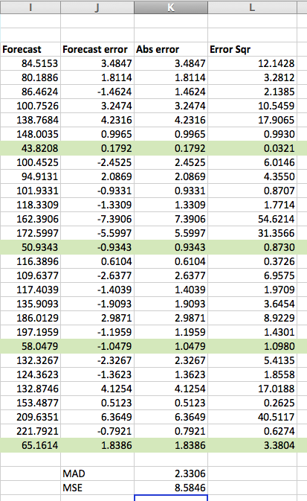
As MAD=2.33 and R square = 0.98166 (high), which means the strong prediction.

d) Forecast the number served for period 29 to period 42:
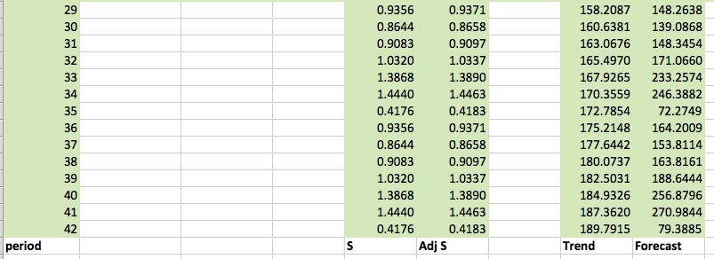

Problem #4
a)
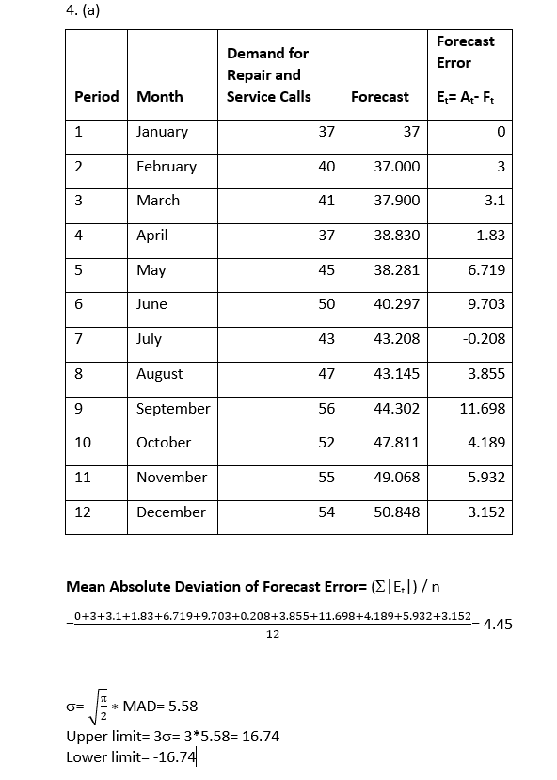
b) In order to perform an adequate forecast, the errors should be expected to fall within the limit of 0± 3 and randomly distributed with the mean of 0. In this case, the errors have a increasing trend so they are not randomly and normally distributed around the mean of 0. Thus, the forecast is not performing adequately.

Problem #5
a)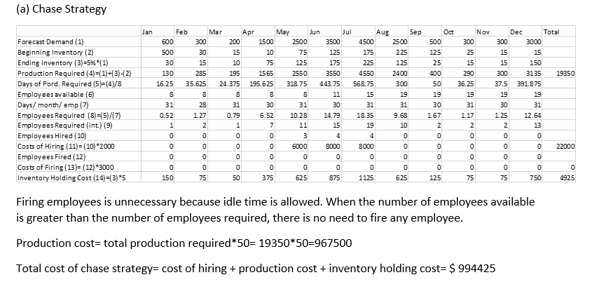
b)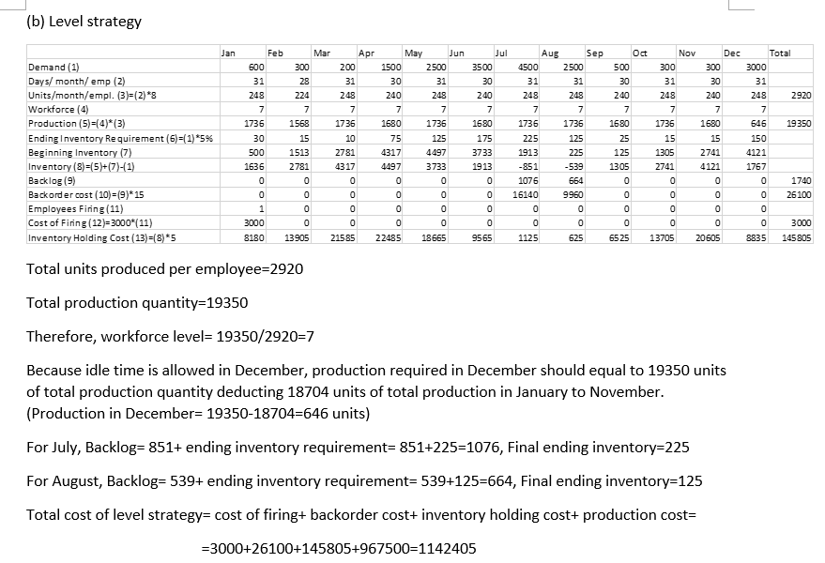
c)
I would recommend chase aggregate planning strategy, because the total cost of chase strategy is less than that of level strategy. (994425<1142405)

Problem #6
a)
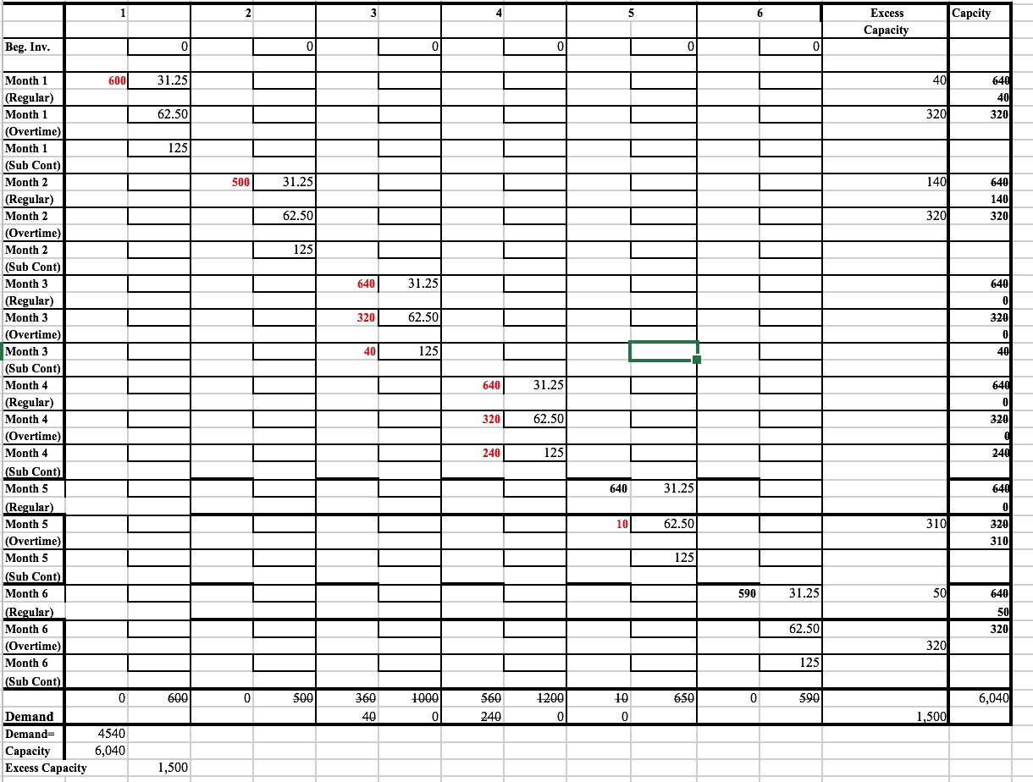

Total Cost Of Production= (600*31.25) + (500*31.25) + (640*31.25) + (320+62.50) + (40*125) + (640*31.25) + (320*62.50) + (240*125) + (640*31.25) + (10*62.50) + (590*31.25)
Total optimal cost= $188 437.50

b)
The cost of having Cohen’s former partner working during the busy time totaled up to 35 000$ alone(40 hours + 240 hours x 125$/h).
The cost associated with having an extra employee would bring the firm’s optimal cost to; 5000$/m up to 30 000 for the next 6 months.

The option of hiring a fourth CPA is the better one as it will be a cheaper option for the firm, potentially up to 5 000$ in salary savings.

Problem #7
a)
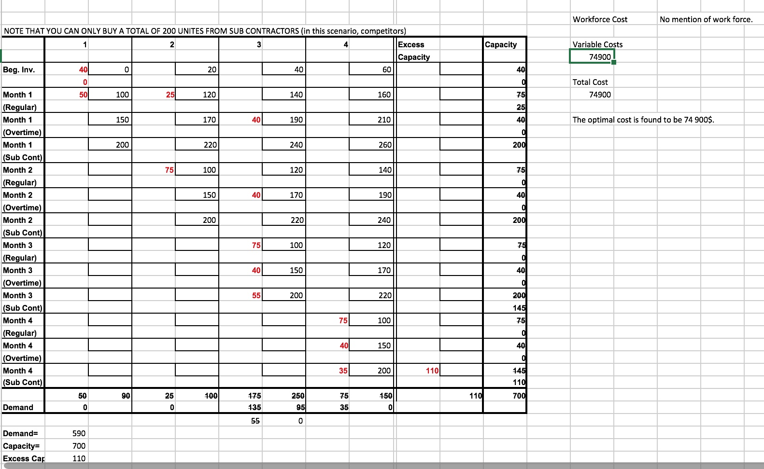

a) Optimal Cost=(50*100)+(25*120)+(75*100)+(40*190)+(40*170)+(75*100)+(40*150)+(55*200)+(75*100)+(40*150)+(35*200)
Optimal cost=74 900$

b) Ending Inventory of Month 1:
Ending inv=Beg Inv +Reg.Inv +OT Prod – demand
=40+75+40-90=65
The ending inventory for month 1 is 65 units.

Ending Inventory Of Month 2:
Ending inv=Beg Inv +Reg.Inv +OT Prod – demand
=65+75+40-100=80
The ending inventory of month 2 is 80 units.

Ending Inventory Of Month 3:
Ending inv=55+80+75+40-250= 0
The ending inventory of month 3 is 0 unit.

c) Linear Programming:
Let XRi=number of sinks produced regularly in month i
XOi=number of sinks produced overtime in month i
XPi=number of sinks purchase from competitor in month i
XUi=number of sinks used from on-hand inventory in month i
With i=1,2,3,4
Objective:
Z=100*(XR1+XR2+XR3+XR4)+150*(XO1+XO2+XO3+XO4)+200*(XP1+XP2+XP3+XP4)+20*(40-XU1-XU2+40-XU1-XU2-XU3+40-XU1-XU2-XU3-XU4)
=100*(XR1+XR2+XR3+XR4)+150*(XO1+XO2+XO3+XO4)+200*(XP1+XP2+XP3+XP4)+20*(120-3*XU1-3*XU2-2*XU3-XU4)

Subject to:
XRi<=75;
XOi<=40;
XP1+XP2+XP3+XP4<=200

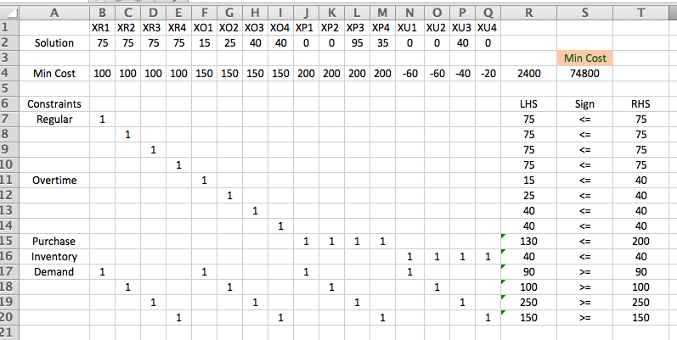

To summarize, the Melhta firm can produce 75 dinkd regularly per month and the overtime production would be 15 sinks for month, 40 sinks for month 3 and 40 sinks for month 4 as well. Also, the Melhta will purchase 95 sinks for month 3 and 35 sinks for month 4 for its competitor. And the minimum cost will be $74,800.

The following chart are sensitivity report and answer report:


