PSY1101

Chapter 6: Sensation and Perception

Sensation - the process by which our sensory receptors and nervous system receive and represent stimulus energies from our environment

Perception - the process of organizing and interpreting sensory information, enabling us to recognize meaningful object and events

Sensory adaptation - diminished sensitivity as a consequence of a constant stimulation

- Emotions and motivations influence perception by expectations and context

Weber’s law - the principle that, to be perceived as different, two stimuli must differ by a constant minimum percentage

Difference threshold - the minimum difference two stimuli required for detection 50% of the time, we experience the difference threshold as a just noticeable difference

Retinal disparity - a binocular cue for perceiving depth: By comparing images from the retinas in the two eyes, the brain computes distance - the greater the disparity (difference) between the two images, the closer the objects

Frequency - the number of complete wavelengths that pass a point in a given time

Pitch - a tone’s experienced highness or lowness; depends on frequency

- Short wavelength = high frequency (high-pitched sounds)
- Long wavelength = low frequency (low-pitched sounds)

Sound Waves into Nerve impulses that our Brain Interprets
- the outer ear collects sound waves, which are translated into mechanical waves by the middle ear and turned into fluid waves in the inner ear
- The auditory nerve then translates the energy into electrical waves and sends them the brain, which perceives and interprets the sound

- Place theory best explains how we sensed high pitches
- Frequency theory best explains how we sense low pitches
- Some combination of place and frequency theories seems to handle the pitches in the intermediate ranges

Noiceptors - sensory receptors that enable the perception of pain in response to potentially harmful stimuli

- Our experience of pain is influenced by biological facts (such as sensory receptors that detect pressure), psychological factors (such as our focused attention), and social-cultural factors (such as social expectations about tolerance and expression of pain)

The Pain Circuit
- sensory receptors (noiceptors) respond to potentially damaging stimuli by sending an impulse to the spinal cord, which passes the message to the brain, which interprets the signal as pain

(Biopsychosocial approach to pain) Our experience of pain is much more then the neural messages sent to our brain

Taste, Smell, and Memory
- information from the taste buds travels to an area between the frontal and temporal lobes of the brain, it registers in an area not far from where the brain receives information from our sense of smell
- The brain’s circuitry for smell also connects with areas involved with memory storage, which helps explain why a smell can trigger a memory

Sensory Interaction - the principle that one sense may influence another

Synesthesia - where one sort of sensation involuntary produces another

Embodied Cognition - in psychological science, the influence of bodily sensations, gestures, and other states on cognitive preference and judgements

Chapter 3: Consciousness and the Two-Track Mind

(Part 1)

Visual Action Track - guides our moment-to-moment movement

Visual Perception Track - enables us to “think about the world” - to recognize things and to plan future actions

Parallel processing - the processing of many aspects of a problem simultaneously: the brain’s natural mode of information processing for many functions

Inattention blindness - failing to see visible objects when your attention is directed elsewhere

Change blindness - failing to notice changes in the environment

Altered states of consciousness In addition to normal, waking awareness, consciousness comes to us in altered states, including daydreaming, drug-induced hallucinating, and meditating.

Two tracks and Dual Processing
- Our mind has separate conscious and unconscious tracks that perform dual processing—organizing and interpreting information simultaneously.

- Attention is powerfully selective: your conscious mind is one place at a time

Selective Attention Directing Our Perception
- We selectively attend to, and process, a very limited portion of incoming information, blocking out much and often shifting the spotlight of our attention from one thing to another. Parallel processing takes care of the routine business, while sequential processing is best for solving new problems that require our attention. Focused intently on one task, we often display inattentional blindness to other events and change blindness to changes around us.

(Part 2)

Sleep and Dreams
- EEG recordings confirm that the brain’s auditory cortex responds to sound stimuli even during sleep

Circadian Rhythm
-thinking is sharpest and memory is most accurate when we are at our daily peak in circadian arousal
- night owls tend to be smart and creative
- Morning types tend to do better in school, to take more initiative, and to be less vulnerable to depression

REM sleep - rapid eye movement sleep; a recurring sleep stage during which vivid dreams commonly occur. Also know as paradoxical sleep, because the muscles are relaxed (except minor twitches) but other body systems are active

Hallucinations - false sensory experiences, such as seeing something in the absence of an external visual stimuli

REM
- brain’s motor cortex is active, but your brainstem blocks its messages
- The body is internally aroused, with waking-like brain activity, yet asleep and externally calm
- You cannot be easily awakened ( This immobility may occasionally linger as you awaken from REM sleep,, producing a disturbing experience of sleep paralysis)

Order of Sleep Stages
1.NREM-1 (“fleeting images”)
2.NREM-2
3.NREM-3 (“minimal awareness”)
4.NREM-2
5.REM (“story-like dream”)

What Affects Our Sleep Patterns?
- sleep patterns are genetically influenced
- Adults average 7-8 hours of sleep
- Bright morning light tweaks the circadian clock by activating light-sensitive retinal proteins
- Proteins control the circadian clock by triggering signals to the brain’s SCN
- Suprachiasmatic nucleus: a pair of clusters in the hypothalamus that controls circadian rhythm. In response to light, the SCN causes the pineal gland to adjust melatonin production, thus modifying our feelings of sleepiness
- SCN: decreases and increases production of melatonin
- Being bathed in or deprived of light disrupts our 24-hour biological clock

“The Biological Clock”
- light striking the rent signals the SCN to suppress the pineal gland’s production of the sleep hormone melatonin.
- At night, the SCN quiets down, allowing the pineal gland to release melatonin into the bloodstream

Why Do We Sleep?

1.Sleep Protects
-a species sleep pattern tends to suit its ecological niche

2. Sleep Helps Us Recuperate
-helps restore the immune system and repair brain tissue
-slow-wave sleep, which occurs most in the final hours of a long night’s sleep, produces growth hormone necessary for muscle development
-REM and NREM-2 sleep help strengthen neural connections that build enduring memories

3. Sleep Helps Memory
- reactivates recent experiences stored in the hippocampus and shifts them for permanent storage

4. Sleep Feeds Creative Thinking
-after working on task, then sleeping on it, people solve difficult problems more insightfully than do those stay awake
- to think smart and see connections, it often pays to ponder a problem just before bed and then sleep on it
- Boost thinking and learning

Effects of Sleep Loss
- for students, less sleep also predicts more conflicts in friendships and romantic relationships
- Predictor of depression
- REM sleep’s processing of emotional experiences help protect against depression
- Causes difficulty studying, diminished productivity, tendency to make mistakes, irritability, fatigue
- A large sleep debt “make you stupid”
- Increases, ghrelin, hunger arousing hormone
- Decreases, leptin, hunger suppressing hormone
- Decrease metabolic rate
- Increases cortisol, a stress hormone that stimulates the body to make fat
- Enhances limbic brain response to food
- Decreases cortical inhibition
- Sleep less = weigh more
- Suppress immune cells
- Slows reaction and increases error on visual attention tasks

Major Sleep Disorders

Insomnia
- 1/10 adults and 1/4 adults
- result is tiredness and increased risk of depression
- insomnia is worsened by fretting about it

Narcolepsy
- narco, “numbness” and lepsy, “seizure”
- 1/2000
- Immune system attack on brain cells
- Might be effectively relieved by a drug that mimics the missing orexin and can sneak through blood/brain barrier

Sleep Apnea
- associated with obesity
- Warning signs: daytime sleepiness, irritability, and (possibly) high BP (increases risk of heart attack or stroke)
- Depression symtoms

Night terrors
- a sleep disorder characterized by high arousal and an appearance of being terrified; unlike nightmares, night terror occur during NREM-3 sleep, within two or three hours of falling asleep, and are seldom remembered
- As deep NREM-3 sleep diminishes, so do night terrors and sleepwalking

(sleepwalking and sleep taking are NREM-3 disorders as well)

(Part 3)

Dreams - notable for their hallucinatory imagery, discontinuities and incongruities, and for the dreamer’s delusional acceptance of the content and later difficulties remembering it

Dreams: Content
- daydreams ten to involve the familiar details of our life
- REM dreams tend to be vivd, emotional, bizarre
- Dream’s storyline incorporates traces of previous days’ non sexual experiences and preoccupation
- 1/10 men, 1/30 report dreams with sexual content
- Our two track-mind continues to monitor our environment while we sleep
- Sensory stimuli- smells, sound may be instantly and ingeniously woven into the dream story

Why We Dream

To Satisfy Our Own Wishes
- dreams provide a psychic safety valve that discharges otherwise unacceptable feelings
- Understanding our inner conflicts
- Manifest content: the remembered storyline of a dream (as distinct from its latent, or hidden content)
- Latent content: the underlying meaning of a dream (as distinct from it manifest content

To File Away Memories
- the information-processing perspective proposes that dreams may help sift, sort, and fix the day’s experiences in our memory
- Sacrificing sleep time to study actually worsens academic performance

To Develop and Preserve Neural Pathways
- dreams, brain activity associated with REM sleep serve a physiological function, providing the brain with periodic stimulation
- Stimulates experiences preserve and expand the brain numerals pathway’s

To Make Sense of Neural Static
- dreams erupt from neural activation spreading upward from the brainstem
- Internal stimuli activate brain areas that process visual images but not the visual cortex area, which receives raw input from the eyes
- Limbic system adds emotional tones
- Damage to the limbic system or the visual centres active during dreaming, and dreaming itself may be impaired

To Reflect Cognitive Development
- dreams are a part of brain maturation
- Dreams overlap with waking cognition and feature coherent speech
- Simulate reality by dating on our concepts and knowledge
- Engage brain networks that are also active in daydreaming
- Cognitive perspective: emphasizes our mind’s top-down control of our dream content
- “dramatize our wishes, fears, concerns, and interests in striking scenarios that we experience as real events”
- Mental simulation happen whenever there is
- loss of conscious attention
- Absence of external stimuli
- Sufficient brain activation
- such as during REM sleep

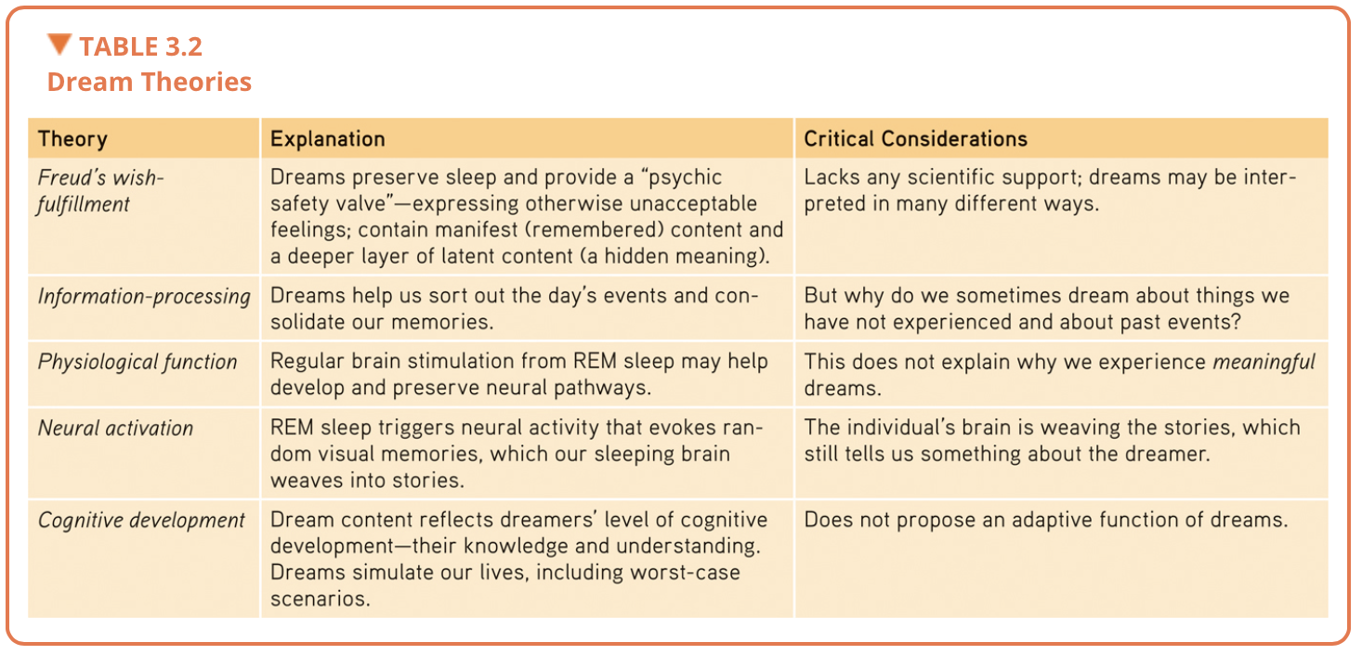
REM rebound - the tendency for REM sleep to increase following REM sleep deprivation (created by repeated awakenings during REM sleep)
Drugs and Consciousness

- a drug overall effects depends on not only its biological effects but vary with social and cultural contexts

Alcohol-use Disorder - (popularly know as alcoholism) alcohol use marked by tolerance,
withdrawal, and a drive to continue problematic use

Alcohol
- alcohol enlivens a drinker by acting as a disinhibitor - slow brain activity that controls judgement and inhibitions
- Increases helpful tendencies
- Increases harmful tendencies
- “the urges you would feel if sober are the ones you will more likely act upon when intoxicated”

Slowed Neural Processing
-low doses: slows sympathetic nervous system activity
- paired with sleep deprivation, alcohol is a potent sedative
- When heavy drinking follows an earlier period of moderate drinking, which depresses the vomiting response
- People may poison themselves with an overdose that their bodies would normally throw up

Memory Disruption
- binge drinking can contribute to nerve cell death and reduces the birth of new nerve cells
- Impairs growth of synaptic connections
- alcohol suppresses REM sleep, which helps fix the day’s experiences into permanent memories

Reduced Self-Awareness and Self-Control
- produces myopia by focusing attention on a arousing situation and distracting it from no normal inhibitions and future consequences

Expectancy Effects
- expectations influence behaviour
- When people believe that alcohol affects social behaviour in certain ways, and believe they have been drinking alcohol, they will behave accordingly

Barbiturates
- drugs that depress central nervous system activity, reducing anxiety but impairing memory and judgement

Opiates
- opium and its derivatives, such as morphine and heroin; depress neural activity, temporarily lessening pain and anxiety
- Pupil constrict, breathing slows, and lethargy sets in as blissful pleasure
- When repeatedly flooded with an artificial opiate, the brain eventually stops producing endorphins, its own opiates
- If the artificial opiate is then withdrawn, the brain lacks the normal level of these painkilling neurotransmitters

Amphetamines - drugs that stimulate neural activity, causing speeded-up body functions and associated energy and mood changes

Stimulants
-pupils dilate, heart and breathing rate increase, and blood sugar levels rise, causing a drop in appetite
-cutting off your usual dose, you may crash into fatigue, headaches, irritability, and depression

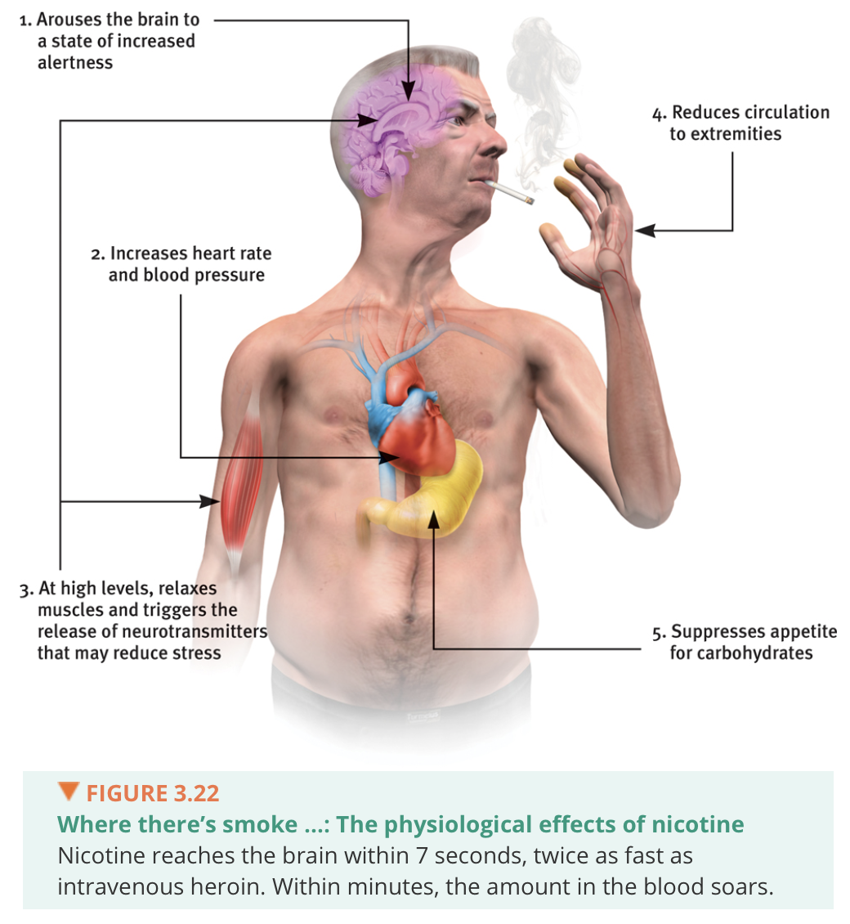

Nicotine - a stimulating and high addictive psychoactive drug in tobacco
- (-12 minutes)/cigarrette
- Smoker develop tolerance
- Quitting causes withdrawal symptoms: craving, insomnia, anxiety, irritability, and distractibility

Cocaine
- a powerful and addictive stimulant derived from the coca plants; produces temporarily increased alertness and euphoria
- Snorted, injected, or smoked
- Enters the bloodstream quickly, producing a rush that depletes, the brain’s supply of the neurotransmitters dopamine, serotonin, and norepinephrine
- Heightens reactions
- Leds to emotional disturbances, suspiciousness, convulsions, cardiac arrest, or respiratory failure
- psychological effects depend in part on the dosage and form consumed
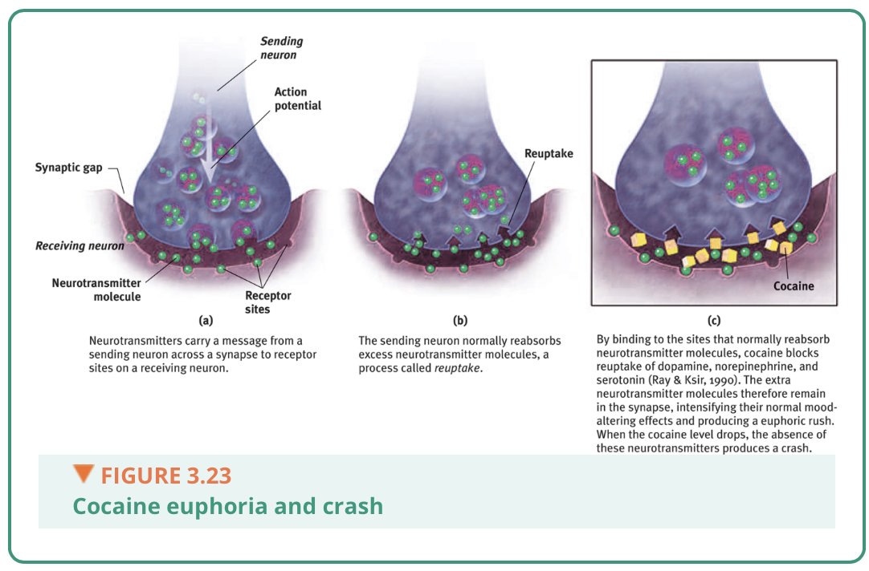
- The situation, user’s expectation, and personality also play a role

Chapter 7: Learning

Learning
- allows us to adapt to our environments
- We learn expect and prepare for significant events such as food or pain (classical conditioning)
- We learn new behaviours by observing events and watching others

Associate Learning
- this process of learning associations is conditioning. It takes two main forms:
- in Classical Conditioning, we learn to associate two stimuli and thus to anticipate events
(a stimulus is any event or situation that evokes a response)
- we associate stimuli we do not control, and we respond automatically, which is called respondent behaviour
- Form associations between a CS and the US it signals
(respondent behaviour is a behaviour that occurs as an automatic response to some stimulus)
(2) in Operant Conditioning, we learn to associate a response (our behaviour) and its consequence
- learn to repeat acts followed by good results and avoid acts followed by bad results
- Associate produce operant behaviours
(operant behaviours are behaviours that operates on the environment, producing consequences)
Limit on Operant Conditioning: biological constraints predispose organisms to learn associations that are natural adaptive

Cognitive learning - the acquisition of mental information, whether by observing events, by watching others, or through language

Classical Conditioning - a type of learning in which one learns to link two or more stimuli and anticipate events

Acquisition
- in classical conditioning, the initial stage, when one links a neutral stimulus and an unconditioned stimulus so that the neutral stimulus begins triggering the conditioned response. In operant conditioning, the strengthening of reinforced response

High-Order Conditioning
- a procedure in which the conditioned stimulus in one conditioning experience is paired with a new neutral stimulus, creating a second
(often weaker) conditioned stimulus. For example, an animal that has learned that a tone predicts food might then learn that a light predicts the tone and begin responding to the light alone (aka second-order conditioning)

Extinction
- the diminishing of a conditioned response; occurs in classical conditioning when an unconditioned stimulus (US) does not follow a conditioned stimulus (CS); occurs in operant conditioning when a response is no longer reinforced

Spontaneous Recovery
- the reappearance, after a pause, of an extinguished conditioned response

Generalization
- the tendency, once a response has been conditioned, for stimuli similar to the conditioned stimulus to elicit similar responses
- can be adaptive
- Generalized fears can linger

Discrimination
- slightly different stimuli can be followed by vastly different consequences
- Ex; confronted by a guard dog and confronted by a guide dog

With classical conditioning , we learn associations between events we do not control.
With operant conditioning, we learn associations between our behaviour and resulting events.

Skinner Experiment’s
- developed a behavioural technology that revealed principles of behaviour control
- Explored the precise conditions that foster efficient and enduring behaviour

Reinforcement - in operant conditioning, any event that strengthens the behaviour it follows

Shaping - an operant conditioning procedure in the reinforcers guide behaviour toward closer and closer approximations of the desired behaviour

Shaping Behaviours
- if we can shape an organism to respond to one stimulus and not to another, then we know they can perceive the difference

(Part 2)

Positive and Negative Reinforcement
Positive reinforcement: any stimulus that, when present after a response, strengthens the response
Negative reinforcement: any stimulus that, when revoked after a response, strengthens the response (NOTE: negative reinforcement is not punishment)
- removes a punishing (aversive) event

Primary Reinforcers
- Unlearned

Reinforcement Schedules

Continuous Reinforcement
- a pattern that defines how often a desired response will be reinforced
- Best choice for mastering a behaviour
- When reinforcement stops the behaviour soon stops
- Real life rarely provides continuous reinforcement

Partial (intermittent) Schedule
- reinforcing a response only a part of the time; results in slower acquisition of a response but much greater resistance to extinction than does continuous reinforcement
- Hope springs eternal

Fixed-ratio schedules
- reinforces behaviour after a set number of responses
- Once conditioned, you can be reinforced on a fixed ratio
- Once conditioned, animals only briefly cause after s reinforcer before returning to a high rate of responding

Variable-ratio schedules
- because reinforcers increase as the number of responses increase, variable-ratio schedules produce high rate of responding

Fixed-interval schedules
- this produces a choppy stop-start pattern rather than a steady rate of response

Variable-interval schedules
- tend to produce slow, steady responding

In general, response rates are high when reinforcement is linked to the number of responses ( a ratio schedule) rather than to time (an interval schedule)

But responding is more consistent when reinforcement is unpredictable (a variable schedule) than when it is predictable (a fixed schedule)

Punishment
- swift and sure punisher can powerfully restrain unwanted behaviour
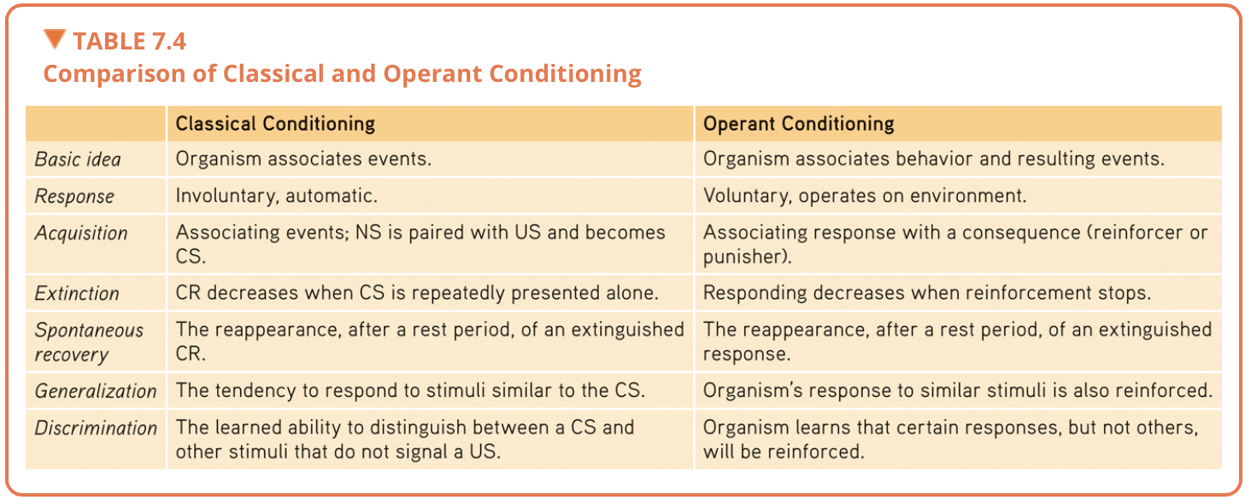
- Criminal behaviour, much of it impulsive, is also influenced more by swift and sure punishers than by the threat of severe sentences

Intrinsic Motivation
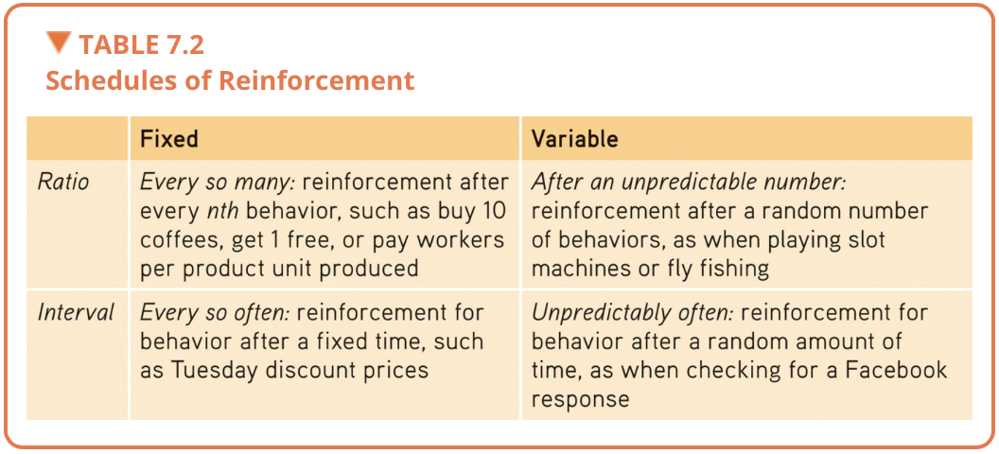
- “ if I have to be bribed into doing this, it must not be worth doing for its own sake”
- Fuels your efforts

Extrinsic Motivations
- signals a job well done (rather than to bribe or control someone) can be effective
- boost feelings competence, enjoyment, improve performance, and spark creativity

Learning by Observation
- cognition is a factor
- By watching a model. We learn to anticipate a behaviour’s consequences in situations like those sea re observing
- When we identify with someone, we experience their outcomes vicariously
- “We are, in truth, more than half what we are by imitation”

Chapter 8: Memory

(Part 1)

Recall - a measure of memory in which the person must retrieve information learned earlier, as on a fill-in-the-blank test

Recognition - a measure of memory in which the person need only identify items previously learned, as on a multiple choice test

Relearning - a measure of memory that assess the amount of time saved when learning material again

Encoding - the processing of information into the memory system

Storage - the process of retaining encoded information over time

Retrieval - the process of getting information out of memory storage

Parallel processing - the processing of many aspects of a problem simultaneously

Sensory memory - the immediate, very brief recording of sensory information in the memory system

Short-term memory - activated memory that holds a few items briefly

Long-term memory - the relatively permanent and limitless storehouse of the memory system, includes knowledge, skills, and experiences

Working memory - a newer understanding of short-term emery that focuses on conscious, active processing of incoming auditory and visual-spatial information, and of information retrieved from long-term memory

Explicit memory - memory of facts and experiences that one can consciously know and ‘declare’

Automatic Processing
- our implicit memory include procedural memory for automatic skills

Ionic memory - a momentary sensory memory of visual stimuli, a photographic or picture-image memory lasting no more than a few tenths of a second

Echoic memory - a momentarily sensory memory of auditory stimuli; if attention is elsewhere, sounds and words can still be recalled within 3 or 4 seconds

Memory Model
- get information into our brains, a process called encoding
- Retain that information, a process called storage
- Get that information back out, a process called retrieval

Explicit Memory System: The Frontal Lobes and Hippocampus

Hippocampus
- a neural centre located in the limbic system; helps process explicit memories for storage
- Memories are not permanently stored here
- Acts as a loading dock where the brain registers and temporarily holds the elements of a remembered episode- its smell, feel, sound, and location

Memory consolidation - the neural stager of a long-term memory

The Frontal Lobes
The left frontal lobe
- ex, recalling a password and holding it in working memory
The right frontal lobe
- ex, recalling a visual party scene

The hippocampus and nearby brain networks are active as people form explicit memories of names, images, and events. Damage to this structure therefore disrupts recall of explicit memories.

Implicit Memory System: The Cerebellum and Basal Ganglia
- implicit memories for skills and newly conditioned associations

The Cerebellum
- key role in forming and storing imlilic memories created by classical conditioning

The Basal Ganglia
- deep brain structure involved in motor movements, facilitate formation of our procedural memories for skills
- Receive input from the cortex

(Part 2)

Review key memory structures in the brain
Frontal lobes and hippocampus: explicit memory formation
Cerebellum and basal ganglia: implicit memory formation
Amygdala: emotion-related memory formation

The Amygdala, Emotions, and Memory
- stress hormones focus memory
- Stress provokes the amygdala to initiate memory trace in the frontal lobes and basal ganglia
- Stronger emotional experiences make for stronger, more reliable memories
- Memory serves to predict the future and to alert us to potential dangers
- Emotional events produce tunnel vision memory

Synaptic Changes
- LTP is believed to be a neural basis for learning and memory
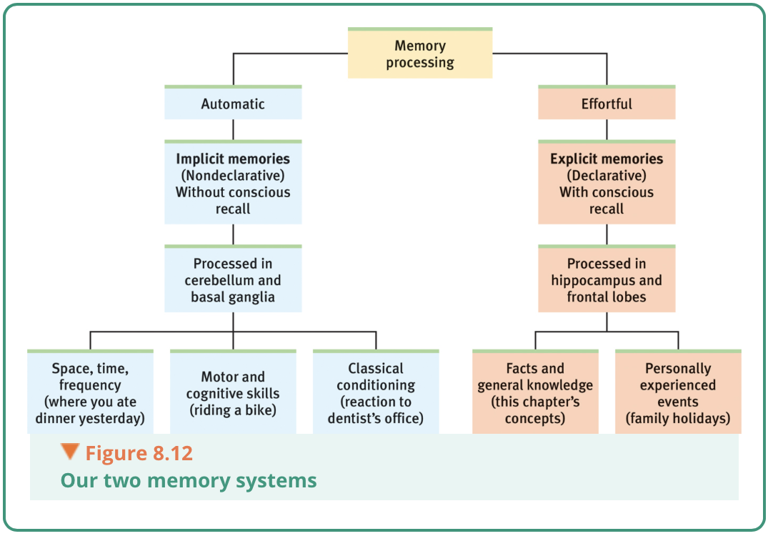
- after LTP has occurred, passing an electric current through the brain won’t disrupt old memories but will wipe out recent memories

Memory Retrieval
- memories are held in a storage by a web of associations, each piece of information interconnected with other
- When encoding a memory, the more retrieval cues, the better your chances of finding a route to the suspended memory

Priming
- “wakening of associations”
- Invisible memory, with your conscious memory
- Can influence behaviours as well

Context-Dependent Memory
- in new settings, we may not have the memory cues needed for speedy face recognition
- Our memories depend on context, and on the c use we have associated with that context

State-Dependent Memory
- what we learn in one state, maybe be more easily recalled when we are again in that state
- What people learn when drunk, they don’t recall well in any state- but they recall it better when again drunk
- Emotions that accompany good or bad events become retrieval cues
- Memories are somewhat mood congruent
- Being depressed sours memories by priming negative associations
- Mood effects on retrieval help explain why our moods persist

Serial Position Effect
- our tendency to recall best the last ( a recency effect) and first ( a primacy effect) items in a list
- Explains large holes in our memory of a list of recent events

Forgetting
- to disregard the clutter of useless or out-of-date memory

Forgetting and the Two-Track Mind
- anterograde amnesia: an inability to form new memories
- Retrograde amnesia: an inability to retrieve information from one’s past

Encoding Failure
- the brain areas that jump in actions when young adults encode new information are less responsive in older adults
- We selectively attend to few of the myriad sights and sounds continually bombarding us

Storage Decay
- after encoding something well, we can still forgot it
- Gradual fading of the physical memory trace

Retrieval Failure
- often forgetting is not memories faded but memories unretrieved
- Sometimes even stored memories cannot be accessed
- An ability to tune out clutter helps people to focus, and focusing helps us recall information
- Proactive interference ex: buying a new combination lock, you well-rehearsed old combination may interfere with your retrieval of the new one
- Retroactive interference ex: someone singing new lyrics to the tune of an old song, you may have trouble remembering the original words
- Information presented in the hour before sleep is protected from retroactive interference because the opportunity for interfering events in minimized
- Old and new learning do not always compete with each other
- Previously learned information often facilitates our leaning of new information called positive transfer

Motivated Forgetting
- as we process information we filter, alter, or lose, much of it
- Freud: we repress painful or unacceptable memories to protect our self-concept and to minimize anxiety
- More recently, researchers think that repression rarely, if ever, occurs
- People succeed in forgetting unwanted neutral information, but its harder to forget emotional events
- Repression: in psychoanalytic theory, the basic defence mechanism that banishes from consciousness anxiety- arousing thoughts, feelings, and memories

Memory Construction Errors
- we infer our past from stored information plus what we later imagined, expected, saw, and heard
- We don’t just retrieve memories, we reweave them
- To some degree, all memory is false
- Re-consolidation: a process in which previously stored memories, when retrieved, are potentially altered before being stored again

Misinformation and Imagination Effects
- so powerful is the misinformation effect that it can influence later attributes and behaviours
- misinformation effects occurs outside our awareness, it is nearly impossible to sift the suggested ideas our of the larger pool of real memories
- Even imagining nonexistent actions and events can create false memories
- Misinformation and imagination effects occur partly because visualizing something and actually perceiving it activates similar brain areas

Source Amnesia
- attributing to the wrong source an event we have experienced, heard about, read about, or imagined of, and is at the heart of many false memories
- Déjà vu: that eerie sense that “i’ve experienced this before”, cues from the current situation may unconsciously trigger retrieval of an earlier experience

Chapter 11: What Drives Us: Hunger, Sex, Friendship, and Achievement

Motivation
- arise from the interplay between nature and nurture
- Instinct theory: focuses on genetically predisposed behaviours
- Drive-reduction theory: focuses on how we respond to our inner pushes
- Arousal theory: focuses on finding the right level of stimulation
- Abraham Maslow’s hierarchy of need: focuses on the priority of some need over others

Instincts and Evolutionary Psychology
- rather than explaining human behaviours, the early instinct theorist were simply naming them
- Failed to explain must human motives, but its underlying assumption continues in evolutionary psychology
- Genes do predispose some species-typical behaviour

Drives and Incentives
- Drive-reduction theory: the idea that a physiological need c creates an aroused tension state (a drive) that motivates an organism to satisfy the need
- With a few exceptions, when a physiological need increases, so does a psychological drive- an aroused motivated state
- We are pushed by our needs to reduce drives, we also are pulled by incentives
- When there is a need and an incentive, we feel strongly driven

Optimum Arousal
- some motivated behaviours actually increase arousal
- Human motivations aims not to eliminate arousal but to seek optimum levels of arousal having all our biological needs satisfied
- we feel driven to experience stimulation and we hunger for information
- Yerkes-Dodson Law: the principle that performance increases with arousal only up to a point, beyond which performance decreases

A Hierarchy of Motives
- Maslow’s pyramid of human needs, beginning at the base with physiological needs that must first be satisfied before higher-level safety needs and then psychological needs become active
- Some people also can reach a level of self-transcendence, a level where people strive for meaning, purpose, and communion that are transpersonal, beyond the self
- The simple idea that some motives are more compelling than others provides a framework for thinking about motivation
- World wide life-satisfaction surveys support this basic idea

The Physiology of Hunger
- experience a hungry feeling because of a homeostatic system designed to maintain normal body weight and an adequate nutrient supply

Body Chemistry and the Brain
- we automatically regulate their caloric intake to prevent energy deficits and maintain a stable body weight
- Blood vessels connect the hypothalamus to the rest of the body, so it can respond to our current blood chemistry and other incoming information

Set Point
- the point at which your “weight thermostat” is supposedly set
- When your body falls below this weight, increased hunger and a lowered metabolic rate may combine to restore the lost weight
- Slow sustained change in body weight can alter one’s set point
- Psychological factors also sometimes drive our feelings of hunger

Part 2

The Psychology of Hunger

- internal hunger is pushed by our physiological state

Taste Preferences: Biology and Culture
- influenced by body chemistry, environmental factors, and taste preferences
- Carbs boost serotonin = calming effects
- Preference for sweet and salty taste are genetic and universal
- Culture affects taste
- Neophobia: adaptive for our ancestors, protecting them from potentially toxic substances
- Exposure to one set of novel foods increases our willingness to try another
- Spices most commonly used in hot-climate recipes-where food, especially meat, is at risk of spoiling more quickly
Situational Influences on Eating
- presences of others tend to amplify our natural behaviours
- When offered a supersize standard portion, people put away more calories
- Food variety stimulates eating
- For our early ancestors, food variety was healthy

Obesity and Weight Control
- obesity can be socially toxic
- Associated with a lower psychological well-being, especially among women, and increased depression

The Physiology of Obesity
- fat is an ideal form of stored energy- a high-calorie fuel reserve to carry the body through periods when food is scarce
- Over the last 33 years, no country has reduced its obesity rate
- Fitness matters more than being a little overweight
- Extreme obesity increases risk of suicidal behaviours
- Research also has liked women’s obesity to their risk of late-life cognitive decline, including Alzheimer’s disease and brain tissue loss
- One experiment found improved memory performance 12 weeks after severely obese people had weight-loss surgery and lost significant weight
- Those not having the surgery showed some further cognitive decline

Set Point and Metabolism
- once we become fat, we require less food to maintain our weight that we did to attain it
- Fat has a lower metabolic rate than does muscle- it takes less food energy to maintain
- When an overweight person’s body drops below its previous set point, the brain triggers increased hunger and decreased metabolism

The Food and Activity Factors
- high levels of heritability (genetic influence on individual differences) without heredity explaining group differences
- Genes mostly determine why one person today is heavier then another
- Environment mostly determines why people today are heavier than their counterpart 50 years ago
- Our eating behaviour also demonstrates the now-familiar interaction among biological, psychological, and social-cultural factors

Sexual Motivation
- not an actual need
- Desires and pleasures of sex are our genes’ way of preserving and spreading themselves

Hormones and Sexual Behaviour
- asexual: having no sexual attraction to others
- Testosterone: the most important of the male sex hormone. Not males and females have it, but the additional testosterone in males stimulates the growth of the male sex organs during the fetal period, and the development of the males sex characteristics during puberty
- Estrogens: sex hormone, such as estradiol, se creed in greater amounts by females by males and contributing to female sex characteristic. In nonhuman female mammals, estrogens levels peak during ovulation, promoting sexual receptivity
- Females become sexual receptive when their estrogens peak at ovulation
- Male hormone levels are more constant
- The pubertal surge in sex hormones triggers the development of sex characteristics and sexual interest
- In later life, estrogen levels fall, and women experience menopause
- For some, surgery or drugs may cause hormonal shifts
- biology is necessary but not a sufficient explanation of human sexual behaviour

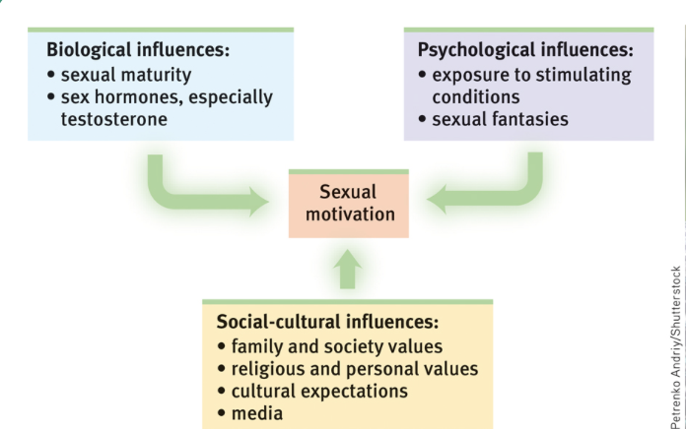
Psychological Influences

External Stimuli
- with repeated exposure, the emotional response to any erotic stimulus often lessens, or habituates
- Mens feelings of sexual arousal have much more closely mirrored their (more obvious) genital response than women’s

Imagined Stimuli
- the brain - our most signified ant sex organ
- Lacking genital sensation does not stop us from feeling sexual desire
- Fantasizing about sex does not indicate a sexual problem or dissatisfaction

Part 3

The Sexual Response Cycle
- 1960s, Masters and Johnson recorded the physiological responses of volunteers who came to their lab to masturbate or have intercourse

Paraphilias - sexual arousal from fantasies, behaviours, or urges involving nonhuman objects, the suffering of self or others, and/or non consenting persons

Sexual Orientation
- “the neuroanatomical correlates of male homosexuality differentiate very early postnatally, if not prenatally”

Affiliation and Achievement

The Pain of Being Shut Out
- ostracism elicit increased activity in brain areas, such as the anterior cingulate cortex, that also activator in response to physical pain

Chapter 12: Emotions, Stress, and Health

Emotion

