Experiment 1: Thin Layer Chromatography

By:
Angela Lueth
300044850

CHM1321- Section C01

TA:
Yiran Li

Department of Chemistry

University of Ottawa

January 16th, 2018

Protocol:
- Refer to the procedure in the Organic Chemistry Lab Manual pages 13-19 for Experiment 1: Thin Layer Chromatography.
  - Modifications:
    - Instead of letting the TLC sit in the sealed jar within the solution for 3-5 minutes, allowed the TLC to sit the sealed jar until the solvent had moved up the TLC leaving a 1 centimeter gap from the top.
  - Reference:
    - “Experiment 1: Thin Layer Chromatography” – Organic Chemistry Laboratory Manual – By: Dr. Tony Durst, Dr. Tito Scaiano, Dr. William Ogilvie, Dr. Alison Flynn - Revised by: Dr. Bianca van Lierop, Dr. Alex Bush, and Dr. Rashmi Venkateswaran
Observations:
- Most of the chemicals appeared transparent such as the biphenyl and the dichloromethane along with both of our Unknowns (Unknown #64 and Unknown ZZ). \
  - With the exception of P-Bromonitrobenzene as it appeared as a yellowish colour to the naked eye.
- Most of the chemicals gave off a strong scent.
- As my partner and I preformed our TLCs, we recorded to the time of each TLC (the time it took for the solvent to reach 1 cm from the top):
  - TLC 1: 5 minutes
  - TLC 2: 3 minutes
  - TLC 3: 5 minutes
  - TLC 4: 4.5 minutes
  - TLC 5: 6 minutes
  - TLC 6: 5.5 minutes
  - TLC 7: 3 minutes
  - TLC 8: 4.5 minutes
  - TLC 9: 6.2 minutes
    - Each TLC corresponds to the figure # in the next part.
- Some spots were harder to see, while others were grouped together.

Thin Layer Chromatography:

- Figure 1:
  - TLC plate lanes go as followed (first lane being the leftmost lane):
    - First lane containing Benzophenone,
    - Second lane containing both Benzophenone and the Unknown,
    - Third lane containing the Unknown #64 dissolved in 2 ml of Dichloromethane.
  - Prepared in a 10 mL solvent system of a 2:8 mixture of Ethyl Acetate (EtOAc) to Hexanes in a developing jar.

- Figure 2:
  - TLC plate lanes as followed:
    - First - Biphenyl,
    - Second - Containing both Biphenyl and Unknown,
    - Third - Containing the Unknown #64 dissolved in 2 ml of Dichloromethane.
  - Prepared in a 10 mL solvent system of a 2:8 mixture of Ethyl Acetate (EtOAc) to Hexanes in a developing jar.

- Figure 3:
  - TLC plate lanes as followed:
    - First – Benzophenone,
    - Second - Benzophenone and the Unknown,
    - Third - Containing the Unknown #64 dissolved in 2 ml of Dichloromethane.
  - Prepared in a 10 mL solvent system of Ethyl Acetate (EtOAc) in a developing jar.

- Figure 4:
  - TLC plate lanes:
    - First – Biphenyl,
    - Second - Containing both Biphenyl and the Unknown,
    - Third - Containing the Unknown #64 dissolved in 2 ml of Dichloromethane.
  - Prepared in a 10 mL solvent system of Ethyl Acetate (EtOAc) in a developing jar.

- Figure 5:
  - TLC plate lanes:
    - First - Benzophenone,
    - Second - Containing both Benzophenone and the Unknown,
    - Third - Containing the Unknown #64 dissolved in 2 ml of Dichloromethane.
  - Prepared in a 10 mL solvent system of Hexanes in a developing jar.

- Figure 6:
  - TLC plate lanes:
    - First - Biphenyl, the
    - Second - Both Biphenyl and the Unknown,
    - Third - Containing the Unknown #64 dissolved in 2 ml of Dichloromethane.
  - Prepared in a 10 mL solvent system of Hexanes in a developing jar.

- Figure 7:
  - TLC plate lanes:
    - First - Containing M-Bromonitrobenzene,
    - Second - Containing both M-Bromonitrobenzene and the Unknown,
    - Third - Containing the Unknown ZZ.
  - Prepared in a 10 mL solvent system of a 9:1 mixture of Hexanes to Ethyl Acetate (EtOAc) in a developing jar.

- Figure 8:
  - TLC plate lanes:
    - First - Containing P-Bromonitrobenzene,
    - Second - Containing both P-Bromonitrobenzene and the Unknown,
    - Third - Containing the Unknown ZZ.
  - Prepared in a 10 mL solvent system of a 9:1 mixture of Hexanes to Ethyl Acetate (EtOAc) in a developing jar.

- Figure 9:
  - TLC plate lanes:
    - First - Containing O-Bromonitrobenzene,
    - Second - Containing both O-Bromonitrobenzene and the Unknown,
    - Third - Containing the Unknown ZZ.
  - Prepared in a 10 mL solvent system of a 9:1 mixture of Hexanes to Ethyl Acetate (EtOAc) in a developing jar.

Calculations:

Rf values:
$$Rf value=\frac{x}{y}$$
x= the distance from the dotted line to the middle of the spot
y= the distance the solvent travelled from the dotted line to the solid line.
Ex.
- First dot on the left side is 3.0 cm from the dotted line (Benzophenone).
- Farthest right dot is 3.71 cm from the dotted line (Unknown).
- Solution travelled 4.1 cm from the bottom dotted line to the top dotted line.
Using the Rf value equation:
Benzophenone:
$$Rf value=\frac{x}{y}$$
$$Rf value=\frac{3.0 cm }{4.1 cm}$$
$$Rf value for Benzophenone=0.732\sim 0.73$$

Unknown:
$$Rf value=\frac{x}{y}$$
$$Rf value=\frac{3.71 cm}{4.1 cm}$$
$$Rf value for Unknown=0.904 \sim 0.90$$
Mole Percent:
The mixture is a Meta-Ortho-Bromonitrobenzene compound due to the observation.
Abundance of Meta= 27141.070
Abundance of Ortho= 9852.530
% Absorbance of Meta= [(Meta)/ (Meta+Ortho)] x 100 = [(27141.070)/(27141.070+9852.530)]
= 0.7336 x 100 = 73.36 $\sim$ 73.4%
% Absorbance of Ortho = 100% - Absorbance of Meta
= 100% - 73.4% = 26.6%
Using Calibration Curve of Meta – Ortho:

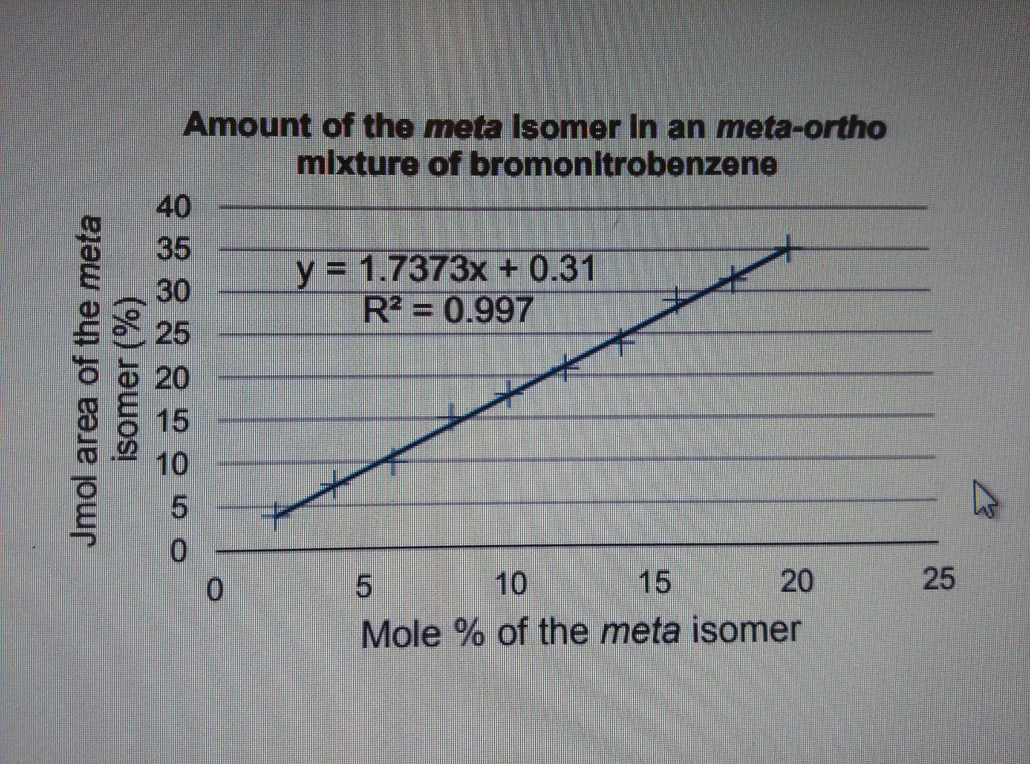

y = % of Absorbance of meta-isomer = 73.4 %
$$y=1.7373x+0.31$$
$$73.4=1.7373x+0.31$$
$$73.4-0.31=1.7373x$$
$$73.09=1.7373x$$
$$x=\frac{73.09}{1.7373}$$
$$x=42.07\sim 42.1\%$$

x = Meta-isomer mole % = 42.1 %
Ortho-isomer mole % = 100% - 42.1% = 57.9%

Discussion/Questions:
Protocol justification:
- Although there was a time set between 3-5 minutes for the TLC to sit within the solvent, my partner and I did not follow that rule due to some of the TLCs were not fully soaked to the 1 centimeter line from the top. Due to this, we still continued to time the TLCs but instead of pulling them out at 5 minutes, we allowed them to stay within the solution until they reached approximately the 1 cm mark from the top of the TLC.
Analysis of TLCs and Results:
- The Analysis of the TLC will occur according to the figure number:
  - Figure 1:
    - From the results of the first TLC, we made the prediction that the unknown compound was nonpolar as it travel further up the TLC. We also concluded that it did not contain any Benzophenone as the spots did not lineup.
    - Upon using the UV light to see the spots, majority of the spots were clear therefore allowing for a more accurate and precise prediction of the Rf value. And since the unknown compound had a high Rf value, it lead us to the conclusion, that it was nonpolar or had a low polarity compared to the Benzophenone.
  - Figure 2:
    - Combining the results of first TLC and the second TLC, it confirmed our prediction of the unknown compound being nonpolar. The Biphenyl also travelled very far, very close the unknown value leading us to the conclusion that the unknown compound contains some Biphenyl.
    - Since the Rf values of both compounds were very high, my partner and I believe that both the Biphenyl and unknown compound are nonpolar.
  - Figure 3 and 4:
    - These two TLCs observations are combined due to the fact that both TLCs are similar. The reference compound – whether it was Benzophenone or Biphenyl – travelled and reached a Rf value of around 0.91. With this result, I am lead to believe the reason why both reference compounds travelled so far was because of the solvent solution they were put in. The results show that the solution must have been very polar and the benzophenone and biphenyl compounds are nonpolar as well as the unknown since all three compounds travelled very far.
  - Figure 5:
    - The solvent solution changed to only Hexanes which showed a difference in the benzophenone in the fifth TLC.
    - Within this TLC, the Rf value was zero for the benzophenone which allows me to reach the conclusion that the benzophenone is polar. The unknown instead travelled further causing my partner and I to believe the compound is nonpolar.
  - Figure 6:
    - The Biphenyl compound travelled far and the spot was very close to the spot of the unknown of the benzophenone reaction. The biphenyl compound was 0.40 while the unknown compound had a Rf value of 0.41. As a result, my partner and I believe the unknown compound contains a high concentration of biphenyl, due to the close Rf values.
  - Figure 7, 8 and 9:
    - These three TLCs are combined in one result because all three of them were used to determine the Unknown compound ZZ.
      - Our conclusion, Unknown compound ZZ is meta-ortho.
        - This conclusion was reached through analysing each TLC and combining the data to form one result.
      - Since the Unknown compound ZZ was said to be meta-ortho through experimental data (showed above in the figures), we composed our calculations to reach the mole percentage of both the meta and ortho isomers within the compound.
      - We also reached the conclusion that the compound was more polar than other compounds as the Rf values of both meta and ortho isomers are lower.
Source of Error and Possible Amelioration:
- There are a variety of sources of errors and possible ameliorations that were found.
  - One source of error would be the timing of the TLCs in the solution.
    - There were a few where we had forgotten to time once we sealed the jar, therefore we approximated the times such as the time for the first two TLCs with one for Benzophenone and other for Biphenyl in the 2:8 mixture of Ethyl Acetate to Hexanes.
  - Another source of errors were the spots.
    - My partner and I had some troubles in the beginning of making a small but definite spot on the TLC. Small spots are definitely preferred and easier to see under the UV light but it was challenge as displayed in the pictures of the TLCs.
  - Measurements of the spots.
    - This was also a challenge as my partner and I did not draw straight lines on our TLCs therefore, that might affect our results as well measuring the spots from crooked line may have affected the overall Rf values of each substance.
  - Our ability to observe the spots.
    - We are scientists, but we are not entirely skilled in the area of indicating a spot. My partner and I had some troubles in identifying some spots after looking at the TLCs under the UV light as some spots were combined with other sports, leading back to the source of error of making larger dots. This also may have affected our Rf values and the mole percentage of the Unknown ZZ in Part C.
  - A Possible Amelioration: Using a Ruler for lines.
    - Using a ruler to construct the dotted line at the bottom and bolded line on the top of the TLC would improve the value of the Rf because we would not have to guess the distance.
  - Another Possible Amelioration: Smaller spots.
    - Smaller spots would increase the accuracy of our TLCs and the accuracy of the mole percentage. The smaller the spot, the easier it is to spot and take note of.
  - Questions:
    - How does increasing the polarity of the solvent system affect the results of a TLC?
      - Increasing the polarity of solvent affects the chemicals that are being tested in the TLC directly. If one is to test a nonpolar solution, if it were placed in a solvent with high polarity, the chemicals in the solution that are nonpolar will not move up the TLC as far as a polar chemical will. Polar compounds are more attracted to the silica therefore causing them to not move as far as the nonpolar compounds.
    - In the following sets of compounds, which would have the smallest Rf on silica gel?
      - Benzoic acid would have the smallest Rf value because it is the most polar compound of them all, and the more polar the compound it is, the shortest it travels on silica gel.
    - benzyl alcohol
    - benzaldehyde
    - benzyl acetate
    - aniline
    - N,N-dimethylaniline
    - naphthalene
    - benzophenone
    - biphenyl
    - benzoic acid



