CHM1301 – Section 4
Introduction to Chemistry

Experiment 1: Validation of Boyle’s Law

Emily Agnew 300024280
Hana Sabo 300002037

TA: Marina Sanita
Lab date: September 19, 2017
Due date: September 26, 2017

Introduction:
Boyle’s law is one of the many laws used to explain the properties of gases, and is used to delineate the relationship between volume, pressure, and temperature of a gas. Throughout a multitude of experiments, it has been determined that when temperature is kept constant, the product of the pressure and the volume of a gas is a constant. The purpose of this experiment is to examine this relationship.

Equipment:
- Vernier Gas Pressure Sensor
- LabQuest 2
- 20 mL gas syringe
- USB key
- Safety glasses

Procedure:
- Put on safety glasses and ensure they are on for the entirety of the procedure.
- Prepare the Gas Pressure Sensor and air sample, and set up LabQuest 2 in data collection mode, as stated in the lab manual (Verification of Boyle’s Law, Dr. Rashmi Vankateswaran, Exp. 1, p. 4).
- Collect data and plot measurements.
  - Hold plunger to 3 mL using bottom black line closest to the tip of the plunger – ensure that each subsequent volume is measured in the same way.
NOTE: ensure that each volume reading includes the volume inside the Gas Pressure Sensor as well (0.8 mL).
  - Once pressure reading stabilizes, tap “Keep” and enter 3.8 mL, select “OK” to proceed.
  - Repeat the process with the following volumes: 6 mL, 9 mL, 12 mL, 15 mL, 18 mL.
  - For the final measurement, move plunger back to 3 mL (3.8 mL), record, stop data collection.
- Decide which measurement of the original data to keep.
  - Examine the plotted points and determine which of the two points is a better fit within the data set.
  - Tap the “Table” icon (top of the screen), choose which data to remove by tapping on it.
  - Open “Table”, on the menu that appears, tap “Strike Through Data”.
  - Tap of the “Graph” icon to return to the graph screen.
- Analyze graph to determine mathematical relationship. To test various functions:
  - Tap “Analyze” and choose “Curve Fit Pressure (kPa)”.
  - Open menu below “Fit Equation” and choose a function to perform on your data.
  - Determine the equation that best fits the data and select “OK” to return to the graph screen, where the function will be plotted along with your data.

Observations:
Table 1: Observations of Volume and Pressure
Trial | Independent Variable  Volume + 0.8 mL  (mL) | Dependent Variable  Pressure  (kPa)
1 | (3 mL + 0.8 mL =) 3.8 | 101.89
2 | 6.8 | 52.65
3 | 9.8 | 36.28
4 | 12.8 | 28.89
5 | 15.8 | 23.21
6 | 18.8 | 19.39
7 | 3.8 | 96.72

NOTE: Trial 7 (3.8 mL @ 96.72 kPa) is removed from the data set, as it is likely that some air leaks out over the course of the experiment. It is determined that trial 1 is a more accurate measurement.

Graph 1: The Effect of Change in Volume Over Pressure of a Gas
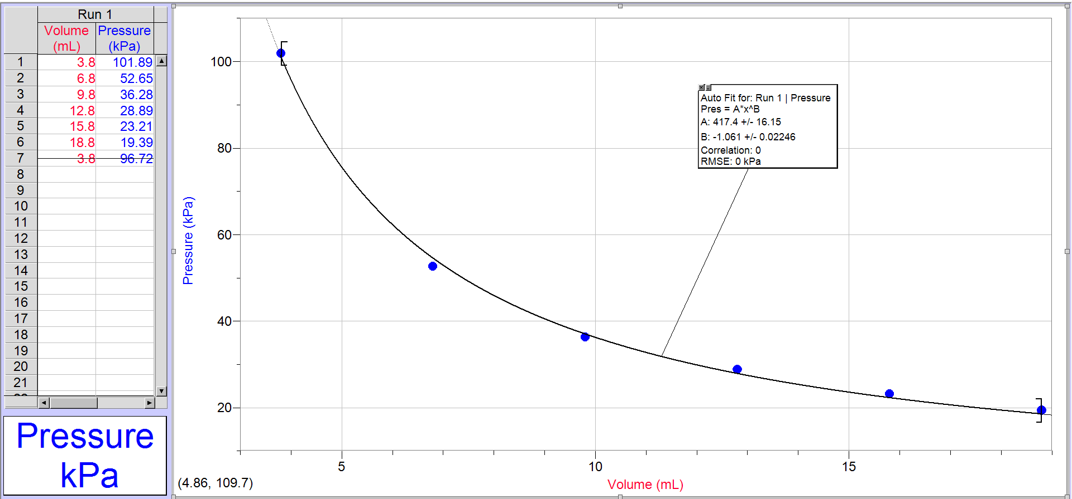

Calculations:
Table 2: Calculation of Constant (k)
Let (k) be the Boyle’s law constant.
Trial | Volume (mL) | Pressure (kPa) | Constant (k)
1 | 3.8 | 101.89 | (3.8 mL)(101.89 kPa) = 387.18
2 | 6.8 | 52.65 | 358.02
3 | 9.8 | 36.28 | 355.54
4 | 12.8 | 28.89 | 369.79
5 | 15.8 | 23.21 | 366.72
6 | 18.8 | 19.39 | 364.53
Average of constant k |  |  | 366.96

Data Analysis:
- Refer to Table 2: Calculation of Constant (k) for Boyle’s law constant calculations. The constant is determined by assuming that variables T (room temperature) and n (moles) are controlled throughout the experiment. From this, we can assume the formula:
$$PV=k$$

To determine this formula, the observed volume is multiplied by its corresponding pressure to find the constant k. Refer to Table 2: Calculation of Constant (k) for an example of this calculation.
Once k is calculated for each trial, and average of constant k is determined. The average of the constant is shown to be equal to 366.96. This is then compared to the k value determined from the slope of the graph, which in the case of this experiment is equal to 417.38. Although there is a fairly significant difference of 50.42 between the two values of the constant k, this difference can be accounted for as human error (refer to sources of error in question 4). It is assumed that the k value derived from the slope of the graph is less accurate than the average value of k as calculated in Table 2: Calculation of Constant (k), due to the fact that the curve only passes through some of the points.
- The mathematical relationship observed can be represented by the following power function:
$$y=Ax^{B} \\ A:417.38 \\ B:-1.0613 \\ RMSE:1.0979$$

Using the constant calculated in Step 1, the following formula is determined:
$$PV=k$$
- It is important to take multiple readings of the same variable in order to ensure accuracy in the measurements. As shown in this experiment, two different values are obtained for the same volume (noting a difference of 5.17 kPa). Throughout any experiment, it is likely that there is some degree of equipment or human error, so multiple trials are necessary to account for this variance in values.
- Boyle’s law states that:
$$PV=nRT=k$$
All variables aside from pressure and volume are assumed to be constant. There is no way to accurately measure T and n, as the experiment is not conducted in a contained environment. These variables are considered, but for the purpose of this experiment, an assumption is made that they remain the same. R is always a constant, and as such, is negligible in these calculations.
No significant change in the temperature or moles occurs throughout this experiment. If there is any drastic change in these variables, it will be reflected in the data observations, and as such, will also be reflected in the calculations of constant k. Pressure, volume, and temperature are directly related, so if the temperature is increased, the pressure and volume increase accordingly. This in turn affects the value of the constant k.
This inability to adequately control the temperature can be seen as a source of error in the experiment. Any fluctuation in temperature disrupts the results, leading to an inaccurate measurement. Another source of error occurs in the equipment used. While the syringe has a rubber seal, it is observed that throughout the course of the experiment, air leaks out of the syringe. It is noted that when a second measurement is taken at a volume of 3.8 mL at the end of the data collection, a difference of 5.17 kPa is discovered between the two measurements. Therefore, it is predicted that a) the connection between the tip of the syringe and the Gas Pressure Sensor is not airtight, or b) the rubber seal at the opposite end of the syringe is not airtight. It should also be noted that the measurement of volume is done by hand, and as such, a possible lack in measurement precision is recognized. Another source of error found throughout the course of the experiment is that air is not an ideal gas, and some variance in values for P must be noted to account for this.

Conclusion:
This experiment confirms that there is in fact a Boyle’s law constant, and that the relationship between pressure and volume is inversely proportional. The data collected supports this law, as all the calculations for the constant k fall within a relatively small range. The value of constant k is determined to be approximately 366.96.

References:
Hall, N. (Ed.). (2015, May 5). Boyle's Law. Retrieved September 22, 2017, from
https://www.grc.nasa.gov/www/k-12/airplane/boyle.html
Dr. Rashmi Vankateswaran. “Do I Dare Disturb the Universe?” Lab Manual. Page 4. (2017).

Peer Evaluation Form:
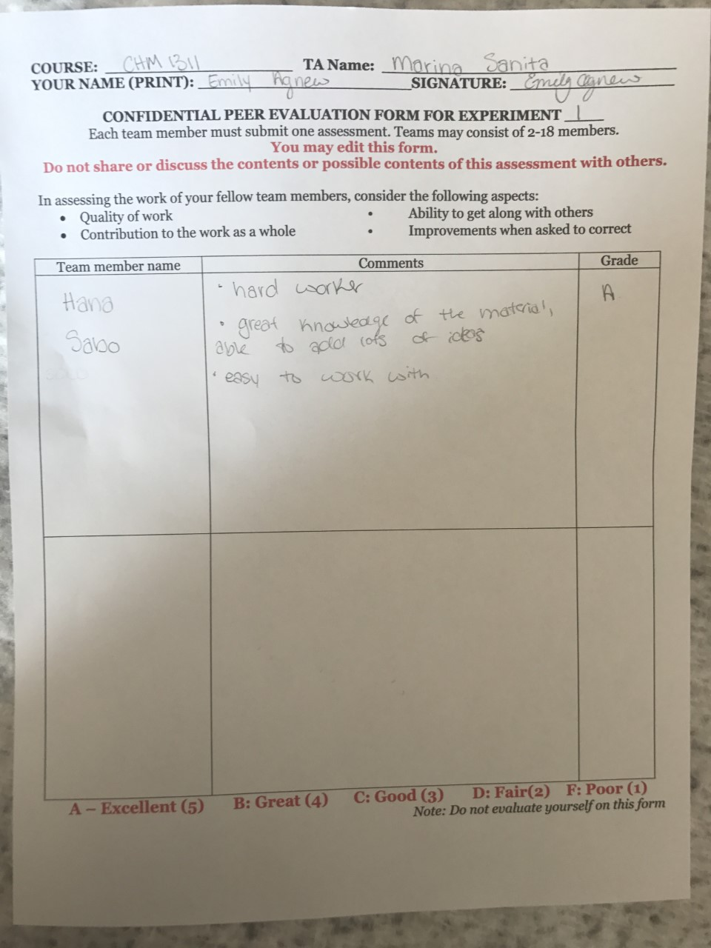

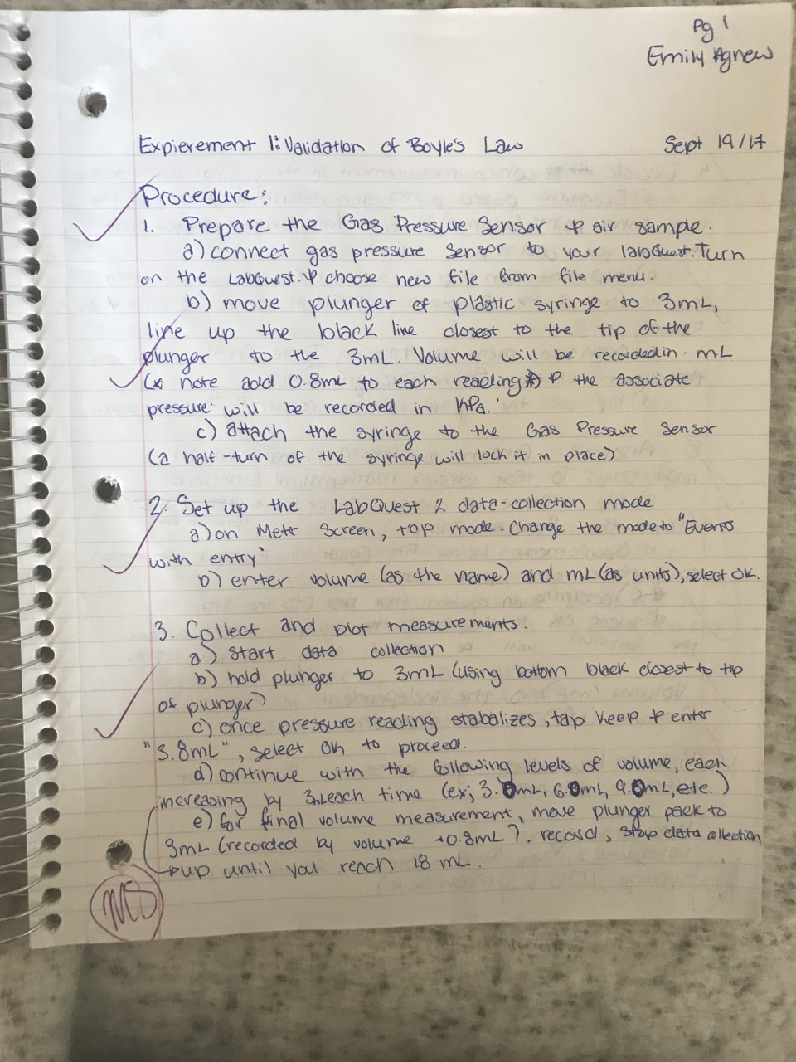
Raw Data:



