Experiment 1: Thin Layer Chromatography

Name: Mays Abu Sheikh
Student Number: 300010766
Partner: Hershelle Ribo
Student Number: 300018882
TA: Kimia Jahandar Kojouri
CH1321-A07
Lab performed: January 11th, 2018

Protocol:
See laboratory manual page 17 to 19.
Observations:
- Unknown compound #74 was white and crystalline
- Compound ZZ had a slight yellow tint
TLC Images:
Columns:
“r”-reference
“c”- co-spot
“s”- sample
Part A: 2:8 EtOAc in developing jar. Sample: unknown #74
Plate #1: Biphenyl Plate #2: Benzophenone
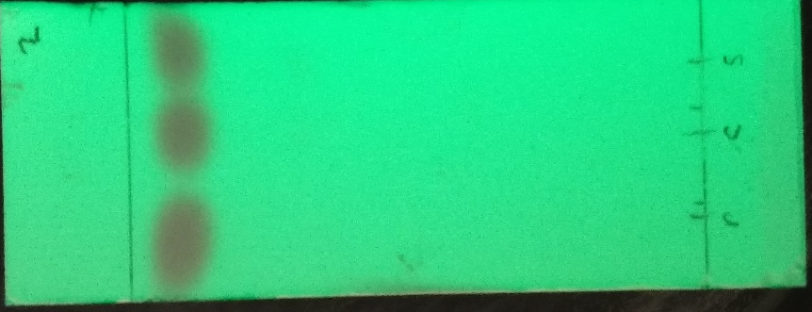
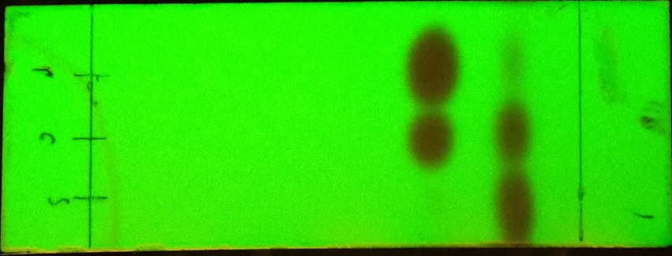
4.3 cm
4.3 cm
3.5 cm
4.3 cm

Part B:
Plate #3a: Biphenyl in EtOAc Plate #4a: Benzophenone in EtOAc
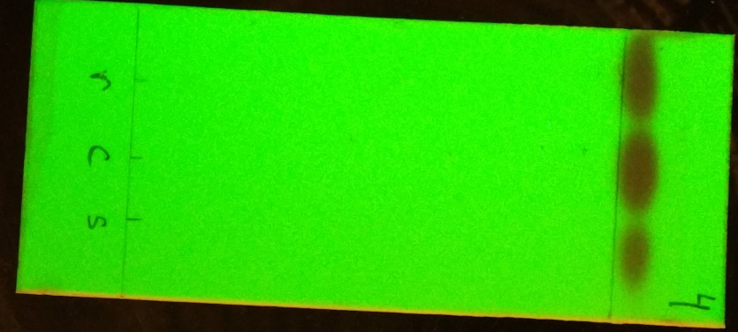
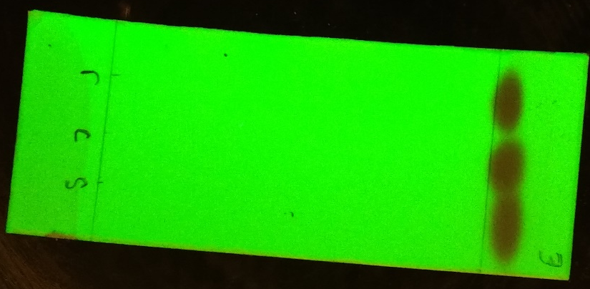
4.8 cm
4.8 cm

Plate #3b: Biphenyl in hexane Plate #4b: Benzophenone in hexane
(borrowed data) (borrowed data)
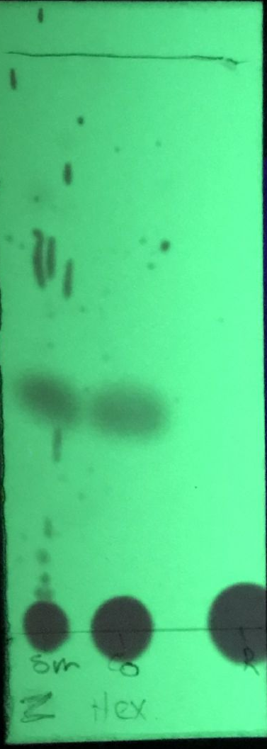
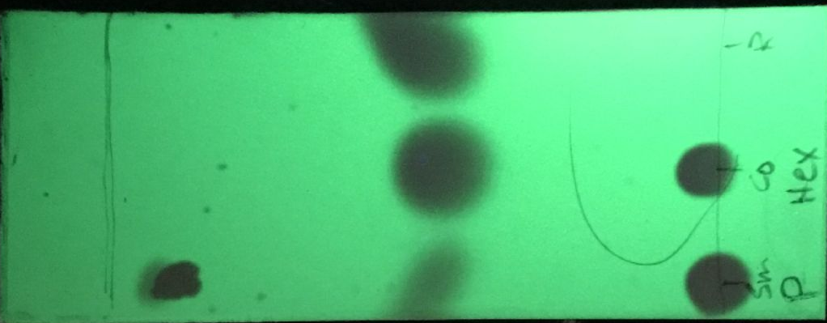
Part C: unknown compound: ZZ
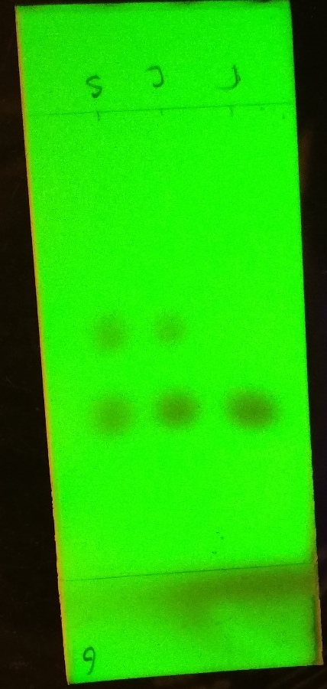
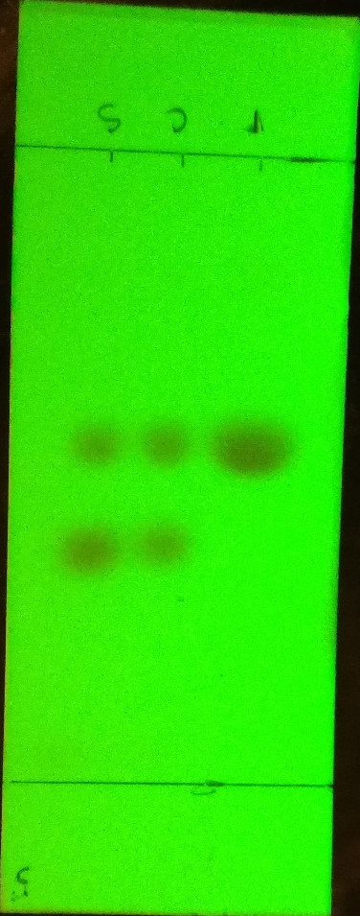
Plate #5: o-bromonitrobenzene Plate #6: m-bromonitrobenzene

Plate #7: p-bromonitrobenzene

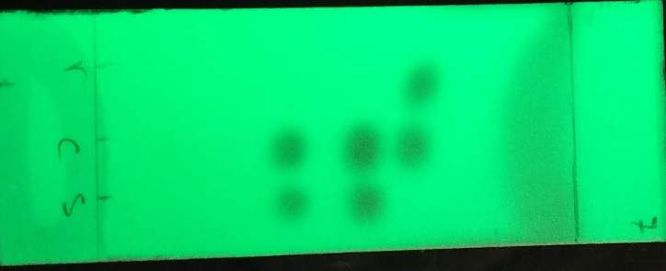

Calculation Sample:
Rf value equation:
Rf= d1/dt
Sample calculation for part A, plate #2:
d1= 4.3 cm
dt= 4.9 cm
Rf= d1/dt = 4.3cm/4.9 cm
Rf= 0.88
Image J Calculations:
Calculations for % absorbance:
- Absorbance of ortho: 34926
- Absorbance of meta: 40192
% Absorbance of ortho = (34926/ (34926+40192)) x 100% = 46.5%
% Absorbance of meta = 100% - 46.5% = 53.5%
Calculations for mole %:
Y= % absorbance (meta)
Y= 1.7373x + 0.31
Thus, x= 30.6%
% mole (meta)= 30.6%
% mole (ortho)= 69.4%
Plot for plate 5 (ortho):

Plot for plate 6 (meta):

Table of Rf Values:
 |  | Rf Value
Plate #1 | Sample | 0.88
Plate #1 | Co-spot | Rf1=0.88 Rf2=0.71
Plate #1 | Reference | Rf1= 0.88 Rf2= 0.71
Plate #2 |  | 0.88
Plate #3a |  | 1.0
Plate #3b | Sample | Rf1=0.0 Rf2=0.92
Plate #3b | Co-spot | Rf1= 0.0 Rf2= 0.49
Plate #3b | Reference | Rf= 0.51
Plate #4a |  | Rf=1.0
Plate #4b |  | Rf= 0.0
Plate #5 | Sample | Rf1=0.63 Rf2=0.52
Plate #5 | Co-spot | Rf1=0.63 Rf2= 0.52
Plate #5 | Reference | Rf=0.52
Plate #6 | Sample | Rf1=0.63 Rf2=0.52
Plate #6 | Co-spot | Rf1=0.63 Rf2=0.52
Plate #6 | Reference | Rf1=0.63

Discussion:
- This experiment tested the polarity of compounds through thin layer chromatography.
- Like dissolves like when it comes to polarity
- The more polar a compound is, the more hydrogen bonds it can form
- In part A, an unknown compound, #74 in this case, was tested with both biphenyl and benzophenone as references on 2 separate TLC plates.
- One plate was prepared with biphenyl as the reference compound, and the other used benzophenone as the reference compound.
- By looking at the results of part A (plates 1 and 2), it is evident that the compound is less polar than biphenyl, and about the same polarity as benzophenone.
- This conclusion can be made by looking at the positions of the different circles on the TLC plate. Th circle for the unknown #74 is higher than that of biphenyl, which makes it less polar.
- This means the compounds with the higher Rf value, meaning they are higher up the TLC plate, are less polar than those with a smaller Rf value.
- Part B was done to test whether ethyl acetate or hexane was more polar by observing how far the spots are, and calculating the Rf values.
- When looking at the plates, 3a&b and 4a&b, we can see that the ethyl acetate solvent is more polar than the hexane.
- That’s because the spots on the TLC that developed in hexane are much lower, while the spots in ethyl acetate solvent are very high up the TLC.
- The EtOAc solvent results in very high Rf values, while the hexane solvent has much lower Rf values.
- Part C was performed using the unknown compound ZZ as the sample, and three TLC plates were developed using o, m, and p-bromonitrobenzene as the references in a 9:1 Hexanes: Ethyl Acetate
- After developing and viewing the plates under the UV light, o and p-bromonitrobenzene had similarly placed dots on the TLC plates, but not p-bromonitrobenzene
- Using the equation y=1.7373x+0.31, the mole % of both ortho and meta was found, which were 69.4% and 30.6% respectively.
- Therefore, the ratio would be 2.3:1
Errors:
- The second half of part B was accidentally skipped, and therefore some data had to be borrowed from another group.
- This may have disrupted the consistency of the results since the borrowed data was obtained under different conditions, in another lab section.
- It was nearly impossible to make sure that our fingers did not, even partially, touch the silica gel on the TLC plate
- As a result, the gel may have been affected which would impact the results and the clarity of the spots

Questions:
- Increasing the polarity of the solvent system will cause the less-polar compound on a TLC to move up higher on the plate. This will also result in a higher Rf value of the less-polar compound.
- a) the smallest Rf value would belong to Benzyl alcohol, since it’s the most polar. Being the most polar means sticking to the silica gel and not travelling as high as the other less-polar compounds.

b) Aniline would have the lowest Rf since it’s the most polar out of the three structures.

c)The smallest Rf value would belong to benzoic acid, since it’s the most polar due to the hydrogens and oxygens in its structure.

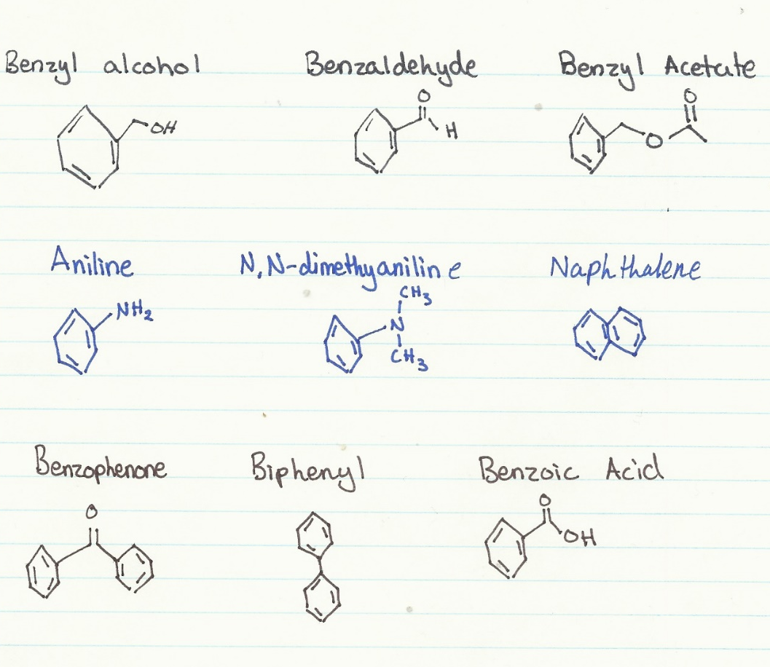

Citation
Borrowed data:
Name: Nazanin Aliabadi (300006827) and Klaudia Baumann
Lab section: A



