Boyle’s Law Verification
September 28, 2017

Introduction:
The behavior of gases is defined by three laws; Boyle’s law relating the effects of volume and pressure, Charles’ law relating temperature and pressure, and Avogadro's constant relating the number of moles and volume. Our objective is to understand the changes of pressure air will undergo when the volume of a closed container is changed. Which means by holding the value of temperature and moles fixed we are free to use the principles of Boyle’s law.
P₀V₀ = P₁V₁ [1]
By using the initial pressure and volume as a tool we can modify the formula to better suit our experiment and to prove Boyle’s law.
P₀V₀ = C [2]
The value of C must remain the same for all volumes we test, therefore the pressure varies leaving it to be our dependent variable, using the constant from our initial test we can calculate and check our mathematical values against our experimental values to see if the relationship that Boyle describes is accurate. n being any of our test cases.
P_{n} = C / V_{n} [3]
From this equation we can see the relationship between pressure and volume is inversely proportional, now to see if the experimental data will verify the mathematical data.

Materials:
- Gas pressure sensor
- Syringe (20mL)
- LabQuest 2
- USB

Procedure:
- Prepare a syringe, a gas pressure sensor, and LabQuest 2.
- Connect the gas pressure sensor to LabQuest 2.
- Move the plunger to the 20 mL mark.
- Attach the syringe to the valve of the gas pressure sensor and lock it in with a half turn.
- On LabQuest 2, the metre screen, tap mode and change the mode to events with entry. Enter the name (your independent variable) and units for the variable.
- Start data collection and hold the syringe plunger at 20 mL and after the reading stabilizes, tap keep and enter the volume +0.8 mL (to make up for the air not measured in the tip of the syringe.
- Move the plunder 2 mL inwards to change the volume of air in the syringe and hold it in place. Tap keep after reading stabilizes and enter the volume (+0.8).
- Repeat step 7 for 5 different volumes. For the final volume, move the plunger back to the original volume mark and take the reading.
- Do steps 7-8 two more times for a total of 3 trials.

Data:

Trial 1 |  | Trial 2 |  | Trial 3
Volume (mL) | Pressure (kPa) | Volume (mL) | Pressure (kPa) | Volume (mL) | Pressure (kPa
20.8 | 100.79 | 20.8 | 101.84 | 20.8 | 102.21
18.8 | 112.55 | 18.8 | 112.86 | 18.8 | 115.47
16.8 | 126.25 | 16.8 | 125.09 | 16.8 | 126.82
14.8 | 141.31 | 14.8 | 143.91 | 14.8 | 144.91
14.8 | 157.23 | - | - | - | -
12.8 | 146.69 | 12.8 | 167.83 | 12.8 | 162.60
10.8 | 193.72 | 10.8 | 201.54 | 10.8 | 199.42
8.8 | 225.21 | 8.8 | 225.21 | 8.8 | 225.21
20.8 | 101.84 | 20.8 | 102.18 | 20.8 | 102.20

Average Volume (mL) | Average Pressure (kPa)
20.8 | 101.84
18.8 | 113.63
16.8 | 126.05
14.8 | 148.84
12.8 | 159.04
10.8 | 198.23
8.8 | 225.21

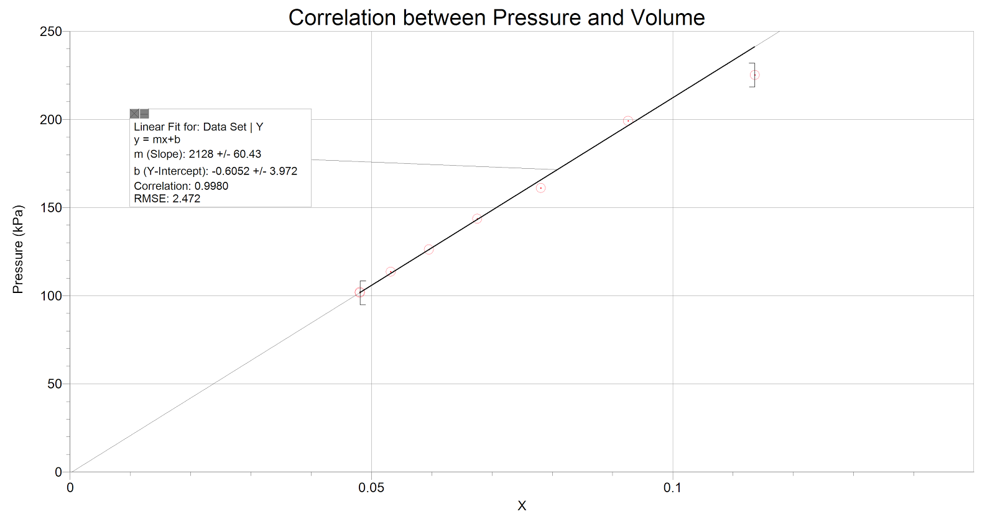

Figure 1: Correlation between average Pressure and 1/ Volume
Line equation is : y = mx + b
m = 2128 +/- 60.43
b = -0.6052 +/- 3.972

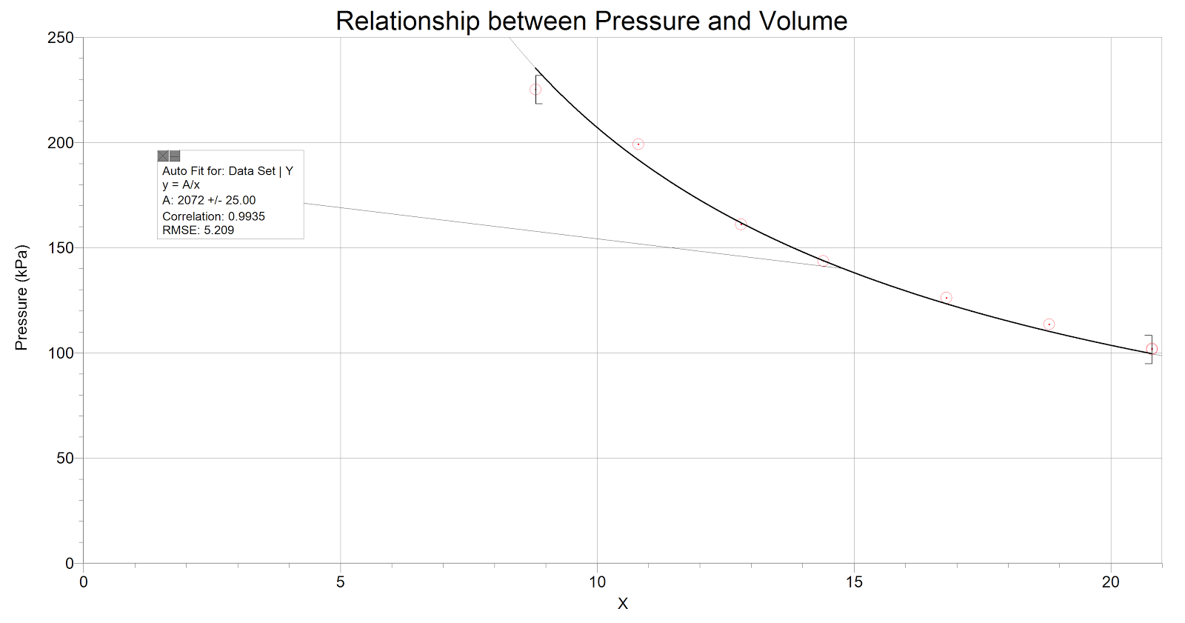

Figure 2: Relationship between average Pressure and Volume
Curve equation is: y = a/x
a = 2072 +/- 25.00

Observations:
Qualitative
As the volume inside the syringe was being decreased by an increment of 2 mL, the pressure inside could be felt increasing. At 10 mL, it began to become very difficult to decrease the volume and became impossible to decrease the volume further than 8 mL due to insufficient strength. This can be explained through figure 1 where it shows a linear relationship between pressure and the inverse of volume because to compress the gas within the syringe and increase the pressure further, more force needs to applied to plunger. The temperature could not have been affected through touch due to the syringe being held at the plunger.

Calculations (using average values found):

P₀V₀= (20.8)(101.84) = 2118.27 = C (Because temperature is constant throughout)
- V₁ = 18.8 2118.27/18.8 = P₁
P₁ = ? 112.67 kPa= P₁ Experimental value = 113.63

2. V₂ = 16.6 2118.27/16.8 = P₂
P₂ = ? 125.84 kPa = P₂ Experimental value = 126.05

3. V₃ = 14.8 2118.27/14.8 = P₃
P₃ = ? 143.13 kPa = P₃ Experimental value = 146.84

4. V₄ = 12.8 2118.27/12.8 = P₄
P₄ = ? 165.49 kPa = P₄ Experimental value = 159.04

5. V₅ = 10.8 2118.27/10.8 = P₅
P₅ = ? 196.14 kPa = P₅ Experimental value = 198.23

6. V₆ = 8.8 2118.27/8.8 = P₆
P₆ = ? 240.71 kPa = P₆ Experimental value = 225.21

Discussion:
The theory behind Boyle’s law shows that when the volume increases, the pressure decreases and vice versa. Our data shows exactly this inverse relationship, but the constant d differs slightly. This is due to the mathematical and experimental data which are not exactly the same, and this could be explained through the error in our procedure and in the experiment, itself. This can be explained through the standard error of the volume when it was taken. Another reason is because the mixtures of gases in the syringe do not all act like ideal gases which can cause deviations within the quantitative data. The gases in the real world have mass and intermolecular forces in between them. Furthermore, after pushing the plunger past the 10mL mark, it became increasingly difficult to push it down further or keep it stabilized for a long period of time, so the pressure reading could have been off.

(Question 1) The constant for Boyle’s is the volume multiplied by the pressure so using our beginning values:
P₀V₀ = C
(20.8)(101.84) = C
2118.27 =C
The constant can also be seen as the slope of the linear graph shown in figure 1.

(Question 2)The relationship between volume and pressure is inversely proportional as shown in the graph. The constant of this relationship is based on the initial value of volume and pressure in the area so:
P₀V₀ = C
At the same time the values of pressure and volume are reliant upon the constant and if one changes the other reacts accordingly.
P₁V₁ = C
Now we can combine these two equations because they are both equal to the constant, making that if we have known values for three of the four variables we are able to calculate the fourth.
P₀V₀ = P₁V₁

(Question 3)The importance of taking multiple tests of the same independent variable is confirm the value of the dependent variable. In this case we can see there are slight changes every time we measure our starting volume, this is caused because the seal between the gas pressure sensor and the syringe not being airtight, and allowing some molecules to escape. Another reason to confirm the dependent variable is for our calculations to be as precise as possible and avoiding assumptions that the procedure will function perfectly every time.

(Question 4)The conditions that needs to be met for the other gas variables are that they are constant. These variables are temperature and the number of moles within the system. These variables were taken into consideration as temperature of the gas was room temperature and the plunger was not taken out of the syringe to ensure that the moles stayed constant throughout the different volumes and trials.
We made sure to hold the syringe by the plunger and the end so there is less chance of increasing the temperature through body heat. To ensure that the moles stayed constant we made sure the wire connecting to LabQuest 2 was tight and made sure the plunger formed a seal with the barrel of the syringe.

Erroneous procedures most likely lead to erroneous results. In the experiment, it is possible that we did not leave a long enough window for the readings to stabilize before keeping the value in LabQuest 2. The seal between the syringe and the gas pressure sensor could have become loose after the pressure increased.

Conclusion:
In the experiment, we can see the defined relationship between the volume and the pressure being inversely proportionally. Our experimental results compared to the mathematical data are off, but not by an amount that would skew the results and also demonstrates the area that the ideal gas law takes effect. The data for smaller volumes differed larger from the mathematical results, evidence of the ideal gas law. That can also be seen in the error percentage for 18.8mL we had an error percent of 0.85%, but for 8.8mL the error percent was -6.4%.

References
Vertchenko, L; Dickman, AG, “Verifying Boyle’s law in a teaching laboratory using strictly measurable quantities”, Revista Brasileira De Ensino De Fisica, Vol. 34, 2012, December. Website: http://www.scielo.br/scielo.php?pid=S1806-11172012000400012&script=sci_arttext



