CHAPTER 27

Prokaryotic structure
Unicellular
Variety of distinct shapes
Very small (0,5-5 micrometres)
Well organized

Key feature
Function of the cell wall
Maintains cell shape
Protects the cell
Prevents it from bursting in a hypotonic environment (concentration inside the cell is > outside of the cell, to become isotonic, the water goes inside the cell and the cells gets bigger)

In a hypertonic environment, most prokaryotes lose water and shrink away from their wall (plasmolyze), water losses can inhibit cell reproduction

Differ in structure from eukaryote’s cell wall
They contain peptidoglycan

Peptidoglycan
Most bacterial cell walls contain peptidoglycan a polymer composed of modified sugars cross-linked by short polypeptides
Encloses the entire bacterium and anchor’s other molecules
Polypeptides: Proteins
Used to classify bacterial species

Rank 3 types of prokaryotes in terms of the amount of peptidoglycan in their cell wall
We’re looking for more or less peptidoglycan
Complexity of cell wall structure
Lipopolysaccharides are carbohydrates bond to lipids, they are in outer membrane
Gram negative are much more pathogenic because….
- Lipopolysaccharides are often toxic
- Outer membrane protects against the body’s defences
- Outer membrane impedes entry of antibiotics
- Common antibiotics inhibit cross-linking of peptidoglycan, particularly in gram +

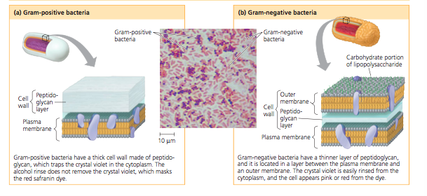
Gram stain, we can classify species into 2 groups based on differences in cell wall composition
Samples are first stained with crystal violet dye iodine, then rinsed in alcohol and finally stained with a red dye (safranin). The structure of the cell wall determines the staining answer

Gram negative are more resistant than gram-positive because the outer membrane impedes entry of drugs

Internal organization & DNA
Prokaryotic cells lack complex compartmentalization found in eukaryotes
Some prokaryotes cells do have specialized membranes

Prokaryotic DNA
Less DNA
Circular chromosome
- fewer proteins
- smaller ribosomes (differ in protein and RNA content)
Lack a membrane-bounded nucleus; their chromosome is located in the nucleoid
In addition to its single chromosomes a typical prokaryotic cell
Plasmid
In addition to its single chromosome, a typical prokaryotic cell may also have much smaller rings of independently replicating DNA molecules called plasmids, most of them carrying only a few genes

Reproduction and Adaptation
Adaption
Endospores
Some cells can survive in harsh environments because of biochemical adaptations or structural adaptations
Certain bacteria, for example, develop resistant cells called endospores when they lack an essential nutrient
The original cell produces a copy of its chromosomes and surrounds it with a tough multi-layered structure forming the endospore, water is removed from it and its metabolism halts
Original cell lyses releasing the endospore
Lysis: the disintegration of a cell by rupture of the cell wall or membrane
Most endospores can survive in boiling water, killing them requires 121 C
Resistant cells
Copy of chromosome surrounded by though wall
Dormant until conditions improve

Endospores and anthrax
Bacillus anthracis
Resistant endospore remains dormant in soil
Reactivated upon inhalation or digestion

Reproduction
Reproduction
Production of new organisms
Sex
Genetic recombination
Combining genes from 2 individuals into a single genome
Genetic transfer involving 2 individuals
Gender
Anisogamy
X vs Y chromosomes
Sexual reproduction
Sex linked in time w/ reproduction
Meiosis & recombination

Benefit of sexual reproduction
Genetically diverse offspring
Benefits of asexual reproduction
Faster reproductive rate
Genetic diversity is due to rapid reproduction

Binary fission
Most common in prokaryotes, asexual reproduction, cell splitting into 2 identical cells (reproduction without sex)
Prokaryotes are highly successful in part because of their potential to reproduce quickly in a favourable environment

By binary fission, a single prokaryotic cell divides into 2 cells, which then divide into 4,8,16 and so on. Under optimal conditions, many prokaryotes can divide every 1-3 hours; some species can produce a new generation in only 20 minutes
The cells eventually exhaust their nutrient supply, poison themselves with metabolic wastes, face competition from other microorganisms, or are consumed by other organisms
Reproduction without sex
Binary fission different from mitosis?
- Mitosis happens in eukaryotes
Mitosis is impossible in prokaryotes because no spindle, centrioles, dance of chromosomes
They work in the same way but they are different processes

How can prokaryotes adapt so quickly with no sexual reproduction?
- Genetic diversity due to
1) Rapid reproduction
2) Mutation
3) Genetic recombination
- Transformation
- Transduction
- Conjugation

Genetic recombination
New mutations are a major source of variation in prokaryotic populations, additional diversity arises from genetic recombination (combining of DNA from two sources)
In eukaryotes: sexual process of meiosis and fertilization combine DNA from 2 individuals in a single zygote
In prokaryotes: Meiosis and fertilization do not occur in prokaryotes there are 3 other mechanisms- transformation, transduction, and conjugation- they can bring together prokaryotic DNA from different individuals (that is, cells)

- Transformation
The genotype and possibly phenotype of a prokaryotic cell are altered by the uptake of foreign DNA from its surroundings (absorption and étranger de son environnement)
The cell becomes a recombinant: Its chromosomes contains DNA derived from 2 different cells
Once inside the cell, the foreign DNA can be incorporated into the genome by homologous DNA exchange
Uptake of foreign DNA from environment
Incorporated into chromosome by recombinant

- Transduction
Phages (from “bacteriophages”, the viruses that infect bacteria) carry prokaryotic genes from one host cell to another. In most cases, transduction results from accidents that occur during the phage replicative cycle
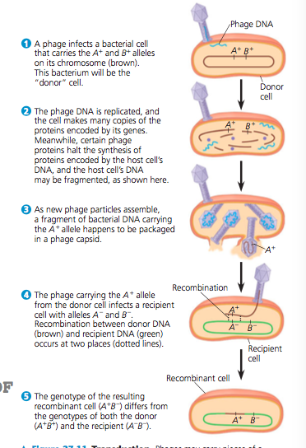
However, the virus can attach to another prokaryotic cell (a recipient) and inject prokaryotic DNA acquired from the first cell (the donor). If some of this DNA is then incorporated into the recipient cell’s chromosome by DNA recombination, a recombinant cell is formed
Bacteriophages carry bacterial genes between hosts

- Conjugation
DNA is transferred between two prokaryotic cells (usually of the same species) that are temporarily joined. In bacteria, the DNA transfer is always one-way: One cell donates the DNA, and the other receives it.
The ability to form pili and donate DNA during conjugation results from the presence of a particular piece of DNA called the F factor (fertility)

Bacteria do have sex
One cell donates the DNA and the other one receives it
One way transfer
-Donor to recipient
-through a sex pilus
Sex without reproduction
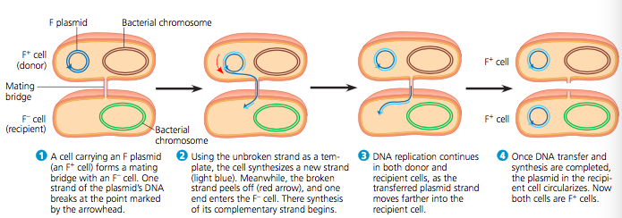

4 major modes of nutrition of prokaryotes
2 Sources of energy for all organisms
Light: phototrophs
Chemical bonds: chemotrophs
2 sources of carbon
Inorganic CO₂: autotrophs (need only CO₂ in some form as a carbon source
Organic molecules: heterotrophs (require at least on organic nutrient such as glucose to make other organic compound)

- Phototrophs
Organisms that obtain energy from the light
Photosynthetic prokaryotes
Energy source: light
Plants, protists, cyanobacteria

- Chemotrophs
Organisms that obtain energy from chemicals
Energy source: Inorganic chemicals
Unique to certain prokaryotes

- Photoheterotroph
Energy source: light
Unique to some prokaryotes

- Chemophototroph
Most prokaryotes, animals, fungi, some protists
Energy source: Organic compounds

The role of Oxygen in metabolism
Prokaryotic metabolism also varies with the respect to oxygen

Obligate aerobes
They must use O₂ for cellular respiration and cannot grow without it
Use O₂ in electron transport chain
May also carry out anaerobic cellular respiration

Obligate anaerobes
Poisoned by O₂
Survive only under very low oxygen
Anaerobic respiration or fermentation
Use something other than oxygen in electron transport chain (sulphite, nitrate, iron, manganese, mercury,etc.)
Example: Clostridium botulinum (causes botulism)

Facultative anaerobes
Facultative anaerobes use O₂ if it is present but can also carry out fermentation or anaerobic respiration in an anaerobic environment
Grow best under anaerobic conditions but are not poisoned by oxygen

Nitrogen fixation
Nitrogen is essential for the production of amino acids and nucleic acids in all organisms
Eukaryotes can obtain nitrogen from limited group of nitrogen compounds
Prokaryotes can metabolize nitrogen in a wide variety of forms

Nitrogen fixation is a process in which some cyanobacteria and some methanogens (group pf archaea) convert atmosphere nitrogen (N₂) to ammonia (NH₃)
Makes N available to plants
Critical component of many ecosystems

The cells can then incorporate this “fixed” nitrogen into amino acids and other organic molecules
In terms of nutrition nitrogen-fixing cyanobacteria are some of the most self-sufficient organisms since they only need light, CO₂, N₂, water, and some minerals to grow

Metabolic Cooperation
Cooperation between prokaryotic cells allows them to use environmental resources they could not use as individual cells
Biofilms
Metabolic cooperation between different prokaryotic species often occurs in surface-coating colonies known as biofilms. Cells in a biofilm secrete signalling molecules that recruit nearby cells, causing the colonies to grow. The cells also produce polysaccharides and proteins that sick the cells to the substrate and to one another
Biofilms are common in nature, but they can cause problems by contaminating industrial products and medical equipment and contributing to tooth decay and more serious health problems.

BACTERIA
Proteobacteria (Gram -)
- Alpha: Rhizobium (ancestors of mitochondria)
- Beta: Role in nitrogen cycling
- Gamma: Sulfur bacteria pathogens; E.coli
- Delta: Myxobacteria, the slime bacteria
- Epsilon: Pathogens
Chlamydia
Parasites
Blindness and ITS
Spirochetes
Spiral
Somme are free-living; some patho
Cyanobacteria
Blue-Green Algae
Photoautotrophs
Photosynthesis
Ancestors of chloroplasts
Gram positive bacteria (suggests that all the other bacteria are Gram negative)
High diversity
Free-living soil species; solitary species
Mycoplasmas: lack a cell wall

ARCHAEA
Prokaryotes once classified as bacteria are more closely related to eukaryotes and belong in their own domain: archaea
First prokaryotes assigned to this domain lived in environments so extreme that few other organisms can survive there

Extremophiles are “lovers” of extreme conditions and include extreme halophiles and extreme thermophiles
- Extreme halophiles
Live in highly saline environments (Great Salt Lake and Dead Sea), they require an environment that is several times saltier than seawater
Example: The proteins and cell wall of Halobacterium have unusual features that improve function in extremely salty environments but render these organisms incapable of survival if the salinity drops below 9%
- Extreme thermophiles
Live in very hot environments
Up to 121°C
Methanogens
Release methane as by product of their unique ways of obtaining energy
Anaerobes
Use CO₂ to oxidize H₂ : give off methane
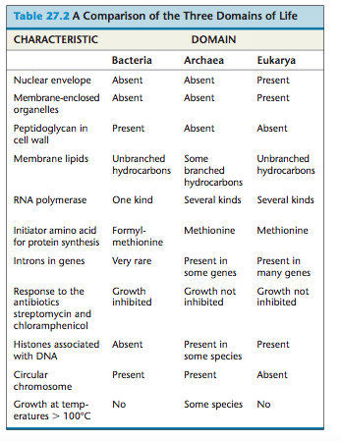

Importance of Prokaryotes
Crucial to the survival of most life on earth
They are decomposers: breaking down dead organisms as well as waste products and unlocking supplies of carbon, nitrogen, etc
Symbiosis: ecological relationship with 2 species live in close contact with each other
They form symbiosis associations
Parasitism: eco relation with parasite eats the cell contents, tissues, or body fluids of its host

Pathogenic bacteria usually cause illness by producing poison which are classified as exotoxins and endotoxins

- Exotoxins
Proteins secreted by a certain bacteria and other organisms
Dangerous diarrheal disease is caused by this
Botulinum

- Endotoxins
Lipopolysaccharide components of the outer membrane of gram negative bacteria
Released only when the bacteria dies and their cell wall break down

CHAPTER 28

Write down the 6 key concepts of the chapter
- Protists are a diverse group of eukaryotes that span all 4 supergroups
- Excavates include protists with modified mitochondria and protists with unique flagella
- The SAR clade is a highly diverse group of protists defined by DNA similarities
- Red algae and green algae are the closest relatives to land plants
- Unkonts include protists that are closely related to fungi and animals
- Protists play key roles in ecological communities

Protists
Mostly unicellular eukaryotes
Considered to be the simplest eukaryotes but are the most elaborate cells at the cellular level
Formerly: kingdom of unicellular eukaryotes
Now: any euks that are not plants, animals or fungi
Wide variety of nutritional lifestyle
Protists as a clade are a paraphyletic group
The most diverse eukaryotes
First eukaryotes

Nutritional diversity
Chemoheterotrophs & photoautotrophs
Mixotrophs
3 ecological groups: 1 for each of 3 main euk groups
- Protozoans: Ingestive heterotrophs
- Fungus-like: Absorptive heterotrophs
- Algae: photoautotrophs

Prokaryotes do not have a cytoskeleton but they have a cell wall

Origin of Eukaryotes
Sudden arrival
Came with nucleus, organelles, ER & Golgi, cytoskeleton
Mitosis, meiosis, sexual reproduction

Endosymbiont theory
What started as an endosymbiont between cyanobacteria and a eukaryote ended with the formation of an organelle and the integration of photosynthetic metabolism in a previously nonphotosynthetic organism

Primary endosymbiosis
The formation of a chloroplast (plastid) from an endosymbiotic cyanobacteria within a eukaryote host
Have occurred only once
Newly created photosynthetic eukaryote resulted in Archaeplastida, a group that includes land plants, chlorophytes, and green and red algae
Eukaryotic cell engulfs cyanobacteria to form a plastid and we end up with a chloroplast in the cell
Result: Archaeplastida

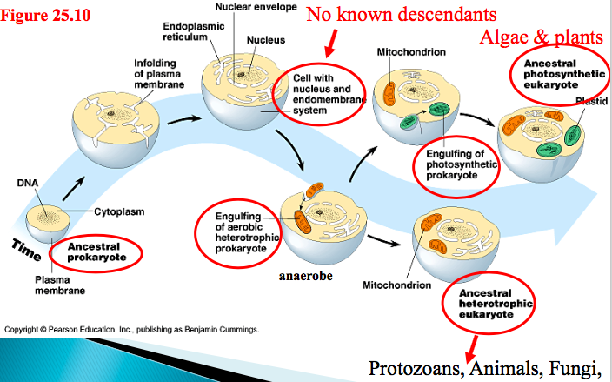

Secondary endosymbiosis
Have already created the ancestral protist, animal, fungi & plant
We don’t need more endosymbiosis but it just happens
A nonphotosynthetic eukaryote engulfs red or green algae (they are eukaryotes, protists,) that we formed in primary symbiosis
Result: SAR and Excavata
After 2 endosymbiosis, there is a vestigial nucleus and 4 membranes (2 from cyanobacteria, 1 from algae and one of them is the heterotroph’s food vacuole)
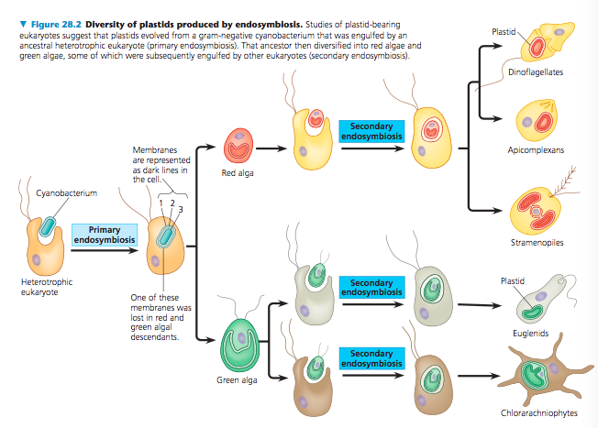

List the 4 super groups of eukaryotes

- Excavata
Some members of this group have an “excavated” feeding groove on the side of the cell body
Include protists with modified mitochondria
Include protists with unique flagella
Includes diplomonads, parabasalids and euglenozoans
Diplomonads
Lack plastids so they do not perform photosynthesis (lack functional electron transport chain and cannot use oxygen to help extract energy)
Get food from anaerobic pathways
Have a reduced, modified mitochondrion
Many are parasites
2 equal-sized nuclei and multiple flagella (extensions of cytoplasm)
Parabasalids
Have a reduced, modified mitochondrion
Many are parasites
Get food from anaerobic pathways
Trichomonas vaginalis
Sexually transmitted parasite
Euglenozoans
Diverse clade
Includes predatory heterotrophs, photosynthetic autotrophs, mixotrophs and parasites
Presence of a rod with either a spiral or crystalline structure inside each of their flagella
2 subgroups
Kinetoplastids
Single large mitochondrion, unusual of interlocking

Euglenoids
Has a pocket at one end of the cell from which one or two flagella emerge

- SAR clade
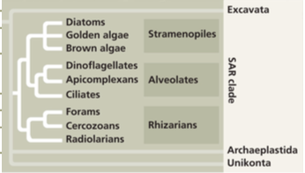

Stramenopiles
Includes some of the most important photosynthetic organisms
Hairy and smooth flagella
- Diatoms
Unicellular algae
Glass-like wall made of hydrated silica embed in organic matrix
100 000 sp. of unicellular phytoplankton
- Golden algae
Golden colour from yellow and brown carotenoid pigments
Components of freshwater & marine phytoplankton
- Brown algae
Multicellular, mostly marine (many of the seaweeds)
Includes giant kelp & other seaweeds
Alternation of generation (alternation of multicellular haploid and diploid forms)
Multicellular diploid individual is called sporophyte
Meiosis in the sporophyte produces haploid cells called spores
Haploid spores divides mitotically generating multicellular male and female gametophytes which produce gametes
Union of two gametes results in a diploid zygote and gives rise to a new multicellular sporophyte
- Heteromorphic: 2 generations look different (sporophyte and gametophytes are structurally different)

Alveolates
Membrane-bounded sacs (alveoli) under the plasma membrane
Abundant
Photosynthetic and heterotrophic
- Dinoflagellates (group of flagellates)
Photo, mixo & hetero
Characterized by cells that are reinforced by cellulose plates
2 flagella make dinoflagelles spin as they move through water
Can cause phenomenon “red tide” which can be toxic
- Apicomplexans (group of parasites)
Parasites of animals and can cause serious human disease
Spread through their host as tiny infectious cells sporozoite
One end of sporozoite (apex) contains a complex of organelles specialized for penetrating host cells and tissues
Require 2 or more host species for completion
Plasmodium-malaria
- Ciliates
Large varied group of protists
Cilia for mvt & feeding
Presence of 2 nuclei: micronuclei & macronuclei
Genetic variation results from conjugation (sexual process where 2 individuals exchange haploid micronuclei but do not reproduce)
Micronuclei exchange of genetic info during sexual reproduction during conjugation
Generally, reproduce asexually by binary fission
Each macronucleus typically contains multiple copies of the ciliate’s genome
Genes in the macronucleus control the everyday functions of the cell, such as feeding, waste removal, and maintaining water balance
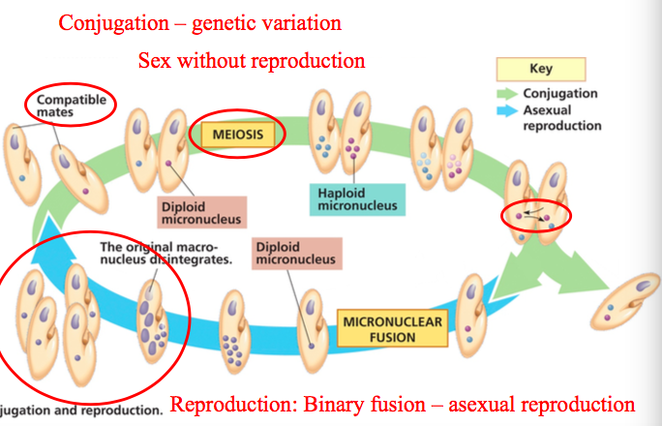

Rhizarians
Amoebas with threadlike pseudopodia for moving and feeding
Include flagellated protists
- Radiolarians
Symmetrical internal skeletons made of silica
- Forams
Carbonate shells
In ocean & freshwater
- Cercozoans
Contains most of the amoeboid and flagellated protists
Heterotrophs

- Archaeplastida
Monophyletic group descended from ancestral protist that engulfed a cyanobacterium
3 groups: red algae, green algae, and land plants

Red algae
Red because they contain a photosynthetic pigment, phycoerythrin which masks the green chlorophyll. + allows them to absorb blue and green light (penetrate far into the water)
Multicellular algae, including some seaweeds

Green algae
Chloroplasts have a structure and pigment composition similar to land plants chloroplasts
Closely related to land plants
Divided in many groups but the main ones are:
- Charophytes
The algae most closely related to land plants
- Chlorophytes
7000 species
Ranging from unicellular to multicellular
Chlamydomonas
Larger size & greater complexity evolved in chlorophytes by 3 different mechanisms
- Volvox: Formation of colonies of individual cells
- Ulva: Formation of true multicellular bodies by cell division and differentiation
- Caulpera: Repeated division of nuclei with no cytoplasmic division

- Unikonts
2 major clades: amoebozoans and opisthokonts
Amoebozoans: Slime molds
Thought to be fungi because like them they produce fruiting bodies that aid in spore dispersal
Distinguished by interesting life cycles

Amoebozoans
Include many species of amoebas that have lobe or tube-shaped rather than threadlike pseudopodia
Include slime molds, gymnamobeas and entamoebas
Tubulinids: Free- living
Entamoebas: Vertebrate parasites

Cellular slime mold
Feeding stage of these organisms consists of solitary cells that function individually, but when food is depleted, the cells form an aggregate that functions as a unit
Haploid organisms (only zygote = diploid)
Fruiting bodies that function in asexual rather than sexual reproduction

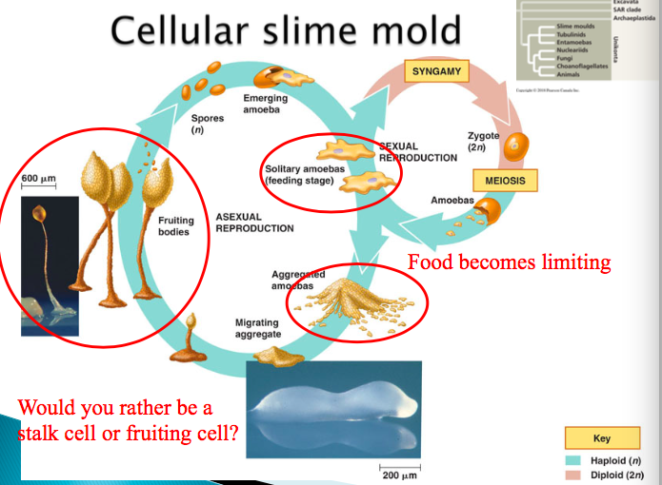

Fruiting body stage: cells that form the stalk die as they dry out, while the spore cells at the top survive and have potential to reproduce
Mutations in a single gene can turn individual Dictyostelium cells into cheaters that never become part of the stalk
Cheating mutants lack a protein on their surface, and noncheating cells can recognize this difference
Noncheaters aggregate together, thus depriving cheaters of the opportunity to exploit them

Gymnamoebas
Large and varied group
Unicellular protists ubiquitous in soil, freshwater, and marine environments
Most are heterotrophs that seek and consume bacteria, some feed on detritus

Entamoebas
Parasites
Infect all classes of vertebrate animals and some invertebrates

Opisthokonts
Diverse group of eukaryotes, Includes animals, fungi, and several groups of protists
More closely related to fungi than to other protists

Nucleariids
Choanoflagellates

Protists key roles in ecological communities
Most are aquatic, attach to rock or components of plankton

Symbiotic protists
Associations with other species
Dinoflagellates

CHAPTER 29

Write down the 3 key concepts of the chapter
- Land plants evolved from green algae
- Mosses and other nonvascular plants have life cycles dominated by gametophytes
- Ferns and other seedless vascular plants were the first plants to grow tall

Aquatic life on planet for 3,9 billion years BP (before present)
Terrestrial life on planet 500 million years BP (before present)

Closest living relative of land plants?
Green algae called charophytes (particularly Chara and Coleochaete) are the closest relatives of land plants
Charophytes are the only algae that share the following 4 distinctive traits with land plants
- Ring of cellulose-synthesizing proteins: they synthesize the cellulose microfibrils of the cell wall
- Peroxisome enzymes: help minimize the loss of organic products resulting from photorespiration
- Structure of flagellated sperm
- Formation of phragmoplast

Move to land
Sporopollenin
Species of charophytes algae inhabit shallow waters around edges of ponds and lakes, where they are subject to occasional drying
NS favours individuals that can survive periods when they are not submerged in water
In charophytes, a layer of durable polymer called Sporopollenin prevents exposed zygotes from drying out
Accumulation of such traits by at least one population of charophytes ancestors enabled their descendants to live permanently above waterline

Cuticle
Epidermis in many species has a covering, the cuticle which consists of wax and other polymers acts as waterproofing, helping prevent excessive water loss from the above-ground plant organs, while also providing some protection from microbial attack

Interesting point is that mycorrhizal fungi form extensive networks of filaments through the soil, enabling them to absorb nutrients more effectively than a plant can on its own

List and define the 5 derived characteristics that are common to all land plants
Charophyte algae lack the four key traits of land plants, this suggests that these four traits were absent in the ancestor common to land plants and charophytes but instead evolved as derived traits of land plants
- Alternation of generations
- Multicellular, Dependent Embryo
- Sporangia
- Multicellular Gametangia
- Apical Meristems

- Alternation of generations
Gametophyte and sporophyte are multicellular
Heteromorphic (different structures)
Life cycles of all land plants alternate between 2 generations of distinct multicellular organisms: gametophytes and sporophytes, each generation gives rise to the other, a process called alternation of generations
Distinguished by the fact that life cycles include both multicellular haploid organisms and multicellular diploid organisms.
Spores grow into the haploid gametophyte
Gametophyte produces gametes and 2 gametes go through fertilization
Gametophyte
The multicellular haploid gametophyte (gamete-producing plant) is named for its production by mitosis of haploid gametes- eggs and sperm- that fuse during fertilization, forming diploid zygotes
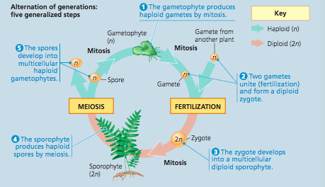
Sporophyte
Mitotic division of the zygote produces a multicellular diploid sporophyte (spore-producing plant). Meiosis in a mature sporophyte produces haploid spores, reproductive cells that can develop into a new haploid organism without fusing with another cell

- Multicellular, Dependent Embryos
Multicellular plant embryos develop from zygotes that are retained within the tissues of the female parent (a gametophyte)
Protected from drying
Nourished by maternal tissue: Parental tissues protect embryo from environmental conditions and provide nutrients (sugars & amino acids)
Land plants are known as embrophytes

- Walled Spores produced in Sporangia
Plant spores are haploid reproductive cells that can grow into multicellular haploid gametophytes by mitosis
The sporophyte has multicellular organs called sporangia that produce the spores
Within a sporangium, diploid cells called sporocytes which undergo meiosis and generate the haploid spores
The outer tissues of the sporangium protect the developing spores until they are released into the air
Sporophyte (the diploid)
Walled spores produced in Sporangia:
Surrounded by resistant covering of Sporopollenin (polymer)

- Multicellular Gametangia
Feature distinguishing early land plants from their algal ancestors was the production of gametes within multicellular organs called Gametangia

Female Gametangia are called archegonia
Pear shaped organ that produces a single no motile egg retained within the bulbous part of the organ

Male Gametangia are called antheridia
Produce sperm and release them into the environment
Sperm have flagella and swim to the eggs through water droplets or a film of water

Happens in haploid stage in gametophyes

- Apical Meristems
Photosynthetic organism requires Light and CO₂ (available above ground water, mineral nutrients found in soil)
Plants cannot move from place to place but their roots and shoots can elongate, increasing exposure to environmental resources
This grow in length is sustained by apical meristems (localized regions of cell division at the tips of roots and shoots)

When moving to land, a plant needs access to air and soil
Plants cannot really move so roots and shoots have to extend to get the 2 resources
Growth of tissues – elongation and specialization

4 major groups of plants
- Nonvascular plants (bryophytes) ex: mosses started with origin of land plants
- Vascular plants ex: ferns
- Seed plants ex: conifers Gymnosperms
- Angiosperms ex: flowers

- Colonization of land
475 mya
Bryophytes
The nonvascular plants (bryophytes) are represented by 3 phyla of small herbaceous plants: liverworts (phylum Hepatophyta), mosses (phylum Bryophyta), and hornworts (phylum Anthocerophyta)
- Bryophytes
Nonvascular plants (no vascular tissue that transports water and nutrients)
Inhabit moist habitats
Adaptations for life on land?
Embryos
Gametangia
Apical meristems
Waxy cuticle
Resistant spores
Most have a stomata
Unique life style
Gametophyte is dominant
Sporophyte is dependent: nutrients, water & sugars
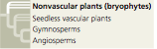

Bryophyte Gametophytes
Unlike vascular plants, in all 3 bryophyte phyla the haploid gameteophytes are the dominant stage of the life cycle: They are larger and longer-living than the sporophytes, as shown in the moss life cycle
They are heteromorphic

When bryophyte spores are dispersed to a favourable habitat they may germinate and grow into gametophytes
- Spores develop into threadlike protonema
Protonema has a large surface area that enhances absorption of water and minerals
- Haploid protonema produces “buds” that divide by mitosis and grow into gametophores (protonema + gametophore = body of moss gametophyte)

Important:
Gametophytes are anchored by delicate rhizoids which are long tubular single cells (in liverworts and hornworts) or filaments of cells (in mosses)
Not composed of tissue + Lack specialized conducting cells

- Male makes sperm through mitosis in antheridia
Female makes egg through mitosis in archegonia
Water needs to be introduced to help the sperm reach the egg
- In archegonium fertilization happens and gametes fuse to form diploid zygote which grows to form a sporophyte
- Sporophyte grows inside the mother until one day cracks up and grows a long stalk that emerge from archegonium
- Attached by its foot the sporophyte remains nutritionally dependent on the gametophyte
- Meiosis occurs and haploid spores develop in the capsule
When the capsule (sporangium) is mature, its lid pops off and the spores are released

Sporophyte cannot live independently, remain attached to the parental gametophyte
Bryophytes have the smallest sporophytes
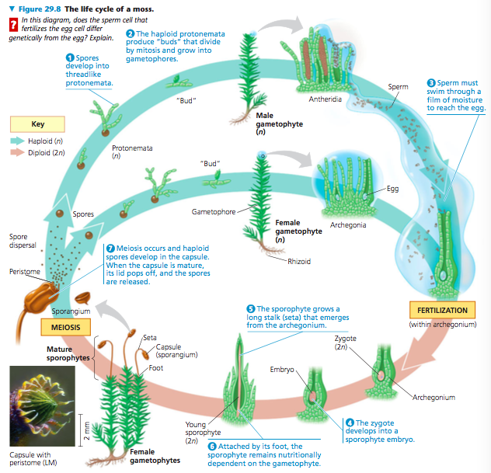

Limitations for life on land
Swimming sperm so we need water
No vascular tissue
No woody tissue

- Ferns and seedless vascular plants
The first plants to grow tall
Examples:
Lycophytes: spike moss, quillwort, club moss
Monoliophytes: whisk fern, horsetail, fern

Adaptations for terrestrial life?
Vascular tissue
Sporophyte becomes dominant
Specialized tissues: roots, leaves
Haploid bisexual gametophyte (produces egg and gametophyte)

Origins and Traits of vascular plants
Unlike the nonvascular plants, these species had branched sporophytes that were not dependent on gametophytes for nutrition

Life cycles with Dominant Sporophytes
Sporophyte (diploid) generation is the larger and more complex in plant alternation of generations

- Sporangia releases spores: Most fern species produce a single type of spore that develops into a bisexual photosynthetic gametophyte
- Each gametophyte develops sperm-producing organs called antheridia and egg producing organs called archegonia

In most fern species a gametophyte produces sperm and eggs at different times therefore, an egg from one gametophyte is fertilized by a sperm from another gametophyte

- Sperm uses flagella to swim to eggs in archegonia, an attractant secreted by archegonia helps direct the sperm
- A zygote develops into a new sporophyte and the young plant grows out from an archegonium of its parent, the gametophyte
- On the underside of the sporophyte’s reproductive leaves are spots called sori, each sorus is a cluster of sporangia

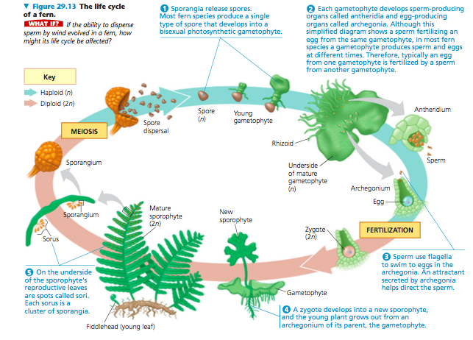

Transport in Xylem & Phloem
Vascular plants have 2 types of vascular tissue: xylem & phloem
Xylem
Conducts most of the water and minerals
Includes tracheids (tube-shaped cells that carry water and minerals from the roots)

Phloem
Has cell arranged into tubes that distribute sugars, amino acids, and other organic products
Lignin
The water-conducting cells in vascular plants are lignified; that is, their cell walls are strengthened by the polymer lignin
Lignified vascular tissue permitted vascular plants to grow tall
Their stems become strong enough to provide support against gravity, and they could transport water and mineral nutrients high above the ground

Lignified vascular tissue contributed to the evolution of roots (organs that absorb water and nutrients from the soil)

Limitations for life on land?
Swimming sperm (we still need water)
Fragile & Independent gametophytes
Typically, moist habitat

Coal forests
290-60 million BP
Died in wetlands –· forms coal – over years of heat and pressure coal is formed
Reduced CO₂ level 5-fold which contributed to a global warming
Drier, cooler conditions previous to the Permian extinctions
Fossil fuel –global warming

Vascular tissue
One way to distinguish group of plants Is whether they have an extensive system of vascular tissue, cells joined into tubes that transport water and nutrients throughout the plant body
Plants that do not have an extensive transport system do not have an extensive transport system – liverworts, mosses and hornworts- are described as “nonvascular” often called bryophytes (they do not form a monophyletic clade)

CHAPTER 30

Write down the 4 key concepts of the chapter
- Seeds and pollen grains are key adaptations for life on land
- Gymnosperms bear “naked” seeds, typically on cones
- The reproductive adaptations of angiosperms include flowers and fruits
- Human welfare depends greatly on seed plants
Seed vascular plants (gymnosperms &angiosperms)
Key adaptations of seed plants?
Seed
Reduction of the gametophyte
Pollen: vehicle for the sperm
Seed
A seed consists of an embryo and its food supply, surrounded by a protective coat
Replaces the spore as dispersal phase
More resistant than spore
Protects and nourishes embryo

Mosses and bryophytes have life cycles dominated by gametophytes
Ferns and other seedless vascular plants have sporophyte-dominated life cycles
Gametophytes of seed plants are mostly microscopic; they can develop from spores retained within the sporangia of the parental sporophyte
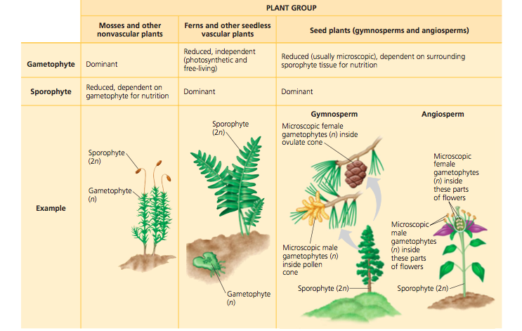
Sporophyte dominant

Key adaptations of seed plants
Seed
Reduction of gametophyte
Pollen

Most seedless plants and ferns are homosporous: They produce one kind of spore, which usually gives rise to a bisexual gametophyte
Seed plants or their ancestor became heterosporous producing 2 kinds of spores:
- Megasporangia: megaspores that give rise to female gametophytes
- Microsporangia: microspores give rise to male gametophytes

Dev of male gametophyte in a pollen grain & dev of female gametophyte within an ovule

Ovules and Production of Eggs

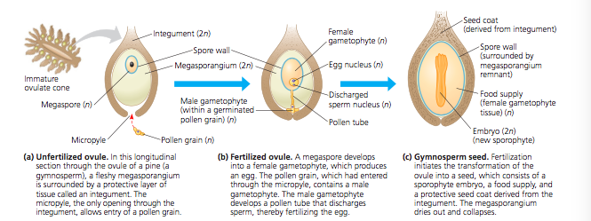

Integument: Layer of sporophyte tissue envelops & protects megasporangium
Gymnosperm Megasporangia surrounded by one integument but those in angiosperms usually have 2 integuments

megasporangium, megaspore, integument = ovule
Inside each ovule a female gametophyte develops a megaspore and produces one or more eggs

Pollen and Production of Sperm
Pollen grain
A microspore develops into a pollen grain that consists of a male gametophyte enclosed within the pollen wall (house of male gametophyte)
Pollen: Vehicle for sperm, replaces swimming sperm, though protective coating
The outer layer of the pollen wall is composed of molecules secreted by sporophyte cells; hence, we refer to the male gametophyte as being in the pollen grain, not equivalent to the pollen grain.
Transfer of pollen to the part of a seed plant that contains the ovules is called pollination
If pollen grain germinates it gives rise to a pollen tube that discharges sperm into female gametophyte
Advantage of seeds
Spores= single-celled
Seeds
- multicellular consisting of an embryo protected by layer of tissue, seed coat
- can remain dormant for days, months, or even years
- unlike spores they have a supply of stored food
Gymnosperms “Naked seeds”
Not enclosed in ovaries, seeds are exposed on modified leaves that usually form cones
“naked seeds”, sporophylls form cones, not enclosed by ovary, 300 million BP
Conifers –pines, firs, redwoods, 4 phyla

4 phyla of living gymnosperms
- Phylum Ginkgophyta
Ginkgo biloba only surviving species of this phylum
Tolerates air pollution well
- Phylum Cycadophyta
Largest group of gymnosperms after conifers
300 species
Large cones
Palm-like leaves
Endangered
- Phylum Gnetophytes
70 species in 3 genera: welwitschia, gnetum, ephedra
Some tropical some in desert
Very different in appearance
- Conifers
600 species
Many large trees
Most are evergreens

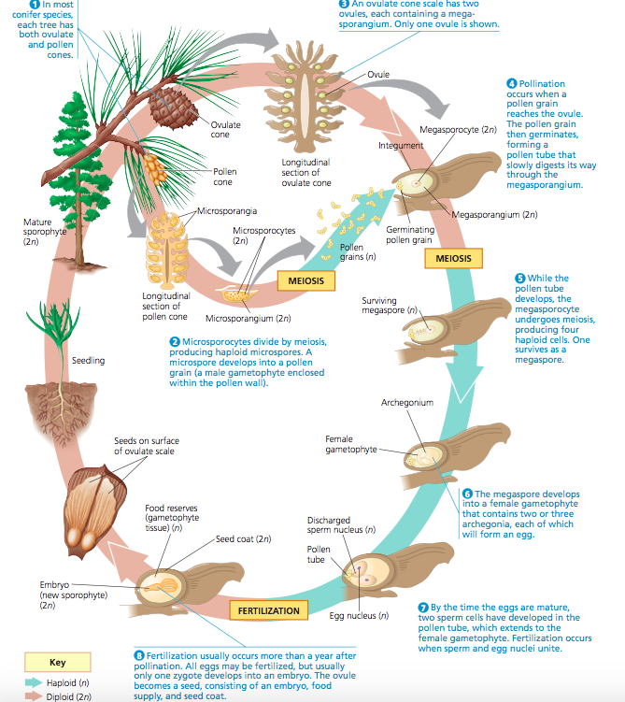

- In most conifer species, each tree has ovulated and pollen cones
- Microsporocytes divide by meiosis producing haploid microspores. A microspore develops into a pollen grain (male gametophyte enclosed within pollen wall)
- An ovulate cone scale has two ovules each containing a megasporangium
- Pollination occurs when pollen grain reaches ovule, pollen grain germinates forming a pollen tube that slowly digests its way through the megasporangium
- While pollen tube develops, megasporocyte undergo meiosis producing 4 haploid cells, one survives as a megaspore
- Megaspore develops into female gametophyte that contains 2 or 3 archegonia each of which will form an egg
- By the time eggs are mature, 2 sperms have developed in the pollen tube, which extends to the female gametophyte, fertilization occurs when sperm and egg nuclei unite
- Fertilization usually occurs more than a year after pollination. All eggs may be fertilized, but usually only one zygote develops into a embryo. The ovule becomes a seed, consisting of an embryo, food, supply and seed coat.

Flower
Reproductive structure
An angiosperm structure specialized for sexual reproduction. In many angiosperms species, insects or other animals transfer pollen from one flower to another flower which makes pollination more directed than wind-dependent pollination of gymnosperms
Double fertilization
Facilitates fertilization, attracts pollinators, pollen into the wind

Fruit
Mature ovary containing seeds, can also include other flower parts
Protect dormant seeds and aid in their dispersal

Many angiosperms rely on animals to carry seeds

Angiosperm life cycle
Flower of the sporophyte produces:
- Megaspores that form female gametophytes
- Microspores that from male gametophytes:
- In pollen grains which develop within microsporangia in anthers
- Each male gametophyte has 2 haploid cells:
- Generative cell: divides forming 2 sperms
- Tube cell: produces pollen tube

In ovary we have ovules, each one of them contains female gametophyte: Embryo sac
It consists of few cells: one is the egg

After pollen released from anther it is carried to sticky stigma at the tip of carpel

Angiosperms have mechanisms ensuring cross pollination: transfer of pollen from an anther of a flower on one plant to the stigma of a flower on another plant of the same species

Double fertilization
One fertilization event produces a zygote and the other produces a triploid cell
One sperm fertilizes the egg = diploid zygote (2n)
- Develops into a sporophyte embryo with rudimentary root and one or 2 seed leaves called cotyledons
One sperm fuses with 2 nuclei = Endosperm (3n)
- Develops into endosperm, tissue rich in starch and other food reserves that nourish the developing embryo

Function: Prevents squandering food on infertile ovules

CHAPTER 31

Some characteristics :
Eukaryotes, absorptive heterotrophs, sexual and asexual reproduction, haploid, chitinous cell walls

31,1 Fungi are heterotrophs that feed by absorption

Nutrition of fungi
Heterotrophs: cannot make their own food as plants and algae
Do not ingest their food, they absorb nutrients from the environment outside of its body
Use enzymes to transform the complex molecules in order to enable them to absorb the nutrients

Yeast
Most common fungal body structures are multicellular filaments and single cells
Species grow in filaments or in yeast (few)
Inhabit moist environments, including plant sap and animal tissues

Hyphae
Network of tiny filaments formed from the bodies of these fungi
Tubular cell walls surrounding the plasma membrane and cytoplasm of the cell
Not strengthen by cellulose but by chitin

Coenocytic
In most fungi hyphae divided into cells by cross-walls (septa)
Fungi lacking septa = Coenocytic fungi
Organism consist of a continuous cytoplasmic mass having hundred or thousand nuclei

Mycelium
Interwoven mass formed from fungal hyphae, feeding network of the hyphae
Infiltrates the material on which the fungus feeds
Mycelium structure maximizes surface-to-volume ratio, making absorption of nutrients very efficient

Mycorrhizae
Mutually beneficial relationships between fungi and plant roots
Improve delivery of phosphate ions and other minerals to plants
Specialized hyphae for nutrient exchange, mutualist with plant host

Spore
Mycorrhizal fungi colonize soils by dispersing haploid cells called spores that form new mycelia after germinating
Spore dispersion = key component of how fungi reproduce and spread to new areas

31,2 Fungi produce spores through sexual or asexual cycles
Fungi propagate themselves by producing spores sexually or asexually
Nuclei are often haploid; many fungi have transient diploid stages that form during sexual life cycles

Sexual reproduction begins when
- Hyphae from 2 mycelia releases sexual signalling molecules called pheromones
- If mycelia are from different mating type the pheromones from each partner bind to receptors on the other, and extend to the source of pheromones
- Union of cytoplasm of two mycelia is plasmogamy
- In most fungi, haploid nuclei from each parent do not fuse right away
Heterokaryon/dikaryon
In most fungi, haploid nuclei given by each parent do not fuse right away
Instead, parts of the fused mycelium contain coexisting genetically different nuclei
Such mycelium is said to be a Heterokaryon meaning different nuclei

Dikaryotic: In other species, the haploid nuclei pair off two to a cell, one from each parent

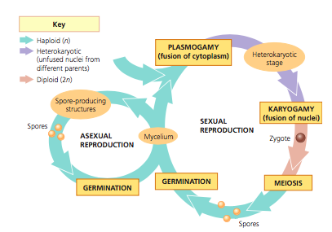
Karyogamy
Next stage after Plasmogamy
During this stage, haploid nuclei contributed by the 2 parents fuse, producing diploid cells
Only diploid stage in most fungi

Meiosis restores the haploid condition
Leading to the formation of spores

Asexual reproduction fungus can reproduce sexually & asexually
Mold
Many fungi reproduce asexually by growing as filamentous fungi that produce (haploid) spores by mitosis; such species are known as moulds if they form visible mycelia

31,3 The ancestor of fungi was an aquatic, single-celled, flagellated protist
Fungi and animal are more closely related to each other than either group is to plants or most eukaryotes

Fungi evolved from flagellated ancestor (now most of them lack flagella but some fungi have one)

31,4 Fungi have radiated into a diverse set of lineages

Unique feature of Chytrids
Early descendants of ancestral fungi
Only fungi with flagella (on spores)
Mainly aquatic
Some are decomposers, others are parasites of protists, mutualists other fungi, anima or plants
Cell walls made of chitin and key enzymes and metabolic pathways with other fungal
Having spores called zoospores

Unique feature of zygomycetes
Plasmogamy results in zygosporangium
Fast growing molds
Parasites or commensal symbiont of animals
Life cycle
Hyphae spread out over the food surface, penetrate it, and absorb nutrients

Glomeromycetes
160 species
Ecologically important
Nearly all mychorrhizae

Defining feature of an ascomycete
650 000 species
Production of spores in saclike asci (singular ascus) during sexual reproduction; thus they are commonly called sac fungi
Unlike zygomycetes during their sexual stage, most ascomycetes develop fruiting bodies called ASOCARPS (contain spore-forming asci)

Defining feature of basidiomycetes

Lichen

CHAPTER 32

32,1 Animals are multicellular, heterotrophic eukaryotes with tissues that develop from embryonic layers
Animals are multicellular, heterotrophic eukaryotes with tissues that develop from embryonic layers

Nutritional mode
They cannot construct their own organic molecules and in most cases, they ingest them and use enzymes to digest them

2 types of specialized cells: muscle cells and nerve cells organized into TISSUES

Reproduction and development
- Small flagellated perm fertilizes larger nonmotile egg = diploid zygote
- Zygote undergoes CLEAVAGE: succession of mitotic cell divisions, an 8 cell embryo is formed by 3 rounds of cell division
- Cleavage leads to the formation of multicellular stage called BLASTULA: typically, a hollow ball of cells that surround a cavity called the blastocoel
- Next stage is the GASTRULATION: Process during which the layers of embryonic tissues that will develop into adult body parts are produced, producing layers of embryonic tissues ectoderm (outer layer) and endoderm (inner layer) the resulting developmental stage is the GASTRULA

32,2 The history of animals spans more than half a billion years

Cambrian explosion

32,3 Animals can be characterized by “body plans”
Body plan is a set of morphological and developmental traits integrated into a functional whole- the living animal

Basic feature of animal bodies Is their type of symmetry or absence of symmetry
Radial symmetry
Type of symmetry found in a flowerpot
Sea anemones have a top side and a bottom side but no front or back ends and no right or left sides
Sessile (living attached to a substrate) or planktonic

Bilateral symmetry
2 sided symmetry seen in a shovel
A bilateral animal has 2 axes of orientation: front to back and top to bottom
Such animals have a dorsal (top) side and a ventral (bottom side), a left side and a right side, and an anterior end and posterior end
Move from place to place and have a central nervous system

Cephalization
Many animals with bilaterally symmetrical body plan have sensory equipment concentrated at their anterior end, including a central nervous system (brain) in the head- an evolutionary trend called cephalization

Body plans also vary depending of the tissue organization
Tissues
Collections of specialized cells isolated from other tissues by membranous layers

Sponges and a few other groups lack true tissues
In all other animals, the embryo becomes layered through the process of gastrulation
Layers are called gem layers and they form the various tissues and organs of the body

Ectoderm
Germ layer covering the surface of the embryo, gives rise to the outer covering of the animal, and in some phyla, to the central nervous system

Endoderm
Innermost germ layer, lines the pouch that forms during gastrulation and gives rise to the lining of the digestive tract and organs such as the liver and lungs of vertebrates

Diploblastic
Animals that have only these 2 germ layers

Mesoderm
All bilaterally symmetrical animals have a third germ layer called mesoderm which fills much of the space between the ectoderm and endoderm

Triploblastic
Having the 3 layers
The mesoderm forms the muscles and most other organs between the digestive tract and the outer covering of the animal

Most triploblastic animals have a body cavity, a fluid or air-filled space located between the digestive tract and the outer body wall it is also called the coelom

3 major ways of distinguishing protostomes from deuterostomes
- Cleavage
Animals with protostome development undergo spiral cleavage
- Coelom formation
- Fate of the blastopore

