Experiment 3: Extraction

----------

02/08/18

Organic Chemistry/CHM1321: A03

TA: Lixuan Ren

Lab Partner: -----------

University of Ottawa

Winter Term 2018

Procedure:

The procedure that was used in this experiment is located in the Laboratory manual, “CHM1321 Organic Chemistry Laboratory Manual 2018”: pages 28-33

Observations:
Part A: Extraction of water soluble dyes

Solvents | Characteristics
- Ether | - Clear, strong odor
- Distilled Water | - Clear, odorless
- 0.006 methylene blue solution | - translucent blue liquid
- 0.006 methyl red solution | - red liquid
- 0.003 M aqueous crystal violet | - dark violet liquid
- 0.5 mL of 1- Butanol | - clear, strong odor

Table 1: Characteristics of the solutions used in part A: extraction of water soluble dyes

Test tube # | Results
1 | - layers separated from each other (dark blue/blue). Separated dye is organic
2 | - layers separated (light brownish/clear). Separated dye is organic
3 | - whole test tube is one whole color (dark purplish blue). No separation occurred
4 | - NaCl was added to the test tube. The top of the test tube was dark purplish, whereas the bottom was clear

Table 2: The phases of each test tube by extraction

Part B: Separating a mixture with reactive extraction

- Unknown Sample #2 – White crystal powder
- Dichloromethane- clear, strong odor
- 0.83g of unknown sample #2 was used in this part of the experiment
- HCl+ aqueous solution= warm flask
- Solid product- 0.57 g
- 2:8 EtAOC: hexane mixture was clear, used for TLC developing.
- NaCl: strong odor and clear
- HCL- precipitate: white and grainy
- Refiltration better

Trials | Lower | Upper | Results
1 | Less | More | Lower is aqueous
2 (Organic) | More | Less | Upper is aqueous
3 | More | Less | Upper is aqueous

Table 3: This table represents when separating a mixture with reactive extraction

TLC Plate Number | Reference Spot | Co-Spot |  | Sample Spot | Rf Value of Reference Spot |  | Rf Value of Sample Spot
1 | Original Solution of Unknown Sample #2 with Benzoic Acid | Original Solution of Unknown Sample #2 and Extraction from Organic Layer |  | Extraction from Organic Layer | 0.83 | 0.51 | 0.83

TLC Plate Number | Reference Spot | Co-Spot |  | Sample Spot | Rf Value of Reference Spot |  | Rf Value of Sample Spot
2 | Original Solution of Unknown Sample #2 with Benzoic Acid | Original Solution Product from Aqueous Layer with Dichloromethane |  | Product from Aqueous Layer with Dichloromethane | 0.40 | 0.83 | 0.00

TLC Plate Number | Reference Spot | Co-Spot |  | Sample Spot | Rf Value of Reference Spot |  | Rf Value of Sample Spot
3 | Biphenyl | Benzophenone |  | Unknown Mixture with Benzoic Acid | 0.81 | 0.62 | 0.81 0.41

TLC:

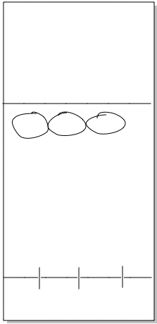

TLC #1: In TLC #1, the original sample (unknown sample #2) was spotted as the reference and co-spot. The organic layer from the extraction was spotted on the sample and the co-spot.
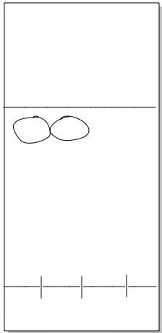
TLC #2: In TLC #2, the product from the aqueous layer dissolved in a few drops of dichloromethane was spotted on the sample and co-spot.

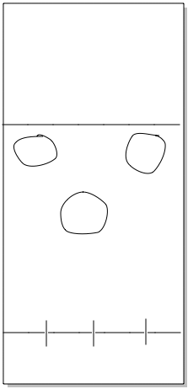
TLC #3: In TLC #3, biphenyl was spotted in the reference lane, benzophenone was spotted in the co-spot lane, and the unknown mixture was spotted in the sample lane.

Flow Chart:
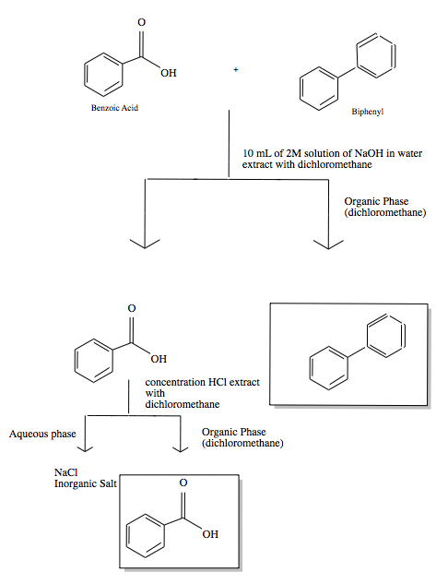

Calculations:

Percent Yield of Benzoic Acid

Mass of product formed: m=0.57 g
Mass of unknown sample #2: m= 0.83 g
Percent of Benzoic Acid= (mass of product/ mass of unknown sample #2) * 100%
= (0.57 g / 0.83 g) * 100%
= 68.67 %
Therefore, the percent yield of benzoic acid is 68.67%

Sample Rf Value Calculation

Rf value= 0.51
Rf value for one of the reference spots on TLC #1:
Rf value= distance traveled by compound/ distance traveled by solvent
= 2.9/5.7
=0.51
Therefore, the Rf value for one of the reference spots on TLC plate #1 is 0.51

Discussion:

Extraction is a technique that involves the separation of components of a mixture by the tendency of the individual components to dissolve in a particular solvent. Part A of the experiment demonstrated the separation of compounds based on dissolving in either an organic or aqueous layer. In this part of the experiment, different type of dyes was used which made the separation more clearly visible to observe.

In test tube #1 Methylene blue was used which was a translucent blue liquid that has a chloride cation and a sulfur anion which results in the interaction to be more favorable to dissolve in water. Since methylene blue is a polar compound it attracts polar water molecules which made the blue dye appear in the aqueous layer rather than the organic layer.
In test tube #2 the dye Methyl Red was used which is an organic, non-polar substance. Since methyl red is non-polar its interactions were to be more favorable with the non-polar solvent of Ether. Organic substances are uncharged and are not soluble in the aqueous phase, which results in the methyl red to appear in the organic phase which matches its properties.
In Test tube # 3 where the mixture of methyl blue and methyl red solution was separated in the immiscible solvents of ether and distilled water. Being that methyl blue is a polar substance, it dissolved in water while methyl red being non-polar dissolved in the ether which resulted the aqueous phase to appear blue while the organic phase was a very light tint of red. During the salt out effect, the addition of NaCl into the 4th test tube that had the crystal violet aqueous solution resulted in the aqueous crystal violet out of the aqueous layer to the organic layer. The NaCl in the test tube saturated the aqueous water phase and then resulted the water molecules to rise to the organic phase. Therefore, there was a bit of discoloration at the bottom of the test tube due to the fact that the ionic salt was heavily present and the crystal violet aqueous compound was absented from that part of the solution. Other than that, the bottom portion of the test tube #4 was clear while the top part of the test tube had a dark violet layer in the organic phase because the NaCl made the crystal violet aqueous compound distant from the bottom of the test tube.

In TLC plate #1, the organic and aqueous layers helped determine the separation that occurred on the TLC plate between benzoic acid and the organic compound. In TLC #1, the original sample (unknown sample #2) was spotted as the reference and co-spot. The organic layer from the extraction was spotted on the sample and the co-spot. The isolated organic phase displayed one spot due to the fact that only the organic compound was present in that phase. The spot in the sample lane matched with the upper unknown spot. This resulted in the same Rf value of 0.83. The acidic spot on the plate remained to stay because the possibility of high concentration and high polarity which prevented the spot to travel across the TLC plate. The effective separation occurred as the spotted organic phase which was a non-polar compound and the spotted aqueous phase was a highly polar compound.
In TLC plate #2, the product from the aqueous layer dissolved in a few drops of dichloromethane was spotted on the sample and co-spot. This resulted in the reference and co-spot to not travel across the TLC plate and the sample lane not having a spot which resulted in a Rf value of 0.00. The polarity of the aqueous layer that was dissolved in dichloromethane must have been low on the sample lane. The reference and co-spot must have been acidic and high polarity to have spotted and prevented the spots to travel. The effective separation of the product from the aqueous layer and the unknown sample being non-polar.
In TLC #3, biphenyl was spotted in the reference lane, benzophenone was spotted in the co-spot lane, and the unknown mixture was spotted in the sample lane. The higher unknown compound with the biphenyl spot indicates that the other component of the unknown mixture was biphenyl. This resulted in the matching Rf value of 0.81. There was no benzophenone in the unknown compound because the benzophenone spot didn’t match with the unknown sample spot. The Rf was also different being 0.62, 0.41 and 0.81. This then concludes that the unknown compound #2 was biphenyl with benzoic acid.

In the separation of the biphenyl and benzoic acid the properties of being acid and base resulted in a reactive separation. The extractions were on an acid/base extraction and depended on the acid or base to react which is indicated between the compounds as an acid/an organic compound. The acid base reaction was able to produce salts that were dissolved in the water and then separated the organic acid and the uncharged organic substance. NaOH being a strong base helped the benzoic acid be able to react. In the extraction of the aqueous layer, the extraction is done by the conjugate base in the aqueous phase which is above the organic phase in this case. NaOH was added to make sure that no acid was left over in the organic phase. To convert the conjugate salt into the organic acid, HCl, a strong acid was put into the aqueous beaker. This then results in the salt to turn back into an acid with inorganic salt produced in the process of it. This all results in the separation of the organic compound and the acid/base.

There were possible errors that could have occurred in this experiment that could have altered/influenced the results obtained. False measurement of the TLC plates for the Rf value could alter the results and the reasoning and false measuring the solutions and not accurately putting the correct amount that the laboratory manual indicates and incorrect measuring of the solid product and not being able to fully obtain all the precipitated product and leaving some behind on the filtered paper. Another error could be the performance of the extraction. Maybe some of the organic phase contained aqueous solution still and wasn’t extracted properly which would affect when spotting the TLC and would lead to wrong spots and incorrect Rf values. Cross contamination could influence the data and observations if the materials were not washed thoroughly prior to the experiment. Lastly, the spotting of the TLC incorrectly. Spotting the wrong lanes could influence the results or using the same capillary and not cleaning out between the spotting.

Questions:

- Why would it be difficult to perform an extraction using ethanol and water?

- The reason extraction would be difficult if using ethanol and water is because extraction separates the compounds in the solution by their polarity. Ethanol and water are both polar solvents and this would lead to them being miscible. Ethanol is miscible in water and to have a successful extraction would be very difficult with the circumstances.

- Would adding NaCl to test tube contacting water, ether and methylene blue increase or decrease the amount of dye in the aqueous layer?

-NaCl dissolves in water and is more likely to interact with the molecules of water rather than interacting with the methylene blue substance which happens to be a slightly charged organic compound which causes the amount of dye in the aqueous layer to decrease.

- Compound Y has a solubility of 2.0 g/100 mL in water and 20.0 g/100 mL in ether. What a mass of compound Y would be removed from a solution of 1.8 g of Y in 100 mL of water by single extraction with 100 mL of ether?

- KD= (W1/V1)/(W2/V2)
= (2.0 g/ 100 mL)
= 0.1
Let w represent the mass of compound Y in the aqueous (distilled water) phase.
Let m represent the mass of compound Y in the organic (ether) phase.
M+w= 1.8 g
M= 1.8 g –w
0.1= (w/100 mL)/(1.8 g –w/ 100 mL)
w= 0.08 g
m=1.8 g –w
=1.8 g- 0.08 g
=1.72
Therefore, 1.72 g of compound Y will be removed from the solution of 1.8 g of Y in 100 mL of water by the single extraction with 100 mL of ether.

- What mass of compound Y would be removed from the original water solution in question 3 by two extractions using 50 mL of ether each time?

One extraction, using 50 mL of ether:
Let w represent the mass of compound Y in the aqueous (distilled water) phase.
Let m represent the mass of compound Y in the organic (ether) phase.
M+w =1.8 h
M=1.8g –w
KD= (W1/V1)/(W2/V2)
0.1= (w/100 mL)/(1.8 g-w/ 50ml)
w= 0.30 g
m=1.8g –w
1.8 g -0.30 g
1.50 g
Therefore, in the first extraction, 1.5 grams of compound Y will be removed from the solution 100 mL of water by the extraction with 50 Ml of ether.

Extraction two, also using 50 mL of ether:
M+w= 0.30 g
M=0.30 –w
KD=(W1/V1)/W2/V2)
0.1= (w/100 mL)/(0.3-w/50 ml)
w= 0.05 g
m=0.30g – 0.05 g
=0.25 g
Therefore, in the second extraction, 0.25 g of compound Y will be further removed from the solution of 1.8 g of Y in 100 mL of water by the extraction with 50 ml of ether.
Total extracted amount of compound Y:
Total mass of Y removed = 1.50 G + 0.25 G
=1.75 G
Therefore, in the total after the two extractions, 1.75 g of compound Y were removed from the solution.

- During an extraction, a student loses track of which later is the organic layer. How could she determine which layer is aqueous phase?

- The student could try and use dyed water to try and determine which layer was the aqueous layer and which one was the organic layer. In the aqueous phase, there is water there so this would help indicate which phase the water travels and determine which layer is aqueous.

- Describe how you would separate a mixture of benzyl amine (an organic base) and naphthalene. Both compounds are insoluble in water and soluble in ether.

- The way you would separate it is by adding HCl, which is a strong acid and doing this it will react with the base which in this case is the benzyl amine. This will then produce a conjugate acid in salt form, which leads to it dissolving in water. The separatory funnel will divide the organic and aqueous later and would lead us to the extraction of benzyl amine. If needed HCl can be added to the solution to extract more benzyl amine from the organic phase. After performing several extractions, the organic phase would be placed in a beaker being the organic layer and naphthalene would be present in the organic phase. Then the aqueous layer would be extracted like the organic phase and placed in a beaker where NaOH would be added and this would contain the salt. Enough amount of NaOH must be added to the solution so that the conversion of salt to base, benzyl amine could occur. Then proceed to put beaker in ice bath then after use the suction to filter the solution and obtain the pure solid precipitate of benzyl amine.

Appendix/Raw Data:



