RECOGNIZING USE, MISUSE, ABUSE, & ADDICTION TO DRUGS & BEHAVIOURS

Drug Use, Misuse, & Abuse
- Use, misuse, abuse
  - Drug use: taking a drug, as instructed
  - Drug misuse: taking a drug, not prescribed
  - Drug abuse: excessive use of a drug
- Individual Response: Set and Setting
  - Response to drugs is influenced by
    - One’s internal environment (“set”)
    - Total external environment (“setting”)

Defining Addiction
- Addiction
  - Persistent dependence on behaviour, substance
- Aspect of “Addiction”
  - Excessive use (compulsive behaviour)
  - Persistent desire to control (loss of control)
  - Frequent incapacitation (negative consequences)
  - Avoid withdrawal symptoms (remove pain)
- The Physiology of Addiction
  - Neurotransmitters influence receptor cites
  - Tolerance: to obtain desired effects = larger dose
  - Withdrawal: drug causes an effect the body creates by itself
- The Addictive Process (Psychosocial)
  - Nurturing through avoidance: maladaptive, emotionally
  - Behaviour or drug, no longer pleasurable
    - Still preferable to current (unhappy) life circumstances
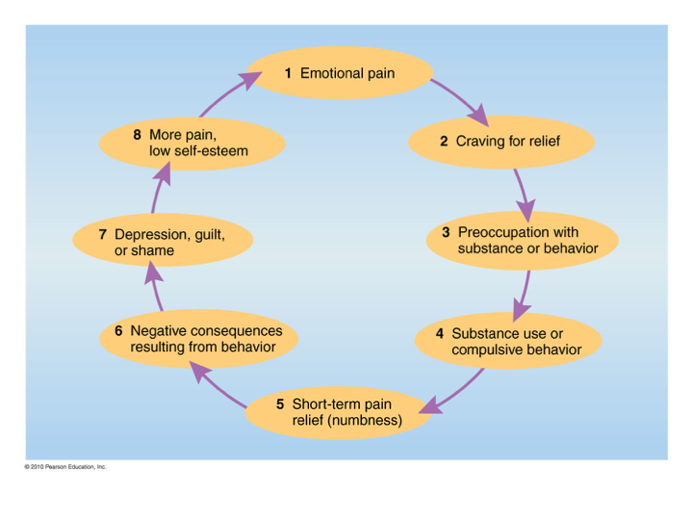

Addictive Behaviours
- Gambling
  - Video lottery terminals: role in gambling problems
  - More men than women; increasing among students
  - Unable to control urge to gamble
- Shopping and Borrowing
  - Excessive spending on purchases
  - Easy credit (companies target students)
  - Gambling, shopping can lead to compulsive borrowing
- Exercise Addiction
  - Exercise, a powerful mood enhancer (endorphins)
  - Needs: nurturance, intimacy, self-esteem, competency
- Technology Addictions
  - Risk of overexposure has grown
    - Phones, video games, social media
  - ~1/8 internet users will experience internet addiction

Managing an Addiction
- Intervention
  - Planned process of confrontation by family, significant others, and loved ones
  - Break “denial”, in a compassionate way
  - Understand the destructive nature of addiction
- Forms of Therapy:
  - Individual, Group, Family, 12-step

Drug Dynamics
- Drugs attach to receptor sites in the body
- Receptor sites: specialized proteins (lock & key)
- Cells and tissue have different receptors
  - Different drugs, different effects
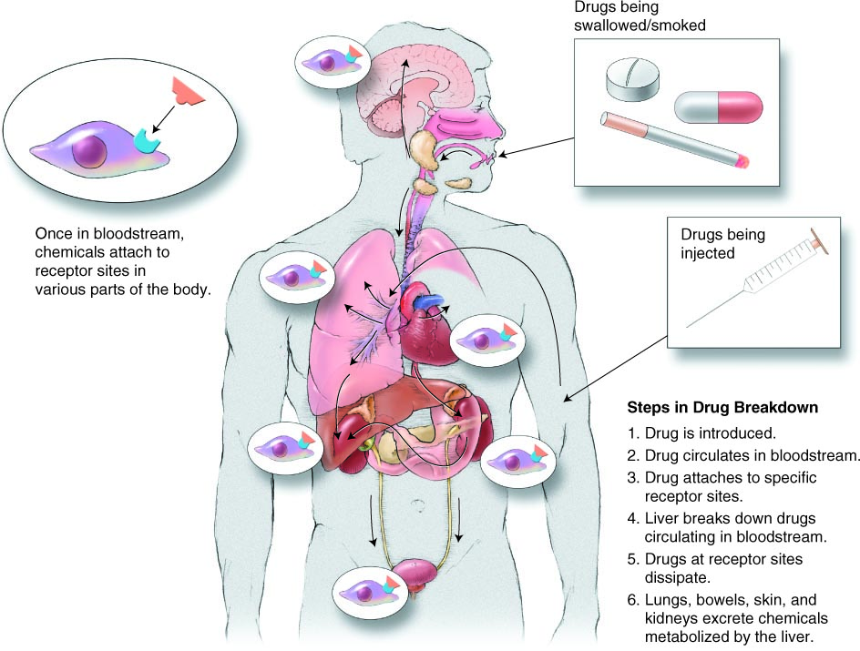
Types of Drugs
- Psychoactive drugs
  - Alter moods or behaviours
- Prescription drugs
  - Only prescription from physician
- Recreational drugs
  - Used to relax, socialize
- Over-the-counter (OTC) drugs
  - Purchased without prescription
- Herbal preparations
  - Substances of plant origin
  - Believed to have medicinal properties
- Illicit drugs
  - Possession, cultivation, manufacture, sale (illegal)
- Commercial preparations
  - Chemical substances with drug action
- Routes of Administration
  - The ways in which a drug is taken into the body
    - Injection (intravenous, intramuscular, subcutaneous)
    - Inhalation
    - Suppositories
    - Oral Ingestion
    - Inunction

Drug Interactions
- Synergism
  - Interaction of 2+ drugs; effects are magnified
- Inhibition
  - One drug eliminates effects of another
- Intolerance
  - 2+ drugs, together produce uncomfortable reactions
- Cross-Tolerance
  - Tolerance carries to another drug

Prescription Drugs
- Types of Prescription Drugs
  - Antibiotics
  - Sedatives
  - Tranquilizers
  - Antidepressants
  - Amphetamines
  - Analgesics

- Use of Generic Drugs
  - Generic Drug: Sold under chemical, not brand, name
  - Contain same active ingredients
  - Controversy surrounding effectiveness
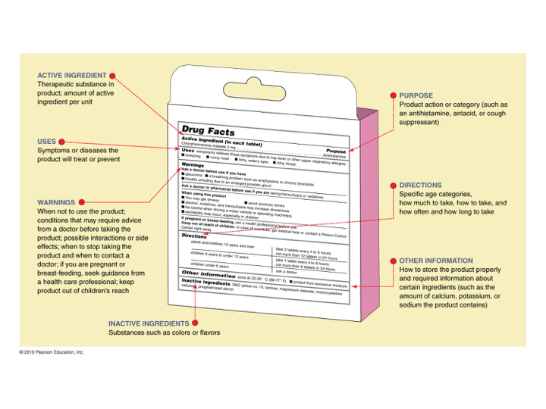

Over-the-Counter (OTC) Drugs
- Types of OTC Drugs
  - Analgesics: prostaglandin inhibitors
- Cold, Cough, Allergy, and Asthma Relievers
- Expectorants
- Antitussives
- Antihistamines
- Decongestants
- Anticholinergics
  - Stimulants
  - Sleeping Aids and Relaxants
  - Dieting Aids: laxatives or diuretics
  - Inhalants

