DIABETES

Diabetes: Incidence & Mortality
- Type 1 Diabetes:
  - Insulin-dependent
  - Autoimmune disease
- Type 2 Diabetes:
  - Non-insulin dependent
  - 90-95% of all diabetes cases
- Gestational Diabetes:
  - During pregnancy
  - Increases risk of developing type 2 diabetes
    - Within 5-10 years of giving birth
- Understanding the Development of Type 2 Diabetes
  - Pancreatic insulin-producing cells overworked
  - Overabundance of free fatty acids
  - Prediabetes can lead to type 2 diabetes
    - Plays role in metabolic syndrome (MetS)
    - Linked to overweight and obesity
- Non-modifiable risk factors
  - Increased age, ethnicity, genetic, biological factors
- Modifiable risk factors
  - Body weight, diet, physical activity, sleep
  - Level of stress, BMI of 25+
  - Waistline: 102cm+ males and 89cm+ females
- Blood tests to diagnose and Monitor Diabetes
  - Fasting plasma glucose test (FPG)
    - Patient fasts overnight; blood tested (glucose)
  - Oral glucose tolerance test (OGTT)
    - Patient drink liquid: concentrated glucose
    - 2 hours later, blood tested for glucose
- Complications Associated with Diabetes
  - Cardiovascular disease
  - Kidney disease
  - Amputations
  - Eye disease and blindness
  - Flu and pneumonia-related deaths
  - Pregnancy complications

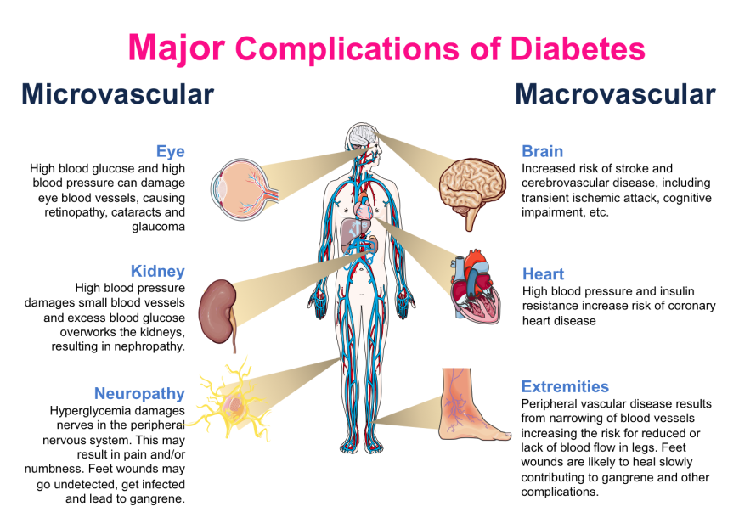

- Lifestyle Changes Can Improve Glucose Levels
  - Weight loss
    - Recommended: Lose 5 to 10% of current weight
  - Eat well
    - Whole grains, high-fiber foods, fatty fish
  - Increasing Physical Fitness
    - The diabetes prevention program: recommends --- 30 minutes of activity 5 days a week
- Insulin Injections May be Necessary
  - Essential for Type 1 diabetics
  - For some Type 2 diabetics:
    - When glucose uncontrollable with other treatments

