ENGAGING IN PHYSICAL ACTIVITY FOR HEALTH, FITNESS, & PERFORMANCE

Physical Activity
- Canada: CSEP recommends > 60* minutes per day of continuous physical activity (*moderate intensity)
- ~15% adults meet physical activity recommendations
- ~7% children and adolescents meet recommendations
  - Average: children appear more active than adolescents
- Average: males appear more active than females

Physical Activity for “Health”
- “Active living”
- Benefits of physical activity include reduced:
  - Cardiovascular disease (CVD), diabetes, cancer
  - Hypertension, obesity, osteoporosis
  - Depression, premature death

Physical Activity for “Fitness”
- “Exercise”: planned, structured, repetitive movements
  - Specific intensity, duration, type, frequency (“routine”)

Physical Activity for “Performance”
- Indicators: power, agility, speed, coordination
- Methods: calisthenics, plyometric, interval training, cross-training, weightlifting, bodybuilding, etc.
- Safest for those with high level of fitness and conditioning

Benefits of Regular Physical Activity
- Improved “Cardiorespiratory Endurance”
  - Reduced risk of heart disease
  - Prevention of hypertension
    - Lowers systolic and diastolic blood pressure
  - Improved blood lipid and lipoprotein profile
    - Lowers LDL (“bad”) and raises HDL (“good”)
- Improved Bone Health
  - Reduced osteoarthritis (OA) and osteoporosis
- Improved Weight Management
  - Direct effect on metabolic rate (daily energy usage)
- Improved Quantity & Quality of Life
  - Prevention of Type-2 Diabetes
  - Increased Longevity (less morbidity)
  - Improved immunity to disease
- Improved Mental Health & Stress Management
Improving Cardiorespiratory Endurance
- “Cardiorespiratory Endurance”
  - Heart, lungs, and blood vessels function efficiently
- “Aerobic Power”
  - Volume of oxygen consumed by the muscles (VO2)
- Graded Exercise Test:
  - Test of aerobic capacity (peak exertion)

Cardiorespiratory Fitness Programs
- Determining exercise “frequency”
- Determining exercise “intensity”
  - Ex: target heart rate = (220-age) x % value
- Determining exercise “Time”
- Determining exercise “type”
- The recovery
  - Recommendation: 18-24 hours rest between exercise

Cardiorespiratory Fitness Programs: Exercise Intensity (Perceived Exertion)
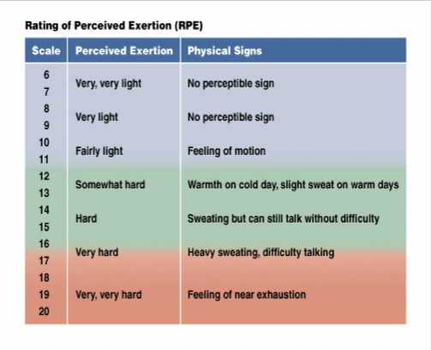
Improving Muscular Strength & Endurance
- Muscular “Strength” and “endurance”
  - Muscular strength: one repetition maximum (1 RM)
  - Muscular endurance: duration, without fatigue
- Principles of Strength Development
  - The tension principle
  - The overload principle
  - The specificity of training principle
  - The recovery principle
- Types of “Muscle Contractions”
  - Isometric muscle contraction
  - Concentric muscle contraction
  - Eccentric muscle contraction
- Methods of Providing “Resistance”
  - Bodyweight resistance
  - Fixed resistance and variable resistance
- Getting Started
  - Set specific training goals and strategies
  - Strength training
    - Minimum one exercise per major muscle group
    - Intensity should be >60% of IRM
  - Muscular Endurance Training
    - Number of repetitions

“Cardiovascular” & “Strength”
- Cardiovascular (Aerobic):
  - Walking/jogging, cycling, swimming, Skiing, interval training
- Strength/Resistance (Anaerobic):
  - Circuit-training/Cross-fit, plyometric, calisthenics, weightlifting
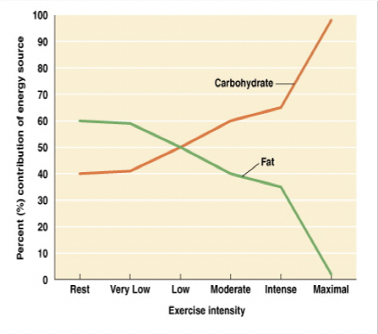
Metabolic Pathways
- ATP-CP
  - Anaerobic (alactic): <15 seconds
- Glycolysis
  - Anaerobic (lactic: 15-90 seconds)
  - Aerobic (oxidative: 90-180 seconds)
- Fatty Acid Oxidation
  - Aerobic (oxidative): >180 seconds

Improving Your Flexibility
- Flexibility: Range of Motion (ROM)
  - Amount of movement possible at a given joint
    - Enhances efficiency of movement
- Types of “Stretching” Exercises
  - Flexibility enhanced by control stretching of muscles
  - Static stretching: slow, gradual lengthening of muscles
    - Recommendation: 4-7 times per week
  - Other types: dynamic (sport-specific) and PNF

Yoga, Tai Chi, & Pilates
- Yoga
  - Flexibility, vitality, posture, agility, and coordination
- Tai Chi
  - Combines stretching, balance, coordination, and meditation
- Pilates
  - Flexibility, agility, coordination, strength, economy of motion

Body Composition
- Relative portions of fat and lean tissue
- Body composition parameters
  - Total body mass: lbs. or kg
  - Fat mass (FM): relative and absolute
  - Fat-free mass (FFM): relative and absolute
  - Regional fat distribution: location

Planning Your Physical Fitness Training Program
- Identifying your physical fitness goals
  - Determine needs and set goals
  - Select appropriate program, commit to it
- Designing your physical fitness program
  - Warm-up
  - Cardiorespiratory Endurance
  - Resistance training
  - Cool-down
  - Flexibility

Fitness-Related Injuries
- Causes of fitness-related injuries
  - Overuse injuries: cumulative stress on body
  - Traumatic injuries: sudden and violent
- Prevention
  - Appropriate Footwear
    - Replace regularly
  - Appropriate protective equipment
    - Must fit well
- Common Overuse Injuries
  - Plantar Fasciitis: inflammation, bottom of foot
  - Shin splints: pain, front of lower leg
  - Runner’s knee: abnormal movement of kneecap
  - Treatment
    - RICE = Rest, Ice, Compression, and Elevation

- Exercising in the Heat
  - Acclimatize to the weather:
    - Avoid dehydration
    - Wear appropriate clothing
    - Use common sense
- Heart Stress Illnesses
  - Heat cramps, heat exhaustion, heat stroke
- Exercising in the Cold
  - Hypothermia: potentially fatal, abnormally low core temperature
  - Prevention of hypothermia
    - Analyze conditions (e.g. wind, humidity)
    - Use the buddy system
    - Wear appropriate layers
    - Hydrate
- Your Movement Journey
  - Changes in physical literacy and activity, with age
    - Allows understanding of journey
    - Helps to set new goals

