ANP1106C Midterm 2 Notes

GROSS ANATOMY OF A SKELETAL MUSCLE

Muscle Fiber: a single muscle tissue cell.
Several different levels of CT wrapping:
- Endomysium: Fine layer of Ct that surrounds each muscle fiber (cell).
- Perimysium: Sheath around a fascicle
- Epimysium: Dense, fibrous CT that surrounds & holds together a group of fascicles = outside layer of a single muscle.
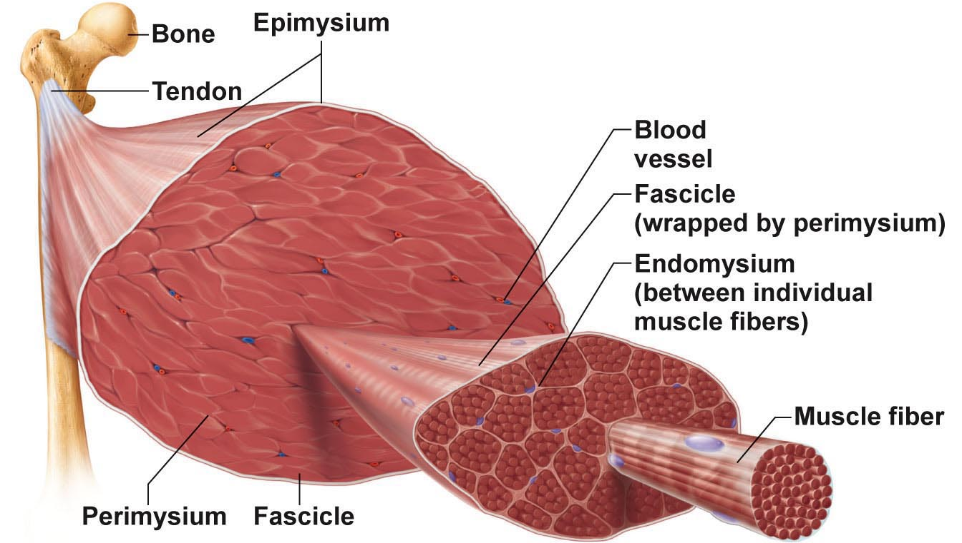
- Deep fascia: Still coarser layer of dense CT that binds muscles into functional groups. Ex. Hamstrings

- Most muscles span joints
- Most muscles area attached to bones in at least 2 places
Origin: Bone staying still
Insertion: Bone that is being moved

- Most attachments are indirect attachments involving either a tendon or an aponeurosis.

ARRANGEMENT OF FASCICLES

All skeletal muscles have fascicles; There are 4 basics pattern:

Parallel: can be straplike (sartorius) or fusiform (biceps brachii)

Pennate: unipennate (eg: extensor digitorum longus, bipennate (eg: rectus femoris) multipennate (eg: deltoid)

Convergent: muscle is triangular or fan-shaped (eg: pectoralis major)

Circular: concentric rings surround ext openings & contract to close opening (eg: orbicularis oris)

INTERACTIONS OF SKELETAL MUSCLES

4 functional groups: prime movers, antagonists, synergists & fixators

- Prime Mover: the principal muscle involved. Ex. biceps brachii & elbow flexion

- Antagonist: A muscle with the opposite action of the prime mover. Can provide resistance to prevent overshoot or control rate of movement. A single muscle can be a prime mover for one action & an antagonist for another action. Ex. biceps brachii & triceps brachii

- Synergists: muscles that help the prime mover by: a) promoting the same movement
b) reducing undesirable movements (Ex. finger flexor muscles cross both wrist & phalangeal joints)

- Fixators: immobilize a bone. Ex. muscles involved in posture

Naming Skeletal Muscles
1.Location of muscle: bone or body region – eg: temporalis, intercostal

2.Shape of muscle: eg: deltoid (triangular), right & left trapezius muscles form a trapezoid

3.Relative size of muscle: maximus, minimus, longus, brevis – eg: gluteus maximus & gluteus minimus

4.Direction of muscle fibers: eg: rectus = straight, parallel to midline (rectus femoris); also transversus abdominis, oblique

5.Number of origins: biceps, triceps, quadriceps – eg: biceps brachii

6.Location of muscle’s origin and/or insertion: if both indicated, origin always indicated first – eg: sternocleidomastoid (neck region – dual origin on sternum and clavicle & insertion on mastoid process of temporal bone)

7.Action of the muscle: flexor, extensor, adductor – eg: adductor longus for thigh adduction & suppinator muscle in forearm

Example: Extensor carpi radialis longus – back, thumb side, associated with radial bone.

Muscles of the Head – Facial Expression
- insert into skin or other muscles, not bones; innervated by the facial nerve

Epicranius = main muscle of scalp – consists of:
(i) frontalis (frontal belly): raises eyebrows, wrinkles forehead
(ii) occipitalis (occipital belly): pulls scalp posteriorly

Orbicularis oculi: surrounds rim of orbit; protects eyes from light/injury – blinking, squinting, also draws eyebrows down

Zygomaticus (cheek to corner of mouth): smiling muscle
Orbicularis oris: lips; multi-layered; closes, purses, protrudes lips
Mentalis (mandible to chin): V-shaped pair – protrudes lower lip; wrinkles chin
ʘ buccinator (mandible/maxilla to orb.oris): deep to masseter – whistling, sucking; hold food in place when chewing; especially in nursing infants
Platysma (fascia of chest to mandible): helps depress mandible; tenses skin of neck

Muscles that move the tongue
- Genioglossus (mandible to inferior tongue & hyoid bone): prime mover of tongue protrusion; anchors tongue to prevent obstruction of respiration
- Hyoglossus (hyoid bone to inferolateral tongue): depresses tongue, especially lateral margins
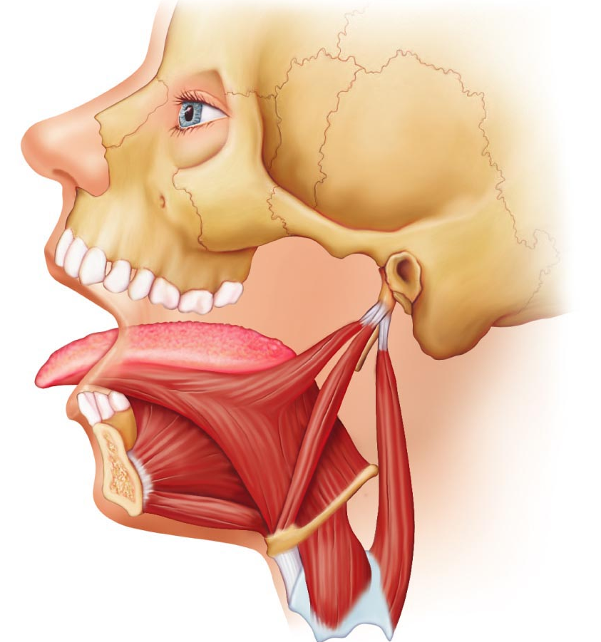
- Styloglossus (styloid process of temporal bone to inferolateral tongue): retracts & elevates tongue
Muscles of the Head:
4 pairs involved in chewing; all innervated by mandibular division of cranial nerve V

ʘ Masseter (zygomatic to mandible): prime mover of jaw closure (powerfully)

ʘ Temporalis (temporal to mandible): elevates and retracts mandible (closes jaw); maintains closed jaw at rest.

Medial and lateral pterygoid (sphenoid to mandible): both two-headed; additional jaw movements (eg: side-to-side grinding movments)

Buccinator (mandible/maxilla to orbicularis oris): helps keep food between grinding surfaces of teeth during chewing

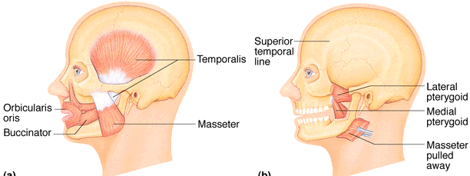

Muscles of the Neck & Vertebral Column
- head moved by muscles originating from axial skeleton

Sternocleidomastoid (manubrium/clavicle to mastoid process of temporal): 2-headed; deep to platysma; prime mover (both muscles) of head flexion; individual muscle action for head rotation to side, head tilts
Scalenes (cervical vertebrae to 1st 2 ribs): more laterally and deep to platysma & sternocleidomastoid – elevate first 2 ribs, role in coughing, flex & rotate neck
ʘ Splenius (vertebrae to mastoid process of temporal): superficial; “bandage muscle”; head extension (both sides) or rotation, tilts
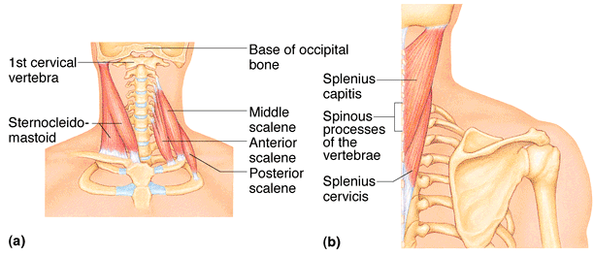

Erector spinae: prime mover of back extension; consists of 3 columns of muscles (iliocostalis, longissimus, spinalis); resistance to bending forward & extensors for return to erect position.

ʘ Semispinalis: deeper, composite muscle from thoracic region to head; extends vertebral column & head, rotation of head, synergistic with sternocleidomastoid muscles.

Quadratus lumborum (iliac crest to lumbar vertebrae): individual muscles flex vertebral column laterally; jointly to extend lumbar spine & fix 12th rib; maintain upright posture

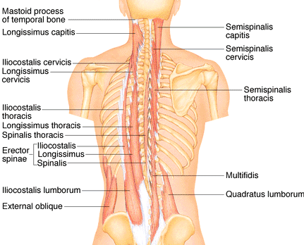

Muscles of Respiration

ʘ External intercostals: 11 pairs, between ribs; oblique; pull ribs together to elevate rib cage (inspiration;1st ribs fixed by scalene muscles).

Internal intercostals: 11 pairs, between ribs; ^ external intercostals; draw ribs together to depress rib cage (expiration; 12th ribs fixed by quadratus lumborum).

Diaphragm: dome-shaped when relaxed; prime mover of inspiration.
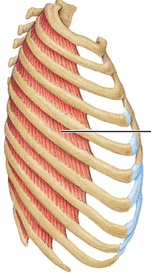
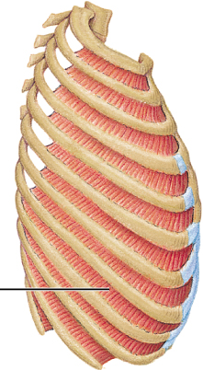
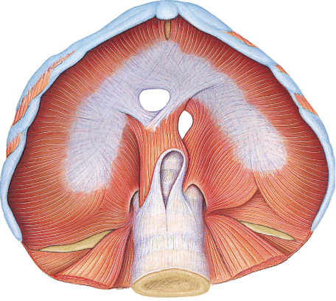

Muscles of Abdominal Wall

ʘ Rectus abdominis – medial superficial; pubis to rib cage; lumbar rotation, fix & depress ribs, stabilize pelvis during walking.
External oblique – largest & most superficial lateral muscle; together Ø increase ab pressure, flex vertebral column; individual Ø rotation.
Internal oblique – deeper, but same actions as ext obliques.
ʘ Transversus abdominis – deepest; compresses abdominal contents.

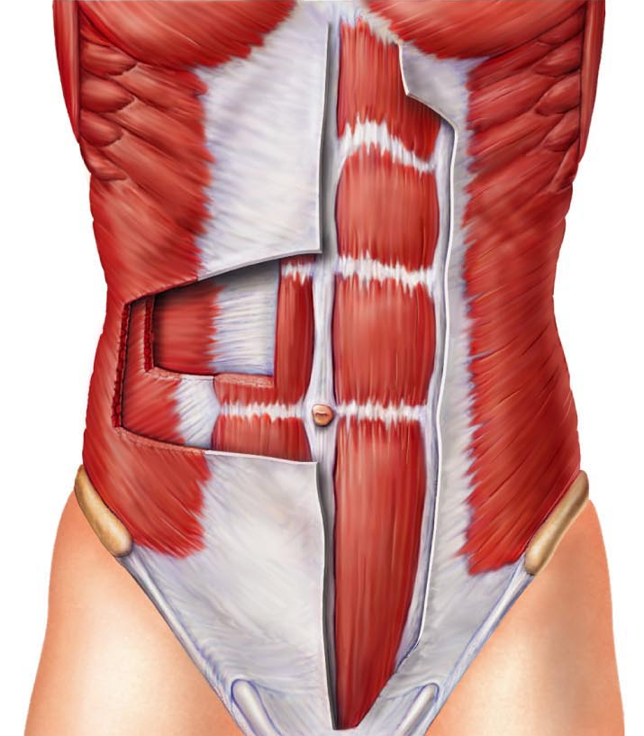
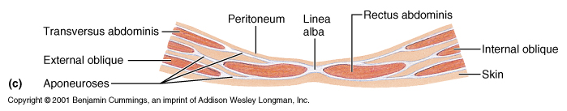

Muscles of the Pelvic floor and Perineum

Levator ani (pubis to inner coccyx): supports pelvic viscera & forms supportive sling at anorectal junction & vagina; resists increase in intra-abdominal pressure.

Coccygeus (spine of ischium to sacrum & coccyx): supports pelvic viscera & coccyx.

Urogenital diaphragm: supports pelvic viscera and constricts urethra.
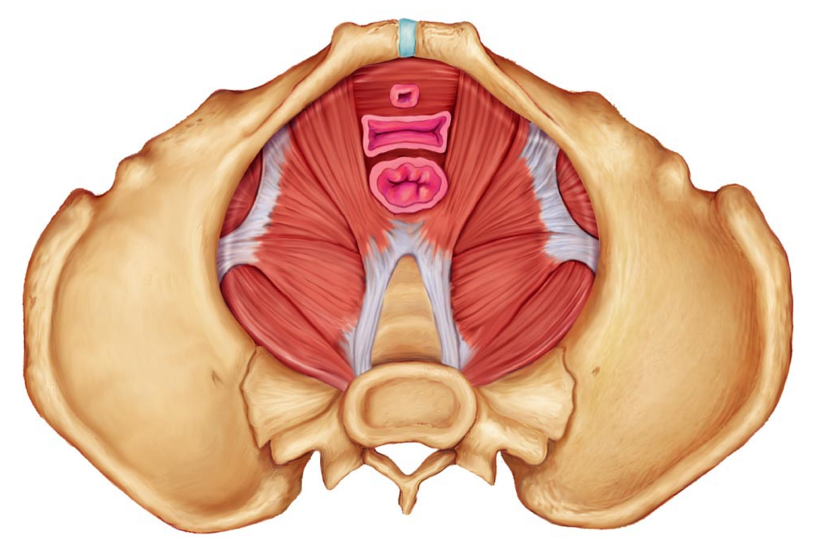

Superficial Muscles of Thorax

ʘ Pectoralis major (sternum/rib cartilages to humerus): prime mover of arm flexion; rotates arm medially; adducts arm; climbing, throwing, pushing.

ʘ Latissimus dorsi (vertebrae to humerus): broad, flat back muscle; prime mover of arm extension, arm adductor, rotates arm at shoulder, rowing, swimming.

ʘ Deltoid (clavicle/scapula to humerus): thick, rounded, site of IM injection, prime mover of arm abduction (all fibers); also lateral & medial rotations, flexion or extensions if only some fibers used; swinging arm when walking.

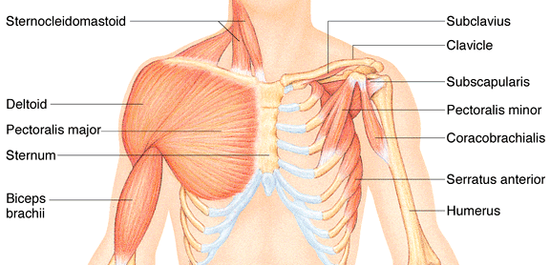

Trapezius (occipital & vertebrae to scapula): superficial, stabilizes, raises, retracts, rotates scapula.
Rhomboids (vertebrae to scapula): deep to trapezius; aid in scapula movements (eg: squaring shoulders, rotation when lowering arm).
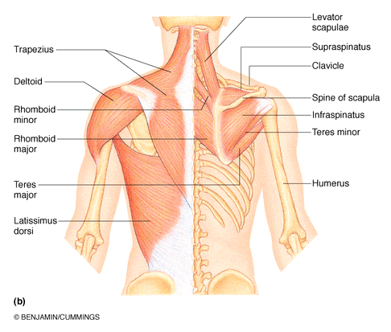

Muscles Crossing the Shoulder & Elbow Joints

ʘ Triceps brachii (scapula/humerus to ulna): only muscle of posterior compartment of arm; powerful forearm extensor, may help stabilize shoulder joint.
Biceps brachii (shoulder to radius): anterior, flexes elbow joint & supinates forearm; weak flexor of arm at shoulder.
Brachialis (humerus to ulna): immediately deep to biceps brachii; major forearm flexor (strong) – lifts ulna as biceps lifts radius.
ʘ Brachioradialis (humerus to radius): superficial; from distal humerus to distal forearm; synergist in forearm flexion.
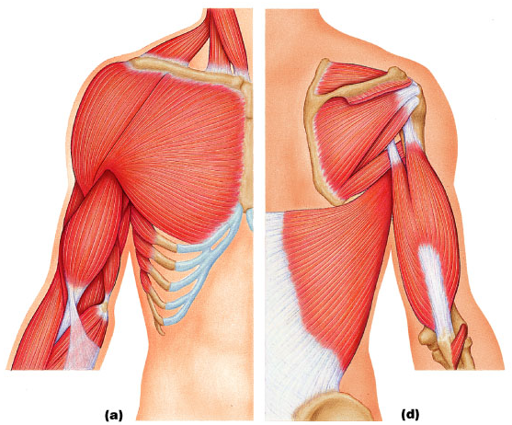
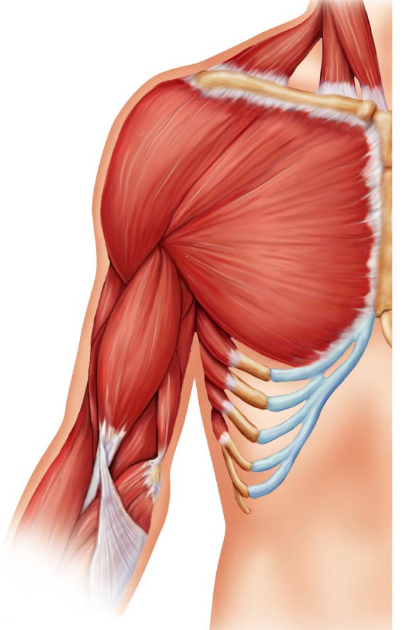
Anterior Posterior

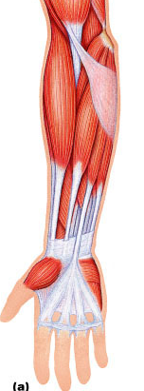
Muscles of the Forearm
2 functional groups allow for movements of
(i) the wrist and of (ii) the fingers and thumb

Pronator teres (humerus/ulna to lateral radius):
pronates forearm, weak flexor of elbow
Flexor carpi radialis (humerus to metacarpals):
diagonally across forearm, powerful flexor of wrist; abducts hand
ʘ Flexor carpi ulnaris (humerus/ulna to carpals/metacarpals):
powerful flexor of wrist; also adducts hand in concert with extensor carpi ulnaris;
stabilizes wrist during finger extension
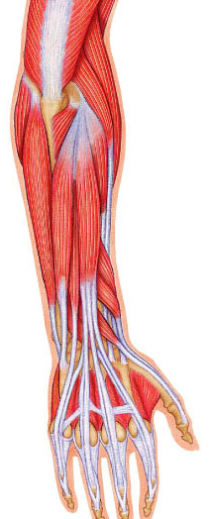
ʘ Flexor digitorum superficialis (humerus/ulna to phalanges):
2-headed, deeper; flexes wrist & middle phalanges of fingers 2-5

Extensor carpi radialis longus/brevis (humerus to metacarpals):
extends & abducts wrist
Extensor digitorum (humerus to phalanges):
prime mover of finger extension; extends wrist, can abduct fingers
Supinator (humerus to radius):
deep; assists biceps brachii to supinate forearm

Muscles of Hip, Thigh & Leg

ʘ Iliopsoas (iliac crest & lumbar vertebrae to femur): composite of 2 muscles; prime mover of hip flexion
ʘ Sartorius (iliac spine to medial tibia): strap-like; longest muscle; flexes & laterally rotates thigh; weak knee flexor
Adductors (magnus, longus, brevis) (pubis to femur): all adduct, flex, medially rotate thigh – eg: riding a horse, walking, fixing hip when knee flexed
Pectineus (pubis to femur): adducts, flexes & medially rotates thigh
Gracilis (pubis to medial tibia): adducts thigh, medially rotates leg (walking)
ʘ Rectus femoris (iliac spine to patella & tibia): extends knee; flexes thigh at hip
Vastus (lateralis, medialis, intermedius): all extend the knee
ʘ Tibialis anterior (tibia to tarsals and 1st metatarsal ): prime mover of dorsiflexion; inverts foot
Extensor digitorum longus (tibia to phalanges): dorsiflexes foot; prime mover of toe extension

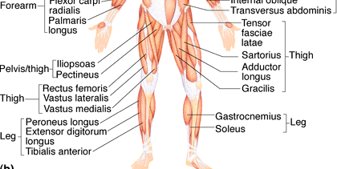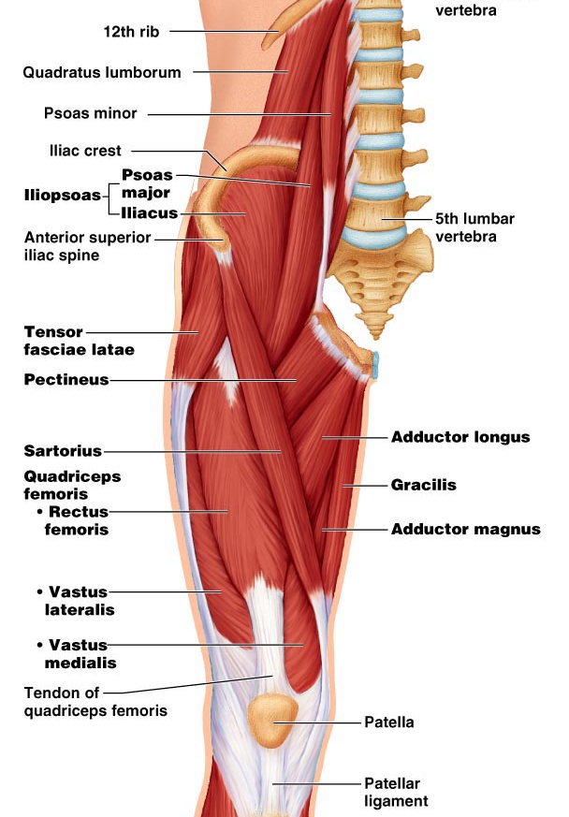
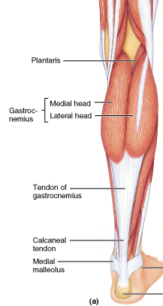
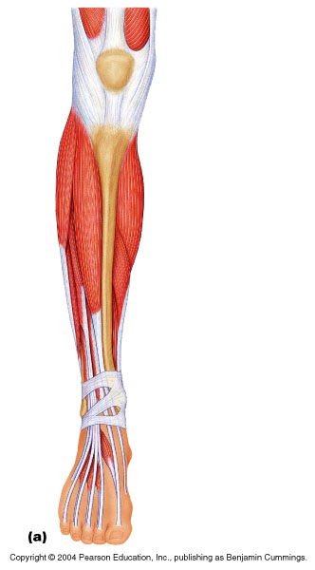
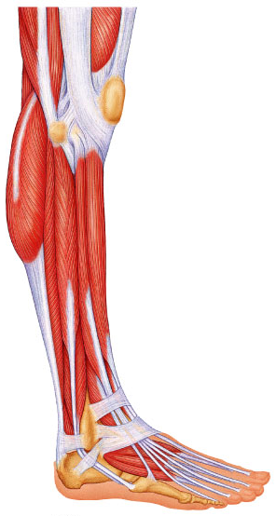
tibialis anterior

extensor digitorum longus

Gluteus maximus (ilium/sacrum to femur): largest & most superficial buttock muscle; major thigh extensor - climbing stairs, running (im injection)
Gluteus medius (ilium to femur): abducts & medially rotates thigh; esp. during walking (im injections)
Hamstrings (ischial tuberosity to tibia/fibula): 3 muscles; all extend thigh & flex knee

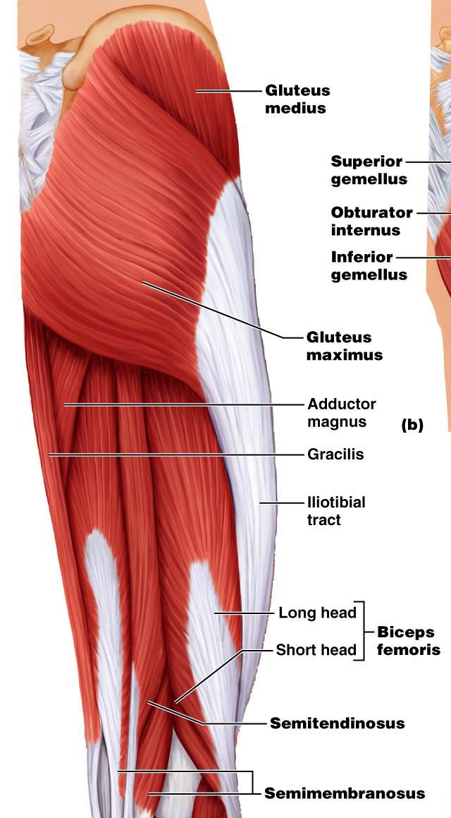
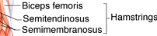
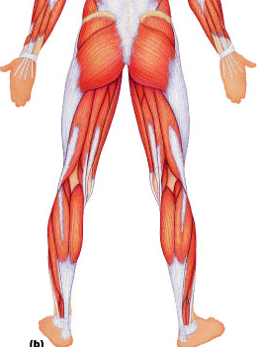

ʘ Gastrocnemius (femur to calcaneal tendon): plantar flexes foot when knee extended; flex knee if foot dorsiflexed
Soleus (proximal tibia/fibula to calcaneus): deeper, plantar flexes ankle: walking, running, dancing
ʘ Fibularis (peroneus) longus (fibula under foot to 1st metatarsal): plantar flexes & everts foot; helps keep foot flat on ground
Calcaneal (Achilles tendon): largest tendon in body (G & S)

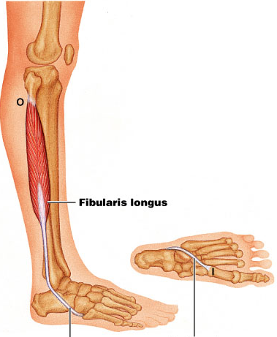

Topic 6 Midterm 2
Anatomy of the Nervous System

Central Nervous System: brain + spinal cord; integrating & command center.

Peripheral Nervous System: cranial & spinal nerves; communication between CNS & all parts of body.
- Sensory division: somatic & visceral fibers; from receptors to CNS.
- Motor division: motor nerve fibers from CNS to effectors.
        - Somatic ns: voluntary; from CNS to skeletal muscle.
        - Autonomic ns: involuntary; (visceral motor); from CNS to cardiac muscle, smooth muscle, glands
          - Sympathetic division: “fight or flight”
          - Parasympathetic division: conserve energy at rest

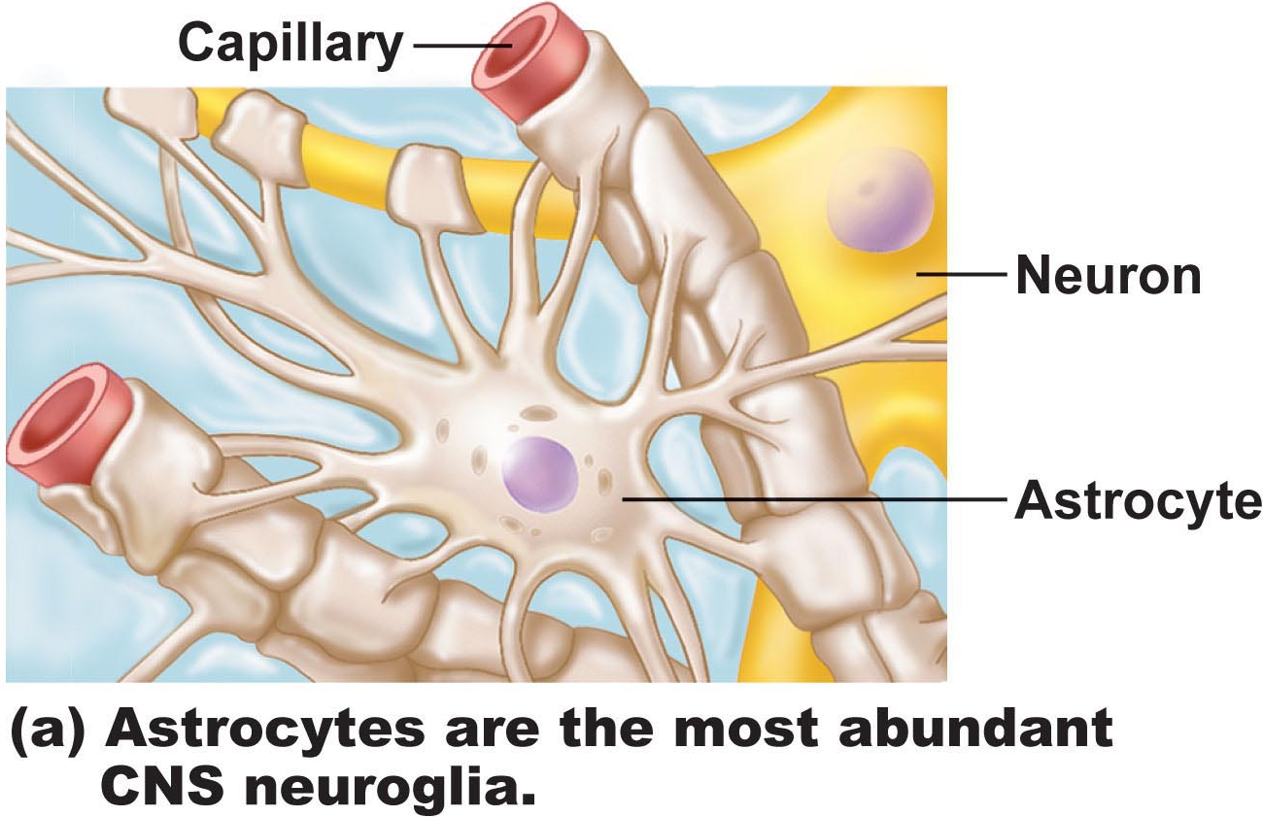
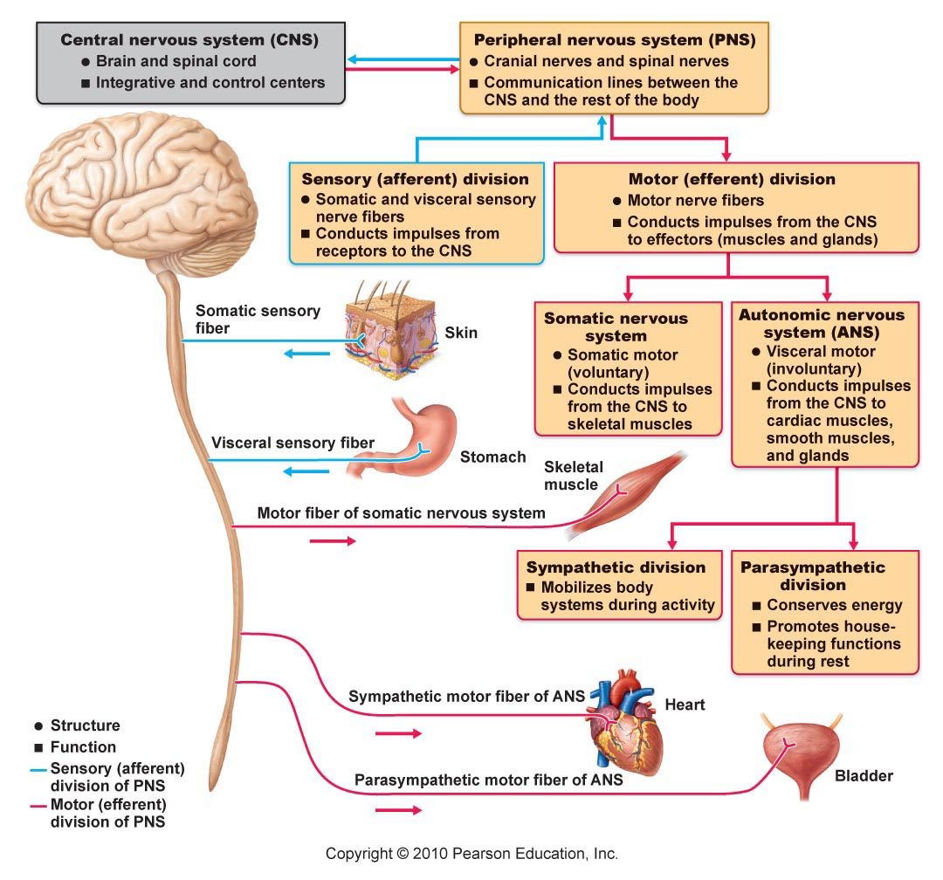

Histology of Nervous Tissue
• very cellular; minimal extracellular matrix
• 2 principal types of cells:
(i)neurons
(ii) supporting cells
A.Supporting cells: (6 types)

CNS: (4 types – neuroglia)
- Astrocytes: star-shaped, most abundant; anchor neurons close to capillaries
• roles in nutrient exchange, antigen presentation, control of environment
- Microglia: protective; touch neurons to monitor well-being; can transform into macrophages
- Ependymal cells: line cavities of brain & spinal cord as barrier between CSF & fluid bathing cells of CNS; cilia circulate CSF
- Oligodendrocytes: “few branches”; provide myelin sheaths to CNS neurons.

PNS:
(1) Satellite cells: surround neuron cell bodies in ganglia – influence chemical environment of these neurons (?)
(2) Schwann cells: form myelin sheaths around larger neurons in PNS; vital to peripheral nerve cell regeneration

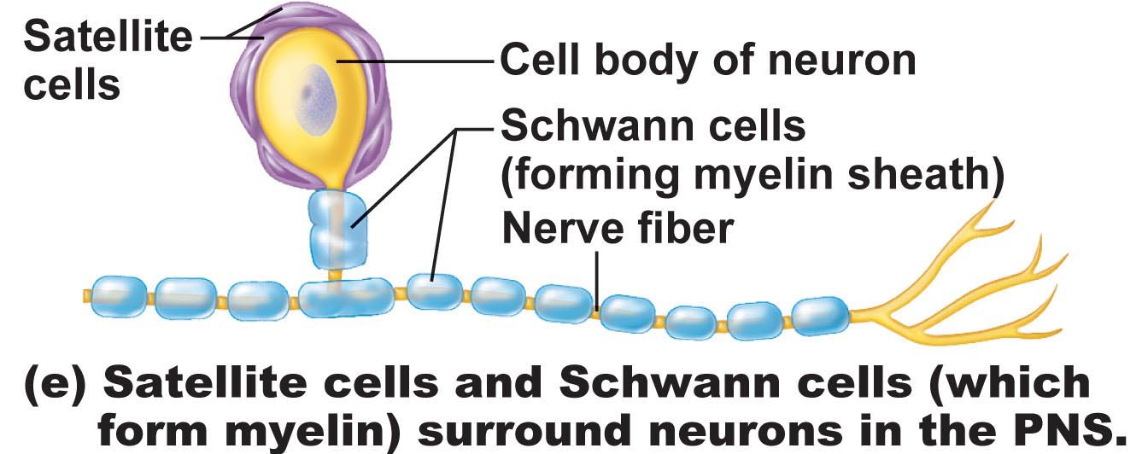

Neurons
• extreme longevity, amitotic, high MR
• know: cell body, dendrites, axon, axon hillock, myelin sheath, node of Ranvier, terminal branches, axonal terminals
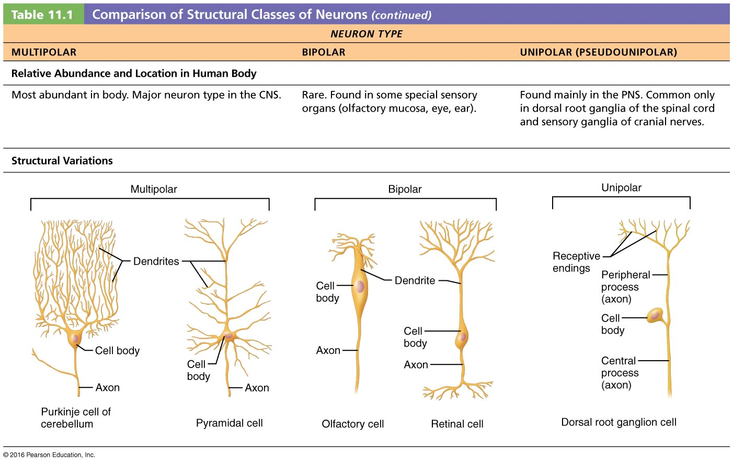

D. Functional Classification of Neurons
• according to direction nerve impulse travels wrt CNS
• sensory, motor & association neurons
(i)sensory: toward CNS; primary, secondary, tertiary
• except bipolar neurons in some special sense organs, virt all primary sensory neurons are unipolar & cell bodies located in ganglia outside CNS
• higher order sensory neurons all multipolar & reside entirely within CNS – conduction to higher brain centres for interpretation
(ii)motor: away from CNS to effector organs like muscle & glands; multipolar; most cell bodies reside in CNS
(iii)association (interneurons): between sensory & motor neurons – integration of info; multipolar; most entirely within CNS; 99% of neurons of the body
The Brain
• complexity of wiring rather than size is what matters
subdivisions:
cerebral hemispheres
diencephalon (thalamus, hypothalamus, epithalamus)
brain stem (midbrain, pons, medulla)
cerebellum

Arrangement of gray & white matter:
Spinal cord has central cavity surrounded by gray matter & white matter.
Brain has same design, but with additional regions of gray matter;
cerebral hemispheres & cerebellum have outer “bark” of gray matter

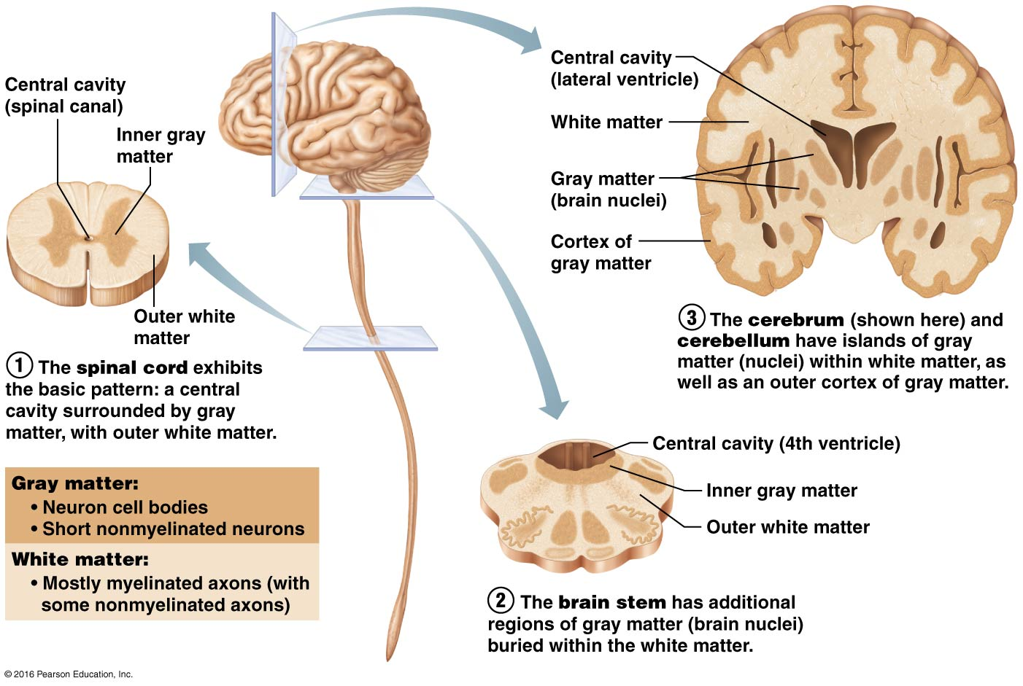

Ventricles of Brain:
continuous with one another and with central cavity of spinal cord; filled with CSF & lined by ependymal cells
(i)Paired lateral ventricles separated by narrow septum pellucidum
(ii)Each communicates with narrow 3rd ventricle in diencephalon via interventricular foramen
(iii)3rd ventricle to 4th ventricle (dorsal to pons) via cerebral aqueduct
(iv)4th ventricle continuous with central canal
(v)3 apertures (paired lateral apertures & median aperture) connect ventricles to subarachnoid space (surrounds brain)
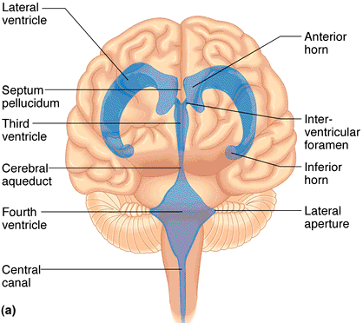
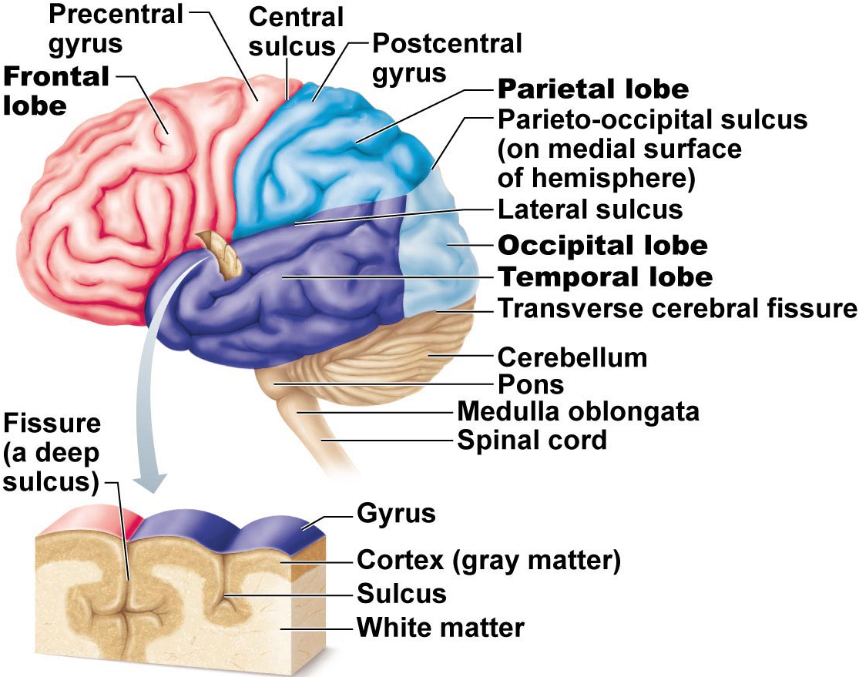
A1. The Cerebral Hemispheres
superior; ~83% of brain mass
gyri separated by sulci; anatomical landmarks
longitudinal fissure; transverse cerebral fissure
Lobes: frontal, parietal, occipital, temporal, insular
central sulcus: precentral/postcentral gyrus
parieto-occipital sulcus, lateral sulcus

Cerebral cortex:
• allows us to perceive, communicate, remember, understand, appreciate, initiate voluntary movements -- conscious behavior.
• cell bodies, dendrites & unmyelinated axons; only 2-4 mm thick, but many convolutions triple surface area
• Brodmann areas: numbered according to subtle differences in thickness, structure of contained neurons; some areas link with particular functions; other functions (memory & language) have overlapping domains; more diffusely organized.
(i) 3 functional areas: motor, sensory & association
(ii)each hemisphere handles sensory & motor functions of opposite side of body
(iii)largely symmetrical, but not 100% equal in function (lateralization)
(iv)no functional area of cortex acts alone; all conscious behavior involves entire cortex in some way.

(i)Motor Areas:
• posterior part of frontal lobes: primary motor cortex, premotor cortex, Broca’s area & frontal eye field
1) Primary motor cortex: - precentral gyrus of frontal lobe of each hemisphere; pyramidal cells allow control of skeletal muscles; axons project to spinal cord as pyramidal/corticospinal tracts
• entire body represented spatially in primary motor cortex of each hemisphere – somatotopy. Motor innervation is contralateral.
control not as simple as in diagram – some neurons send impulses to more than one muscle – think about coordinated movement of arm.
no overlap between muscles involved in unrelated movements.
stroke: damage to area of right hemisphere paralyzes body muscles on left – only voluntary movement lost; reflex contraction still possible.
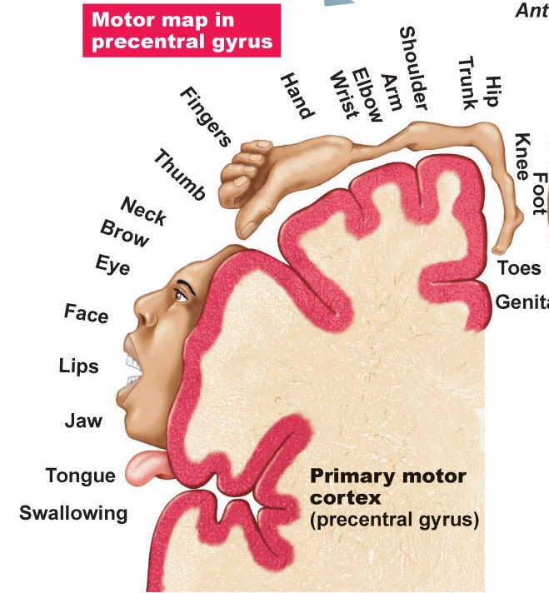

2.Premotor cortex:
• anterior to precentral gyrus
• helps plan movements by selecting and sequencing basic motor movements into more complex tasks (e.g. playing musical instrument, keyboarding)
• coordinates movement of several muscle groups simultaneously/sequentially by activating motor cortex
•can control voluntary actions that depend on sensory feedback – e.g. feeling for light switch in a dark room
Damage to premotor cortex, cause loss to muscles memory. Need to retrain brain.

3.Broca’s area:
• overlaps Brodmann areas 44 & 45
•present in one hemisphere only – usually the left
• originally thought to be only a motor speech area
• newer studies: Broca’s area is active when we prepare to speak and plan voluntary activities other than speech.

4. Frontal eye field:
• Brodmann area 8; controls voluntary movements of the eyes

(ii)Sensory Areas
1.Primary somatosensory cortex:
• in postcentral gyrus of parietal lobe (Brodmann areas (BA) 1-3)
• receives info from somatic sensory receptors (skin) & proprioreceptors (skeletal muscle)
• spatial discrimination
2.Somatosensory association cortex:
• posterior to PSC (BA 5-7) - many connections with it
• integrate/analyze somatic inputs (temp, pressure,) – interpret wrt size, texture, relationship of parts based on prior experience

3.Visual areas:
primary visual cortex Ø posterior tip occipital lobe
• largest cortical area; contains map of visual space on retina (opposite sides)
visual association area Ø surrounds PVC
• interprets visual image based on prior experience – eg: recognition of a face, letter (also movement!)
Damage to visual cortex, leads to blindness, damage to visual association area they don’t know what they are seeing.
4.Auditory areas:
primary auditory cortex (~ BA 42) sound evaluated wrt pitch, rhythm, loudness
auditory association area (~ BA 22) interpretation based on memory – speech, words, music, thunder, etc.
5. Vestibular (equilibrium) cortex:
•awareness of balance – posterior part of insula & adjacent parietal cortex

6. Olfactory cortex:
• medial aspects of temporal lobes = uncus
• small in humans; most of surrounding tissue now forms limbic system (emotions, memory)
•conscious awareness of different odors
7. Gustatory cortex:
• insula; ~ BA 43 and a bit anterior
8. Visceral sensory area:
•posterior to gustatory cortex

Visual Agnosia – the inability to recognize/understand things that you see
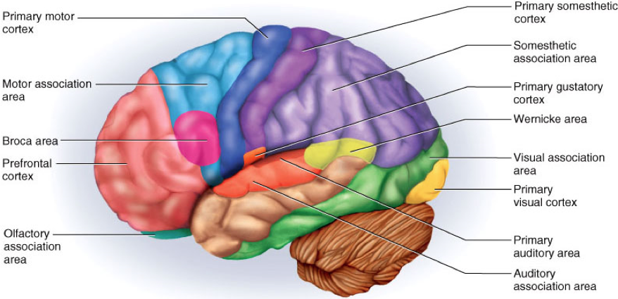
(iii) Multimodal Association Areas:
any cortical area that is not “primary”

sensory receptors
↓
primary sensory cortex
↓
sensory association cortex
↓
multimodal association cortex

1.Anterior Association Area (Prefrontal Cortex):
•intellect, complex learning (cognition) & personality (working memory is here)
• abstract ideas, judgment, reasoning, persistence, planning, concern, conscience
• matures slowly; dependent on feedback from social environment
• closely linked to limbic system; involved in mood

Phineas Gage
•Railway worker injured in 1848 by a tamping bar during an explosion
•Sensory, motor OK – but dramatic personality changes
•Autopsy revealed damage to some parts of the anterior association area (prefrontal cortex)

2. Posterior Association area: parts of temporal, parietal & occipital lobes
• input from all sensory association areas – storage of complex memories linked to sensation – put info together to understand what see, feel etc
•localization of self and surroundings in space
•recognition of patterns, faces
• some parts for understanding written & spoken language (Wernicke’s area)

3.Limbic Association area:
•provides emotional impact – e.g. be aware of the danger associated with a particular situation and to remember it, etc.

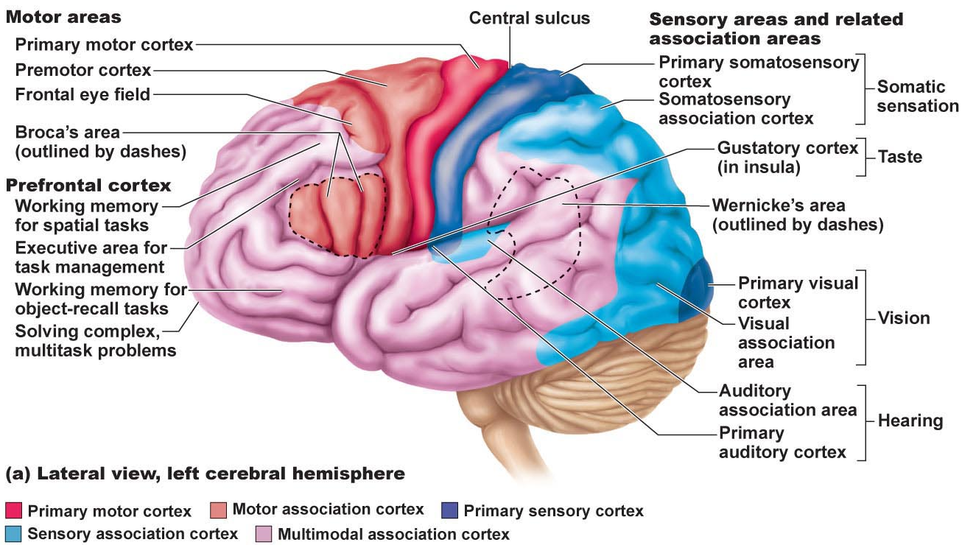

Lateralization of Cortical Functioning
•each cerebral hemisphere has some abilities not completely shared by other hemisphere
•cerebral dominance = hemisphere that is dominant for language
• 90% of people: left hemisphere dominant for language, math, logic
• other hemisphere dominates for visual-spatial skills, intuition, emotion, appreciation of art & music – creative side, better at recognizing faces
• most individuals with left cerebral dominance are right-handed
• in remaining 10%, roles reversed or shared equally

A3. Cerebral White Matter
communication between cerebral areas, between cortex & lower CNS centres
commissural fibers: connect corresponding areas between the 2 hemispheres – largest is corpus callosum
association fibers: connections within a hemisphere (connect gyri, lobes)
projection fibers: to or from cortex and rest of nervous system; these ones run vertically
Basal Nuclei
• caudate nucleus +[putamen & globus pallidus = lentiform nucleus]
• inputs from entire cerebral cortex, other subcortical nuclei & each other
• project to premotor & prefrontal cortices to influence muscle movements directed by primary motor cortex – have no direct access to motor pathways
• precise roles elusive (difficult to access; some roles overlap with cerebellum) – roles in starting, stopping, monitoring intensity of movements executed by cortex, especially if slow, sustained, stereotyped; also inhibit antagonistic and/or unnecessary actions
• disorders can result in too much movement (e.g. Huntington’s disease) or too little movement (Parkinson’s disease)
Huntington’s Disease
•hereditary disorder in which mutant huntingtin protein accumulates in brain cells ® degeneration of the basal nuclei and eventually of the cortex
•as caudate deteriorates, connections to frontal lobe become lost so that the affected individual in unable to control feelings, thoughts or movements
Parkinson’s Disease
•degeneration of dopamine-releasing neurons of substantia nigra (midbrain)
•causes basal nuclei usually targeted by substantia nigra to become overactive ® persistent tremor at rest; muscles become rigid leading to difficulty walking, loss of facial expression, difficulty writing, etc.
The Diencephalon
• thalamus, hypothalamus, epithalamus – enclose the 3rd ventricle
Thalamus: 80%; bilateral masses of gray matter held together by midline commissure called the intermediate mass
• consists of many different nuclei, named for their position in thalamus – afferent impulses from all senses & all parts of body converge on thalamus
• sorting & editing of information; group like impulses to send to appropriate region of cortex – crude awareness of sensation at level of thalamus
• also input pertaining to emotions & viscera from hypothalamus
• key roles in mediating sensation, motor activities, cortical arousal, learning, memory = “gateway to cerebral cortex”

Hypothalamus: “below” thalamus
(i)Autonomic control centre: centres for bp, heart, GI, respiration, etc
(ii)Centre for emotional response & behaviour: heart of limbic system
(iii)Body temperature regulation:
(iv)Regulation of food intake: hunger, satiety
(v)Regulation of water balance & thirst: release of ADH; thirst centre
(vi)Regulation of sleep-awake cycles: suprachiasmatic nucleus
(vii)Control of endocrine system: releasing factors plus 2 nuclei (supraoptic & paraventricular) produce ADH & oxytocin.

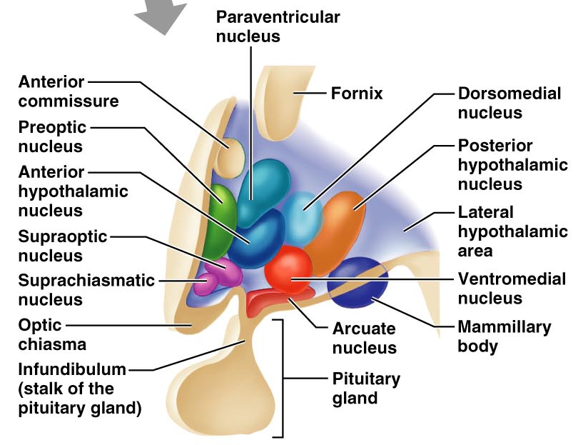

Epithalamus: most dorsal part of diencephalon & forms roof of 3rd ventricle; pineal gland (melatonin) extends from its dorsal border
• choroid plexus (CSF-forming structure) also part of epithalamus

The Brain Stem: consists of midbrain, pons, medulla oblongata
(i) rigidly programmed, automatic behaviors necessary to survival
(ii) pathway between higher & lower neural centers
(iii) associated with 10 pairs of cranial nerves

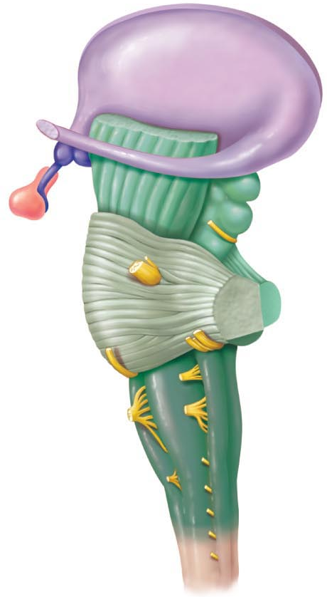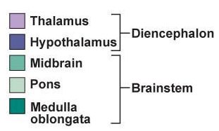

Midbrain:
2 cerebral peduncles that contain large pyramidal (corticospinal) motor tracts
hollow cerebral aqueduct runs through midbrain
periaqueductal gray matter involved in pain suppression
Corpora quadrigemina: superior colliculi are visual reflex centers; inferior colliculi are part of auditory relay (also startle reflex).
Midbrain (cont):
• substantia nigra: band-like nucleus; high melanin content (precursor Ø dopamine); linked to basal nuclei of cerebral hemispheres (Parkinson’s disease)
• red nucleus: rich vascular supply, iron pigment in neuron cell bodies; relay nuclei for descending pathways influencing limb flexion
• also, some nuclei associated with reticular formation

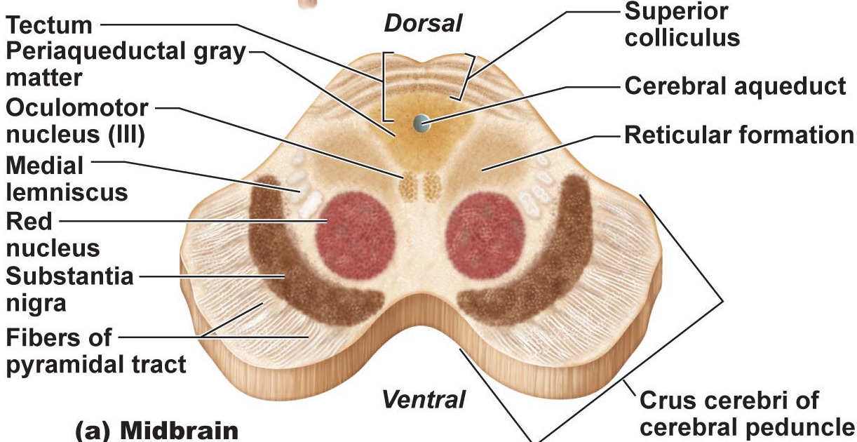

Pons: dorsally, forms part of anterior wall of 4th ventricle
• primarily conduction tracts (“bridge”); some run longitudinally; others oriented transversely to communicate with cerebellum
• cranial nerves V (trigeminal), VI (abducens) & VII facial; other pons nuclei are part of reticular formation and others are involved in respiration).
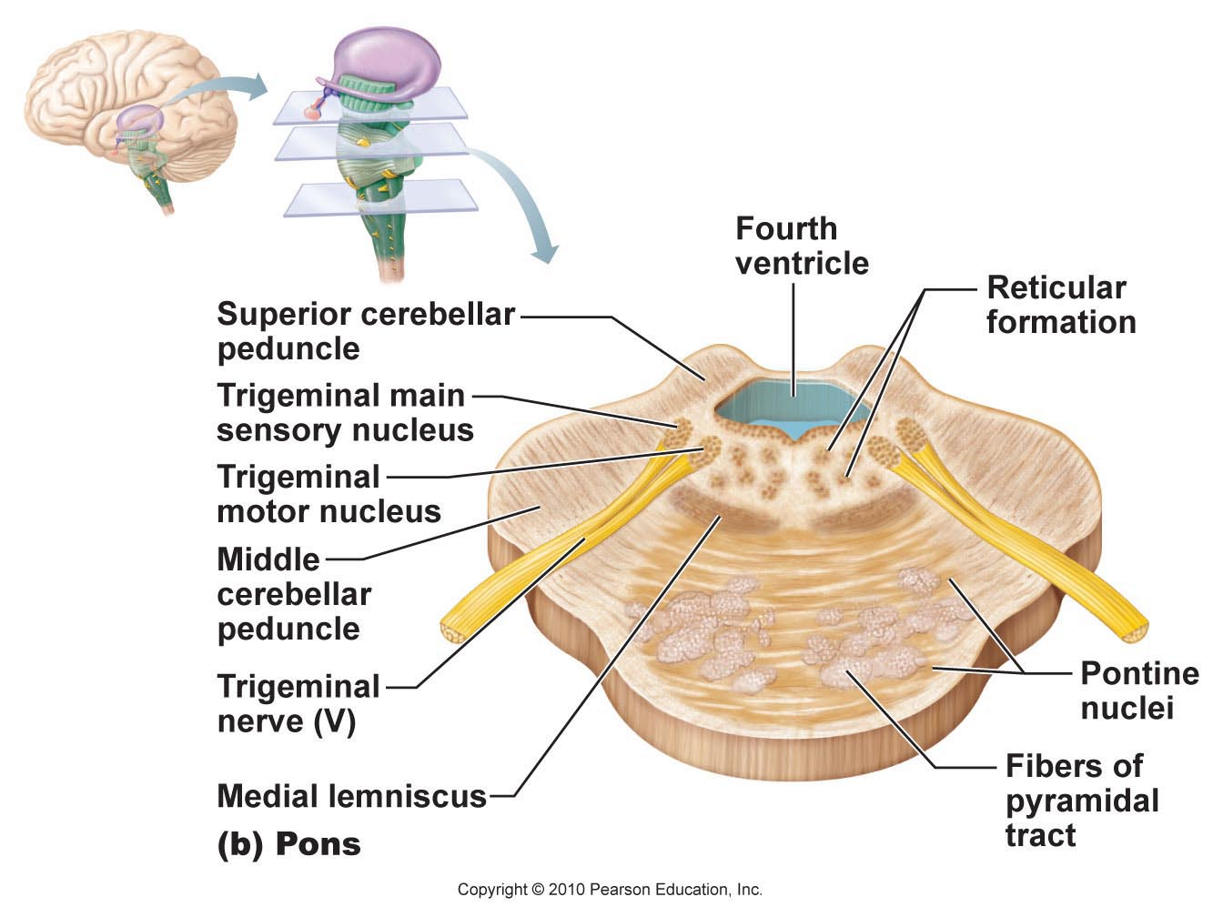

Medulla oblongata: from pons to spinal cord
• pyramids, decussation (significance of this?)
inferior olivary nuclei: relay sensory info re muscles & joints to cerebellum
cranial nerves XII (hypoglossal), IX (glossopharyngeal), X (vagus), XI (accessory)
vestibulocochlear nerve fibers (VIII) synapse with cochlear nuclei.

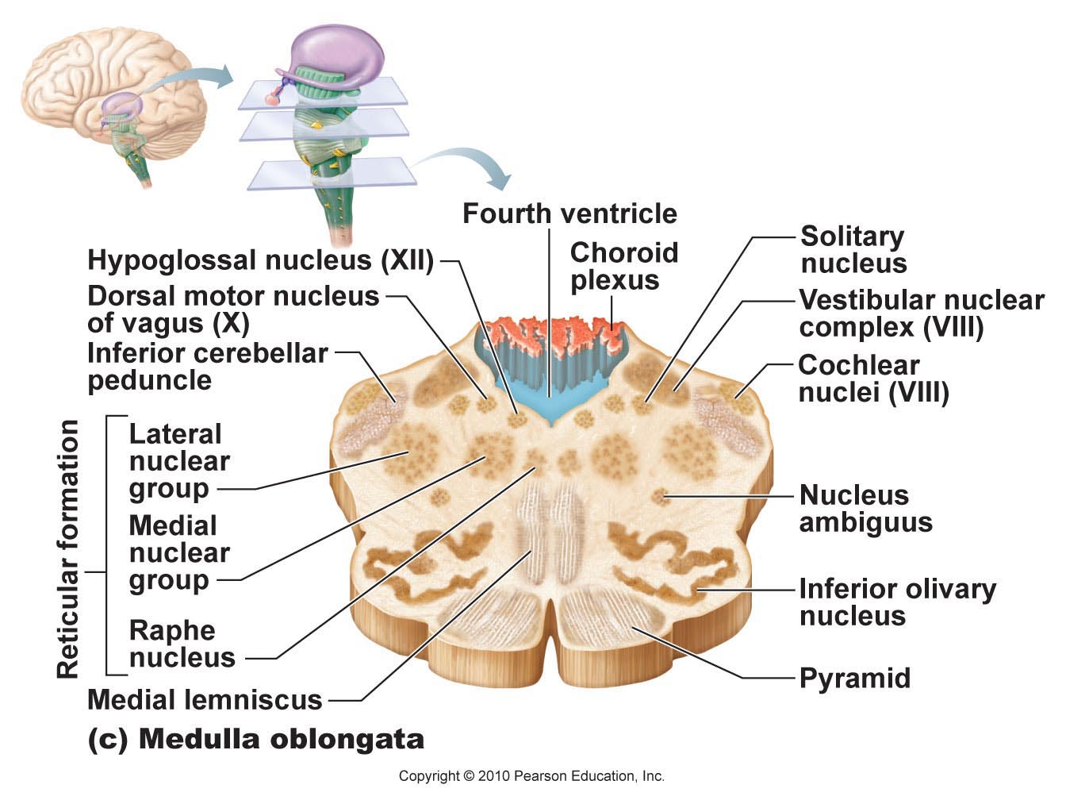

Medulla oblongata: crucial role as autonomic reflex center for homeostasis
(i)Cardiovascular center: cardiac & vasomotor centers
(ii)Respiratory centers: rate & depth of breathing
(iii)Other centers: eg: vomiting, hiccupping, swallowing coughing, sneezing
• overlap with hypothalamus: hypothalamus controls most visceral functions by relaying instructions through medullary centers which carry them out.

The Cerebellum:
• processes inputs from cerebral motor cortex, brainstem nuclei & sensory receptors Ø timing & patterns of skeletal muscle contraction for smooth, daily movements – eg: driving, typing, playing a musical instrument, etc (not under conscious control)
• bilaterally symmetrical; connected by vermis; fine transverse fissures called folia; each hemisphere divided into 3 lobes: anterior, posterior, flocculonodular.

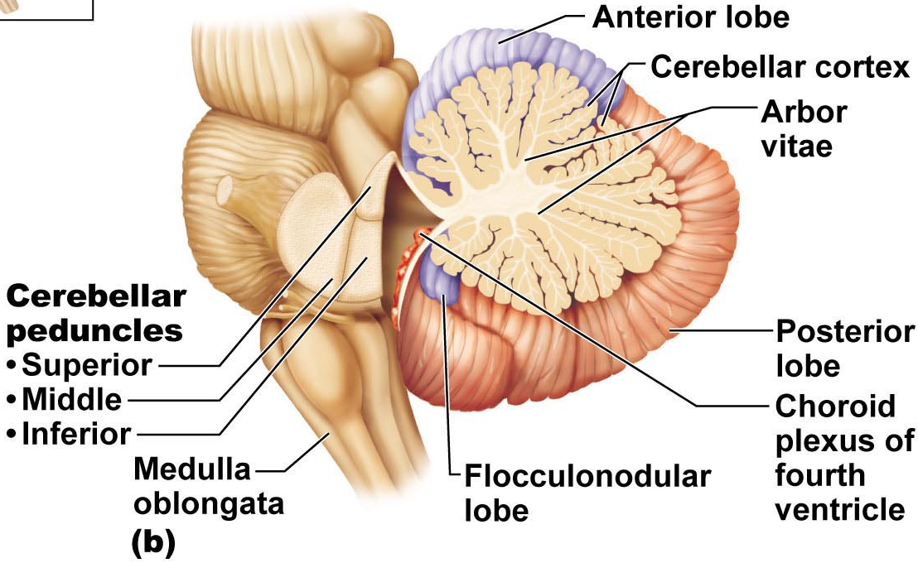

4.The Cerebellum (cont):
• anterior & posterior lobes have overlapping sensory & motor maps of body
medial: trunk & girdle
intermediate: distal limbs, skilled movements
lateral: input from association areas of cortex (esp. planning movements)
• flocculonodular lobes – input from equilibrium sensors: balance, some eye movements.

Cerebellar Peduncles
• connect cerebellum to brain stem
• virtually all fibers entering & leaving cerebellum are ipsilateral (unlike cerebral cortex)
Superior: connect cerebellum & midbrain; fibers originate from neurons in deep cerebellar nuclei & project to cerebral motor cortex via thalamus
Middle: connect pons & cerebellum; one-way communication from pons to cerebellar neurons (informs cerebellum of voluntary motor activities initiated by motor cortex)
Inferior: connect cerebellum & medulla; afferent tracts - sensory info to cerebellum from muscle proprioceptors & vestibular nuclei of brain stem (equilibrium & balance)
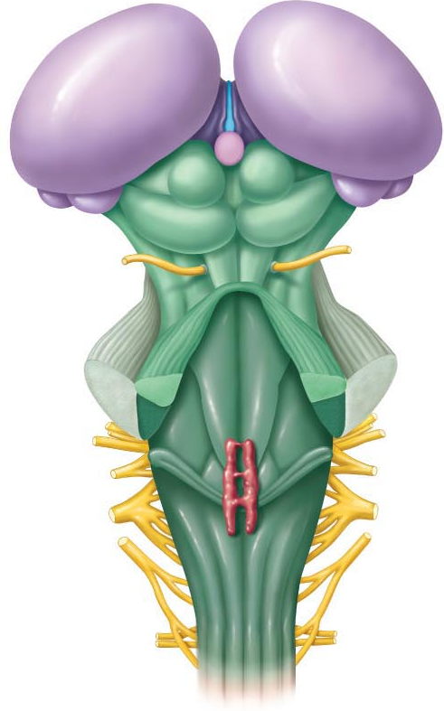

Cerebellar processing:
Cortex frontal motor association area indicates intent to initiate action & sends collaterals to cerebellum to notify
Cerebellum also receives proprioceptive info & info from visual & equilibrium pathways: Where is body & where going? How well are movements being done?
Cerebellar cortex receives this info & determines best way to coordinate force, direction extent of muscle contraction
Via superior peduncles, cerebellum dispatches blueprint for coordination to cortex; output also to brain stem nuclei (eg: red nucleus) which project to motor neurons of spinal cord

Limbic system: (limbus = ring)
• medial aspect of each cerebral hemisphere & diencephalon
• emotional-visceral brain – esp: amygdala (anger, fear, assess danger), hippocampus (emotions & memory), anterior cingulate gyrus (gestures, resolve conflicts when frustrated)
• link between odours, memories & emotions
• link for psychosomatic illnesses: stress & effects on bp, GI tract, heart
• links with cortex:(i) aware of emotions, (ii) react emotionally if consciously understand; also: emotions can override logic; reason can stop us from expressing emotions.

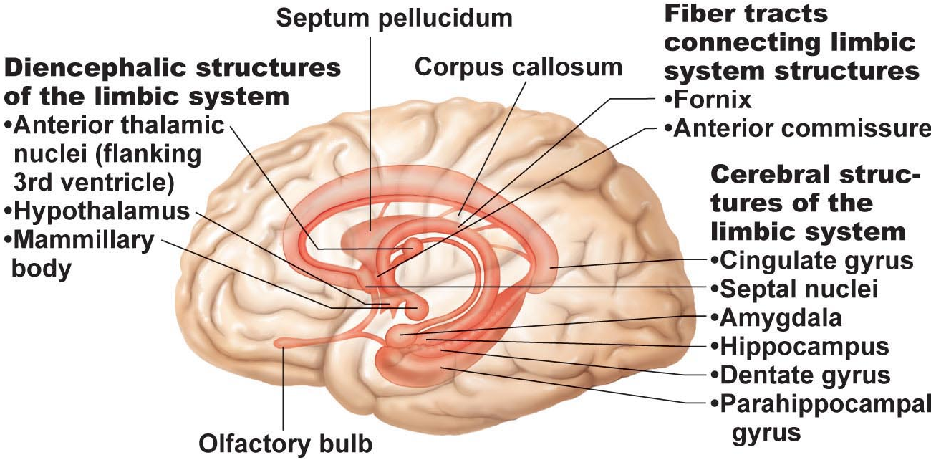
Reticular formation:
• central core of medulla oblongata, pons, midbrain; neurons project to hypothalamus, thalamus, cortex, cerebellum, spinal cord
• reticular activating system (RAS):
(i) maintains arousal of brain;
(ii) filter for incoming signals (RAS & cerebral cortex disregard ~99% of all sensory stimuli)

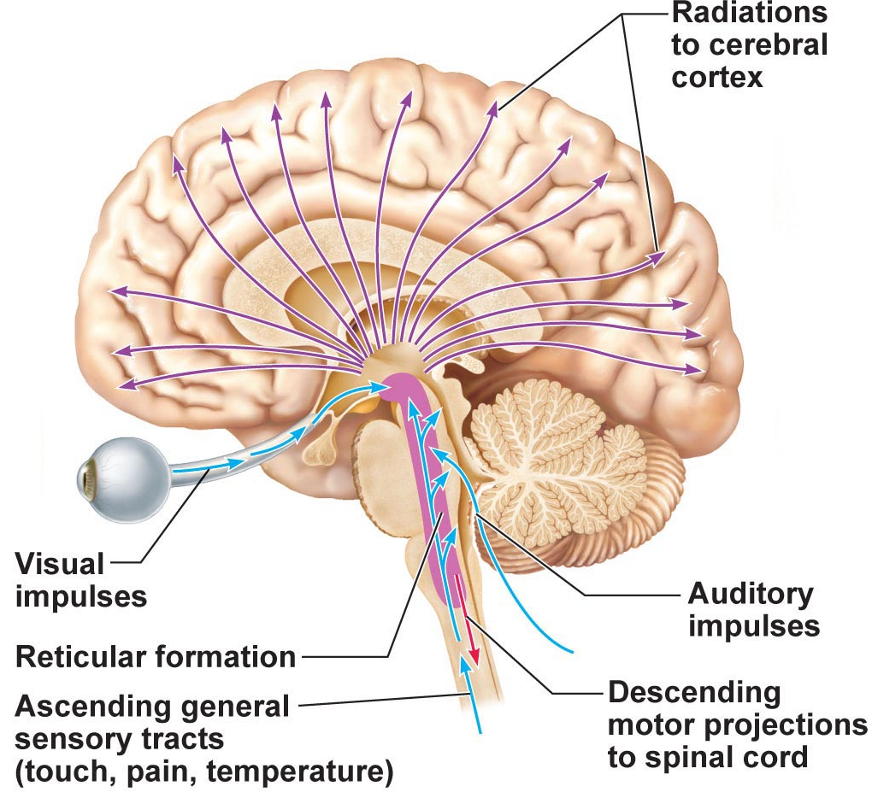
The Spinal Cord.
• from foramen magnum to 1st/2nd lumbar vertebra; below this is ideal spot for lumbar puncture
(i) 2-way conduction system
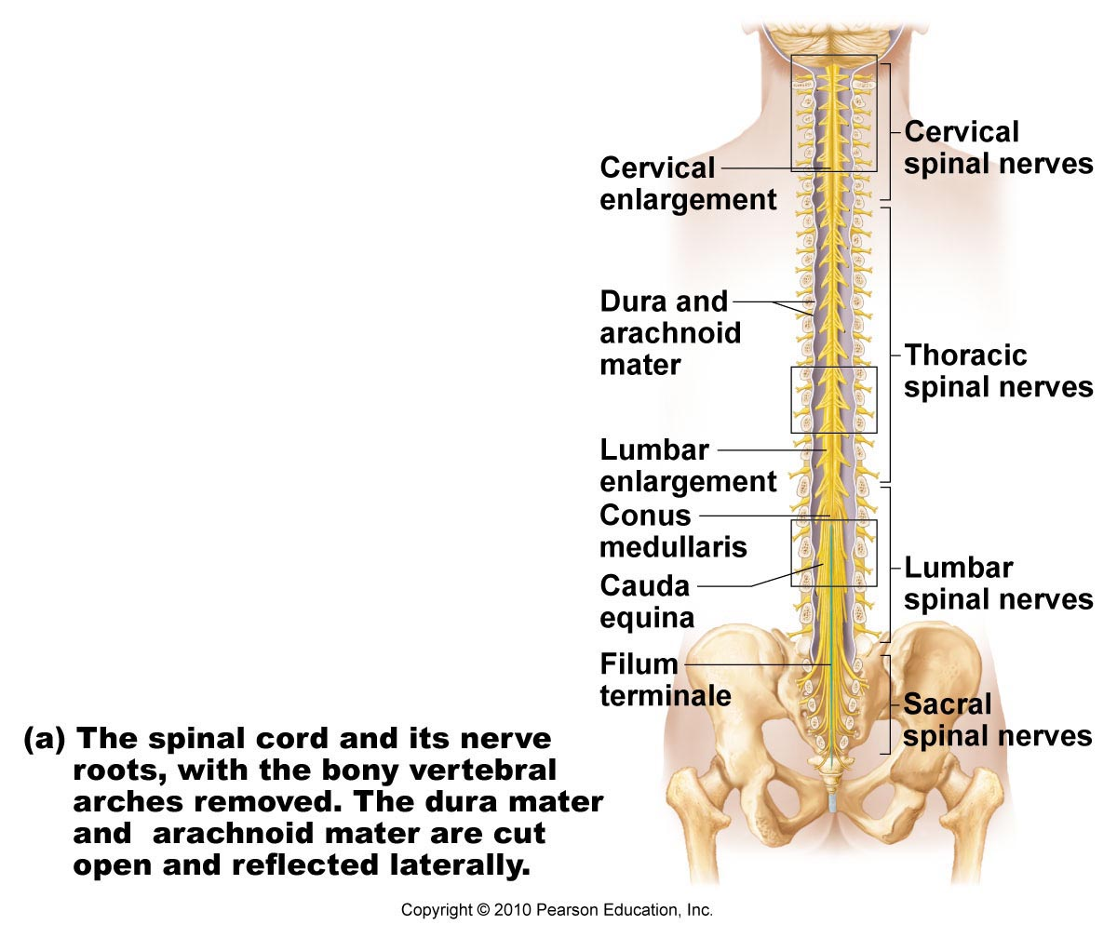
(ii) major reflex centre
(iii) initiates complex patterns of motor activity
• spinal cord held in place by:
Denticulate ligaments: pia mater shelving
Filium terminale: pia mater-covered conus extension.
Cervical & lumbar enlargements allows for entry and exits of Spinal nerves
Cauda equina- horses tail

Gray Matter & Spinal Roots
• gray matter as for other regions of CNS – but all neurons multipolar
• organized like butterfly wings: paired anterior (ventral) &
posterior (dorsal) horns connected by gray commissure
• small lateral horns associated with thoracic & superior lumbar regions of cord.

Anterior horns:
• nerve cell bodies of somatic motor neurons – axons exit via ventral roots
• largest at levels of cervical & lumbar enlargements – why??Because of how much motor neuron output.
Lateral horns:
• sympathetic motor neurons to visceral organs; also exit via ventral roots.

Dorsal root ganglion:
• afferent fibers from peripheral sensory receptors form dorsal roots; dorsal root ganglia house cell bodies of associated sensory neurons – their axons enter cord to:
(i) travel to higher cord/brain centres
(ii) synapse with interneurons in posterior horns at level they enter
• spinal nerve = fused dorsal & ventral roots

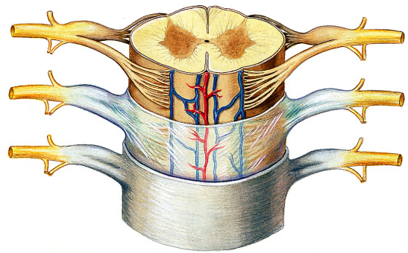
Poliomyelitis- affects outgoing motor neurons.
Blue arrow – dorsal root ganglion
Star- spinal nerve

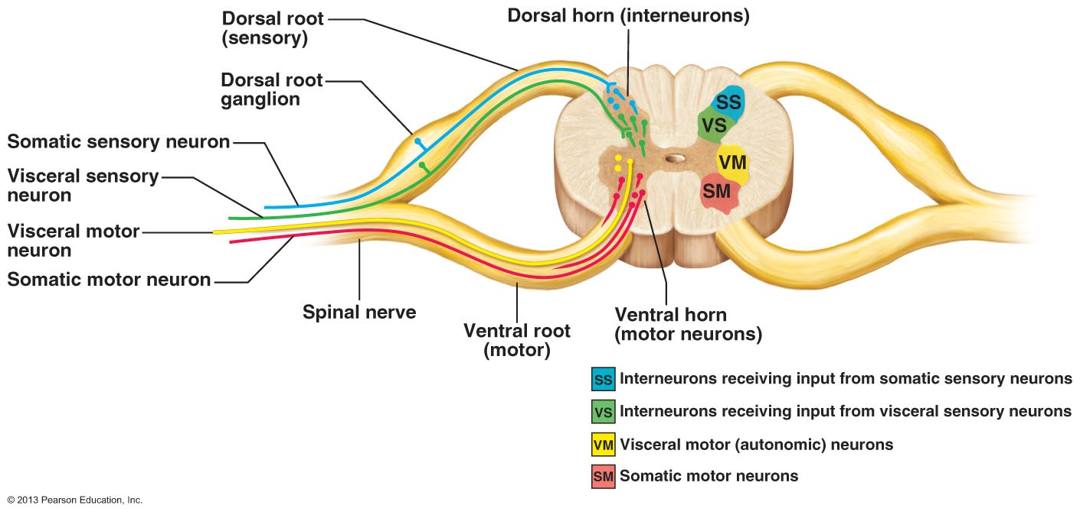

White Matter
• myelinated & unmyelinated fibers – communication between different parts of cord & between cord & brain
• ascending, descending & transverse (commissural) tracts – direction of fibers
Some general properties of spinal tracts:
(i)Most pathways cross over from one side of CNS to other (decussate)
(ii)Most consist of a chain of 2 or 3 neurons
(iii)Most exhibit somatotopy:
(iv)All pathways & tracts are paired

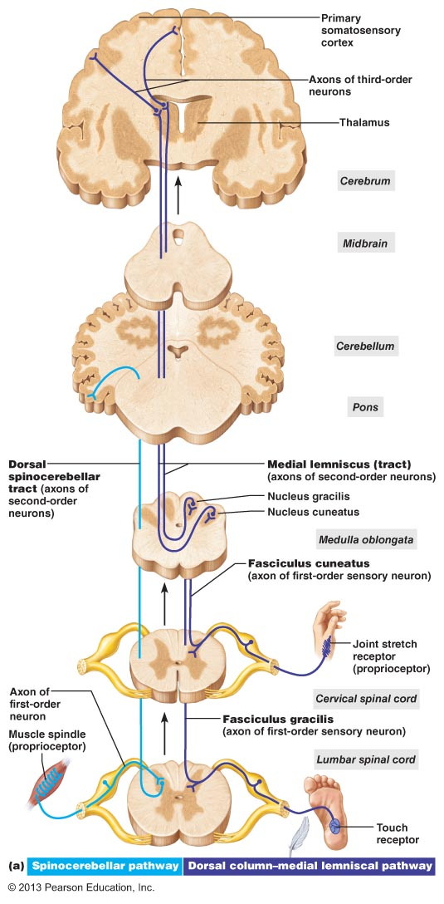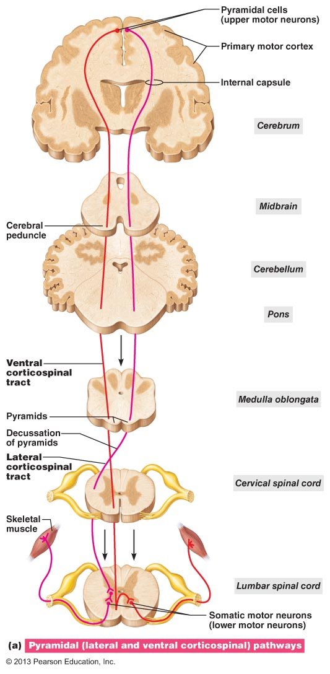

Sample pathway for discriminative touch and conscious proprioception
Direct pyramidal descending tract to skeletal muscle

Protection of the CNS
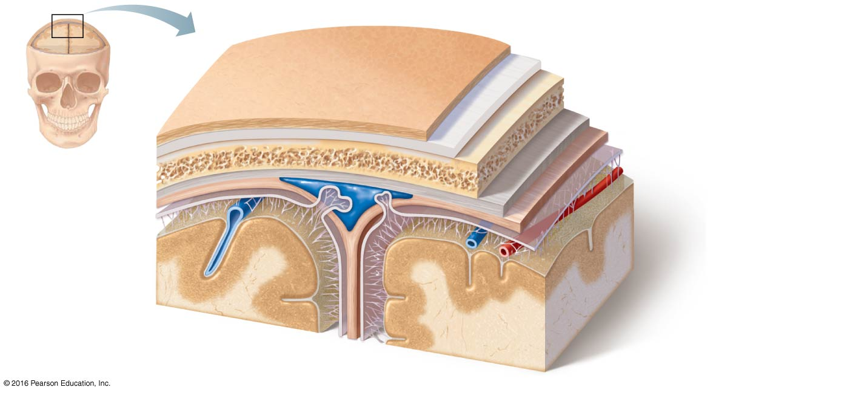
(i)Bones
(ii)Meninges
(iii)Cerebrospinal fluid
(iv)Blood-brain barrier
Meninges (meninx)
• 3 CT membranes that: (a) cover & protect CNS
(b) protect blood vessels & enclose venous sinuses
(c) contain cerebrospinal fluid
(d) form partitions within skull
Dura mater:
• tough; 2 layers around brain: outer periosteal layer & inner meningeal layer
• spinal cord has only meningeal layer
• around brain, 2 layers fused except where enclose dural sinuses
• dural septa to partition and anchor: falx cerebri, falx cerebelli, tentorium cerebelli

