Prologue: The story of Psychology
Fast Facts
-First lab December 1879 German University Leipzig by Wilhelm Wundt (testing ‘atoms of the mind’)
-International Union of Psychological Science 182 member nations.
-China first uni psych dept. began in 1978; by 2008 nearly 200.
Women in Psychology
William James did this
-Admitted Mary Whiton Calkins into his graduate seminar (1987). Male students all dropped out. So she got private tutoring. She finished Harvard Ph.D requirements but they wouldn’t give it to her. Offered her a degree from sister college.

Structuralism | -Edward Bradford Titchener  -introspection (Verbally communicating thoughts and feelings) Unreliable.
Functionalism | -William James  -influenced by darwin  -consciousness serves a function  -mental processes enable an organism to adapt, survive, and flourish
Behaviourism | John B. Watson and B.F. Skinner  -Psychology defined as the scientific study of observable behaviour  -you cannot observe a sensation, thought, or feeling, but you can record people’s behaviour as they respond  -one of two major psychs in 1960s
Freudian Psych | -Sigmund Freud  -unconscious thought process and emotional responses to childhood experiences affect our behaviour
Humanistic Psych | -Carl Rogers and Abraham Maslow  -Freudian and behaviourism too limiting  -current environment nurtures or limits growth potential.  -Love and acceptance must be satisfied
Cognitive Psych | -1960s  -ways we perceive, process, and remember info  -cognitive neuroscience stemmed from this (neuroscience and cognitive psych brain child)
Modern Psych | -science of behaviour and mental processes  -behaviour:anything an organism does  -mental processes: anything internal, subjective, infer from behaviour
Evolutionary Psych | -how are humans alike because of our common biology and evolutionary history?
Behaviour Genetics | -how are we diverse because of our differing genes and environments?
Cross-Cultural Psych | -culture shapes our behaviour  -Though shared biological heritage unites us as a universal human family  -studying people of all races and cultures helps to see the similarities and differences
Gender Psych | -There are differences, but still we are all overwhelmingly similar
Positive Psych | -happiness is a by-product of a pleasant, engaged, and meaningful life.  Uses scientific method to explore building of a good life that engages our skills and a meaningful life that points beyond ourselves.
Psychodynamic | -how behaviour springs from unconscious drives and conflicts
Nature vs Nurture Debate
-are human traits present at birth, or do they develop through experience?
-Plato: inherit character and intelligence and certain ideas are born
-Aristotle: Nothing in the mind that doesn’t first come through external senses
-John Locke (1600s): Mind is a blank slate. Experience is everything.
-René Descartes: Disagrees w/ Locke. Some ideas are innate.
-Charles Darwin(1831): 1859 in his book “On the Origin of species” introduced Natural Selection

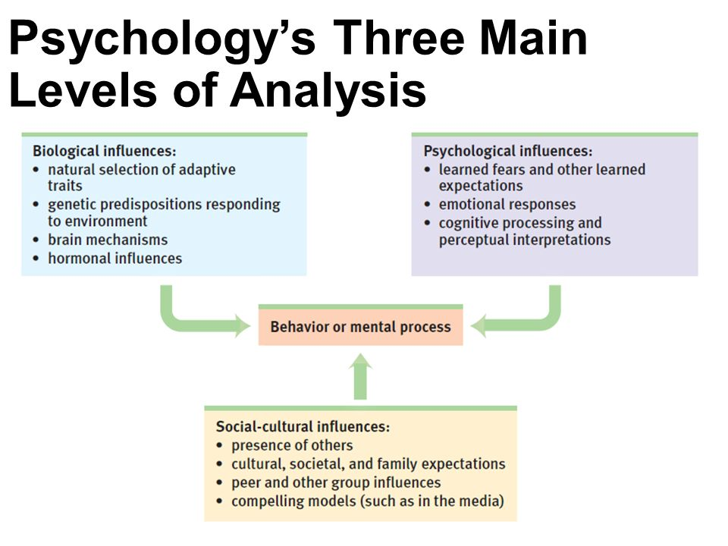
Biopsychosocial approach
Psychology sub-categories
Applied research | Scientific study aims to solve practical problems
Counseling Psychology | Branch that assists people with problems in living (often related to school, work, or marriage) and in achieving greater well-being
Clinical Psychologu | Studies, assesses and treats people with psychological disorders.
Psychiatry | Branch of medicine dealing with psychologiial disorders; practiced by physicians who sometimes provide medical treatments as well as psychological therapy.
Community Psychology | Studies how people interact withtheir social environments and how social institutions affect individuals and groups.

Chapter 1
Intuition: an effortless, immediate, automatic feeling or thought, as contrasted with explicit, conscious reasoning.
Hindsight bias: the tendency to believe. After learning an outcome, that one would have foreseen it.
Hindsight bias, overconfidence, and our tendency to perceive patterns in random events often lead us to overestimate our intuition.
The Scientific Attitude: Curiosity, skepticism, humility
Critical Thinking: thinking that does not blindly accept arguments and conclusions. Rather, it examines assumptions, appraises the source, discerns hidden values, evaluates evidence, and assesses conclusions.
The Scientific Method
Theory: an explanation using an integrated set of principles that organizes observations and predicts behaviours or events
Hypothesis: a testable prediction, often implied by a theory.
Operational definition: a carefully worded statement of the exact procedures used in a research study. For example, human intelligence may be operationally defined as what an intelligence test measures.
Replication: repeating the essence of a research study, usually with different participants in different situations, to see whether the basic finding extends to other participants and circumstances.

Description
Case study: a descriptive technique in which one individual group is studied in depth in the hope of revealing universal principles; individual cases can suggest fruitful ideas. What’s true of all of us can be glimpsed in any one of us. But to discern the general truths that cover individual cases, we must answer questions with other research methods.
Naturalistic observations: A descriptive technique of observing and recoding behaviour in naturally occurring situations without trying to manipulate and control the situation; offers interesting snapshots of daily life but w/o controlling all other factors that may be influencing behaviour. It’s one thing to observe but another to understand.
Survey: A descriptive technique for obtaining the self-reported attitudes or behaviours of a particular group, usually by questioning a representative, random sample of the group. The importance of wording effects and random sampling.
Population: all those in a group being studied, from which samples may be drawn.
Random sample: a sample that fairly represents a population because each member has an equal chance of inclusion

Correlation
Correlation: a measure of the extent to which two factors vary together, and thus of how well either factor predicts the other.
Correlation coefficient: a statistical index of the relationship between two things (-1 to +1).
Regression toward the mean: the tendency for extreme or unusual scores or events to fall back (regress) toward the average; when a fluctuating behaviour returns to normal, there is no need to invent fancy explanations for why it does so. Regression toward the mean is probably at work.

Correlation and causation: Correlation does not prove causation. Correlation indicates the possibility of a cause-effect relationship but does not prove such.

Experimentation
Experiment: a research method in which an investigator manipulates one or more factors (independent variables) to observe the effect on some behaviour or mental process (the dependent variable). By random assignment of participants, the experimenter aims to control other relevant factors.
Experimental group: in an experiment, the group exposed to the treatment, that is, to one version of the independent variable.
Control group: in an experiment, the group not exposed to the treatment; contrasts with the experimental group and serves as a comparison for evaluating the effect of the treatment.
Random assignment: assigning a participants to experimental and control groups by chance, thus minimizing pre-existing differences between the different groups.
Unlike correlation studies which uncover naturally occurring relationships, an experiment manipulates a factor to determine its effect.
Double-blind procedure: an experiment procedure in which both the research participants and the research staff are ignorant about whether the research participants have received the treatment or the placebo. Commonly used in drug-evaluation studies.
Placebo effect: experimental results caused by expectations alone; any effect on behaviour caused by the administration of an inert substance or condition, which the recipient assumes is an active agent.
Independent variable: in an experiment, the factor that is manipulated, the variable whose effect is being studied.
Confounding variable: in an experiment, a factor other than the independent variable that moght produce an effect.
Dependent variable: the outcome that is measured; the variable may change when the independent variable is manipulated.
Research Method | Basic Purpose | How conducted | What is manipulated | Weaknesses
Descriptive | To observe and record behaviour | Do case studies, naturalistic observations, or surveys | Nothing | No control of variables; single cases may be misleading
Correlational | To detect naturally occurring relationships; to assess how well one variable predicts another | Collect data on two or more variables; no manipulation | Nothing | Cannot specify cause and effect
Experimental | To explore cause and effect | Manipulate one or more factors; use random assignment | The independent variable(s) | Sometimes not feasible; results may not generalize to other contexts; not ethical to manipulate certain variables

Psychology research ethics
Protecting research participants
-studying and protecting animals (varies by culture too. As do all ethics.)
-studying and protecting humans
Informed consent: giving potential participants enough information about a study to enable them to choose whether they wish to participate.
Debriefing: The postexperimental explanation of a study, including its purpose and any deceptions, to its participants.

Describing Data
Measures of central tendency
Mode: most frequently occurring score(s) in distribution
Mean: the arithmetic average of a distribution, obtained by adding the scores and then dividing by the number of scores.
Median: The middle score in a distribution; half the scores are above it and half below.
Measures of Variation
Range: The difference between the highest and lowest scores in a distribution
Standard deviation: A computed measure of how much scores vary around the mean score.
Normal curve: (normal distribution) a symmetrical, bell-shaped curve that describes the distribution of many types of data; most scores fall near the mean and fewer and fewer near the extremes.
Significant differences
When is an observed difference reliable?
- Representative samples are better than biased samples
- Less variable observations are more reliable than those that are more variable.
- More cases are better than fewer.
When is an observed difference significant?
Statistical significance: A statistical statement of how likely it is that an obtained result occurred by chance.
Statistical significance indicates the likelihood that a result will happen by chance. But this does not say anything about the importance of the result.

Chapter 2: The Biology of the Mind
Neural and Hormonal Systems:
Fast Facts:
-German physician Franz Gall proposed phrenology (studying bumps on skull think bathroom deco reveals character traits and mental abilities) early 1800s. Not sciency but they got the idea of localization of function (various brain regions have [articular functions).

Neural Communication
Neurons: a nerve cell; the basic building block of the nervous system. Each has a cell body, dendrites, an axon. Dendrites listen. Axons speak.
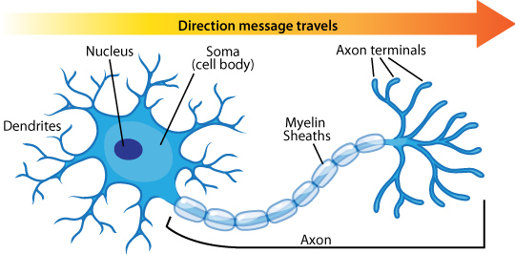
Dendrites: A neuron’s bushy, branching extensions that receive messages through its branches to other neurons or to muscles or glands.
Axon: The neuron extension that passes messages through its branches to other neurons or to muscles or glands.
Myelin sheath: A fatty tissue layer segmentally encasing the axons of some neurons; enables vastly greater transmission speed as neural impulses hop from one node to another. (If myelin sheath deteriorates, multiple sclerosis results and the communication to the muscles slows, with eventual loss of muscle control.
Glial Cells: Cells in the nervous system that support, nourish, and protect neurons; they may also play a role in learning, thinking, and memory. (neurons like queen bees, cannot support themselves. Glial cells are like worker bees.) nutrients, insulate myelin, guide neural connections, mop up ions and neurotransmitters. More complex animal, the greater the number of glial cells.

Neural Impulse
Action potential: A neural impulse; a brief electrical charge that travels down an axon.
Refractory period: a period of inactivity after a neuron has fired.
Threshold: the level of stimulation required to trigger a neural impulse.
All-or-none response: A neuron’s reaction of either firing (with a full strength response) or not firing.
Neurons transmit when stimulated by signals from our senses or from chemical signals from neighbouring neurons. Neuron fires an impulse called action potential. In the neurons ions are exchanged. Fluid outside of axon’s membrane has mostly positively charged sodium ions; fluid interior has negative ions. Positive outside/negative inside called resting potential. Axon’s surface is selectively permeable. When a neuron fires, gates open, positively charged sodium ions come in. loss of inside/outside charge is called DEPOLARIZATION. Causes next axon channel to open, and then the next and so on. The inflow of positive ions is the action potential. In refractory period, neuron pumps sodium back out, back to resting potential. Most signals are excitatory (accelerate signal). Some are inhibitory (stop signal). If excitatory signals exceed inhibitory signals threshold, the action potential continues. If the stimulation increases above the threshold, the intensity of the neural impulse does not increase, neurons have all-or-none response only.

How Neurons Communicate
Synapse: The junction between the axon tip of the sending neuron and the dendrite or cell body of the receiving neuron. The tiny gap at this junction is called the synaptic gap or the synaptic cleft.
Neurotransmitters: Chemical messengers that cross the synaptic gaps between neurons. When released by the sending neuron, neurotransmitters travel across the synapse and bind to receptor sites on the receiving neuron, thereby influencing whether that neuron will generate a neural impulse.
Reuptake: A neurotransmitter’s reabsorption by the sending neuron.

- Electrical impulses (action potentials) travel down a neuron’s axon until reaching a tiny junction known as a synapse.
- When an action potential reaches an axons end (terminal), it stimulates the release of neurotransmitter molecules. These molecules cross the synaptic gap and bind to receptor sites on the receiving neuron. This allows electrically charged atoms to enter the receiving neuron and excite or inhibit a new action potential.
- Excess neurotransmitters are reabsorbed (a process called reuptake), drift away, or are broken down by enzymes.
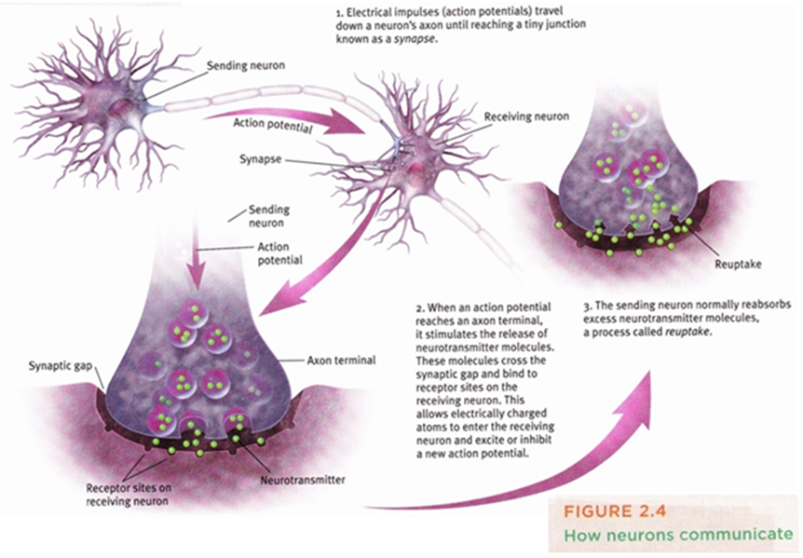
Neurotransmitter | Function | Examples of Malfunctions
Acetylcholine (ACh) | Enables muscle action, learning, and memory | With Alzheimer’s disease, ACh producing neurons deteriorate
Dopamine | Influences movement, learning, attention, and emotion | Oversupply linked to Schizophrenia. Undersupply linked to tremors and loss of motor control in Parkinson’s disease.
Serotonin | Affects mood, hunger, sleep, and arousal. | Undersupply linked to depression. Some drugs that raise serotonin levels are used to treat depression.
Norepinephrine | Helps control alertness and arousal | Undersupply can depress mood.
GABA (gamma-aminobutyric acid) | A major inhibitory neurotransmitter | Undersupply linked to seizures, tremors, and insomnia.
Glutamate | A major excitatory neurotransmitter; involved in memory. | Oversupply can stimulate the brain, producing migraines or seizures (which is why some people avoid MSG, monosodium glutamate, in food.)

Endorphins: “morphine within” – natural, opiate-like neurotransmitters linked to pain control and to pleasure.
Agonist: A molecule that increases a neurotransmitter’s action. May increase the production or release of neurotransmitters, or block reuptake in the synapse. Others might be similar enough to a neurotransmitter to bind to its receptor and mimic its excitatory or inhibitory effects.
Antagonist: A molecule that inhibits or blocks a neurotransmitter. Antagonists are enough like the natural neurotransmitter to occupy its receptor site and block its effect, but not similar enough to stimulate the receptor. (ex. Curare, a poison some south American Indians have applied to hunting dart tips, occupies and blocks ACh receptor sites on muscles, producing paralysis in their prey.

