Experiment #2: Thermochemistry
Enthalpy of various reactions

By:
Olivia Harvey 300035716
With:
Zaina Abu Omar 8756232
Myeesha Begum 7653648
Babu Ranjan 300005251
Ravinna Raveenthiran 300012132
Drishtie Phartiyal 8268135

Date: October 13, 2017
CHM1311 C10
TA: Patrick Berro
Friday, even, 14:30

Introduction
Thermodynamics play a crucial role in the field of chemistry. It is the branch of science that deals with the relationship between heat and other forms of energy. It allows one to understand and recognize the complexity of a reaction and how matter interacts with the universe. There are 3 fundamental principles of thermodynamics, these fundamental principles include: the first law of thermodynamics is the law of conservation of energy, “states that energy can neither be created nor destroyed; energy can only be transferred or changed from one form to another.” (Lucas 2015). The second law of thermodynamics states that “the entropy of any isolated system always increases” (2015). The last theory states that “the entropy of a system approaches a constant value as the temperature approaches absolute zero” (2015).

ΔH is the change in enthalpy. Meaning that it is the change in the heat of a system that is at constant pressure. The change in enthalpy depends on the type of reaction taking place. During an exothermic reaction the change in enthalpy is negative because the energy is lost during the reaction. This means that the enthalpy of the reactants was higher than the enthalpy of the products so the enthalpy decreases. On the other hand during an endothermic reaction, the enthalpy is positive because the heat is absorbed by the reaction. That means that the enthalpy of the products is higher than the enthalpy of the reactants. At constant pressure q is denoted as q_{p.} The q is the heat loss or gained by the system. To calculate the q use this formula:
q = m c ΔT

In the equation the mass and and specific heat capacity stay constant and the temperature varies. When the system (ammonium chloride salt) is heated the q is positive because the final temperature is greater than the initial temperature thus absorbs heat. In contrast, when the system (water and aluminium can) is cooled the q is negative because the final temperature is less than the initial temperature and thus it gives off heat. In this lab, a constant pressure calorimetry made with styrofoam will be used. Then the change in temperature can be observed. In the calorimeter, salt can be added in the cup to help the reaction take place. Adding salt can be endothermic or exothermic. In the endothermic reaction it will breakdown in the water and absorb heat so that the temperature will go down.

For this experiment, ammonium chloride is being used to cool down the temperature of the pop cans because it is the safest and most cost efficient. Both ammonium chloride and ammonium nitrate, when reacted with water undergo an endothermic reaction. This means that using either chemical would achieve the desired goal. However, after researching, it is found that ammonium nitrate NH4NO3 is highly a combustible material and that it is used, it will put the consumer under potential risk because product will be contaminated by an organic matter [1]. Also, it will be very hard to work with ammonium nitrate in the lab because extreme caution is required when handling it. This makes it a poor chemical to be used in the lab. Overall, ammonium chloride is less costly, a lot more safer to work with than ammonium nitrate so it is more suited for this experiment. Also, the calorimeter was put in a container that was filled with some water because you want to keep the drink separate from the salt that is being used since NH4Cl is toxic when consumed by humans.

Materials
- Analytical balances
- Aluminium can (opened top)
- Calorimeter
- 50 mL beaker
- 50 mL graduated cylinder
- LabQuest
- Temperature probe
- Scoopula
- NH₄Cl
- Distilled water

Procedure

- Record the mass of the can using an analytical balance.
- Turn on LabQuest and set it up
- Pour 100 mL of distilled water into the can. Then place the can inside the calorimeter and pour 130 mL of distilled water into the space inside the calorimeter, surrounding the can. Use the 50 mL graduated cylinder to measure precisely.
- After setting up the LabQuest, plug in the temperature probe attachment to LabQuest and put the probe inside the can that is inside the calorimeter. Before starting the timer, ensure that the probe is placed inside the hole at the top of the calorimeter and that there is no space between the probe and the calorimeter hole that will let heat go in or out.
- Make sure the temperature stabilizes before continuing on. After the temperature stabilizes, record the initial temperature of water.
- Add 15.27 g ammonium chloride to the 50 mL beaker. Use the analytical balance for precise measurement.
- Add ammonium chloride to the water that is surrounding the can in the calorimeter. After adding it, immediately close the calorimeter by placing the top of the calorimeter back on.
- Set the time for 5 mins
- Start swirling the calorimeter lightly to start the reaction without the overflow of the ammonium chloride solution into the can.
- Make sure to mark down the time when ammonium chloride is added into the calorimeter. It is 5 minutes from this time when the temperature should be cooled down to 5℃
- After 5 minutes are done. Record the final temperature of the calorimeter that is shown on the LabQuest screen.
- Open the calorimeter, remove the temperature probe and dispose the water in the waste container. Clean all equipment
- Repeat steps 2-12 using the other different amount of ammonium chloride masses, 14.27g and 16.27g

Observations

Table 1: Quantitative observations of ammonium chloride dissolving in calorimeter
Number of Trials | Mass of NH₄Cl | Initial temperature of water | Final temperature of water
Trial 1 | 15.27g | 23℃ | 18.2℃
Trial 2 | 16.27g | 20.5℃ | 15.5℃
Trial 3 | 14.27g | 21℃ | 17℃

Qualitative Observations

Trials | Qualitative Observations
Trial 1 | - Not all the salt was poured in at once, had to use scupula (resulted in container being open for a few seconds)  - Container leaks water from the bottom  - A very small amount of salt remained in the 5mL beaker  - Temperature probe was touching the bottom of the can
Trial 2 | - Not all the salt was poured in at once, had to use scupula (resulted in container being open for a few seconds)  - Container leaks water from the bottom  - A very small amount of salt remained in the 5mL beaker  - Temperature probe was touching the bottom of the can
Trial 3 | - Not all the salt was poured in at once, had to use scoopula (resulted in container being open for a few seconds)  - Container leaks water from the bottom  - A very small amount of salt remained in the 5mL beaker

Ammonium Chloride
- White
- Solid
- Crystalline powder
- Odourless
- Hygroscopic (it absorbs water from the air)

Water
- Colourless
- Liquid
- Odourless
- Transparent

When water and Ammonium Chloride NH₄Cl were mixed together, an endothermic reaction occurred and resulted in the cooling of the calorimeter. Visual observations were unable to be seen and that is because the reaction occurred inside of the calorimeter.

Graph

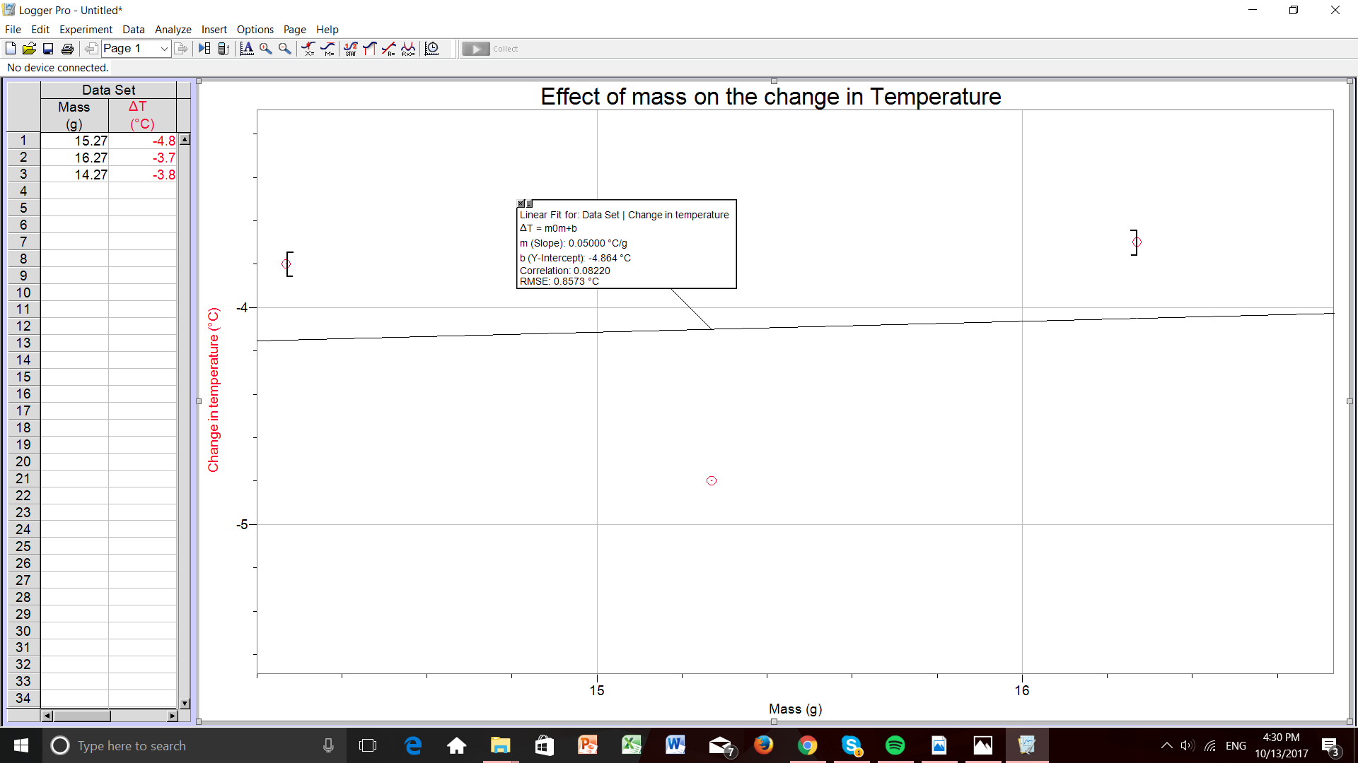

Calculations

Theoretical calculation: Determining the amount (g) of NH₄Cl required to change temperature by 5 degrees
Heat capacity of water=4.18J/g°C
Weight of can = 8.50g
Mass of water = 230g
Heat capacity of aluminum = 0.9J/g°C

qt= q water + q cal/can
= mcΔT + mcΔT
= 230g(4.184J/g°C)(-5) + (8.5g)(0.9J/g°C)(-5)
= =-4849.85 J
= -4.84985 kJ

n_{salt} = Qt = -4.84985 kJ = 0.28528 mol
ΔH_{sol} 17kJ/mol

m= n(M) = (0.28528mol)(53.5g/mol) = 15.2627g = 15.26g

Actual calculations were not possible to do because the temperature did not drop by exactly 5°C. The following calculations are based on our data sets from each trial.

Actual calculations: Heat of ammonium chloride

Trial 1

Mass of NH₄Cl = 15.27g
Initial temperature of water = 23℃
Final temperature of water = 18.2℃

qNH₄Cl= mcΔT
=15.27g(84.1J/g°C)(23℃-18.2℃)
= 6164 J

Trial 2

Mass of NH₄Cl = 16.27g
Initial temperature of water = 20.5℃
Final temperature of water = 16.8℃

qNH4Cl = mcΔT
= (16.27g)(84.1 J/g℃)(20.5℃-16.8℃)
= 5062 J

Trial 3

Mass of NH4Cl = 14.27g
Initial temperature of water = 22.1℃
Final temperature of water = 20.7℃

qNH4Cl = mcΔT
= (14.27g)(84.1 J/g℃)

Discussion

In this experiment, three different masses of ammonium chloride were tested in the system. This is important in order to identify which one of the masses would be the closest to bringing down the temperature of the calorimeter to 5℃. In the graph, the change in temperature decreases as the mass of the salt increases since the reaction is endothermic and makes the water colder, which results in the graph having a negative slope.

After completing three trials of the experiment, the amount of NH₄Cl needed to decrease the temperature of the water inside the can by 5℃ could not be determined because the water’s temperature never fully decreased by 5℃. This happened due to multiple errors that occurred during the experiment, some of which could be controlled and some that could not. One of the errors that could have been controlled was that the water inside of the can was not changed between trials one and two. This would mean that the water in the can and the water surrounding the can are at two separate temperatures, since the water inside the can is still cold from the previous trial. Fortunately, this was corrected for trials three and four, but it means that the data from trial two is inaccurate. Also, the can that the 100g of water was contained in also cooled down from trial to trial and the temperature of that should have remained consistent throughout all trials. Otherwise, the can will cool down the water that is inside it and surrounding it, thus making the temperature of the water colder than it was before it came in contact with the can. However, some of the errors could not be controlled, such as the styrofoam container leaking. This caused a lot of the solution containing water and salt to get out. This solution was what was supposed to make the water inside the can cool down, but due to the leak, there was less salt water solution which would skew the temperature readings. It also throws off the calculations which list 230 total grams of water inside of the container at all times.

Some suggestions for improvement include changing the water inside the calorimeter and the can after every trial, because not changing the water will affect the results.
Furthermore, making sure that no heat is coming in or going out while doing the experiment and that could be done by ensuring that the temperature probe that is put in the calorimeter hole has no space of letting heat in or out the calorimeter. Another suggestion is making sure that the calorimeter is not leaking any of the water out because that will change the readings of the temperature, mass, and ultimately the calculations. Lastly, changing the can after every trial will give more accurate readings and allow for the calculations to be more precise. The can after each trial would be cold and would cause the temperature of the water in and around it to be inaccurate.

Conclusion

After conducting four trials of this experiment, it was determined that the most effective salt to decrease the temperature of water by 5 degrees Celsius is ammonium chloride, or NH₄Cl. Although the sources of error in the experiment caused skewed results, NH₄ Cl is the safest and most efficient salt to cool down one’s body temperature.

References:
- National Institute for Occupational Health and Safety. (2014). Retrieved from https://www.cdc.gov/niosh/ipcsneng/neng1051.html
- B. (n.d.). The Laws of Thermodynamics. Retrieved October 13, 2017, from https://courses.lumenlearning.com/boundless-chemistry/chapter/the-laws-of-thermodynamics/
- Ammonium nitrate. (n.d.). Retrieved October 13, 2017, from http://www.newworldencyclopedia.org/entry/Ammonium_nitrate

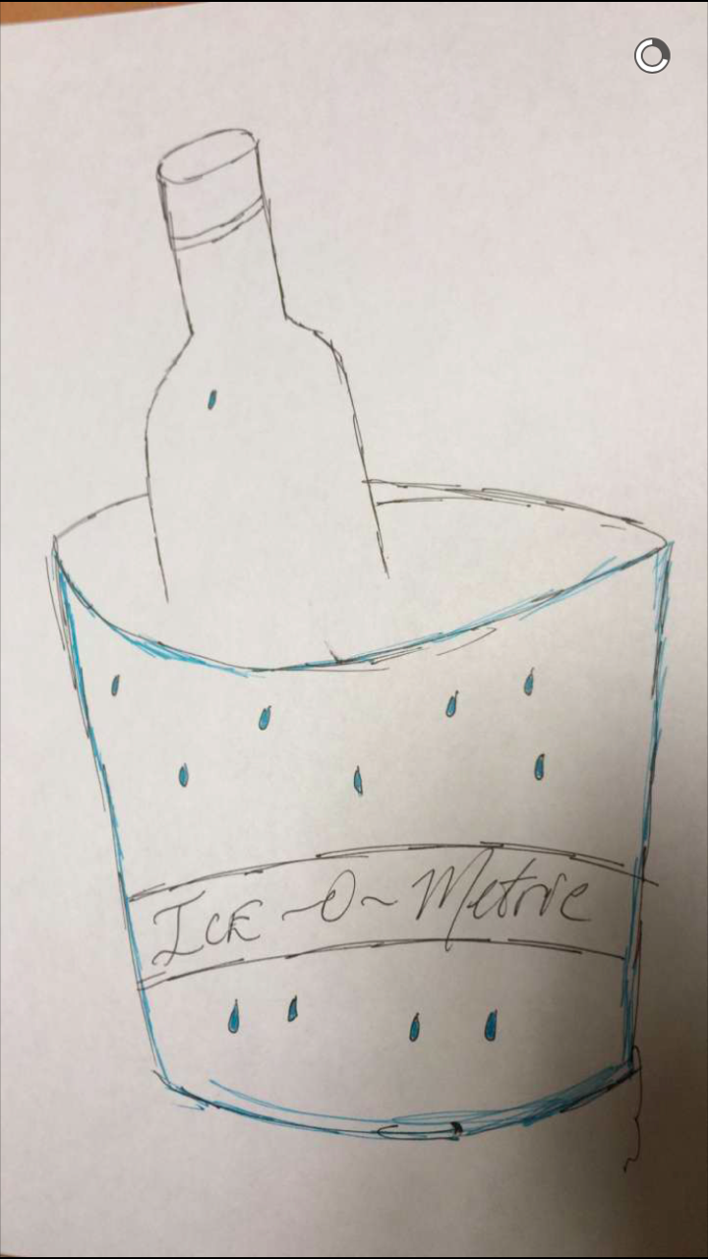
BONUS
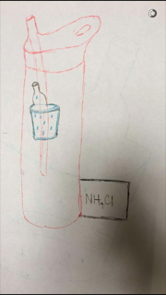
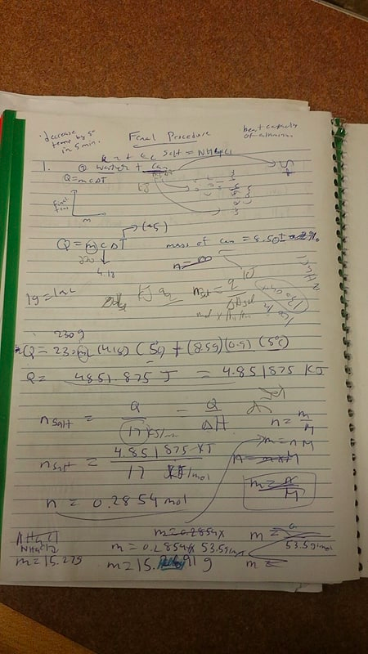

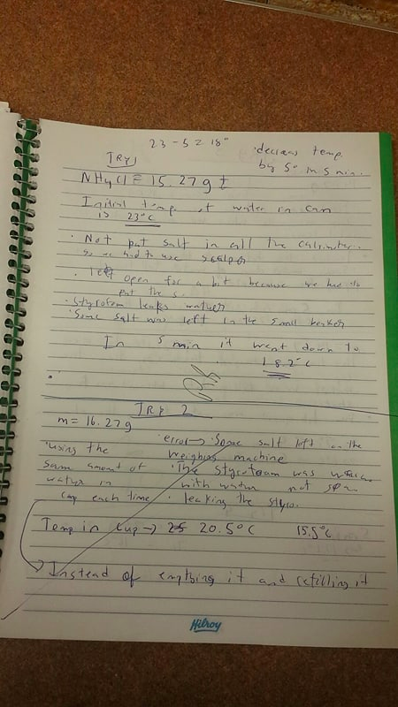

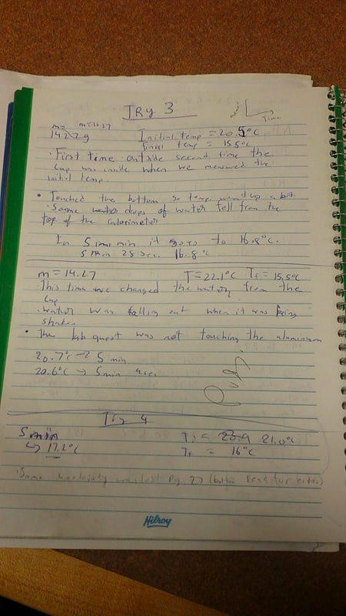

COURSE: _CHM1131___________ TA Name: __Patrick Berro___________
YOUR NAME (PRINT): __Olivia Harvey_______SIGNATURE: __Olivia Harvey

CONFIDENTIAL PEER EVALUATION FORM FOR EXPERIMENT 2
Each team member must submit one assessment. Teams may consist of 2-18 members.
You may edit this form.
Do not share or discuss the contents or possible contents of this assessment with others.

In assessing the work of your fellow team members, consider the following aspects:
- Quality of work • Ability to get along with others
- Contribution to the work as a whole • Improvements when asked to correct

Team member name | Comments | Grade
Zaina Abu Omar  Babu Ranjan  Drishtie Pharityal | Wonderful to work with, friendly  Easygoing, but not laid back  Helpful editing advice as well as suggestions  Logical and very good quality of work  Accommodating  Motivated  Helped collect raw data  Friendly, somewhat controlling, but overall easy to work with | A  A  B
Myeesha Begum  Ravinna Raveenthiran | Efficient, provided many suggestions for formatting  Extremely friendly, took charge  Contributed a lot to discussion  Extremely amiable  Creative ways of solving problems  Helpful | A  A
A – Excellent (5) B: Great (4) C: Good (3) D: Fair(2) F: Poor (1)
Note: Do not evaluate yourself on this form

