Experiment #1

“Do I Dare Disturb the Universe?”
Verification of Boyle’s Law
By Zaina Abu Omar, 8756232
and Olivia Harvey, 300035716
T.A.: Patrick Berro, University of Ottawa
Friday, even, 14:30-17:30

Theory

Gases are characterized by their ability to move freely throughout the entire volume of a container. The Ideal Gas was derived from the theory that depicts gases to have negligible volume and attraction to each other. Properties of ideal gases such as pressure, temperature, volume, and number of moles are defined by the Ideal Gas Law, PV=nRT. While the these conditions can be met in reality at high temperatures and low pressures, as both of those variables change, gases do not act as they do in ideality. This is because in reality, gas particles do have volume and exert force on one another.

Boyle’s Law defines the relationship between volume and pressure, holding all other variables such as the number of moles and the temperature constant. It states that when volume increases, pressure decreases and vice versa. This relationship was proven by Robert Boyle in 1662. Boyle's law formula can be represented in the following form(s):

PV= K and P= K(1/V)

This law is meant to apply for ideal gases.

Materials

- Vernier Gas Pressure Sensor
- 20mL syringe
- LabQuest2
- USB

Procedure

- Connect gas pressure sensor to LabQuest 2.
- Move the plunger of the syringe so that the first visible rubber line inside the syringe reads 3.0 mL.
- Connect the syringe to the gas pressure sensor by inserting the point of the syringe into the side of the sensor with the measurement lines facing under. Once attached, turn the syringe 180 degrees to lock it into place.
- On LabQuest, select “Mode” and change the mode to “Events with Entry.” Enter its name (Volume) and the units (mL). Select “OK.”
- Set Vernier to record data by selecting “Play.”
- Allow the gas pressure sensor to make a reading. Give the sensor some time to stabilize. Then, select “Keep” and record the volume of the syringe. The recorded volume must account for the extra 0.8mL of space inside the pressure sensor itself (volume in mL in the syringe + 0.8 mL in the gas pressure sensor). Additionally, record reading in Lab Book.
- Once data has been recorded, pull the plunger to 6.0 mL. Repeat data collection step 6. Continue this process, adding 3.0 mL of volume to the syringe for each data point. Collect six data points total.
- After six data points have been recorded, return the syringe plunger to its original position at 3.0 mL. Record the pressure once more. Then, stop data collection by selecting “Stop.”
- Examine the recorded data and decide which measurement of pressure at 3.0 mL to keep. Remove the other recording of data and have an explanation as to why the point kept is more effective.
- Select “Analyze” on Vernier to determine the mathematical relationship of the graph. Choose “Curve Fit”>”Volume” from the Analyze menu. Then, select the function that best fits your data. Record the function.
- Select “OK” to return to the graph screen. Save the data from Vernier onto a USB drive.
- Remove plunger from gas pressure sensor, then repeat steps 2-11.

Table 1

Pressure at a specific volume of two different trials.

Volume (mL) | Pressure (kPa), Trial 1 | Pressure (kPa), Trial 2
3.8 | 108.00 | 105.99
6.8 | 57.81 | 55.54
9.8 | 39.60 | 38.41
12.8 | 30.61 | 29.70
15.8 | 25.40 | 24.52
18.8 | 21.50 | 20.78

Observations

In this experiment, a Vernier gas pressure sensor and a 20 mL syringe were used to apply Boyle's law and calculate the pressure and the volume at different variables. To start off, the experiment started at a volume of 3.0 mL to calculate the pressure in kPa. At 3.0 mL, the pressure was the highest for both trials, then as the volume increases the pressure decreases. At 6.0 mL, the pressure for both trials dropped by almost 60 kPa. The pressure was the lowest at the last variable which was the 18.0 mL, the pressure reached 21.50 kPa for trial 1 and 20.78 kPa for trial 2. Overall, the data showed a power function with a negative slope.

Graphs

Graph 1
Power graph for trial one. It shows the correlation between the pressure and the volume

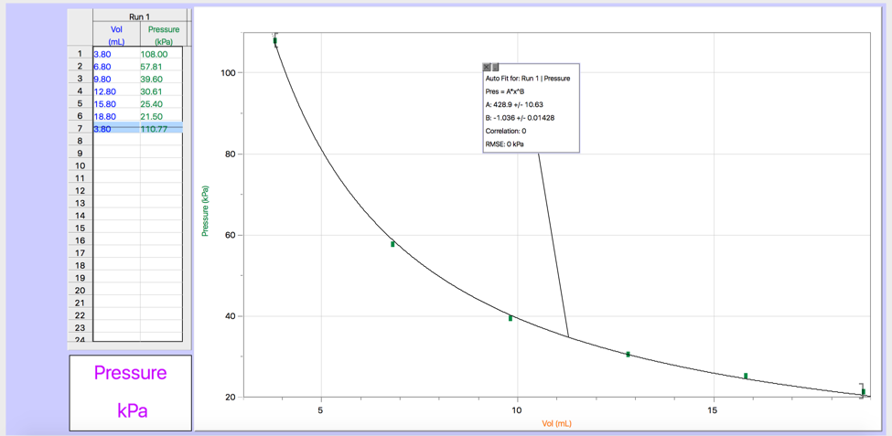

Graph 2
Power graph for trial two. It shows the correlation between the pressure and the volume

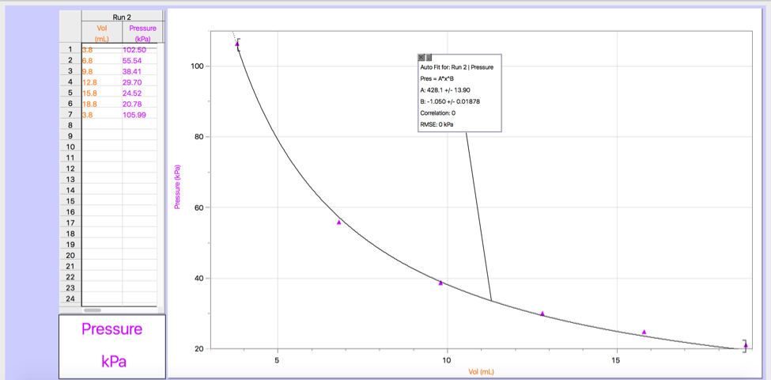

Calculations

- Calculating Boyle’s Law constant using PV=K, where p is the pressure, v is the volume and k is the constant.

Trial 1:
Data point 1: k= PV= (0.0038 L)(108.00 kPa)= 0.410
Data point 2: (0.0068 L)(57.81 kPa)= 0.393
Data point 3: (0.0098 L)(39.60 kPa)= 0.388
Data point 4: (0.0128 L)(30.61 kPa)= 0.392
Data point 5: (0.0158 L)(25.40 kPa)= 0.401
Data point 6: (0.0188 L)(21.50 kPa)= 0.404

The constant k for Trial 1 ranges from 0.38 to 0.41.

Trial 2:
Data point 1: k= PV= (0.0038 L)(105.99 kPa)= 0.402
Data point 2: (0.0068 L)(55.54 kPa)= 0.378
Data point 3: (0.0098 L)(38.41 kPa)= 0.376
Data point 4: (0.0128 L)(29.70 kPa)= 0.380
Data point 5: (0.0158 L)(24.52 kPa)= 0.387
Data point 6: (0.0188 L)(20.78 kPa)= 0.390

The constant k for Trial 1 ranged from 0.37 to 0.40.

2. The mathematical relationship illustrated by Boyle's law is described as an inverse proportional relationship. It is defined as an inverse proportional relationship because as the volume increases, the pressure will decrease as a result. The mathematical relationship is represented below with the use of Boyle’s law Constant (k):

P= k(1/V)

3. Taking multiple readings of the dependent variable for the same value of the independent variable is important because no matter how steady the syringe is at a specific volume, the pressure does not completely stabilize. This makes it hard to take an accurate reading. Taking multiple readings of the pressure for the same volume helps prove that the data is not entirely inaccurate.

4. Boyle’s Law requires the temperature and number of moles to be held constant. During the experiment, it is not definite that this was the case. Although the equipment and procedure were followed carefully, it is possible the temperature and number of moles varied during the trials. This potentially could have skewed the data, as Boyle’s Law cannot account for changes in temperature of moles of air. When these variables are not constant, they are described by the Ideal Gas Law, PV= nRT.

Discussion

This experiment is done calculate the volume and the pressure when all the other variables are constant. Boyle’s law give the relationship between the pressure and the volume if the temperature and the amount are constant. The results of this lab prove Boyle's law by showing that as the volume increases, the pressure decreases. When the volume was the lowest (3.0 mL), the pressure for both trials was the highest out of all the other volumes. It reached a pressure of 108.00 kPa for the first trial and 105.99 for the second.. Every time the volume increased by 3.0 mL, the pressure decreased constantly. When the last volume which is the 18.0 mL is measured, the pressure was at its lowest value which was 21.50 kPa for trial one and 20.78 kPa for trial two.

Doing two different trials and measuring the pressure twice proves Boyle's law because it shows that the numbers barely deviated from the first reading. For the first trial, the pressure when the volume is at 3.0 mL wa a little higher than the pressure in trial two, but they both start off as the highest pressure when the volume is at its lowest. As the volume increases, the pressure for both trials decreases by almost the same amount. In trial one, the pressure is higher the pressure in trial two for all the volume measurements, but only by no more than 2.0 kPa.

Some sources of error include the possibility that the amount of air in the syringe changed over the course of the experiment. Additionally, the heat from our hands may have changed the temperature of the air in the syringe. Another possible source of error is the function of the gas pressure sensor itself, as we noticed that the pressure reading never stabilized for longer than 1 second. This had a slight impact on the data points.

Two measurements of pressure at 3.0mL were taken in each trial, and then one was selected over the other. The first measurement was a better option for the data set. This is because it is less likely that the reading would have been less affected by sources of error, including changes in temperature and number of moles of air.

Conclusion
The experiment verifies Boyle’s Law, which states that when volume is increased, pressure will decrease. As we increased the volume of the 20mL syringe, the pressure of the air consistently decreased. Slight differences in data exist between the two trials; however, these differences can be accounted for by sources of error.

