EFFECTS OF INSULIN: ↓ Glucose BV / ↑ Glycogen storage
- Release β-cells of Langerhans pancreas cuz ↑ glucose/ ↑ AA

 | Insulin Stimulates (+) | Insulin Inhibits (-)
Glucose Metabolism | - ↑ diff glucose → muscle, liver, adipocytes  - ↑ cellular respiration (oxidation)  - ↑ Glycogen formation  - Limited ^ → Glycerol + FA = TG | - Gluconeogenesis  - Glycogenolysis
Fat Metabolism | - Lipogenesis & its storage (≠ use for ATP)  - ↑ Glucose enter adipose tissue  - Converts to glycerol  - Glycerol + (↑flow) FFA = TG | - Adipose cell lipase
Protein Metabolism | - ↑ influx AA in cells = ↑ protein synthesis  - ↑ translation of mRNA, long-term faster DNA transcription | - Protein catabolism
Individual Cell | - ↑ Glucose uptake  - ↑ Glycogen formation, Fat deposition  - ↑ Protein synthesis  - ↑ K+ Uptake | - ↓ Glycogenolysis  - ↓ Gluconeogenesis  - ↓ Lipolysis  - ↓ Glucagon secretion
Effect of Blood | - ↓ Glucose, AA, FFA, ketones, K+  ^ cuz promotion uptake

EFFECT OF GLUCAGON: hyperglycemic hormone
- Release α-cells of Langerhans cuz ↓ Glucose/ ↑ AA
- Promotes:
  - ↑ Glycogenolysis/Gluconeogenesis
  - ↑ Lipolysis

Insulin mechanism of action:
- W/o insulin → glucose ≠ get into cells → hyperglycemic always = insulin pump
- Insulin independent: RBC/Brain → glut-4 proteins always there

- Insulin binds to receptor on membrane wall (skeletal/cardiac/adipose tissue or liver cuz insulin dependant)
- Signals transduction cascade
- Glut-4 vesicles = exocytosis
- Glut-4 carrier proteins merge w/ membrane = Glucose enters cell

DIABETES MELLITUS (DM): mellitus = sweet pee
- What: ↑ lvlz of glucose in BV cuz defect from insulin prod and/or insulin action

- Primary:
  - Type 1 DM: No production
    - Autoimmune destruction of pancreatic β-cells
    - 100% insulin deficiency cuz no other source in body
    - Rx: administer insulin

- Type 2 DM: Insulin resistant
    - Insulin deficiency (not making enough)
    - Why? Cuz insulin binding :( → excessive weight cuz cholesterol lvl = lipotoxicity → affects insulin receptors
    - Rx: oral glycemic drugs ~10 years, then becomes type 1

- Secondary: cuz of something else

METABOLIC CONSEQUENCES:
- ↓ glucose uptake by peripheral tissue = ↑ gluconeogenesis = ↑ glycogenolysis from liver

Type 1 DM | Hyperglycemia:  - Glycosuria: loss of glucose in urine  - Polyuria: ↑ water loss, followed by ^  - Polydipsia: dehydration = excessive thirst  - Polyphagia: excessive hunger cuz no glucose transport into cells  - Chronic ↑ G-lvl = amputation, eye loss cuz ↓ nutrient can get inside  Lipolysis: ↑ FFA in BV & their use  Ketoacidosis: cuz ≠ enough oxaloacetate (acceptor of acetyl-coA)  Gluconeogenesis: from proteins  - ↑ protein degradation = ↑ urea cuz by product  - ↓ muscle mass
Type 2 DM | ≠ enough G goes into cells = ↑ Plasma G-lvl  - Hyperinsulinemia: ↑ insulin secretion, G-lvl under control temporarily  - Down-regulation: # of insulin receptors on walls of cells ↓ = even more insulin resistant  - β-cell failure: ≠ enough insulin production for demand  - ~ ^ → β-cell exhaustion: need insulin injections

Fnc of liver:
- Metabolism
  - CHO:
    - Galactose/fructose → glucose ~ → fats
    - Glycogenolysis, gluconeogenesis (AA)
  - Lipids:
    - B-oxidation (FA to acetyl CoA) ~ → ketone bodies
    - Stores Fat, synthesises lipoproteins + cholesterol (from acetyl-CoA)
  - Protein:
    - Deamination of AA for gluconeogenesis
    - Transamination of non-essential AA
    - Urea + plasma protein synthesis
- Storage: glycogen, vitamins (ADEK, B12), minerals (iron/cooper)
- Detoxification: poisons/drugs/hormones (eg. Urea)
- Excretion: bilirubin pigment into bile
- Synthesis: bile salts, clotting factors, lipoproteins
- Phagocytosis: old RBC, WBC, Stellate macrophages cell for bacteria

CHOLESTEROL:
What: ≠ energy source → structural unit bile salts/steroid hormones/Vit D/plasma proteins
Where: 85% made by liver, lost from body feces cuz bile salts or catabolism

Transport - LIPOPROTEINS: = TG, phospholipids, cholesterol, proteins
- ^ regulates exit/entry target cells
- ↑ the % of TG, ↓ density (cuz oil floats on top of water)

- Produced in GI mucosa:
  - Chylomicron: produced in GI mucosa → lymph (↑ proteins/ ↓ GI)

- Produced in Liver:
- VLDL's: Very low density lipoproteins (↑↑ TG)
  - Transports TG to ~ adipose tissue
- LDL's / Bad cholesterol: Low-density lipoproteins (↑↑ Cholesterol)
  - Transports to tissues for membrane/hormone synth
  - ↑ levels = <3 disease, cuz lipoprotein binds to receptor = receptor mediated endocytosis → enough LDL in cell? → receptors don't return to membrane → stay in BV and can form fatty plaque
- HDL's / Good cholesterol: High-density lipoproteins (↑↑ Proteins, proteins sink in water)
  - Sucks excess cholesterol back into liver → becomes bile
  - Gives cholesterol to steroid producing organs
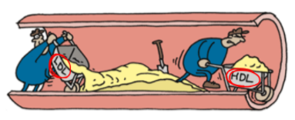
REGULATION OF BV CHOLESTEROL LVL:

- Saturated FA: ↑ liver synt/↓ excretion
Unsaturated FA: ↓ liver synt / ↑ excretion
- Trans fats: ↑ LDL/↓HDL
- Unsaturated Omega-3 FA:
  - Make platelets less sticky → ↓ clotting
  - Antiarrhythmic effects on heart
  - Lower BP
- Stress/Smoking: ↓ HDL levels
- Aerobic exercise & estrogen: ↑ HDL/ ↓LDL levels
- Apple body shape: ↑ LDL levels
Pear body shape: ↓ LDL levels
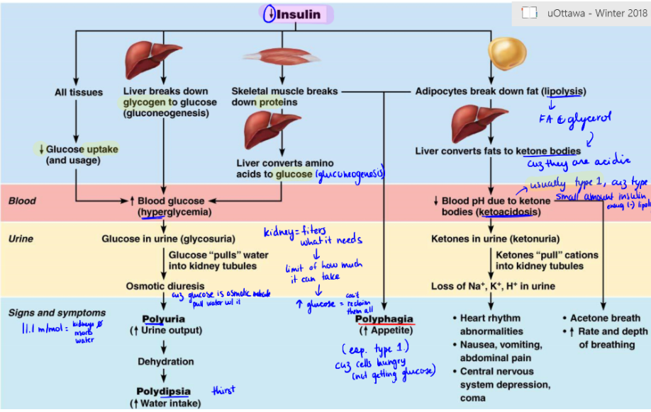

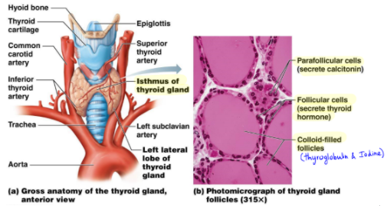
THYROID GLAND:

- Location & Structure:

- Isthmus: median mass connecting 2 lobes
- Follicles: hollow sphere made with…
  - Follicular cells: cells that produce glycoprotein thyroglobulin
  - Colloid: fluid in ^ lumen of follicles storage thyroglobulin + iodine
- Parafollicular cells: don't form follicles → produce hormone calcitonin (↓ BV Ca++)

- Hormone production: structural unit = 2 tyrosine CHM → iodine-containing amine hormones

- T4 (Thyroxine): w/ 4 bound Iodine atoms → must be converted to T3 in tissue

- T3 (Triiodothyronine): w/ 3 bound iodine atoms (10x more active than ^)

- Fnc of TH:
How: binds w/ receptors on nucleus → transcription of metabolic genes

Physiologic effects: over-production = anxiety, paranoia/ under-production = sluggishness

- Calorigenic effect: ↑ BMR/ ↑ Heat production
  - ↑ CHO metabolism (↑ glycolysis/↑ gluconeogenesis)
  - ↑ Fat metabolism (↑lipolysis + utilization)
  - ↑ Protein renouvellement
- Regulation of tissue development: Skeletal, NS, reproductive
  - Hypothyroidism: growth retardation
  - Hyperthyroidism: fast growth earlier age → premature closure epiphyseal plate = shorter

- Maintains BP: ↑ adrenergic receptors in BV (stimulates SNS)
- Stimulates:
  - ↑ Blood flow, HR, CO, BP
  - ↑ Respiration/CNS activity
  - ↑ Gastric motility/muscle contraction

- Synthesis:
Storage: T3/T4 in follicles ~3 months reserve

Role of Iodine:
- Source: food as iodides
- Trapping: in follicles w/ active pumping inside cell from BV
  - Rate influenced by TSH (Thyroid stimulating hormone)

- Thyroglobulin synt & thrown in follicle lumen
- Iodide (I-) pumped in follicle lumen
- Iodide oxidized: iodide → iodine (I2) in lumen colloid
- Iodine + Tyrosine: attachment w/ peroxidase enzyme
  - MIT: monoiodotyrosine
  - DIT: Diiodotyrosine
- Linkage of Iodinated tyrosines ^
  - MIT + DIT = T3
  - DIT + DIT = T4
- Endocytosis from colloid lumen by follicular cells & combined w/ lysosomes
- Lysosomal cleavage T3/T4 from thyroglobulin → secreted into BV

- Transport/Regulation:
  - Thyroxine-binding globulins (TBGs): & bind to target receptors

Negative feedback:
- ↑ lvl TH = (-) of release of TSH
  - Hypothalamic thyrotropin-releasing hormone (TRH): hijacks feedback if pregnancy/exposure to cold

- Clinical Note:

HYPOTHYROIDISM
- Myxedema: TH Hyposecretion adults
  - Symptoms: ↓ BMR, thick/dry skin, puffy eyes, cold, constipated, edema, mental sluggishness, lethargy
  - Goiter: if lack of iodine → unusable thyroglobulin stocked
    - Endemic goiters: cuz soil iodine poor, ≠ iodine rich sea food

- Cretinism: TH Hyposecretion infants
  - Symptoms: intellectual ↓, disproportionate body, thick tongue/neck

- Hashimoto Thyroiditis: chronic autoimmune thyroiditis
What: destruction of TH producing cells ^
Symptoms: causes hypothyroidism, ↑ w/ age

HYPERTHYROIDISM
- Grave's Disease: autoimmune
Symptoms: ↑ BMR (w/ weight loss), rapid/irregular HR, Nervousness
- Exophthalmos: eyes protrude cuz tissue behind eyes = edematous/fibrous

ENERGY BALANCE:
- In: food abs
- Out: work, heat loss (homeostatic T), fat/glycogen storage

Energy balance factors:
- Genetic makeup (Thrifty genotype: more likely to save up food for "famine")
- Diet/Environment
- Lifestyle (activity, sleeping, smoking, stress, gut bacteria)

BMI: Body mass index (sustained when Eout=Ein)
- (Kg/m^2)
- Overweight [25; 30[ / Obese [30, +[

Clinical Note: 5 risk factors that ↑ x2 <3 disease/ x5 Diabetes
- ↑ Waist circumference
- ↑ Blood pressure/glucose/TG
- ↓ Blood HDL lvl

REGULATION FOOD INTAKE:
Where: feeding/satiety centers → hypothalamic nuclei

Hypothalamic Nuclei:

- Arcuate Nucleus (ARC):
  - ↑ Appetite: Neuropeptide (NYP) & Agouti-related peptides
  - ↓ Appetite: Proopiomelanocortin (POMC) & Cocaine-amphetamine regulated transcript (CART)

- Lateral hypothalamic area (LHA):
  - ↑ Appetite: when (+) neuropeptides (NYP)

- Ventromedial neurons (VMN):
  - ↓ Appetite: w/ corticotropin-releasing hormone (CRH) when stimulated by appetite-supressing peptides (POMC/CART)

Short Term Regulation | Neural Signals from GI: (-) hunger  - ↑ Protein meal = ↑ Vagal nerve signals (PSNS)  - ↑ Distention = ↑ Vagal nerve signals (PSNS)  Bloodborne nutrients: (-) hunger  - ↑ Glucose/ AA  - ↑ FA during absorptive stage  Hormones:  - (-) hunger  - GI hormones (Insulin, CCK)  - (+) hunger  - Glucagon, Epinephrine  - Ghrelin (from stomach)
Long Term Regulation | Leptin: (-) hunger  - Synt: adipocytes when ↑ in body mass, protects  - Fnc: prevents weight loss times of poor diet  - Action: ARC neurons  - ↓ NPY appetite stimulant  - ↑ (eg. CART) appetite suppressants  Insulin: minor effect (-) hunger  - Action: ARC Neurons  - ↓ NPY appetite stimulant
Other regulation | Other:  - T: cold = hunger  - Stress: depends ind.  - Psychological  - Sleep deprivation  - Adenovirus infection  - Gut bacteria

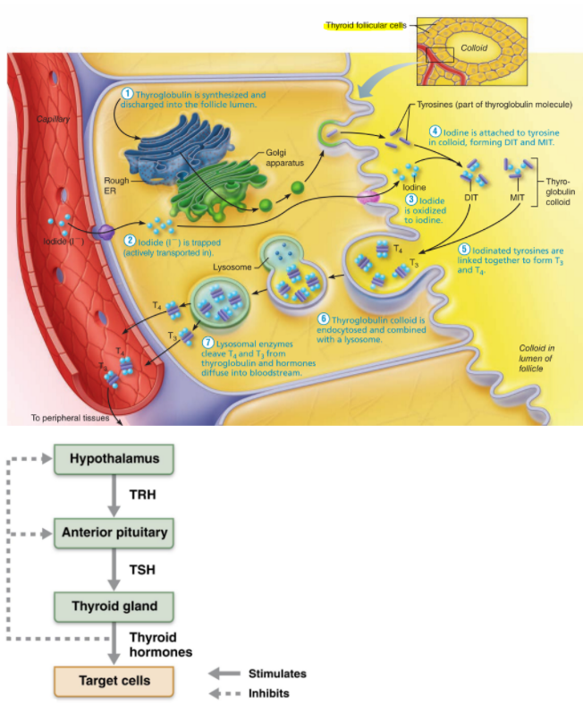
Regulation Food intake:
Fasting | ↑ NYP / ↓ POMC / ↑ Ghrelin
Feeding | ↓ NYP / ↑ POMC / ↑ Leptin  GI ↑ CCK

BMR: basal metabolic rate

Measuring:
  - Calorimeter (direct): heat in water chamber
  - Respirometer (indirectly): O2 consumption proportional to heat production
  - When: postabs state (12 hr fast) / reclined relaxed room T

- Factors:
  - Surface area: ↑ = ↑ BMR
  - Age: ↓ w/ age
  - Gender: cuz for fat free mass, ↑ higher, so BMR male ↑
  - Others = ↑ BMR: Body T, environmental T, Hyperthyroidism, stress, pregnancy/lactation, male sex hormones, GH,
  - Others = ↓ BMR: sleep, malnutrition

TMR: total metabolic rate
Synonym TDEE: total daily energy expenditure
- TEA: thermic effect activity
- TEF: thermic effect food (thermogenesis)

TMR = TDEE= BMR + TEA + TEF
Regulation Body T: tolerate cold better
- Reflect balance heat production/loss = 37C +/- 5C → Optimal enzyme activity
  - Most heat rest: liver, <3, CNS, kidneys, endocrine glands / skeletal for exercise
- Fever:
  - < 5 y/o → 41C = convulsions
  - ~43C = death

Heat exchange:
- Core Temperature: must stable, inc. head
- Shell Temperature: ↕ [20C; 40C]

- Radiation: loss of heat w/ infrared rays
- Conduction: heat transfer direct contact w/ object
- Convection: heat transfer w/ surrounding air
- Evaporation: heat loss cuz H20 evaporation from body surface
  - Heat of vaporization: Heat abs by water during ^
  - Insensible Heat loss: cuz lungs, oral mucosa, skin
  - Sensible Heat loss: w/ sweating

HYPOTHALAMUS - Thermoregulatory centers: body's thermostat
Where: pre-optic region
Input:
- Peripheral thermoreceptors (shell/skin)
- Central thermoreceptors (core & hypothalamus)

What: initiates activities…
- Heat-promoting centers:
  - Voluntary:
    - ↑ clothes
    - Hot fluids
    - Posture (crossing hands)
    - ↑ physical activity
  - Involuntary:
    - ↑ SNS = constriction cutaneous BV
    - Mechanical thermogenesis: shivering skeletal muscles
    - ↑ BMR: chemical thermogenesis
      - Epinephrine/Norepinephrine (infants)
      - Brown adipose tissue (infants & adults)
    - ↑ Thyroxine (infants)

Homeostatic balance: eg.
- ↑ Body T = Activates Heat-loss center in hypothalamus
- Skin BV dilate & Sweat glands activated
- ↓ Body T = Heat-loss center shuts off

Clinical Note:

- Frostbite: Blood Flow skin restricted → cells die

- Hypothermia: vital signs ↓
  - Shivering ≠ [30C; 32C]
  - Coma or Death → Cardiac Arrest ~ 21C

- Hyperthermia: ↑ T = depresses hypothalamus
Heat cramps | 1st: muscle cramps  2nd: Thirst / Profuse sweating / Fatigue | AC area & Sip water
Heat exhaustion | 1st: Pale/Cool skin & Weakness  2nd:  - See 2nd of ^  - Headache/nausea → faintness/dizziness  - Chills/Goose bumps ≠ sweating | AC are, loosen clothes & sip water, cool/wet cloth on body  Vomit → MD
Heat stroke | 1st: Rapid pulse & hot/dry skin & confusion  2nd: see 2nd of ^ | Call 911 & Cold water bath  Do not give fluids

- Fever:
What: controlled hyperthermia cuz infection/cancer/allergy/CNS injury
  - Reverse action of pathogens, they try to ↓ Body T cuz WBC :(
Rx: body T ↑ until prostaglandins go away → NSAID's

- Macrophages produce cytokines: in response pathogens products
- Cytokines = ↑ Vagal nerve to CNS
- CNS = produce Prostaglandins (PGE) → ↑ Hypothalamic temperature set point
- Hypothalamus send out signals → body = ↑ BMR/shivering, vasoconstriction, piloerection

LEUKOCYTES: = WBC
- Only "true cell" in BV, < 1% Qt. = protection → bacteria, viruses, parasites, toxins, tumors
  - Diapedesis: leaves BV = mount immune response → amoeboid motion (oublah cytoplasmic) / chemotaxis (movement towards spec. CHM)
  - Leukocytosis: body response to bacteria/virus invasion = x2 in hrs
- Never Let Monkeys Eat Bananas:
  - Neutrophils, Lymphocytes, Monocytes, Eosinophils, Basophils
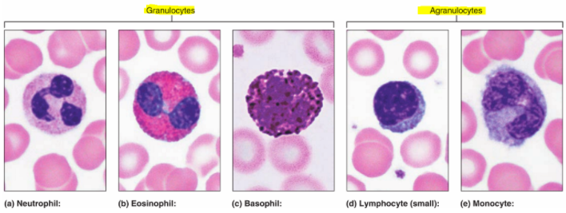

- GRANULOCYTES:
  - Round, large, lobed nuclei (>1), cytoplasmic granules

- Neutrophils: most common WBC
- Multilobed nucleus (Polymorphonuclear cells),
- Cytoplasm = 2 types granules → acidic/basic dies aka red/blue
  - Granules: Hydrolytic enzymes & antibacterial proteins (defensins) → get attracted to inflammation site
- Attacks: phagocytes bacteria & fungi w/ respiratory burst (oxygen loaded CHM attack ^)

- Eosinophils:
- Bilobed nucleus → telephone receiver red/blue
- Cytoplasm: red cytoplasmic granules
- Attacks: parasitic worms cuz ≠ be phagocytized cuz too big ≠ surround & digestive enzymes
- Control: immune response → allergies/asthma

- Basophils: rarest WBC
- Bilobed nucleus (S/U shaped/ dark purple)
- Cytoplasm: granules → histamine (BV leaky & signal attract other WBC)

- AGRANULOCYTES:
  - No granules, nucleus big, round/kidney

- Lymphocytes: 2nd most common WBC
- Nucleus large/dark purple w/ small rim pale blue cytoplasm
- Location: lymphoid tissue
  - T lymphocytes (T cells): attack virus-infected cells & tumors cells
  - B lymphocytes (B cells): plasma cells produce antibodies

- Monocytes: largest WBC
- Nucleus U/kidney shaped
- Attacks: gets into tissue → becomes macrophages phagocytes chronic infections, viruses, ~ bacteria

LEUKOPOEISIS: hormonally regulated → Interleukins (ILs)/ colony-stimulating factors (CSFs)
- Hematopoiesis = erythropoiesis/leukopoiesis
- Storage: bone marrow = mature granulocytes (≠ RBC)
- Lifespan: [0.5; 9days] → most die fighting
- Developmental pathway: between committed & mature cells
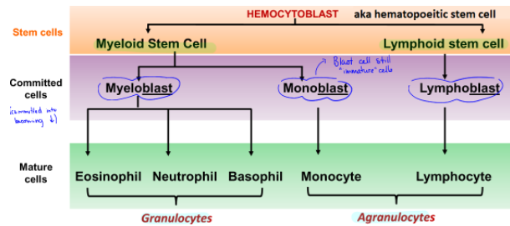

Clinical Note:

- LEUKEMIA: cancer WBC
  - Unregulated growth: descendants 1 cell = unspecialized/mitotic
    - Acute: ^ is blast-type cell
    - Chronic: ^ is later stages (~ fnc)
  - Bone marrow overcrowding = ↑WBC ≠ fnc
    - Symptoms: severe anemia, clotting problems, fever, weight loss, bones pain (cuz pression in medullary cavity)
    - Death: internal bleeding/overwhelming infections
    - Rx: irradiation, anti-leukemic drug → bone marrow transplant (only cure)

- INFECTIONS MONONUCLEOSIS:
  - Cause: Epstein-Barr virus = ↑ large/abnormal lymphocytes ≠ ~fnc
  - Symptoms: tired, achy, chronic sore throat, low-grade fever

- LEUKOPENIA:
  - ↓↓ WBC count ~ cuz drugs (glucocorticoids, anticancer agents)

THE IMMUNE SYSTEM:

- Innate/Nonspecific defenses:
Protects from pathogens w/o identifying them

- 1st Line → Skin & Mucous membranes: effective but = breached
  - Acid: skin, vaginal, stomach = ↓ growth bacteria
  - Enzymes: lysozymes in saliva, respiratory mucus, lacrimal fluid / protein-digesting enzymes stomach
  - Mucin: digestive/respiratory passages = sticky w/ H2O → traps them
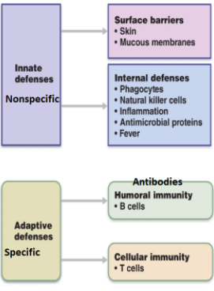
  - Defensins: antimicrobial peptides made by skin/mucous membranes
  - Other CHM: lipids in sebum & dermicidin eccrine sweat

- 2nd Line → Cells & Chemicals: necessary if invasion of deeper tissue

- Phagocytes:
  - Neutrophils: ↑ common, die fighting
  - Macrophages: made from monocytes that leaves BV = robust

Phagocytosis steps:
- Chemotaxis/adherence of microbe to phagocyte
- Ingestion = inside a phagosome (phagocytic vesicle)
- Lysosome + phagosome = phagolysosome
- Digestion of microbe & discharge of waste (puss)

- Natural Killer Cells:
Nonphagocytic, large granular lymphocyte = police BV/LV
- kills virus-infected cells before adaptive immune system is activated
  - Contact target → inject toxins → forces it = apoptosis
  - Toxins: Perforins (pokes holes in surface) & Granzymes
- ≠ recognize cell, only abnormalities cell surface
- ↓ if AIDS

- Inflammation:
Redness/Heat (vasodilatation), Swelling (↑ vascular permeability), Pain (stops + stress)
Beneficial effects:
- Stops spread across tissues
- Disposes of waste/pathogens
- Prepares for repair process
- Alerts adaptive immunity

Stages of inflammation:
- Inflammatory CHM release: Histamine, kinins, prostaglandins, complement
- Vasodilation/↑ vascular permeability
- Phagocyte mobilization
  - Leukocytosis: neutrophils enter BV from bone marrow
  - Margination: ^ stick to capillary walls
  - Diapedesis: ^ squeeze themselves through leaky capillaries
  - Chemotaxis: ^ follow CHM trail
  - Phagocytosis

- Interferons (IFN)
  - Immune syst controlling proteins

- Alerts immune syst.
  - Activate macrophages/mobilize NKC → ~ anticancer effects
- Secreted by all virus-infected cells → diffuse neighbours → so they detect it fast and kill it before virus highjacks protein synt & causes it to lyse (↑ spread)

Mechanism:
- Virus enter cell
- Interferon gene = ON → protein synthesis
- Exocytosis interferon proteins → bind surface nearby cell
- Turns on genes for antiviral proteins = protected
- Antiviral proteins block virus high jacking (enzymes breaks down viral RNA)

- Complement:
  - Plasma proteins circulating in plasma (inactive)
  - Activated = amplify all aspects of inflammatory process

Activation by…
- Classical pathway:
Antibodies bind to pathogen and then binds to complement = activation
- Lectin pathway:
Lectins produced by innate syst = recognize foreign invaders
- Alternative Pathway:
Complement cascade activated spontaneous when complement binds to invader
- All act on C3 protein… ÷ into
  - C3b - Opsonization: coats pathogen surface, ↑efficient phagocytosis, ↑ tasty
    - Bind to Membrane attack complex:
^ inserts into membrane of invader = cytolysis (burst cuz osmotic imbalance)
  - C3a - Enhances inflammation: ↑ histamine, attracts phagocytes by chemotaxis

- Fever:
  - Systemic response to invaders
  - Body's thermostat 37C → Reset by pyrogens released w/ leukocytes/macrophages
  - ↑Fever dangerous = denatures proteins

Benefits:
- ↑ effect interferons / ↑ phagocytic efficiency WBC
- ↑ Rate of attack, w/ ↑ HR/CO = more WBC to the area

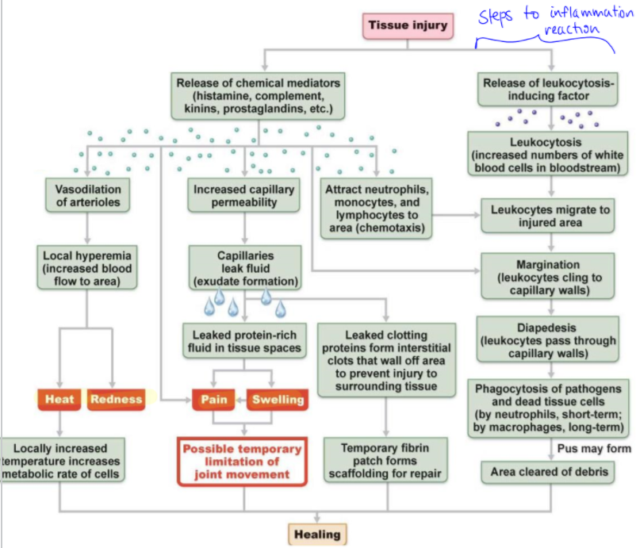

ADAPTIVE IMMUNE SYSTEM: Specific
- ++ inflammatory response & activates complement → if primed first
- Specific: targets specific antigens
- Systemic: ≠ restricted to initial site → all body
- Memory: stronger/quicker attack ≥ 2x

- Humoral immunity: Antibody-mediated
  - Bind to inactive target cell → mark for destruction = phagocytes/complement
  - Extra cellular targets: if multiply inside cell :(
- Cellular immunity: Cell-mediated
  - Lymphocytes act against cell → can kill pathogens multiply inside cell
  - Direct
  - Indirect: w/ ↑ CHM that + inflammatory response & activating other lymphocytes/macrophages

ANTIGENS:
- Substance/CHM that = immune response
- Antigenic determinants: pt antigen antibodies/lymphocytes receptors bind to
- 1 antigen > antigenic sites

- Complete Antigens
  - Immunogenicity: ↑ proliferation spec lymphocytes (B/T cells)
  - Reactivity: reacts w/ activates lymphocytes/antibodies released
Eg. Foreign proteins, polysaccharides, lipids

- Hapten Antigen (incomplete)
  - Not immunogenic by itself: cuz too small to be seen (eg. Nucleotides, hormones)
  - Yes = immunogenic: if hapten + own cell protein = foreign now!
  - Harmful: cuz attacks self-protein at same time
Eg. Poison Ivy, cosmetics, detergents

- Self-Antigen: MHC proteins
Major Histocompatibility complex (MHC): genes ea. ind. on glycoprotein cell surface aka self marker
    - Grooves on ^: bowl hold either self-antigen/foreign antigen
      - T-Lymphocytes: only recognize antigens if in bowl ^

3 CELL TYPES IMMUNITY:

- LYMPHOCYTES:
  - B-Lymphocytes/B-cells: humoral immunity = antibodies
  - T-Lymphocytes/T-cells: cellular immunity
    - Effector/Helper/Memory T-cells

Lymphocytes Origin/Development/Maturation:
Lymphocyte origin | - Red bone marrow → both T/B cells = hemocytoblasts  - Become w/ one? Depends where in body acquire immunocompetence
Lymphocyte maturation | T-cell education = Thymus: 2-3 days  - Manager: thymic hormones  Clonal deletion: ensures self tolerance  - Positive Selection: teaches body cells = friends  - If can't recognize MHC aka can't bind properly = destroyed apoptosis  - Negative Selection: must not attack body cells  - If binds to self-MHC → destroyed apoptosis  - Immunocompetent: cuz now can bind to ONE antigen  B-cell education:  - In bone marrow: self-reactive weeded out like ^  - Immunocompetent: before even meeting the cell
Seeding secondary lymphoid organs + circulation | Naïve Lymphocytes: cuz immunocompetent but never exposed to antigen yet  - Seeding: exported from thymus/bone marrow → secondary lymphoid organ (lymph nodes, spleen…) cuz ↑ chances of meeting its spec antigen
Antigen encounter = Activation | First encounter: triggers activation and…  - Clonal Selection: when ^ = ↑ exact copies of itself (50% effector cell/memory cells)
Proliferation & Differentiation | - Proliferation of clones: w/ continuous circulation  - Effector clones: fight infection  - Memory cells: ability respond ↑ quickly next time  - Genes determine what pathogen our immune system recognize/attack NOT ANTIGENS

- ANTIGEN-PRENSENTING CELLS (APC):
  - Chews it → presents it to lymphocytes ^
  - Look out spot

Presentation Steps:
- Endocytosis:
  - Endoplasmic reticulum: unused Class II MHC receptor not yet used exported as a vesicle
  - Antigen in interstitial space: phagocytized and joined w/ lysosome = phagolysosome
- a) and b) Merge together = migrate to plasma membrane
- Presentation: Class II MHC now on membrane w/ antigenic peptide on it

Dendritic Cells | Where: CT & Epidermis = mobile sentinels @ tissue boundaries  - Attack: phagocytize pathogen → enter lymphatics to present to T-cell in lymph node  - Most effective antigen presenter (link innate/adaptive immunity)
B-Cells | - Present antigen to helper-T cells to assist their own activation  - Doesn't activate naïve T-cells
Macrophages | Where: CT & Lymphoid organs (trigger inflammatory response & recruit ++ defenses)  What:  - Antigen presenter: Eat pathogen → puts those antigens surface → T-cell recognition  - Activation T-cells: w/ secretion soluble proteins  - Lymphoid organs cuz ↑ chances contact pathogen cuz circulation brings them there

- Effectiveness Immune system:
  - Ability recognize foreign substances & binding
  - Ability communicate w/ one another = systemic attack

HUMOURAL IMMUNITY & VACCINES:
- In lymph tissue → if B-cell catches it = humoral immune response

- B-Cell + Antigen: humoral immune syst evoked (↑ antibodies by effector B-cells aka plasma cells)
- Killing: antibodies made & bind & destroy antigen
- Memory: Memory B-Cells put into a bank for LT

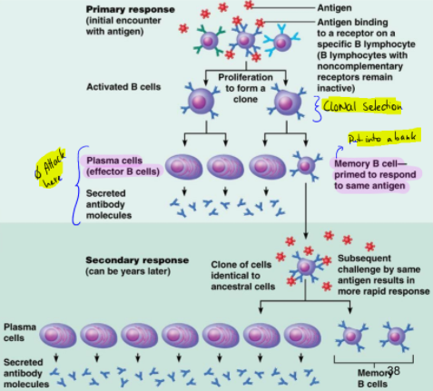

VACCINES:
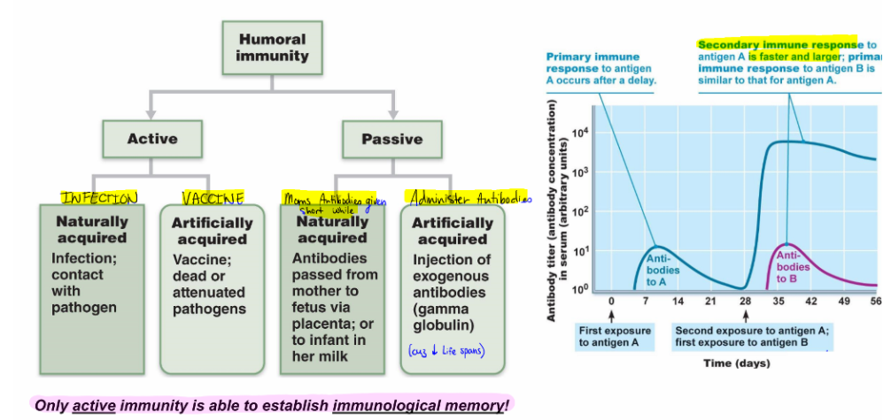
- Second time infected: no delay time → Antibodies start ↑ and to a much ↑lvl than before

ANTIBODIES: aka Immunoglobulins (Igs)
- Secreted plasma cells (B-lymphocytes) → make-up gamma globulin pt in serology
  - Plasma cells can switch from one class if Ig to another
- Binds to Antigen: that has been detected B-cells

Antibody Structure:
- Y shaped: polypeptide linked w/ disulfide bonds
  - (H)eavy Chains: identical (inner V)
  - (L)ight Chains: identical (outer V)
  - Stem Region: under hinge = determines antibody class…
    - IgM: Pentamer, 1st antibody released
    - IgA: 2 Y stuck together, in secretions (mucus, tears)
    - IgD: Y attached to surface B-cells
    - IgG: Y (Most common in plasma BV, most common 2nd response)
    - IgE: Y for allergies/parasitic infections

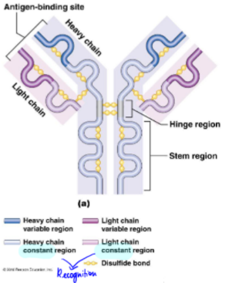
Mechanism Antibody action:
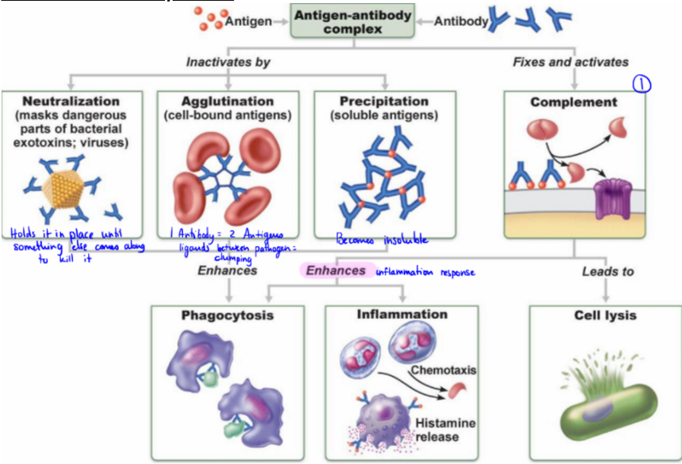

CELL-MEDIATED IMMUNE RESPONSE: T-CELLS
- Blind: only sees processed antigen fragments on body's own cells
  - Displayed w/ MHC proteins

    - Class I MHC: displayed by all cells exc. RBC
      - Recognized: Naïve CD8 cells + Cytotoxic cells
      - Presents: endogenous pathogens/CHM
      - Message:
        - IF APC: I captured this, kill any cells like this
        - IF NOT APC: I'm cancer/sick kill me

    - Class II MHC: displayed by APC's (dendrites, macrophages, B-cells)
      - Recognized: Naïve CD8 cells + Helper cells
      - Presents: exogenous pathogens/CHM
      - Message: Help me mount a defense against this
  - Production Endoplasmic reticulum

Activation T-cells: on surface of same APC
- Antigen binding: CD4 T-cell and its receptor+ Class II MHC on APC
- Co-stimulation: Put the gear on "D" to drive (co-stimulation on each of ^ join together)

Proliferation/Differentiation:
- Clone formation: proliferation and causes differentiation (into Helper T-Cells or CD4 T memory cells)

Types of T-cells:
CD4/CD8 = receptors on cell surfaces and then become real thing…

- Cytotoxic T-Cells: (From CD8 cells aka Tc) -- Killer T-Cell
  - Attacks w/ Lethal hit: via exocytosis (even though tightly bound)
    - Perforins: punch holes membrane (esp. for…)
    - Granzymes: triggers apoptosis, then takes off and kill something else
  - Targets: virus infected/cancer cells, cells /w intracellular bacteria/parasites, foreign cells (transfusions/transplants)

- Helper T-cells: (From CD4 aka Th)
↑ proliferation/activity other lymphocytes (inc. B) = ↑ common type
- Crucial for immune response = activates cellular + humoral arm (w/o it = none)
- Once primed w/ APC:
  - Activates B-cells & other T-cells
  - ↑ B/T cell proliferation
  - Secretes Cytokines recruits other immune cells

- Regulatory T-cells: (T.reg) Wind down immune response by…
  - Direct contact
  - Secretions: inhibitory cytokines (IL-10 & TGF-B aka transforming growth factor beta)
  - Research on it: cuz supressed self-reactive lymphocytes

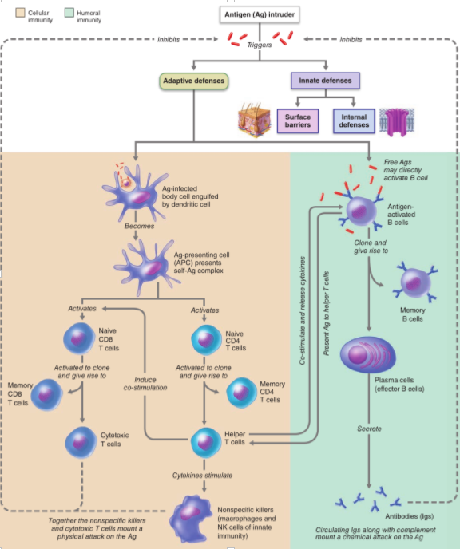

RENAL SYSTEM:
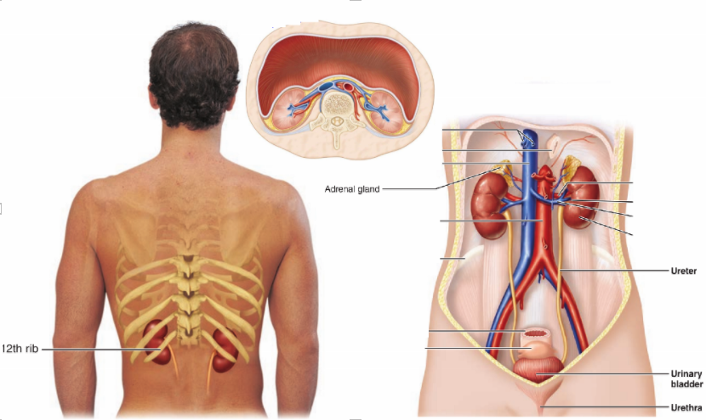
Position in body:

- Retroperitoneal, superior lumbar (T12 → L3) = ~ protection rib cage
- Right kidney ↓ by liver
- Renal Hilum leads to internal space renal sinus
- Adrenal glands: (Ad = towards)

Protection = 3 lvl CT:
- Renal capsule: fibrous, stuck onto kidney, prevents infections spreading in
- Perirenal fat capsule: Cushion, hold kidney in place
- Renal fascia: dense CT adrenal gland + kidneys = anchors

Clinical Note:
- Renal ptosis: loss fat perirenal fat capsule → kidney drop down → obstruction cuz noeud ureter
Rx: Surgery

Internal Anatomy:
- Cortex: filtration blood
- Medulla: medullary/renal pyramids nipple towards ureter, striped cuz collecting ducts in between (renal column) extension of cortex ^
- Pelvis: Flat tube w/ ureter
  - Minor Calices: (singular = calix)
Kisses nipple (papillae) of renal pyramids → small funnel urine collection
  - Major Calices: collect urine from small funnels ^
  - Walls Calyces/Pelvis: smooth muscle = propels w/ peristalsis

Clinical Note:
- Pyelitis: inflammation tubular parts
- Pyelonephritis: ^ that becomes inflammation of kidneys

Circulatory Pathway Kidneys:
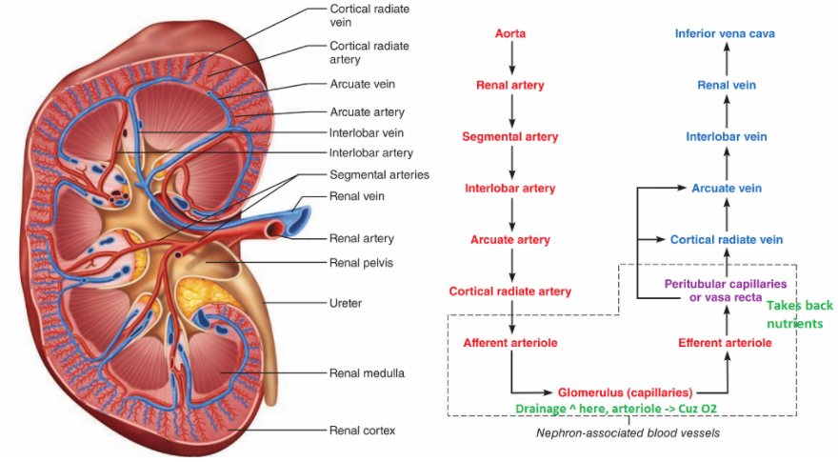

- [Innervation] Renal plexus made of ~ ↑SNS = regulate BP w/ diameter of afferent/efferent renal arteriole

NEPHRONS: Structural unit kidneys
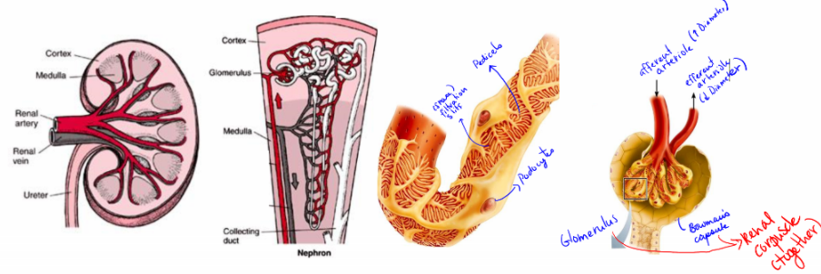
- Renal corpuscle:
  - Glomerulus: ↑ permeable capillaries
    - Fenestrated glomerular endothelium: ↑ solutes exp. Proteins = filtrate
    - Afferent/Efferent arterioles: ↑resistance vessels (3x BP), afferent arteriole ↑ diameter cuz takes a while to filter (= ↓ efferent)
  - Bowman's capsule:
    - Parietal layer: just structure ≠ filtration fnc
    - Visceral layer: clings to basement membrane glomerulus
      - Layer of Podocytes: branching of these cells = pedicels
        - Filtration slits: spaces between pedicels ^ allow filtrate enter bowman's capsule

Nephron tubular circulation:

- Proximal convoluted tubule: has microvilli
  - Abs of 66% H20/Na+ (osmolarity),
  - Abs Glucose, HCO3-
- Loop of Henle:
  - Descending: Concentration of filtrate, H20 ↑ abs passive medullary osmolarity
  - Ascending: Reabs 20% Na+ , dilute tubular fluid (thick segment H20 impermeable) = salt transporter out to BV
- Distal convoluted tubule:
  - Abs remaining Na+/H20, HCO3-
  - Secretes K+
  - Synt HCO3-
- Cortical collecting duct: fine adj. to []
  - Principle cells: Salt/H20 balance (≠ microvilli) = secretes K+
  - Intercalated cells: acid-base balance BV (microvilli) = secretes H+ in lumen, synt HCO3 for blood
- Medullary collecting duct: hormonally regulated, last chance abs
  - H20/Urea out cuz hypertonic interstitium

Types of Nephrons:

- Cortical (85%)
  - Peritubular capillaries: Gas exchange - supplied by efferent arteriole of glomerulus
    - Drain into renal venules
- Juxtamedullary: (15%)
  - Role: dehydrated = saves your life → allow for ↑H2O reabs in Loop of Henle
  - Vasa Recta: supplied by efferent arteriole of glomerulus
    - ^ Wanna be peritubular capillaries = orderly organization
  - Longer loop of Henle

Juxtaglomerular apparatus: in between afferent/efferent arterioles
- Role: regulate renal fnc (filtrate formation + Systemic BP)

- Granular Cells/JG cells: on arteriole walls
  - Smooth muscle = mechanoreceptors/secrete renin

- Macula Densa cells: tubular wall ascending loop Henle
  - CHM receptors + osmo filtrate → adjust GFR
  - Do NOT monitor blood

MICTURATION PATHWAYS:

- MALE:
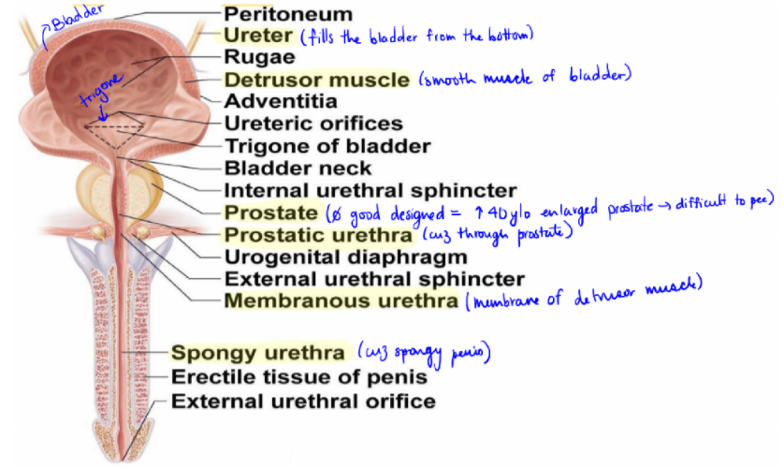

- Trigone: always urine there = imp for clinical infections
- Urethral sphincter:
  - Internal: Smooth muscle, pt of bladder
  - External: skeletal muscles = voluntary

- FEMALE:

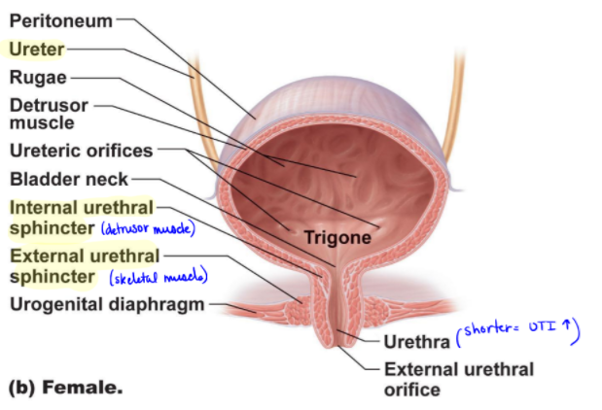

RENAL PHYSIOLOGY:
- Filtrate: plasma (-) proteins
- Urine: filtrate (-) nutrients

FNC: Main = 1,2
- Filter: toxins, met waste, excess ions in urine
- Return of materials needed by body via BV
- Regulate Blood volume & Composition
- Synt renin (regulate BP & kidney fnc)
- Synt erythropoietin (↑ RBC)
- Activates vit D = active form

GLOMERULAR FILTRATION: (Glomerulus BV → Filtrate w/ hydrostatic pressure)
- Tubular reabs (Filtrate → BV) / tubular secretion (BV → filtrate w/ ATP)
- Glomerular Absorption Rate: 125mL/min plasma forced into renal tubule (!)

↑ Efficient cuz:
- +++ permeable than other capillaries
  - 3 layers:
    - PASS: H20, glucose, AA, N-Wastes
    - NO: Plasma proteins (cuz mechanical) also electrical (-) protein VS. (-) basement membrane → maintain osmotic pressure = blood flow yes
      - Proteinuria: damage membrane maybe ^
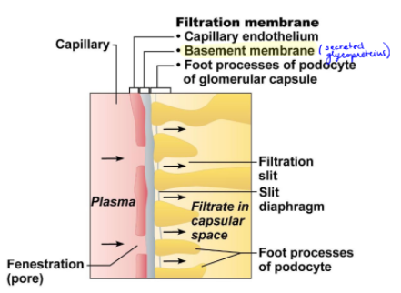
  - Fenestrated capillary endothelium
  - Basement membrane
  - Visceral membrane glomerular capsule aka podocytes
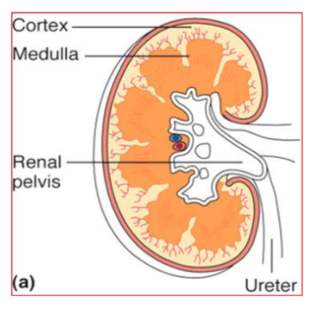
- BP +++ than ^ cuz constriction afferent/efferent arteriole


