Inflation reduces the real value of nominal GDP per capita because:

nominal GDP is calculated based on goods and services valued at current prices.

Explanation:
Nominal GDP is calculated based on goods and services valued at current prices. Real GDP per capita = nominal GDP per capita - inflation rate - populaton growth rate. Real GDP per capita is the amount of goods and services produced per person. Nominal GDP per capita is the number of dollars produced per person. Inflation increases the number of dollars required to purchase goods and services. If a country’s nominal GDP is fixed, inflation will reduce the amount of goods and services that can be purchased with the fixed amount of nominal GDP.

When policy makers discuss policies that encourage long-run growth in per capita real GDP, they often mention policies aimed at reducing the growth rate in the population. If effective, these policies could improve long-run growth because a smaller population increases:

per capita real GDP for a given level of real GDP.
However, these policies can:

reduce nominal GDP at the same time and may be coercive.

Explanation:
Given that real GDP per capita growth rate = Nominal GDP growth rate − Inflation rate – Population growth rate, if one can keep the nominal GDP growth rate and inflation rate the same while simultaneously reducing the population growth rate, then real GDP per capita growth rate will rise. More intuitively, if one can keep the size of a cake growing at the same rate but reduce the number of people among whom you have to divide up the cake, everyone will get bigger and bigger slices. There are two primary costs. First, the policies that reduce population growth may also reduce nominal GDP at the same time. For example, lower population growth will eventually reduce the amount of labour a country can provide or may reduce the rate of technological innovation or capital accumulation. Second, the policies required to reduce population growth may be considered coercive or a violation of human rights. For example, China’s “one child” policy is often criticized on human rights grounds.

Does the rule of 70 predict greater increases in the amount of income for richer or poorer countries when both have the same growth rate?

No, the rule of 70 predicts that the amount of time it will take for a country’s income to double is dependent only on its growth rate, not on its initial level of income.

Explanation:
The rule of 70 predicts that the amount of time it will take for a country’s income to double is dependent only on its growth rate, not on its initial level of income. However, the size of the increase certainly depends on its starting point. For example, two countries with a 7% real per capita growth rate will both have their incomes double in 10 years (70/7 = 10). If one country started with a GDP of $1,000 per capita and the other started with a GDP of $10,000 per capita, the poor country would have experienced an increase in income from $1,000 to $2,000 per person in 10 years, an increase of $1,000 per person. The rich country would have experienced an increase in income from $10,000 to $20,000 per person in 10 years, an increase of $10,000 per person.

Even though many rich countries already have very high levels of physical and human capital, they are able to continuously grow because they:

can continuously increase any of the components that lead to productivity growth.

Explanation:
Rich countries with high levels of physical and human capital will be able to continuously grow if they can continuously increase any of the components that lead to productivity growth. First, it is possible that even countries with high levels of physical and human capital can continue to accumulate even higher levels of these factors of production. Second, countries with high levels of physical human capital are well equipped to engage in technological innovation, another component of productivity growth.

All else equal, at a young age, would you rather have a high level of savings or a pool of savings that was increasing at a faster rate? As a general rule of thumb, over long time periods, small differences in:

growth rates can overcome even large initial differences in endowments.

Explanation:
Obviously, this answer depends on the relative size of the pools of savings and relative rates of growth. As a general rule of thumb, however, even small differences in growth rates can overcome large initial differences in endowments over long time periods.

Refer to the figure below to answer this question.

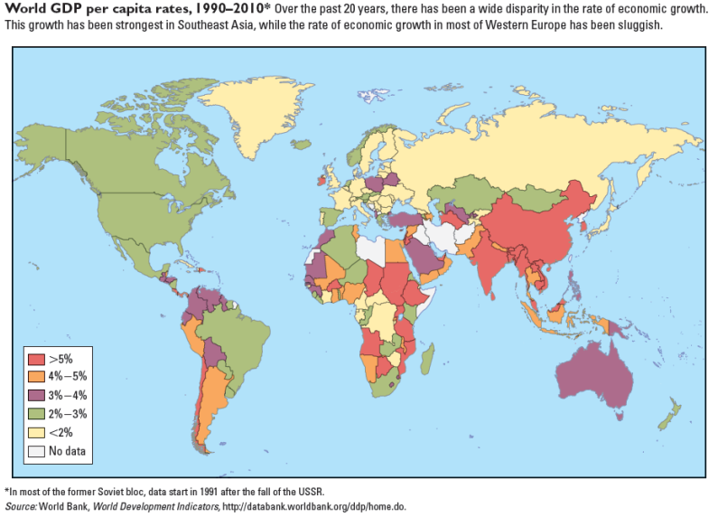

Using the growth rates for countries over the past 20 years, is there evidence that poorer countries in Africa and Asia are converging to the level of income found in Western Europe?

Yes, the map shows that over the past 20 years countries in Africa and Asia have grown faster than countries in Western Europe.

Explanation:
The map shows that over the past 20 years countries in Africa and Asia have grown faster than countries in Western Europe. This suggests that some level of convergence has taken place.

Some southeastern countries in Asia are, on average, poorer than northern Asian countries like Japan and South Korea. But they have higher growth rates of real GDP per capita, on average, than northern countries.

These facts:

do not allow us to determine whether conditional convergence is occurring because we do not know all of the other parameters that characterize southeastern and northern countries.

To be more certain of our conclusion, it would be useful to have comparisons related to:

Instructions: You may select more than one answer. Click the box with a check mark for correct answers, and click to empty the box for the wrong answers.

the levels of education.
the population.
the levels of technology.
the savings rates.
the geographic size.

Explanation:
Convergence theory does explain why southern states are growing faster, but it does not guarantee that they will reach the same level of income.

Key parameters to know, for example, are the respective savings rates, the levels of technology, and the levels of education.

Many believe that technology is very costly to create, but cheap to transfer. For example, think of the personal computer. The technology underpinning the personal computer took a generation of time and a ton of money to create. However, now that the personal computer has been created, it is easy for others to purchase and reap the benefits. Canada has traditionally been more apt to create new technology, whereas China has traditionally been more apt to adopt technologies created elsewhere. These observations imply that growth:

should be slower in a country that has to engage in the creation of new technologies and faster in countries that get to deploy technologies that have already been created elsewhere.

Explanation:
Growth would be slower in a country that has to engage in the creation of new technologies and faster in countries that get to deploy technologies that have already been created elsewhere. Thus, China would grow faster than Canada. The idea of technology transfer is one reason why economists believe that convergence is likely to occur between rich and poor countries.

Low rates of savings in Canada can limit the accumulation of physical capital. This is because if a country must rely primarily on:

domestic sources of savings in order to provide funds for investment, a low savings rate will result in a low rate of physical capital accumulation.

Explanation:
If a country must rely primarily on domestic sources of savings in order to provide funds for investment, a low savings rate will result in a low rate of physical capital accumulation.

Realizing that poor countries must solve many problems at once has shifted donors away from the idea of giving multiple small payments and toward the idea of a “Big Push”. This Big Push entails giving a very large sum of money that could be used to fix multiple problems at once. In fact, the amount of money required might be so large that rich countries might be the only ones who could afford the donation.

From the donor country's perspective, the trade-off associated with this idea is that:

improving the lives and welfare of foreigners will mean less money for domestic problems.

From the recipient's perspective, the trade-off associated with this idea is that:

a developing country might begin pushing for policies that it thinks will attract more foreign funds, rather than pushing for policies that are actually in the country's best interests.

Explanation:
There are trade-offs faced by both the donor country and the recipient country. From the donor country's perspective, a large donation to a developing nation could have great humanitarian benefits, including reducing poverty and encouraging sustainable growth in that country. However, this money could have been used for other purposes within the donor country. In Canada, it is a frequent source of contention that Canada donates "so much" money to other countries instead of rebuilding its own cities. (Of course, we don't actually donate a large portion of our GDP.) So, the trade-off is between improving the lives and welfare of foreigners with the opportunity cost of the money.

From the recipient's perspective, the benefits of a large donation could be quite dramatic—again, reducing poverty and encouraging sustainable growth. However, receiving a sudden large donation might simultaneously undermine that country's nascent set of institutions. Corruption, for example, might arise as local officials try to siphon off some of the incoming funds. Also, the developing country might begin pushing for policies that it thinks will attract more foreign funds, rather than pushing for policies that are actually in the country's best interests.

How is it possible that Switzerland, a landlocked country with almost no natural resources, is one of the richest countries in the world while the Democratic Republic of the Congo, a huge country with vast deposits of many strategically important minerals, is one of the poorest? The case of Switzerland vs. the DR Congo highlights that:

natural resources do not make up for all of the advantages that the other components of productivity growth bring.

Explanation:
The case of Switzerland vs. the DR Congo clearly highlights that natural resources are only one component of productivity. All things equal, it is probably better to have more natural resources than less, but when comparing a country with high levels of physical capital, human capital, technology, and good governance but few resources (Switzerland) and a country with many resources but little human or physical capital, low levels of technology, and a long history of corrupt governance (Congo), we see that natural resources alone generally can’t make up for all of the advantages that the other components of productivity growth bring.

Think about the connection between the press and the government. A free press can be important for economic growth because a free, independent press:

makes government officials less inclined to engage in behaviour that is detrimental to the economy because their actions might be imposed.

Explanation:
Good governance is an important component of economic growth. A free, independent press serves to promote good governance by publicizing government corruption, waste, and fraud. Government officials who are at the risk of public exposure are less inclined to engage in behavior that is detrimental to the economy.

