Journal Entry: In focus- Business in Society

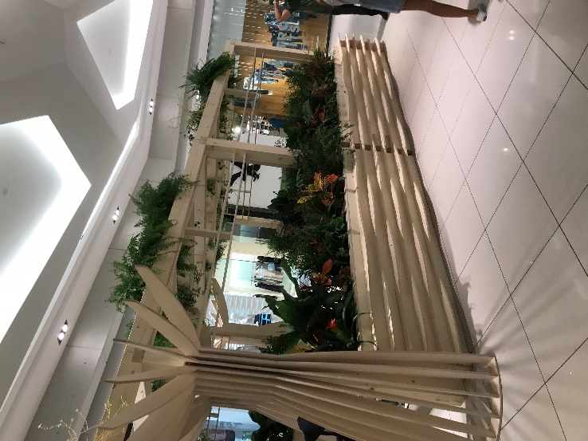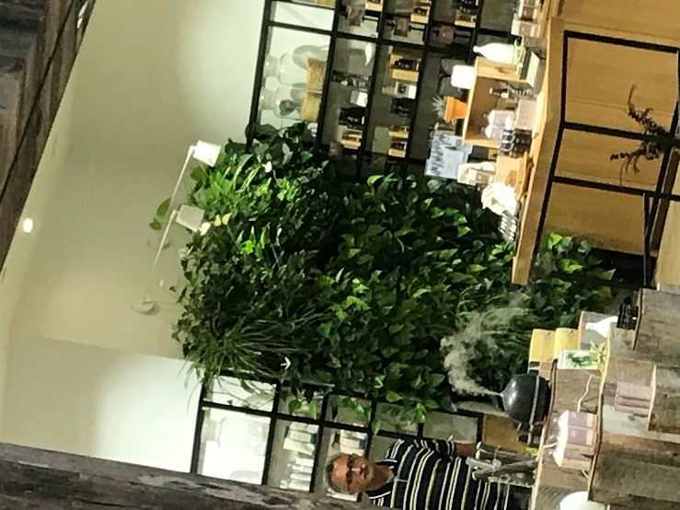
Above are two pictures taken inside the Rideau Centre. On the right is a picture of fake plants surrounding an eating area, and on the left, is a picture of real plants in a store. The store with the real plants is being very environmentally friendly by actually taking care of the planet and not creating a larger carbon footprint by buying artificial plants.

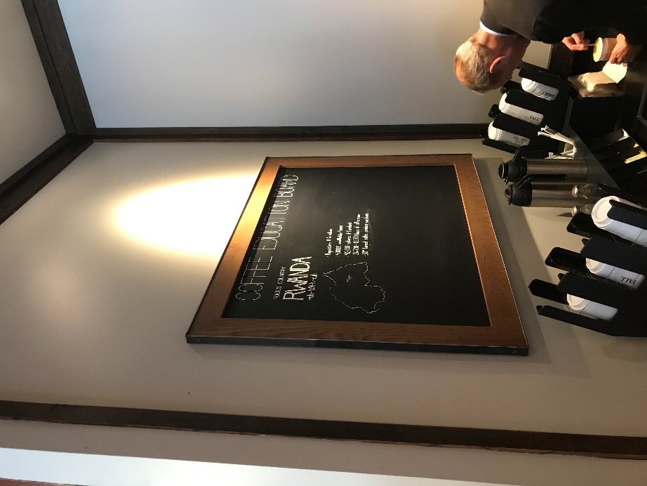
This picture was taken in a Starbucks on Rideau Street. This blackboard is putting a spotlight on Rwanda, a country in central Africa that Starbucks buys their fair-trade coffee from. This is being very socially responsible on Starbucks’ part as they are educating the general public on the ethical practices of their coffee.

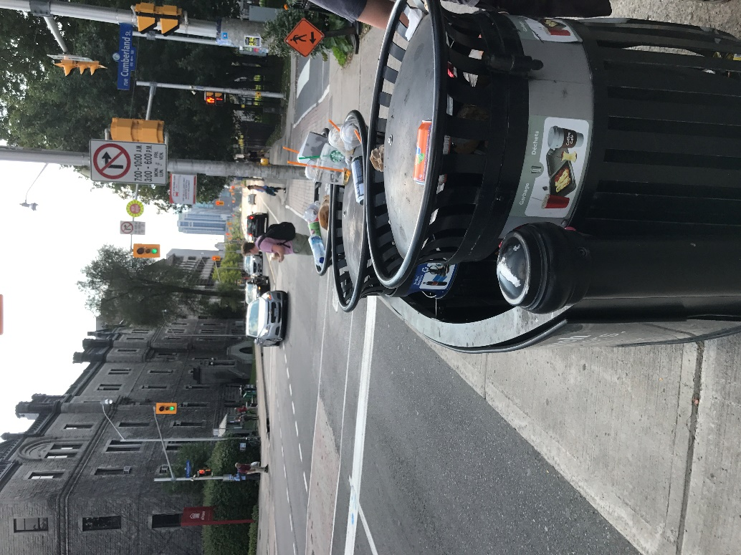
This final picture was taken right outside the Second Cup on campus. Everyday these garbage’s are overflowing with cups and cans bought from Second Cup. This isn’t very socially responsible on Second Cup’s part as they are not caring about the environment. By letting these garbage’s overflow everyday Second Cup is indirectly promoting littering.

