  - Chapter 1: Macroeconomics and Life
What is Economics?
- The study of how people manage resources
- Resources are not just physical things (cash and gold mines), but they are also intangible things (time, ideas, technology, job experience and personal relationships)
What is Microeconomics?
- The study of how individuals and firms manage resources
What is Macroeconomics?
- The study of the economy on a regional, national or international scale
What is the Classical Theory?
- It focuses on an equilibrium aspect where supply and demand interact
- It suggests that if demand and supply are not equal, the market will adjust in such a way that equilibrium ultimately will prevail
What do economists assume of people?
- Compare all available choices
- Purposefully behave in the way that will best achieve their goals (rational behaviour)
What are the FOUR questions economists use to break down problems?
- What are the wants and constraints of those involved? – relates to scarcity
- What are the trade-offs? – relates to opportunity cost
- How will others respond? – relates to incentives
- Why isn’t everyone already doing it? – relates to efficiency
What is Scarcity?
- People’s wants are greater than available resources
- Individuals resources: time and money
- Societies resources: factors of production (land, capital, labour, technology)
What is Gross Domestic Product (GDP)?
- A measurement of national income for a specific period of time, which can also be viewed as a measurement of output
- Market value of final goods and services produced within a country in a given period of time
- When an economy’s output is rising, we have economic growth
- When an economy’s output is decreasing, we have business cycles
What is Unemployment Rates?
- The number of unemployed workers in the labour force
- When unemployment is high, the amount of output decreases
What is Inflation?
- When the overall price level is rising
- May disrupt the saving-investment process
What are Policy Decisions?
- What policy makers look for that lead to faster long-term growth and reduce the severity of recession
What are Policy Decisions concerned with?
- Monetary Policy
- Fiscal Policy
(Used to keep economic output at a level that is consistent with full employment)
What is Monetary Policy?
- Conducted by the Bank of Canada which involves controlling the money supply and the setting of interest rates
- Low interest rates tend to stimulate output and employment but may create higher inflation
- Higher interest rates tend to keep inflation low but may lower output and employment
What is Fiscal Policy?
- Conducted by the federal government that involves the use of government spending and taxation to influence the economy’s output
- Higher government spending and lower taxes will boost economic output buy may bring a higher level of inflation and public debt
- Lower government spending and higher taxes will keep inflation and public borrowing in check but may lead to lower output and employment
What is Opportunity Cost?
- The value of what you have to give up in order to get something
- People compare two things, the additional benefits against the additional costs without considering related benefits and costs of pas choices – referred to marginal decision making
- The direct cost includes all associated costs
- Question: Why do professionals (doctors, lawyers) are less likely to mow their lawn?
- Answer: Because professionals have an enormous time opportunity cost. The value of the next best alternative is an additional surgery or court case
- Ex. the mechanic’s car is the worst one, because if he/she is going to work on a car, the opportunity cost of working on his or her own car is the forgone earnings from working on someone’s else car
Example of Opportunity Cost:
You are studying for your econ exam and your friends ask you to go to the movies.
What is the opportunity cost of going to the movies?
- The opportunity cost of going to the movies is the value placed on studying. This could be valued at the change in grade from study or forgone future earnings
How does this change if you are borderline failing?
- The costs of possible retaking the class are now considered
What is the opportunity cost of studying econ?
- The opportunity cost of studying econ is the value of going to see the movie. It could be valued at the ticket price
How does this change depending on the movie?
- If the individual has a big desire to see the movie, this will increase the opportunity cost
What is the rule of thumb in deciding which activity to choose?
- Choose the activity with the lowest opportunity cost
(The opportunity cost of going to the movies is the value placed on studying. Assuming that studying leads to a higher grade and a higher grade leads to higher future earnings, the cost of going to the movies is the forgone future income. If a student is in danger of failing, then obviously the cost of retaking the class is also included in the opportunity cost. The opportunity cost of studying economics is the value of going to see the movie. Given that individuals’ valuation of the movies is not equal to the ticket price, their opportunity cost is their valuation of going to the particular movie. It should be made clear that as the opportunity cost rises, the willingness to engage in this activity decreases.)
Example of Marginal Decision Making:
Canada’s Wonderland has a $25 admission price and charges $5 per ride. If you are standing outside the park, the cost of the first ride is $30, because you will have to pay the admission price and buy a ticket to go on the ride. Once you are inside the park, the marginal cost of each additional ride is $5. When deciding whether to go on the roller coaster a second or third time, then, you should compare only the benefit or enjoyment you will get from one more ride with the opportunity cost of that additional ride
What are Sunk Costs?
- Costs that have already been incurred and cannot be recovered
- Sunk costs should not have any bearing on your marginal decision about what to do next, but often times, people feel the need to psychologically justify their decisions
What are Incentives?
- Something that causes people to behave in a certain way by changing the trade-offs they face
- Positive Incentive: makes people more likely to do something by lowering their opportunity cost
- Negative Incentive (disincentive): makes people less likely to do something by raising their opportunity cost
- Ex. lowering the price of spaghetti creates a positive incentive for people to order it because it lowers the opportunity cost – when you pay less for spaghetti, you give up fewer other things you could have spent the money on – charging people more for pizza is a negative incentive to buy pizza, because they now have to give up more alternative purchases
- when an incentive is provided on a large scale, the consequences can be extremely large and vice versa
- asking how others will respond can help prevent bad decisions by predicting the undesirable side-effects of a change in prices or policies
Example of Incentives:
Your higher education institution permits your final exam score to replace a midterm exam score in a course
How does this affect your opportunity cost of going to the movies?
- The opportunity cost of going to the movies increases. The institution has given students a disincentive to engage in non-school related activities
What is Efficiency?
Resources are used in the most productive way possible to produce the goods and services that have the greatest total economic value to society
- Increasing efficiency means finding a way to better use resources to produce the things that people want
- Seek opportunities to get what you want
What are FOUR ways economies do not operate efficiently?
- Innovation: yet to be discovered innovations/ideas increase efficiency
- Market Failure: people and firms may be prevented from capturing the benefits of the opportunity or incur additional costs
- Intervention: cause transactions to not take place (most often government policies)
- Goals Other Than Profit: individuals and governments have goals other than profit
What is an economists Problem-Solving Toolbox?
- Accurately spotting the fundamental economic concepts at work in the world is sometimes difficult
- Ex. the sun doesn’t revolve around the earth and droughts are not caused by witches giving people the evil eye
What does Economic Analysis require?
- Theory to be combined with observations
- Scrutiny of both theory and observations before drawing conclusions
What is Correlation?
- A consistently-observed relationship between two events
- Positive Correlation: Increase in A and B (wearing raincoats is positively correlated with rain)
- Negative Correlation: Increase in A and a Decrease in B (high temperatures are negatively correlated with people wearing down jackets)
- If there is no consistent relationship between two variables, we say they are uncorrelated
What is Causation?
- One event brings about the other (A causes B)
- Ex. weather causes people to make certain choices about the clothing they wear
(When we observe a consistent relationship between two events, we can say there is a correlation between them. When two events tend to occur together, that is a positive correlation. For example, beer consumption and watching football games. When two events tend not to occur together, that is a negative correlation. For example, coconut water consumption and watching football games. Two events can be correlated, but one may not cause the other. In the above example, watching football games typically induces adults to drink beer, but not coconut water.)
What are the THREE reasons why an assumed causal relationship may be false?
- Correlation without causation: two events may be extremely correlated, making it appear that a causal relationship exists
- Ex. shoe size and reading comprehension scores are positively correlated
- Omitted variables: two events may be extremely correlated due to a third event causing the two
- Ex. school violence data indicates that schools with predominantly black students are more violent than schools with predominantly white students. However, schools with predominantly black students are located in poorer neighborhoods with gang activity (either within the school or surrounding the school). Thus, gang activity is the omitted variable
- Ex. education and future earnings is positively correlated
- Reverse causation: sometimes it is under whether Event A causes Event B or if Event B causes Event A
- Ex. baby booms are caused by higher-quality minivans
What is a Model?
- A simplified representation of a complicated situation
- Models are a simplification of complex problems
What is a Model in economics?
- Show how people, firms, and governments make decisions about managing resources and how their decisions interact
What makes a Model useful?
- Make clear assumptions
- Describes the real world accurately
- Predicts cause and effect
What is the Circular Flow Model?
- Represents a basic economy and shows how all transactions work together
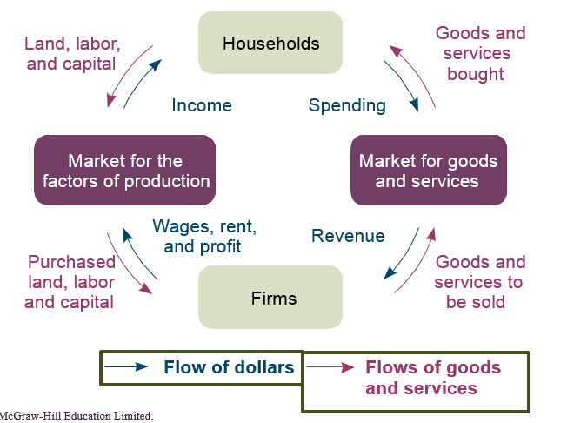

What are the TWO important types of actors in the economy?
- Households
- Supply land and labour to firms and invest capital in firms (land, labour, and capital are called factors of production)
- They buy goods and services from firms that produce
- Firms
- They buy or rent the land, labour, and capital supplied by households
- Produce and sell goods and services
What are the TWO markets that connect households and firms?
- Market for goods and services
- Households spend their wages from labour and their income from land and capital
- Firms earn revenue from selling their goods and services
- Market for the factors of production
- Households supply land, labour, capital
- Firms hire, purchase or rent these inputs
What are the TWO loops?
- Inputs
- Are land, labour, and capital firms use to produce goods
- Outputs
- The goods and services that firms produce using the factors of production
(Another LOOP incorporated into the inputs/outputs is the flow of dollars/money)
Understanding the Flow of Physical Items:
1. Households rent (supply) their land and capital and work for firms
2. Firms purchase (demand) these factors of production
3. Firms produce (supply) and sell goods/services
4. Households purchase (demand) goods/services
Other Way to Understand the Economy through the Flow of Money:
- Firms pay wages, rent, and profits for the use of factors
- Households receive income from firms
- Households spend income to purchase goods/services in the market for goods/services
- Firms receive money in the form of revenue
What is a Positive Statement?
- A statement that makes a factual claim about how the world actually works
- Ex. GDP fell by 0.05% during last quarter
- Ex. the TSX rose about 13000 in 2013
What is a Normative Statement?
- A statement that makes a claim about how the world should be
- Ex. given an inflation rate of 2% no one should be concerned with higher costs of living
Chapter 7: Measuring the Wealth of Nations
When constructing a measure of how much a nation can produce in a given year, what TWO hurdles must be overcome?
- How to add up unique goods and services into one measure of productivity
- Not double counting intermediate goods and services that go into final goods and services
- Unique goods and services: adding up apples, oranges, roller coaster rides and haircuts can be difficult unless each has a relative importance to other
- Not double counting intermediate goods: peanuts that enter into peanut butter – peanut butter that enters into school lunches
How to unpack the definition of GDP?
- Market value: used so there are common units to add up goods and services
- Final goods and services: only count expenditures on goods and services sold to the consumer
- Produced within a country: goods and services are counted towards GDP in terms of location of production
- If a Canadian company owns a factory in Mexico, the value of the goods produced in that factory will count towards Mexican GDP, not Canadian GDP
- Canadian citizens working in other countries contribute towards that country’s GDP, not the Canadian GDP
- Gross national product (GNP) can be used to measure the value of what is produced by Canadian-owned resources, regardless of location.
- Given period of time: usually refers to an annual estimate
What does Production = Expenditure = Income mean?
- It’s only if we lived in a closed economy where everything is produced and sold domestically and consumed as soon as it’s produced. However, the actual economy is a bit more complicated. The existence of international trade means the economy is not closed; items that are kept in inventory are not consumed as soon as they are produced \
What is the Size of the Economy referred to?
- Either output or production
What can Total Output be measured as?
- Total income
- Total expenditures – because every transaction has a buyer and seller
What is the Expenditure Approach?
- Breaks expenditures down into 4 categories:
- Consumption: spending on goods and services by private individuals and households
- Must be NEW items
- Something that is purchased used on eBay is not included in current GDP (as it was already counted when it was first produced and sold) – the transaction fee and the payment for delivery is included in GDP
- Ex. groceries, clothing, electronics, tutoring, plumbing, tuition
- Investment: spending on productive inputs, such as factories, machinery, and inventory changes
- Inventory: The stock of goods that a company produces now but doesn’t sell immediately, but in the future – their value is subtracted from inventory and added to consumption – DON’T increase GDP – Ex. Apple producing 100 new iPads but storing them in a warehouse until the product’s release date
- Must be NEW items
- A newly built house is investment, but renting a place to live is consumption (think of it as “consuming a place to live”)
- Ex. a farmer buying a new tractor a clothing factory buying a new machine for the assembly line
- Investments like stocks, bonds and mutual funds are NOT included in investment because (1) when you buy, the money is not given to the company but instead to another investor who has decided to sell (2) if they were included, simply buying and selling could increase GDP and therefore make it seem like the economy is growing even though the same number of shares are just trading hands
- Includes capital goods: machines and tools used for production of other goods or services
- Includes buildings and structures that provide goods and services
- Government Purchases: spending on goods and services by all levels of government
- Includes “consumption-type” purchases (ex. new bulbs for street lights), services (ex. paying for labour to fix city streets) and “investment type” purchases (ex. buying a truck for government workers to use to fix city streets)
- Transfers are NOT counted – they refer to spending that transfers resources between individuals (ex. Social Security or Canada Pension Plan)
- Net Exports: exports minus imports
- Represents the value of goods and services produced domestically and consumed abroad minus the value of goods and services produced abroad and consumed domestically
- If exports are higher than imports, NX will be positive
- If imports are higher than exports, NX will be negative
- Count all goods and services produced in Canada regardless if they are consumed in Canada or in another country
- If they are consumed in Canada, they will already be a part of consumption, investment or government purchases
- Items produced in Canada and consumed by other countries are exports and are included in GDP
- DON’T count goods produced in other countries that Canadian citizens consume (imports)
(Expenditure = C + I + G + NX = Production)
Examples According to the Expenditure Approach:
Situation | GDP Category | Why?
Buying a new digital camera | Consumption | Purchasing a new good or service always counts toward GDP.
Buying a used camera on a classified site | Not counted | As a used good, the camera does not count toward GDP, as it was already counted when new. The fees paid to eBay for selling the camera count as consumption, though.
Buying a new house | Investment | Since the house can increase or fall in value, it makes sense to think of it as an investment.
Renting an apartment | Consumption | You are paying the owner of the house for a service, so it is counted as consumption.
Blackberry making a new batch of phones but not selling them until next year | Investment | Counted as a part of investment, as Blackberry is holding these phones as a part of its inventory.
Buying shares of Bombardier stock | Not counted | Shares of stock are a transfer of money from one owner of the stock to another. Including stocks would cause a double-counting problem.
CATSA buying plastic bins for airport security | Government spending | Any consumption or investment purchases made by the government are counted in GDP as government spending.
Babysitting for your neighbour | Not counted | In principle, it should be included in GDP, but such income is often not reported to Revenue Canada and thus it can’t be included in official statistics.
More Examples of Expenditure Approach:
- Air Canada purchases an airplane built in the U.S – investment, import
- DELL Canada Inc. builds a new computer. At the end of the year, the computer is not sold and is placed in storage – investment, inventory
- The government pays a Canadian company for a new naval missile carrier – government expenditure
- Joe purchases Justin Bieber tickets in Toronto – consumption
- Sarah purchases a new Honda manufactured in Japan – consumption, import
- The government pays $100 million to war veterans – transfer, not counted
What is the Income Approach?
- Adds up the income earned by everyone (households and firms) in a country
- This includes wages earned by workers, interest earned on capital investments, rents, earned on land, and profits earned by firms
- Equation: Income = Wages + Interest + Rental Income + Profits
- Yields the same results as the expenditure approach in an economy without any imports or exports
- Everything produced domestically is added to GDP, regardless whether it’s purchased for consumption, investment, by the government or by foreigners (exports)
- Goods that are abroad but are consumed in Canada (imports) are subtracted from GDP because they represent expenditures leaving the country
- Foreign transactions are between foreign producers and foreign buyers and are not part of domestic GDP calculations
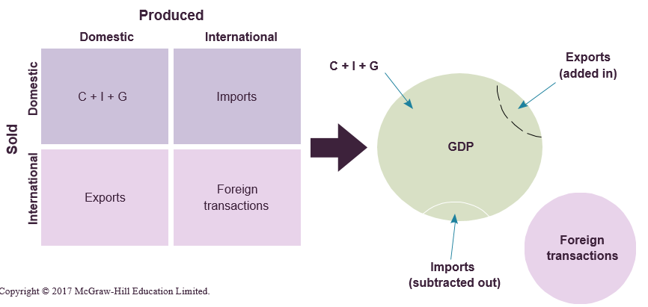

What is the Value-Added Approach?
- Calculates the value that each transaction adds to the economy
- This allows us to determine how much of the total amount paid was created at each step in the production process
- This approach is helpful in avoiding double-counting and calculating how the resale of existing goods contributes to GDP
- Sums up the value added at each stage of the production process
- Ex. Peanut Butter:
- Peanut farmer adds value combining seeds, land, and water to grow peanuts. The farmer sells the peanuts to a wholesaler who sells the peanuts to a factory. The factory sells peanut butter jars to a grocery store who sells the final product to the consumer.
- Subtract the amount paid at each stage from the amount paid in the previous stage this is the value added for each stage. Sum each of these up to determine the final value added. This will be the same amount as if the other methods were used.
Expenditure vs. Income vs. Value-Added:
Expenditure – Separates different types of expenditures (e.g., how much more do consumers contribute to GDP than the government?).
Income – Provides information about the relative importance of different factors of production.
Value-added – Identifies the value associated with each production stage.
What is Nominal GDP?
- Goods and services are valued at current prices
How to calculate Nominal GDP?
- Multiply the quantity of each good in a given year by its price in that year
What is Real GDP?
- Goods and services are valued at constant prices
How to calculate Real GDP?
- Select a base year to fix prices
- Multiply the quantity of each good in a given year by its base year price
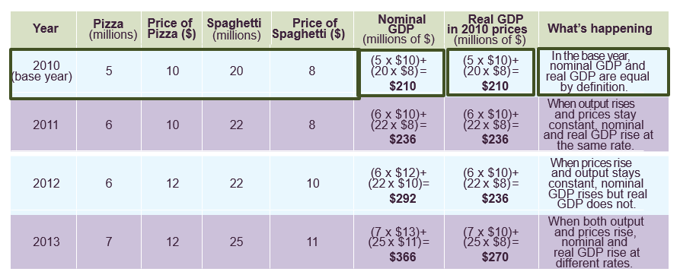

What is the GDP Deflator?
- Measure of the overall change in prices in an economy
- Provides the ratio between the base-year value of current output and the current-year value of current output
- Helps summarize how prices have changed over the entire economy
What is the formula of GDP Deflator?
- = Nominal GDP / Real GDP X 100
What is Inflation?
- How fast overall level of prices is changing
- Can be calculated by looking at the percentage change in the GDP deflator between any two years
What is the formula for Inflation?
- = [(deflator of year 1 – deflator of year 2)/ deflator of year 2] X 100
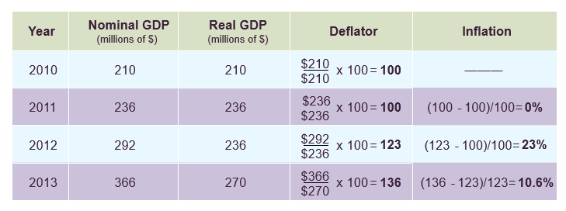

What is GDP Per Capita?
- GDP Per Capita = GDP/ Population
- Per Capita means per person
- Knowing the GDP per capita for different countries suggests a lot about differences in life and well-being between countries
- GDP Per Capita doesn’t provide information about the distribution of income or the cost of living within a country
What is the formula for GDP Growth Rates?
- = GDP (t) – GDP (t-1) / GDP (t-1) X 100
- t = current year
- t-1 = last year
- NOTE: high growth rates don’t necessarily mean high total GDP
What is Recession?
- Period of significant economic decline – negative GDP growth rate
What is Depression?
- A severe or extended recession
What is Green GDP?
- An alternative measure of GDP that subtracts the environmental costs of production from the positive outputs normally counted
In GDP calculations, what is left out in terms of important types of economic activity?
- Home production: Goods and services that are both produced and consumed within one household. For example, if you clean your own house, it’s not included in GDP (even though if you hired a cleaner it would be included). Similarly, making a meal at home is not included (even though going out to eat at a restaurant is).
- Underground economy: Goods and services that are sold outside of official records. This includes the transaction of things like drugs, restricted weapons, and endangered animals. (These transactions take place in what is called the black market). Also included in the underground economy are services like mowing your neighbor’s lawn or babysitting your nephew.
- Environmental externalities: The costs associated with pollution are not included in GDP. For example, electricity is part of GDP, but the resulting air pollution from electricity factories is not accounted for as a cost of this action. To incorporate the value of pollution, some calculate green GDP, where environmental costs of production are subtracted. This can greatly change GDP growth rates. For example, China has few regulations against pollution, and 2007 green GDP calculations that adjusted for the pollution caused by some Chinese province’s manufacturing plants resulted in GDP growth rates close to zero.
Chapter 8: The Cost of Living
What is the main idea of the Cost of Living?
- A large focus is prices, but more importantly how changes in prices impact how much we can buy
- Price change at different speeds across time and place
- Changing prices have effects on people’s incentives and choices
- Price levels determine the relative value of salaries, savings and borrowing, and the relative cost of living in a different city
- What a dollar can buy changes depending on time and location, even within the same country
What is the Market Basket?
- List of specific goods and services in fixed quantities
- To see how the cost of buying the goods and services on the list changes over time and location
- Are items typically purchased by individuals
- Keeping the quantities of each item constant ensures that changes only reflect price changes
Example of Market Basket: How much did the cost of groceries rise between years?
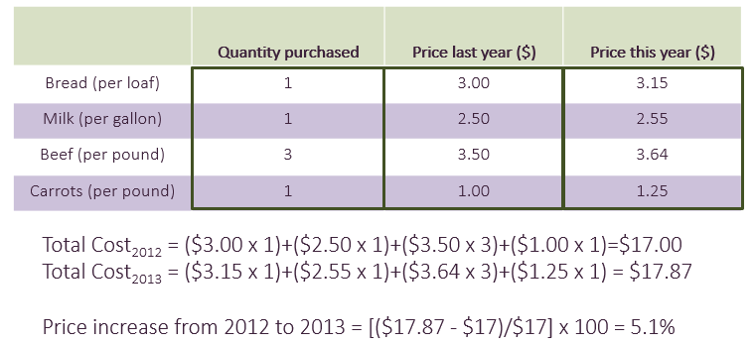

Step 1: Fix quantities in basket. Quantities are fixed for all food items across years
Step 2: Calculate total cost (equal to the sum of price x quantity for each good). Prices are identified for each item for every year
Step 3: Calculate the percentage change in total cost.
(NOTE: this assumes that you buy the same items in the same quantities. Many people don’t buy the exact same thing when prices change – the Law of Demand: when prices rise, quantity demanded usually falls. So, we might expect consumers to switch from carrots, to potatoes as the prices of carrots rises – we use this simplification to focus on the price change alone)
What is the formula for calculating a Percentage Change?
- [(x2-x1)/x1] x 100
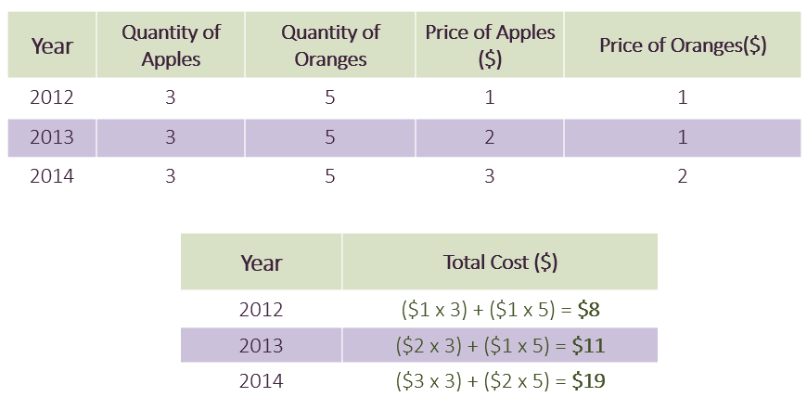
Example of Market Basket:

What is Price Index?
- A measure showing how much the cost of a market basket changed relative to the cost in a base time period or location
- Base year index = 100
What is the Consumer Price Index (CPI)?
- A measure that tracks changes in the cost of a basket of goods and services purchased by a typical Canadian household
- Measures the increase in the cost of the market basket relative to the cost in a given base year
- CPI mostly used for tracking changes in the cost of living in Canada and compares the cost of living today with the cost of living at some other point in time
- CPI is tracked by Stats Canada
How does Stats Canada measure CPI?
- Stats Can comes up with a basket of goods and services purchased by a typical household
- Every month it collects data on the prices of those goods and services in a variety of places around the country
- Stats Can calculates the cost of buying that market basket
(NOTE: CPI is an index number, not a %)
What is the formula for calculating CPI?
- = cost of desired – year basket in base – year prices / cost of base – year basket in base year prices x 100
- The index will be greater than 100 if the cost of the basket is greater than the base-year cost
- The index will be less than 100 if the cost of the basket is less than the base-year cost
- When the numerator increases (current cost of basket), the index increases
- When the numerator decreases, the index decreases
Example of CPI:
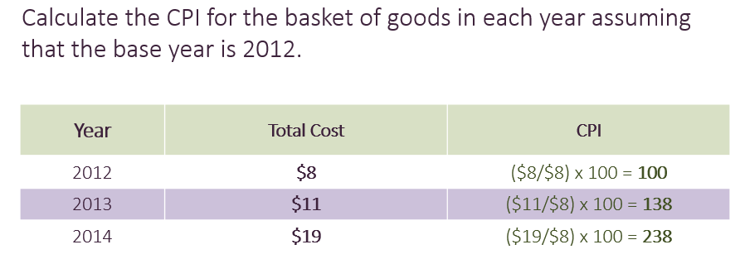

What are the TWO main challenges in measuring Price Changes?
- Which goods should be included in the market basket?
- A single number cannot be perfectly describe changes in the cost of living for everyone because you consume different amounts of different goods than your neighbour
Stats Can tries to come up with a basket that represents a “typical” household
- The CPI basket is based on the average goods and services purchased by “urban consumers”
- Anyone living in a city of 100000 or more
- This accounts for 69% of the Canadian population and includes people in all sorts of jobs (unemployed and retired people)
- Doesn’t include people living in rural areas, members of the military, or the institutionalized population (people living in prisons or mental hospitals)
- One family’s cost of living could be different than that computed by the CPI – depends on what they purchase
- The basket of goods remains fixed even if consumers substitute between similar goods
- If the relative price of goods changes, the quantities change as well
- As new goods and services become available (innovation), people will adjust what they consume
- Substitution: people switch between similar goods and services when relative prices shift
- Ex. if the price of carrots goes up by 25% while the prices of other vegetables increase by a smaller amount, people will tend to buy fewer carrots and more other vegetables
- Ex. if the price of going out to the movies goes up and the price of streaming video goes down, people will tend to watch more videos at home and fewer at the movie theatre
- Innovation: as new goods and services become available, people change what they consume
- The CPI keeps types and quantities of goods constant, which doesn’t account for consumption changes
What is the point of using Price Indexes?
- Transform nominal values into real values
- Isolate changes in prices from changes in other economic variables, like income and output
- Nominal means that the value of a good(s) is expressed in current dollars – this doesn’t account for changes in prices over time
What is Inflation Rate?
- The size of the change in the overall price level
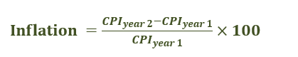
What is the formula for calculating Inflation Rate?

Example of the Inflation Rate:

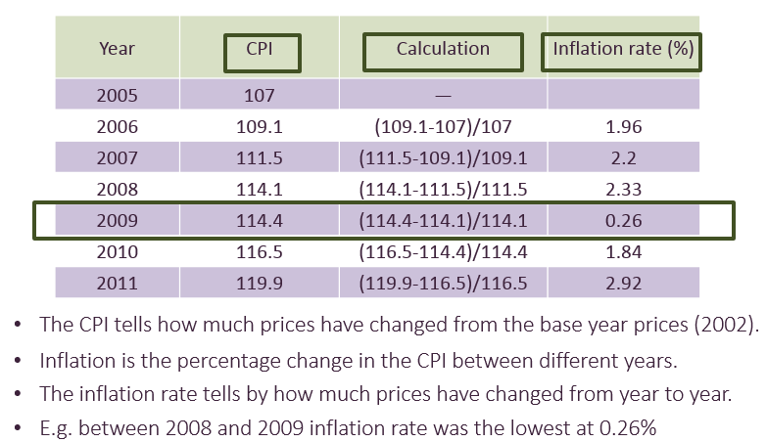

What are the ways to report Inflation?
- Headline Inflation: measures price changes for the entire market basket
- Core Inflation: measures price changes with food and energy costs removed
- Energy and food prices fluctuate often, which could over-or understate the real change in overall prices
- Producer Price Index (PPI) measures the prices of goods and services purchased by firms
- It is considered a good predictor of future consumer prices because it reflects the input prices of products that will eventually make it to the consumer
- GDP deflator measures the prices of goods and services produced in the country
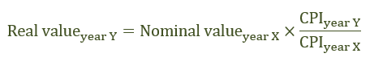
What is the formula for calculating the Deflation of Nominal Variables?

What is the point of deflating Nominal Variables?
- Compares purchasing power over time
Example of Deflating Nominal Variables:

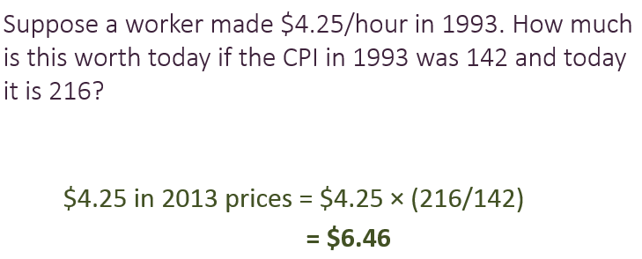
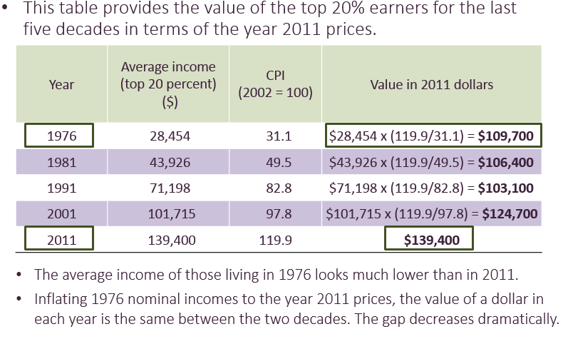
Example:

What is a fundamental theory in macroeconomics?
- States that wages should naturally rise to offset the effects of inflation
- However, there are times when some prices change faster than wages
What is Indexing?
- A practice of automatically increasing payments in proportion to the cost of living
- These payments are often referred to as “cost of living adjustments”
(NOTE: Wages should rise with enough time to offset inflation so that people’s wellbeing and choices are not affected. Indexed payments exist because we want the real value of a payment to stay constant over time)
Examples of Indexing:
- Social security (the government increases the level of benefits in accordance with the cost of living)
- Minimum wage increases
- Indexing is more common in other countries (e.g., countries in Europe)
What is Purchasing Power Parity (PPP)?
- Purchasing power in different countries should be the same when stated in a common currency
Why doesn’t PPP almost never hold?
- Because of 3 main factors:
- Transaction Costs
- It costs money to move goods from place to place (transportation costs)
- It costs time and money to find sellers in another country
- If the price differences are small but the costs associated with making the transaction are large, the trade-off might not be worth it
- Non-Tradeables
- Some goods and services just can’t be taken from place to place very easily, or at all (for example, apartments, fresh pizza, haircuts)
- Trade Restrictions
- International trade isn’t free (tariffs)
- Restrictions increase the cost or difficulty of making exchanges across national borders
- Restrictions discourage people from buying from other countries at lower prices
Example of Purchasing Power Indexes (Big Mac Index):
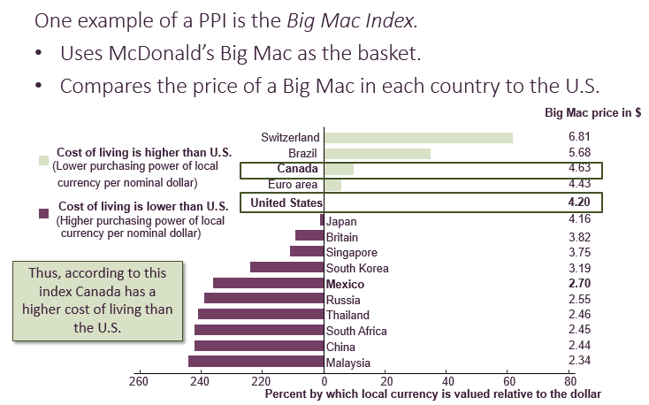

For the Big Mac index, the U.S. is the base country. The index compares the cost of a Big Mac between countries.
- In 2012 a Big Mac cost $4.20 in the U.S. but 37 pesos in Mexico. If PPP held, they should both have the same real price. The exchange ratio should be 8.81 pesos/dollar (37 pesos/dollar). But this index shows that, in reality, the exchange rate was 13.68 pesos per dollar.
- This gives us a negative exchange rate, which means that real purchasing power is higher in Mexico than in the U.S. That is, if you exchange your dollars for pesos, they will go farther in Mexico than in the U.S.
What is the PPP-Adjustment?
- Recalculates economic stats to account for differences in price levels across countries
What is the formula for calculating PPP-Adjustment?
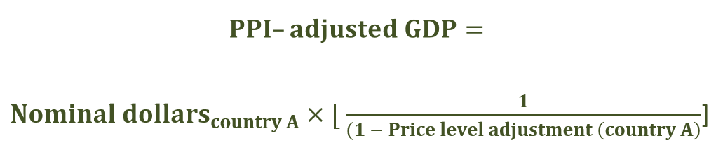

Example of PPI-Adjustment:
- The PPI-adjusted GDP for Mexico in 2011 is $10,064 × [1/(1- 0.344)] = $10,064 × 1.5244 = $15,341.56. That is, the cost of living in Mexico is 34.4 percent lower than the United States. Thus, $10,046 goes farther in Mexico than in the United States.
Example of PPI-Adjusted GDP:
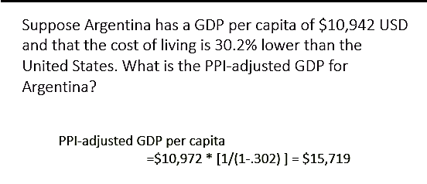

Chapter 9: Economic Growth
What is Rapid Economic Growth considered?
- A modern phenomenon
What do you combine to yield another factor?
- Combining real GDP with population data yields real GDP Per Capita
- Real GDP Per Capita describes the change in purchasing power for each person over time
What is the formula for calculating Real GDP Per Capita Growth Rate?
- Nominal GDP Growth Rate – Inflation Rate – Population Growth Rate
How does Economic Growth build?
- Economic growth builds on itself over time
- This process is similar to compounding interest in a savings account with earlier interest payments getting added to the account and earning interest in turn
What is the formula for calculating GDP Per Capita in any year?
- GDP of Year A = GDP of Year B x (1+ Growth Rate) ^ (Year A – Year B)
- GDP Per Capita gives the amount of time between the two years of interest
What is a simple shortcut to understand how many years it takes for GDP to double?
- The Rule of 70
- States the number of years it will take for income to double at the current real growth rate
What is the formula for calculating for the Rule of 70?
- Years until income doubles = 70 / Real GDP Growth Rate
What is Productivity?
- A measure of the output per worker and is what drives growth
- The only way to consume more and enjoy a higher standard of living is to increase the amount each person produces
- The standard of living in a country is driver by the average productivity of its workers
- Increases in productivity per person -> increases in per capita income = economic growth
What is the first component of productivity and what is it?
- Physical Capital
- The stock of equipment and structures that allows for production of goods and services
- New – Old Physical Capital = the net amount of physical capital that has been added to the economy
- Ex. Factories, machines, cell phone towers
What is the second component of productivity and what is it?
- Human Capital
- The set of skills, knowledge, experience, and talent that determines the productivity of workers
What is the third component of productivity and what is it?
- Technological Improvements
- Innovations that cause the same inputs to produce more outputs
- Ex. Agricultural breakthroughs (higher-yielding seed varieties), invention of the internet, more efficient water pumps, and car engines with a higher MPG
What is the fourth component of productivity and what is it?
- Natural resources
- Production inputs that come from the earth
- Two Categories:
- Renewable: Can be replenished over time (ex. Trees, rivers, electricity)
- Nonrenewable: Cannot be replenished over time (ex. Coal, oil, gold)
What is the analogy for thinking about the differences between wealthy countries and fast-growing countries?
Imagine you are driving a car and merging onto the highway. You start at 50 kmph and are at 60 kmph seconds later
- Your level of speed is low, but your rate of change is high
Once you are on the highway, you cruise at a speed of 70 kmph
- Your level of speed is high, but your rate of change is zero
Example of Rates vs. Levels:
For example, China has low levels of physical and human capital, productivity, and standard of living, along with little access to the latest technologies, but the rate of growth is very high (accelerating). Switzerland, on the other hand, has high levels of physical and human capital, productivity, and standards of living, along with access to sophisticated technology, but has low growth rates (cruising).
What is the Convergence Theory (Catch-Up Effect)?
- States that countries that start out poor will grow faster than rich ones eventually converge to the same growth rate as the rich ones
- Relates to the idea of decreasing marginal returns to the factors of production
- Countries with little initial physical and human capital will get a higher return from adding a unit of capital than countries that start with a higher level
- Countries will eventually converge to the same growth rate BUT doesn’t mean that they will converge to the same level of income
- NOTE: THIS THEORY DOESN’T ALWAYS WORK
What do public policy responses aim to do?
- Aim to spark and sustain growth
- There is no one-size fits all policy
What is Investment Trade-Off?
- A reduction in current consumption to pay for investment in capital intended to increase future production
What is Domestic Savings?
- Savings for capital investment that come from within a country
What TWO sources Domestic Savings come from?
- Households spending less than they earn
- Government revenues exceeding non-capital expenditures
NOTE: domestic savings = domestic income – consumption spending
NOTE: there is an opportunity cost involved with an investment trade-off
What is Foreign Direct Investment (FDI)?
- When a firm runs part of its operation abroad or invests in another company abroad
- Ex. Toyota (a Japanese firm) operating a plant in Cambridge Ontario. Toyota owns the machinery and buildings at that plant, even though the production happens within Canada.
What are the Benefits of FDI?
- Governments actively work to attract FDI when domestic savings aren’t large enough
- Can result in human capital transfer from foreign firms to local workers
What are the Costs of FDI?
- Firms might demand special tax breaks or legal exemptions
- Human capital and technology transfer is not guaranteed
What is Education?
- The way a country can increase its human capital is by ensuring that high-quality public education is freely available to all children
What is Health?
- Workers who are in good health will be more productive and less likely to miss days of work
- Reducing vitamin and mineral deficiencies can improve mental and physical energy
What is Technological Development?
- Helps countries improve the productivity of existing inputs
What is critical to a well-functioning economy?
- Enforceable laws and effective, trustworthy government services
What do most countries have mechanisms to?
- Punish those who violate other’s property rights
- Enforce contracts between buyers and sellers
- Settle disputes
Why is Stability in Leadership important?
- Because firms are more likely to invest in an area when there isn’t a high risk of new leaders coming in and seizing it, or areas where tax policies or laws don’t change frequently and unpredictably
What is the Juggling Act?
- There are trade-offs between different ways of promoting growth through public policy
- Many governments cannot pay for all of the factors that promote growth at once
- The poorer the country, the harder the trade-off
- This “poverty trap” is one of the main justifications for foreign aid that provides loans or funding for investment and development : the richer you are, the more able you are to pay for things that will help you be even richer in the future : the poorer you are, the less able you are to pay for things that can make you better
- There are trade-offs associated with economic growth and natural resource sacrifices
Chapter 10: Unemployment and the Demand for Labour
What is Unemployment?
- A situation where someone wants to work but cannot find a job in the current market
- People who do not have jobs and are not interested in obtaining one are NOT counted as unemployed
How does Statistics Canada define unemployment as people who?
- Didn’t work at all in the previous week
- Were available to work if they had been offered a job
- Were making efforts to look for a job
What is the Labour Force?
- The people who are in the working-age population and are either employed or unemployed
- People who are currently working or who would like to work and are actively trying to find a job
- The working-age population is the civilian, non-institutional population over 15 years of age
- All adults expect for armed forces (soldiers) or inmates in an institution (prison or mental-health facility)
What is Unemployment Rate?
- = Number of Employed People / Number of People in the LF x 100
- Labour Force = Number of Employed + Unemployed
What is the formula for calculating the Labour-Force Participation Rate (LFPR)?
- = Labour Force / Working-Age Population x 100
What does the Labour-Force Participation Rate indicate?
- What fraction of the population wants to be working, regardless of whether or not they actually have a job
- It is common for the LFPR to fall during a recession (decline) because people choose to go back to school, or take early retirement or become homemakers
What is Discouraged Workers?
- People who have looked for work in the past year, but have given up because of labour market conditions
What is Underemployed Workers?
- People who are either working less than they would like or in jobs below their skill level
Where do the data come from?
- The main source of information on unemployment in Canada is a household survey, conducted by Stats Can, called the Labour Force Survey (LFS)
- Surveys approx. 60,000 households per month
- Surveys ask people if they are working and how much they are earning, etc.
- Seasonally adjusted to help expected seasonal patterns
What is the function of labour?
- Labour is bought and sold in a market, just like other goods and services
- There is a demand for labour (from firms wanting to hire workers)
- There is a supply of labour (from individuals looking for jobs)
- There is a price (called the wage)
- The price should adjust until the market reaches equilibrium where quantity supplied and demanded are equal
- The existence of unemployment suggests that the model of supply and demand doesn’t fully explain the labour market
What is the Labour Demand Curve?
- The relationship between the total quantity of labour demanded by all firms in the economy and the wage rate
- Firms will want to hire more labour when wages are lower and less labour when wages are higher
What is the Labour Supply Curve?
- The relationship between the total labour supplied in the economy and wage rate
- People will be willing to supply more labour at higher wage rates, and less labour at lower wage rates
What are the TWO Categories of Unemployment?
- Natural Rate of Unemployment:
- The normal level of unemployment that persists in an economy in the long run
- What are THREE Contributors to the Natural Rate of Unemployment?
- Frictional Unemployment
- Caused by workers who are changing location, job or career
- Structural Unemployment
- Caused by a mismatch between the skills workers can offer and the skills in demand
- Real-wage or Classical Unemployment
- Results from wages being higher than the market-clearing level
- Cyclical Unemployment:
- Caused by short-term economic fluctuations
- Economists use the term business cycles to describe the pattern of short-term ups and downs
- Wages are “sticky” in the real world: they are slow to respond to shifts in the economy which results in actual wages that are above the market-clearing level
What are the Factors that May Stop Wage Rates from Falling?
- The government might prevent it, through Minimum-Wage Legislation
- Minimum Wage: the lowest wage that a firm is legally allowed to pay workers
- Labour Unions who bargain with their employer(s) over salaries and work conditions
- Efficiency Wages above the market rate to increase productivity and less likely to quit
What is Unemployment Insurance?
- Money paid by the government to people who are unemployed
- Can affect how quickly people find jobs, which will affect the natural rate of unemployment
Why is the effect of unemployment insurance ambiguous?
- People might not look as hard for work if the payment is generous
- If people don’t have to rush into taking the first job they’re offered, they are more likely to find the right job for them
What are other factors that influence unemployment?
- Taxes on wage income (lower taxes would reduce unemployment)
- People have a higher incentive to find a job, knowing they will keep more of the income they earn from the job
- The degree of difficulty for firing employees can also affect unemployment
- Employers may be reluctant to hire people if they know that it will be difficult to get rid of them

