Lecture 1: Tuesday, January 9, 2018

Digestive System

Main Functions of Digestive System
- Take in food
- Break food down into nutrient molecules
- Absorb molecules into bloodstream
- Rid body of any indigestible remains
- Nutrient production → synthesis of vitamins by bacteria that lives in the intestine
- Production of neurotransmitters, hormones + hormone-like compounds (hormones: gastrin, ghrelin, cholecystokinin, secretion, VIP, motilin, gastric inhibitory peptide. Neurotransmitters: acetylcholine, serotonin, histamine, nitric oxide

2 groups of organs…
- Alimentary Canal: aka GI tract or gut, is the continuous muscular tube from mouth to anus = mouth, pharynx, esophagus, stomach, small intestine, large intestine, anus. Digests food + absorbs digested fragments into blood
- Accessory Digestive Organs: teeth, tongue, gallbladder, glands = salivary glands, liver, pancreas (produce secretions that help break down food). Gallbladder + glands connect to alimentary canal via ducts

Digestive Process
- Ingestion → taking food into digestive tract
- Mechanical Breakdown → increases surface area for digestion by enzymes. Chewing, mixing, churning, segmentation
Segmentation: moves food backward + forward at same time, non-adjacent segments of alimentary canal organs contract/relax. Some propulsion may occur
- Propulsion → moves food through canal (swallowing, peristalsis)
Peristalsis: major means of propulsion, alternating waves of contraction/relaxation of muscles in organ walls; squeezes food along tract
- Digestion → Catabolism: enzymatic breakdown of food into molecules to be absorbed
- Absorption → passage of digested end products + vitamins, minerals, water from lumen of GI through mucosal cells by active or passive transport into blood/lymph
- Defecation → eliminates indigestible substances from body via anus as feces

*most digestive system organs reside in the abdominopelvic cavity

Peritoneum: serous membrane (slippery) of the abdominopelvic cavity
- Visceral Peritoneum: covers external surfaces of most digestive organs
- Parietal Peritoneum: lines body wall/cavity
- Peritoneal Cavity: space between peritoneums containing fluid secreted by them → lubricates mobile organs 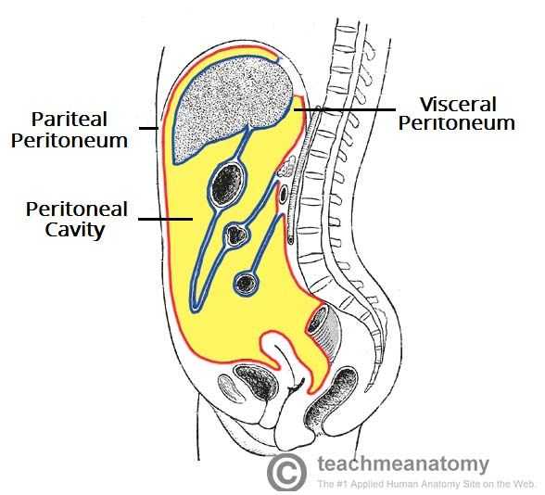

Mesentery: a double layer of peritoneum, 2 serous membranes fused together, extends to digestive organs from body wall. Provides route for blood vessels, lymphatics + nerves, holds organs in place, stores fat

Intraperitoneal Organs → within peritoneum

Retroperitoneal Organs → located outside/posterior to peritoneum (most of pancreas, duodenum, parts of large intestine)
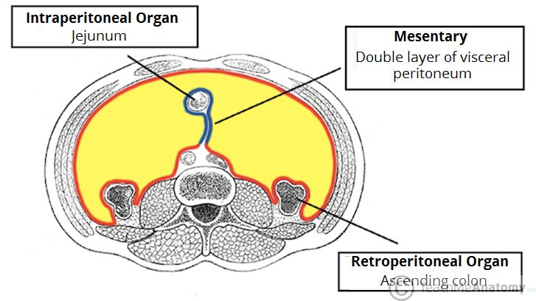
Peritonitis: inflammation of peritoneum (itis = inflammation). Can be caused by abdominal wound, perforating ulcer or ruptured appendix → sprays bacteria all over peritoneum. Peritoneal coverings stick together, helps localize infection b/c can be lethal if widespread
- Treatment: debri removal + megadose of antibiotics

Alimentary Canal 4 tissue types
- Mucosa: innermost layer, lines lumen. Secretes mucus, digestive enzymes, hormones. Absorbs end products of digestion into blood, protects against infection 3 sublayers:
- Lining Epithelium: simple columnar → has mucus secreting cells to protect against digestive enzymes, except mouth, esophagus + anus is stratified squamous for more protection)
- Deep to that is a Lamina Propria: loose areolar connective tissue, capillaries nourish epithelium + absorb digested nutrients, has bits of MALT/lymphoid follicles
- Deep to that is a Muscularis Mucosae: layer of smooth muscle cells, produces local movement of mucosa that enhance absorption/secretion
- Submucosa: external to mucosa, areolar connective tissue, rich supply of blood/lymphatic vessels, lymphoid follicles, nerve fibers → supply surrounding tissues. Abundant elastic fibers (allow organs like stomach to regain shape after stretching after large meal)
- Muscularis Externa: surrounds submucosa, responsible for segmentation/peristalsis, has inner circular layer + outer longitudinal layer of smooth muscle cells. Circular layer thickens at sphincters (controls food passage, prevent backflow)
- Serosa: outermost layer, aka visceral peritoneum, areolar connective tissue covered with mesothelium (single layer of squamous epithelial cells)
*in esophagus, serosa is replaced w/ adventitia (dense connective tissue, binds it to surrounding structures
*retroperitoneal organs have both an adventitia + a serosa
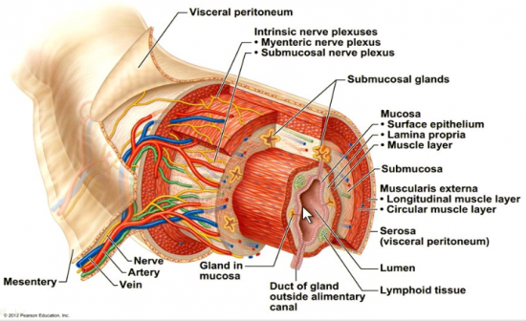

Splanchnic Circulation: includes arteries that branch off abdominal aorta to serve digestive organs + hepatic portal circulation
- Arterial Supply = branches of celiac trunk → serve spleen, liver, stomach + inferior/superior mesenteric arteries → serve small/large intestines. Normally receive ¼ of cardiac output (increases after meal, decreases during exercise)
- Hepatic Portal Circulation = collects nutrient rich venous blood draining from digestive viscera + delivers it to liver via portal vein (giant metabolic factory, stores things for later use), then to inferior vena cava

Lecture 2: Friday January 12, 2018

Enteric Nervous System: nerve supply of alimentary canal, staffed by enteric neurons that communicate w/ one another to regulate digestive system activity. Major nerve supply to GI tract wall that controls motility

Enteric neurons = bulk of 2 major intrinsic nerve plexuses found in walls of alimentary canal…
- Submucosal Nerve Plexus: occupies submucosa. Contains sensory + motor neurons, regulates glands + smooth muscle in mucosa
- Myenteric Nerve Plexus: lies between circular/longitudinal muscle layers of muscularis externa, provides major nerve supply to GI, controls GI tract motility (pacemaker cells + local reflex arcs between enteric neurons)

Enteric NS participates in short + long reflex arcs…
- Short Reflexes: mediated entirely by enteric NS plexuses in response to stimuli within GI tract. Patterns of segmentation/peristalsis = automatic, involving pacemaker cells + reflex arcs between enteric neurons
- Long Reflexes: involve CNS integration centers + extrinsic autonomic nerves. Enteric NS sends info to CNS via afferent visceral fibers. Receives sympathetic/parasympathetic motor fibers of ANS that enter intestinal wall to synapse w/ neurons in intrinsic plexuses
*parasympathetic inputs enhance digestive activity → stimulates secretion + motility

3 concepts govern digestive activity regulation…
- Digestive activity = provoked by range of mechanical/chemical stimuli
- Mechano/chemo -receptors located in walls of tract organs respond to several stimuli
- Stretching of organ by food in lumen, changes in osmolarity, pH of contents, presence of substrates/end products of digestion
- Effectors of digestive activity are smooth muscles + glands
- Receptors in GI tract initiate reflexes that stimulate smooth muscle of GI tract walls to mix lumen content + move them along tract
- Reflexes can activate/inhibit glands that secrete digestive juices into lumen or hormones into blood
- Neurons (intrinsic/extrinsic) + hormones control digestive activity
- Intrinsic controls = short reflexes (enteric NS), extrinsic controls = long reflexes (autonomic NS)
- Stomach + small intestine contain hormone-producing cells
- When stimulated, cells release products to interstitial fluid in extracellular space
- Blood + interstitial fluid distribute hormones to target cells

Mouth
- Oral cavity/buccal cavity
- Bounded by lips, cheeks, palate + tongue
- Oral Orifice: anterior opening
- Walls = stratified squamous epithelium → withstands friction
- Epithelium on gums, hard palate + dorsum of tongue = slightly keratinized

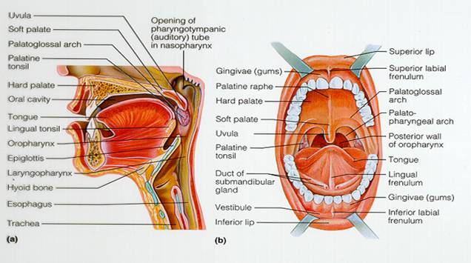
Lips + Cheeks
- Help keep food between teeth when we chew
- Skeletal muscle covered by skin
- Lips = fleshy orbicularis oris muscle
- Cheeks = buccinator muscles
- Oral Vestibule: recess internal to lips/cheeks, external to teeth/gums
- Oral Cavity Proper: within teeth/gums
- Labial Frenulum: median attachment of each lip to gum

Palate
- Roof of mouth
- Hard Palate: underlain by palatine bones + palatine processes of maxillae, forms rigid surface against which tongue forces food, slightly corrugated (helps create friction)
- Soft Palate: mobile fold, mostly skeletal muscles, rises reflexively to close off nasopharynx when we swallow (uvula projects downward from it)

Tongue
- Occupies floor of mouth, bundles of skeletal muscle fibers
- Grips food during chewing, constantly repositions it between teeth
- Mixes food w/ saliva, forming bolus
- Initiates swallowing by pushing bolus into pharynx
- Also initiates speech + taste
- Body: anterior ⅔ of tongue residing in oral cavity
- Root: posterior ⅓ of tongue residing in oropharynx
- Terminal Sulcus: marks division between body + root
- Intrinsic Muscles: confined in tongue, not attached to bone, their muscle fibers allow tongue to change shape, becoming thicker/thinner loner/short for speech/swallowing
- Extrinsic Muscles: extend to tongue from points of origin on bones, alter tongues position → protrude/retract it + move it side to side
- Lingual Frenulum: secures tongue to floor of mouth, limits its movements

Ankyloglossia: congenital condition, children are born w/ an extremely short lingual frenulum, results in “tongue-tying” due to restricted tongue movement

Papillae (peg-like projections covered w/ epithelium) of Superior Tongue Surface
- Filiform Papillae = whitish, give tongue roughness/provide friction
- Foliate Papillae = on lateral aspects of posterior tongue, contain taste receptors
- Fungiform Papillae = reddish, scattered over tongue, contain taste receptors
- Circumvallate Papillae = v-shaped row in back of tongue, contain taste receptors

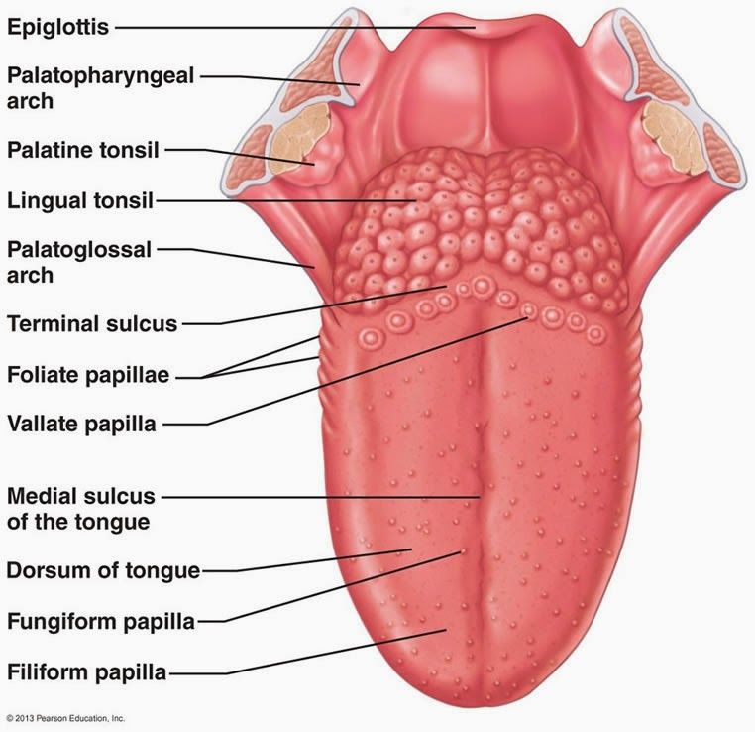

Saliva
- Cleanses mouth + helps clean teeth
- Dissolves food chemicals so they can be tasted
- Moistens food, helps compact it into a bolus
- Contains amylase/lipase → begins breakdown of fat + carbohydrates
- Protects from bacteria

Saliva Composition: largely water - 97-99.5%, slightly acidic (pH 6.75-7.00), solutes = electrolytes (Na, K, Cl, PO4, HCO3), amylase/lipase, proteins (mucin, lysozyme, IgA), metabolic wastes
- Mucin: forms thick mucus, lubricates oral cavity + hydrates foodstuffs
- Saliva protects against microorganisms b/c t contains IgA antibodies + lysozyme (bactericidal enzyme that inhibits bacterial growth) + defensins (local antibiotic)
- Friendly bacteria on back of tongue promote conversion of food-derived nitrates in saliva to nitric oxide in an acidic environment (transformation occurs around gums where acid-producing bacteria cluster) → NO is bactericidal
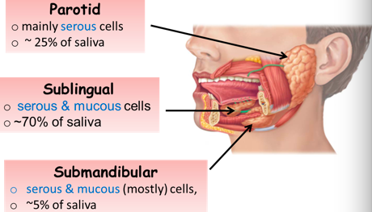
Serous Cells: secretory cells, produce watery secretion, enzymes, ions, bit of mucin
Mucous Cells: secretory cells, produce mucus

Extrinsic/Major Salivary Glands: produce most saliva outside oral cavity, secretion released into ducts that empty into oral cavity → (see photo)

Intrinsic/Minor Salivary Glands: scattered in oral mucosa

Mumps: inflammation of parotid gland caused by mumps virus, spreads in saliva, causes pain when opening mouth/chewing, moderate fever, pain when swallowing acidic foods

Control of Salivation
- Minor salivary glands secrete saliva continuously to keep mouth moist
- Major glands activated when food enters mouth → larger amounts of saliva
- Average 1500mL/day
- Food = ingested → chemo/mechano-receptors in mouth signal salivatory nuclei in brain stem (stimulates parasympathetic impulses along fibers in cranial nerves VII + IX to glands)
- Chemoreceptors = strongly activated by acidic substances
- Mechanoreceptors = strongly activated by mechanical stimuli (chewing)
- Other stimuli that increases salivation = sight/smell of food, irritation of lower GI tract by bacterial toxins, spicy foods, hyperacidity

Xerostomia: strong activation of sympathetic division constricts blood vessels serving salivary glands, inhibits salivation = dry mouth

Halitosis: bad breath, usually due to bad hygiene. Decomposing food particles accumulate + bacteria flourish

Teeth
- Lie in sockets in gum-covered margins of mandible (lower jaw) + maxilla (upper jaw)
- Mastication: process of chewing, tears/grinds food into smaller fragments
- Crown: enamel-covered, exposed part of tooth above gingiva/gum
- Root: portion of tooth embedded in jaw-bone
- Neck: connects crown + root

Tooth Shapes
- Incisors: chisel-shaped (pointy edge) for cutting off pieces of food
- Canines: fang-like, tear/pierce
- Premolars: bicuspids, broad crowns + rounded cusps, grind/crush
- Molars: broad crowns, 4-5 cusps, best grinders

Digestive Processes of Mouth
- Mouth ingests, begins mechanical breakdown by chewing, initiates propulsion by swallowing + starts digestion of polysaccharides + lipids
- Mastication: chewing, production of bolus. Mechanical = closed lips + cheeks keep food in cavity, teeth break down, tongue does mixing w/ saliva. Chemical = breakdown of carbs by salivary amylase, breakdown of fats by lingual lipase

Pharynx
- Food passes posteriorly from mouth into oropharynx then into laryngopharynx
- Mucosa = friction-resistant stratified squamous epithelium + mucus-producing glands
- External muscle layer consist of 2 skeletal muscle layers
- Inner layer cells run longitudinally, outer layer (called pharyngeal constrictor muscles) encircle wall of pharynx → contractions propel food into esophagus below

Esophagus
- Flat, muscular tube, about 25cm, lives behind trachea
- Runs from laryngopharynx to stomach
- Collapsed when not involved in food propulsion
- Foods routed toward esophagus b/c epiglottis closes off larynx
- Esophageal Hiatus: where esophagus pierces diaphragm
- Cardial Orifice: where esophagus joins stomach, surrounded by gastroesophageal/lower esophageal sphincter (thickening of circular smooth muscle)
- Sphincter prevents reflux of stomach acid into esophagus, but mucus cells on both sides of sphincter help protect esophagus when it does occur

Heartburn: first symptom of gastroesophageal reflux disease, burning when stomach acid regurgitates into esophagus. Most likely occurs when person has drunk/eaten to excess, + in conditions that force abdominal contents superiorly (pregnancy, obesity, running)

Hiatal Hernia: structural abnormality, relaxation/weakening of gastroesophageal sphincter. Superior part of stomach protrudes slightly above diaphragm, causes heartburn. Prolonged/frequent episodes may result in esophagitis (inflammation of esophagus), esophageal ulcers + esophageal cancer
Esophageal Features
- Has all 4 alimentary canal layers
- Mucosa contains non-keratinized stratified squamous epithelium, changes to simple columnar at esophagus-stomach junction
- Submucosa contains mucus-secreting esophageal glands → bolus compresses glands as it moves through esophagus, causes them to secrete, “greases” walls + aids in food passage
- Muscularis externa = skeletal muscle in upper third, skeletal/smooth muscle in middle third, smooth muscle in lower third
- Esophagus has fibrous adventitia instead of serosa, composed entirely of CT that blends with surrounding structures
*skeletal muscle we have control over, smooth muscle we do not

Swallowing
- Pharynx + esophagus = conduits to pass food from mouth to stomach, single digestive purpose is propulsion + deglutition (swallowing)
- Buccal Phase: occurs in mouth, is voluntary
- Upper esophageal sphincter is closed
- Tongue contracts, presses against hard palate, forces food into oropharynx
- Ends when food bolus leaves mouth + stimulates tactile receptors in posterior pharynx, initiating next phase
- Pharyngeal-Esophageal Phase Begins: involuntary, controlled by swallowing center in brain stem (medulla + lower pons)
- Cranial nerves, mainly vagus, transmit motor impulses from swallowing center to muscles of pharynx/esophagus
- Food enters pharynx, respiration is inhibited + all routes are blocked off (tongue blocks mouth, soft palate + uvula rise closing nasopharynx, larynx rises so epiglottis blocks trachea)
- Food passes from from oropharynx to esophagus as upper esophageal sphincter relaxes
- Pharyngeal-Esophageal Phase Continues: constrictor muscles of pharynx contract, forcing food into esophagus, upper esophageal sphincter contracts after food enters

Stomach Gross Anatomy
- Temporary storage tank, begins chemical breakdown of protein
- Bolus is converted to paste-like chyme (bolus + gastric juices)
- Empty stomach has volume of 50mL, when distended = 4L
- Rugae: mucosa folds formed when empty stomach collapses inward
- Cardial Part: surrounds cardial orifice
- Fundus: dome-shaped part beneath diaphragm
- Body: midportion
- Pyloric Part: funnel-shaped, more superior/wider area = antrum, narrows to pyloric canal, terminates at pylorus
- Pylorus is continuous w/ duodenum through pyloric sphincter/valve (controls stomach emptying)
- Greater Curvature: convex lateral surface
- Lesser Curvature: concave medial surface
- 2 mesenteries called omenta extend from curvatures to help tether stomach to other digestive organs
- Lesser Omentum: from lesser curvature to liver
- Greater Omentum: drapes inferiorly from greater curvature to cover coils of small intestine, runs dorsally/superiorly to wrap spleen + transverse portion of large intestine before blending with mesocolon (mesentery that secures large intestine to abdominal wall)
- Greater omentum contains fat deposits + lymph nodes
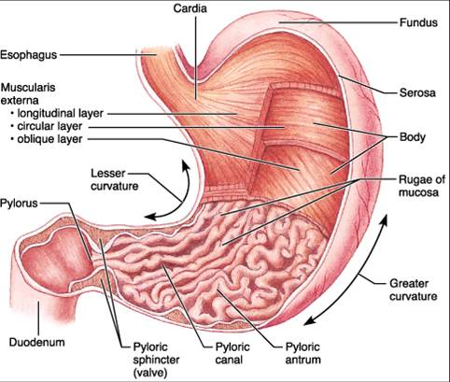

Stomach Supply
- Served by ANS
- Sympathetic fibers from thoracic splanchnic nerves are relayed through the celiac plexus
- Parasympathetic fibers are supplied by vagus nerve
- Arterial supply is provided by branches of celiac trunk
- Veins are part of hepatic portal system, ultimately drain into hepatic portal vein

Microscopic Anatomy of Stomach
- Contains 4 alimentary tunics
- Muscularis externa has innermost layer of smooth muscle fibrils that run obliquely → allows stomach to pummel food (break it down into smaller fragments + ram it into small intestine)
- Epithelium = simple columnar epithelium composed entirely of mucus cells → produce 2-layer coat of alkaline mucus, surface layer traps layer of bicarbonate-rich fluid beneath it
- Mucosa is dotted w/ millions of deep gastric pits that lead into tubular gastric glands that produce gastric juice
- Walls of gastric pits are formed by mucus cells

Types of Secretory Cells In Gastric Glands
- Mucous Neck Cells: produce thin, soluble, acidic mucus, function unknown
- Parietal Cells: secrete hydrochloric acid (HCL) + intrinsic factor
- HCL makes stomach very acidic, necessary for optimal activity of protein-digesting enzyme pepsin (acidity denatures proteins + breaks down cell wall of plant foods, harsh enough to kill bacteria)
- Intrinsic factor = glycoprotein required for vitamin b12 absorption in small intestine
- Chief Cells: produce pepsinogen (inactive form of pepsin) that is activated by HCL, also secrete lipases that digest ~15% of lipids
- One pepsin is present, it catalyzes its own conversion of pepsinogen to pepsin
- Enteroendocrine Cells: release variety of chemical messengers, some act locally as paracrines, some act as paracrines + hormones that diffuses into capillaries to influence several digestive system organs
- Gastrin: regulates HCL secretion, stomach motility, opening of pyloric sphincter
- Ghrelin: stimulates appetite, gastric motility + opening
- Paracrines = histamine (activates HCL secretion) + serotonin (causes contraction of stomach muscle)

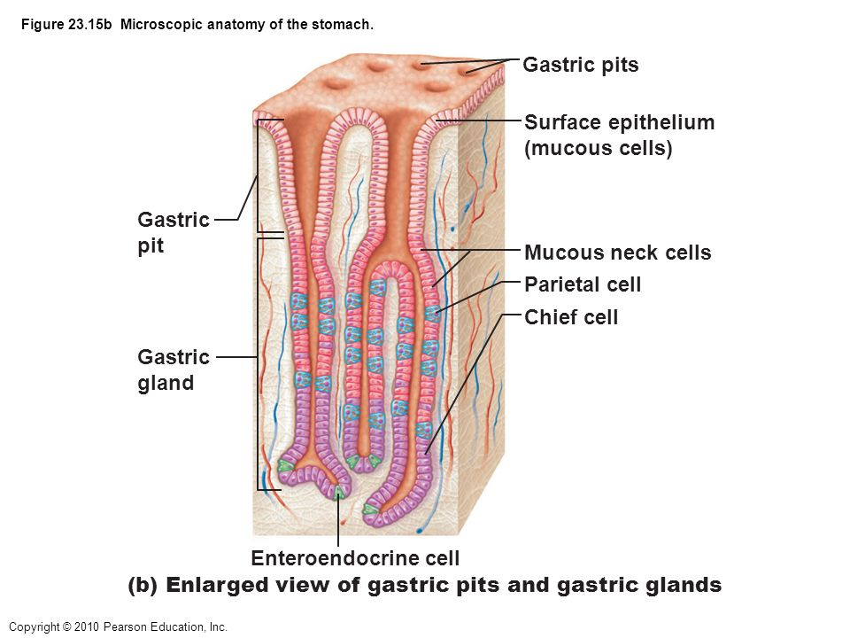

Mucosal Barrier
- Stomach mucosa is exposed to harsh conditions (gastric juice = acidic, protein-digesting enzymes can digest stomach) needs protection
- 3 factors create barrier
- Thick coating of bicarbonate-rich mucus builds up on stomach wall
- Epithelial cells of mucosa are joined by tight junctions, prevents gastric juices from leaking into underlying tissue layers
- Damaged epithelial mucosal cells are shed/replaced quickly by undifferentiated stem cells that reside where gastric pits join gastric glands. Entire surface epithelium of stomach is renewed every 3-6 days

Gastritis: anything that breaches mucosal barrier causes inflammation of stomach wall, persistent damage to underlying tissue can promote peptic ulcers, specifically gastric ulcers when they are erosions of stomach wall
- Danger = perforation of stomach wall, leading to peritonitis + possible massive hemorrhage
- Can be caused by aspirin, non-steroidal anti-inflammatory drugs (ibuprofen)
- 90% of ulcers caused by acid-resistant, corkscrew-shaped pylori bacteria → burrow through mucus + destroy protective mucosal layer

Digestive Processes in Stomach
- Holding area for ingested food
- Further degrades food chemically/physically, delivers chyme to small intestine
- Protein digestion occurs in stomach (main enzymatic breakdown that occurs there)
- HCL denatures proteins to prepare for enzymatic digestion
- Rennin: stomach glands secrete this milk-protein enzyme in infants, converts it to curdy substance
- Alcohol + aspirin are some of few things absorbed in stomach that easily pass from mucosa into blood
- Intrinsic factor = required for intestinal absorption of b12, needed to produce mature erythrocytes (pernicious anemia occurs in its absence, can be fixed w/ b12 injection)

Regulation of Gastric Secretion
- Gastric mucosa secretes up to 3L of gastric juice daily
- Neural controls = long vagus nerve-mediated + short local enteric reflexes
- In each reflex, ACh is released, stimulates output of gastric juice
- When stimulated by vagus nerves, activity of glands increases. Opposite for sympathetic stimulation
- Hormonal control = gastrin, stimulates secretion of HCl + enzymes by stomach + hormones of small intestine (usually gastrin antagonists)
- Control of HCl-secreting parietal cells = stimulated by ACh, gastrin + histamine (when one binds to parietal cell receptors, secretion is scanty, but binding of all 3 makes HCl pour out)

3 Phases of Gastric Secretion
- Cephalic Reflex Phase
- Occurs before food enters stomach → triggered by aroma/taste/sight/thought
- Triggers act via vagus nerve to stimulate gastric glands, gets stomach ready

- Gastric Phase
- Lasts 3-4 hours once food reaches stomach, provides ⅔ of gastric juice released
Stimulation:
- Stomach distension activates stretch receptors, initiates short/long reflexes
- Chemical stimuli by partially digested proteins, caffeine + rising pH activate gastrin-secreting enteroendocrine cells called G cells
- Gastrin stimulates release of enzymes, mainly HCl from parietal cells
- Gastrin acts directly on parietal receptors + stimulates enteroendocrine cells to release histamine, both result in HCl release
- When protein is in stomach, pH rises b/c proteins act as buffers that tie up H+ → rise in pH (becomes basic) stimulates gastrin secretion, HCl release = acidic conditions needed for protein digestion
Inhibition:
- Highly acidic gastric contents inhibit gastric secretion (commonly occurs between meals)
- Stress inhibits gastric secretion b/c sympathetic overrides

- Intestinal Phase
Stimulation:
- Set into motion as partially digested food fills duodenum
- Stimulates intestinal mucosal cells to release intestinal gastrin = encourages gastric glands to continue their secretory activity
- Brief effect b/c overridden by inhibitory stimuli as intestine fills
Inhibition:
- Distension of duodenum or presence of fatty/acidic/hypertonic chyme trigger neuronal/hormonal signals to tell stomach “enough already”
- Protects small intestine from excessive acidity + from massive influx of chyme that overwhelms absorptive capacities of duodenum
- Inhibition is achieved in 2 ways
- Enterogastric Reflex: duodenum inhibits acid secretion in stomach by short reflexes in enteric NS + by long reflexes involving sympathetic fibers/vagus nerves
- Enterogastrones: enterogastrone hormones = released by enteroendocrine cells in duodenal mucosal epithelium, 2 most important = secretin + cholecystokinin (CCK) → inhibit gastric secretion

HCl Secretion
- When parietal cells are appropriately stimulated, H+ is pumped into stomach lumen by H+K+ ATPases (proton pumps)
- Acids pumped into stomach, base (HCO3-) is exported into blood via Cl-/HCO3- antiporter. Flow of base out of stomach = alkaline tide
- Cl- is pumped from interstitial fluid to lumen to trade places w/ HCO3-, joins w/ H+ to form HCl

Response of Stomach To Filling
- Stomach stretches to accommodate incoming food, but pressure remains constant until ~1.5L of food = ingested (after, pressure rises)
- Unchanging pressure in filling stomach due to 2 factors
- Receptive relaxation of smooth muscle in stomach occurs in anticipation of + in response to food moving through esophagus/into stomach. Swallowing center of brain coordinates this process
- Gastric accommodation = intrinsic ability of visceral smooth muscle to exhibit stress-relaxation response → stomach can stretch w/o greatly increasing its tension + contracting expulsively (important in hollow organs that serve as temporary reservoirs)

Gastric Contractile Activity
- Peristaltic waves begin near gastroesophageal sphincter + approach pylorus at rate of 3 per minute
- Contractions become more powerful as they approach pylorus due to thicker musculature
- Contents of fundus + body (storage area) remain relatively undisturbed, while food in/around pyloric antrum receives pummeling
- Pyloric part holds about 30mL, acts as filter that allows only liquids/small particles to pass through pyloric valve
- Each peristaltic wave reaching pyloric muscles pushes 3mL or less of chyme into duodenum
- Contraction also closes valve, so rest (~27mL) is propelled backward (retropulsion = back/forth pumping action that breaks up solids)
- Rhythm of 3 waves per minute = set by enteric pacemaker cells (muscle-like non-contractile cells formerly called interstitial cells of Cajal)
- Pacemaker cells = located between smooth muscle layers, depolarize/repolarize spontaneously 3x/min, establishing the basic electrical rhythm of the stomach
- Gap junctions couple pacemakers electrically to rest of smooth muscle sheet → beat = transmitted to entire muscularis

Regulation of Gastric Emptying
- Stomach usually empties completely in 4 hours
- Rate of gastric emptying depends on contents of duodenum + what’s happening in stomach
- Chyme enters duodenum, receptors in its wall respond to chemical signals/stretching, initiates enterogastric reflex + hormonal mechanisms to inhibit acid/pepsin secretion and prevent further duodenal filling by reducing force of pyloric contractions
- Fats form oily layer at top of chyme = digested more slowly
- Fatty chyme entering duodenum causes reflexes to slow stomach emptying, food can remain in stomach for 6+ hours

Accessory Organs

- Liver: produce bile a fat emulsifier, for export to duodenum
- Gallbladder: stores bile
- Pancreas: supplies most enzymes that digest chyme + bicarbonate that neutralizes stomach acid

Liver Gross Anatomy
- Largest gland in body (3lb)
- Under diaphragm, almost entirely within ribcage
- 4 primary lobes: right lobe (largest) separated from left lobe by a deep fissure, posteriormost caudate lobe + quadrate lobe that’s inferior to the left lobe
- Falciform Ligament: mesentery that separates right/left lobes + suspends liver from diaphragm and anterior abdominal wall
- Round Ligament: fibrous remnant of fetal umbilical vein
- Lesser omentum anchors liver to lesser curvature of stomach
- Hepatic artery proper + hepatic portal vein + common hepatic bile duct enter liver at porta hepatis
- Gallbladder rests on inferior surface of right lobe of liver
- Bile leaves liver through right/left hepatic ducts that fuse to form large common hepatic duct that travels toward the duodenum
- Common hepatic duct also fuses w/ cystic duct draining gallbladder to form the common bile duct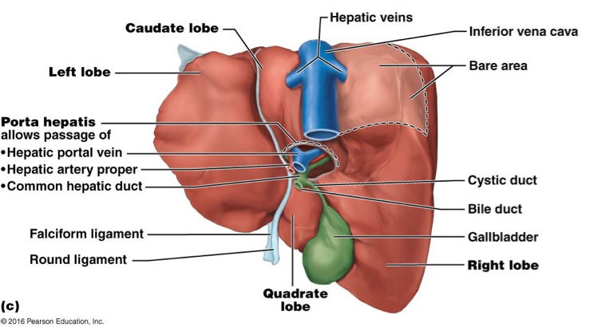
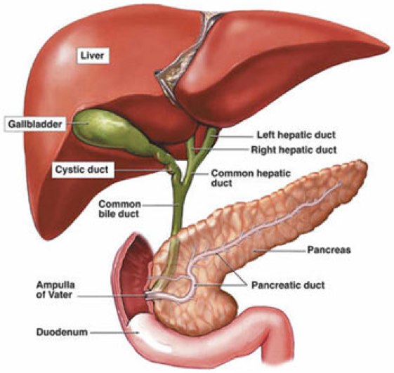
Liver Micro-Anatomy
- Liver Lobules: hexagonal, structural, functional units, consist of plates of hepatocytes (liver cells)
- Hepatocytes filter + process nutrient-rich blood
- Hepatocyte plates radiate outward from a central vein that runs through the length of a lobule
- At each corner of a lobule is a portal triad containing a branch of hepatic artery proper (supplies oxygenated blood to liver), a branch of hepatic portal vein (carrying venous loaded w/ nutrients) + a bile duct
- Liver Sinusoids: enlarged, heavily fenestrated, between hepatocyte plates. Blood from artery proper + portal vein filters through them from triad regions + empties into central vein → hepatic vein → inferior vena cava
- Hepatic Macrophages: remove debris like bacteria/worn-out blood cells from blood
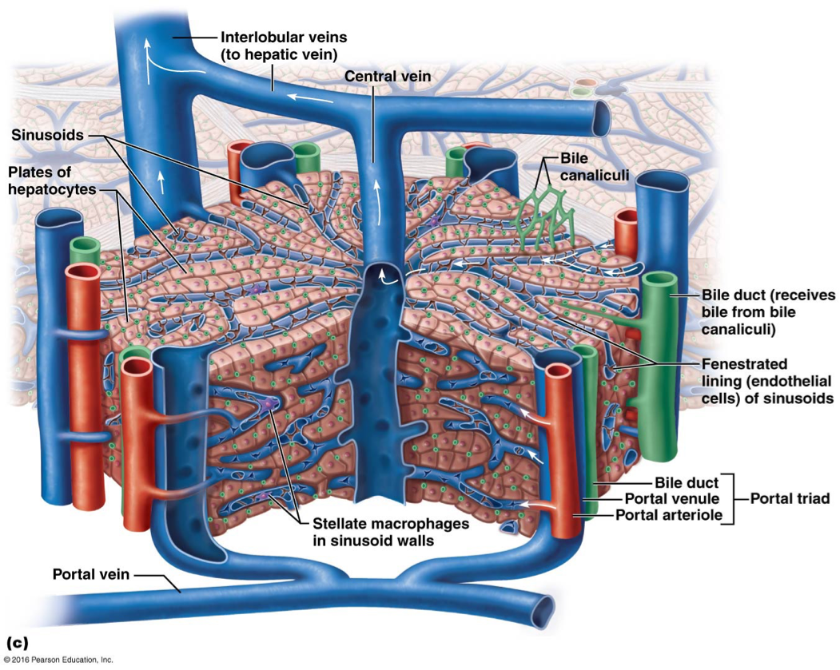

Functions of Liver
- Hepatocytes have large amounts of rough/smooth ER, golgi apparatus, peroxisomes, mitochondria
- Hepatocytes secrete 900mL of bile per day (ONLY DIGESTIVE FUNCTION)
- Process bloodborne nutrients in various ways
- Store fat-soluble vitamins (A, B12, D, E, K), carbohydrates (glycogen), minerals (iron, copper)
- Detoxify → poisons, drugs, hormones (ridding blood of ammonia by converting it to urea)
- Excretion of bilirubin to bile
- Synthesis of most clotting factors + lipoproteins
- Phagocytosis (breaking down) of old RBCs, leukocytes, some bacteria

Bile Composition
- Yellow/green alkaline solution containing bile salts, bile pigments, cholesterol, triglycerides, phospholipids + electrolytes
- Only bile salts + phospholipids aid digestion
- Bile Salts: cholesterol derivatives, fat emulsification + absorption
- Recycling method of bile salts (enterohepatic circulation):
- Salts are reabsorbed into blood by ileum (last part of small intestine)
- Salts are returned to liver via hepatic portal vein
- Salts are re-secreted in newly formed bile → 95% of secreted bile salts = recycled, only 5% newly synthesized each time
- Bilirubin = chief bile pigment, yellow waste product of heme formed during erythrocyte breakdown
- Bilirubin = absorbed from blood by liver cells, excreted into bile, metabolized in small intestine by resident bacteria → one of its breakdown products, stercobilin, gives feces brown colour

Hepatitis: inflammation of liver due to viral infection. Non-viral causes include alcohol/drug-induced toxicity + wild mushroom poisoning

Non-Alcoholic Fatty Liver Disease (NAFLD): most common liver disease in North America, 30% of population, 70% of the obese. Associated w/ abnormal lipid metabolism + liver inflammation

Cirrhosis: progressive chronic inflammation, usually from severe chronic hepatitis due to chronic alcoholism, NAFLD, or infectious hepatitis

Portal Hypertension: damaged hepatocytes can regenerate, livers scar tissue regenerates faster. Liver activity is depressed, liver becomes fibrous w/ scar tissue which obstructs blood flow through hepatic portal system
- Liver transplants are only clinically proven effective treatment
- Liver can regenerate to former size in 6-12 after surgical removal of 80% of its mass

Gallbladder
- Thin-walled green muscular sac on inferior surface of liver
- Stores bile not immediately needed for digestion
- Concentrates bile by absorbing some of its water/ions
- Contains honeycomb folds that allow it to expand when it fills (like rugae of stomach)
- Muscular walls contract to expel bile into cystic duct → from there bile goes to common bile duct
- Gallbladder = covered by visceral peritoneum

Gallstones
- Bile excretes cholesterol from body, bile salts keep cholesterol dissolved within bile
- Gallstones form when too much cholesterol/too few bile salts allow cholesterol to crystallize
- Obstructs flow of bile from gallbladder
- When gallbladder contracts, sharp crystals cause pain
- Treatments: crystal-dissolving drugs, ultrasound vibration, laser vaporization or surgery
- Bile duct blockages prevent bile salts + bile pigments from entering intestine
- Result = yellow bile pigments accumulate in blood, eventually deposit in skin causing it to become yellow/jaundiced
- Obstructive Jaundice: jaundice caused by blocked ducts
- Jaundice can also reflect liver disease → liver is unable to carry out its normal metabolic duties

Pancreas
- Tadpole shaped gland, extends across abdomen from its tail to its head
- Head is encircled by duodenum
- Retroperitoneal, lies deep to greater curvature of stomach
- Exocrine part of pancreas → produces pancreatic juice
- Acini: clusters of secretory acinar cells, produce enzyme-rich component of pancreatic juice. Full of rough ER, produce zymogen granules that contain inactive enzymes (proenzymes)
- Ducts transport secretions of acinar cells
- Epithelial cells of smallest ducts secrete water, makes up bulk of pancreatic juice + bicarbonate that makes secretion basic/alkaline
- Endocrine part of pancreas → has pancreatic islets that release insulin + glucagon

Pancreatic Juice
- 1200-1500 ml per day of pancreatic juice produced
- Mainly water, contains enzymes + electrolytes (mainly bicarbonate ions)
- High pH helps neutralize acidic chyme entering duodenum + provides optimal environment for intestinal/pancreatic enzymes
- Enzymes = proteases (proteins), lipases (fats), amylases (carbohydrates), nucleases (nucleic acids)
- Proteases = produced + released in active form, activated in duodenum → protects pancreas from digesting itself
- Enteropeptidase: enzyme bound to membrane of duodenal epithelial cells, activates trypsinogen to trypsin
- Trypsin activates more trypsin + two other pancreatic proteases (procarboxypeptidase + chymotrypsinogen) to active forms carboxypeptidase + chymotrypsin

Anatomy of Duct Systems
- Common bile duct (delivering bile from liver) + pancreatic duct (carrying pancreatic juice from pancreas) unite in wall of duodenum at bulblike structure hepatopancreatic ampulla where they fuse
- Ampulla opens into duodenum via volcano-shaped major duodenal papilla
- Hepatopancreatic Sphincter: smooth muscle valve, controls entry of bile/pancreatic juice
- Accessory Pancreatic Duct: smaller, empties directly into duodenum just proximal to main ducts

Regulation of Bile + Pancreatic Secretion
- Hormones = 2 enterogastrones = cholecystokinin (CCK) + secretin
- Bile salts = major stimulus for enhanced bile secretion when enterohepatic circulation returns large amounts of bile salts to liver, bile secretion increases
- Chyme entering duodenum causes CCK release + secretin from duodenal enteroendocrine cells
- CCK release = stimulated by proteins + fat in chyme
- Secretin release = stimulated by acidic/fatty chyme
- Both enter bloodstream, secretin stimulates liver cells to secrete bile + duct cells to secrete HCO3 pancreatic juice, CCK induces acinar cells to secrete pancreatic juice + causes gallbladder to contract + hepatopancreatic sphincter to relax
- No digestion occuring = hepatopancreatic sphincter is closed + released bile backs up cystic duct into gallbladder, where it is stored until needed
- Liver makes bile continuously, but bile does not small intestine until gallbladder contracts

Intestines

Small Intestine Gross Anatomy
- Convoluted tube extending from pyloric sphincter to ileocecal valve (2-4m long)
- Duodenum = retroperitoneal
- Ileum + jejunum = intraperitoneal
- Duodenum: curves around head of pancreas, ~25cm long, has major duodenal papilla (volcano-shaped opening in which the ampulla opens into)
- Jejunum: ~2.5 m long, from duodenum to ileum
- Ileum: ~3.6m long, joins large intestine at ileocecal valve

Small Intestine Microscopic Anatomy
- Length = huge surface area increase → size of tennis court
- Circular Folds: deep permanent folds of mucosa/submucosa, each ~1cm tall, force chyme to spiral through lumen, slowing movement + allowing time for absorption
- Villi: finger-like projections of mucosa ~1mm high, with core containing dense capillary bed + lymphatic lacteal for absorption
- Microvilli: long, densely packed cytoplasmic extensions of absorptive mucosal cells, give mucosa fuzzy appearance called brush border
- Brush Border Enzymes: enzymes found in plasma membranes of microvilli, complete digestion of carbohydrates + proteins

Histology of Small Intestine Wall
- Between villi, mucosa = studded w/ tubular glands called intestinal crypts, they decrease in number along intestine
- 5 major types of cells found in mucosal epithelium of villa + crypts
- Enterocytes: form bulk of epithelium, simple columnar cells bound by tight junctions w/ lots of microvilli → absorb nutrients + electrolytes
- In crypts, enterocytes = mainly secretory cells → secrete intestinal juice (watery mixture that contains mucus, serves as a carrier fluid for absorbing nutrients from chyme
- Goblet Cells: mucus-secreting, in epithelia of villi + crypts
- Enteroendocrine Cells: source of secretin + CCK, mostly found scattered in crypts
- Paneth Cells: deep in crypts, specialized secretory cells, release antimicrobial agents like defensins + lysosomes → destroy bacteria + help determine which bacteria colonize intestinal lumen
- Stem Cells: divide in depths of crypts, daughter cells differentiate to become all other cell types
- Epithelial cells at tips of villi undergo apoptosis + are shed, renewing villus epithelium every 3-5 days
- MALT = Peyer’s patches = primarily located in lamina propria, occasionally protrude into submucosa below
- Increasing abundance of peyer’s patches toward distal end of small intestine reflects fact that this region contains huge numbers of bacteria = must be prevented from entering bloodstream
- Lamina propria of mucosa contains large numbers of immunoglobulin A (IgA) = secreting plasma cells, help protect against intestinal pathogens
- Submucosa = areolar connective tissue
- Mucus-secreting glands in duodenal glands in submucosa produce alkaline mucus, helps neutralize acidic chyme
- Muscularis = bilayered
- Bulk of duodenum = retroperitoneal + has adventitia, rest of external surface covered by visceral peritoneum (serosa)

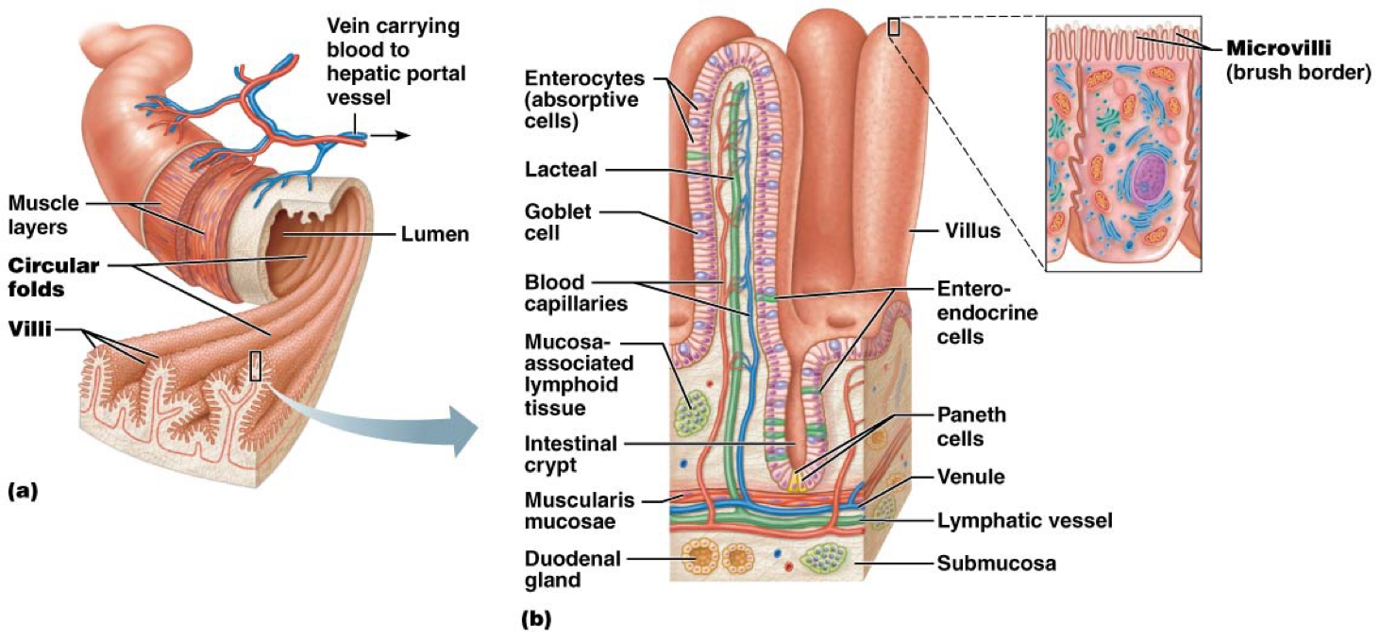

Intestinal Juice
- 1-2L daily secreted by intestinal glands in response to distension or irritation of mucosa
- Major stimulus = hypertonic or acidic chyme
- Juice = slightly alkaline (7.4-7.8) + isotonic w/ blood plasma
- Largely water, contains some mucus, secreted both by duodenal glands + goblet cells of mucosa

Digestive Processes In Small Intestine
- Carbohydrates + proteins are partially degraded, fat digestion has only begun
- Small intestine = where most water + virtually all nutrients are absorbed

Sources of Enzymes For Digestion
- Bile, digestive enzymes (except brush border enzymes) + bicarbonate ions are imported from liver/pancreas
- Brush border enzymes perform final digestion of food into simple components, can be absorbed by intestinal cells
- Note* brush border enzymes remain bound to brush border plasma membranes

Regulating Chyme Entry
- Chyme entering = hypertonic → if large amounts rush in, osmotic water from blood into lumen would result in dangerously low blood volume
- Low pH of entering chyme must be well mixed w/ bile + pancreatic juice for digestion to continue
- Feedback via enterogastric reflex + enterogastrones to stomach pylorus carefully controls food movement into small intestine
- Note* feedback mechanisms regulating chyme entry = same as those that decrease gastric secretion

Motility of Small Intestine
- Segmentation = principle form of motility → ensures chyme is thoroughly mixed w/ bile + pancreatic/intestinal juices
- Segmentation also ensures absorbable products of digestion come in contact w/ mucosa for absorption
- Primary motor pattern is form of peristalsis called migrating motor complex (MMC)
After A Meal…
- Intrinsic pacemaker cells in circular smooth muscle layer initiate segmenting movements
- Intensity = increased by parasympathetic activity, decreased by sympathetic, altered by hormones
- Pacemakers in duodenum depolarize more frequently than those in ileum, result = segmentation moves intestinal contents slowly + steadily toward ileocecal valve → allows time for complete digestion/reabsorption
Between Meals
- After most nutrients = absorbed, duodenal mucosa begins to release hormone motilin
- Motilin blood levels rise → peristaltic waves are initiated in proximal duodenum every 90-120 minutes → sweep slowly along intestine
- Each wave begins bit more distally → MMC
- Complete “trip” from duodenum to ileum takes ~2 hours, process repeats after, sweeping last remnants of meal + bacteria + sloughed-off mucosal cells + other debri into large intestine
- “Housekeeping” function prevents bacteria from large intestine from entering small intestine

Ileocecal Valve Control
- Valve usually closed → 2 mechanisms cause it to relax, allow food residues to enter cecum
- Gastroileal Reflex: long neural reflex triggered by stomach activity, increases force of segmentation in ileum + relaxes valve
- Gastrin: hormone released by stomach, increases motility of ileum + relaxes valve

Large Intestine Gross Anatomy
- Teniae Coli: longitudinal muscle layer reduced to 3 bands of smooth muscle
- Haustra: tone of teniae coli puckers the wall of the intestine into these pocket-like sacs
- Epiploic Appendages: small fat-filled pouches of visceral peritoneum, hang from surface of intestine, significance unknown

Subdivisions of Large Intestine
- Saclike cecum lies below ileocecal valve
- Attached to cecum = wormlike appendix, contains masses of lymphoid tissue as a part of MALT → plays important role in body immunity, also storehouse of bacteria, recolonizes gut when needed
- Appendix’s twisted structure makes it susceptible to blockages
- Note* colon, ascending colon, right colic (hepatic) flexure, transverse colon, left colic (splenic) flexure, descending colon
- Descending colon enters pelvis where it becomes S-shaped sigmoid colon
- In pelvis, sigmoid colon joins rectum which runs in front of the sacrum
- Rectum has 3 transverse folds called rectal valves, stop feces from being passed along with gas
- Anal Canal: ~3cm, opens to body exterior at anus. Has 2 sphincters, an involuntary anal sphincter of smooth muscle (part of muscularis) + voluntary external anal sphincter of skeletal muscle
- Rectum + anal canal lack teniae coli + haustra

Appendicitis: acute inflammation of appendix, results from blockage (often by feces), traps infectious bacteria in its lumen. Unable to empty, appendix swells, squeezing off venous drainage, may lead to ischemia + necrosis (low blood flow, tissue death). Appendix ruptures = feces containing bacteria spray over abdominal contents, causing peritonitis
- Symptoms: pain in umbilical region, loss of appetite, nausea/vomiting, pain relocalization to lower right abdominal quadrant
- Surgical removal = accepted treatment

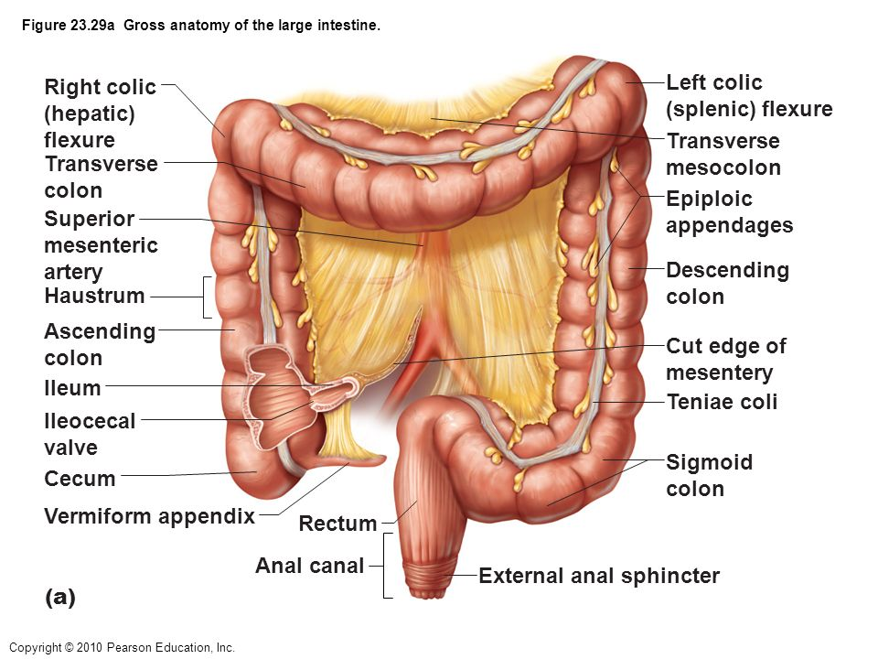

Relationship of Large Intestine To Peritoneum
- Cecum, appendix, rectum = retroperitoneal
- Colon also retroperitoneal except for transverse + sigmoid parts → they’re intraperitoneal + anchored to posterior abdominal wall by mesentery sheets called mesocolons

Microscopic Anatomy of Large Intestine
- Mucosa = simple columnar epithelium except in anal canal
- No circular folds, villi, brush border
- Mucosa = thicker, crypts are deeper + contain goblet cells
- Mucus produced by goblet cells eases passage of feces + protects wall from irritating acids + gases released by resident bacteria
- Mucosa of anal canal = stratified squamous epithelium, merges w/ true skin surrounding anus, is quite different from mucosa in rest of colon → reflects greater abrasion that region receives
- Superiorly, anal canal mucosa hangs in long ridges/folds called anal columns
- Anal Sinuses: recesses between anal columns, exude mucus when compressed by feces, aids in emptying
- Pectinate Line: horizontal, tooth-shaped line, parallels anal sinuses
- Superior to this line, visceral sensory fibers innervate mucosa = relatively insensitive to pain, area inferior = sensitive to pain → reflection of somatic sensory fibers serving it
- 2 superficial venous plexuses associated w/ anal canal, one w/ anal columns + other w/ anus itself → if these veins become dilated/inflamed, hemorrhoids result

Causes of Hemorrhoids: pregnancy, obesity, sitting for too many hours, constipation, heredity, low fiber diet
- Symptoms: itching, swelling, irritation/pain, bleeding, sensation of mass in anal canal even after a bowel movement
- Treatment: applying warm, soft compress, warm bath for 15-20 minutes. Dietary recommendations same as for constipation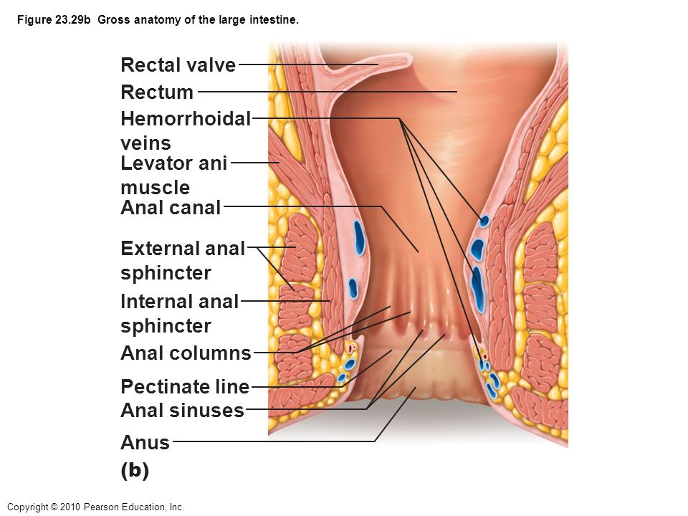

Bacterial Flora
- Over a thousand different types in large intestine
- Outnumber rest of our body’s cells by 10:1
- Some bacteria colonize colon via anus, others enter from small intestine still alive from antimicrobial defenses
Metabolic Functions
- Fermentation: gut bacteria ferment some indigestible carbohydrates + mucin in gut mucus → resulting short-chain fatty acids can be absorbed + used for fuel by body’s cells. Also produces mixture of gases, some quite odorous, ~500mL of gas produced daily
- Vitamin Synthesis: B complex vitamins + some of vitamin K liver needs to produce several clotting proteins are synthesized by gut bacteria

Keeping Pathogenic Bacteria In Check
- Gut bacteria instruct immune system not to overreact to their presence
- Beneficial bacteria outcompete + suppress harmful bacteria, as a result usually vastly outnumber them
- Immune system destroys any bacteria that try to breach mucosal barrier
- Epithelial cells recruit dendritic cells to mucosa to sample microbial antigens + present to T cells of MALT, triggering production of IgA that restricts microbes
- Type of bacteria present influences balance between subtypes of T-cells, so affects balance between pro- and anti-inflammatory responses

Gut Bacteria In Health + Disease
- Mounting evidence that kinds/proportions of bacteria in our gut can influence our body weight, our susceptibility to various diseases + even our mood
- Manipulating gut bacteria may become routine health-care strategy in near future

Antibiotic-Associated Diarrhea: accounts for 14,000 deaths per year. Clostridium difficile, an anaerobic bacterium = most common cause. C. difficile = normal but in small fraction of gut bacteria. When other bacteria are wiped out by antibiotics, c. difficile flourishes in gut
- May cause pseudomembranous colitis (inflammation of colon) → leads to bowel perforation + sepsis
- C. difficile = resistant to many antibiotics, difficult to treat (fecal transplants can work)

Digestive Process of Colon
- Residue remains in large intestine for 12-24 hours
- No food breakdown occurs except what enteric bacteria digest of residue
- Large intestine harvests vitamins made by bacterial flora, reclaims most of remaining water + some electrolytes
- Primary concerns = propulsive activities that force fecal material toward anus + eliminate it via defecation

Motility of Large Intestine
- Movement most seen in colon = haustral contractions → slow, segmenting movements, last about 1 minute, occur every 30 mins or so
- Contractions reflect local controls of smooth muscle within walls of individual haustra
- Haustra fills w/ food residue, distension stimulates its muscle to contract
- Movements mix residue → aids in water absorption
- Mass Movements: long, slow-moving powerful contractile waves that move over large areas of colon 3-4 times daily, force contents toward rectum
- Presence of food in stomach activates propulsive gastrocolic reflex in colon that results in mass movements
- Segmenting movements in descending/sigmoid colon promote final drying out of feces + stores feces until mass movements propel it into the rectum
- Fiber in diet strengthens colon contractions + softens feces

Diverticula
- Diet lacks fiber + volume of residues in colon is small, colon narrows + contractions become powerful, increasing pressure on its walls
- Promotes formation of diverticula, small herniations of mucosa through colon walls
- Condition = diverticulosis, commonly occurs in sigmoid, affects over half of people over age 70
- 4-10% of diverticulosis cases progress to diverticulitis → diverticula = inflamed, may rupture, leaking into peritoneal cavity, can be life threatening

Irritable Bowel Syndrome: functional GI tract disorder, recurrent abdominal pain relieved by defecation = changes in stool, bloating, flatulence, nausea, depression. Stress = common precipitating factor, stress management = important in treatment

Defecation
- Rectum usually empty except when feces forced into it by mass movements
- Stretching of rectal walls initiates defecation reflex → parasympathetic reflex causes sigmoid colon + rectum to contract + internal anal sphincter to relax
- Feces = forced into anal canal, messages reach brain allowing us to decide whether external anal sphincter should be open or remain closed
- If delayed, next mass movement initiates reflex again, until person chooses to defecate
- During defecation, muscles of rectum contract to expel feces
- Aid process w/ Valsalva’s maneuver → voluntarily closing the glottis + contracting diaphragm to increase intra-abdominal pressure
- We also contract levator ani muscles → lifts anal canal superiorly, leaves feces below anus + outside body
- Involuntary defecation occurs in infants b/c they haven’t gained control of external sphincter

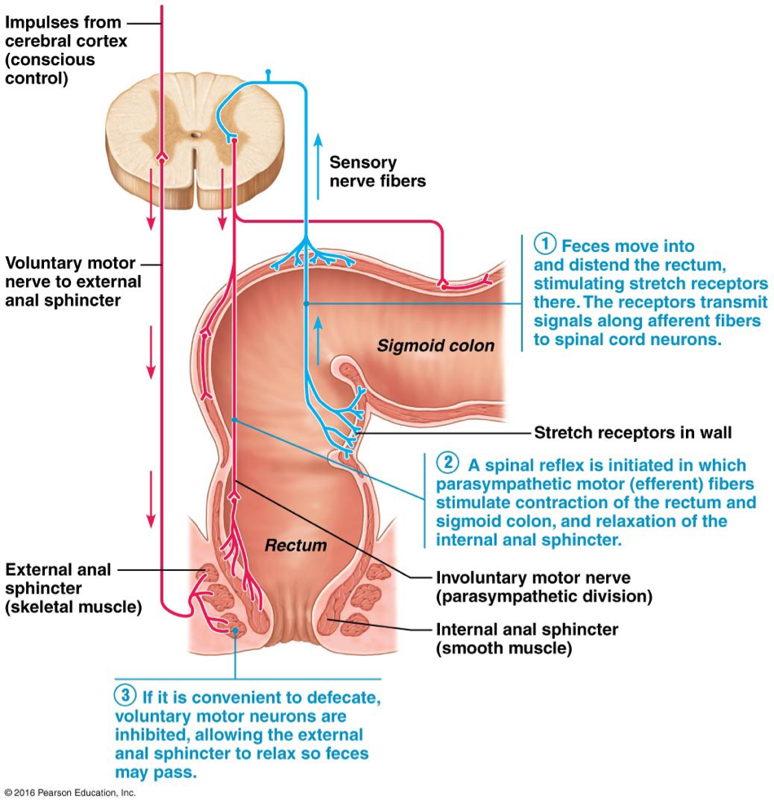

Diarrhea
- Caused by any condition that rushes food residue through large intestine before it has had sufficient time to absorb remaining water
- Causes = irritation of colon by bacteria or jostling of digestive viscera
- Prolonged diarrhea = dehydration + electrolyte imbalance (acidosis + loss of K)

Constipation
- Food remains in colon for extended time, too much water absorbed, stool becomes hard + difficult to pass
- May result from insufficient fiber/fluid in diet or improper bowel habits, lack of exercise or laxative abuse

Physiology of Digestion

Enzymatic Hydrolysis
- Digestion = catabolic process that breaks down large food molecules into monomers, accomplished by enzymes secreted into lumen of alimentary canal by intrinsic + accessory glands
- Hydrolysis: enzymatic breakdown of any food molecule, involves water
- Most digestion done in small intestine
- Pancreatic enzymes break larger chemicals into smaller pieces that are broken down into individual components by brush border enzymes
- Alkaline pancreatic juice neutralizes acidic chyme that enters small intestine → provides proper environment for operation of enzymes
- Pancreatic juice + bile = necessary for fat breakdown

Mechanisms of Absorption
- Absorption: moving substances from lumen of gut into body
- Tight junctions join epithelial cells of intestinal mucosa → substances can’t move in between cells, must pass through them
- Materials enter through apical membrane from lumen + exit through basolateral membrane into interstitial fluid then diffuse into capillaries
- From capillary they are transported in hepatic portal vein to liver
- Exception = some lipid digestion products, enter lacteal in villus to be carried via lymphatic fluid to blood
- Non-polar substances can be absorbed passively, all others need carrier mechanisms
- Most nutrients = absorbed by active transport processes, driven directly/indirectly
- Up to 10L of food, drink + GI secretions enter canal daily, only 1 or less reaches large intestine
- Absorption occurs all along length of small intestine, most is completed by time chyme reaches ileum
- Major role of ileum = reclaim bile salts to be recycled back to liver for re-secretion

Carbohydrates
- Digestion begins in mouth with salivary amylase that splits polysaccharides into oligosaccharides (2-8 sugars) → continues until amylase = inactivated by stomach acid + broken apart by stomach protein-digesting enzymes
- Any that escape are acted on by pancreatic amylase in small intestine
- Brush border enzymes break remaining oglio- + disaccharides into monosaccharides, most important = dextrinase + glucoamylase (act on oligosaccharides of more than 3 sugars) + lactase, maltase, sucrase which act on lactose, maltose + sucrose
- Intestine can only absorb monosaccharides
- Monosaccharides are cotransported across apical membrane, shuttled by secondary active transport w/ Na+ into cells
- Proteins that transport monosaccharides into cells = located very close to disaccharide enzymes on brush border → combine w/ monosaccharides as soon as broken down
- Monosaccharides exit across basolateral membrane by facilitated diffusion + pass into capillaries via intercellular clefts

Lactose Intolerance
- Lactase becomes deficient due to genetic factors
- When people w/ intolerance consume lactose, undigested disaccharides create osmotic gradient, prevent water from being absorbed in intestines + pull water from interstitial space into intestine, result = diarrhea
- Produces large amounts of gas, bloating, flatulence + cramping
- Add lactase drops to milk or take lactase tablets

Proteins
- Begins in stomach when pepsinogen secreted by chief cells is activated to pepsin at pH of 1.5-2.5 → cleaves bonds involving amino acids breaking proteins into polypeptides
- Pepsin = inactivated by high pH in duodenum
- Pancreatic proteases break down proteins into smaller fragments → trypsin + chymotrypsin cleave proteins into smaller peptides + carboxypeptidases split off one amino acid at a time
- Brush border enzymes break oligo- + dipeptides into amino acids = aminopeptidases, carboxypeptidases + dipeptidases
- Amino acids = cotransported across apical membrane of absorptive epithelial cell, carriers transport AA’s + are coupled to active transport of Na+ or H+
- AA’s exit across basolateral membrane via facilitated diffusion, enter capillaries through clefts

*whole proteins, in rare cases are taken up by endocytosis + released on opposite side of epithelial cell by exocytosis, common in newborn babies reflecting immaturity of their intestinal mucosa. Accounts for early food allergies, immune system “sees” intact proteins as antigenic + mounts attack

Lipids
- Triglycerides = most abundant fat in diet
- Small intestine = primary site of lipid digestion, pancreas is major source of lipases
- Emulsification
- Triglycerides = insoluble, need special pretreatment w/ bile salt
- In aqueous solutions, triglycerides aggregate to form large fat globules, only molecules at surface are accessible to lipase
- Bile salts increase surface area by breaking globules into small droplets
- Bile salts have polar/nonpolar regions → nonpolar part clings to fat + polar part allows them to repel each other + interact w/ water
- Result = fatty droplets pulled off globules, forming emulsion; aqueous solution of fatty droplets
- Emulsification reduces attraction between fat molecules so they can be more dispersed
- Digestion
- Pancreatic lipases catalyze breakdown of fats by splitting off two fatty acid chains, yielding free fatty acids + monoglycerides
- Micelle Formation
- Bile salts = essential for absorption of lipid digestion end products
- Monoglycerides + free fatty acids quickly become associated w/ bile salts + lecithin (phospholipid in bile) to form micelles
- Micelles: collections of fatty elements clustered together w/ bile salts in way that polar ends face water + nonpolar portions form core, similar to emulsion droplets but 500x smaller + easily diffuse between microvilli to come into close contact w/ apical surface
- Diffusion
- Micelles reach cells, various lipid substances leave + move through lipid phase of plasma membrane by simple diffusion
- Chylomicron Formation
- Free fatty acids + monoglycerides enter cells, smooth ER converts them back to triglycerides
- Triglycerides combine w/ lecithin + other phospholipids + cholesterol, coated w/ skin of proteins to form water-soluble lipoprotein droplets called chylomicrons
- Chylomicron Formation
- Chylomicrons = too large to pass through plasma membrane of cell or basement membrane of capillary
- Chylomicrons migrate to basolateral membrane + are extruded by exocytosis, then enter lacteals
- In bloodstream, triglycerides of chylomicrons are hydrolyzed to free fatty acids + glycerol by lipoprotein lipase
- Fatty acids + glycerol can pass through capillary walls to be used by tissue cells for energy or stored as fats in adipose tissue
- Short-chain fatty acids simply diffuse into portal blood for distribution

Nucleic Acids
- Nuclei of cells of ingested foods contain DNA/RNA
- Pancreatic nucleases in pancreatic juice hydrolyze nucleic acids to nucleotide monomers
- Brush border enzymes nucleosidases + phosphatases break nucleotides apart to nitrogenous bases, pentose sugars + phosphate ions
- Carriers in epithelium of villi actively transport breakdown products across epithelium, then enter blood

Vitamin Absorption
- Small intestine absorbs dietary vitamins, large intestine absorbs some K + B vitamins made by its enteric bacteria
- Fat-soluble vitamins (A, D, E, K) are carried by micelles + diffuse into capillaries
- Water-soluble vitamins (C + B) are absorbed by diffusion or by passive/active transporters
- Exception = B12, needs to bind to intrinsic factor produced by stomach, then that complex binds to specific mucosal receptor sites in the ileum → trigger its active uptake by endocytosis

Electrolyte Absorption
- Ions = actively absorbed along entire length of small intestine
- Absorption of iron + calcium = largely limited to duodenum
- Na+ absorption = coupled w/ active absorption of glucose + amino acids
- Bicarbonate = actively secreted into lumen in exchange for Cl-
- K+ ions move passively across mucosa by facilitated diffusion
- As water is absorbed from lumen, rising K+ levels in chyme create concentration gradient for its absorption
- Anything that interferes w/ water absorption reduces K+ absorption but also pulls K+ from the interstitial space
- Fe+ is actively transported into mucosal cells where it binds to protein ferritin, complex = local storehouse for iron
- When body reserves are inadequate, only 10-20% is allowed to pass into portal blood, most stored iron is lost as epithelial cells slough off
- When iron reserves = depleted, iron uptake from intestine + its release to blood accelerate
- In blood, iron binds to protein transferrin → transports it in circulation
- Menstrual bleeding = major route of iron loss in women, intestinal epithelial cells of women have about 4x as many iron transport proteins as men
- Active form of vitamin D promotes active calcium absorption, decreased blood levels of calcium prompt PTH release from parathyroid glands
- PTH stimulates activation of vitamin D to calcitriol by kidneys, in turn accelerates calcium ion absorption in small intestines

Water Absorption
- 9L of water enter small intestine daily, 95% absorbed in small intestine by osmosis
- Most of rest = absorbed in large intestine, leaving only about 0.1L to soften feces
- Water moves freely in both directions across mucosa, net osmosis occurs whenever a concentration gradient is established by active transport of solutes (Na+) into mucosal cells
- Water uptake = coupled to solute uptake

Celiac Disease
- Genetic condition caused by immune reaction to gluten
- Breakdown products of gluten interact w/ molecules of immune system in GI tract, forming complexes
- Complexes activate T cells, attack intestinal lining, damaged villi + reducing surface area of brush border
- Bloating, diarrhea, pain + malnutrition = result
- Treatment = eliminate gluten-containing grains from diet

Crohn’s Disease
- Inflammatory bowel disease causes inflammation of lining of GI tract
- Leads to abdominal pain, severe diarrhea, fatigue, weight loss + malnutritions

Aging + Digestive System
- Old age = decline of GI tract
- GI produces less digestive juice, absorption is less efficient, peristalsis slows → causes decline in frequency of bowel movements
- Taste/smell becomes less acute, periodontal disease often develops
- Diverticulosis, fecal incontinence + cancer of GI tract = common

