ANATOMY OF THE NERVOUS SYSTEM

Central Nervous System (CNS)
- Connected as single unit, but anatomically divided into 2 parts:
  - Central Nervous System:
    - brain & spinal cord; integrating & command centre
  - Peripheral Nervous System:
    - Cranial & spinal nerves; communication between CNS & all parts of body
      - Sensory Division: Somatic & visceral fibers; from receptors to CNS
      - Motor Division: Motor never fibers from CNS to effectors (muscles & glands)
    - Somatic NS: Voluntary; from CNS to skeletal muscle
    - Automatic NS: Involuntary; (visceral motor); from CNS to cardiac muscle, smooth muscle, glands
      - Sympathetic Division: “Fight or Flight”
      - Parasympathetic Division: Conserve energy at rest; system relaxes

Histology of Nervous Tissue
- Very cellular; minimal extracellular matrix
- 2 principal types of cells:
  - Neurons
  - Supporting Cells (6 types)
    - CNS: (4 types --- Neuroglia)
    - Astrocytes:
      - Star-shaped, most abundant; anchor neurons close to capillaries
      - Roles in nutrient exchange, antigen presentation, control of environment
    - Microglia:
      - Protective; touch neurons to monitor well-being; can transform into macrophages
    - Ependymal Cells:
      - Line cavities of brain & spinal cord as barrier between CSF & fluid bathing cells of CNS; cilia circulate CSF
    - Oligodendrocytes:
      - “few branches”; provide myelin sheaths to CNS neutrons
  - PNS (2 types)
    - Satellite Cells:
      - Surround neuron cell bodies in ganglia --- influence chemical environment of these neurons(?)
    - Schwann Cells:
      - From myelin sheath around larger neurons in PNS; vital to peripheral nerve cell regeneration
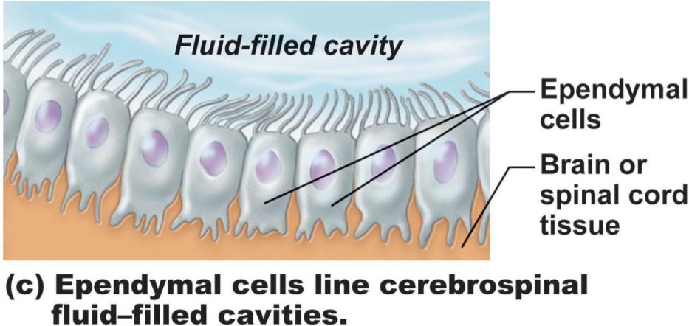
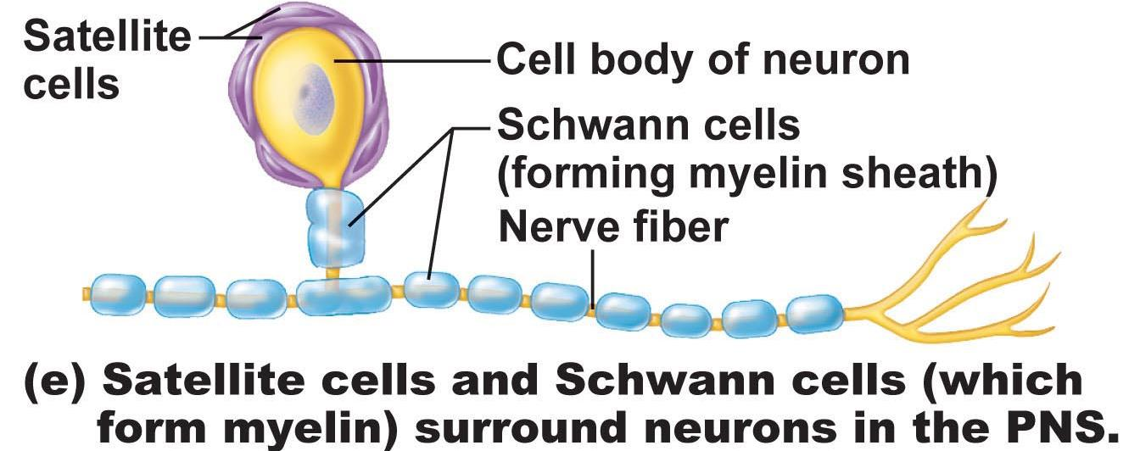
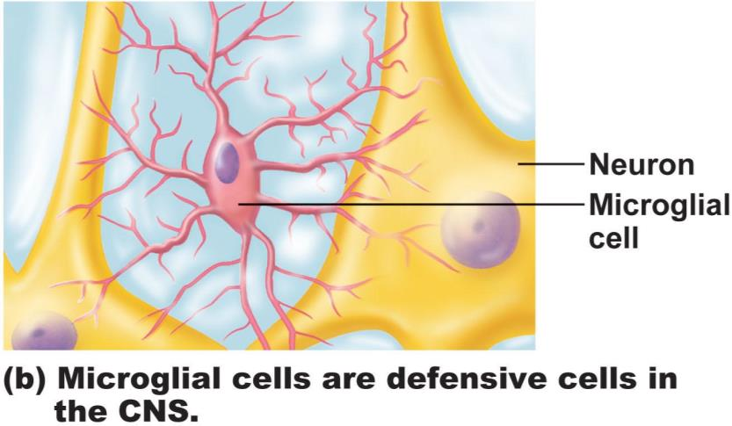
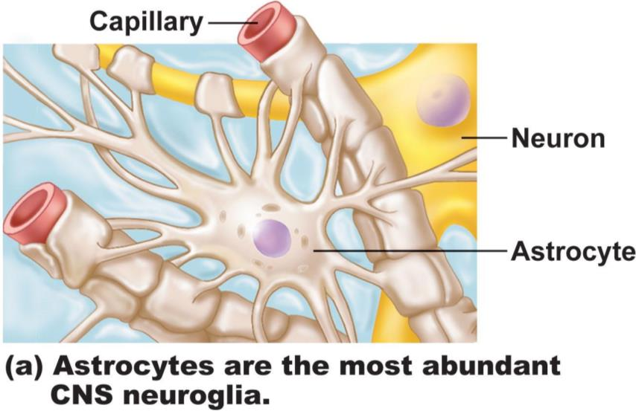
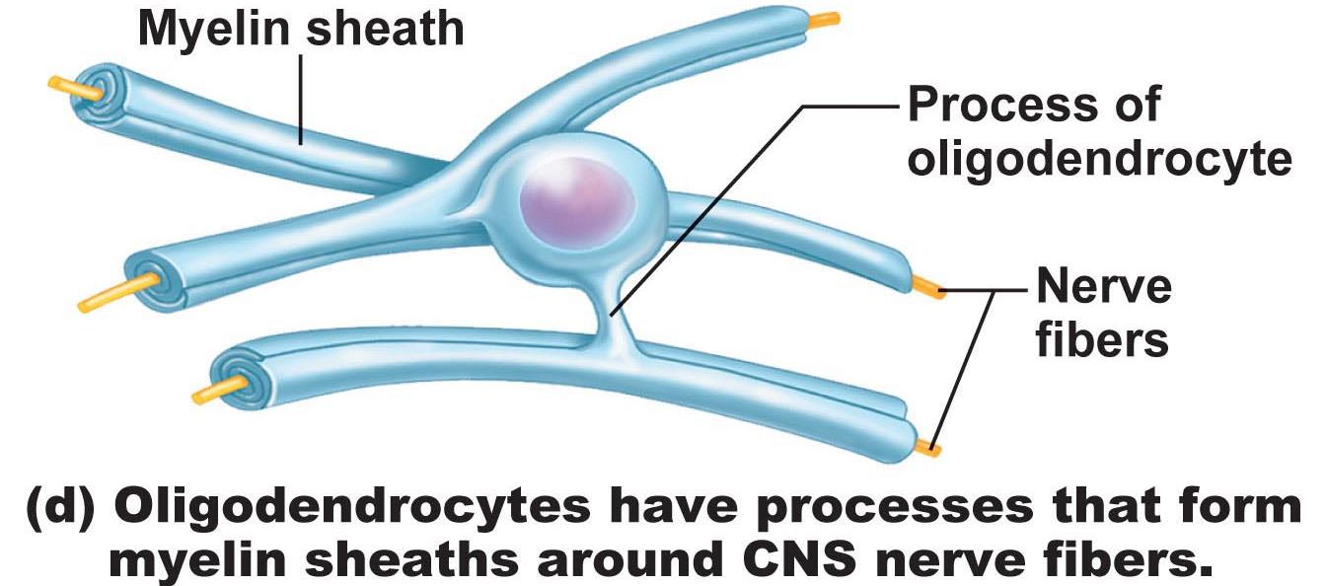

Neurons
- Extreme longevity, amitotic, high Metabolic Rate
- Cell body = soma = perikaryon
- Know: dendrites, axon, axon hillock, myelin sheath, node of Ranvier, telodendria (terminal branches), axonal terminals
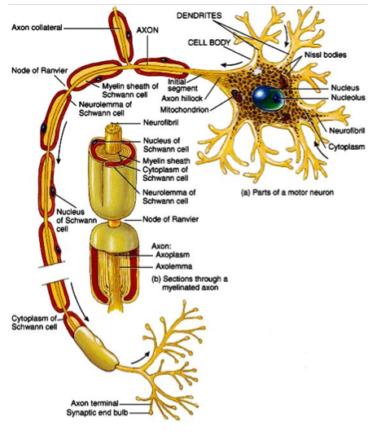
Structural Classification of Neurons
- Multipolar vs. Bipolar vs. Unipolar
  - Multipolar
    - 3+ processes --- most common type & major type in CNS
  - Bipolar
    - 2 processes --- an axon & a dendrite extend from opposite sides of cell body --- only in some special sense organs (Eg. Retina, olfactory mucosa)
  - Unipolar
    - Single process --- divides into proximal & distal fibers; usu in ganglia of peripheral NS & function as sensory neurons
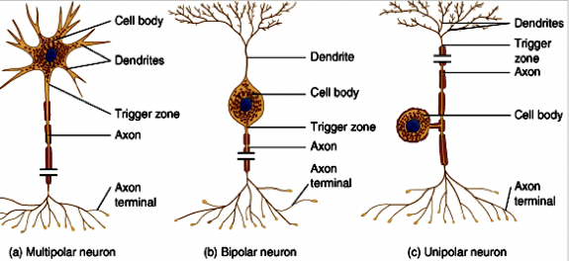

Functional Classification of Neurons
- According to direction nerve impulse travels wrt. CNS
- Sensory, motor & association neurons
- Sensory:
  - Toward CNS; primary, secondary, tertiary
  - Except bipolar neurons in some special sense organs, virt. all primary sensory neurons are unipolar & cell bodies located in ganglia outside CNS
  - Higher order sensory neurons all multipolar & reside entirely within CNS --- conduction to higher brain centres for interpretation
- Motor:
  - Away from CNS to effector organs like muscle & glands; multipolar; most cell bodies reside in CNS
- Association (interneurons):
  - Between sensory & motor neurons --- integration of info; multipolar; most entirely within CNS; 99% of neurons of the body

The Brain
- Complexity of wiring rather than size is what matters
- Subdivisions:
  - Cerebral Hemispheres
  - Diencephalon (thalamus, hypothalamus, epithalamus)
  - Brain Stem (midbrain, pons, medulla)
  - Cerebellum
Arrangement of Gray & White Matter
- Spinal Cord has central cavity surrounded by gray matter & white matter
- Brain has same design, but with additional regions of gray matter; cerebral hemispheres & cerebellum have outer “bark” of gray matter
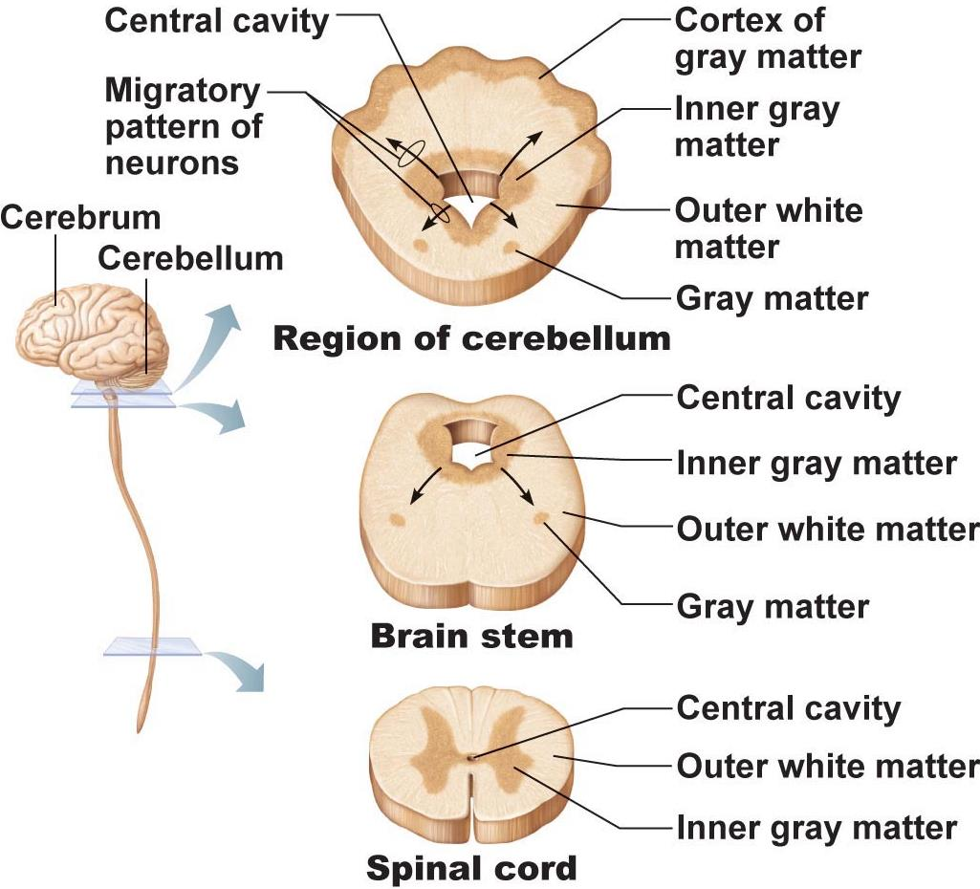

Ventricles of the Brain
- Continuous with one another and with central cavity of spinal cord
- Filled with CSF & lined by ependymal cells
- Paired lateral ventricles separated by narrow septum pellucidum
- Each communicates with narrow 3rd ventricle in diencephalon via interventricular forearm
- 3rd ventricle continuous with 4th ventricle (dorsal to pons) via cerebral aqueduct
- 4th ventricle continuous with central canal
- 3 apertures (paired lateral apertures & median aperture) connect ventricles to Subarachnoid space (surrounds brain)
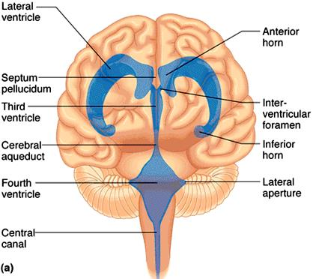
The Cerebral Hemispheres
- Superior; ~83% of brain mass
- Gyri separated by sulci; anatomical landmarks
- Longitudinal Fissure; transverse cerebral fissure
- Lobes: frontal, parietal, occipital, temporal, insular
- Central Sulcus: precentral/postcentral gyrus
- Parieto-occipital sulcus, lateral sulcus
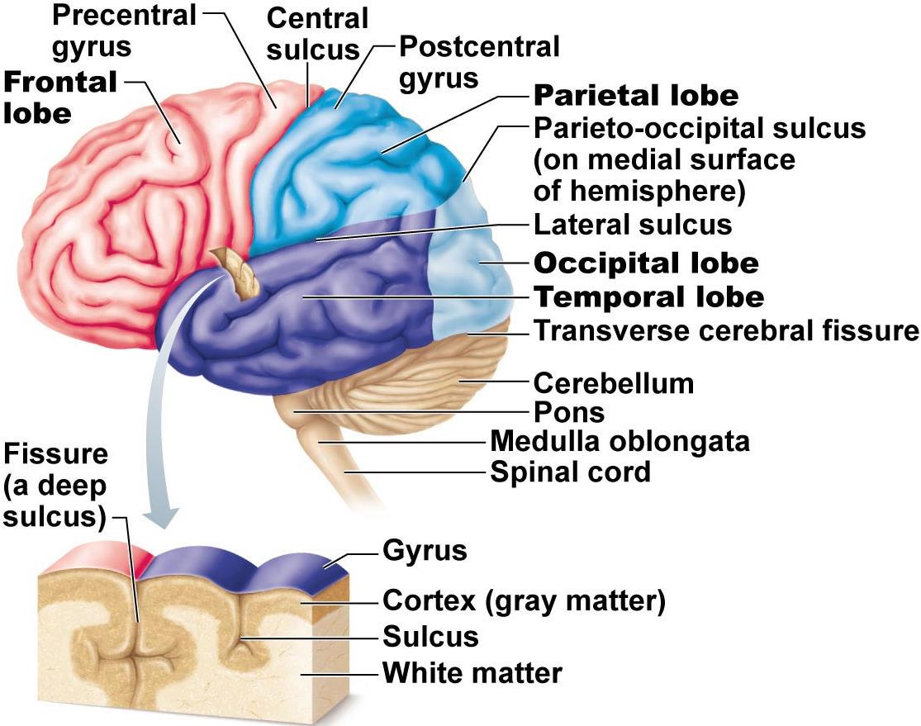

Cerebral Cortex
- Allows us to perceive, communicate, remember, understand, appreciate, initiate voluntary movements --- conscious behaviour
- Cell bodies, dendrites & unmyelinated axons; only 2-4mm thick, but many convolutions triple surface area
- Brodmann Areas: Numbered according to subtle differences in thickness, structure of contained neurons; some areas link with particular functions; other functions (memory & language) have overlapping domains; more diffusely organized
  - 3 functional areas: Motor, sensory, association
  - Each hemisphere handles sensory & motor functions of opposite side of body
  - Largely symmetrical, but not 100% equal in function (lateralization)
  - No functional area of cortex acts alone; all conscious behaviour involves entire cortex in some way
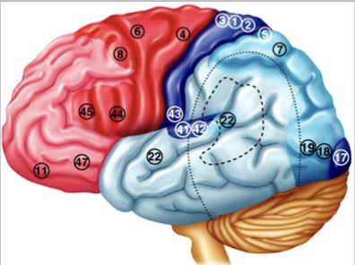
Motor Areas
- Posterior part of frontal lobes: Primary motor cortex, premotor cortex, Broca’s area & frontal eye field
- Primary Motor Cortex
  - Precentral gyrus of frontal lobe of each hemisphere; pyramidal cells allow control of skeletal muscles; axons project to spinal cord as pyramidal/corticospinal tracts
  - Entire body represented spatially in primary motor cortex of each hemisphere --- somatotopy
  - Which areas require most precise motor control?
  - Motor innervation is contralateral
- Premotor Cortex
  - Anterior to precentral gyrus
  - Learned motor skills that are repetitious/patterned
  - Coordinates movement of several muscle groups simultaneously/sequentially by activating motor cortex
  - What if there is damage to the area of premotor cortex regulating keyboarding?
- Broca’s Area
  - Overlaps Brodmann areas 44 & 45
  - Originally thought to be only a motor speech area
  - Newer studies: Broca’s area is active when we prepare to speak and plan voluntary activities other than speech
- Frontal Eye Field
  - Brodmann area 8; controls voluntary movements of the eyes

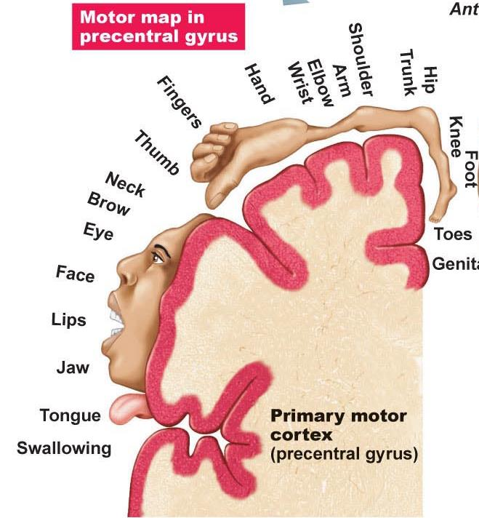

Sensory Areas
- Primary Somatosensory
  - In postcentral gyrus of parietal lobe (Brodmann areas 1-3)
  - Receives info from somatic sensory receptors (skin) & proprioceptors (skeletal muscle)
  - Spatial Discrimination
- Somatosensory Association Area
  - Posterior to PSC --- many connection with it
  - Integrate/analyze inputs (temp, pressure,..) --- interpret wrt size, texture, relationship of parts based on prior experience
- Visual Areas
  - Primary visual cortex = posterior tip occipital lobe
- Largest cortical area; contains map of visual space on retina (opposite sides)
  - Visual association area = surrounds PVC
- Interprets visual image based on prior experience --- Eg. Recognition of face, letter (also movement!)
  - What is the result of damage to the primary visual Cortex? To the visual association area?
- Auditory Areas
  - Primary auditory cortex = sound evaluated wrt pitch, rhythm, loudness
  - Auditory association area = interpretation based on memory --- speech, words, music, thunder, etc.
- Vestibular (Equilibrium) Cortex
  - Awareness of balance --- posterior part of insula & adjacent parietal cortex
- Olfactory Cortex
  - Medial aspects of temporal lobes = uncus
  - Small in humans; most of surrounding tissue now forms limbic system (emotions, memory)
  - Conscious awareness of different odors
- Gustatory Cortex
  - Insula; anterior to area #43
- Visceral Sensory Area
  - Posterior to gustatory cortex
  - What sort of information?
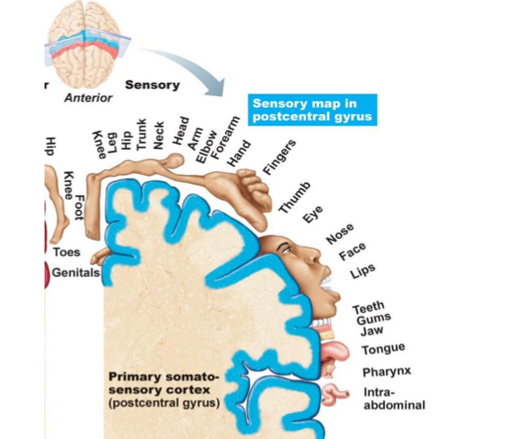
Multimodal Association Areas
- Any cortical area that is not “primary”
- Some communicate with 1⁰ sensory & motor areas & with other sensory association
- Areas to analyze, recognize, act on sensory inputs --- multiple inputs & outputs
- Anterior Association Area (Prefrontal Cortex)
- Intellect, complex learning (cognition) & personality (working memory is here)
- Abstract ideas, judgement, reasoning, persistence, planning, concern, conscience
- Matures slowly; dependent on feedback from social environment
- Closely linked to limbic system; involved in mood
- Posterior Association Area
- Parts of temporal, parietal & occipital lobes
- Input from all sensory association areas --- storage of complex memories linked to sensation --- put info together to understand what see, feel, etc.
- Recognition of patterns, faces
- Some parts for understanding written & spoken language (Wernicke’s Area)
- Limbic Association Area
- Provides emotional impact --- Eg. Be aware of the danger associated with a particular situation, etc.
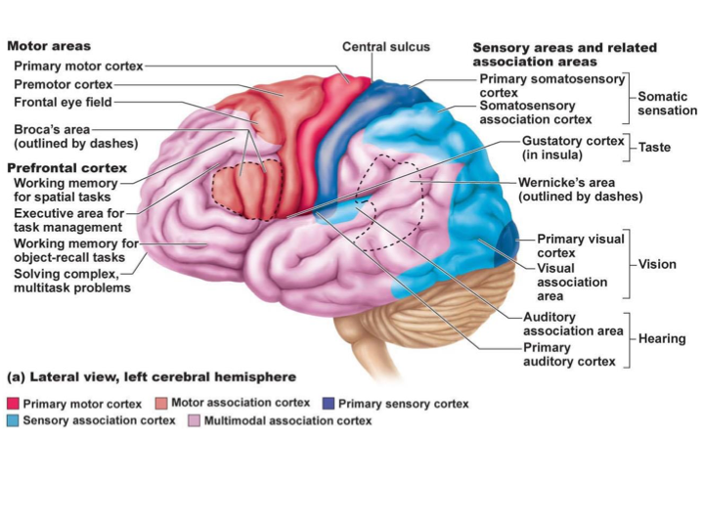

Lateralization of Cortical Functioning
- Each cerebral hemisphere has abilities not completely shared by other hemisphere
- Cerebral dominance = hemisphere that is dominant for language
- 90% of people: left hemisphere dominant for language, math, logic
- Other hemisphere dominates for visual-spatial skills, intuition, emotion, appreciation of art & music --- creative side, better at recognizing faces
- Most individuals with left cerebral dominance are right-handed
- In remaining 10%, roles reversed or shared equally

Cerebral White Matter
- Communication between cerebral areas, between cortex & lower CNS centers
- Commissural Fibers:
  - connect corresponding areas between the 2 hemispheres --- largest is corpus callosum
- Association Fibers:
  - Connections within a hemisphere (connect gyri, lobes)
- Protection Fibers:
  - To or from cortex and rest of nervous system; these ones run vertically
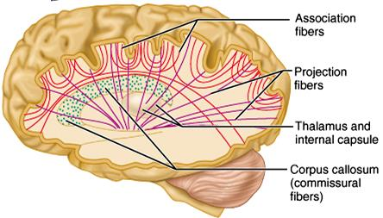

Basal Nuclei
- Caudate nucleus + [Putamen & Globus pallidus = Lentiform nucleus]
- Inputs from entire cerebral cortex, other subcortical nuclei & each other
- Project to premotor & prefrontal cortices to influence muscle movements directed by primary motor cortex --- have no direct access to motor pathways
- Precise role(s) difficult to determine --- roles in starting, stopping, monitoring movements executed by cortex, esp. if slow, sustained, stereotyped
- Also influence movement intensity, inhibit antagonistic/unnecessary actions
- Disorders can result in too much movement (Eg. Huntington’s disease or too little movement (Parkinson’s disease)

Huntington’s Disease
- Hereditary disorder in which mutant huntingtin protein accumulates in brain cells = degeneration of the basal nuclei and eventually of the cortex
- As caudate deteriorates, connections to frontal lobe become lost so that the affected individual is unable to control feelings, thoughts or movements

Parkinson’s Disease
- Degeneration of dopamine-releasing neurons of substantia nigra (midbrain)
- Causes basal nuclei usually targeting by substantia nigra to become overactive = persistent tremor at rest; muscles become rigid leading to difficulty walking, loss of facial expression, difficulty writing, etc.
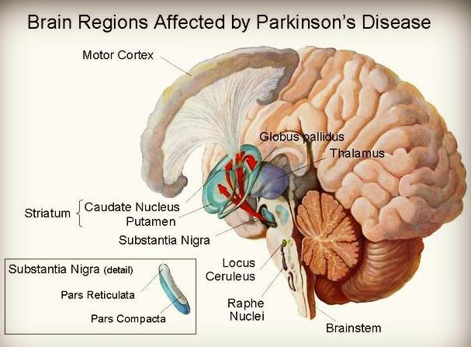

The Diencephalon
- Thalamus, hypothalamus, epithalamus --- enclose the 3rd ventricle
- Thalamus: 80%; bilateral masses of gray matter held together by midline commissure called the intermediate mass
- Consists of many different nuclei, named for their position in thalamus --- afferent impulses from all senses & all parts of body converge on thalamus
- Sorting & editing of information; group like impulses to send to appropriate region of cortex --- crude awareness of sensation at level of thalamus
- Also input pertaining to emotions & viscera from hypothalamus
- Key roles in mediating sensation, motor activities, cortical arousal, learning, memory = “gateway to cerebral cortex”

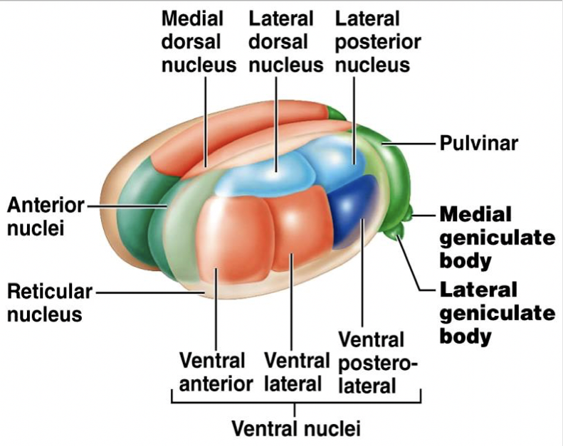
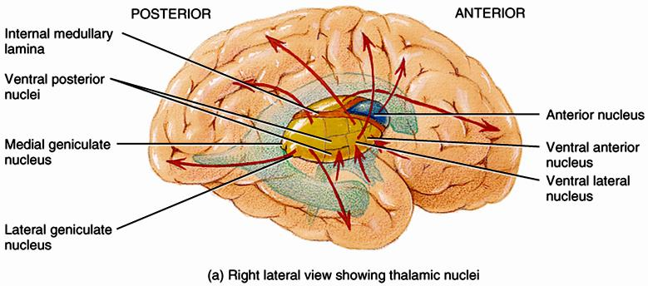

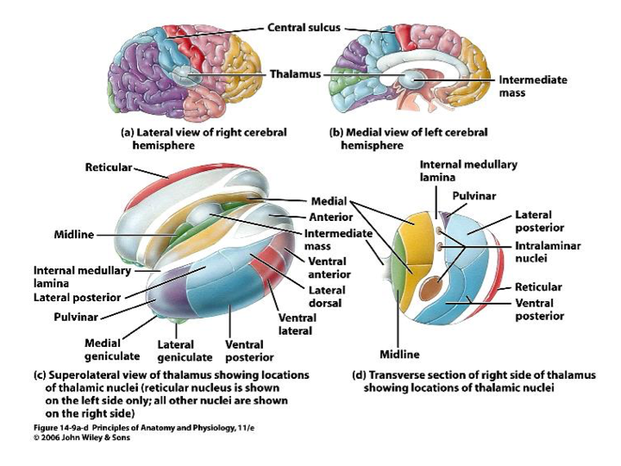
Hypothalamus
- “Below” thalamus
- Autonomic control centre: centres for blood pressure, heart, GI, respiration, etc.
- Centre for emotional response & behaviour: heart of limbic system
- Body temperature regulation
- Regulation of food intake: hunger, satiety
- Regulation of water balance & thirst: release of ADH; thirst centre
- Regulation of sleep-wake cycles: suprachiasmatic nucleus
- Control of endocrine system: releasing factors plus 2 nuclei (supraoptic & paraventricular) produce ADH & oxytocin
- Hypothalamic Disturbances
  - Cause disorders in body homeostasis such as body wasting, obesity, sleep disturbances, dehydration, emotional imbalances
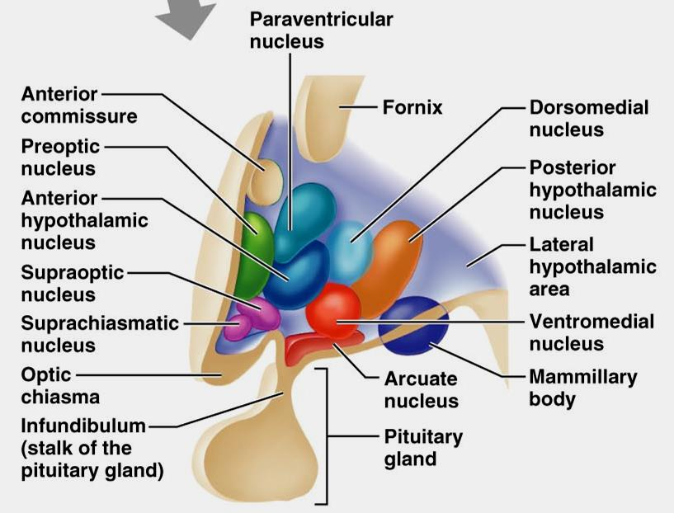
Epithalamus
- Most dorsal part of diencephalon & forms roof of 3rd ventricle; pineal gland (melatonin) extends from its dorsal border
- Chronic Plexus (CSF-forming structure) also part of epithalamus
The Brain Stem
- Consists of midbrain, pons, medulla oblongata
- Rigidly programmed, automatic behaviours necessary to survival
- Pathway between higher & lower neural centres
- Associated with 10 pairs of cranial nerves

Midbrain
- 2 cerebral peduncles that contain large pyramidal (corticospinal) motor tracts hollow cerebral aqueduct runs through midbrain periaqueductal gray matter involved in pain suppression
- Corpora Quadrigemina:
  - Superior colliculi are visual reflex centres; inferior colliculi are part of auditory relay (also startle reflex)
- Substantia Nigra:
  - Band-like nucleus; high melanin content (precursor = dopamine; linked to basal nuclei of cerebral hemispheres (Parkinson’s disease)
- Red Nucleus:
  - Rich vascular supply, iron pigment in neuro cell bodies; relay nuclei for descending pathways influencing limb flexion
- Also some nuclei associated with reticular formation
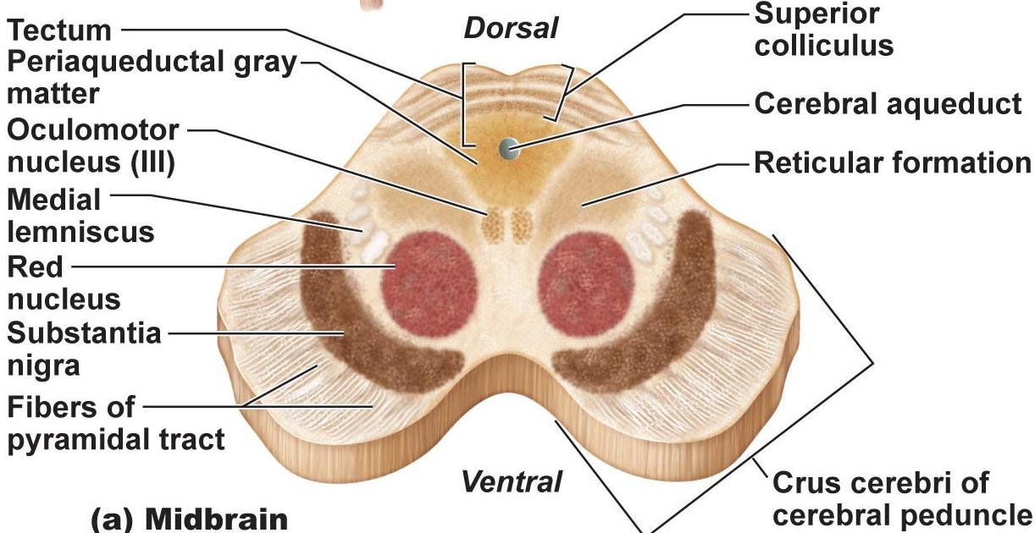

Pons
- Dorsally, forms part of anterior wall of 4th ventricle
- Primarily conduction tracts (“bridge”); some run longitudinally; others oriented transversely to communicate with cerebellum
- Cranial Nerves V (trigeminal), VI (abducens) & VII facial; other pons nuclei are part of reticular formation and others are involved in respiration
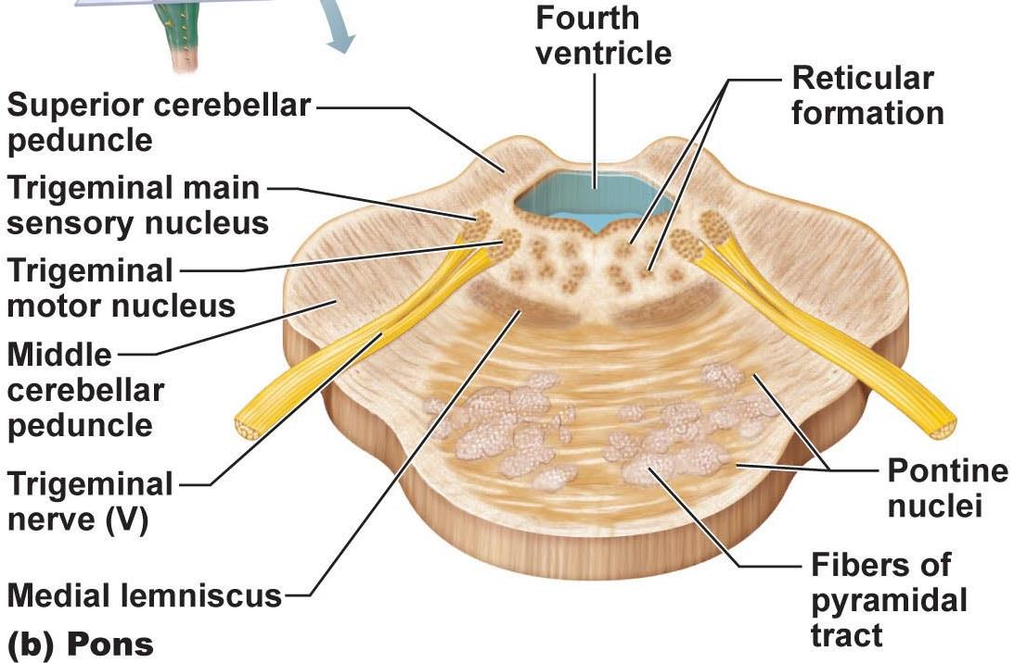

Medulla Oblongata
- From pons to spinal cord
- Pyramids, decussation (significance of this?)
- Inferior olivary nuclei: relay sensory info re muscles & joints to cerebellum
- Cranial Nerves XII (hypoglossal), IX (glossopharyngeal), X (vagus), XI (accessory)
- Vestibulocochlear nerve fibers (XIII) synapse with cochlear nuclei
- Crucial role as autonomic reflex centre for homestasis
  - Cardiocascular Centre: cardiac & vasomotor centres
  - Respiratory Centres: rate & depth of breathing
  - Other centres: eg: vomiting, hiccupping, swallowing coughing, sneezes
- Overlap with hypothalamus: hypothalamus controls most visceral functions by relaying instructions through medullary centres which carry them out
- Function?
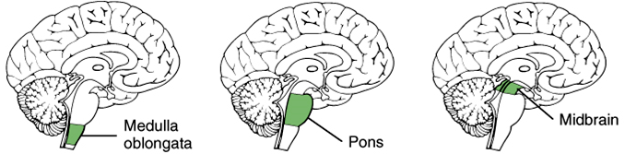
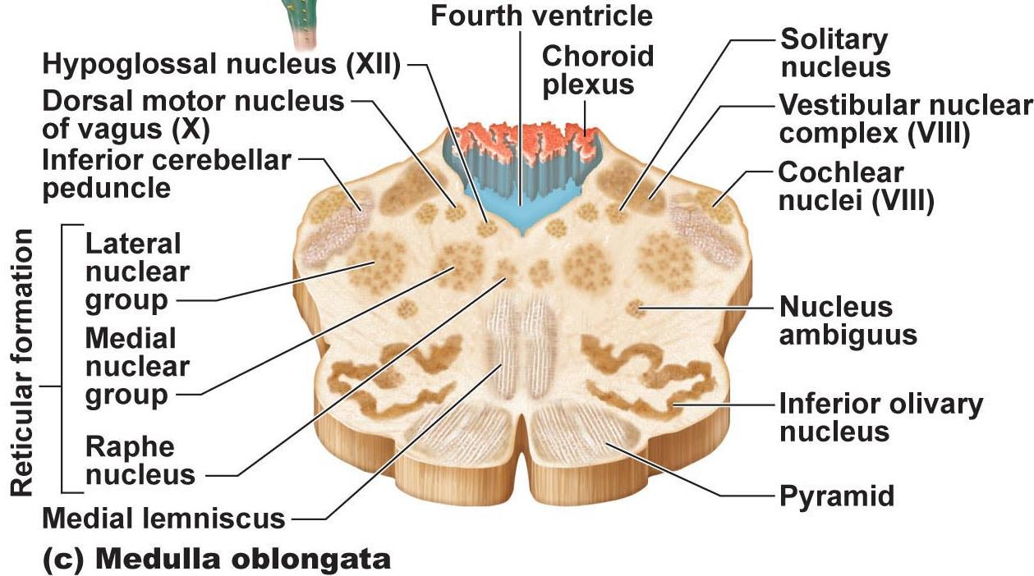

The Cerebellum
- Processes inputs from cerebral motor cortex, brainstem nuclei & sensory receptors = timing & patterns of skeletal muscle contraction for smooth, daily movements --- eg: driving, typing, playing a musical instrument, etc. (not under conscious control)
- Bilaterally symmetrical; connected by vermis; fine transverse fissures called folia; each hemisphere divided into 3 lobes: anterior, posterior, flocculondular
- Anterior & posterior lobes have overlapping sensory & motor maps of body
  - Medial: trunk & girdle
  - Intermediates: distal limbs, skilled movements
  - Lateral: input from association areas of cortex (esp. planning movements)
- Flocculonodlar lobes --- input from equilibrium sensors: balance, some eye movements
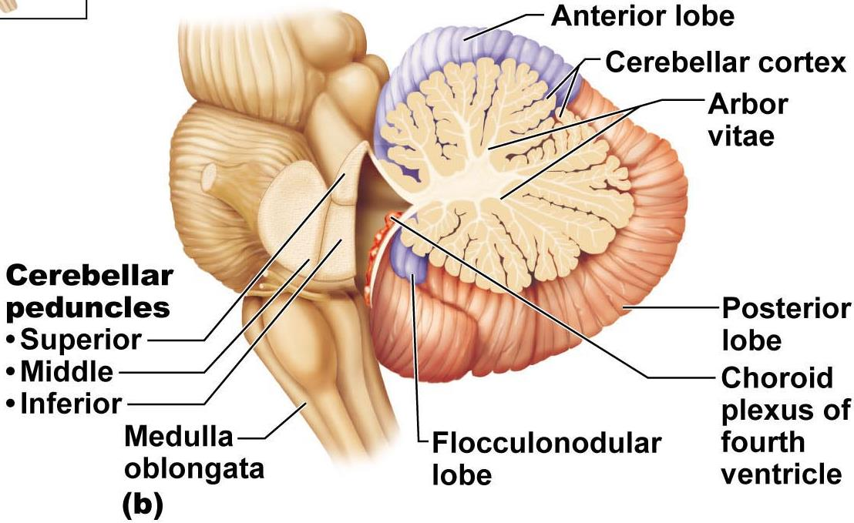

Cerebellar Peduncles
- Connect cerebellum to brain stem
- Virtually all fibers entering & leaving cerebellum are ipsilateral (unlike cerebral cortex)
- Superior:
  - connect cerebellum & midterm; fibers originate from neurons in deep cerebellar nuclei & project to cerebral motor cortex via thalamus
- Middle:
  - Connect pons & cerebellum; one-way communication from pons to cerebellar neurons (informs cerebellum of voluntary motor activities initiated by motor cortex)

Cerebellar Processing
- Cortex frontal motor association area indicates intent to initiate action & sends collateral to cerebellum to notify
- Cerebellum also receives proprioceptive info & info from visual & equilibrium pathways: Where is body & where going? How well are movements being done?
- Cerebellar cortex receives this info & determines best way to coordinate force, direction extent of muscle contraction
- Via superior peduncles, cerebellum dispatches blueprint for coordination to cortex; output also to brain stem nuclei (eg. Red nucleus) which project to motor neurons of spinal cord

Functional Brain Systems
- Networks of neurons that work together but span large distances within brain

Limbic System (limbus = ring)
- Medial aspect of each cerebral hemisphere & diencephalon
- Emotional-visceral brain --- esp: amygdala (anger, fear, assess danger), hippocampus (emotions & memory), anterior cingulate gyrus (gestures, resolve conflicts when frustrated)
- Link between odours, memories, & emotions
- Link for psychosomatic illnesses: stress & effects on bp, GI tract, heart
- Link with cortex: (i) aware of emotions, (ii) react emotionally if consciously understand; also: emotions can override logic; reason can stop us from expressing emotions

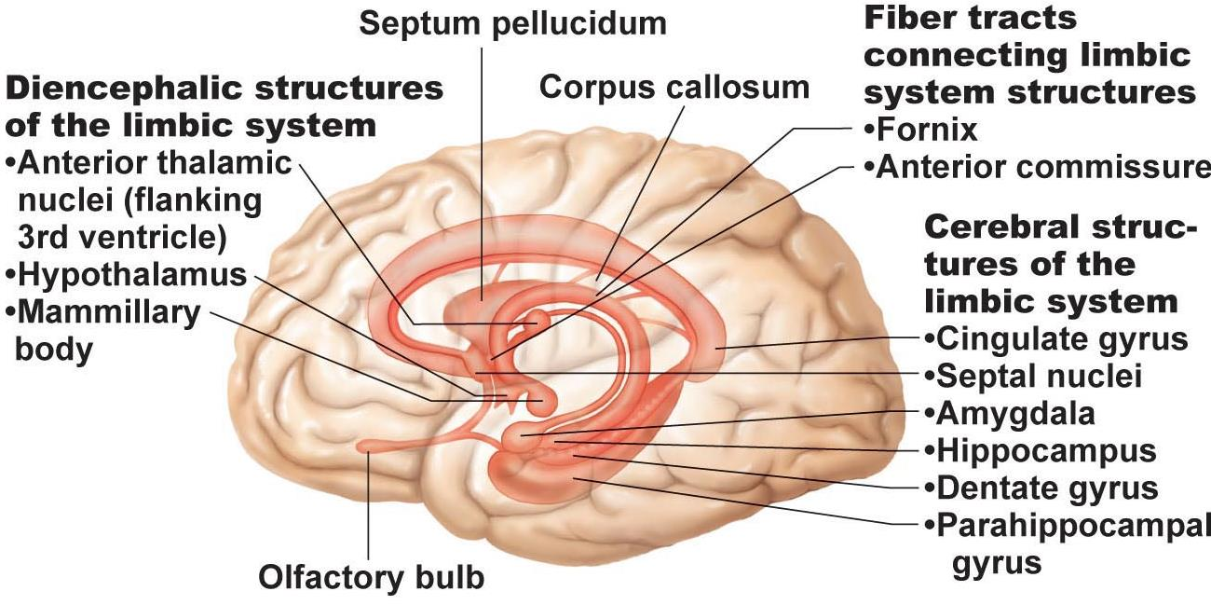

Reticular Formation
- Central core of medullar oblongata, pons, midbrain, neurons project to hypothalamus, thalamus, cortex, cerebellum, spinal cord
- Reticula activating system (RAS):
- Maintains arousal of brain
- Filter for incoming signals (RAS & cerebral cortex disregard ~99% of all sensory stimuli)


