PATH3610:
(Hypo – reduced)

General Pathology

Pathology of organ systems
Disease – pathology – pathos means suffering
- Lesion is a structural change
- Cause (of disease) can also be referred to as etiology
- Pathogenesis is how a lesion develops (the cause, mechanism and lesion)

Cellular Injury and Adaptation – cell death
- The degeneration of cells and cell death are seen as:
- Ulcer
- Pus
- Burn
- All of which are made up of dead cells

Stimulus/insult and injury:
- Duration, severity, physiological state
  - Adapt – reversible (stimulus)
  - Degenerate – reversible – (injury)
  - Death – irreversible – (injury)

Adaptation:
- Hypertrophy
- All cells
- if you are training for an event you will stimulate which will include adaptation. With this adaptation and training muscles can get bigger (hypertrophy).
- Atrophy is the opposite
- Hyperplasia
- Labile and stable cells
    - Labile cells are cells that multiply constantly throughout life. stable cells when stimulated will divide, they only multiply when they are needed
- There are some cells that can increase in number during stimulus and adaptation, (taking off shoes and walking around the bottoms of feet get thicker… this is known as hyperplasia) Hyperplasia is an adaptation by stimulus which results in more cells forming. Cells of the skin can undergo hyperplasia.

(atrophia – not fed; -plasia – to form)

Response to injury:
Permanent (post-mitotic) cells: in general conditions these cells do not have a group of cells that are continuously dividing. Cells of the brain (neurons are permanent and do not divide… if lost gone forever). Cardiac myocyte is permanent, and skeletal myocyte as many as you have is the same forever.

Stable cells (resting): the stem cells are resting, very slow, they don’t need to be replaced all the time. Smooth muscle cell (digestive tract and hair on arms). Can replace the cells and it is really slow but normally in resting.
Examples include: fibroblasts, smooth muscle cell, some epithelial cells (liver and kidney)

Labile cells (stem cells): a group of stem cells that are continuously replacing itself. Can recover from injury very quickly. Chemotherapy the labile cells are affected. Examples include: epithelial cells of skin, stomach, intestine. Bone marrow progenitors/stem cells, and target of cytotoxic chemotherapy.

(myo-muscle; cytos -cell; progenitor – ancestor or parent; toxic – capable of causing death_

Response vs healing
Healing is the body’s responses to injuries - healing is by regenerations. It uses the same mechanisms but different name because a different process. Replace dead cells.
Adaptation is a response to a stimulation – it is hyperplasia, hypertrophy, also no response

Principles of healing by regeneration
To regenerate you need stem cells. System is a bunch of organs, you can’t regenerate organs and therefore can regenerate systems. Primary tissue may or may not depending on organ. Supporting tissue can, blood vessels can.
- Systems – no
- Organ – no in mammals
- Primary tissue
- Supporting tissue (fibrous tissue)
- Blood vessels
- Other cells
- Tissue – YES
- Similar cells together (and their product)
- Cell - Yes
Cell cycle:
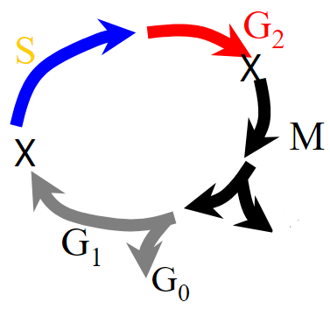
- G0 – Resting - most cells in body. To enter cell cycle and divide there has to be a stimulus.
- G1 – Presynthetic - after stimulus
- S – DNA synthesis
- G2 – Premitotic
- M – mitotic - when cell divides
- Cell division (one or both can continue cell cycle or stay in the resting stage)
- X are check points: when cells divide there are tests done to check if the cell is normal, this checkpoint a cell cycle can be stopped and cell can be killed.

Cell cycle regulation:
Growth factors (GF) (+ and -):
- Epidermal growth factor (EGF)
- Transforming growth factor (TGF) beta
- Insulin like growth factor (IGF)
- Fibroblast growth factor (FGF)
- Vascular endothelial growth factor (VEGF)
There is a balance. If you cut your finger you want it to heal but you don’t want it to grow too long.
Growth factors (GF) make sure there is a balance. Epidermal growth factor was found in urine, some in salvia. (in dogs).
What regulates a cell cycle: hormones (stimulate from a distance), growth factors, and cytokines (affect movement). The inherent characteristics of a cell determine - Embryonic stem cells are found in the blood of fetuses. (pluripotent). Stem cells can regrow anything. A problem is controlling them, if you stimulate they can cause cancer. Adult stem cell: can only grow specific things liver cells only liver, they are restricted differentiation patterns.
(cytos – cell; kine -movement; growth factor – cell growth and differentiation; hormone – stimulates at a distance)

Cell Death – the terminology:
Death of an organism, friend, family member, pet. Death is a normal process in our body. There are different levels of death.
- Macroscopic: Frostbite in fingers which is a macroscopic appearance because of blackness. Pus is also macroscopic. Gross means visual with eyes.
- Histological (study of tissue at microscopic level). Cell death can be a normal component. Skin cells are programmed to die.
- Molecular pathways

Macroscopic appearance and descriptors of necrosis:
- Coagulative – dry gangrene (dry gangrene is frostbite) AKA coagulative necrosis
- Liquefactive necrosis – pus, abscess, wet gangrene
- Caseous necrosis – dead tissue is dry and crumbly
(gangrene – localized death and decomposition of body tissue; caseous – like cheese)

Cell death: Microscopic/histological descriptors; cell swelling:
- Cell swelling (oncotic necrosis)
- Cellular (hydropic) swelling – plasma membrane and organelles injured, dysregulated ion and fluid homeostasis
- Fatty change
- Dead cells look the same as normal cells
- Shrunken cells

Cell death: histology and mechanisms:
- Apoptosis – cell shrink, caspase induced proteolysis (breakdown of proteins)
- Autophagy – cell vacuolated (containing one or more vacuoles), autophagosomes formed (vacuoles), fuse with lysosomes
- Necrosis – oncosis – oncotic necrosis: cells swell, loss of membrane function, enzyme release (basic for tests on serum)
(oncotic – condition of swelling)

Cell Death: Molecular pathways:
- Accidental cell death – trauma, freezing, burns, infarct
- Regulated cell death – 13 molecular subroutines or programs, which occurs depends on injury, time, severity, physiological state
- Programmed cell death – physiologic/embryologic/post embryologic cell death i.e cornification
(cornification – process of making cornified (converted into keratin (fibrous protein like hair, feathers, hoofs) cells of epidermis)

Cell death:
- About 40 BILLION cells die in your body each day
- Efficiently and silently removed by macrophages by process of efferocytosis – silent removal of cell corpses!

Degeneration and death of the whole body – aging – free radicles

Death: growing old gracefully:
- Fountain of youth – megavitamin therapy
- Facial strip/exfoliation
- Botox
- Plastic surgery

death aging theories
- Intrinsic cellular aging
- Chromosomal shortening – telomeres and telomer
- Clock genes – nematodes
- Extrinsic cellular aging
- Lifetime of wear and tear
- Oxygen derived free radicals (ODFR)
- Counteract ODFR with antioxidants
Death: free radical injury:
- Production vs scavengers
- Inflammation
- Microbial injury
- Irradiation
- Aging
death: antioxidants and aging
- Drosophila – alter oxidative pathways
- BMR and aging – higher free radical formation
- Caloric restriction in spiders, guppies, rodents, and dogs. Inconclusive in primates
death: antioxidants
- Natural
- vitamin A, C and E
- Glutathione
- While theoretically beneficial, evidence suggests that vit E supplements are not effective, and may harm.

Things Vascular
- Equine amnion: arteries, arterioles, capillaries, venules, veins. Around the heart – from all the arteries move into the arterioles down to the capillary stage (very tiny structures) out of capillary into the venules into the veins
- Blood is a mechanism that is used by more complex organisms to survive.
- Humans are complex organisms – little channels carry blood throughout the body and circulate

Blood: components of blood:
- Red blood cells (erythrocytes, RBCs)
- White blood cells (leukocytes, WBCs)
- Plasma (serum plus clotting proteins)
- Water and electrolytes
- Proteins – albumin, clotting proteins, globulins (inc immunoglobulins)
- Lipids and carbohydrates
- Serum (fluid without clotting proteins)
Cellular component – important job to carry oxygen (red blood cells), second cellular component is white blood cells. Percentage of red blood cells is around 40%
If you centrifuge blood the top will be plasma (serum is the blood minus the clotting protein. Water electrolytes, proteins, if you were to eat pizza before the top layer would be white with lipids.)

Capillary Bed:

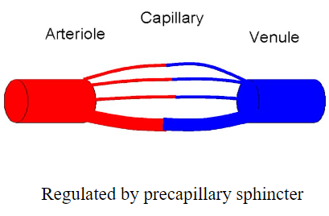
Capillary is where exchange happens. Capillary is a bunch of thin channels, some have red blood cells flowing through some do not. More capillary space in the body than blood. (we are alive because not every capillary have a lot of blood flowing through at one time)
Sphincter something that contracts – precapillary sphincter controls the amount of blood flowing through.
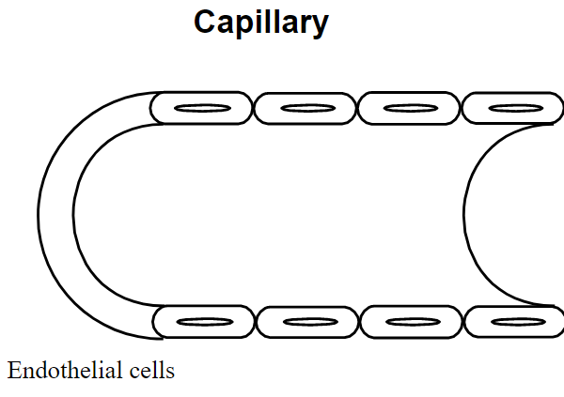
Blood flows at the centre of the vessel, if the vessel is really tiny (capillary) the vessel will have to deform.

Capillary is one cell (endothelial cells) thelial means body/organism endo means inside. Holding in the blood. The cells have little gaps between them and they can open and close. The capillary has the ability to shrink.

Oedema (edema USA):
- Excess extravascular fluid
- Edema vs effusion
- Examples
- Ascites
- Hydropericardium
- Hydrothorax
- Peripheral oedema
60% of the body is made up of water. 2/3 of that is inside cells.
Edema is increased blood. examples of edema. Peripheral oedema is edema in the hands and feet (after an airplane ride).
(hydro – water; ascites – hydroperitoneum; peripheral edema – opposite to central)

Blog output whole, fills up, oedema,

Oedema: starling’s forces of hemodynamics:
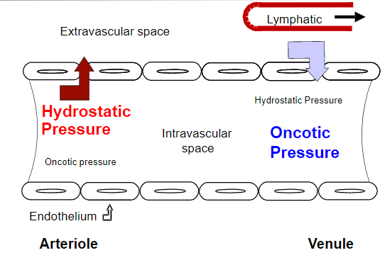
Important diagram –
Precapillary sphincter controls the pressure. Pressure drops from the beginning to the end of the capillary. Drops because the fluid is leaving the capillary.

Oncotic pressure is colloidal osmotic pressure, sucks fluid back in.
Red bloods cells go from bright red to an almost blue colour. Lymphatics take away that extra fluid. Oedema happens almost always at the end,

Oedema:
Divided into two components
- Inflammatory oedema – increased permeability endothelium
- Noninflammatory oedema – everything else

Oedema: mechanisms and causes:
- Increased permeability – inflammation
- Increased venous hydrostatic pressure – heart failure, postural edema
- Reduced oncotic pressure – hypoproteinaemia/hypoalbuminemia, kwashiorkor
- Lymphatic obstruction – removal of lymph node
- Increased total body water – sodium retention
- Albumin found in the blood that causes oncotic pressure
- Oedema a change in circulation:

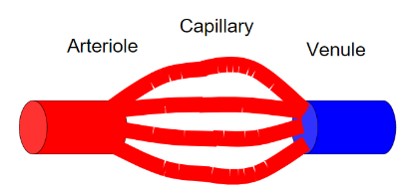
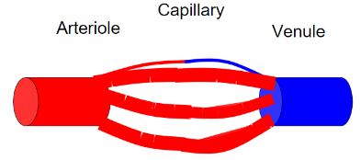
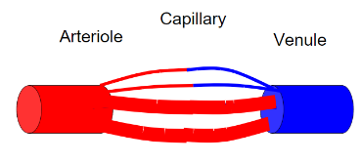
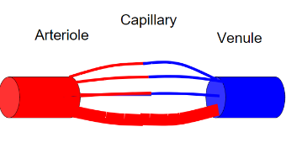
Circulatory disturbances: increased flow
precapillary
Sphincter opens

Hyperemia (hyper – increase, emia – blood) an active process.
- More blood in capillaries
- Hyperemia – active, precapillary sphincter
- Congestion – passive, post capillary obstruction
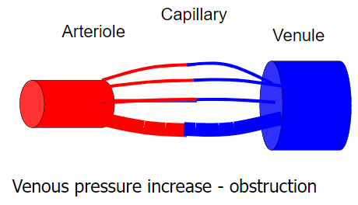
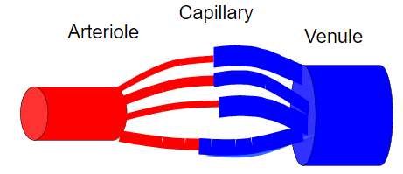
Congestion:
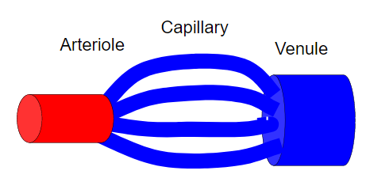
Congestion means a build up in capillaries. Less flow of blood.

Circulatory disturbances: decreased flow
- Ischemia (the stopping of the blood) If you decrease the flow so much that the tissue dies it is called infarction. Part of frostbite is ischemia.
- Reduce FLOW of blood – vasoconstriction
- Infarction
  - Death of tissue due to ischemia
  - Venous (red) or arterial (white)
  - End-artery systems (no collaterals; heart, brain, kidney)
- Two circulatory disturbances: white and red – venous (red) infarct caused by severe congestion
- Myocardial (white) infarct
- Venous (red) infarct
- If you block an artery you will have no blood flowing and therefore tissue will die
- Obstruction of veins could cause edema
Circulatory disturbances: haemorrhage
Haemorrhage (bleeding) occurs because there is some kind of break in the vascular system, dividing haemorrhage into two categories:
- External haemorrhage – bleeding outside the body (including into the stomach and intestines. External haemorrhage can be identified in the feces
- Internal haemorrhage – into cavities (haemoperiteum, haepericardium), into tissue
- Whenever there is haemorrhage it is bleeding by some kind of rupture

Define haemorrhage for how big it is.
In tissue:
- Petechia haemorrhage – pinpoint haemorrhage which are tiny little spots example each of the dots in the hickey
- Ecchymosis haemorrhage - is like a bruise – it is many dots of petechia in one section
- Haematoma haemorrhage – is a swelling of blood, like a blood blister, broken leg and swelling
coagulation
- Blood clot: happens when it is not in a vessel or the blood attempts to stop bleeding. A blood clot is coagulation, it is a gel
- Blood clot in a blood vessel that happens after death is called a post-mortem clot
- Thrombus is a blood clot in a blood vessel in a living organism, if someone get a blood clot in their leg it is called a thrombus
Hemostasis
- If you have a break in a blood vessel, the body has a system to prevent a lot of blood loss. The system is the endothelial cells – cell fragments in the blood called platelets that make the clotting (procoagulant) there is also anticoagulant that interact with coagulation and let blood flow freely
- Endothelial cells
  - Anticoagulant normally
  - Procoagulant when injured
- Platelets
  - Cell fragments of megakaryocytes
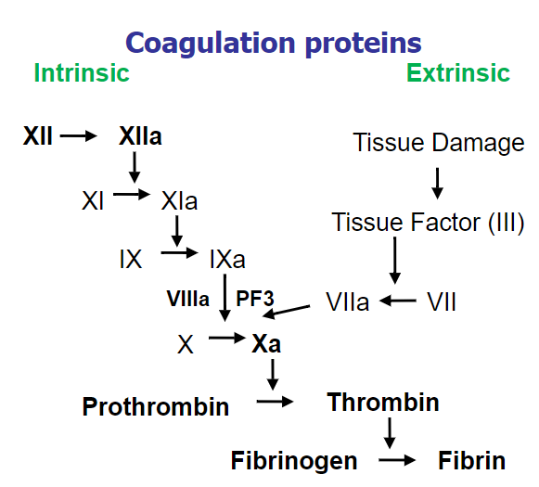
- Coagulation proteins

- Step by step process by which the cells die, there are 13 pathways called subroutines
- Fibrinogen generates fibrin (a gel in the clot made up of fibrinogen and it is the last stop in thrombus there is also thrombin (an inactive molecule, in the body an enzyme will make it active) that can help out with this process)
- Fibrinogen globes together to form fibrin (mesh of fibrinogen molecules (last step in formation of thrombus)) the enzyme thrombin gets fibrin to bind together.
- Prothrombin is an inactive molecule that is activated into thrombin
- Extrinsic operates in body most of the time
- Prothrombin Thrombin: is known as the common pathway

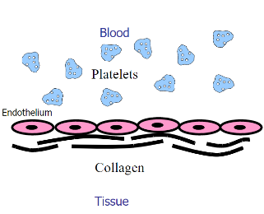
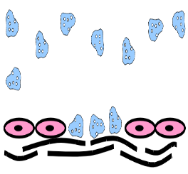
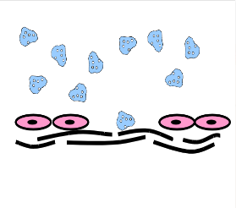
- If someone gets injured the body goes from anticoagulant to procoagulant and the damage endothelium cells are damage, the platelets move towards the injury and form a sticky substance
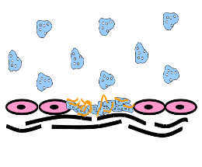
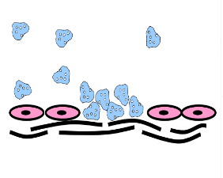
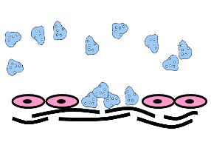
- Platelets stick to one another when cells are damaged and activate extrinsic coagulation. If you have low platelet count you will get petechial.

haemostasis; measurement
- Platelets
- Bleeding time
- Platelet count
- Intrinsic and common system
- Activated partial thromboplastin time (APTT)
- Extrinsic (alternate pathway)
- Prothrombin time (PT)
- The type of bleed you get is petechia which means there is a platelet tissues
- Measurement of platelet function includes bleeding time (poking finger and time how long it takes to stop) can also APTT and PT
- Coagulation - Pulmonary thrombus – thrombus in the pulmonary artery (lungs)
thrombogensis
- Endothelial injury occurs in atherosclerosis (fat, cholesterol,) severe trauma damages endothelial cells, surgery then endothelial cells may be affected developing thrombi is called thrombogenesis
- Altered blood flow: Stagnation of blood flow is common in legs, develop thrombosis in deep vein
- If you go on a long plane ride (25% approx. will develop) travel related venous thromboembolism
- Hypercoagulability (increased risk) – smoking, obesity, cancer, chronic – more likely to develop deep vein thrombosis
Disseminated intravascular coagulation
- A severe complication of excessive thrombosis
- Thrombi in many capillaries
- Consumption of platelets and clotting factors
- Infarction, petechae and excessive bleeding (prolonged bleeding time, PT and APTT, and platelet deficiency)

embolism
- Thrombotic (pulmonary thromboembolism, PTE)
- Gas (decompression sickness – DCS, the bends)
- Air (injection)
- Marrow (fractures)
- Neoplastic (cancer)
shock
- Widespread hypoperfusion of tissues and cells
- Causes
- Neurogenic
- Hypovolemic
- Cardiogenic
- Septic
- Anaphylactic

Immunology
innate immunity:
- Non-antigen specific host defenses that exist prior to exposure to an antigen and involve anatomic, physiologic, endocytic and phagocytic, anti-microbial and inflammatory mechanisms, and which exhibit no adaptation or memory characteristics
- Innate- immune before being exposed (hours)
adaptive immunity:
- Host defenses that are mediated by B- cells and T- cells following exposure to antigen that exhibits specificity, diversity, memory, and self non-self discrimination
innate vs adaptive
- Adaptive- learns from being exposed, works better than innate after initial exposure (days)

Innate immunity:
- Minutes to hours
- Limited and fixed specificity
- Response to repeat infection is the same
- Major components are barriers, phagocytes, pattern recognition molecules

- Adaptive immunity:
- Days
- Highly diverse; improves during course of response
- More rapid and effective response on subsequent exposure
- Mediated by T and B- cells; antigen specific receptors; antibodies

immune system overview
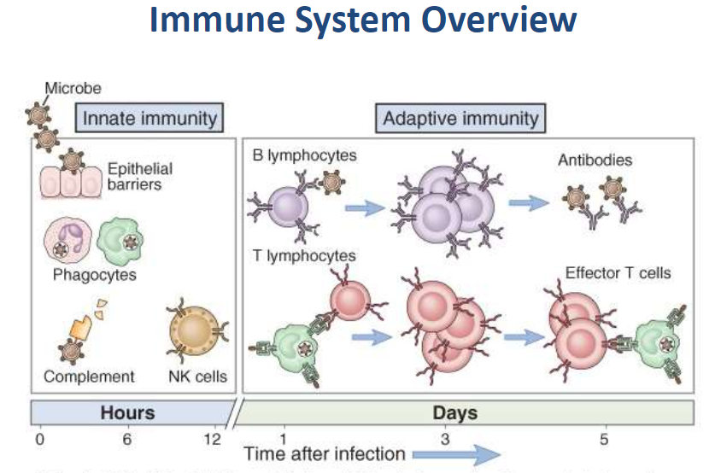
Body has natural defenses (acids, proteins, enzymes, etc) they kill bacteria and viruses
Phagocytosis
Eats pathogen (digest bacteria with lysosomal enzymes)
Recognize pathogens through receptors

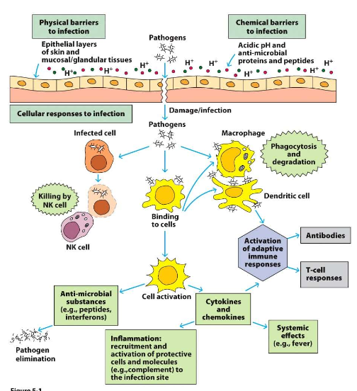
innate immune mechanisms
- Mechanical
- Soluble/chemical
- Biological
- Cellular

anatomical barriers and mechanisms
- Antimicrobial peptides
- Enzymes
- Acidic pH
- Normal flora
- Mechanical
- Directional flow or fluid
- Cilia
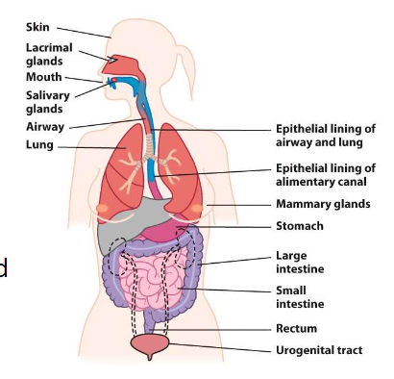
- Coughing, sneezing
antimicrobial proteins and peptides
- Lysozyme
- Saliva, tears and fluids of respiratory tract
- Cleaves peptidoglycan of bacterial cell walls
- Surfactant proteins SP-A, SP-D
- Secretions of respiratory tract, other mucosal epithelia
- Block bacterial surface components, promote phagocytosis
- Antimicrobial peptides
- Alpha and beta – defensins and cathelecidins
- Secreted by epithelial cells, neutrophil granules
- Interact with lipid bi-layers of bacteria, fungi, parasites and virus
- Others
phagocytosis
- Engulfment and internalization of materials such as microbes for their clearance and destruction
- Microbes are recognized by receptors on phagocytes
- May recognize pathogen – associated molecular patters (PAMPs)
- May recognize soluble opsonin proteins bound to microbes
cells of the immune system

Myeloid progenitors
- Red blood cells
- Granulocytes
- Neutrophils- kills pathogen directly (phagocytic cell)
- Basophils and mast- allergies
- Eosinophils- antibody coated parasites
- Monocytes- in tissue and can differ from macrophages and dendritic cells
  - Marcophages- activation of bactericidal mechs and antigen presentation (phagocytic cell)

  - Dendritics- antigen uptake in peripheral sites and antigen presentation (phagocytic cell)
- Megakaryocytes
Lymphoid progenitors
- B lymphocytes (phagocytic cell)
- T lymphocytes
  - CD4+ T helper cells
    - Th1, Th2, Th17, Treg
  - CD8+ T cytotoxic cells
  - NKT cells
- Natural killer cells (NK)
  - Kill infected body cells

granulocytes
Neutrophils: function – direct harm to pathogens by phagocytosis and activation of bactericidal mechanisms
Basophils and Mast Cells: function – inflammation, allergy, non-phagocytic
Eosinophils: activated function – killing of antibody coated parasites, anti-parasitic activity

monocytes
- Migrate into tissues and can differentiate into macrophages and dendritic cells
macrophages
- Activated function – phagocytosis, activation of bactericidal mechanisms and antigen presentation
dendritic cells
- Activated function – antigen uptake in peripheral sites and antigen presentation

natural killer cells
- Activated function – release granules that kill some virus-infected cells
the complement system
- A group of serum proteins circulating in inactive form
- Once activated, multiple possible outcomes
  - Target cell membrane lysis
  - Chemotaxis
  - Opsonization to enhance phagocytosis

adaptive immune responses

Antibody – mediate:
- Extracellular pathogens
- B cells and CD4+ T cells
- Th2 cells (IL4, IL5, IL13)
- Specific antibodies eliminate pathogens by a variety of effector mechanisms
Cell – mediated
- Intracellular pathogens
- CD4+ and CD8 T cells
- Th1 cells (IFN-gamma)
- Cells including cytotoxic T cells and NK cells eliminate pathogens by a variety of mechanisms

MEMORY IS THE HALLMARK OF ADAPTIVE IMMUNITY:
- PRIMARY RESPONSE – first exposure to an antigen
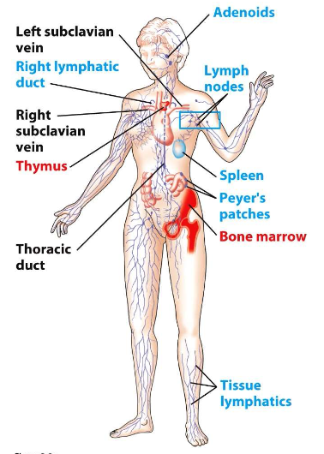
  - Antigen – specific memory lymphocytes are generated
- SECONDARY EXPOSURE to the antigen stimulates memory lymphocytes
  - Yields response of greater speed and magnitude
Lymph
- PRIMARY LYMPHOID ORGANS:
  - B cells (bone marrow)
    - Soluble or membrane bound (BCR)
    - Receptors bind antigens directly
  - T cells (thymus)
    - Membrane bound (TCR)
    - Receptors need antigen in self antigen?
- SECONDARY LYMPHOID ORGANS
  - Lymph nodes
  - Spleen
  - MALT – mucosal – associated lymphoid tissue
Antigen
- Lymphocyte antigen recongnition molecules:
  - B- cells – soluble or membrane bound Ig (BCR)
  - T- cells – membrane bound T cell receptor (TCR)
- Antigen presenting cells (APC) – process antigen and present antigenic peptides on their cell surface
  - Macrophages, dendritic cells and B cells
- Naïve T cells are activated by APCs to differentiate and become effector cells
  - CD8+ T cells go on to become killer T cells
  - CD4+ T cells differentiate into several different subsets
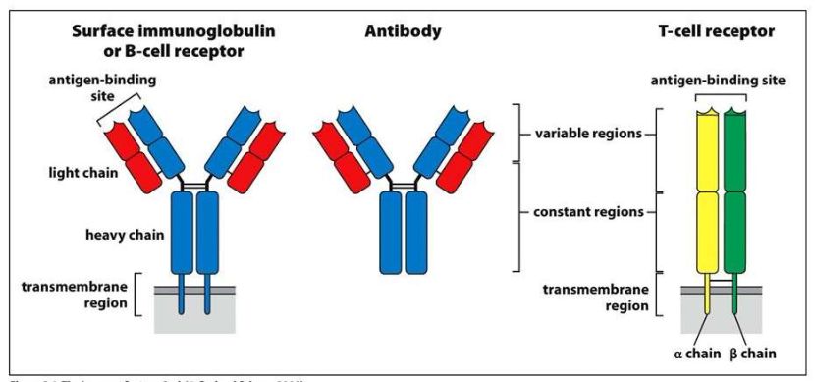
lymphocyte antigen receptors

antigen specific recognition (b-cells)
- Antibody and B-cell receptors bind antigen directly, but T-cell receptors require antigen presented in the context of self antigen (MHC)
- Each lymphocyte recognises only 1 epitope
antigen presentation
- Major histocompatibility complex (MHC) required for antigen presentation to T cells and are responsible for graft rejection
- Antigen processing – cellular pathways that lead to antigen degradation and association with MHC
- Antigen presentation – appearance of MHC – peptide complexes on cell surface for recognition by T cells
  - There are two different forms of MHC
the role of the mhc and expression patterns

- Class I – presents intracellular antigen peptides
  - Self proteins or cells infected with viruses
  - “checking” that cells are self and are healthy
  - Presents to CD8+ T cells

- Class II – presents extracellular antigen peptides
  - More restricted; generally found only on antigen presenting cells
  - Helps to direct immune response according to pathogen
  - Presents to CD4+ T cells

  - *Immunoglobulin – all antibodies are immunoglobulins, but not all immunoglobulins are antibodies
antibody-mediated effector functions
- Neutralization
- Opsonization
- Complement fixation
- Antibody-dependent cell mediated cytotoxicity (ADCC)
- All nucleated cells
- Fas-fasL (ligand) interaction
- Granzyme/perforin mediated cytolysis

CTL-mediated killing: The CTLs (Cytotoxic T Lymphocytes), also known as killer T-cells, are produced during cell-mediated immunity designed to remove body cells displaying a foreign epitope, such as virus-infected cells, cells containing intracellular bacteria, and cancer cells with mutant surface proteins. The CTLs are able to kill these cells by inducing a programmed cell death process known as apoptosis

Dysfunctions of immunity

Two broad categories:
- Overly active or misdirected immune responses
  - Over activity (allergies/asthma)
  - Autoimmune disease (e.g. multiple sclerosis, Crohn’s disease)
- Immunodefiency
  - Primary (genetic) loss of immune function
  - Secondary (acquired) loss of immune function (HIV
allergy – type -1 hypersensitivity
- Hypersensitivities are caused by overreaction to stuff that doesn’t pose a danger to the person (allergies)
  - Mediated by IgE (allergen specific) (on own isn’t destructive)
  - If exposed to allergen the mass cell degranulates and releases all the mediators (cause symptoms) outcome depends on exposure level or times exposed
Autoimmunity
- Result of a failure in tolerance toward inactivation/elimination of self-reactive lumphocytes
- Can’t distinguish between good and bad cells
- Enables T and B cells attack own tissue
- May be organ – specific or systemic
- May involve antibodies, T-cells, immune complexes, or a combination of these elements
Tolerance
- Tolerance- prevention of immune response against self structures
- 2 types

  - Central - delete self-recognizing lymphocytes before mature
    - inside bone marrow

  - peripheral – eliminates, regulates or renders self-reactive lymphocytes non-responsive
    - cells that avoided central
    - outside bone marrow
      - apoptosis- destroyed

Development of autoimmunity
Intrinsic and extrinsic factors can influence susceptibility to autoimmune disease:
- Genetic and environmental factors
  - Environmental- diet diference, geographic area
- Genetic susceptibility - alleles
  - MHC genes linked to specific autoimmune disorders
- Self-reactive T-helper cells
  - Autoreactive Th1 cells secreting IFN-gamma multiple Sclerosis
  - Dictates nature of disease
    - Ex) T1 promotes MS
autoimmunity

Can be organ specific
- Type 1 diabetes
  - Might be environmental because of increase in past years
  - Attacks insulin-producing beta cells
  - CD8 cytotoxic T cells (activate macrophages in pancreas)

Systemic
- Systemic lupus erythematosus (SLE)
- More common in women (9:1)
- Auto – Ab against DNA, histones, other self structures
- Spectrum of symptoms dependent on the specificity of auto-antibody produced:
  - Fever, weakness, arthritis, skin rashes, and kidney dysfunction
primary immunodeficiencies
- Can vary in severity from mild to nearly fatal
- Can be loosely categorized as affecting innate or adaptive responses
- Severe combined immunodeficiency (SCID)
  - Genetic defects leading to a lack of functional T cells in the periphery
  - Bubble boy disease
  - Treatment by replacement therapy and/or bone marrow transplant
- B cell immunodeficiency

  - Hyper IgE syndrome
    - Job syndrome
    - Characterized by skin abscesses, recurrent pneumonia, eczema, and high concentration of serum IgE
    - Causes dysregulation of T-helper pathways
    - May be accompanied by facial abnormalities and bone fragility

  - Selective IgA
    - Affects 1:7
    - B cells unable to differentiate into IgA-Ab secreting plasma cells
    - Susceptible to respiratory or GI tract bacterial infections
    - Other antibody isotype levels remain normal
    - Susceptible to respiratory and genitourinary tract bacterial infections

- Disruption of Innate components
  - Leukocyte adhesion deficiency
    - Limits leukocyte recruitment to inflamed areas
  - Chronic granulomatous disease
    - Defect in NADPH oxidative pathway used by phagocytes to generate reactive oxygen species
  - Chediak-higashi syndrome
    - Lysosomal storage and transport
  - Mendelian susceptibility to mycobacterial disease
  - Complement deficiencies are relatively common
- Secondary immunodeficiencies – acquired immunodeficiency causing heightened susceptibility to common infectious agents and opportunistic infections
  - Causes- drugs, malnutrition, HIV, metabolic disease
- Human immunodeficiency virus (HIV-1)
  - HIV-1 is spread by intimate contact with infected body fluids
  - Dendritic cells in virus-exposed areas may take up and harbor virus, passing it to CD4 T cells
  - Acute phase
    - Anti-HIV antibody
  - Asymptomatic phase
    - Slow decrease in CD4+ T cells
    - Increase in viral load
  - AIDS
    - Depletion of CD4+ T cells
    - High concentration of HIV blood

Healing – inflammation and repair

overal scheme in healing
- Stimulus – injury
  - Direct injury
  - Damage-associated molecular patterns (DAMPs)
  - Pathogen-associated molecular patterns (PAMPs)
- Local response
  - Primitive response is phagocytosis and hypertrophy/hyperplasia
  - Inflammation-reaction of blood vessels
  - Repair
- Systemic response
inflammation
- ‘-itis’ work
  - Rhinitis, pharyngitis, tracheitis, bronchitis
  - Hepatitis, dermatitis
  - Pneumonia
  - (rhino-nose; hepaticus-liver; pneumon-lung)
- Initial
  - Minutes/days
  - Major ‘players’ – plasma, neutrophils
- Long term
  - Weeks
  - Major ‘players’ – fibrous tissue, macrophages, lymphocytes, plasma cells

Acute inflammation:
- Clinical signs (observations one makes in order to make a diagnosis)
- Inflammation clinical signs (written in Latin):
  - Rubor (red)
  - Tumor (swelling)
  - Calor (heat)
  - Dolor (pain) (you cannot see may be a symptom but you can feel for a person)
  - Loss of function

Inflammation:

- Inflammation good
  - Neutralize the stimulus/agent
  - Prepare for healing
  - Can dilute and wash away an agent (cold/flu: runny nose is to flush away infectious agents)
- Inflammation bad
  - Life threatening to critical organs
    - Lung, swelling of the brain

Healing: inflammation; Major components of inflammation
- Vascular (fluidic) phase – increasing blood flow to provide building blocks for healing
- Cellular phase – cells enter the blood for healing
- Reparative phase – connective tissue cells and components – fibroblasts.

Vascular (fluidic) phase
- Extends defences in the blood to tissue – (best dealt with on a local basis)
  - Plasma – proteins, nutrients, fluid
  - Blood vessels – endothelium
- Vascular changes - occur on chemical basis
  - Increased blood flow (amines, prostaglandins, precapillary sphincter must be open)
  - Increased permeability (leukotrienes)
  - Transient vasoconstriction – immediate reaction designed to reduce hemorrhage
  - Arteriolar vasodilation and opens capillaries – red colouring primary because vasoactive amines, prostaglandins, nitride oxide
  - Blood flow increases
  - Circulation slows down due to increased permeability
  - Stasis develops and leukocytes marginate
Permeability increases
- Leukotrienes
- This increase is responsible for inflammatory oedema
Cellular phase – cells
- White blood cells (leukocytes)
  - Neutrophils – can go into tissue within seconds of a stimulus, they are in blood, 1000s in each microliter of blood ( phil = attraction),
  - Macrophages – macro – big, phage – to eat,
  - Platelets
Cellular Phase
- Leukocyte emigration – upregulation of chemokines and cell adhesion molecules, endothelial cells will have a receptor and the cells will have a molecule (selectin ligand) that finds the receptor, then the integrin ligands and ICAM will tell it to stop, PECAM will tell the cell when to leave the blood vessel through endothelial cells, once in the tissue they locate bacterial and dispose of them
- Chemotaxis and leukocyte activation
- Phagocytosis – (process of eating cells)
  - Recognition – as being bad
  - Attachment
  - Engulfment
  - Killing or degradation
- Release of leukocyte products – attracts other leukocytes to come to the area,
Therapy – treatment
- Specific therapy removes the underlying cause (ex – splinter in finger, remove splinter)
- Symptomatic therapy reduces the symptoms (pain control)
- Replace function
Therapy:
- Target of therapy
  - Chemicals that regulate inflammation (vascular and cellular)
  - Chemical mediators (edema, hyperemia, anything to do with inflammation)
  - Pain
Cost benefit analysis
- Beneficial effect
- Adverse reaction – negative
  - Mild adverse reaction – side effect
  - Serious adverse reaction – idiosyncratic reaction
    - Death, life threatening, hospitalization (ex. Amoxicillin)
- The cost benefit analysis ways the pros and cons whether your condition is worth the possible adverse reaction.
- In USA, about 50% of population take prescription medication
- Average number of prescriptions per person -4
- 1.3 million went to the ER with adverse reactions; 124,000 died
Healing: Inflammation; therapy ‘Natural’ therapy:
- Ice – reduces blood flow
- Compression – prevents/reduces edema
- Elevation – drainage of blood through venues system
- Plasma – a lot of proteins, lot of inhibitors or inflammation
- Medicinal leeches – blood removal
Chemical mediators:

- Really important
- They are the targets for pharmaceuticals
- Originate from plasma or cells
- Many act through receptors
- Many cause release of other mediators
- Most are short lived – nano seconds
- Most may have harmful effects – can be very toxic
- Extremely loss dose is required, extremely potent
- Examples (target for treatment of inflammation):
  - Vasoactive amines
  - Arachidonic acid metabolites
  - Cytokines and chemokines
  - Complement system
  - Complement system
  - Others

Vasoactive mediators – vasodilation and permeability

- Histamine
  - Vasoactive amine,
  - Origin – mast cells, insect venum
  - Dilates arterioles (vasodilation)
  - Increased permeability of venules
- ‘Decongestants’
  - Vasoconstrictions
    - Pseudoephedrine (original Sudafed)
    - Levomethamphetamine
    - Ephedrine
    - Tetrahydrozoline (Visine)
- Antihistamines
  - Drying
  - Sedation (nighttime cold/flu, in daytime sometimes there is caffeine)
  - Benadryl (diphenhydramine – stimulating inflammation, cold/flu medication)
  - Reactine, Claritin, etc

Chemical Mediators

- Cytokines
  - Low MW proteins
  - Extremely potent
  - Secreted by cells
  - Act via receptors
- Chemokines
  - Chemotactic molecules
- Por-inflammatory cytokines
  - Prostaglandin
  - Interleukin (IL) -1
  - Tumor necrosis factor alpha (TNFalpha)
- Anti-inflammatory cytokines
  - IL-1 receptor antagonist
  - IL-4, IL-10
  - Transforming Growth Factor (TGF) beta

General anti-inflammatory drugs:

- Steroids (Corticosteroids)
  - Cortisone
  - Dexamethasone
  - Triamcinolone (Nasacort)
  - Work on vascular and cellular phase

- Non-steroidal (NSAIDs)
  - Acetyl salicylic acid, ASA (Aspirin) – reduces the amount of thromboxane and reduces heart attacks
  - Ibuprofen (Advil)
  - Naproxen (Naprosyn)
  - Celebrex and many others

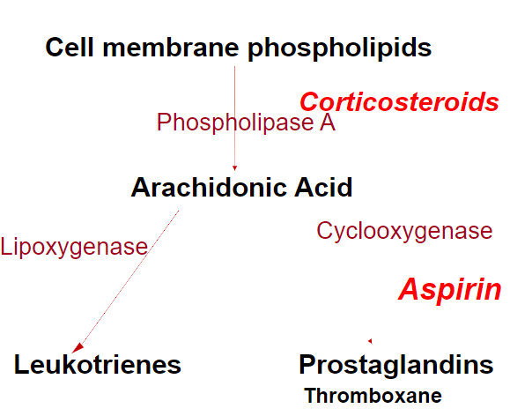
When you damage a cell, you damage the cell membrane and phospholipids, when you damage this it releases the enzyme phospholipase which released arachidonic acid, certain enzymes can breakdown arachidonic acid such as cyclooxygenase into prostaglandins. Also, lipoxygenase breaks down arachidonic acid into leukotrienes
NSAIDS:
- Today’s autoinflammatory target mostly COX 2 and COX3, Asprin targets all three.
- Constitutive (COX 1)
  - Important enzyme that is used by the body for normal function, to maintain the health of the kidney stomach and intestine. Is a constituted
- Inflammatory (COX 2)
  - Target of modern day NSAIDS
- Inflammatory (COX 3)

Analgesia (pain control)
- Local analgesics – only work in a local area, injected into the nerve in the area needed
- Systemic analgesics – work throughout the whole body
  - Narcotic
  - Non-narcotic
    - Acetaminophen
    - NSAIDS
- Pain is a signal that something is wrong, pain is good, having something painful is not good. Some pain can induce shock.
Pain – Local analgesics
- Short acting
- Suitable for small area – tend to be quite toxic so they are used in local tissue they don’t have a lot of systemic effects (unless epidural or major nerve block)
- Cocaine, procaine, lidocaine (Xylocaine) is used mostly today
- Menthol – throat candies
- Salicylic acid – also in Asprin

Pain – Systemic analgesics

- Narcotics (opioids)
  - Opium (use to be in coca-cola), heroin, morphine, demoral, fentanyl
  - Tramadol
  - Addictive
- Non-narcotics
  - Acetaminophen (Tylenol, paracetamol) – works on nerves primarily, in a higher dose range can have COX2 and therefore could work like an NSAIDs, can be combined with some narcotics, can combined with non-steroidal drugs
  - Non-steroidal anti-inflammatory drugs (NSAIDs) - works on cytokines

Site of inflammation:
- Local reaction
  - Preferred handling of injury
- Systemic reaction
  - Spill over of inflammatory cytokines to blood
  - Reaction within blood
  - Systemic inflammatory response syndrome (SIRS) when severe change for a lot of cytokines heading in the blood or reactions within the blood
Systemic effects – Acute Phase Response
- Fever (pyrexia)
- Shivering, chills, somnolence (sleepy), anorexia (lack of desire to eat), malaise, arthralgia (sore joints), myalgia (sore muscles)
- Leucocytosis (increase in the number of leucites in the blood)
- Acute phase protein release – fibrinogen
(arthron – joint, myon – muscle, algia – pain, pyr – fire, an- not, leuco – white, cytos – cell)

Systemic effects:
- Degeneration, cell death +- inflammation
- Cytokine release
- Systemic circulation
- Target tissue
  - Brain – thermoregulatory center
  - Liver – acute phase protein release is produced
  - Joints – chondrocytes
  - Muscle – myocytes

Midterm 1 exam:
- 20 marks, 12 MC – selected from all parts
- 8-mark question will be short answer (about a story so one huge question)
- 40 minutes
- Including Monday lecture

Chronic’ Inflammation
- After initial phase of inflammation
- Repeated bouts of inflammation
- Insidious smouldering reaction
- Proliferation of mature tissue – fibrous tissue
- Chronic means something that lasts at least 3 months
Types of inflammation
- Helps determine the cause and outcome
- Neutrophilic
- Eosinophilic – eosin is a stain, stains red, where there is an allergic reaction or parasites
- Lymphocytic plasmocytic
- Histiocytic and granulomatous
Granulomatous inflammation
- Bacteria
  - Tuberculosis (mycobacterium tuberculosis)
  - Leprosy (M. leprae)
  - Syphilis (Treponema pallidum)
- Fungi
- Inorganic substances/foreign material
  - Asbestos, silica

- Chronic (up to 40 years)
- Dominated by macrophages with lymphocytes and with multinucleated giant cells (Langerhans cells) and typified by granuloma formation

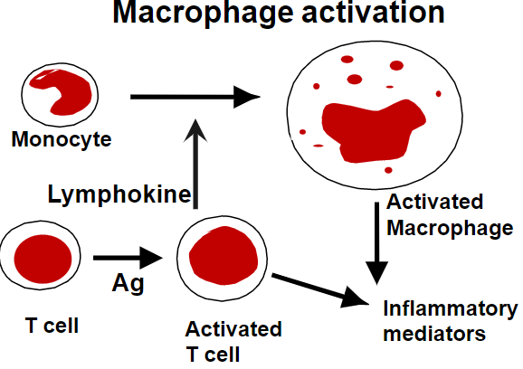
Macrophage
- Activated by activated T cell (antigen attached to T cell) which releases a lymphokine that activates the macrophage
- Very good at producing inflammatory mediators
- What happens when you have foreign material in the body (splinter) anything in the body that is not supposed to be there
Regeneration or repair
- If the body can regenerate it will
- You scar because you cannot regenerate

basic steps
- First step is to get rid of all damaged material (macrophages)
- 2nd is growing blood vessels and cells to replace existing tissue
- 3rd close the wound as much as possible
- 4th angiogenesis- getting blood (nutrients, WBC, etc) to the area
- Agent inactivated and removed
- Debride nonviable framework
  - Angiogenesis
  - Migration of cells
  - Proliferation
- Regenerate and repair
Repair – granulation tissue
- Granulation tissue (not the same as granulomatous inflammation)
- Made of Fibroblast and capillaries
- Turns into scar tissue
- Fundamental repair system cannot regenerate (scar formation)
- Lots of granulation tissue= huge scar (keloid) (proud flesh in animals)
- Takes months to heal

wound healing by

- First intention
  - 24 hours – neutrophils
  - 3 days – macrophages
  - 5 days – granulation tissue
  - 10 days – mature collagen - take stiches out at ten days - you get the zipper effect (scars from the stiches)
  - 1 month – scar
- Second Intention
  - Second intention is when you cannot close the wound
  - Large tissue defect – granulation – proud flesh and keloid

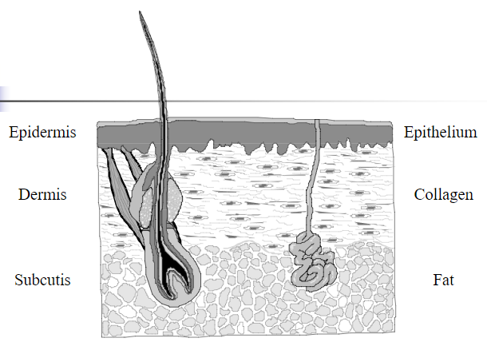
Human skin
- Epithelium (epithelium)
  - regenerates (doesn’t scar)
  - Few cells thick
- Dermis (fibrous tissue)
  - Connective tissue (mostly collagen)
- Subcutis (fat)
- When you cut through the epidermis and dermis you get a blood clot, then granulation tissue, in 5-10 days it slowly changes to scar tissue, the epithelium regrows under the blood clot (crust/scab)
- When you pick a scab the white tissue under is the new epithelium
- Myofibroblast have the ability to contract (shrinks the scar)
- Scar is an altered area of collagen (starts pink than turns white)
- Scar tissue only about 90% as strong as original
deciding factor – stem cells or not
- Determining if it regenerates or repairs
  - Stem cells or not
  - Labile cells regenerate (skin cells)
- Continuously dividing cells (labile)
  - Stem cells replicate and replace terminally differentiated (mature) cells
- Quiescent cells (stable)
  - Most cells are terminally differentiated
  - Some stem cells
- Terminally differentiated (permanent)
Growth factors
- Epidermal growth factor (EGF)
  - EGF- in salvia and urine (why you let a dog lick your wounds) – epithelium
- Platelet derived GF
- Vascular endothelial GF, Fibroblast GF,
  - Angiogenin
- Transforming GF
  - TGF(alpha)=EGF, TGF(beta) (-)
- IL1 and TNF
Modulating healing - systemic
- Heal faster only based on age and if you are malnutrition
  - Extra vitamin C can’t help, zinc, amino acids
- Haematological abnormalities
  - Neutropenia
  - Haemophilia
- Diabetes – WBC, Endothelium
- Corticosteroids
- Chemotherapy
modulating healing – local factors
- Blood supply
- Infection
- Foreign bodies

