Experiment 3: Extraction Methods

By: Alexis Carolan
300018334
Partner: David Difrancescomarino
30002164

CHM1321 Section A02
Demonstrator: Nancy Marina

February 13, 2017
Department of Chemistry
University of Ottawa

Procedure
Please refer to pages 32-33 of the CHM1321 lab manual. We made no changes to the listed procedure during this experiment.

Observations
Table 1: Displays the behaviour of methane blue and methyl red within aqueous ether environments
Compound | Number of Separation Layers | Top Organic Layer Colour | Middle Layer | Bottom Aqueous Layer Colour | Time (s)
Mixture of ether, distilled water, and methane blue | 2 | Clear | None | Blue and Transparent | 2s
Mixture of ether, distilled water, and methyl red | 2 | Red and Transparent | None | Black | 2s
Mixture of ether, distilled water, and methane blue/methyl red | 3 | Red and Transparent | Cloudy | Blue and Transparent | Less than 2s
Mixture of distilled water, 1-butanol and crystal violet with NaCl 0.13g | 2 (saturated) | Dark Purple and Transparent | None | Dark Purple and Cloudy (solute developed here) | Began Cloudy, Cleared after 60s
Mixture of distilled water, 1-butanol and crystal violet without NaCl 0.13g | 2 (larger layer of emulsion) | Dark/Cloudy Purple with a precipitate at the top | Contains lots of emulsion | Clear/Transparent | 30s

In section A of this lab, the observation of what the separation of two separate substances looks like within different colours was allowed. Also, this showed what exactly the emulsion of a substance looks like when sodium chloride is added.

Table 2: Extraction of the Unknown Compound #1
Unknown Compound #1 (0.75mg) and Methylene dichloride | Number of Separation Layers | Top Organic Layer Colour | Emulsion Clarification Time(s) | Bottom Aqueous Layer Colour | Observations
NaOH addition 1 | 2 | Oily and Clear | 30s | Clear | - Visual seperate layers evident when NaOH added  - Emulsion between layers disappeared quickly
NaOH addition 2 | 2 | Oily and Clear | 60s | Clear | - Emulsion took longer to disappear
NaOH addition 3 | 2 | Oily and Clear | 120s | Clear | - Emulsion needed to be swirled in order to disappear quicker
HCl addition | N/A | N/A | N/A | N/A | - Many drops of HCl needed to be added to acidify solution  - Once drops were added, white cloudiness appeared and heat generated  - When mixture turned white it was acidified  - It was placed in a cold-water bath a precipitate formed

With each extraction that occurred, the middle layer took longer to disappear each time that it was added to the sodium hydroxide solution. When the hydrogen chloride was added into the unknown solution, the solution immediately began to acidify and became a white colour with then allowed a precipitate of benzoic acid to develop and be collected.
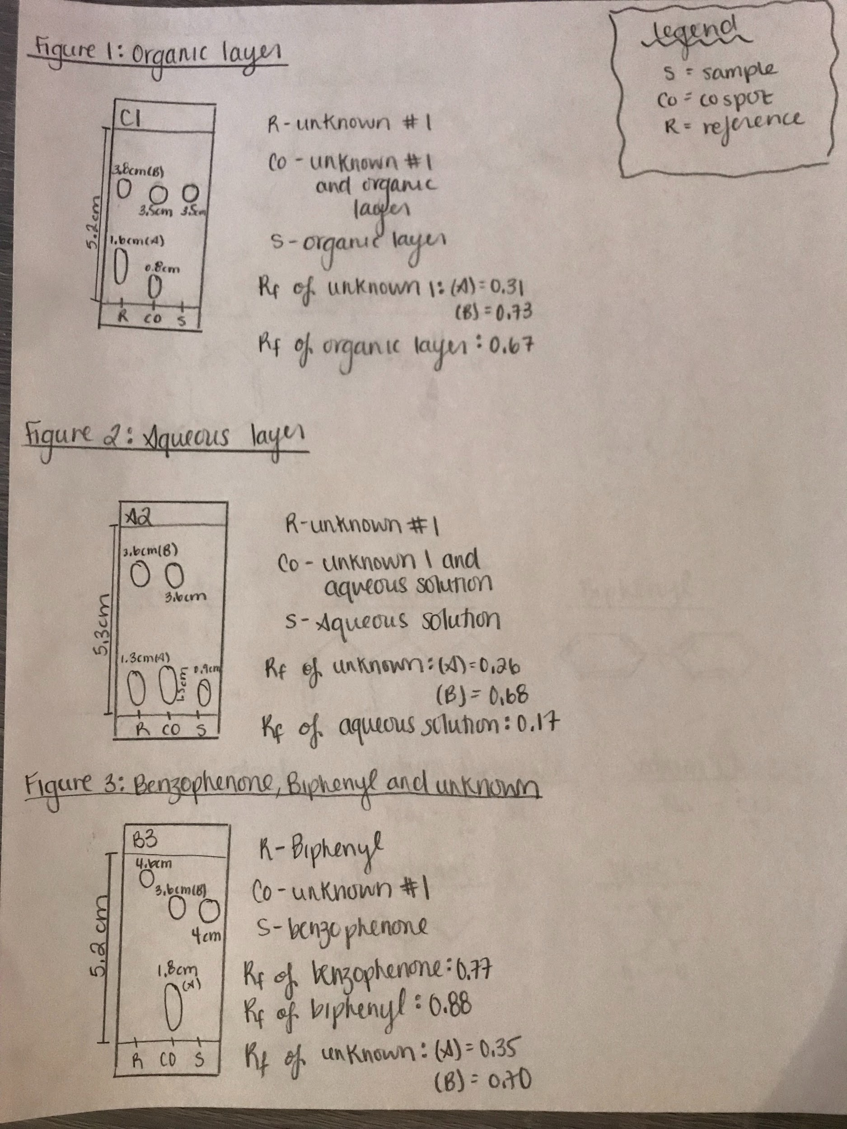
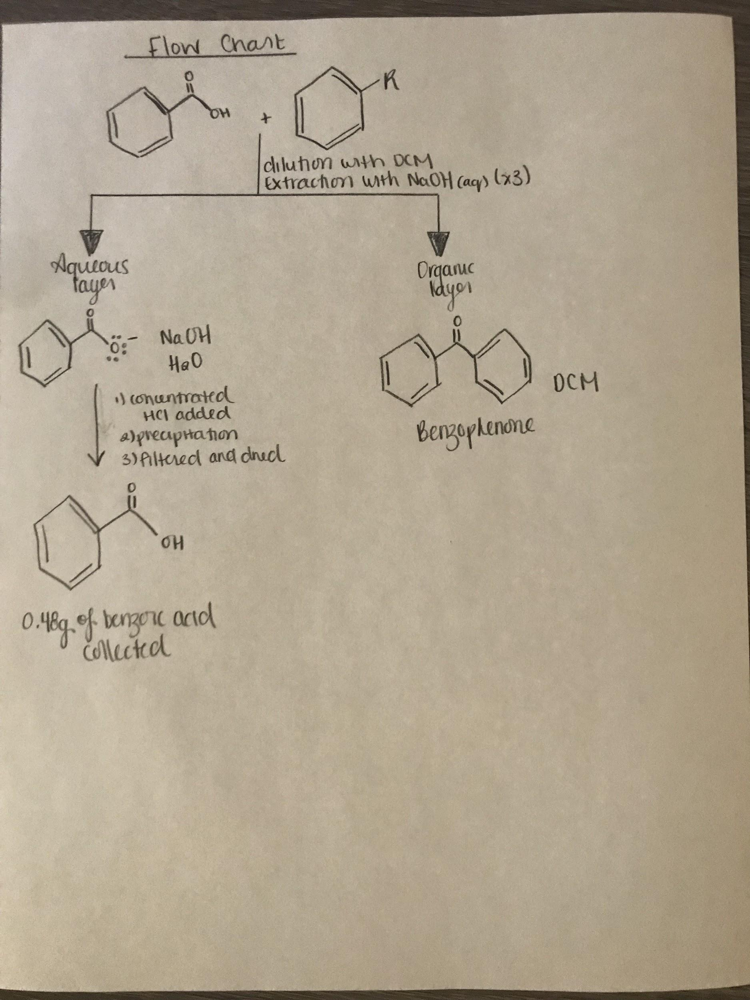

Discussion
In Section A of this lab, the goal was to extract the water-soluble dyes located within the aqueous or organic phases. For the methylene blue mixture, when the dye was added it immediately went to the bottom of the test tube. This is where the aqueous phase is and also, the ethers went to the organic phase at the top. This, occurs because methylene blue has a much greater mass than the ether does and due to the many polar sites, it dissolves within water much easier than ethers. Also, methylene blue is not soluble in ether solutions at all. Within this mixture, methylene blue was complete in the aqueous layer. In part two, methyl red solution was mixed in with distilled water and ether. Methyl red was located in the organic phase and stayed mainly at the top of the test tube. Some methyl red however, was located within the aqueous layer at the bottom. The carboxyl group for methyl red is very polar which allows it to react with the ether and the distilled water as acid base reactions. In this case, the methyl red is contained within both layers as its carboxyl group to bond to both water and ethers, this is where there is no clear separation of methyl red solution. When the two mixtures happened to be mixed together, three distinct layers were formed. What occurred, was that the methylene blue remained at the bottom in the aqueous phase with the water due to its greater density. The middle phase, was a dark colour and contained more water than the methyl red did. The dark colour lightened up when the other methylene blue mixture was added due to how the methyl red is more likely to bond to water molecules than methylene blue since it has a high polarity in the carboxyl group. The organic top phase, remained a transparent red colour but, the layer was thicker because more ether molecules had rose to the top due to their density. As they rose, they attached some of the methyl red in the middle phase to the organic phase. In terms of the methylene blue and methyl red the ether and distilled water is a good way to separate methylene blue and methyl red. This is obvious, when the two mixtures were combined and the methyl red and methylene blue were located within separate layers.

When sodium chloride was being used with the crystal violet solution, there was a substantial difference compared to the mixture without sodium chloride. Without the sodium chloride, the organic layer was a cloudy consistency and not clear due to the two phases not being able to separate properly. When the sodium chloride was added to the solution, an effect called salting out occured. When the sodium chloride was added, the water was strongly attracted to the NaCl which caused ionic bonds to be formed and the crystal violet and the 1-butanol were pushed to the organic layer. This, caused a transparent deep purple colour to occur within the organic layer. The aqueous phase consisted of water and solutes of sodium chloride bonded to the crystal violet which created a dark purple colouring.

In section B of this lab, sodium hydroxide was used in the extraction 3 times due to how it reacted with benzoic acid carboxyl group and separated the hydrogen from the hydroxide group in the benzoic acid molecules. This, allowed the acid removed from the mixture allowing the benzoic anions to combine with the water and seperate the mix from the benzophenone in different phases. The acid, is able to be recovered with the addition of hydrochloric acid. This, protonated the benzoic acid again and allowed filtration of the collection of the benzoic acid. Once this was completed, the extraction has successfully been finished.

The first two TLC plates (figures 1 and 2) depict two things. The first TLC plate, tells us that we have complete a successful separation and this can be concluded because within the organic phase row, there is only one spot which is for benzophenone and no spot for benzoic acid. This means the organic phase is completely separated from the aqueous phase. The second TLC plate, depicts the aqueous phase only contains benzoic acid and there is no benzophenone because of the separation of benzophenone and not biphenyl as there is no spot lining up with the biphenyl and there is a spot that lines up with the benzophenone. Within the unknown mixture, it can be concluded that the unknown sample 1 contains benzoic acid and benzophenone based on the spots on the TLC plate in figure 3.

In this lab, a couple sources of error occured. The first, was the measurement of the substances in the extractions. In section A, some of the dye drops were a little over a drop and this could have skewed the observations recorded in the experiment. Also, the crystal violet separation was not as direct as they were assumed to be prior to the extraction process. Finally, the last error that occured can be seen in the amount of benzoic acid collected in the final extraction. There was 64% of benzoic acid extracted in the unknown solution as recorded in the calculations below. However, by using the composition percentage there is only 40.13% of benzoic acid located within the mixture using theoretical calculations.

(Note that figure 4 below, shows the drawing of the molecules in the substances used in this lab.)

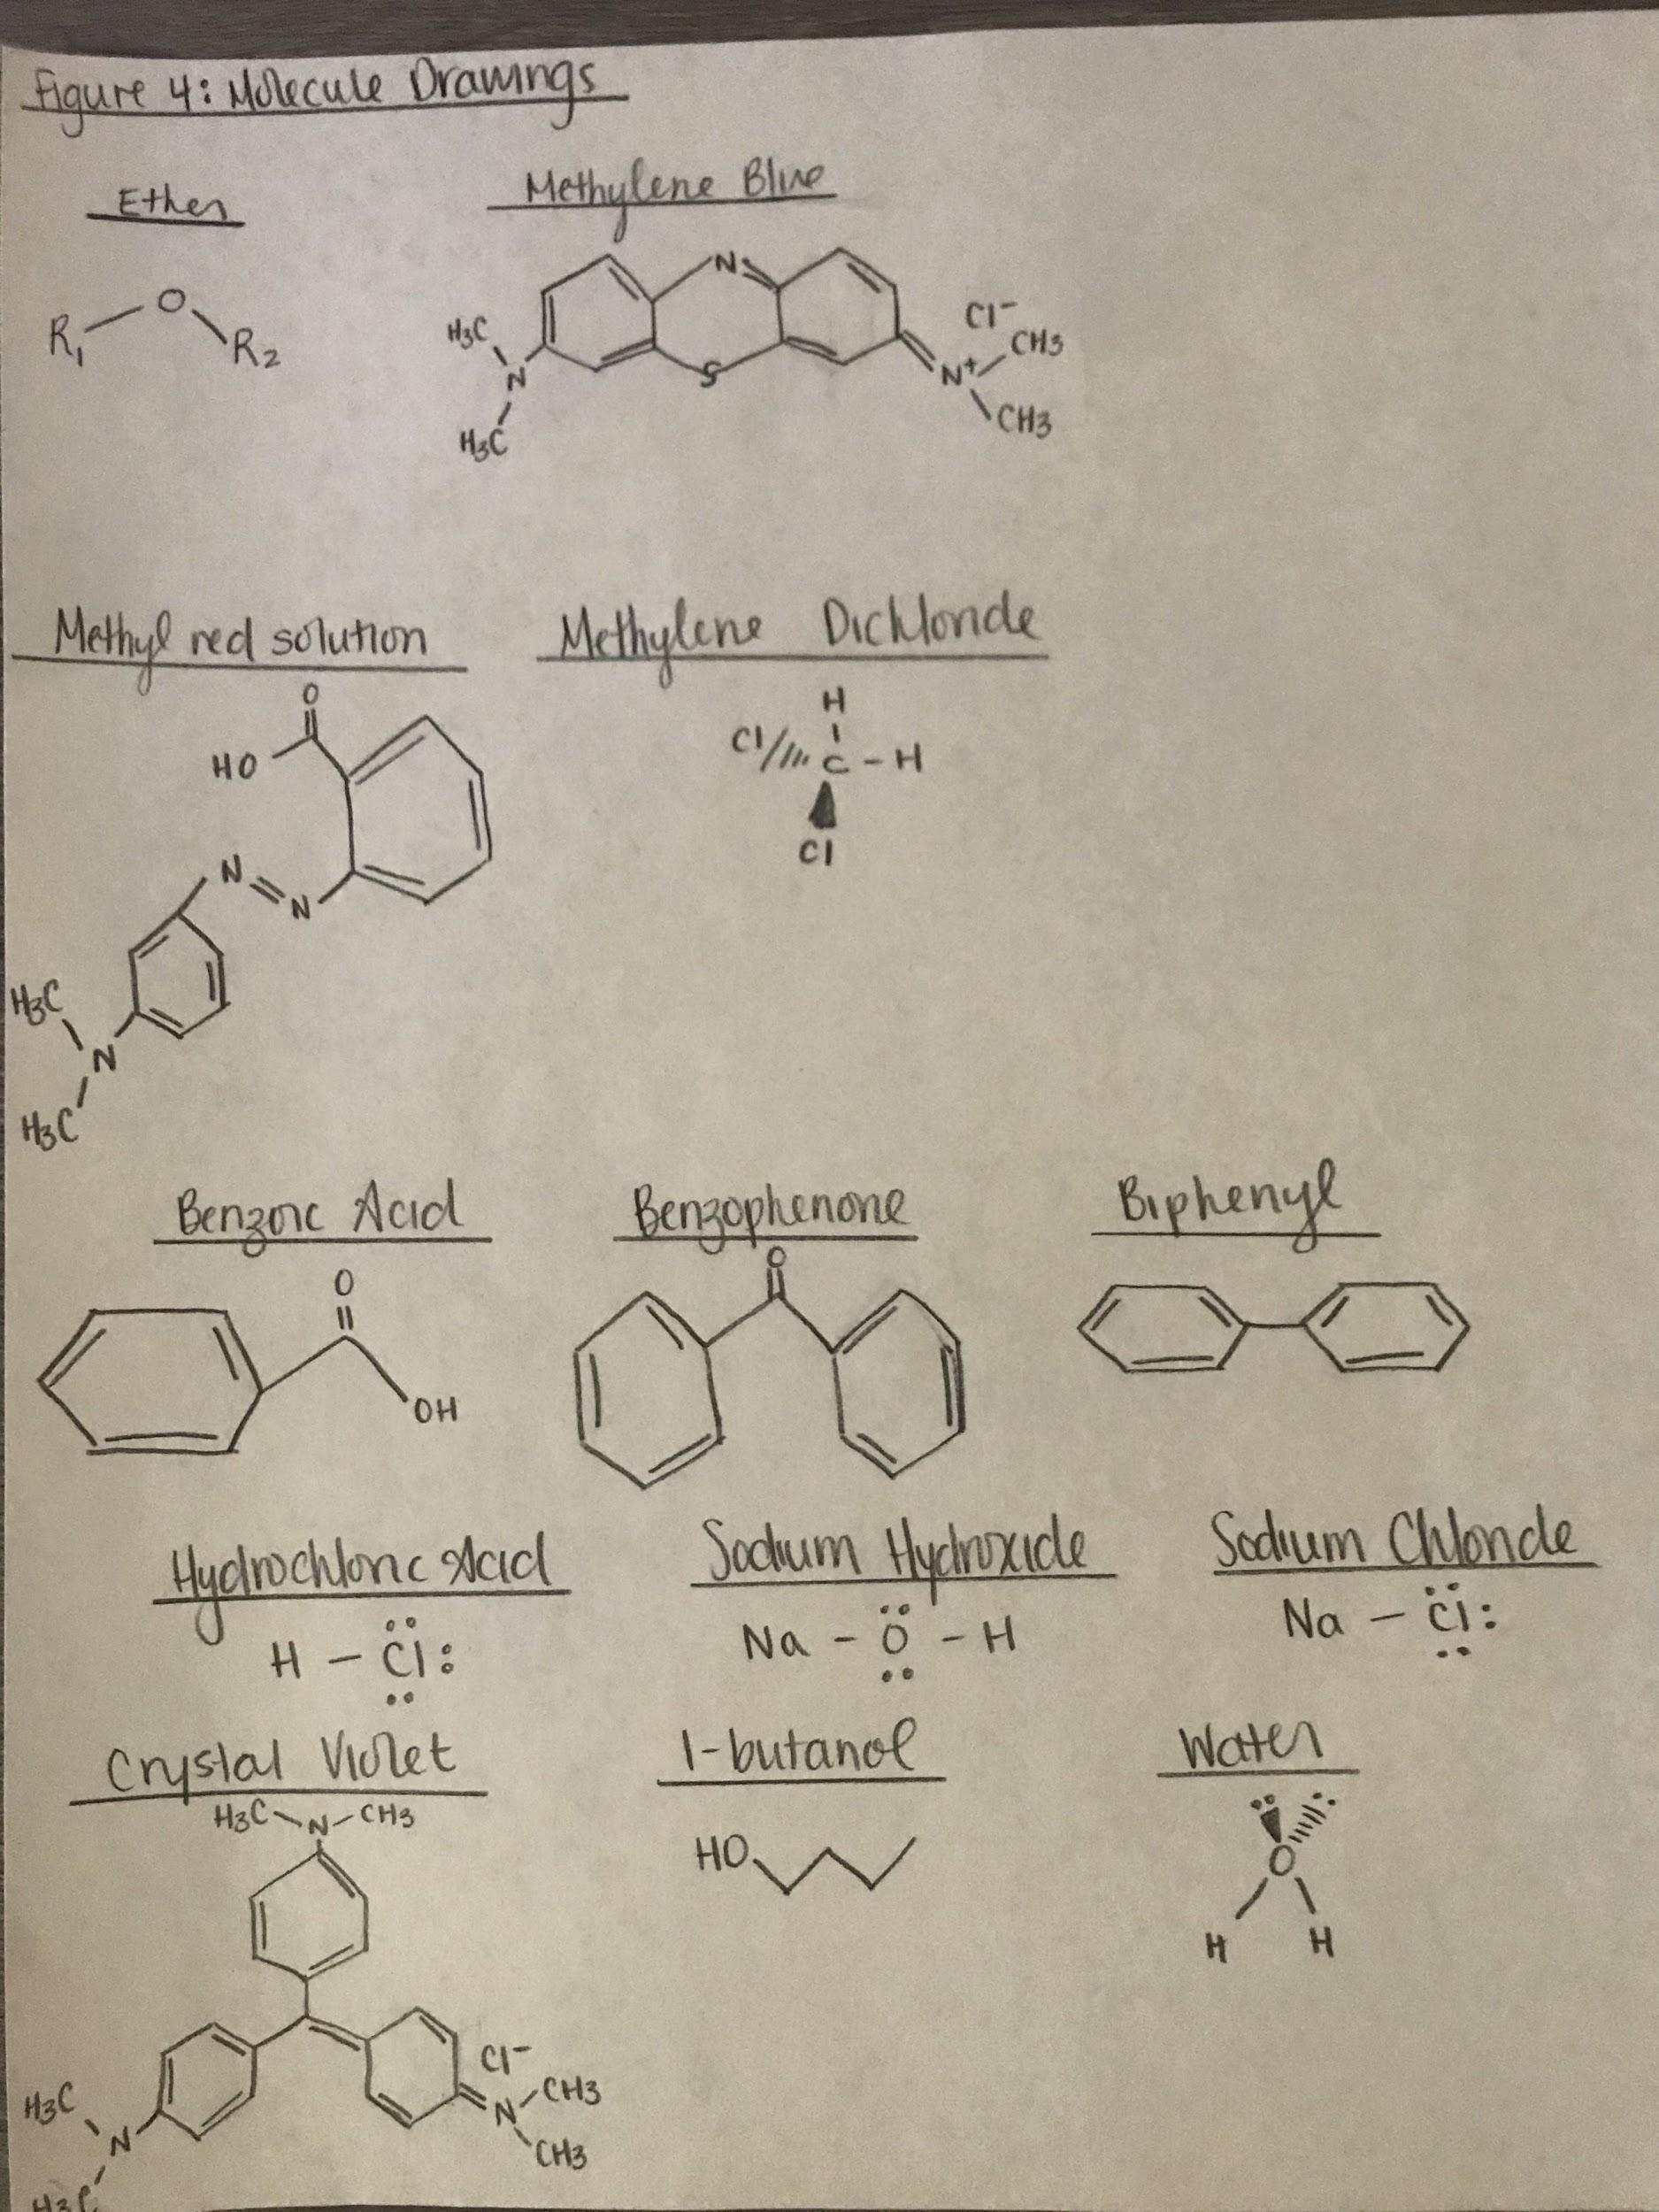

Table of Results
Table 3: Extraction of Benzoic Acid from the Unknown Compound
Unknown Number | Initial Mass (g) | Mass Obtained (g) | Composition | Composition Percentage
1 | 0.75g | 0.50g | Benzoic Acid and Benzophenone | 40.1% Benzoic Acid and 59.9% Benzophenone

Post-Lab Questions
- It would be quite difficult to perform an extraction using ethanol and water due to how ethanol is a highly miscible substance in water. For ethanol, its polar hydroxyl group is extremely attracted to water. This, cause the ethanol to deprotonate and a strong acid-base reaction is caused and hydronium ions are created along with ethanal. This reaction, would first occur in the vast majority of the extraction and therefore they would not be good extraction solutions.
- By adding sodium chloride to the methylene blue ether and distilled water solution, there would be a decrease in the amount of dye within the aqueous layer. This, is due to how the NaCl would bond ionically to the water and push some of the methylene blue into the ether organic layer. This then would cause the ether organic layer to disperse the methylene blue throughout the entire mixture and skew the purpose of using an extraction.
- KD = (W1/V1)/(W2/V2)
KD = (2.0g/100mL)/(20.0g/100mL) = 0.10
KD = (1.8g-Y/100mL)/(Y/100 mL) = 0.10
Y = 1.64g
Therefore, there would be 1.64g of compound Y removed from the water and ether solution within a single extraction.
4. KD = (W1/V1)/(W2/V2)
KD = (2.0g/100mL)/(20.0g/100mL) = 0.10
KD = (1.8g-Y/100mL)/(Y/50mL) = 0.10
Y1 = 1.50g
1.8g - 1.5g = 0.30g
KD = (0.30g-Y/100mL)/(Y/50mL) = 0.10
Y2 = 0.25g
Total extraction= Y1+Y2 = 1.5 + 0.25 = 1.75g
Therefore, there would be 1.75g of compound Y removed from the solution of water and ether when using two extractions.
5. If the student happened to lose track of which is the organic layer and which is the aqueous phase, then the student could add a couple drops of distilled water to their solution. This addition of distilled water, will cause the water to move to the aqueous phase. Once the student adds the water, they would then be able to observe exactly which layer the drops shifted towards. This, will indicate where the aqueous layer is located as the water will disperse into the aqueous layer.
6. In order to separate naphthalene(which is not a base) and benzyl amine (which is a base) the process would be very simple. Due to how benzylamine is a base, it will react with an acid, like sulfuric acid, whereas naphthalene would not. The benzyl amine will then proceed to be converted into a cationic salt form which, is a soluble when in aqueous water solution leaving the naphthalene in the organic layer. The cationic salt from of benzyl amine along with the aqueous solution can then be extracted from a separator funnel. After this, then it can be pronated with hydrochloric and returned back to its original benzyl amine state.

Calculations
Rf value calculations:

RF = (d1) displacement of compound / (ds) displacement of the solvent
= 3.5/5.2
= 0.67

Composition percentage calculation:

Composition percentage = molar mass of benzoic acid x100%
molar mass of total unknown 1

percentage yield = 122.123 x100%
304.345
percentage yield = 40.13%

Percentage yield calculations:

percentage yield = actual yield x100%
theoretical yield

percentage yield = 0.48 g x100%
0.75 g

percentage yield = 64%

Conclusion
For this lab, the purpose was to separate the organic molecule by using different acid and base reactions and eventually extract the wanted organic molecule. This was accomplished by using a process referred to as, extraction.

Raw Data
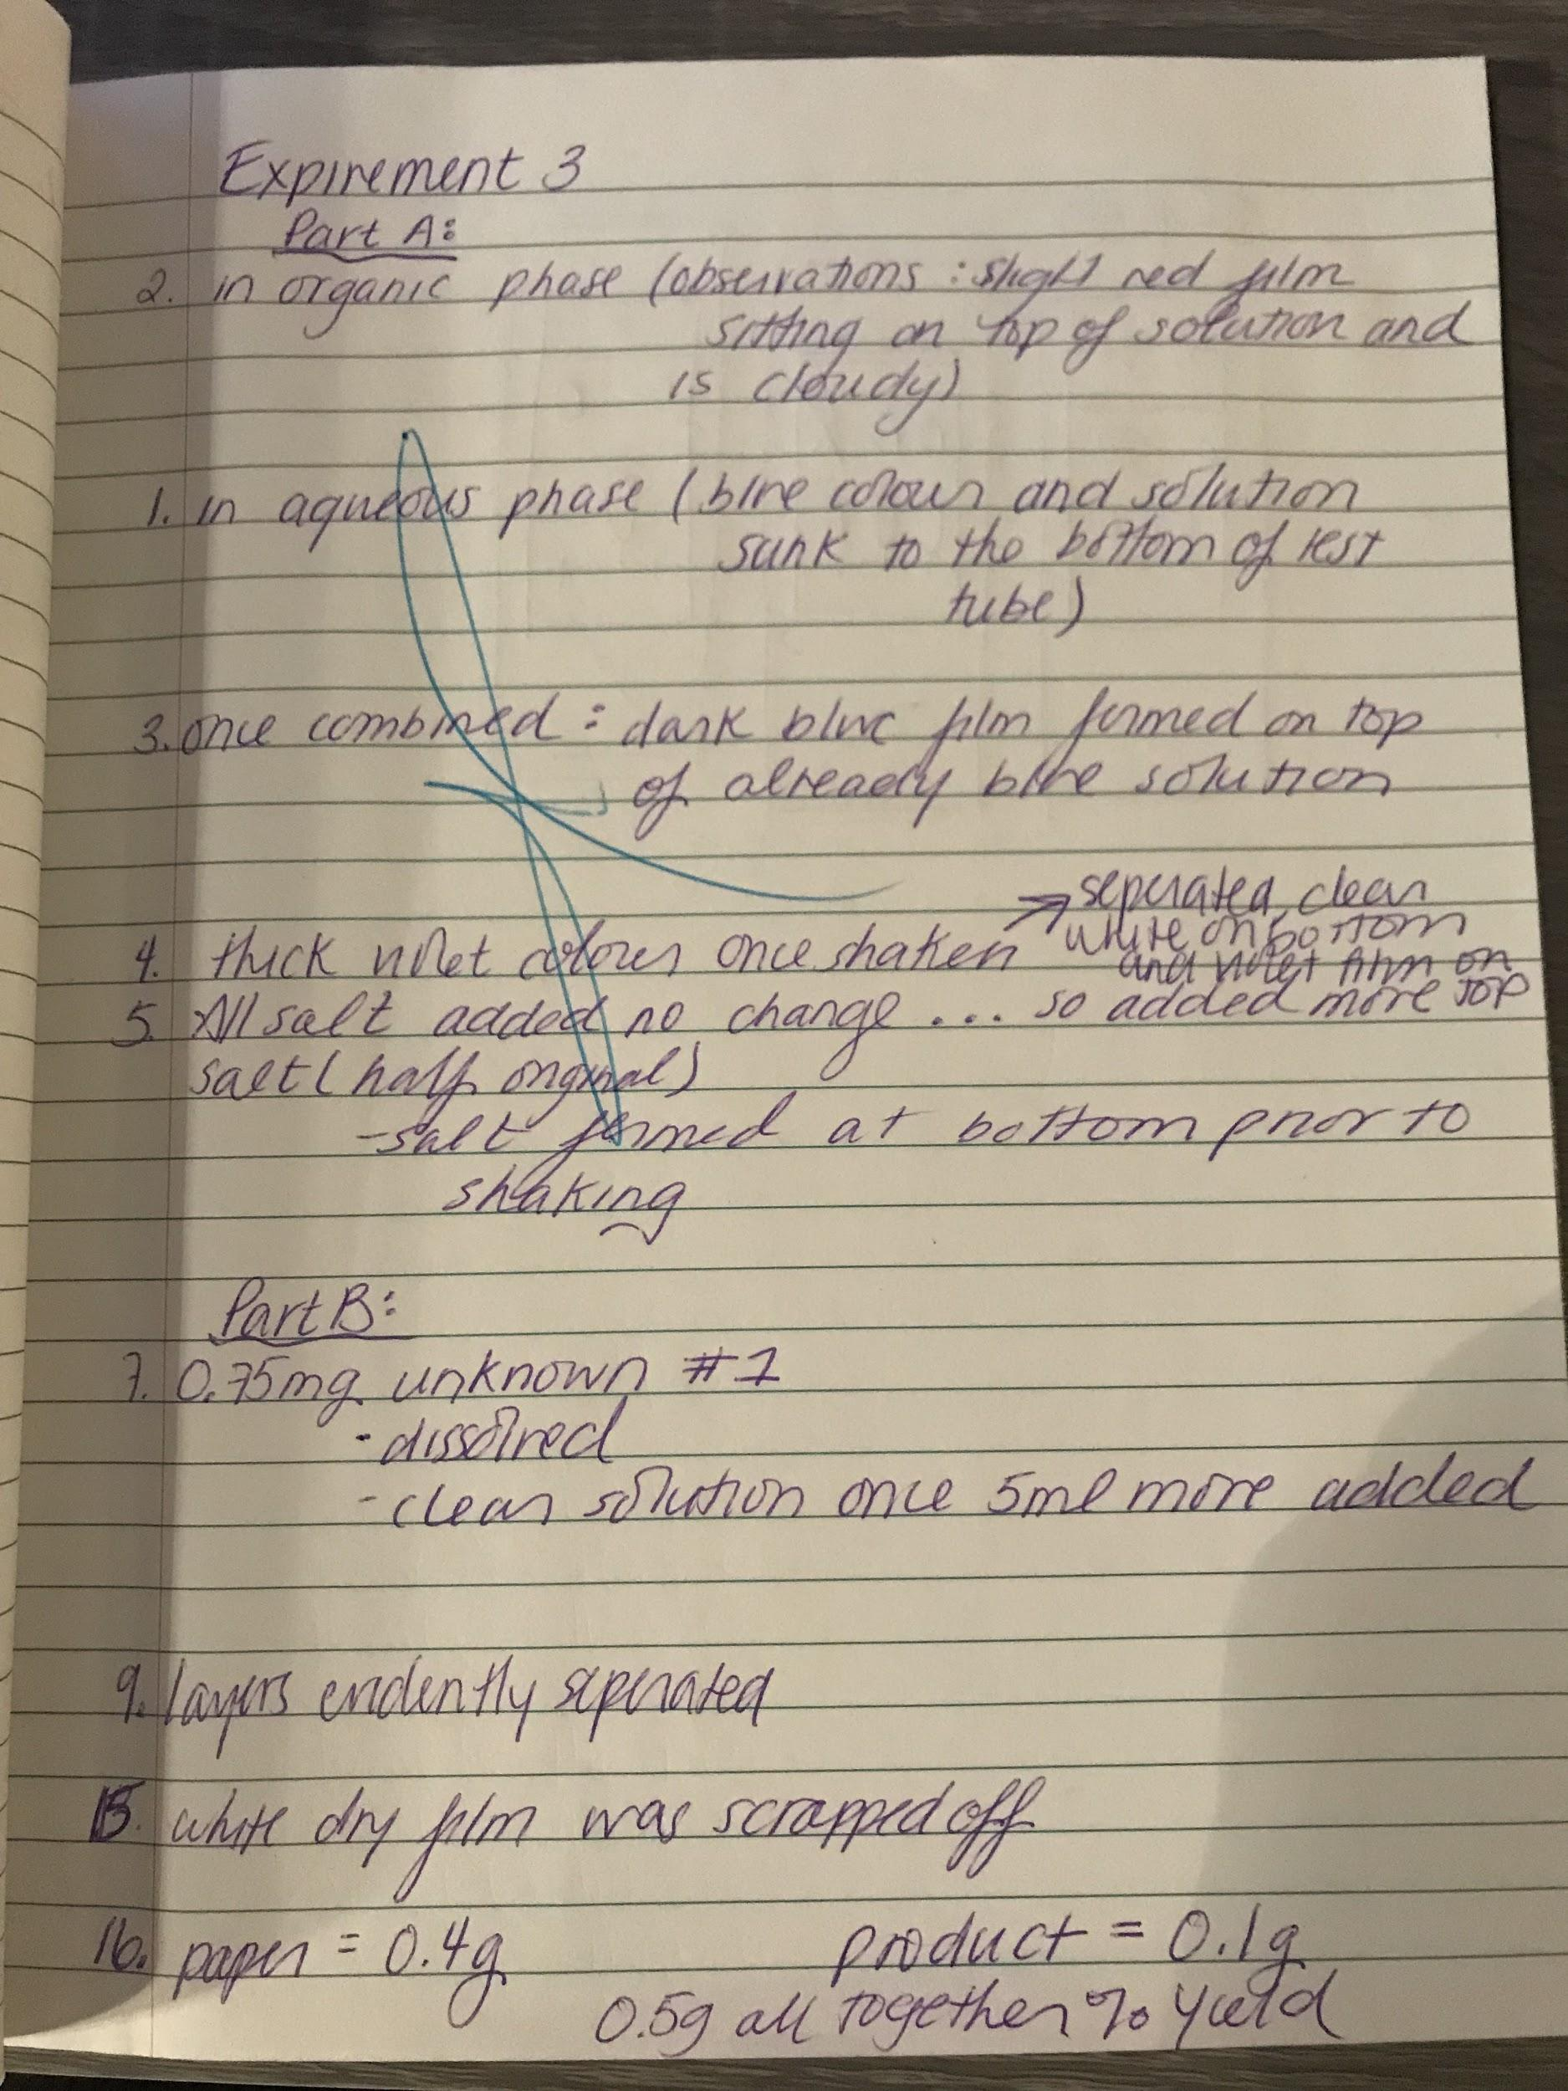

References

Dr. Bianca van Lierop, Dr. Rashmi Venkateswaran and Mr. Alex Bush. CHM1321
Introductory Organic Chemistry Lab Manual

