Chapter 1: IMC Overview
- Involves the coordination of all forms of marketing communications in a unified program that maximizes the impact on consumers and other types of customers
  - Any customer “touch-point” is part of integrated marketing communication
Advertising:
- The placement of persuasive messages in time or space purchased in any of the mass media by organizations that seek to inform and persuade members of a target market

Product advertising: provides information and helps build an image for the product, by presenting the features, attributes, and benefits of the product in a persuasive manner

Promotional advertising: designed to accomplish a specific task
  - Communicate a specific offer in order to elicit some type of immediate response from the customer e.g. coupon or contest with a print ad

Direct Response Communications: The delivery of a message to a target audience of one
- Directly from the marketing company to a specific or prospective user of a company’s product e.g. direct mail

Digital (Interactive Communication)
- Commercial messages for an organization placed on the Internet, a cell phone, or other personal electronic devices

Sales Promotion
- Involves special incentives to stimulate an immediate reaction from customers and distributors e.g. coupons, samples, contests = customer promotions (Pull) price discounts for distributors = trade promotions (Push)

Public Relations: Primarily directed toward gaining public understanding and acceptance
- Influence the attitudes toward and opinions interest groups have about an organization
- Placing messages in the media without having to pay for them
  - Generates “free” exposure e.g. press release (+ legitimacy)
Play a major role when a company finds itself in a crisis

Experiential Marketing: Engage people with a brand in a more personal way
- Event marketing: involves planning, organizing, and marketing an event, whether it is an event for a company or a brand.
- Sponsorship: a company provides money for an event in return for a specific marketing privilege, granted because the company is associated with the event
- Marketers are attracted to events because they reach their target market directly and improve brand awareness when associated with the right event
  - At events, people expect to see branded content; therefore, they are generally more receptive to brand messages and therefore more engaged with the experience

Personal Selling: Face-to-face communication involving the presentation of features and benefits of a product or service to a buyer; the objective is to make a sale

Factors Encouraging Integrated Marketing Communications
- Cooperative approaches to communication problem solving and planning
  - These three ways of thinking are the foundations on which integrated marketing communication strategies are built
    - Each communication alternative is an equal partner
    - Media neutrality
    - Creative solutions are recommended to solve business problems
- Several key issues and trends continue to affect marketing and marketing communications practices:
  - Consumers’ media habits are shifting towards digital media alternatives
  - Popularity of social media networks presents challenges and opportunities for organizations
  - Mobile communications are positioned to become the next “big thing” in marketing communications
  - Role of database marketing and direct forms of communications to reach individuals is expanding
  - Demand for efficiency and accountability in organizations is increasing

Media Consumption Trends and the Shift to Digital Media
- Consumer behaviour while using social media
  - While watching TV, 20.8% of users are using their cellphones and 35.5% are using their tablets at the same time
  - The consumers attention is constantly shifting from one platform to another

Social Media Penetration and Popularity
- Canada has the highest social media penetration in the world 82%
- Rather than looking at the hard-core metrics such as sales and market shares, it should adjust its thinking and see the value in the dialogue-style of marketing presents in social media
  - Conversation between a company and the consumers
    - Engagement
  - Can produce positive word of mouth

Mobile Communications: The Next Big Things
- There is a definite trend to cell phone usage only, one in five households only have cellphones as their only form of telephone service
  - Cellphones is pronounced in households where members are under 35 years of age
    - Carry their media behaviour forward as they age
    - Each passing year, mobile communication will become more and more prominent component of an integrated marketing communications strategy

Database Management Techniques and Customer Relationship Marketing
- Database management systems: continuously collect and analyze information about customers
Can predict how likely it is that customers will buy and can then develop message precisely designed to meet that customer’s unique needs / niches
  - The ultimate goal is to aim directly at the smallest segment, the individual

- Business today is all about relationships
  - Customer relationship marketing (CRM) many involve numerous companies working together to achieve common goals
  - It may involve only one company working together trying to build meaningful relationships with its customers
- CRM (customer relationship management) programs are concerned with establishing, maintaining, and enhancing long-term relationships
- Typically, the more traditional means of communication are used to pursue new customers and the non-traditional media are used to retain and enhance the customer relationship

The Demand for Efficiency and Accountability
- Organizations now understand that scare resources can be put to better use if the efforts of individual activities are coordinated:
  - Encourages synergy
  - Stronger impact on the target audience
- Managers today are accountable for producing tangible results with their marketing communications investments
  - Such a demand is fuelling interest in digital communications because consumer responses to the communications can be tracked electronically and without cost

Input for Marketing Communications Planning: Consumer Behaviour Essentials
- Consumer behaviour: is the study of how people buy, what they buy, when they buy, and why they buy

Needs and Motivations
- There is a direct link between needs and motivations
- Individuals have a need: when they perceive the absence of something that is useful to them
  - A motive: is a condition that prompts the individual to take action to satisfy the need
- An appealing presentation of a product’s features and benefits as they relate to a target’s needs is often enough to stimulate action, purchase
- Maslow’s hierarchy of needs and theory of motivation have a significant impact on marketing and marketing communications strategies
  - His theory is based on two assumptions:
    - When lower level needs are satisfied, a person moves up to a higher-level need
    - Satisfied needs do not motivate; behaviour is influenced by needs not yet satisfied
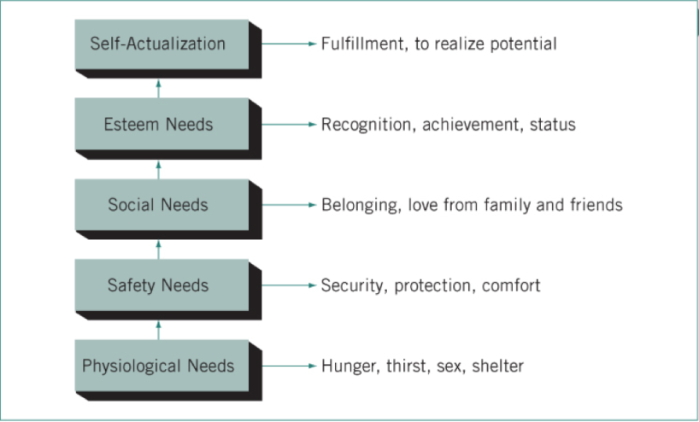

Personality and Self-Concept
- Personality: refers to the individual’s distinguishing psychological characteristics that lead to relatively consistent and enduring responses to the environment in which that person lives
  - Influenced by self-perceptions influenced by family, reference groups, and culture
  - Self-concept: Provided cues about how to communicate with consumers Focuses on our desires
- According to the self-concept theory, the self has 4 components:
  - Real Self: An objective evaluation of one’s self who you really are
  - Self-Image: How you see yourself it may not be your real self, but a role you play with yourself
  - Looking-Glass Self: How you think others see you this can be quite different from how they actually see you
  - Ideal Self: How you would like to be what you aspire to
- The real self and self-image are less significant
  - Looking-glass self and ideal self - appear dynamic
    - They focus more on desires, the way in which we would like to be perceived

Attitudes and Perceptions
- Attitude: individual’s feelings, favourable or unfavourable, toward an idea or object
  - People form attitudes based on what they hear, read, and see about a product, as well as opinions of others they trust
  - As a rule, organizations present their products in accordance with attitudes held strongly by their target audience
    - Attitudes do change, and marketers must keep track of the changes
- Perceptions: refers to the manner in which individuals receive and interpret messages
  - Consumers accept messages that are in line with their needs, personality, self-concept, and attitudes, and ignore messages that are not
- Selective about what we receive, three levels of sensory:
  - Selective Exposure: Our eyes notice only information that interest us
  - Selective Perception: We screen out messages that conflict with our attitudes
  - Selective Retention: We remember only what we want to remember
- “Perception is reality” perceptions held by consumers that advertisers must deal with
  - Example, Toyota original strong reputation for quality was shattered when they suffered a backlash from recalling cars with “sticky gas pedal”
    - The public’s perception of the company changed 20% decrease in sales
- Consumers will quickly tune into messages for products and brands they are contemplating purchasing

Reference Groups
- A reference group or peer group: is a group of people with common interests that influence the attitudes and behaviours of its members
  - Schoolmates, sports teams, frats and sororities, and hobby clubs
  - There is a pressure on member to conform to the standards of the group – “fit in”
- Advertisers have to be careful when approaching the youth market
  - Too much advertising and the target sees the practice for what it is, a dangerous attempt to attract youth consumers without having a clue about their actual tastes
    - The message has to be authentic
- If a brand “goes underground” (the place where pop culture originates) or use some kind of virtual marketing techniques such as a video on YouTube, it has a better chance of connecting with the youth target

Family Influence
- A study reveals that family (70%), friends (67%) and trusted experts (34%) have the greatest influence on female consumers’ decision to try new products
- Each member has some influence on the behaviour of other family members and thus influence the buying decision
  - Such behaviour today relates to the changing roles and responsibilities of family members
    - Households are different
    - 30% of wives earn more than their husband
      - 20% earn the same
    - 92% of Canadian women are solely or jointly in control of family finances
      - 55% of women make the daily financial decision
- Companies that are in tune with these types of changes are double targeting: they are devising marketing strategies that reach both genders
- Today’s children have considerable influence on family buying decision
  - Parents avidly seek their input
    - They are essentially co-purchasers
  - Children are technology savvy and are helping their parents research products and make online buying decisions

Inputs for Marketing Communications Planning: Business and Organizational Buyer Behaviour
- Organizations exhibit more rational behavioural than consumers
  - Consumers do a lot of buying based on emotions
- The business-to-business (B2B) market: is managed by individuals in an organization responsible for purchasing goods and services needed to produce a product or service or promote an idea
- The business market has several characteristics that distinguish it from consumers markers:
  - Business market have fewer buyers, and those buyers tend to be concentrated in industrial areas in and near large cities
  - The buying criteria are very practical, with decisions based on the best buy according to predetermined requirements
  - Formal buying process for evaluating product and service alternatives
- The key factors that a business organization must address when marketing to other business are the criteria established by the buying organization
  - These requirements are set up in advance:
    - Quality
    - Service
    - Continuity of supply
    - Price
- To ensure the right buying decision is made, there is a formal approach involving a
Buying committee: made up of key reps from various functional areas of the company
- A buying center: is an informal purchasing process with individuals in an organization involved in the purchasing process, but not necessarily having direct responsibility for the action decision
  - User Those in the organization who use the product directly
E.g. End-user in the organization
  - Influencer Those who define the product specifications
E.g. Engineer
  - Buyers Those with the authority to buy
E.g. Purchasing manager
  - Deciders Those with the power to finalize the purchase
E.g. High cost decisions are involved, the CEO may be the decider
  - Gatekeepers Those who control the flow of information to the members of the buying center
E.g. A purchasing manager may also fulfil this role
- The seller must know who on the committee or within the buying center has the most influence

Integration and Partnering Influences B2B Communication Strategies
- Business marketers have embraced customer relationship management
- CRM promotes the seamless transfer of information throughout channels to ensure the efficient continuous flow of goods
- Collecting information about customers and their operations is crucial
- The need for print advertising directed at business customers will continue along with the need for strong personal sales contact
  - Sales promotion programs to assist sales people
  - Trade show participation
- A website containing essential product information is indispensable in B2B marketing situations
Ethical Issues in Marketing Communications Practice
Privacy Issues in an Online World
- Collecting information about people’s behaviour when using the Internet
- The collection of online data provides marketers with an opportunity to devise unique advertising messages based on personal interests
- Who do consumers fear?
  - 64% of respondents viewed targeting advertisement as invasive, with 40% saying they would change their online behaviour if advertisers were collecting data
  - Such feeling can vary by age:
    - 55-64-year-olds, 47% were concerned
    - 18-24-year-olds, 33% were concerned
- There are regulations in place to ensure consumers are aware of their rights with regard to how information is used
  - Various opt-in and opt-out clauses are found in agreements people sign when dealing with online organizations
  - Privacy law does exist in Canada through the Personal Information Protection and Electronic Documents Act (PIPEDA) offers a list of guiding principles
    - The degree to which organizations abide by these principles fuels the ongoing debate with consumers

Sex in Advertising
- Using sex appeal in an appropriate manner and for appropriate products seems natural, but gratuitous sex is something consumers shouldn’t have to tolerate
- Is it porn or simply provocative advertising?

Dangerous or Disturbing Advertising
- The extent to which advertisers will go with their message in order to have an impact on their audience can sometimes be an issue

Misleading Advertising
- The control of misleading advertising is the responsibility of Advertising Standards Canada
- Exaggerated Green Claims 75% of Canadians take into account the environmental impact of an organization’s actions when they buy a product
  - 75% of respondents firmly believe that most environmental claims are just marketing ploys
  - “Green washing”, exploitation of environmental ideas to make a company look good
- Targeting children parents are concerned about the content of these messages, which have a powerful influence on the child’s behaviour
  - What age do children become “brand conscious”?
- Cultural Diversity advertisers are often criticized for not reflecting the diversity of Canada’s population in commercial messages

Laws and Regulating Governing Marketing Communications
Advertising Standards Canada
- Industry body committed to creating and maintain community confidence in advertising
  - Ensure the integrity and viability of advertising through industry self-regulations
- Operates two division:
  - The Standards Division: administers the industry’s self-regulating code, the Canadian Code of Advertising Standards
    - Handles complaints from consumers regarding advertising
    - And administers the Trade Dispute Procedure
  - The Advertising Clearance Division previews advertisements in five categories
- The Canadian Code of Advertising Standards (Code) is the principle instrument of self-regulation
  - Developed to promote the professional practice of advertising and form the basis upon which advertising is evaluated in response to consumer complaints
  - Addresses concerns about advertisings and clarity of a message

Competition Bureau
- Administers and enforcement of the Competition Act, a law that governs business conduct and marketing practices in Canada
  - Contains criminal and civil provisions to address false, misleading, and deceptive marketing practices
- Organizations that violates these laws and regulations are subject to financial penalties and other actions

Chapter 2:
Factors Influencing Strategic Planning
- Strategic planning or the corporate strategy: is the process of determining objectives (setting goals) and identifying strategies (ways to achieve goals) and tactics (specific action plans) to help achieve objectives
- Cyclical process in most organizations
  - Annual basis
  - Influenced by changes in the economy, among consumers, in technology, in laws and regulations governing business practices

Economic Influences
- Direct impact on how aggressive or conservative a company is with its business plans
- The general state of the economy is determined by growth rates in the gross domestic product, inflation rates, levels of employment, the value of the Canadian dollar in forging currencies, and income distribution among consumers
  - The relationship among these economic variables is dynamic and wish marketing managers stay abreast of changes and adjust their strategies appropriately
- Smart marketing organizations find solutions to poor economic situations

Competitors Influences
- Assessing the activities of competitors is probably the most thoroughly analyzed aspect of marketing planning
  - How one brand can differentiate itself from others and perhaps standout more in the eyes of consumers
- Canada markets are mostly very competitive and are described as oligopoly (a market with a few major brands) or as being monopolistically competitive (a market with all kinds of brands)
- Competition comes in two forms:
  - Direct competition: is competition from alternative products and services that satisfy the need of the target market
  - Indirect competition is competition from substitute products that offer the customer the same benefit
    - These are becoming blurred

Demographic Influences
- Purpose of devising a profile of potential customers
  - Target market profile

The Population is Aging
- As of 2015, Canada’s population was 35.8 million and the average annual growth rate is averaging about 1 percent a year increase
- Two thirds of Canada’s population come from immigrants
- The population of Canada is aging baby boomers comprise the largest portion of the population
- Y or millennials, a tech-savvy group is the primary target for marketers now and in the future
  - By 2020, 30% of all retail sales will be to millennials
- Baby boomers are also a primary target
  - BY 2021 baby boomers will comprise 40% of the population
    - Burden on Canada’s social programs and health care systems
    - Brands that focus on this target market now will have to adjust their marketing strategies to stay in-tune with their changing needs
    - These brands must also attract younger consumers if they hope to grow in sales

Urban Population
- 80.3% of the population lives in urban areas
  - 6 metropolitan areas account for 46% of Canada’s population
  - Edmonton and Calgary are the fastest growing cities in Canada
    - International migration, formerly flourishing oil industry
- Important consideration when developing marketing strategies and marketing communication strategies
  - With the population clustered, regional in nature or dwell specifically on key urban brands
  - Explains the popularity of regional brands

Changing Household formations
- Married couples comprise only 67% of households
- Today’s modern household includes:
  - Loan parent’s families
  - Same-sex families
  - Blended families
- Canadian households are shrinking, average size of 2.5 people, a reflection of this trend
- Products and services must explore the unique opportunities these trends present
  - Must be aware of who is making the buying decisions or influencing the decisions

Ethnic Diversity
- The population is quickly changing from a predominantly European background to an Asian background
- Subcultures subgroups within the larger cultural context that have distinctive lifestyle based on religious, racial, and geographical difference
- Canada’s foreign-born population represents 20.6% of the population and is expected to rise to 23% by 2017
  - Almost half of Canada’s visible minority population is immigrants from South Asia and China
- Companies that embrace marketing to various ethnic groups will profit the most in the future
  - The sheer size of this developing marketing and the fact that this unique group tends to cluster in urban areas makes them a reachable target for Canadian brands
  - Walmart is a leader in this area

Spending Power and Wealth
- How much people earn has an impact on their spending patterns
- Canadian’s disposable income to grow at a lower rate than the cost of basic necessities required in a household
- Concentration of wealth among upper income groups
- Consumer are more cautious about parting with their money
  - Marketers who stress the value in their marketing strategies will be successful

Social Influences
- Stay in touch with social changes
- The lifestyle of Canadians is always changing and generally speaking, Canadians are very concerned about the natural environment and what companies are doing to preserve and protect it

Lifestyle
- There are two key issues affecting lifestyle:
  - Living hectic lives while trying to live healthier
    - Emphasis on quality of life than on work, but need to work to sustain the type of life we desire
  - More concern for their health and welfare
    - Marketing healthier foods

Natural Environment
- Show serious concern for the natural environment and tend to favour companies that have a strong reputation for protecting our natural resources and for contributing to worthy causes
- Particularly true for millennials
  - If the company that are perceived as showing only tokenism towards such a serious issue can be quickly punished when consumers resist buying products

Technology Influences
- Several factors are combining to make an impact on how we learn about products and buy products
  - Availability of information through the Internet and our obsession with electronic devices such as smartphones and tables
  - 86% of Canadian’s are Internet users
- Canadians have also integrated social media into their daily routine to the extent that ordinary people are producing video content for the brands they like customer generated content

Legal and Regulatory Influences
- Strategic plans are affected by new developments in the political and legal areas
  - Created by federal and provincial legislations
  - Many industries establish and abide by their own self-regulation policies and practices
- Self-regulation is an alternative to government regulation

Strategic Planning Process
- Start the process at the top or senior level of the organization and work downwards
- In the corporate plan: senior executives, financial in nature and become the goals that must be shared be all of the company’s divisions or products
- A marketing plan: is developed for each one of the company’s products and sets out the objectives for all brands
  - How the various elements of the marketing mix will be employed to have the desired impact on the target audience

The Corporate Plan
- A mission statement: is a statement of an organization’s purpose and an indicator of the operating philosophy the organization follows
  - Looks towards the long term
  - NOT FOR MARKETING PURPOSES
- A vision statement: is what an organization would like to be like
- With the mission confirmed, executive’s attention turns to setting corporate objectives:
  - Overall corporate goal
  - Usually financial in nature and are used to evaluate the effectiveness of ineffectiveness of a company’s strategic plan and the people who manage the organization
    - Qualitative and quantitative
- Social responsibility direct impact on the development of marketing objectives and strategies
- To grow and be profitable, a company will give due consideration to a variety of strategic options:
  - Penetration strategy
  - Acquisition strategy
  - New product development strategy
  - Strategic alliance strategy
    - Imply a desire for growth
- A company may decide on a division strategy and sell off various divisions or products
- Acquisition strategy: a plan of action for acquiring companies that represent attractive financial opportunities
- Penetration strategy: involves aggressive marketing of a company’s existing products
  - The goal is to build the business by taking customers from the competition or by expanding the entire market
- New product development strategy: Create new products for new revenue streams at a much greater rate than simply trying to expand existing product lines
- Strategic alliances occur when separate companies with complementary strengths join forces to satisfy their shared customers
  - Very popular now to reduce costs or improve operating efficacy

Marketing Plan
- Involves analyzing, planning, implementing, and controlling marketing initiatives to satisfy target market needs and achieve organizational objectives

Chapter 3:
Defining the Brand
- A brand: is a name, term, design symbol, or any other feature that identifies one seller’s good or service as distinct from those of other seller
  - Legal term is trademark
- Brand can embrace intangible characteristics
- Customer perceptions of brands are largely based on the brand name and what it stands for
  - What they have learned about the brand
- Components of a brand:
  - Brand name: is the part of the brand that can be spoken
    - Presented with their own unique font
  - Brand logo: is some kind of symbol
    - Sometime a brand logo can stand alone without the name and people will know what it, example, Nike swoosh
    - Sometimes a trademark can lose is distinct nature when it becomes too well know and becomes synonymous with their product category Kleenex and Band-Aid
  - Design of the product or package
  - Trademark is the part of the brand that is granted legal protection so that only the owners can use it ™
    - The ® symbol is used when the trademark had not been claimed but registered with the government trademarks office
- Through marketing communications, the “personality” of the brand evolves, and the combination of brand attitudes (tangible) and brand personality (intangible) is what influences brand choices by consumers
- The key for any brand is to offer something unique

Brand Image and Reputation
- Brand express a set of values that customers can identify with
- Good reputation is the end result of consistent approach to marketing and marketing communications over an extended period of time
- Canada’s Brand Leaders by Reputation 2016
  - Google
  - Heinz
  - Shoppers Drug Mart
  - Canadian Tire
  - Kellogg

Brand Loyalty
- Brand loyalty: is defined as the degree of consumer attachment to a particular brand
  - Loyalty is influenced by such factors as marketing communications (what is said about the brand), family or peer pressure, friendship with a sales person, and ultimately, how satisfied a person is with the product
- Brand loyalty is measured in three distinct stages:
  - Brand recognition
    - Early stage of a brands life, the marketing objective is to create brand recognition
    - Consumer is aware of the name, benefit, and package
  - Brand preference
    - Brand achieves brand preference states when it is on the short list of brand alternatives that a consumer will consider buying
    - Consumer knows something about the brand, has evaluated it in relation to his/her needs, and will purchase if available when it is needed
  - Brand Insistence
    - Consumer will search the market extensively for a particular brand
    - No alternatives are acceptable, if the brand is not available, the purchase will be postponed
    - Become advocates for the brand – openly recommend it to others

Brand Equity: Defined as the value a consumer derives from a brand over and above the value derived from the physical attributes
- Influenced by several variables:
  - Brand name awareness, the degree of loyalty expressed by consumers, perceived quality, and the brand’s association with a certain attribute
- Monetary terms
  - Tangible financial value
  - Estimated to be worth
- Effective marketing and marketing communications strategies play a key role in building a brand equity

The Benefits of Branding
- Overtime, a relationship develops between a consumer and the brand
- A brand is a promise delivered to a consumer
- Brands play a key role and offer numerus benefits to an organization:
  - Unique selling point (USP), the primary benefit of a product or service that distinguishes it from its competitors a good brand name communicates the point of difference
  - Allows for the creation and development of an image
  - Satisfied customers will make repeat purchases and, marketers hope, remain loyal to the brand such loyalty will stabilize market share and provide for certain efficiencies in production and marketing

Building a Brand
- Responsibility of the brand manager
- A brand manager: develops and implements the marketing plans for the brand he or she is responsible for
- To build a brand:
  - Identify and establish brand values and positioning strategy
  - Pan and implement brand marketing programs
  - Measure and interpret brand performance
  - Grow and sustain brand equity (managing a brand through its life cycles)

Establishing Core Values and Brand Positioning
- Core values are the primary attributes and benefits a brand delivers to the customers
  - An attribute is a descriptive feature; a benefit is that value consumers attach to a brand attribute
- The brand positioning process
  - Identify brand values and positioning strategy Identify key attributes and benefits
    - Clearly state what the brand will do for customers
  - Plan and implement the marketing program Develop and integrate plan that draws upon key elements of the marketing mix and design and execute the marketing communication mix
  - Measure and evaluate brand performance Evaluate the results against planned objectives, including loyalty, market share, and sales
  - Build brand loyalty and brand equity Alter, expand, and rejuvenate brands to retain their position in the marketplace

Brand Positioning Concepts
- Positioning is the selling concept that motivates purchasing or the image that markets desire a brand to have in the minds of customers
  - Influenced by the brand’s core values, attributes and benefits
- Make the product stand out from the competition in the minds of the target market
- A clearly defined positioning strategy statement provides guidance for all marketing and marketing communication strategies
  - Why potential customers should buy the brand
- Created by taking into consideration Market analysis, target market analysis and competitor analysis positioning strategy
  - Creates the product, price, marketing communication, and distribution strategy

Product Differentiation
- The product differentiation strategy is employed, the product will communicate meaningful and valued differences to distinguish itself from the competition’s offerings
  - Form of the product
  - Performance quality
  - Durability
  - Style

Brand Leadership Positioning
- Employed by brand leaders
- Brand leaders have characteristics that give them an advantage over competing brands
  - They have greater consumers awareness, readily available, and have significant market budget
- Example, Coca-Cola

Head-On Positioning (Comparative Positioning)
- Comparison of one brand with another
- Example, the “Pepsi Challenge”
  - People trying Pepsi and Coke in a blind taste test with Pepsi being the preferred choice
- Challenger brands often adopt a head-on positioning strategy
  - Their mission is to instil “thought” leadership in the customer’s mind
  - Spend considerable amount of money to deliver their message

Innovative Positioning
- Perceived by consumers as new
- Innovative positioning is a marketing strategy that stresses newness as a way to differentiate a brand from the competition
- “Leading-edge”
- Example, Gillette razor with flex ball technology

Price (Value) Positioning
- Based on the premise that consumers search for the best possible value given their economic circumstances

Lifestyle (Image) Positioning
- Involves moving away from the tangible characteristics of the product toward the intangible characteristics
- Usually in very competitive markets
- The use of psychographic information allows companies to develop campaigns based on the lifestyle or desired lifestyle of the target market
  - Hummer vs. Honda Civic

Repositioning
- Changing the place, a product occupies in the mind of the customer, relative to competing products
- If the strategy is working, avoid changing it
- Marketers must continuously monitor changes in the marketplace and adjust their strategies accordingly

Planning and Implementing Marketing and Marketing Communications Programs
- It is an important transfer process that considers two essential factors
  - Decisions must be made about how to employ various brand elements
    - Brand names, trademarks, and characters
  - Appropriate marketing strategies must be developed to communicate the brand values and brand positioning strategy
- Slogans are also important in brand advertising
  - Summarize what the brand stands for – the brand’s positioning strategy
- Marketing communications are the “voice” of a brand’s or company’s positioning strategy

Packaging and Brand Building
- The package is what customers look for when they are contemplating a purchase
- It is very common for the package to play a key role in introductory marketing communication programs
- The colour of a package is an important element of the brand building equations
  - Attracting people’s attention
  - Many brands “own” a colour brand blocking
    - Example, Coca-Cola owns red
- Over the lifecycle of a product, the packaging many change several times to spruce up the image of a brand
- Common package design across all product lines that make up a brand helps maintain brand identity
- Marketers see packages having a growing influence on purchase decisions amid ongoing media fragmentation
  - The majority of purchasing decisions are made in sore up to 70% (40% in super markets)
- Packaging helps build trust between the consumer and the brand, so ultimately the package is a factor that can influence consumer loyalty
- A good packaging serves four functions
  - Protects the product
  - Markets the product
  - Offers convince to consumers
  - Environmentally friendly

Chapter 4:
Communication Essentials
- Communication is defined as transmitting, receiving, and processing information
  - The message was sent reaches its destination in a form that is understood by the intended audience
- Developing the message is referred to as encoding the message is transformed into some attention-getting form
- The message is then transmitted, usually by the media
- Sender (Brand A) Encoding (Message) Transmission (Media) Decoding Receiver (Consumer)
  - Consumer response Feedback back to the beginning with Sender
- Noise, they dilute the impact of an advertiser’s message
  - Whether or not the message breaks through the clutter is usually determined by the relationship among three factors
    - The quality of planning when developing message strategy
    - The execution of the plan being on target with the right timing and frequency
    - The impact of the competitive message
  - The advertiser has control over the first two, but not the last factor
  - If the message does not break through, no action will occur
- Advertising can influence the consumer at each stage ACCA (awareness, comprehension, conviction, action)
  - Part of a theory called DAGMAR (Defining Advertising Goals for Measured Advertising Response)
  - The effectiveness of an advertising campaign is usually linked back to this model
  - An advertisement (or campaign) that achieve good scores with respect to awareness, comprehension and conviction likely to succeed
- Awareness The customer learns something for the first time
  - Can be measured by aided and unaided recall test
- Comprehension The customer is expressing interest
  - A like or dislike for a brand can be measured using attitude scales
- Conviction The customer expresses stronger feelings toward the brand based on the perceived benefits it offers
  - A new or a changed attitude about something has occurred
  - Sufficient motivation to go and buy the product
- Action Desired action occurs
- A second theory of communication revolves around the degree of involvement the consumer has with a product in the purchase decison0making process
  - FCB Grid
- Quadrant One Expensive and require a rational decision-making process during which alternatives are evaluated
  - High importance
  - Examples, cars or computer
- Quadrant Two high involvement but consumers evaluate alternatives more on an emotion
  - Make the consumer feel good
  - The message will appeal to higher-level needs, the looking-glass self (how you think others see you) and the ideal self (how you would like to be)
  - Examples, designer clothing
- Quadrant Three low important products that require a rational decision
  - Compelling reason to buy
  - Key benefits, so the message must be short
  - Example, laundry detergent
- Quadrant Four low involvement products purchased on emotional decisions
  - Not expensive, but make the consumer feel good
  - Example, soft drink, beer, candy

Marketing Communications Planning: Creative
- Advertising is defined as a paid-for message through the media by an identified sponsor
- The advertising plan is developed by an advertising agency, responsible for developing and managing the client’s advertising
- The starting point for any new advertising project is the creative brief
  - A creative brief is a business document developed by the company that contains vital information about the advertising task at hand
  - A discussion document, and the content can change based on the nature of the discussion between the client and agency
    - Some sections are actually left blank
- Information provided by the client includes essential market background information (information from the marketing plan)
  - Market profile
  - Brand profile
  - Competitor profile
  - Target market profile
  - Budget
- The copywriter and art director, a team charged with developing the creative concept or “big idea”, that will be the corner stone of the campaign

Problem Identification
- Advertising plans are usually designed to resolve a particular problem or peruse an opportunity
- Problem statement is a brief statement that identifies a particular problem to resolve or an opportunity to purse and serves as the focus of the marketing strategy

Advertising Objectives
- One the overall goal is determined, specific advertising objectives are identified
  - Objectives should be quantitative in nature so that they can be measured for success or failure at a later date
  - Behavioural in nature or they might focus on issues related to the overall problem
- Creating or increasing brand awareness
  - Creating awareness is always the first challenge for advertising
  - Achieving high levels of awareness depends on:
    - How memorable the ad is
    - How frequent the message is delivered
    - The medium used to deliver the message
- Encouraging trial purchased
  - Sometimes there needs to be an incentive to give an extra nudge
  - These incentives serve a specific purpose, they help reduce the risk associated with purchasing something for the first time
  - Consumers today are looking for better value in the products and services they buy and as a result, incentive-oriented advertising is now more prominent that in the past
- Attracting new target markets
  - The tone and style of advertising may have to change
- Encouraging preferences
  - The objectives for an established brand in growth or mature markets is to stand out from competition brands
    - Product differentiation
  - Typically, it is the unique attributes of a brand that differentiates it from another and create preferences for one brand over another
- Altering consumer preferences
  - The quickest way to alter an image is to launch a completely new advertising campaign with an entirely different message
    - The style and personality of the message will be different to create a new image in the consumers mind

Positioning Strategy Statement
- The positioning strategy identifies the key benefits a brand offers, states what the brand stands for and is a reflection of a brand’s personality
  - Essential inputs assessed by the creative team when it develops the message strategy
  - Trigger that leads to the “bid idea”

Creative Objectives
- Statements that clearly indicate the information to be communicated to the target audience
- The creative brief usually includes what to say about a brand in general terms
- When determining what to say about a brand and how to say it, creative planners refer to the advertising objectives
- The objectives and the primary reason for buying the brand must be related so that a cohesive message presented to the consumer
  - Key benefit statement expresses the basic selling idea, service, or benefit that the advertiser promises the consumer
    - Primary reason for buying the particular brand
  - Support claims statement describes the characteristics that will substantiate the promise
    - Proof of the promise based on criteria such as technical performance and comparative product testing
    - Good support claims give customers a real reason why they should buy the product
    - Less important for brands touting intangible benefits

Creative Strategy
- The creative strategy is a statement of how the message will be communicated to the target audience
  - Issues such as the theme, the tone and style of message that will be adopted, and the appeal techniques that will be employed
- Central theme the glue that binds the various creative elements of the campaign together
  - The theme must be transferable from one medium to another
  - A good theme can last though many campaigns
    - Example, Molson Canadian beet has used a “patriotic” theme for a while

Appeal Techniques
- How to make an advertisement appealing to the customer

Positive Appeal
- Presenting the message in a positive manner is always a safe approach
  - Very common
- Combined effectively with the right theme, positive appeals will work
- Stresses the positive benefits of the product and how a person can gain from purchasing the product

Negative Appeal
- Presents a situation the consumer would prefer to avoid
- Example, Buckley’s cough mixture, “tastes awful but it works”

Humorous Appeal
- Many critics believe that for ads to work it must be entertaining for the audience
- A major weakness of using humor is that it can wear out prematurely
  - Sarcastic humor could insult a cultural group
  - Unwanted negative publicity

Sexual Appeals
- If the core customers don’t find it offensive, the advertiser may be onto something

Emotional Appeals
- Emotional appeals presented effectively will arouse the feelings of an audience

Lifestyle Appeals
- Try to associate their brand with the lifestyle or desired lifestyle of the audience they are trying to reach
- Sexual and emotional appeals are frequently included as elements in the lifestyle campaign
- Popular among advertisers owing to the greater availability of psychographic information about Canadian consumers

Comparative Appeals
- The promise and proof are shown by comparing the attributes of a given product with those of competing products
  - Attributes that are important to the target market
- Focus on the primary reason for buying the product
- Can be direct or indirect
- Usually undertaken by a challenger brand, a brand that tanks behind the category leader in market share
  - It will make the consumer think more about the brand they currently use
  - Risk, the leader could fight back and force the challenger to spend more money on advertising than originally intended & any claims made must not misled the public

Factual Appeals
- The ad simply states what the product will do and back it up with information that is easy for the customer to understand
- Over-the-counter pharmaceuticals use this technique frequently
- Rely on technical information or scientific data to validate the claims

Creative Execution
- This stage of the creative planning, specific decisions are made regarding how to best present the message
- The agency creative team evaluates specific ideas that it thinks have the potential to convert its vision of an ad into reality
  - What is the best way to present the brand’s benefits?
  - Is there a specific technique that will effectively convince the consumers that this is the right brand for them?

Product Demonstration
- For products that want to make claims regarding performance, demonstrations work well

Testimonials
- Traditional approach to advertising
- A testimonial, a typical user of the product presents the message
- Real people in ads are often perceived to be more credible than models and celebrities

Endorsements
- Star power is at the heart of endorsement execution
- Do celebrities work? It is hard to tell
- Source credibility – the source is expert and credible
- Source attractiveness – the source is “known to”, “liked by” and is similar to the consumer
  - So is persuasive
  - Do you relate to the person?
  - Example, John Wayne (tough guy, cowboy)
    - Would he do the right person to sell a headache memory?

Taglines and Slogans
- To reinforce the primary benefit and the central theme of a campaign, and to reflect the positioning strategy of the brand, the creative team develops a tagline for individual ads or a slogan that will appear in all forms of advertising
- The repetition of messages over an extended period of time help ingrain the slogan in the customer’s mind
  - The slogan may change when a brand or company wants to change its image
- The best slogans are short, powerful summations that companies use alongside their logos to drive the brand massage home to consumers
  - Subway: “Eat Fresh”

Native Advertising
- Native advertising is a sub-component of a marketing strategy called content marketing
  - The marketing process of creating and distributing relevant content to attract, acquire and engage a target audience
  - Detailed information in an environment where time and space are not factors
    - Example, Red Bull Skydive from Space
- Native Advertising is a form of paid advertising that matches the form and function of the user experience in the platform on which it appears
  - It does not look like advertising and is identified as a sponsored content
  - What makes this infographic such a great example of native advertising is that it’s virtually indistinguishable from Fast Company’s typical content.
  - The infographic’s use of UPS’ brown and yellow color scheme further reinforces the content’s brand messaging in a subtle way


In Class
- Serif vs. sans serif (what this font is)
  - Long copy, serif fonts are better to use
- Vectors are lines
  - Logo needs to be in vector format
- Bitmaps (very small) are pixels
  - The logos on a website
  - Pictures are bitmaps
- PhotoShop
  - Create and edit bitmaps
- Illustrator
  - Create graphics and logo as vectors
- InDesign
  - Assemble type, photos, graphics into multipage documents
- Vintage is powerful
  - Research by neurologists show emotions guide behaviour
  - Selective retention such that in stirring up feelings of the past, we tend to recall the good memories
  - Retro can be a powerful tool
- If the brand has a story – example, Shinola from Detroit

10 Principles of Advertising from Bill Bernbach
- Go to the essence of the product. State the product’s essence in the simplest terms of its basic advantage. And state this both tangibly and memorably.
- Where possible, make your product an actor in the scene; not just a prop. This makes for a tremendously effective method of getting your product remembered. Because the provocative element in your advertising is also the element that sells your product. This is so simply stated, so difficult to execute.
- Art and copy must be fully integrated. They must be conceived as a unit, developed as a unit
- Advertising must have vitality. This exuberance is sometimes called “personality”. When advertising has a personality, it is persuasively different; and it is the one because of the other. You must fight to get “bounce” in your advertising.
- It is little less than useless to employ a so-called gimmick in advertising —- unless the gimmick itself tells the product story.
- Tell the truth. First, it’s a great gimmick. Second, you go to heaven. Third, it moves merchandise because people will trust you.
- Be relevant. A wonderfully creative execution will get the big “So what” if it isn’t meaningful to their life, family, business etc. And always opt for an ad that’s relevant over one that’s exciting and irrelevant.
- Be simple. Not simpleminded, but single minded. Who has the time or the desire to listen to advertising?
- Safe ideas can kill you. If it’s been done before, your competition will be ready for it. Your only chance of beating the competition is with advertising they’ve never seen before. Which means you’ve never seen it before either! Be brave.
- Stand out. If your advertising goes unnoticed, everything has been wasted.

Chapter 12:
The Role and Scope of Marketing Research
- The data do not guarantee that proper decisions and actions by the firm will be taken, because data are always open to interpretation
  - “Some information is better than no information”
- Research is used to help reduce or eliminate the uncertainty and risk associated with marketing business decisions
- Form of insurance
  - Ensures that the action a company may take is the right action
- Marketing research links the consumer/customer/public to the market though information
  - Designs the method for collecting information, how the information will be implemented, collection process, analyzing the results and communicating the findings
- Research is useful for identifying consumer insights that can be considered for many things
- Requires a significant investment by a marketing organization
  - Diversity of marketing communications
  - Difficult to isolate one communications component and state definitively that it determined success or failure
- How do managers go about collecting information?
  - Reliability refers to the degree of similar results being achieved if another study were undertaken under similar conditions
  - Validity refers to the research procedure’s ability to measure what it was intended to measure

Research Techniques for Marketing Communications
Primary Research
- Refers to the process of collecting and recording new data called primary data to resolve a specific problem, usually a high cost to the sponsoring organization
  - Customer designed and focuses on resolving a particular question or obtaining specified information
  - Steps involved in collecting primary research:
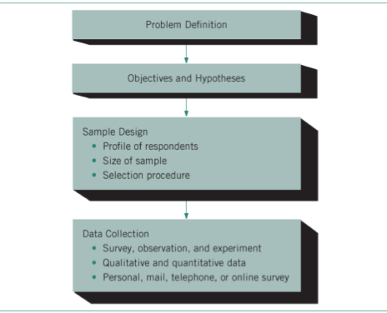

- The marketing organization identifies the precise nature of the problem, the objective of the study and the hypotheses associated with it
  - Research objectives are statements that outline what the research is to accomplish
  - Hypothesis are statements of predicted outcomes which is confirmed or refuted by the data collected

Sample Design
- The researchers identify the characteristics of the people they would like to participate in the study
  - Sample is defined as a portion of the entire population used to obtain information about the population
- Steps must be taken to get a representative sample:
  - Define the Population (Universe): a group of people with specific age, gender, or other demographic characteristics
    - Description of the target market
  - Identify the Sampling Frame: A list that can be used for reaching a population
  - Determining the Type of Sampling: The researcher has the option of using two types of sampling:
    - Non-Probability sampling: respondents have an unknown chance of selection, and their selection is based on factors such as convinces of the researcher’s judgement relies on experience to determine who would be most appropriate
    - Probability sampling: respondents have a known or equal chance of selection and are randomly selected from across the population
  - Determine the Sample Size: Generally, the larger the sample, the greater the accuracy of the data collected and the higher the cost
    - The nature of the research study is determined by the number of participants required
    - A researcher considers the margin of error that is acceptable and the degree of certainty required

Data Collection Methods
- Survey research is Data are collected systematically through some form of communication with a representative sample by means of a questionnaire that records response
- Fixed-response (close-ended) questioning: multiple choice
- Open-response (open-ended) questioning: comments by the respondents
- Observation research: the behaviour of the respondent is observed and recorded
  - Don’t have to be recruited, they can participate in the study without even knowing
  - Respondents are usually aware of being observed
  - Many companies are now into ethnographic research: a form of observation research that involves the study of human behaviour in natural settings
    - How people interact with others, media, a specific brand…etc.
- Experimental research one or more factors are manipulated under controlled conditions, while other elements remain constant
  - Test marketing involves placing a commercial or set of commercials in a campaign (print ads as well) in one or more limited markets, representative of the whole, to observe the potential impact of the ad on the customers

Qualitative Data vs. Qualitative Data
Qualitative Data
- Usually collected from small samples in a controlled environment
- Questions concerned with the “why” and from in-dept probing of the participants
  - Focus group is a small group of people (8-10) with common characteristics brought together to discuss issues related to the marketing of a product or service
    - Concerned on one topic
    - Monitored by a trained monitor
    - Get the participants to interact freely to uncover the reasons and motivations underlying their remarks
    - The major drawback: reliability of the data sample size is too small to be representative of the entire population, and most people in a focus group do not like to show disagreement with a prevailing opinion
  - Online focus groups
    - This option is less costly than face-to-face focus groups

Quantitative Data
- Concerned with the “what”, “when”, “who”, “how many”, and “how often”
- Attempts to put feelings, attitudes, and opinions into numbers and percentages
- The interpretation of the result is based on the number complied

Survey Methodology
- Personal interviews involve face-to-face communication with groups or individuals and are usually done through quantitative questionnaires
  - Shopping malls or homes of respondents
- Telephone interviews involves communicating with individuals over the phone
  - Conducted from a central location (one that can reach all Canadian markets)
  - High refusal rate
- Mail interviews are a silent process of collecting information
  - Highly dispersed sample is reached in a cost-effective manner
  - Draw back, the lack of control and the amount of time required to implement and retrieve the survey
- Online survey allows an organization to be much less invasive collecting information
  - Customers seem more willing to divulge information over the Internet compared with the more traditional means of surveying
  - Effective in testing new product concepts and getting feedback on new advertising ideas
  - Good for short on time and money
  - Draw back, recruiting can be a lot like fishing the validity of the information collected is questionable

Data Transfer and Processing
- Editing stage: completed questionnaires are reviewed for consistency and completeness
- Data transfer answers from questions are transferred to a computer
- Tabulation is the process of counting the various responses for each question and arriving at a frequency distribution
  - Frequency distribution shows the number of times each answer to a question was chosen
  - Cross tabulation is the comparison and contrast of the answers from various subgroups or from particular subgroups

Data Analysis and Interpretation
- Data analysis refers to the evolution of responses question by question, a process that gives meaning to the data
  - Researchers make comparisons between responses of subgroups on percentage basis
- Data interpretation involves relating the accumulated data to the problem under review and to the objectives and hypothesis of the research study
  - Interpretation uncovers solutions to the problem

Measuring and Evaluating Advertising Messages
Client Evaluation
- Creative can be tested at several stages of the development process
  - Qualitative assessment by the client to determine if the message conforms to the strategic direction that was provided to the agency
    - Conducted by a managerial approach whereby certain criteria are established and the advertising ideas are measured against them:
      - Does the content of the advertisement communicate the creative objective and reflects the positioning strategy of the brand (company)?
      - In terms of how the ad is presented, does it mislead or misrepresent the intent of the message?
      - Is the ad memorable?
      - Is the brand recognition effective?
      - Should the ad be research?
- The evaluation process can occur at any stage of the creative development process
External Research Techniques and Procedures
- The objective of most creative research is to measure the impact of a message on a target market
- Pre-testing is the evaluation of an ad before it goes into final production to determine the strengths and weaknesses of a strategy and execution
- Post-testing is the process of evaluating and measuring the effectiveness of an ad during its run or after its run
  - Provides information that can be used in future advertising planning

Recognition and Recall Testing
- Recognition tests, respondents are tested for awareness
  - Recall an ad for a specific brand or any of the points made in the ad
  - Several factors affect the level of recognition in an ad
- Recall test, respondents are tested for comprehensions to measure the impact of ads
  - Aided situation (some information is provided)
  - Unaided (no information is provided)
- Two of the most common methods for collecting recognition and recall information:
  - Starch readership test is a post-test recognition procedure applied to both newspaper and magazine advertisements
    - Measure how many people actually read the ad and how many saw the ad
    - Divided into three categories:
      - Noted: % of readers who remember seeing the ad
      - Associated: % of readers who saw any part of the ad and can clearly indicate the brand
      - Read Most: % of readers who read half or more of the written material
  - Day-after recall (DAR) is for broadcasted media
    - Research is conducted the day after an audience has been exposed to a commercial message for the first time

Option Measure Testing
- Attitudes and opinions
- Exposes an audience to test-commercial messages in the context of special programing
  - Respondents brand name recall, interest in the brand, and purchase intention
- Usually presented twice during the program
- Set of cluster commercials against which the test commercial or commercials can be compared

Physiological-Response Testing
- Measures involuntary response to a specific element of an advertisement
- Eye movement camera test trackers their eye movement
  - Gauges the point of immediate contact, how a reader scans the various components of an ad and the amount of time spent reading it
- Pupilometer test measures the dilation of a person’s pupil to see how it changes based on emotional arousal

Measuring and Evaluating Direct Response Communications
- Response card, a card filled in, usually at the time of purchase that collects information about customers that can be added to the organizations data base

Measuring and Evaluating Internet Communications
- Cookies, an electronic identification tag sent from a web server to a user’s browsers to track the user’s browsing patterns
  - Internet communications are much easier to measure in hard numbers than any other form of media advertising
- Impressions (ad view) it the number of times a banner ad image is downloaded onto a user’s computer
  - Clicks (clickthroughs): the number of times users click on a banner (clicking transfers the user to another website)
  - Clickthorugh rate: the percentage of impressions (ad views) that resulted in a click; determines the success of an ad in attracting visitors to click:
    - Increase of web traffic
    - Length of visit
    - Page views

Measuring the Impact of Social Media Communication
- Reach figures are a reflection of the impact of the social content
  - Reach indicators include the number of likes on Facebook, followers on Twitter, video views and subscribers on YouTube and LinkedIn connections
- Engagement is measured by determining how many people actually interacted with a message
- Share of voice or how large a share of the conversation it has when compared to competitors
  - Dividing the brand conversation by industry conversation will give a brand its share of voice
- Conversation is a measure of how many people actually took the desired action exposure to message
  - Email subscriptions, content subscriptions, online sales…etc.
- The viral nature of social media can be another means of measuring success
- Marketers who realize the difference between offline and online communications reap the benefits of online communications

Measuring and Evaluating Sales Promotion
- The overall goal of sales promotion is to produce an increase in sales in the short term and to build loyalty in the long term
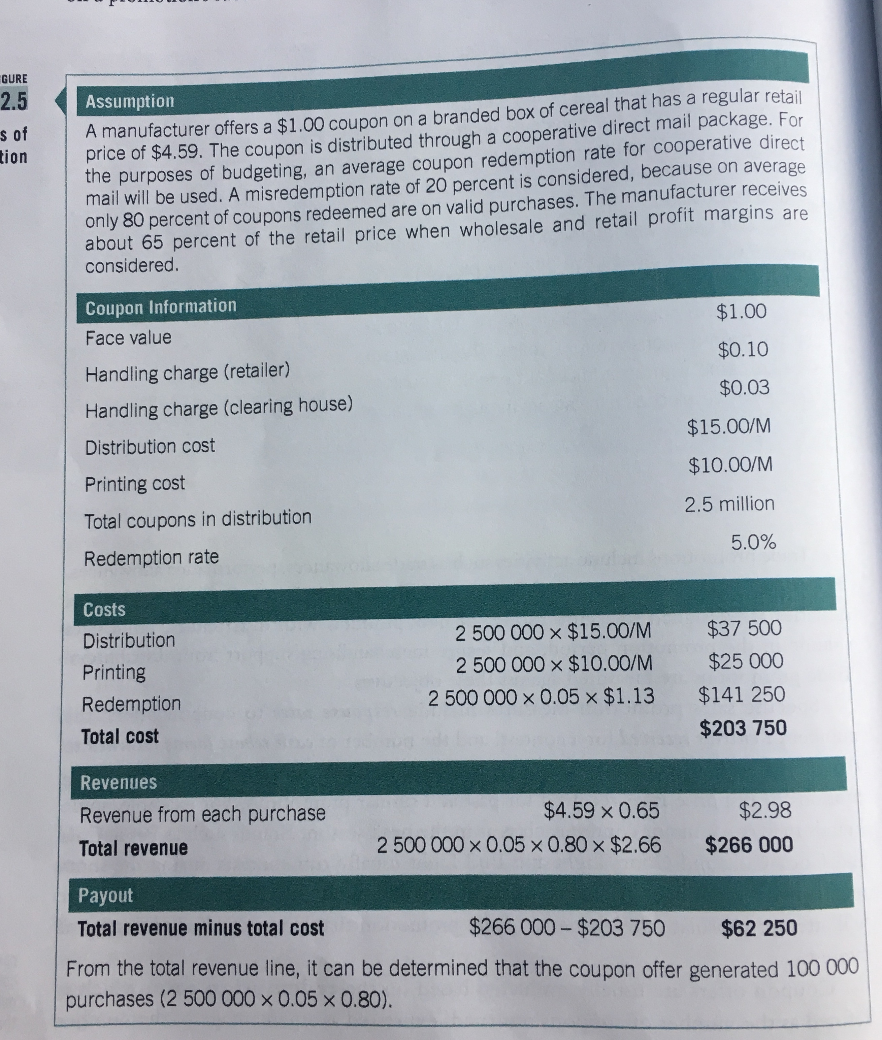

Measuring and Evaluating PR Communication
- Many organizations that are active in PR subscribe to a clipping service which scans the print and broadcast media in search of a company’s name
  - Example, if 500 press releases were issued and there were 50 clippings, the return rate would be 10%
    - The success of the campaign would be based on historical comparisons of return rates
- The number of impressions generated is based on the circulation of the medium in which the organization’s name is mentioned
  - Example, if an article appears in the Toronto Star on Tuesday and the circulation that day is 350,000 the total number of impressions would be 350,000
  - Gross up considering the actual readership of the paper
    - If the average number of readers is 2.8 per copy, the gross impression would be 350,000 x 2.8 = 980,000

Measuring Experiential Marketing Events and Sponsorship
- The most common measure of an event’s success is how well the even reaches the target audience and how well the bran is associated with the event
- Media exposure is a true benefit of event marketing

Measuring the IMC Effort
- An increase in market share would indicate greater acceptance by more customers, a higher degree of brand loyalty amount current customers and a strong competitive position
  - Market share the sales volume of one product or company expressed as a percentage of total sales volume in the market the company or brand is competing in

Additional Reading 1: Celebrity Endorsers
- The endorsement process depends upon the symbolic properties of the celebrity endorser
  - “Meaning transfer” perspective
- Celebrity endorser, any individual who enjoys public recognition and who uses this recognition on behalf of a consumer good by appearing with it in an advertisement

The Literature
Source Credibility Model (Hovland)
- Social psychology
- A message depends for its effectiveness on the “expertness” and “trust-worthiness” of the source
- Expertness is defined as the perceived ability of the source to make valid assertions
- Trustworthiness is defined as the perceived willingness of the source to make valid assertions

Source Attractiveness Model (McGuire)
- Social psychology
- A message depends for its effectiveness on the “familiarity”, and/or “similarity” of the source
- Familiarity is defined as knowledge of the source through exposure, liability as affliction for the source as a result of the source’s physical appearance and behaviour
  - Similarity as a supposed resemblance between the source and receiver of the message

The Source Models
- Have been confirmed by research
- A necessary part of our understanding of the endorsement process
- They do not capture all the issues:
  - Cannot explain the endorsement’s most fundamental features
  - Some product categories are incompatible with celebrity categories
  - For the models' purposes, as long as the credibility and attractiveness conditions are satisfied, any celebrity should serve as a persuasive source for any advertising message
    - Everything to do with the celebrity and not the product
- If the celebrity endorser represents not himself but his stage persona, the issues of expertness and trustworthiness can hardly apply
  - This stage person is added on to the celebrity’s persona
- Do not allow use to understand the appeal of any particular celebrity
  - Why one product but not for another
  - Prevents us from identifying the matches and mismatches
- Never allow us to discriminate between celebrities in any useful way
  - How two different celebrities differ symbolically
- The source models tell us about degrees of attractiveness and credibility when what we need to know about is kinds of attractiveness and credibility

Cultural Meaning and the Celebrity Endorser
- Depends upon the meaning he/she brings to the endorsement process
  - Class
  - Gender
  - Age
  - Status
- A range of personality types
- A range of lifestyle types

Meaning Transfer
The General Process
- According to this model, there is a conventional path for the movement of cultural meaning in consumer societies
- The movement of meaning from the culturally constituted world to consumer is accomplished by advertising and the fashion system
- The movement of meaning from consumer goods to the individual is accomplished through the efforts of the consumer
- Advertising serves as an instrument of meaning transfer:
  - Advertiser identifies the cultural meanings intended for the product
  - the advertiser surveys the culturally constituted world for the objects, persons, and contexts that already contain and give voice to these meanings
    - Bring the selected cultural meanings into the advertisement in a visible form
    - Care is necessary when choosing the objects:
      - Elements come charged with more meanings than are wanted
      - Elements and product must be presented in a way that the similarity between them suggests itself irresistible to the viewer

The Celebrity Endorser’s Contribution
- Stage 1, to reside in the celebrities themselves
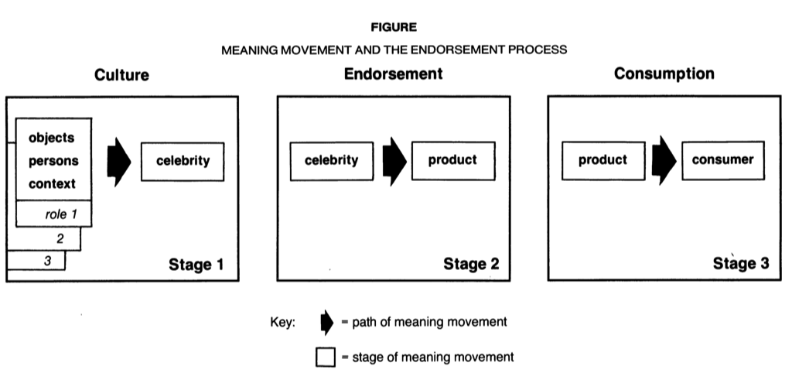
- Stage 2, this meaning is transferred when the celebrity enters into an advertisement with a product

Stage 1
- Special category of person from the culturally constituted world
- The contrast between celebrities and models
  - Anonymous actors and models are charged with meaning
  - The meaning can be imported through an anonymous model
- How does the celebrity add value to the meaning transfer process?
  - Both celebrities and anonymous models offer demographic information
  - Celebrities off those meanings with special precision
    - Range of personality and lifestyle meanings
  - Celebrities are more powerful in the media vs. anonymous models
    - Evoke the meanings in their persona with greater vividness and clarity
    - “own” their meaning because they have created it on a public stage
- Celebrities appear largely unaware of their part in the meaning transfer process concern when typecasting
  - Actors do not like being cast repeatedly in the same role
  - A few actions and actresses are “rinsed” of meaning between them and a role as a result of bringing a new persona to each film
  - Make celebrities useful to the endorsement process

Stage 2
- Marketing/advertising firm first would determine which symbolic properties are in fact sought by the consumer
- Once a celebrity is chosen
  - Capture all the meanings it wishes to obtain from the celebrity
  - Capture only meanings it wishes to obtain from the celebrity
    - Care must be taken to see that these unwanted meanings are kept out of the evoked set
    - Filling the advertisement with people, objects, context, and copy that have the same meanings as the celebrity
- The ad will sometimes operate on the meanings of the celebrity and may even modestly help transform them
  - Typically, in most ads, they are not trying to transform the meanings of the celebrity
- The ad must be designed to suggest the essential similarities between the celebrity and the product so that the consumer will be able to take the last step in the meaning transfer process “sees” the similarities and is prepared to accept them

Stage 3
- Complicated and sometimes difficult
- There is no automatic transfer of meanings no any automatic transformation of the self
- Rituals pay an important part in the process
  - They must select and combine these meanings in a process of experimentation
- Celebrities have created the self
  - The constructed self makes the celebrity a kind of exemplary, inspirational figure to the consumer
  - Admire individuals who have accomplished what they hope to achieve
  - The celebrities have done in stage 1 what the consumer is now laboring to do in stage 3
    - Consumers are laboring to perform their own stage 1
  - Celebrities create the self out of the elements put at their disposal in dramatic roles
    - Make these meanings available in material form to the consumer
- Celebrities play the role of a “super consumer”
  - Film persona of the celebrity consists not merely in the presentation of an interesting film personal but actually in the creation of a self that is new and innovative
  - They are seen as someone that everyone wants to be
- The freedom to choose is now also an obligation to decide, and this makes us especially eager consumers of the symbolic meanings contained in celebrities and the goods they endorse

Additional Reading 2: Building Strong Brands
- Technology and the Internet are changing the way the work interacts and communicates
- There is little consensus on how hands and branding can or should be developed in the modern interactive marketplaces

The Role of Branding
- The concept of brand equity and the important intangible value that brands brand to organizations
  - Defined in terms of marketing effects uniquely attributable to the brand how the brand differentiates itself from the rest
    - Arise from the “added value” endowed to a product as a result of past investments in the marketing for the brand
      - Many different ways that this value can be created for a brand
    - Provides a common denominator for interpreting marketing strategies and assessing the value of a brand
      - Many different ways as to how the value of a brand can be manifested or exploited to benefit the firm
- One key benefit of building a strong brand is increased marketing communication effectiveness
  - Brand equity is central to the way advertising works goal in itself or as a mediator to other goals
- These possible benefits only result from having a strong brand
  - A management priority

The Changing Marketing Communications Environment
- Marketing communications are the means by which firms attempt to inform, persuade and remind consumers – directly or indirectly – about the products and brands they sell
  - Represents the voice of the company and its brands
- The marketing communication mix consists of:
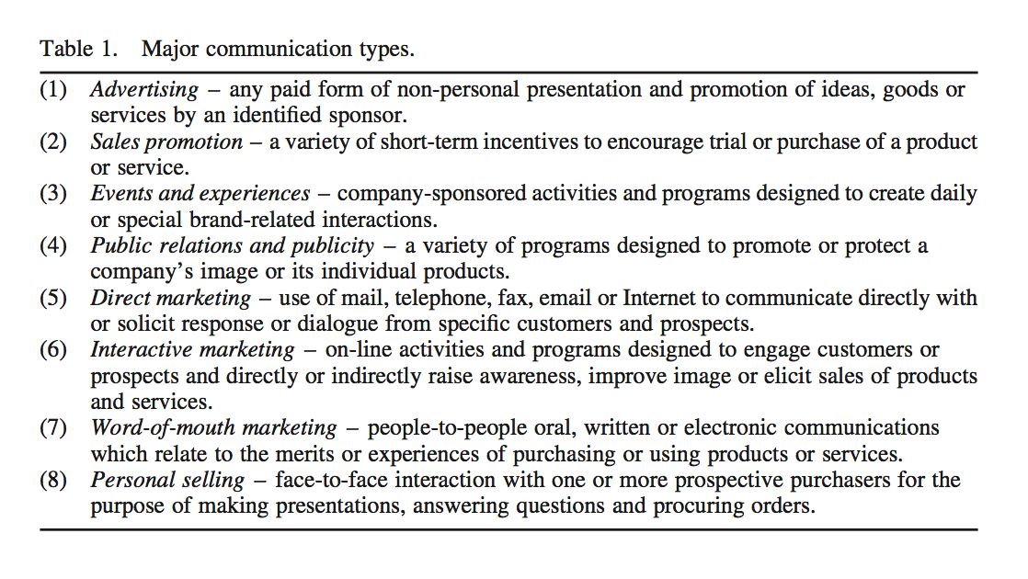

- A number of factors have contributed to the decline of TV advertising:
  - The fragmentation of US audiences and, with the advent of digital technology and the Internet, the media used to reach them
- 40-50% of US householder will own a PVR by 2010 (eliminate commercials)
- Internet is estimated to have a US penetration of 200 million users who can choose whether to view an ad
- The customer is increasingly in control
- The average city dweller is now exposed to 3000 to 5000 ad messages a day
  - Any consumers feel they are becoming increasingly invasive and actively avoid or ignore them, reducing their effectiveness

Integrating Marketing Communications to Build Brand Equity
A model of brand equity for marketing communications
- To understand the role of all the different types of marketing communications for brand building, a comprehensive, cohesive model of brand equity is needed
  - Customer-based brand equity model brand equity is fundamentally determined by the brand knowledge created in consumers’ minds by marketing programs and activities
    - Customer-based brand equity is defined as the differential effect that consumer knowledge about a brand has on their response to marketing for that brand
- Brand knowledge is all the thoughts, feelings, perceptions, images, experiences…etc…that become linked to the brand in the minds of the consumer (individuals and organizations) a set of associations
  - Two important components:
    - Brand awareness
      - The strength of the brand node or trace in memory as reflected by consumers’ ability to recall or recognize the brand under different conditions.
    - Brand image
      - Consumer perceptions of and preferences for a brand, as reflected by the various types of brand associations held in consumers’ memory

The Brand Resonance Pyramid
- How brands should be built in terms of consumer knowledge structures
- the CBBE model views brand building as an ascending series of steps, from bottom to top:
  - (1) ensuring identification of the brand with customers and an association of the brand in customers’ minds with a specific product class or customer need
  - (2) firmly establishing the totality of brand meaning in the minds of customers by strategically linking a host of tangible and intangible brand associations
  - (3) eliciting the proper customer responses in terms of brand-related judgment and feelings
  - (4) converting brand response to create an intense, active loyalty relationship between customers and the brand.
- According to this model, enacting the four steps means establishing a pyramid of six ‘brand building blocks’ with customers
- Rational route on the left-hand side
- Emotional route on the right-hand side
- Brand salience is how easily and often customers think of the brand under various purchase or consumption situations
- Brand performance is how well the product or service meets customers’ functional needs.
- Brand imagery describes the extrinsic properties of the product or service
  - Brand attempts to meet customers’ psychological or social needs
- Brand judgments focus on customers’ own personal opinions and evaluations.
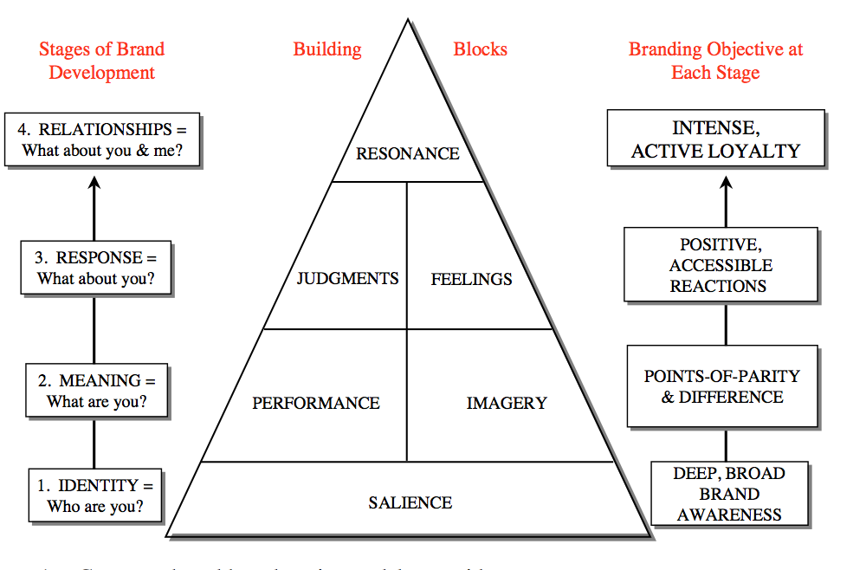
- Brand feelings are customers’ emotional responses and reactions with respect to the brand

- Brand resonance refers to the nature of the relationship customers have with the brand and the extent to which they feel they’re “in sync” with the brand
  - Reflects the intensity or depth of the psychological bond that customers have with the brand, as well as the level of activity engendered by this loyalty

- Brand resonance has four dimensions, which each capture a number of different aspects of brand loyalty:
  - (1) Behavioral loyalty – customers’ repeat purchases and the amount or share of category volume attributed to the brand.
  - (2) Attitudinal attachment – when customers view the brand as being something special in a broader context.
  - (3) Sense of community – when customers feel a kinship or affiliation with other people associated with the brand.
  - (4) Active engagement – when customers are willing to invest personal resources on the brand – time, energy, money, etc. – beyond those resources expended during purchase or consumption of the brand.
- To create brand resonance, marketers must first create a foundation on which resonance can be built

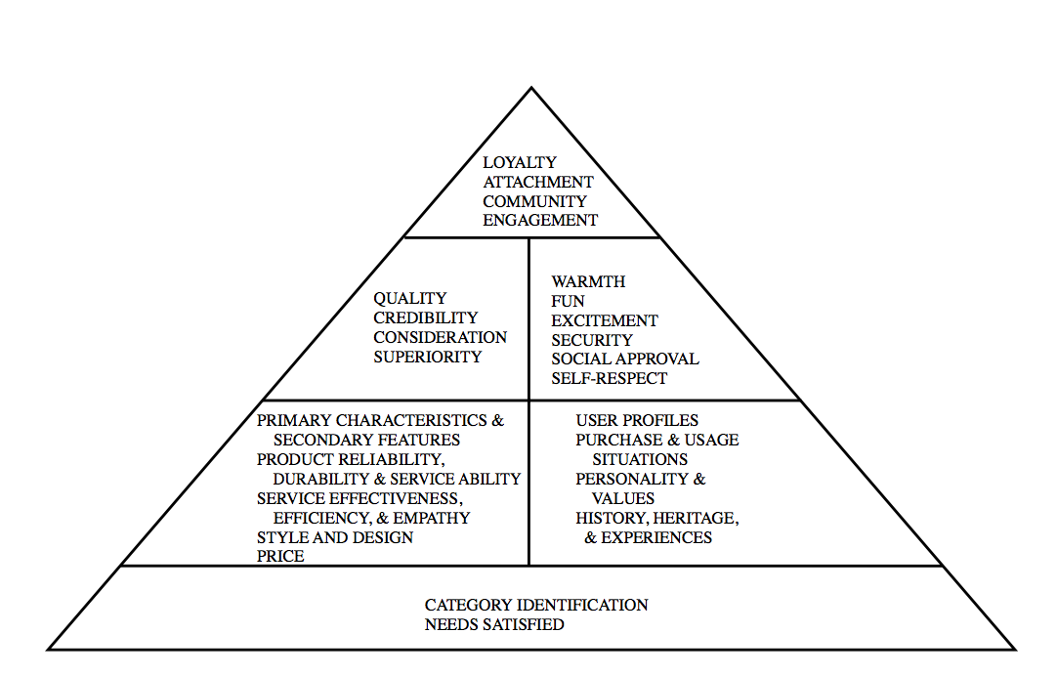

Marketing communication effects on brand equity
- From a customer-based brand equity perspective, marketing communications activities contribute to brand equity and drive sales in many ways:
  - By creating awareness of the brand
  - Linking the right associations to the brand image in consumers’ memory
  - Eliciting positive brand judgements or feelings
  - Facilitating a stronger consumer-brand connection
- The starting point in planning marketing communications is an audit of all the potential interactions that customers in the target market may have with the company and all its products and services

Mixing and matching marketing communications
- In developing an integrated marketing communication program, a number of factors come into play
  - Type of product market, consumer readiness to make a purchase, stage in the product life cycle and the brand’s market share and positioning
- From the perspective of building brand equity, markets should be “media neutral” and evaluate all the different possible communication options according to effectiveness, and efficiency
- Markets should mix and match communication options to build brand equity
  - They have to share a common meaning and content but also offer different and complementary advantages

Brand Building with Interactive Marketing Communications
- Have to go online where the customers are
- Young, high-income, high-education customers’ total online media consumption has exceeded that of TV for several years
- Representative set of 11 different interactive marketing communication options:
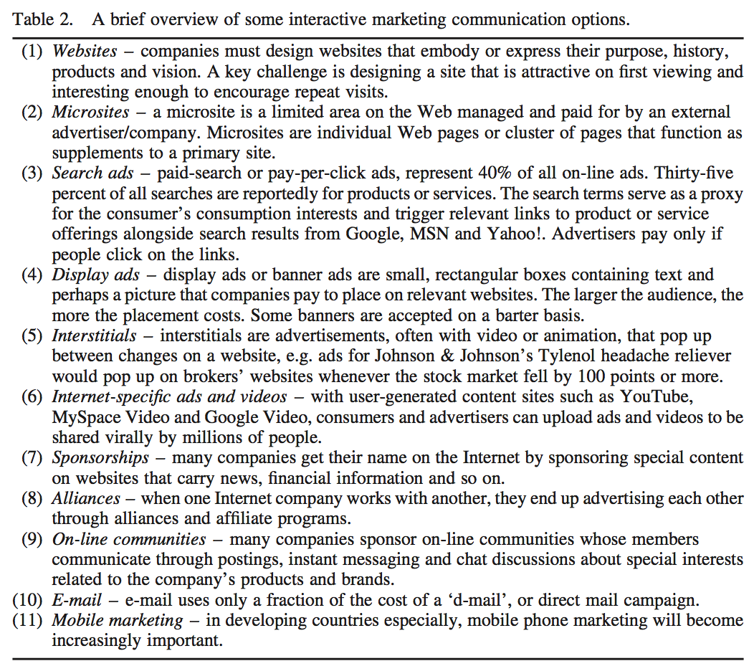

Branding advantages and disadvantages of interactive marketing communications
- Few brand marketing programs are considered complete without some type of prominent online component
- Online companies can send tailored messages that can engage different segments of consumers by reflecting their special interests and behavior
- The Internet offers the advantage of contextual placement, or sites for ad placement that are related to the marketer’s offerings
- Challenges:
  - Customers define the rules of engagement and can insulate themselves with the help of agents and intermediaries if they so choose

Interactive marketing communications and brand resonance
- Every aspect of the brand resonance pyramid can be positively impacted by interacting marketing, as follows

Salience
- Can improve both breadth and depth of brand awareness
- The internet permits very specific targeting of potentially difficult to reach groups
  - Especially effective for reaching people during the day
- Key advantages are the ability to reach customers as they seek information, thus heightening awareness as potential purchase opportunities

Performance and Imagery
- Can help establish a number of key performance and imagery points-of-parity and points-of-difference vs. competitors
- On websites markets can provide this information to consumers

Judgements and Feelings
- Can encourage attitude formation and decision making, especially when combined with offline channels
- Can create an impactful enduring feeling

Resonance
- Most useful in terms of creating resonance in that it permits daily or frequent encounter and feedback opportunities for consumers with a brand
  - Can help strengthen brand attachment
- Can have the most impact with active engagements
  - Learn from and teach others about a brand, as well as express their commitment to a brand and observe the brand loyalty of others
  - Customers can bond with other customers

Integrating interactive marketing communications
- In developing an integrated interactive communication program, markets must take both a micro and macro prospective
  - Micro sense marketing communication activities are designed to be as effective and efficient as possible in isolation
  - Macro sense well integrated with other online marketing communication activities as well as with offline activities

Micro Perspectives
- Websites have a range of functionality that allows them to be a potentially highly effective and efficient communication option to affect brand resonance and equity.
  - Marketers can communicate directly with actual and potential customers to provide more information than can be found in any other medium.
- On-line ads and videos permit highly targeted, timely messages that can expand salience.
  - Moreover, on-line ads and videos can extend the creative or legal restrictions of traditional print and broadcast media to persuasively communicate brand positioning and elicit positive judgments and feelings.
- Blogs and bulletin boards can help to improve salience, performance and imagery, depending on the discourse involved, but are more likely to be valuable at higher levels of the resonance pyramid.
  - By permitting personal, independent expression, blogs and bulletin boards can create a sense of community and foster active engagement
  - They also permit feedback that can improve all aspects of a brand’s marketing program.

Macro Perspective
- Coverage relates to the proportion of the audience that is reached by each communication option employed, as well as how much overlap exists among communication options
- Contribution relates to the inherent ability of a marketing communication to create the desired response and communication effects from consumers in the absence of exposure to any other communication option
  - In other words, contribution relates to the ‘main effects’ of a marketing communication option in terms of how it affects consumers’ processing of a communication and the resulting outcomes (e.g. building awareness, enhancing image, eliciting responses, inducing sales).
- Commonality relates to the extent to which common associations are reinforced across communication options, that is, the extent to which information conveyed by different communication options shares meaning.
- Complementarity relates to the extent to which different associations and linkages are emphasized across communication options
- Versatility refers to the extent that a marketing communication option is robust and effective for different groups of consumers
  - A marketing communication option is deemed versatile when it achieves its desired effect regardless of consumers’ past communication history, level of brand or product knowledge or processing goals and so on.
- Cost refers to the evaluations of marketing communications on all of the preceding criteria must be weighed against their cost to arrive at the most effective and efficient communication program

Implications
- Three key implications are that marketers must:
  - Be media neutral and consider all possible communication options
  - Mix and match the communication options chosen to maximize their respective strengths and weaknesses
  - Ensure that interactive marketing can play a significant role in the total marketing communications program
- For each type of relationship, the focus is on the manner or form of the interaction involved:
  - Consumer-Company relationship
    - What do consumers know and feel about the company behind the brand and how it treats consumers
  - Consumer-Consumer relationship
    - How much interaction occurs among consumers online and offline such that they can learn from and teach others
  - Company-Brand relationship
    - Is the company viewed as good brand steward and ensuring that the brand lives up to its promise?
  - Consumer-Brand relationship
    - How much and how often do consumers use the brand
    - How strongly do they feel attached to it

Future research opportunities and challenges
- Different types of marketing communication options can be effectively and efficiently employed to collectively maximize short-term profitability as well as long-term brand equity
  - There needs to be a more complete understanding of the range of communication effects created by different communication options
There needs to be an understanding of the role of different communication options and how they complement and substitute for each other.

Additional Reading 3: Discipline of Business Experimentation
- Ron Johnson, CEO of J.C. Penny in 2011, eliminated any sort of discount policy, and used technology to eliminate and cashiers, cash registers, and checkout counters
  - 17 months after joining sales plummeted
- Big data can only account for past behaviours not how a consumer will react to changes
  - Managers must rely on their experience or intuition
    - Managers can, however, discover whether a new product or business program will succeed by subjecting it to a rigorous test
- Why don’t companies conduct these tests?
  - Most organizations are reluctant to fund proper business experiments and have considerable difficulty executing them
- More than 90% of consumer business is conducted through complex distribution systems, such as:
  - store networks
  - sales territories
  - bank branches
  - fast-food franchises…etc.
    - Issues with these environments
    - Variety of analytical complexities sample sizes are typically too small to yield valid results
      - Most tests of new consumer programs are too informal
- Ideal experiment the tester separates an independent variable (the presumed cause) from a dependent variable (the observed fact) while holding all other potential causes constant, and then manipulates the former to study changes in the latter
  - To obtain that type of knowledge and ensure that business experimentation is worth the expense and effort, they must ask themselves several critical questions (everything in bold) (the checklist)
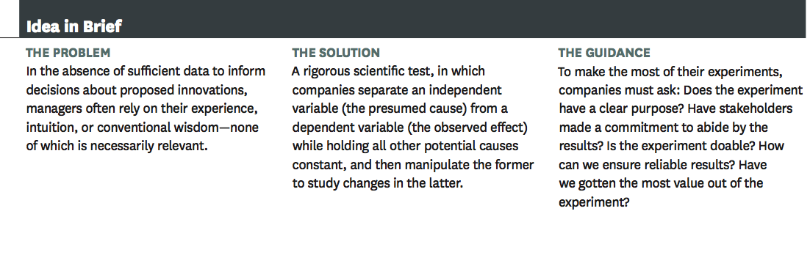

- Checklist for running a business experiment
  - Purpose
  - Buy-in
  - Feasible
  - Reliability
  - Value
Does the Experiment have a clear purpose?
- Companies should conduct experiments if they are the only practical way to answer specific questions about proposed management actions
  - What do the managers want to learn?
- A good hypothesis helps delineate independent variables to test on a specific dependent variable
- Need not only look at the direct effects of an initiative but also the ancillary effects
  - Negative or positive

Have stakeholders made a commitment to abide by the result?
- Before conducting any tests, stakeholders must agree how they’ll proceed once the results are in
- There might be a good reason to put out an initiative even when the anticipated benefits are not supported by the data
  - For example, a program that experiments have shown will not substantially boost sales might still be necessary to build customer loyalty
- A process should be instituted to ensure that test results aren’t ignored, even when they contradict the assumptions or intuition of top executives
  - For projects that make the cut, analytics professionals develop test designs and submit them to a committee that includes the vice president of finance
    - Then they are overseen by an internal test group
  - Important to remember that experiments should be part of a learning agenda that supports the firm’s organizational priorities
- Many test requests are denied because the company has done a similar test in the past
  - Others are rejected because the changes under consideration are not radical enough to justify the expense of testing

Is the experiment doable?
- Experiments must have testable predictions
  - The “casual density” of the business environment the complexity of the variables and their interactions can make it extremely difficult to determine cause-and-effect relationships
    - Example, you may be changing one aspect (have two stores under the same corporate hub but one is making more money but they essentially do the same thing so you decide to change the store that is doing worse to the same name as the sore that is more profitable to see if that would help increase sales)
    - The company can isolate the effect of the name change from those and other variables, the executive won’t know for sure whether the name change has helped (or hurt) business
- Managers often mistakenly assume that a larger sample will automatically lead to better data
  - If they are highly clustered, or correlated to one another, then the true sample size might actually be quite small
- The required sample size depends in large part on the magnitude of the expected effect
  - If the effect is expected to have a large effect the sample can be smaller
  - If the effect is expected to have a small effect, the sample must be larger
- By selecting the right sample size, it can also enable a company to decrease testing costs and increase innovation

How can we ensure reliable results?
- Randomized field trails
  - It helps prevent systemic bias, introduced consciously or unconsciously, from affecting an experiment, and it evenly spreads any remaining (and possibly un- known) potential causes of the outcome between the test and control groups
- Blind test
  - Not aware of what is going on
- Big data
  - To filter out statistical noise and identify cause-and-effect relationships, business experiments should ideally employ samples numbering in the thousands
  - The emphasis is on correlation
    - Getting started
    - Building a control group
    - Targeting the best opportunity
    - Tailoring the program

Have we gotten the most value out of the experiment?
- Executives should take into account a proposed initiative’s effect on various customers, markets, and segments and concentrate investments in areas where the potential paybacks are highest
- “Value engineering” most programs have some components that create benefits in excess of costs and other that do not
  - Implement just the components with an attractive return on investment (ROI)
- Careful analysis of data generated by experiments can enable companies to better understand their operations and test their assumptions of which variables cause which effects
  - The knowledge of causality factors causing the increase (or decrease) ‘
- Value comes from analyzing and then exploiting the data

