Total number of points: 20 + 2 bonus points. Duration: 75 minutes.

1st part (12 points, 1 point per question)

Please answer the following 12 questions.

- In Chapter 10, we studied the figure below describing the adoption of a minimum wage in the covered sector. This is a _________________________ analysis showing the impact of this policy on the uncovered sector as well as on the aggregate labour market. According to this analysis, as a result of the adoption of the minimum wage in the covered sector, the equilibrium wage in the uncovered sector _________. The missing words are:

- general-equilibrium; rises.
- general-equilibrium; falls.
- partial-equilibrium; rises.
- partial-equilibrium; falls.

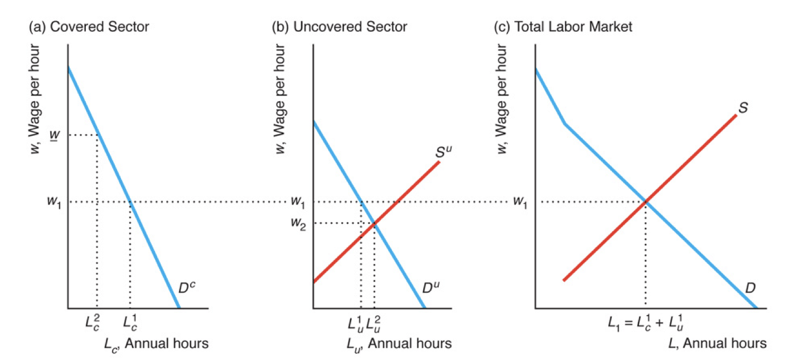

- Competitive firms located in Africa sell good X only in Europe and the United States (which do not produce the good​ themselves). The​ industry's supply curve is upward sloping. Europe puts a tariff of t per unit on the​ good, but the United States does not. As a result of the European tariff, the global market price (i.e. the producer’s price, not the consumers’ price!) of good X ____________ and the aggregate quantity of X ______________. The missing words are:

- increases; increases.
- increases; falls.
- falls; increases.
- falls; falls.

- We say that an outcome/allocation (we will call it A) Pareto dominates another outcome/allocation (we will call it B) if no agent is worse-off in A relative to B and at least one agent is better-off in A relative to B. Consider now the Edgeworth box represented below. (1) According to the figure below, allocation d Pareto dominates allocation e. (2) According to the figure below, allocation c Pareto dominates allocation e. Statements (1) and (2) are respectively:

- true; true.
- true; false.
- false; true.
- false; false.

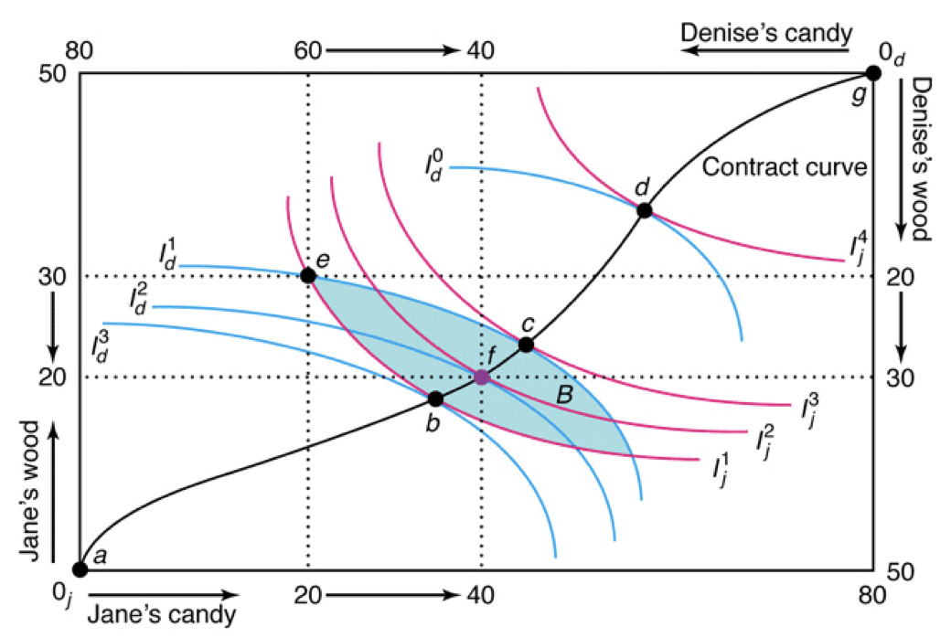

- Consider the Edgeworth box represented below (next page, not above!). According to the price line represented in this figure, the relative price of a candy bar in terms of wood is ___. In this figure, the price line going from allocations e to f ____________ to a competitive equilibrium. The missing words are:

- 2; leads.
- 2; does not lead.
- 0.5; leads.
- 0.5; does not lead.

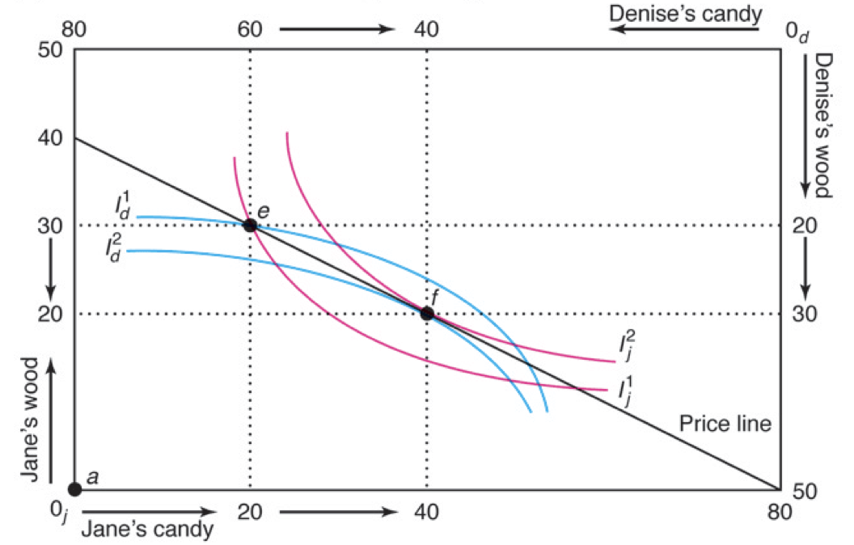

- Please refer to the figure below we studied in class. The figure represents the impact of trade liberalization (a) if there are no distortions and (b) if there is a public subsidy of s per unit sold. In scenario (b), the cost of the subsidy is ___ and the net welfare gain as a result of trade liberalization is ____. The missing words are:

- B + C ; A + B – C.
- B + C ; A – C.
- C ; A + B – C.
- C ; A – C.
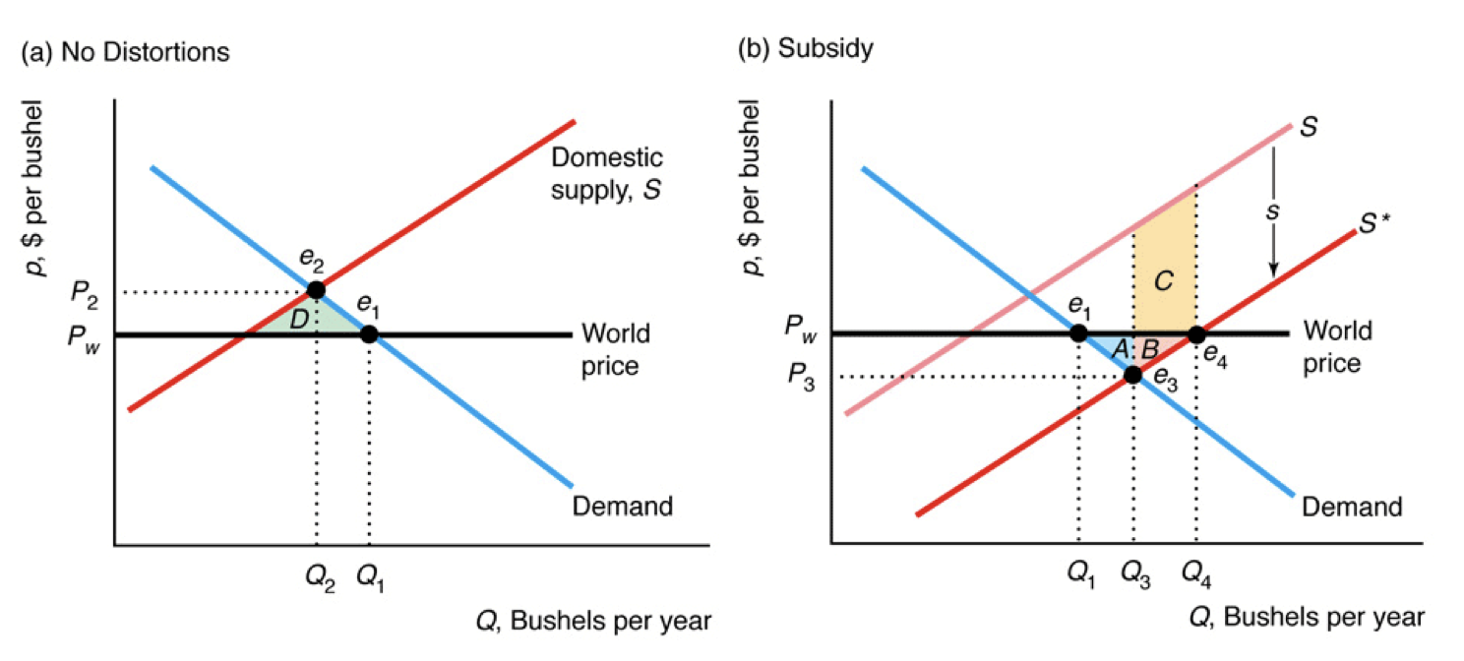

- (1) The production possibilities frontier shows the maximum combination of two outputs that can be produced from a given amount of input. (2) At equilibrium, in a competitive market the marginal rate of substitution of the two goods will be equal to their marginal rate of transformation. Statements (1) and (2) are respectively:

- true; true.
- true; false.
- false; true.
- false; false.

- Progressive taxation is an example of ________________ equity. ________________ efficiency is defined as the state of the economy in which production reflects consumers’ preferences. The missing words are:

- horizontal; allocative.
- horizontal; productive.
- vertical; allocative.
- vertical; productive.

- Assume the United States and China use labour to produce two goods, computers and apparel. (Incidentally, in a trade economics course you would refer to this framework as a 1-factor, 2-good, 2-countries Ricardian world.) There are technological differences between the two countries. The US production functions are given by the following equations: $Q_{A}=Z_{A}L_{A}$; $Q_{C}=Z_{C}L_{C}$, where Z is a technological parameter, L stands for one hour of labour, while the subscripts C and A refer to computers and apparel respectively. The Chinese production functions take a similar form, with the only difference that Chinese variables are represented with a star. Assume the technological parameters to be $Z_{C}=10$, $Z_{C}^{*}=1$, $Z_{A}=5$, $Z_{A}^{*}=1$. (Essentially, one US worker can produce in one hour 10 units of computers or 5 of apparel, while the Chinese equivalent can produce one unit of each.) Which one(s) of the following statements is (are) true?

- Given these technological parameters, there is nothing China can export.
- The US has an absolute advantage in both goods.
- The US has an absolute advantage in computers and China has an absolute advantage in apparel.
- The US has a comparative advantage in computers and China has a comparative advantage in apparel.

- (i) and (ii).
- (iii) only.
- (ii) and (iv).
- (iv) only.

- In class, we studied the following example of a monopoly. The inverse demand function for the good produced by the monopoly is p(Q) = 24 – Q and the short run cost function is C(Q) = Q² + 12. It follows that the marginal revenue is equal to ___ and the marginal cost is equal to ___.
- 24Q – Q²; Q + 12.
- 24Q – Q²; 2Q.
- 24 – 2Q; Q+12.
- 24 – 2Q; 2Q.

- Please refer to the same scenario as in Question 9. The equilibrium solutions for this problem are p* = ___ and Q* = ___.

- 18; 6.
- 6; 6.
- 6; 18.
- 6; 12.

- Please refer to the same scenario as in Question 9. What is the value of the deadweight loss created by the existence of a monopoly (relative to a hypothetical perfect competition outcome)?

- 2.
- 4.
- 6.
- 12.
- The Lerner index is described by this formula: 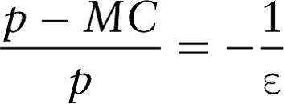. As the Lerner index increases, the mark-up on marginal costs charged by the monopolist _________. The Lerner index captures the insight that the less elastic the demand is, the ______ the market power of the monopolist is. The missing words are:

- increases; larger.
- increases; smaller.
- decreases; larger.
- decreases; smaller.

2nd part (8 points, 4 points par question)

Please answer 2 of the following 3 questions. Use the space below to write your answers.

- The demand functions for each of two goods depend on the prices of the goods, p₁ and p₂: Q₁ = 15 – 3p₁ + p₂ and Q₂ = 6 – 2p₂ + p₁. However, each supply curve depends only on its own price: Q₁ = 2 + p₁ and Q₂ = 1 + p₂. Solve for the equilibrium values of Q₁, Q₂, p₁, and p₂.

From Q₁ = 15 – 3p₁ + p₂ and Q₁ = 2 + p₁, it follows that 15 – 3p₁ + p₂ = 2 + p₁, which means p₂ = 4p₁ – 13. (1)
From Q₂ = 6 – 2p₂ + p₁ and Q₂ = 1 + p₂, it follows that 6 – 2p₂ + p₁ = 1 + p₂, which is equivalent to 5 + p₁ = 3p₂. (2)
Now, plug (1) in (2) to obtain 5 + p₁ = 3(4p₁ – 13) and then solve for p₁ = 4. From this, it is easy to derive p₂ = 3, Q₁ = 6, and Q₂ = 5.

- A social welfare function is thought to be additive along the lines proposed by Bentham and​ Mill: $W=U_{1}+U_{2}+…+U_{n}$, where $U_{i}$ is individual i’s utility and there are n individuals. Suppose and economy is made up of two individuals, John and Jane. Their utility functions are: $U_{John}=24\sqrt{X}$ and $U_{Jane}=2X$. There is a fixed quantity of 60 units of good X. What allocation of good X between John and Jane maximizes social​ welfare?

Keep in mind that the following relationship holds: $X_{John}+X_{Jane}=60$. You can write the social welfare function as $W=24\sqrt{X_{John}}+2\left(60-X_{John}\right)$. You can now take the first order condition with respect to the choice variable (essentially the policy-maker is deciding how to allocate X between John and Jane, and therefore $X_{John}$ is our choice variable – the other being implicitly solved for).

FOC: $\frac{dW}{dX_{John}}=24\left(\frac{1}{2}\right){X_{John}}^{{-1}/2}-2=0$.
You can now solve your equation. The solution is $X_{John}=36$ and
$$X_{Jane}=60-36=24.$$

- The figure below (that we studied in class) captures the welfare effect of monopoly before and after the imposition of a per unit tax. By referring to the triangles A, B, C, D, E, F, and G, you are asked to indicate the consumer surplus, producer surplus, tax revenues, welfare, and deadweight loss before and after tax. (Hint: you do not need to actually attempt to estimate the dollar amounts of these values corresponding to the areas of these geometrical figures.)
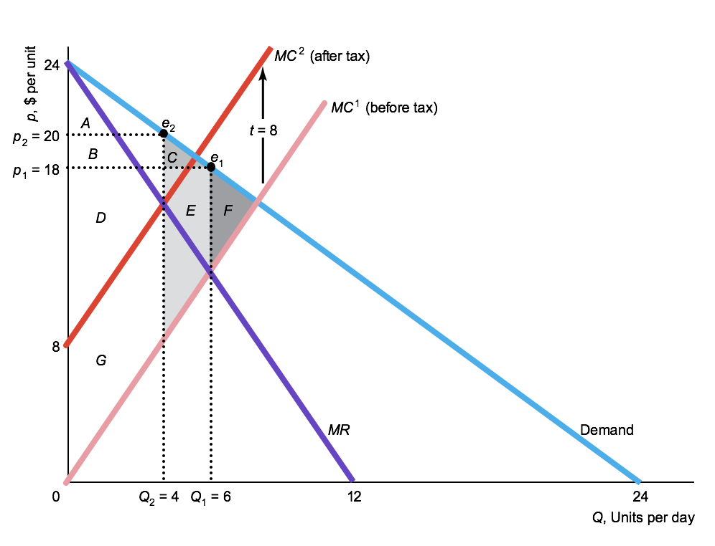

Before tax: CS = A + B + C, PS = D + E +G, Tax revenues = 0,
Total welfare = A + B + C + D + E + G, deadweight loss = F.
After tax: CA = A, PS = B + D, Tax revenues = G,
Total welfare = A + B + D + G, deadweight loss = C + E + F.

Bonus question (2 points)

Assume an Edgeworth box representing the preferences and endowments of two individuals. Assume the two goods are paintings and sculptures and that the two individuals consider them as being perfect substitutes. You are asked to draw the contract curve of this Edgeworth Box (or simply explain what is its specificity). Your answer should consider two relevant possibilities. (Note: each possibility carries one point. There are however no partial points awarded for any of the two possibilities.)

For perfect substitutes, the indifference curves are straight lines.
Scenario 1: The indifference curves do not have the same slope. The tangency points will therefore be corner solutions along two adjacent the edges of the Edgeworth box (essentially two consecutive edges connecting the two origin points).
Scenario 2: The indifference curves have the same slope. In this case, all points within the Edgeworth box are Pareto efficient and therefore have features consistent with the definition of the contract curve.

