BIO1140 Midterm 1 Notes
Please see the examples midterms in the folder entitled BIO1140 practice midterms

Topic 1 Introduction to cell biology and the cell’s features
- In the 1600’s, Robert Hooke came up with the first microscope
- Cell theory
  - Three components;
  - All organisms are composed of one or more cells
  - The cell is the basic structural and functional unit of all living organisms (Schwann, 1839)
  - Cells arise only form divisions of pre-existing cells (Virchow, 1855)
- If there are no cells, it is not classified as a living organism
- Cells do not spontaneously appear
- Prokaryotes range from 1-5 µm in size
- Eukaryotes range from 10-100 µmin size
- Why are cells small?
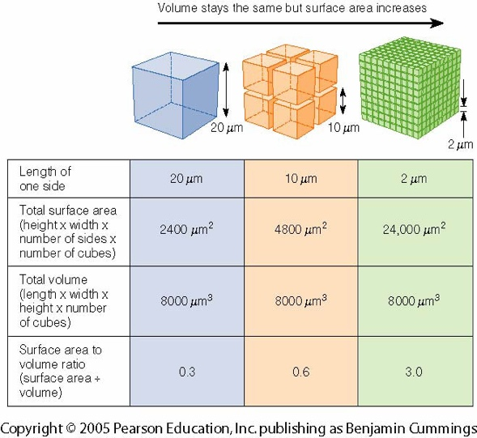
  - Cells are small so that their surface area to volume ratio is large.
  - Cells need things from the outside environment and they can transport things in and out of the cell (most importantly, nutrients). There are gates and channels throughout the membrane to do this.
  - For the given amount of membrane surface, there is a certain quantity or volume of cytoplasm that the molecules must pass through to get to their destination. It is costly and inefficient in terms of distance, time, and energy to equilibrate the cell and to bring in and out what it needs if the cell is very large, therefore instead of having one large cell, splitting it up into multiple smaller cells is more effective and efficient because there is less space for the molecule to travel.
- Each cell is joined to the next in order to collaborate and work together; this allows them to do more complex tasks.
- Cells can remain individual (i.e. the red blood cell) or they can assemble together to form tissue and organs.
- In terms of domains of the tree of life, focus on Bacteria and Eukarya (animals, plants, fungi).
- Archeans look more like bacteria under a microscope however they are much closer relatives to eukaryotes
  - They have a lack of peptidoglycans and the machinery that they use to build proteins is much closer to that the eukaryotes use.

- Prokaryotes;
  - Unicellular, bacteria, archea
  - Very small, simple, highly adaptable, small genomes, no organelles, no internal transport system.
- Eukaryotes;
  - Larger, more elaborate membranes allow compartments to organize cellular functions, transport systems, larger genomes.
- Bacteria;
  - No nucleus, disorganized DNA within cytoplasm
  - Cell wall can be made up of different things depending on the bacteria as well as the composition of the cell wall
  - The different cell walls allow the bacteria to interact with different surrounding
  - They have a slimy capsule called the Glycocalyx
- Plant cell;
  - Lots of organelles in the cytoplasm; large central vacuole
  - Nucleus is present; definitive structure that protects the DNA
  - Have a cell wall; however, there is no cilia or flagella or a method of self-propulsion
- Animal eukaryotic cell
  - Different organelles than a plant cell; no large central vacuole or chloroplasts
  - No cell wall; they only have a cell membrane
- Theory of Endosymbiosis
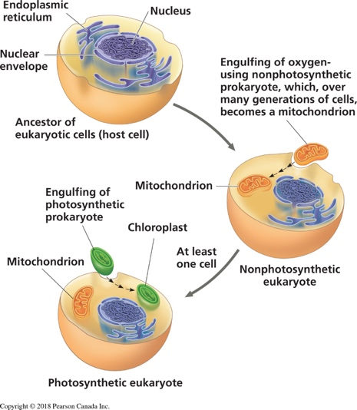
  - A theory stating that the eukaryotes evolved through a process whereby different types of free-living prokaryotes became incorporated inside larger prokaryotic cells and eventually developed into mitochondria, chloroplasts, and possibly other organelles.
  - This is how eukaryotes evolved
  - Endo means within, symbiosis means mutually beneficial relationship
  - There is no direct observational evidence to support this theory; however, there is scientific evidence that helps support the theory
  - Mitochondria have their own DNA as they were once unicellular singular organisms; they have their own set of relevant genes for the tasks that they need to accomplish; they have their own genome and machinery and they can transcribe proteins etc.
- Theory of Endosymbiosis evidence
  - Morphology; shape of mitochondria and chloroplasts and size are similar to bacteria and archea, which allows us to believe they were once prokaryotes
  - Reproduction; mitochondria and chloroplasts increase their own numbers in eukaryotes only by binary fission
  - Genome; circular mtDNA and cpDNA
  - Transcription and translation; fully functional machinery in place that can produce the mitochondria’s own proteins
  - Electron transport; double membrane with ETC; mitochondria can use cellular respiration for energy and chloroplasts can photosynthesize
  - Sequence; bacteria branch on tree of life (mitochondria = proteobacteria; chloroplast = cyanobacteria); compared to bacteria, mitochondria and chloroplasts coincide
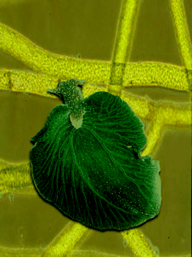
- Symbiosis
  - Not mutually beneficial
  - Kleptoplasty = stealing; sea slug steals the chloroplasts from algae through Kleptoplasty
  - Kleptoplasty; an Endosymbiotic/Symbiotic process during which one organism steals plastids from the other
- Eukaryotic cell organelles
  - Stem from the internal endomembrane system
  - Subcellular compartments within the cytosol surrounded by a membrane
  - Single subcellular compartment without a membrane; ribosomes
    - Ribosomes get out of the nucleus from the nuclear pores on the nuclear envelope
  - Their functions are varied, and depended on the cell’s role
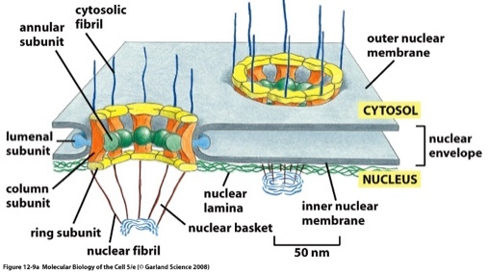
- Nucleus
  - Nuclear pores allow for the ribosomes, protein, and mRNA to be checked before they are released so that compromised organelles don’t get sent out
  - The nuclear pore checks the quality by looking at the structure
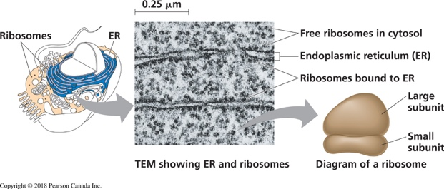
- Ribosomes
  - Two subunits make of rRNA and proteins (small ribonucleic proteins)
  - Do not assemble like this until actually translating an mRNA to a protein
  - The ribosome always have one larger and one smaller subunit
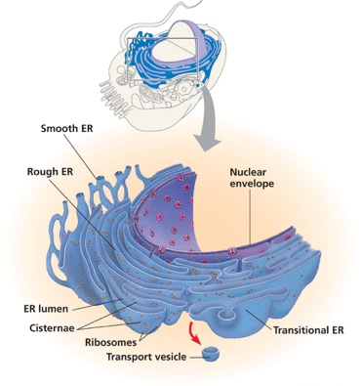
- Endoplasmic reticulums
  - Presence of ribosome determines if it is rough or smooth
  - There is no protein synthesis on the smooth ER because of the absence of ribosomes
  - There is synthesis of lipids and detoxification in the smooth ER but not in the rough ER
  - The ER’s have different enzymes in their lumen which allow for different function
  - Protein moves to the Golgi apparatus via a vesicle
  - Vesicles are the latter part of the transitional part of the ER, the membrane snips off and goes to the Golgi apparatus via motor proteins and the cytoskeleton
- Golgi apparatus
  - Contains a series of membrane folds called cisternae
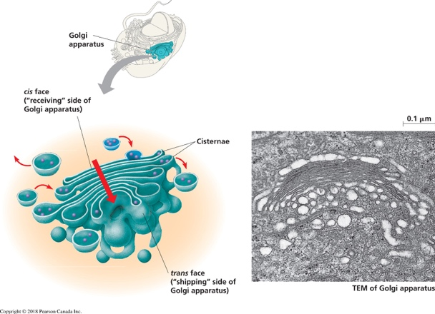
  - This is an oriented organelle; each stack has a different set of constituents; depending on where you look on the Golgi, there is a different function
  - The entrance is on the cis face which is closest to the nucleus
  - The exit is on the trans face, which is away from the nucleus
  - A vesicle will fuse with the Golgi and move its way through the cisternae
  - The Golgi finishes maturation of the protein and makes sure the final destination point is correct so it can be packaged correctly
- Mitochondria
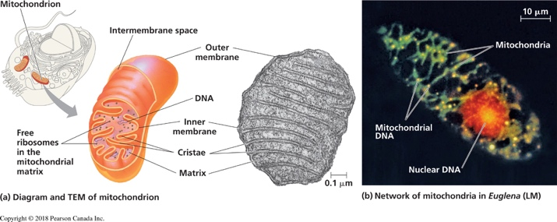
  - Produces ATP
  - Takes care of metabolism
  - Many physiological reaction occur only because of the mitochondria
  - Can store just the right amount calcium; without this, cells could not survive
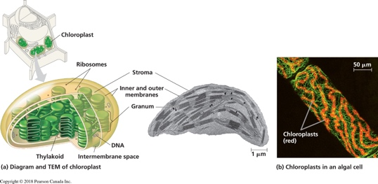
  - Cells dies for numerous reasons, but the heart of the death mechanism is the mitochondria
  - Has own DNA
- Chloroplasts
  - Energy production takes place here
  - Each disc together forms a granum, and all of those make up the thylakoid membrane
  - Is part of the plastid family with amyloplasts and chromoplasts
- Central vacuole
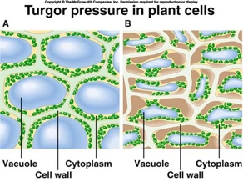
  - Tonoplasts make up the membrane of the CV; they are the only organelles that have a membrane that is as permeable as it is to water
  - CV’s job is to store water, therefore the tonoplast makes it easier for water to into the CV
  - In order to maintain a plant cell’s shape, there must be turgor pressure
- Cell wall and plasmodesmata
  - Plant cells exchange things between each other via the plasmodesmata; this is unique to plant cells
  - The plasmodesmata are very small and can only let very little things through
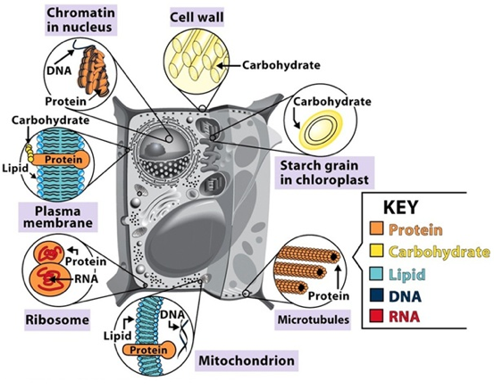
  - The plasmodesmata facilitate the exchange of small ions, water, simple sugars (sometimes)

Topic 2 Macromolecules and chemistry of the cell
- Important macromolecules in biology;
  - Carbohydrates, lipids, nucleic acids, proteins
- All macromolecules interact with each other
- Amino acids
  - There are 20 individual molecules
  - They all have the same back bone
  - There is a unique functional (Radical [R]) group that makes each amino acid different
  - Amino acids are categorized into groups based on their interaction with water and or their charge (polar, non-polar, charged)
  - Polar amino acids are polar because there is an uneven distribution of charge or electrons; this creates areas that are more negative and more positive than the other
  - Nitrogen, oxygen, sulphur, phosphorous, chlorine, and fluorine are all electronegative
  - Charged amino acids are considered polar because they are pulling the electrons in a certain direction and also there is either an absent or extra electron
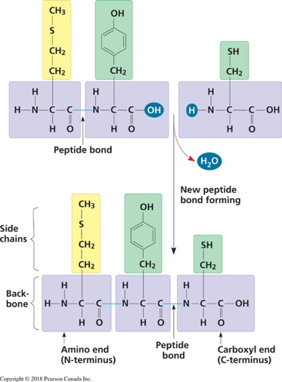
  - All polar amino acids do not have the same degree of polarity because of the different functional groups; cysteine is the least polar of the amino acids and sometimes it can be considered non-polar; tryptophan is the least non-polar and is sometimes considered polar
- Proteins
  - Polymers of amino acids
  - Units are Daltons (Da); 1 amino acid is ~110 Da
  - In a cell, the pH is typically 7.2; most amino acids will be in their ionized form
  - Peptide bond (oriented); has a beginning and an end
  - Any protein if you look at the structure, you can tell where the first amino acid is and where the last is based off of the carboxyl end
  - When you have a chain of 200 amino acids or more, it is called a protein, not a peptide; on average a protein usually has 800 amino acids
- Levels of protein structure
  - The sequence of an amino acid is called the primary structure
  - When you start folding over the structure, there is some hydrogen bonding that occurs; polar amino acids facilitate a flexible ribbon like structure because of the favouring hydrogen bond between the functional groups, and this forms an alpha helix as the secondary structure
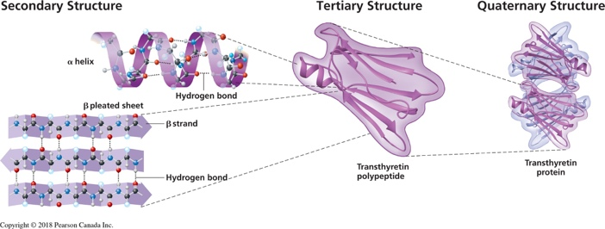
  - Non-polar amino acids form beta pleated sheets as their secondary structure, as they fold over the backbone
  - Beta pleated sheets and alpha helixes fold over each other and new types of bonds form (sulphide bonds); sulphide bonds are stronger than hydrogen bonds because they are covalent, and this strength keeps the tertiary structure in place
  - Tertiary structure is flexible, but it is still a compact, globular protein
  - The amino acids have not formed into an alpha helix or beta pleated sheets may be too short, so tertiary structure is a good mix between polar and non-polar; these areas that the polarity is very balanced is called a linker region
  - Hydrophilic proteins are more soluble than hydrophobic proteins
- Lipids
  - Classified together because they mix poorly, if at all, with water
  - If there is no double bond between carbon atoms composing a chain, then as many hydrogen atoms as possible are bonded to the carbon skeleton; this is called saturated fatty acid because the structure is saturated with hydrogen
  - If there are one or more double bonds, with one fewer hydrogen atom on each double-bonded carbon, it is called an unsaturated fatty acid
  - Kinks usually occur in the cis bond and are more common in plant fats, which is why most animal fats are saturated and most plant fats are unsaturated

Topic 3 Cytoskeleton and Cellular interactions/Extracellular matrix
- The cytoskeleton
  - Its roles include; provide structure and support, intracellular transport of synthesized proteins (directing them to their proper location), position organelles within the cell (anchor them), generate force for cell movement, contribute to cell division
- Microtubules
  - Basic units of microtubules are tubulin dimers (alpha and beta tubulins)
  - GTP binding site location confers the polarities to the MT; “+ end” and “- end” (beta and alpha)
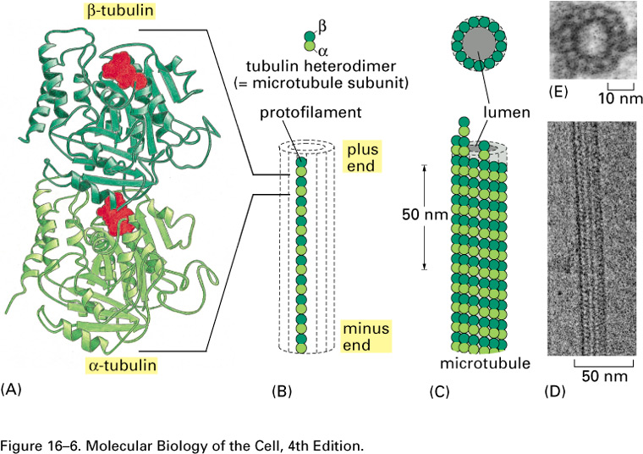
  - Originate from a central point, the MTOC (microtubules organizations center) at the centrosome (near nucleus) (at the “- end”); some MT can originate in the cytoplasm
  - MT are dynamically instable, because they grow and shrink back rapidly
  - The chemical bonds used to build microtubules are hydrogen bonds
  - MT’s moving requires a lot of energy to assemble and disassemble itself very quickly
  - The rate at which the dimers are added and removed stems from the different structural ends
  - Tubulin assemble in dimers; the diners of tubulin lead to MT
  - Dimers make a string called protofilament; thirteen protofilament form a sheet because of the 3D structure, you get a hollow tube that is the MT
  - An end of the MT is positive because then GTP is so close to the edge that it is also exposed
  - When the GTP is so far into the MT that it is not accessible, then the MT end is negative
  - The beta end is the growing side (the positive end where the GTP is exposed)
  - The cell orients on the MT what direction it is travelling (the centrosome is where the alpha end starts and the MT extends outwards from that position, growing in length from the beta end)
- Microtubule formation
  - Tubulin hetero dimers assemble as a single row (protofilament); these will stack to from sheets
  - Their 3D structure assembly of 13 (1 every 28º) explains the tubule shape; it is hollow inside
  - Ability to quickly retract and lengthen is useful for when we need to change the shape of the cell
- Microfilaments
  - Thin fibers, 5 to 7 nm in diameter
  - Made of two apparent strands of actin; right hand helix
  - ATP binding sites and polarity
  - Made of actin
  - Not hollow
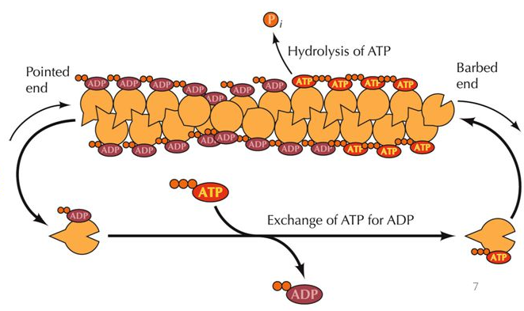
  - Each actin monomer assembles on after each other in a staggered manner which gives the MF the appearance of a right-hand helix; however, it is not a helix, the single stand is just staggered to look this way
  - The ATP presenting side is positive and barbed
  - The ATP absent side is negative, only has ADP and has a pointed end
  - Tubulin and actin lead to structural proteins; this is soluble because of the compact structure and alpha helices and hydrogen bonds; it is highly hydrophilic in the cytoplasm
  - MF are found throughout the entire area of the cytoplasm even all the way up to the plasma membrane (unlike MT who do not make it all the way to the membrane)
- Proteins influence acin polymerizations
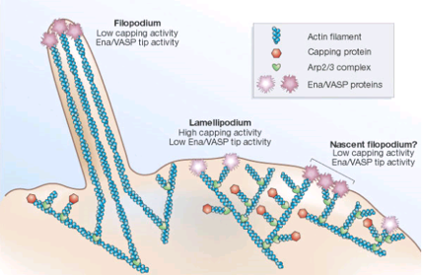
  - As you assemble all the soluble globulin proteins, you are building a specific quaternary strucutre
  - MF are good at branching out because of the binding proteins they possess
  - Capping proteins prevent the adding of more and more actin which limits their growth
  - Extensions of the membrane are due to the MF structure
  - There are many capping proteins which bind to the positive end of the MF
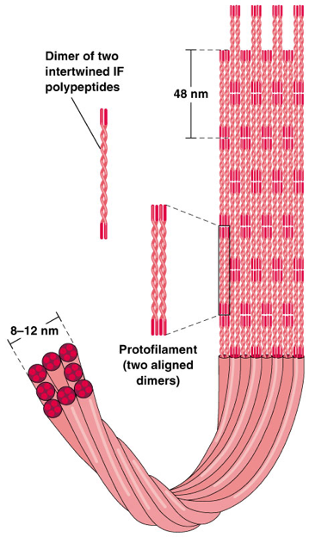
  - ARP complex proteins can attach to anywhere on a microfilament and act as the seed to add more MF that act as a branch
- Intermediate filaments
  - Formed by assembly of various proteins such as keratins, vimentins, lamins; fibrous proteins
  - Assembly; a helix of proteins, which forms a coiled-coil
  - These dimers then associate head to tail to form tetramers
  - These tetramers will stack together in a staggered manner forming rope-like structures
  - Very flexible and help cells withstand torsion and compression however, they are also very strong so when the cell stretches they protect the cell
  - IF are found in very high cencentration surrounding the nucleaus; this protects the nucleus
  - The IFs go all the way to the plasma membrane like the MF
  - There is no energy involved in the assmbly of IF, it is spontaneous assembly; they also have no polarity
  - Teramers are added head to tail
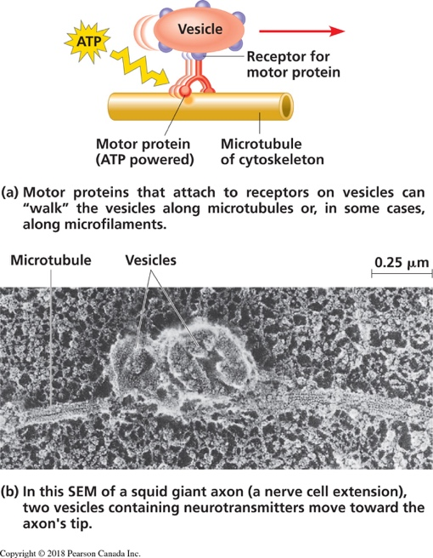
  - There is no orientation with IF, and there is no start or end; because of this, the IF can grow in in any direction and they have no direction and there is no way form them to tell which way they are going within the cell; this does not allow them to contribute to trasnport because they have no way to tell where they are heading
- Motor proteins
  - Are build in such a way that they have different domain with different specializations so they can have different skills
  - They act as feet; they walk on the cytoskelon fibre and carry cargo
  - To prpel the feet, they need energy; there is a section that acts as an enzyme and makes ATP for the protein
  - All of the areas of the motor protein need to work cooperatively in order to perform properly
- Centrosomes / Centrioles
  - Each cell has a centrosome, made up of 2 centrioles, at a right angle with respect to each other (L shape)
  - Centrioles are made of 9 microtubule triplets, arranged in a ring structure (no central triplet)
  - Can serve as an anchor to cilia and flagellum
  - Are the beginning of the MTOC; microtubules originate from the centrosome
  - Mitotic spindle formation
  - One key thing that happens here is the genetic material is duplicated and the organelle are duplicated and they must be distributed through both cells
- Cilia and flagella use microtubules to exert different motion
  - Cells in the lungs have many cilia to move mucous
  - Cilia increase surface area
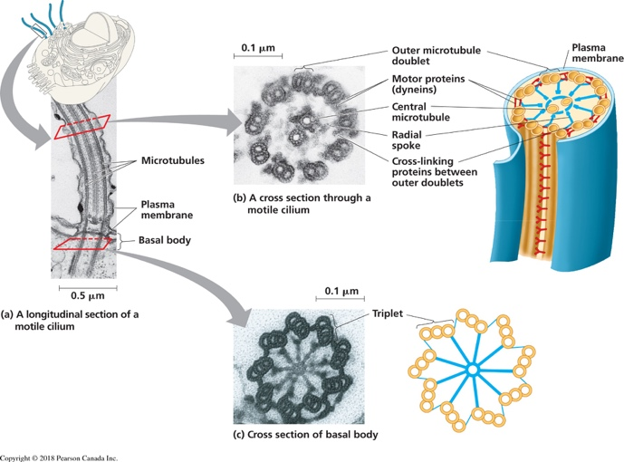
  - They sweep mucous from instantly surrounding the cell
  - Cilia and flagella are microtubules in order to facilitate being able to use MT in these kinds of structures, and not take away from the centrioles, you can bind another starting point near the plasma membrane called basal bodies
  - There is a single doublet within the basal body
  - Flagella and cilia have different motions; their length is the key difference in the way they move
  - Flagella is long and has a wave like motion to propel the cell
  - Cilia are short and have a whip like sweeping motion which is good for cellular motility and sweep things away and towards the cell
  - Cilia and flagella have slightly different structures (9+2 doublets of MTs)
  - Motor proteins are needed to initiate the movement of the cilia or flagella
  - To prevent the two doublets from sliding apart while dynein walks across on with the other as cargo, there is a protein that specializes in cross linking and holding together the doublets; called NEXIN
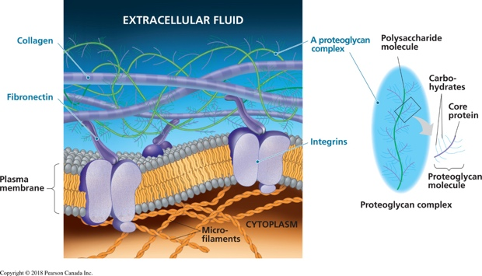
- Extracellular matrix
  - ECM is an extension of the cell
  - It is an integral part of the animal cell
  - Helps to make its way when it needs to grow, has digestive enzymes in it, and a lot of support proteins that form a flexible protein for the membrane, and some protein that act as a link for the exterior of the cell to the plasma membrane
  - Proteoglycans have a high carbohydrate content in the structure
- Cell to cell interactions
  - Tight junctions; fusion of proteins on external plasma membrane. Seals area
  - Anchoring junctions; plaque anchor cells together (adherens – actin and cadherins) (desmosomes – IF, keratins) (mechanical force)
  - Gap junctions; channels formed by proteins bridging cells (connexions). Allows passage of ions and small molecules – cell communication
  - Connexin are proteins that act like sensor; sensitive to the concentration of calcium in the environment, depending on tertiary structure
  - When cells join with each other, there are different means to physically attach them to one another

- If there is a lot of calcium, the gap junctions have one shape, if there is little, they have a different shape
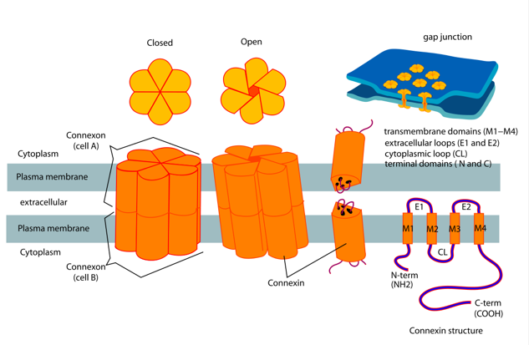
- The concentration of calcium can either leave an open or closed configuration of the pore
- Ions and water molecules make their way through this small pore (very small molecule)
- They are sensitive to calcium and no other ions because calcium is important for a lot of physiological function and you also want to prevent calcium to be in too high concertation because it can be toxic
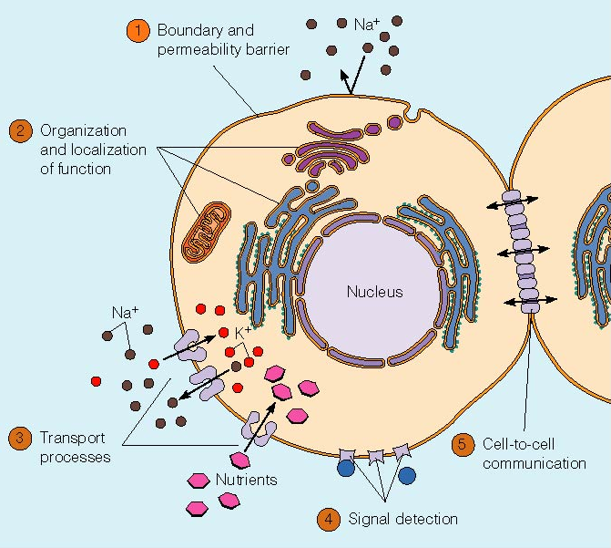
Topic 4 Membranes and Membrane Transport
- Reason why we have membranes (BORRC)
  - Boundary; selective permeability
  - Organize and scaffold
  - Regulate solute transport
  - Receive signals
  - Direct communication
- There are various types of membranes; this shows diversity in lipid/protein content; not all membranes are identical but all have the same basic feature
- Plasma membrane – Fluid mosaic model
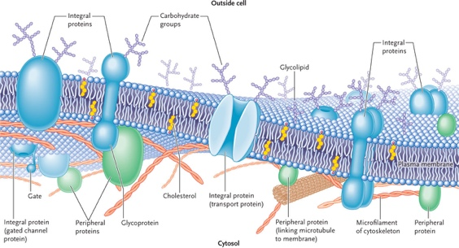
  - Model defines in 1972 by Singer and Nicolson
  - Fluid lipid molecules with embedded, free-floating or anchored proteins
  - Arranges in sheets, non-covalently bound
  - Two facing sheets/lipid layers – provide structure
  - Mosaic of different proteins – allow various function (specificity)
  - Called fluid because it is constantly changing; never static
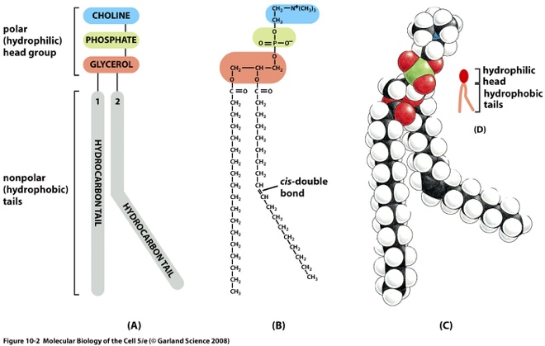
- Composition of the lipid layers
  - Phospholipids are the most abundant lipids in the membrane bilayer
  - Amphipathic; 1 polar head, 2 hydrocarbon non-polar tails
    - Amphipathic; (of a molecule, especially a protein) having both hydrophilic and hydrophobic parts.
  - Presence of unsaturated double bond produces “kink” and influences fluidity of the membrane
    - When there is a kink in one tail, it makes it harder for it to get lined up nice and close with the next one
  - There are 4 main PLs; phosphatidylethanolamine, phosphatidylserine (-), phosphatidylcholine, and sphingomyelin
  - PLs come in all shapes and sizes; they have a glycerol backbone, two fatty acid tails (hydrocarbon chains), and a polar group made of a phosphate and something on top of it that makes it unique
- Composition of the lipid layers
  - Glycolipids (glycosphingolipids) are 1 or 2 fatty acid chains with single or multiple sugar groups attached via glycerol or sphingosine
  - Important for cellular recognition, antigens (e.g. Blood groups)
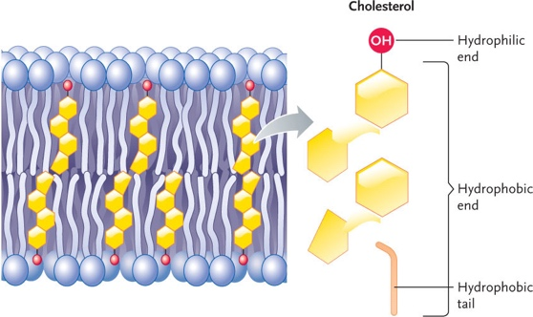
  - GLs are found on the upper leaflet of the membrane, the side that faces the exterior of the cell
  - Sterols are 4-ring hydrocarbons present only in eukaryotes that play an important role in fluidity; both in terms of arrangement and in relation to the temperature (buffers)
    - Animals and protists; cholesterol
    - Fungi; ergosterol
    - Plants; phytosterol
  - Sterols contribute to the fluidity of the membrane by changing the ratio of the membrane’s components, and by keeping the PLs together but not too tightly. They also disrupt order, or cause disruption when need be
  - Cholesterol is a buffer; when fluidity is too high, PLs are not very organized, cholesterol makes PLs pack more tightly; when fluidity is too low, cholesterol makes them pack less tightly
- Properties of the lipid bilayer
  - Membrane asymmetry (both layers are different)
    - Translocation from one layer to the other is rare and requires energy (ATP)
    - This is necessary to maintain the asymmetry of the bilayer
  - Membrane fluidity
    - Length and saturation of fatty acid chains
    - Polar head groups (variable polarity)
    - Sterols (buffering effect)
    - Temperature
    - Because PLs can pack tightly, and not, they have different lengths and saturation levels
    - Temperature affects vibration of PLs; more fluid in higher temperatures, less fluid in colder temperatures
    - Ratio of PLs and proportion of cholesterol and saturation of fatty acid tails can all be changed to help the cell
  - Membrane is dynamic
    - Within each layer, the lipids continuously change places – for example, lateral diffusion occurs very quickly (approx. 1μm²/sec). rarely, a change from one layer to the other occurs
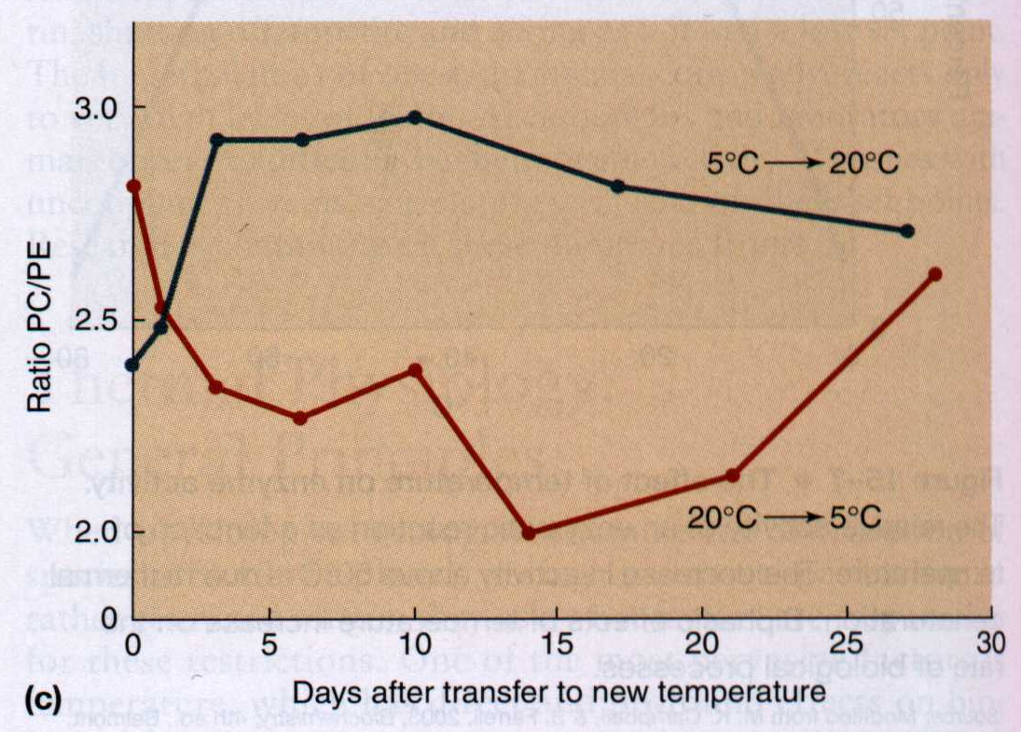
    - Homeoviscous adaptation; the ability to change the membrane’s lipid composition in response to the environment in order to maintain membrane fluidity
  - Fish starting in 2 different temperatures, 5ºC and 20ºC. the have different PC/PE rations (PE confers more fluidity than PC). They are switched to different temperature. The PC/PE ratio will change over time, until they become very similar – maintain dynamics and fluidity!
- Membrane proteins – the Mosaic
  - Different proteins achieve different roles; proteins contribute to structure, joining, recognition, transduction, signaling, transport
  - Domains are areas of your protein structure
  - Channel proteins are one of the ways that the membrane has devised to allow for molecules that would otherwise not be able to get across the double layer of PL to safely pass through
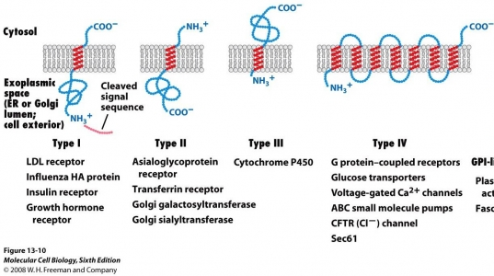
  - Some channels are not selective and only require correct polarity and size; others are very selective and they only allow passage to one specific molecule (for example, aquaporins and potassium channels)
  - Integral proteins
    - Ion channels, transporters, receptors
    - AKA transmembrane proteins
    - Span the membrane once or more (single pass, double pass, or multipass)
    - N or C terminus can face inside or outside the cell
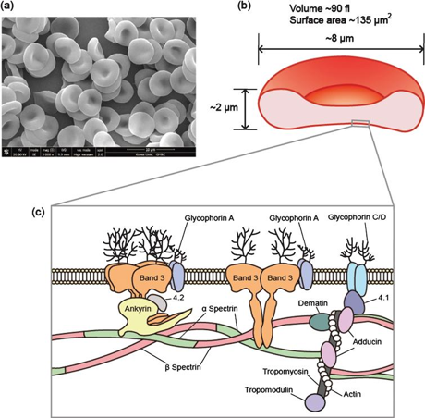
  - Peripheral proteins
    - Spectrin, Ankyrin
    - Can be on the inside or outside of the cell membrane
    - Non-covalently bound to another element (integral protein or cytoskeleton)
    - Can serve to provide structural support (elasticity) or mediate binding
    - Peripheral proteins are near the membrane but do not directly interact with the membrane, however, they interact with something else that directly deals with the membrane
    - Contribute to the elasticity of the membrane and allow the cytoskeleton and membrane to be completely distorted and bounce back unscathed
    - Non-covalently bound so they can easily change what they interact with
  - Lipid-anchored proteins
    - GPI, prenyl, or fatty acid-anchored
    - Proteins can be anchored (covalently) on the outside or inside of the cell
    - There are two types of anchors; extracellular proteins (GPI anchors), and intracellular proteins (fatty acid or prenyl groups)
    - Find themselves interacting with only one or two layers of the membrane; but not both at the same time
    - Different anchors depending on what leaflet they are on; different anchors depending on the environment
    - Contribute to the asymmetry of the membrane
  - Extracellular proteins are good for recognition and contributing to bringing the cells together to form junction and adhesions to one another
  - Intracellular proteins are good at enzymatic activity, signal transmission to the outside of the cell
- Freeze fracture
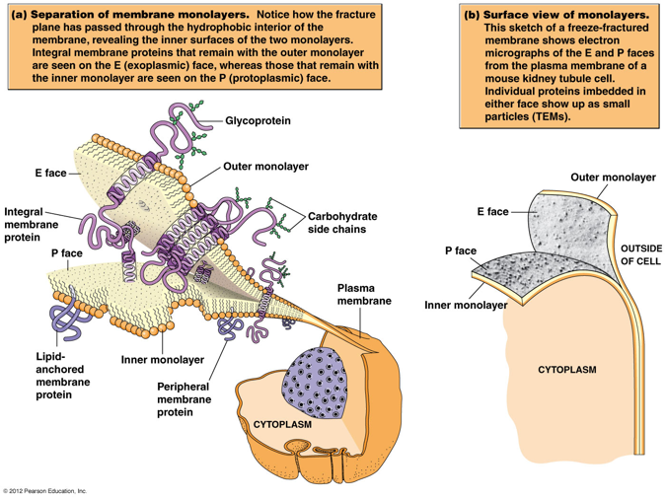
  - A technique where you take a cell and flash freeze it; needs to be done quickly or membrane has a chance to adapt and change its conditions
  - Can separate the two layers of the membrane
  - Those anchored with the outer or inner layer of the PL will stick with that side
  - If something is transmembrane, depending on if there are anchors, it will stick to one side
  - Higher resolution microscopy; super resolution fluorescence or electron microscopy
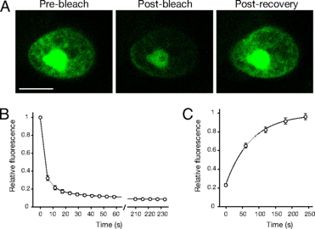
  - If you know some of the properties of which you think you’re looking for, you can label them and that will make visualizing what layer it associated with easier; of if you are just looking around it will allow you to isolate certain components of the membrane
- Fluorescence recovery after photobleaching (FRAP)
  - Allows you to study the membrane fluidity and dynamics without damaging the cells
  - You can bleach a specific area with a laser and quench the fluorescence; the molecules are left unharmed
  - It can show you how stuff moves in a cell, how fast, and where it goes
- Movement across the membrane
  - Relative permeability of molecules
  - Concentration gradient vs. electrochemical gradients.
  - Gradients store potential energy

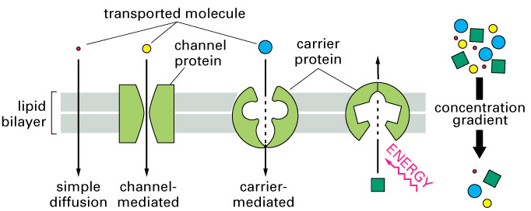
- Transport across membranes

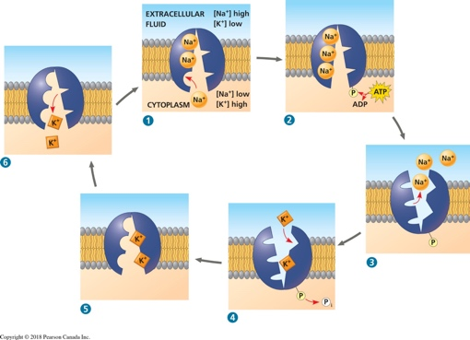

  - The use of the concentration gradient of another solute is called secondary active transport
  - Na/Glucose symporter and Na/Ca exchanger (antiporter)
  - The use of direct energy input such as ATP is called primary active transport (ATP pumps)

Practice Midterm Questions

In which type of microscopy are special lenses used to enhance the differences in density of a cell?
Normarski (differential interference contrast)

The best technique to study the internal components of a lipid bilayer is:
Freeze Fracture

Secondary symport consists of using a different molecule going in the same direction to get the desired molecule across.

How could a trout adapt to a rapid increase in temperature in order to retain membrane fluidity?
Change the ratio of PC/PE and reduce the amount of desaturase

During cellular respiration in eukaryotes, glycolysis does not take place in the mitochondria.
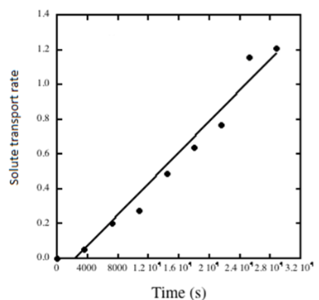
In the figure below, passive diffusion depicts the rate at which glucose is transported across the plasma membrane because the plasma membrane is permeable to glucose.

ATP synthesis using the F-pump ATP synthase takes place where?
The matrix

Lysosomes are not a choice for calcium storage.

Pigment transportation is not a role carried out by the extracellular matrix.

Anchoring junction attaches cells together using intermediate filaments.

Photo synthesis does not allow the capturing of photons of light to create functional macromolecules.

Chemiosmosis is not only useful for ATP synthesis in mitochondria.

Kinesin is the motor protein that travel along microtubules in an anterograde fashion (towards the positive end).

You can find nucleoporins in the nucleus.

Phosphoglycerolipids are amphipathic. What does this mean?
A macromolecule that has both hydrophobic – in this case fatty acid chains linked to glycerol backbone, and hydrophobic areas – in this cause a polar head group containing phosphate.

What makes the rough ER rough, and what function does it serve the cell?
The presence of ribosomes on the membrane. The rough ER is responsible for protein translation and synthesis.

Which organelle is responsible for enzymatic degradation?
Lysosomes or central vacuole.

In which type of microscopy is the sample illuminated at an angle?
Dark field

In which type of microscopy are shift in light phases converted to different brightness of sample in the image?
Phase contrast

Based on evidence gathered, scientists have been able to propose a chronological order for the appearance of life on earth. What is the most plausible order?
Small inorganic molecules, protocells, prokaryotes, eukaryotes.

What is the most plausible scenario to explain how plant membranes can adapt to the hot temperature in the summer?
Increase in saturated fatty acids, decrease in fluidity.

Secondary antiporter is a type of transport through a membrane where a molecule gets in by letting a different molecule out in the other direction.

Pepsin is not one of the components of the ECM.

An increase in unsaturated fatty acids and therefore an increase in fluidity is the most plausible scenario to explain how plant membranes can adapt to the cold temperature in winter.

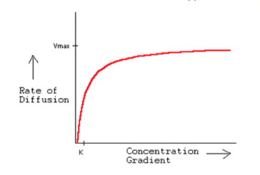
The plant cell wall is made of cellulose microfibrils, where many hundred chains of cellulose are aligned. This structure gains strength with what type of chemical bond between the individual strands?
Hydrogen bonds

Using the figure depicting the rate at which glucose is transported across the plasma membrane; determine which type of transport is being used.
Facilitated diffusion
This is because the rate of diffusion eventually saturates.
It is thought that life developed initially in condition where RNA (as ribozymes) acted as both an information carrier and a catalyst. What best explains why current living organisms use DNA and protein rather than RNA to carry out those tasks?
Proteins are more efficient catalytically and DNA is more stable and better conserved.

Where are eukaryotic ribosome subunits assembled?
In the nucleolus.

The Golgi apparatus is mainly responsible for:
Post translational modification

The junction best to provide mechanical force between two cells is anchoring junctions.

Phagocytosis is possible thanks to what feature of the cytoplasm?
Dynamicity.

The best technique to study the fluidity of phospholipids within the lipid bilayers is FRAP (fluorescence recovery after photobleaching)

Animal tissues are composed of cells…
…and intercellular space containing a complex matrix that may be liquid, solid, semi-solid, or elastic.

Integral proteins are amphipathic. What does this mean? Provide an example of such a protein.
A protein that spans the membrane and as such has both hydrophobic/non-polar and hydrophilic/polar areas. Any receptors, transporter, cytochrome, components of the ETC etc. must be a protein.

In order to transport a vesicle from the rough ER to the Golgi, you must use kinesin and microtubules.

Polysaccharides are formed by long chains of monosaccharides; aloha glucose units joined end to end in 1,4 linkages can form amylose, the basic energy storage form used in plants. However, when the hydroxyl groups are on opposite / different side of the plane formed by the glucose carbon ring, we obtain the beta arrangement for glucose. Linking these together can produce cellulose which is found in the cell wall of plants.

Microfilaments are formed by joining monomers / subunits of actin in order to from a strand. Growth occurs mostly at the beta (+) end because it presents ATP.

Nucleotides / Nucleic acids are macromolecules formed by joining a nitrogenous base, a deoxyribose molecules and a phosphate group. There are four possible conformations and when joined together to form polymers, they will make up the most famous double helix, DNA.

Your favorite cell incorporates a membrane receptor and wishes to transport the vesicle formed containing it towards degradation. Name (a) the process the cell will use to internalize the receptor, then which (b) motor protein will carry this vesicle on the microtubules and finally, to which organelle (c) it will be delivered.
- Receptor mediated endocytosis
- Dynein
- Lysosome

Compare the two following amino acids. Discuss their polarity and the impact they could have on the structure of a peptide.
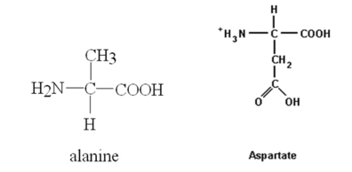
Alanine has a radical group that evenly shares electronegativity and so, it is non-polar amino acid, which aspartate has higher electronegativity and therefore an uneven distribution of electron, due to the NH3 group that is charged and so is a charged polar amino acid.

Polar amino acids such as aspartate them to be part of a soluble, flexible secondary structure such as an alpha helix, while non-polar amino acids such as alanine tend to be part of more rigid secondary structure such as beta pleated sheets.

What properties or feature of the plasma membrane allow it to carry out its five basic roles?
Explain how the plasma membrane remain asymmetric.
- Different ratios of PLs on both leaflets
- And presence of glycoproteins and glycolipids
- Integral proteins
- Many types of PLs are distributed throughout the leaflet – maintains by lateral diffusion, translocation (flip flop) – and with varying lengths and degrees of saturation of the fatty acid chains thanks to desaturase enzyme
- Move freely

Roles of membranes | Properties / Features
Boundary – selective permeability | Diversity in lipid and protein content – fluidity, diffusion
Organize and scaffold | Organelles / functional compartmentalization
Regulate transport | Mechanisms using channels, transporters, pumps, porins
Receive signals | Receptors for signal detection, integral proteins
Communication | Cellular junctions (gap, plasmodesmata, glycolipids)

Complete the following table:

Organelle / Structure | Function / Role
Nucleoporins | A protein based path that mediates the exchange of molecules between the nucleus and cytoplasm
Mitochondria | Double membrane organelle responsible for metabolic and non-metabolic activities in the cell (ex. Cellular respiration)
Central vacuole | Held together by tonoplasts, regulates turgor pressure of the cell, as well as degradation and detoxification activities.
Smooth ER | Extensive network of interconnected membrane channels; responsible for lipid synthesis and detoxification
Golgi apparatus | Series of membrane folds, usually entered by the cis face and exited by the trans face, where many chemical modification to proteins occur
Lysosome | Autography or heterography or degradation/digestion
Centrosome/centrioles | MTOC, mitosis or cell division, basal bodies or center of cytoskeleton organisation

Name two macromolecules important in cell biology and give an example of how they interact with each other.
DNA and protein; interact to from chromatin in nucleus; translation, replication
RNA and protein; transcription, virus capsule
Protein and carbohydrate; glycoproteins in cell membrane
Proteins and lipids; GPI anchored proteins, transmembrane protein in cell membrane

Explain what saturation means in lipid, and discuss the important of saturation with respect to plasma membrane fluidity.
Saturation means that there are no double bonds (single bond, C with 4 H etc.). there are fatty acid carbon chains and saturation is present in phospholipids/glycolipids/triglycerides/lipids.
Fluidity means a large amount of saturated fatty acids that make the membrane more compact due to straight chains and therefore less fluid (more viscous). There is a large amount of unsaturated fatty acids that make the membrane less compact due to kinks in the chains and therefore more fluid.

Compare and contrast motility and flagella.

Characteristics | Cilia | Flagella
Structure | Multiple short structure (9+2 complex of microtubule doublets) | Single long structure (9+2 complex of microtubule doublets)
Movement of structure | Whip like back and forth movement | Smooth s-wave from base to tip
Direction of movement | Away from the cell surface | Away from origin
End result / function | Moves extracellular content on cell surface away from cell (e.g. mucous, liquid, substances) | Propels the cell away from the movement imposed (displaces the cell in environment)
Number | Many | Few

Why is the theory of endosymbiosis accepted within the scientific community?
- Morphology (shape and size match the prokaryotes)
- Reproduction by binary fission
- Genome (circular cpDNA and mtDNA) / own DNA
- Transcription and translation / using own transcription/translation machinery
- Electron transport within double membrane
- Sequence (coincide with bacterial domain)

Using these 10 amino acids as building block, propose a sequence for an integral protein. You sequence must have a transmembrane portion of a length of 6 amino acids, and you must have at least 2 amino acids inside and outside the cell. Draw your polypeptide sequence within the membrane. Cleary label all elements.

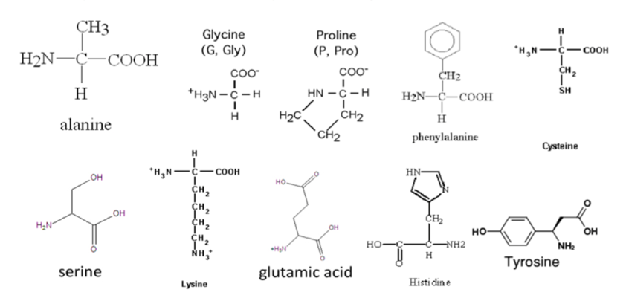

Outside the membrane: Cysteine, Serine, Tyrosine, Glutamine, Histidine, Lysine
Carol shouldn’t touch, Gary has lice!
Inside the membrane: Glycine, Cysteine, Phenylalanine, Leucine, Valine
Got cash, purchased Louis Vuitton!

You have just isolated a protein from heart cells. You want to determine where it is located within the cells, and what macromolecules it interacts with, in order to determine the function of this protein. Propose 3 things you could so experimentally to try and solve this mystery.
Microscopy
Centrifugation
FRAP
Freeze fracture and electron microscopy
Membrane transport – inhibition, saturation, asses rate of diffusion
Sequence analysis

A mouse has been designed so that it cannot express the gene for nexin. With the help of a structural description, explain what the consequences will be if no longer producing this cross-linking protein. You can use a drawing to assist you in your answer.
In the absence of nexin, the microtubule doublets are not linked with each other in cilia/flagella. As dynein uses one doublet as its cargo and walks on the next doublet in 9+2 structure, it will result in both doublets sliding apart from each other rather than exerting the bend required for cilia and the flagella to accomplish their motion.

You wish to localize and quantify a specific protein, titin, which is found in the contractile unit of skeletal muscles (the sarcomere). You have the choice between various chemical markers or antibodies to label the protein. You have other experiments to conduct which this sample after your observation. Which microscope would be best suited for you to achieve your objective?
Fluorescence/confocal microscopy. The magnification is sufficient to visualize cellular compartments/organelles where we expect to find the protein. This technique allows you to specifically label different proteins in cells (using different fluorescent probes/markers), visualize their location and interaction with other macromolecules, while keeping the integrity of the cells.

Describe the structure and the role of centrosomes/centrioles with respect to the cytoskeleton.
Centrioles are a ring-like structure of 9 microtubule triplets (no central component). The 2 centrioles are assembled at a right angle and then are called a centrosome. This is the MTOC which allows to distribute microtubules throughout the cell/role of centrioles in organising microtubule transportation network. Centrioles can serve as basal bodies below the membrane and extend into a 9+2 doublet formation that leads to cilia/flagella. During mitosis, centriole provide the microtubules that become mitotic spindles carrying the chromatids.

Complete the following table:
Protein | Function/Role
Integral | Allows transport of many molecule, some too large for other channels. Allows necessary elements in the cell when they do not fit elsewhere.
Peripheral | Act as receptors for the cell, as well as provide support for the cell and give the cell its shape.
Lipid-Anchored | Act in signal transduction, targeting proteins to the cell surface. As well as contribute to membrane asymmetry.

