Experiment 2: Purifying Chemicals By Distillation

Name: -------

01/23/18

Organic Chemistry/CHM1321: A03

TA: Lixuan Ren

Lab Partner: --------

University of Ottawa

Winter Term 2018

Grade: 42/48: A

Procedure:

The procedure that was used in this experiment is located in the Laboratory manual, “CHM1321 Organic Chemistry Laboratory Manual 2018”: pages 20-27

Observations:

Part A: The Simple Distillation

- 50:50 mixture solution of 2-propanol and 1-butanol- clear, flammable and strong odor.
- The temperature started increasing steadily with a few fluctuations in the beginning process. Throughout the whole distillation it was linear.
- When the distillation process was completed, the appearance and odor of the solution remained the same as it was in before the distillation process.

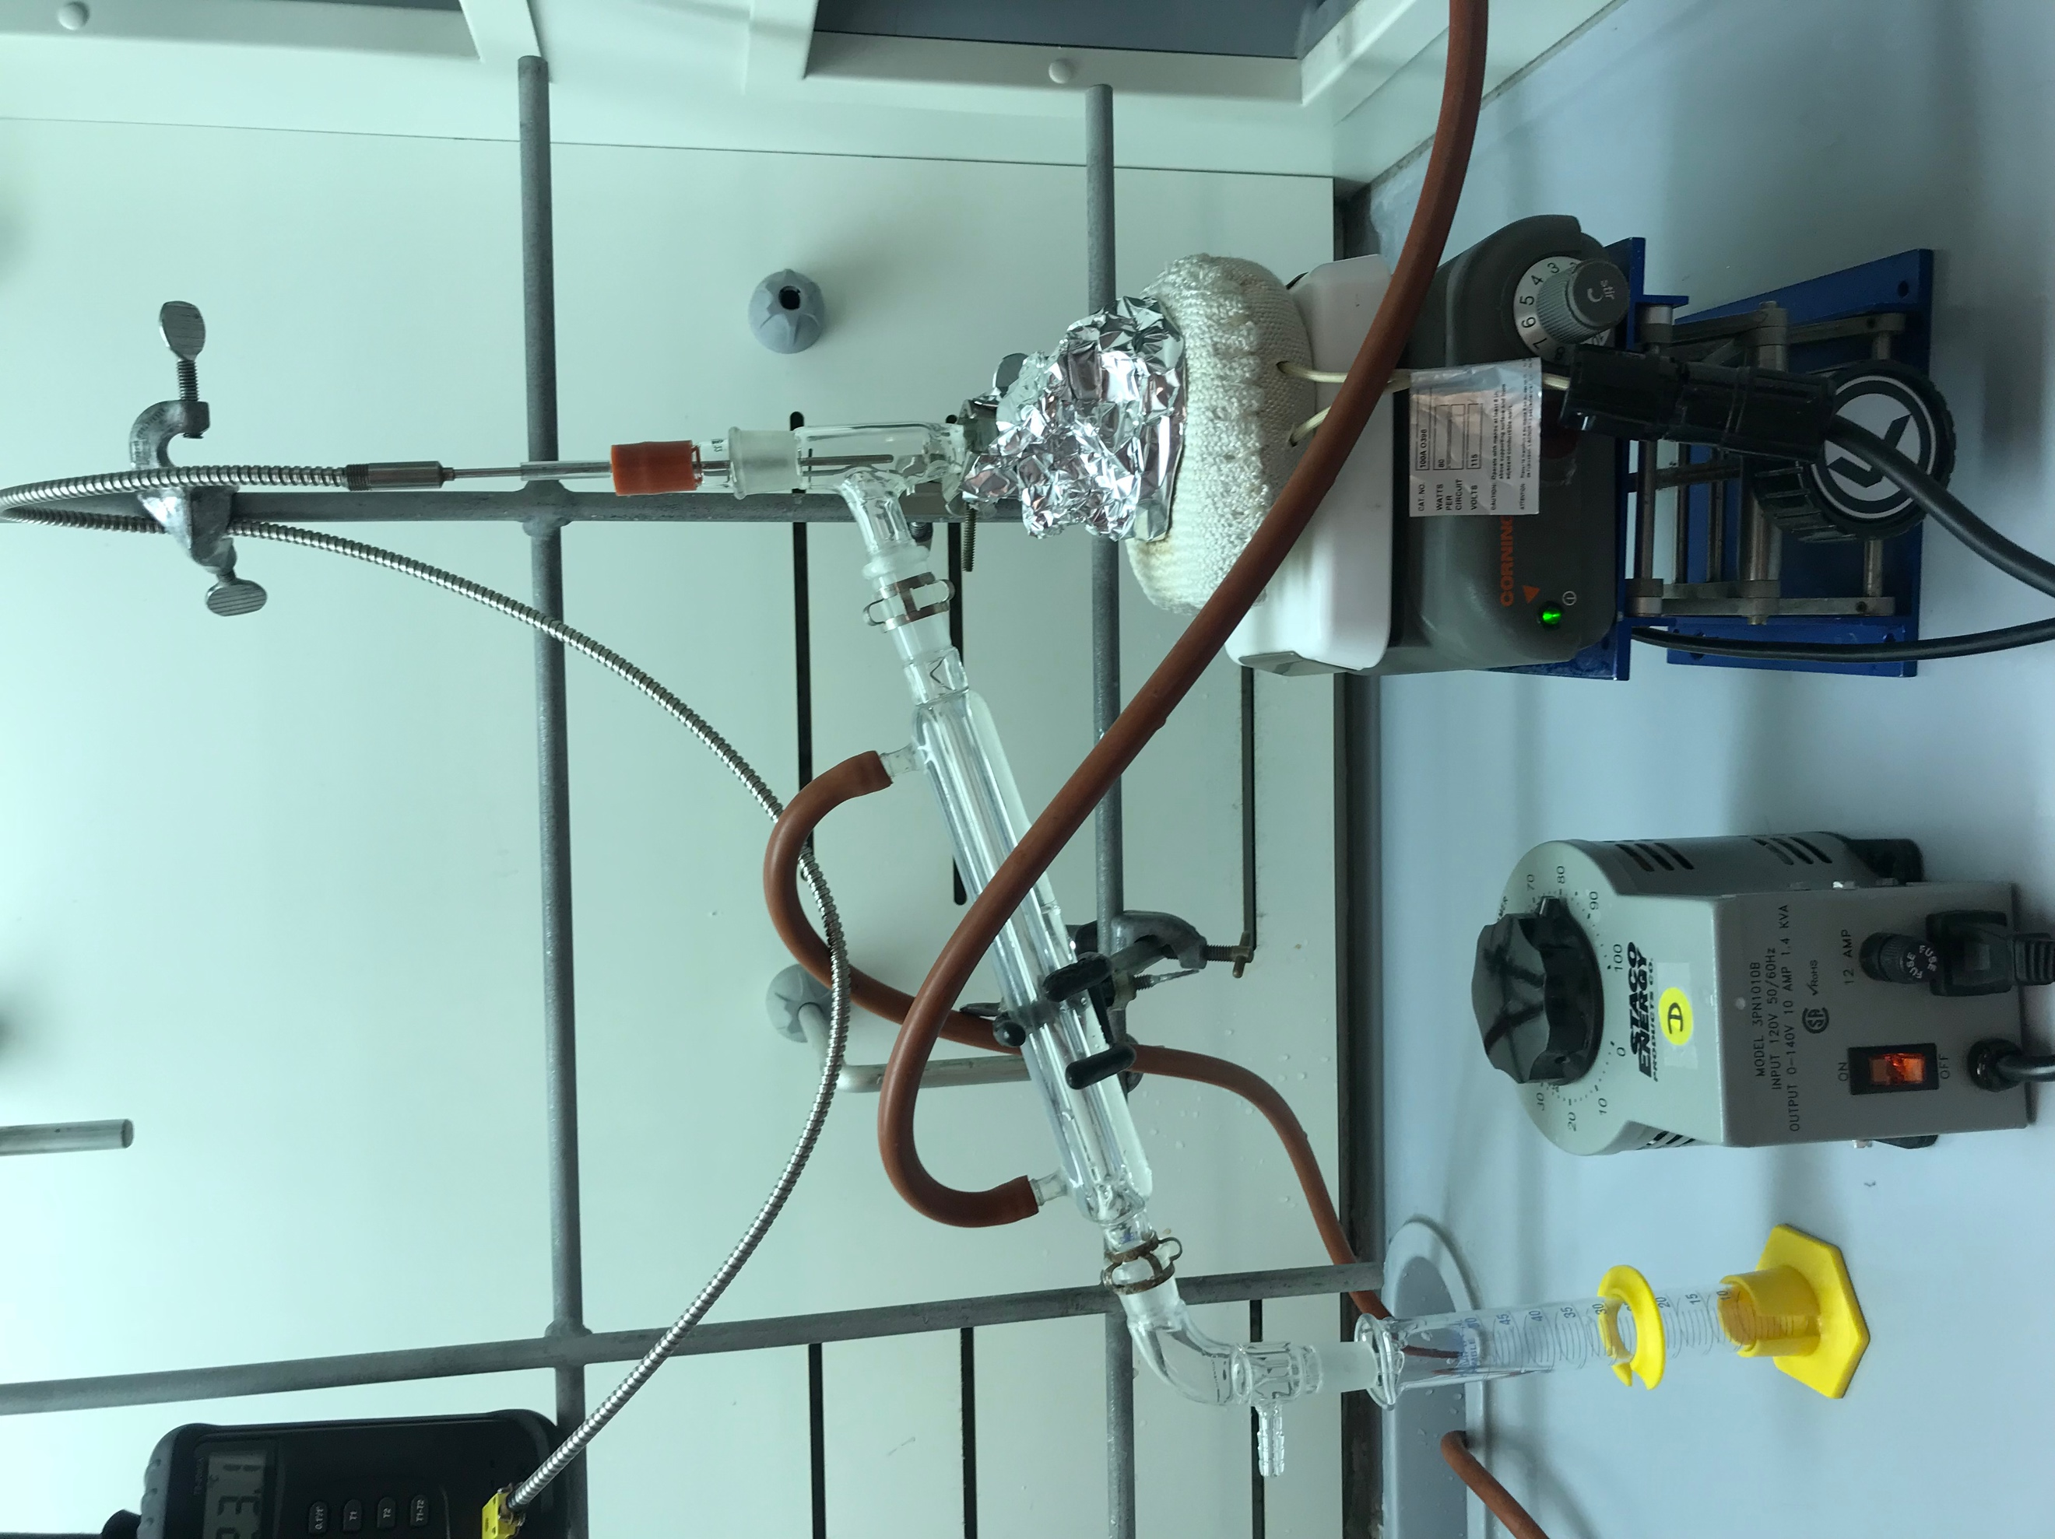

Volume of Distillate (mL) | Temperature (°C)
1 | 78.3
2 | 78.7
3 | 78.0
4 | 78.4
5 | 78.7
6 | 79.6
7 | 80.2
8 | 81.2
9 | 81.9
10 | 82.9
11 | 84.5
12 | 87.1
13 | 88.4

Table 1: Volume x Temperature of part A

-Temperature of distilled recorded every 1 mL
- Measure volume- a 10 mL graduated cylinder was used.
Figure 1: This graph represents the volume of the solvent that dropped into the gradual cylinder from the simple distillation and the temperature that it was at when the solution was dropped into the cylinder until 13 mL.

Part B: Fractional Distillation

Volume of Distillate (mL) | Temperature (°C)
1 | 79.5
2 | 80.5
3 | 81.1
4 | 81.3
5 | 81.5
6 | 82.1
7 | 82.5
8 | 82.8
9 | 83.4
10 | 84.4
11 | 86.2
12 | 89.0
13 | 93.8

Table 2: Volume x Temperature of part B
-Temperature of distilled recorded every 1 mL
- Measure volume- a 10 mL graduated cylinder was used.
Figure 2: This graph represents the volume of the solvent that dropped into the gradual cylinder from the fractional distillation and the temperature at which the solution was dropped into the cylinder until 13 mL.

Volume of Distillate (mL) | Temperature (°C)
2 | 81.0
3 | 81.6
4 | 81.8
5 | 82.1
6 | 82.4
7 | 82.8
8 | 83.3
9 | 83.8
10 | 84.4
11 | 85.5
12 | 87.3
13 | 89.1
14 | 95.1
15 | 106.9
16 | 114.2
17 | 115.7
18 | 115.7
19 | 115.7
20 | 115.7
21 | 115.7
22 | 115.7
23 | 115.6

Table 3: Volume x Temperature of part B (from student data sent from email)
-Temperature of distilled recorded every 1 mL
- Measure volume- a 10 mL graduated cylinder was used.

Figure 3: This graph represents the volume of the solvent that dropped into the gradual cylinder from the fractional distillation and the temperature at which the solution was dropped into the cylinder until 23 mL.

Discussion:

In this experiment, it consisted of 25 mL distillation of 50:50 mixture of 2-propanol and 1-butanol solutions. The boiling point of 2-propanol is 83°C and for 1-butanol is 118°C. Being that 2-propanol is more volatile than 1-butanol they contrast of 35°C. For part A: the simple distillation, it is ideal to separate the compounds that have the difference of greater than or equal to 100°C boiling point. However, as a result of the simple distillation, it was less effective at the separation of the compounds of 2-propanol and 1-butanol. As for fractional distillation, it is preferred when the difference of the boiling point is less than 100°C. With this preference, it is much slower at distillation, making it more efficient.

Mechanically, the simple and fractional distillation differ. The difference between these two distillations is that the fractional distillation had an addition of a fractionating column that contained a metal sponge, whereas the simple distillation did not have the fractionating column. This metal sponge inside the fractionating column increased the surface area even further. The liquid was caught onto the metal sponge which meant that there were multiple distillations occurring. The placement of the fractionating column allowed a greater area and length over the vapors of the substance before they traveled and reached the condenser, which would result in the substance to condense into a liquid and drip into the 10 mL graduated cylinder. The fractionating column provided a more effective separation of the components of the mixture. The simple distillation had a distilling head. The placement of the distilling head made it a short area and length over which the separation could take place. In simple distillation, only one distillation occurs rather than multiple ones like the fractional distillation.

Proven in the procedure, the fractional distillation uses the distilled solution that was obtained from part A and redistills it in part B. The magnetic stir bar was added to the solution to ensure that the mixture was not separated in the least bit. In both distillations aluminum foil is wrapped around the distillation flask due to the fact it creates more insulation for the flask, aiding the temperature increase for both distillations.

In Raoult’s law, it is stated that the partial pressure of liquid A (2-propanol) in the mixture of vapors is equal to the partial pressure of the pure liquid times the mole fraction of that compound in that mixture. This gives the explanation as to why there is an unequal proportion between the two components of the mixture. As a result, the vapor continues to travel up to reach the condenser and the liquid falls back into the graduated cylinder.

In Figure 1, The simple distillation demonstrates a curve or gradual increase of the volume by the temperature. In 1-3 mL there is a small fluctuation which can be from a minor error of preparing the heater to work efficiently. From 4-13 mL, there is a gradual steeper increase in the temperature. This range displays that both components are present in the vapor which means that both are able to receive energy to vapor. The reason for this is to ensure that no complete separation occurred due to the fact that 1-butanol was present in the vapor. The shape of the graph displays a linear function. From the data results from this experiment, it is shown that the graph has a curve and is not perfectly linear, which can be from a source of error.
In Figure 2, the fractional distillation demonstrates a steady constant low curve. From 1-10 mL there is almost no change in temperature making the temperature very constant throughout that range of volume. From 11-13 mL, it is evident that there is a rapid increase of temperature. This range indicates that the 2-propanol almost evaporated completely from the mixture and that the 1-butanol began to get extracted from the solution. Due to the lack of volume, more temperature could not be recorded to observe if the end of the graph would increase or decrease. (Refer to end of discussion)

In Figure 3, is the data set of students Michael Triglow and Heather Smith from section B. In figure 3, the fractional distillation demonstrates a curve with an evident cutoff. From 1-10mL the temperature remains very constant. From 11-15 mL there is rapid increase in temperature. This range can indicate that the 2-propanol almost evaporated completely from the mixture and that the 1-butanol began to get extracted from the solution. From 16-23 mL, the temperature returns back to being constant, but still increasing but very slowly. This graph displays an effective separation of the components and an effective distillation process.

Some sources of errors that may have occurred during this experiment can be the cause of human nature. For example, not paying attention to the solution, miscalculating the volume not being able to focus on reading the temperature and/or not measuring the volume of the distillate solution correctly. Another source of error can be not having an effective apparatus. This can alter your results. For part B, a source of error that occurred with the data set was the misunderstanding of the volumes. For part B, 13 mL was the end point for the volume, which was incorrect due to the fact, the graph is not fully formed at 13 mL to understand the reasoning behind the shape of the graph. However, to correct this misunderstanding a new data set was used from students from another section that exceeded in the volume up to 23 mL to give a more precise shape of the graph to understand the reasoning.

Reference:
Figure 3 and table 3 is the data set from students Michael Triglow and Heather Smith from section B.

Questions:

- Explain why you must have liquid flowing back through the fractionating column in order to get separation of the components during a fractional distillation.
- In order to get separation of the components during the fractional distillation because the component of the mixture with the higher boiling point can’t retain energy to turn into a vapor which results in the liquid which falls back into the graduated cylinder.
- Fractionating columns normally work better if there are insulated in order to maintain a smooth temperature gradient in the column. Why is it important to maintain a uniform temperature gradient in a fractionating column?
- It allows many distillations to occur. The maintenance of a uniform temperature gradient allows a constant state of evaporation and condensation to take place.
- The boiling point of benzene is 81 °C. What is the vapor pressure of benzene at this temperature?
- The vapor pressure is equivalent to the atmospheric pressure.
- What effect does an increase in atmospheric pressure have on the boiling point of a liquid?
- Causes an increase in vapor pressure which can cause an increase of the boiling point.
- Why is it important to have cooling water enter the bottom of the condenser and not the top?
- You want to be able to fill the entire contained with water. It is more effective to have the source of water at the bottom of the contained.
- Compound A has a vapor pressure of 350 mm Hg at 95°C whereas compound B has a vapor pressure of 150 mm Hg at the same temperature. If A and B are miscible, what is the vapor pressure of a 3:1 mixture of A and B at 95°C?
- Ptot= (250 mm Hg)(0.75) + (150 mm Hg)(0.25)= 300 mm Hg. The vapor pressure of 3:1 mixture of A and B at 95°C is 300 mm Hg.

Appendix:



