2.5 List the various hepatic functions associated with metabolism
- the liver one of the most biochemically complex organs in body – conducts over 500 metabolic functions.
- processes nearly every class of nutrients & plays a major role in regulation of plasma cholesterol levels
- liver makes the cholesterol (MOST)-85%
General Metabolic Functions (see also Table 24.5):
Carbohydrate Metabolism:
- isomerizes monosaccharides to glucose
- “packages” glucose as glycogen and fats – serves as a glucose store
- glycogenolysis – to release glucose
- gluconeogenesis – converts amino acids or glycerol to glucose when needed.
Fat Metabolism:
- Primary site for b-oxidation
- Generates ketone bodies from Acetyl-CoA(Immediate b-oxidation)
- Generates lipoproteins for triglyceride transport
- Metabolizes/generating cholesterol, bile salts

Protein Metabolism
- Principal site of amino acid deamination
      - -forms urea for removal of ammonia
- Generates most plasma proteins
- Major site of generation of non-essential amino acids-we can make in the body (by transamination)
Storage
- Stores 1-2 years worth of Vitamin A, 1-4 month supply
- of vitamin D and vitamin B12
- Stores iron (as ferritin) from degraded rbc for release when needed
Biotransformation
- “Inactivates” compounds such as ethanol,
- drugs Will also activate a number of drugs
- Processes bilirubin from heme – bile pigment
- Catabolizes many hormones for excretion

2.6 List and describe the 4 major types of lipoproteins

Triglycerides & cholesterol are insoluble in an aqueous environment, and therefore cannot circulate freely in the blood – are transported as lipoproteins.
All lipoproteins are composed of varying proportions of triglycerides, phospholipids and cholesterol, in addition to protein. Protein important for regulating entry into specific target cells.
In general, the higher the % lipid in a lipoprotein, the lower its density.
Four principal lipoproteins are: chylomicrons, VLDL, LDL and HDL. Each carries out a specific role.

Chylomicrons:
- lowest density; transport newly adsorbed lipids from GI tract
VLDL:
- Primarily made in liver, transports triglycerides to peripheral tissues (mostly adipose tissue). At target cells, the triglycerides are “unloaded’, VLDLs become LDL
LDL:
- primary role is deliver cholesterol to peripheral tissues.
- Recall cholesterol is needed for many functions
- steroid hormones, bile salts, membranes, signaling molecules in development, etc. Not all “bad”.
HDL:
- Protein component of HDL made in liver and secreted in a “collapsed” (lipid-poor) form.
- Primary purpose is to transport excess cholesterol from peripheral tissues to the liver, where it is broken down - bile. Will also deliver cholesterol to some tissues (e.g. ovaries and adrenals) for use in steroid hormone synthesis.
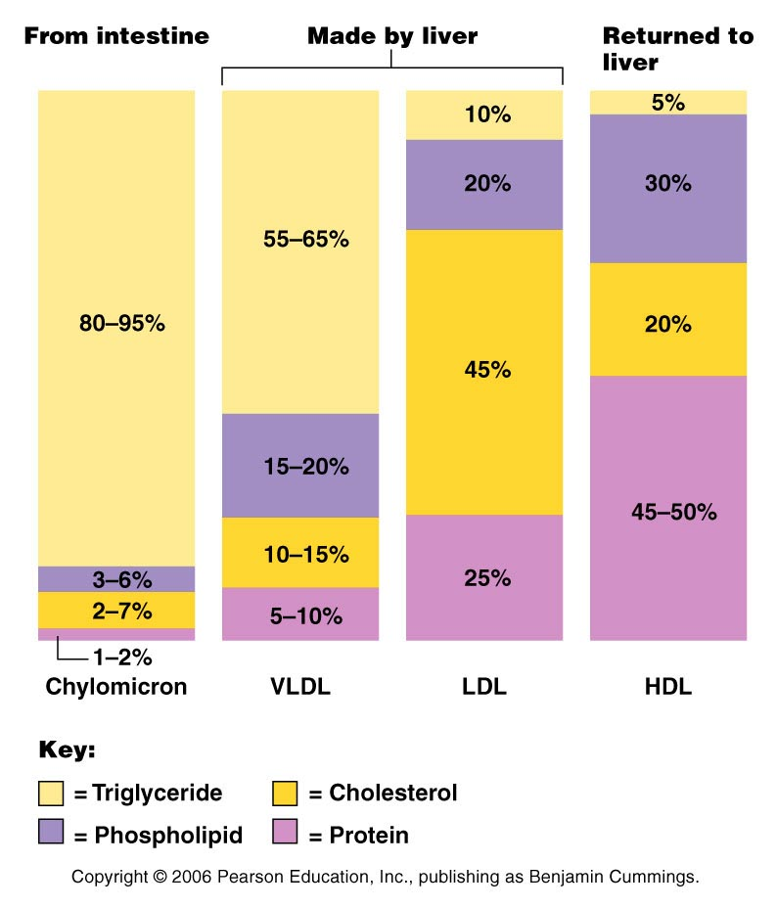

- Excess blood cholesterol (> 200 mg/dl) is linked to an elevated risk of atherosclerosis and associated stroke and heart attack.
- The form of cholesterol is important in this consideration:
- HDL are believed to be “good” because the cholesterol associated with HDL is mainly destined for degradation. (TAKE away excess cholesterol)
- LDL are believed to be “bad” because excessive LDL can lead to deposition of cholesterol in blood vessel walls (esp. lipoprotein (a) - a high risk form of LDL associated with plaque formation in blood vessels). Cholesterol is in places sit shouldn’t be.
- Ratio of HDL to LDL important

Relative cholesterol levels are influenced by a number of factors:
- saturated fatty acids simulate liver synthesis of cholesterol (liver is most important source of cholesterol) and inhibits cholesterol excretion.(drive cholesterol up)
- Unsaturated fatty acids promote catabolism and excretion of cholesterol (ex: olive oil, sunflower oils)
- However, Trans fats, even though they are unsaturated, stimulate an even greater increase in LDL compared to saturated fatty acids and decrease HDL.(Driving the wrong processes)
- unsaturated-cis should be consumed

Is this a good thing?
- no
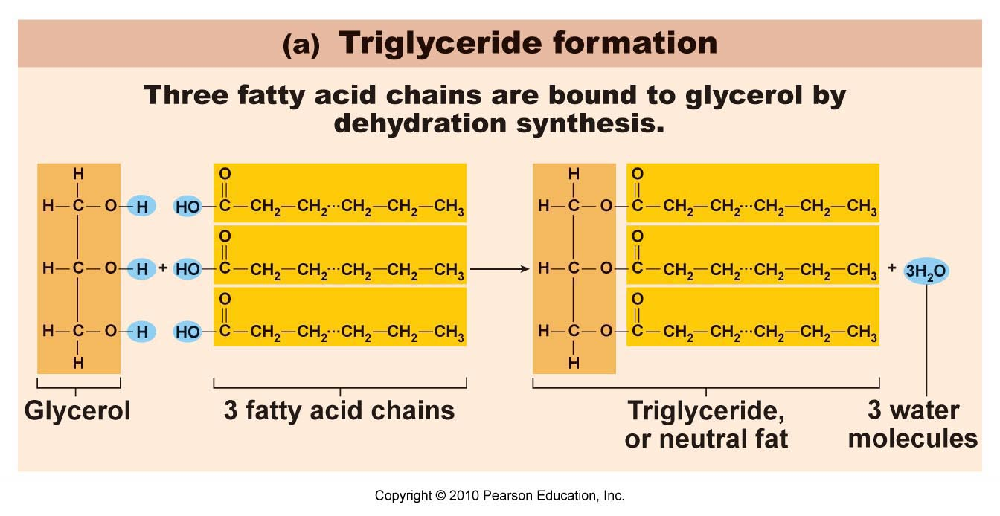

m
2.7 Describe the synthesis of thyroid hormones and its regulation
- The thyroid: a butterfly-shaped organ located on trachea just inferior to larynx
- Consists of two bilateral lobes connected by an isthmus of thyroid gland
- The thyroid is the largest “pure” endocrine gland in the body; it is supplied by a very rich blood supply through the superior and inferior thyroid arteries from the carotid artery.
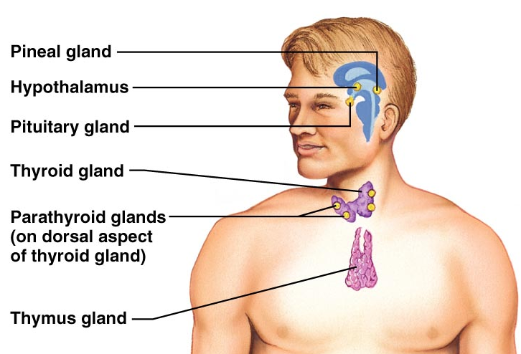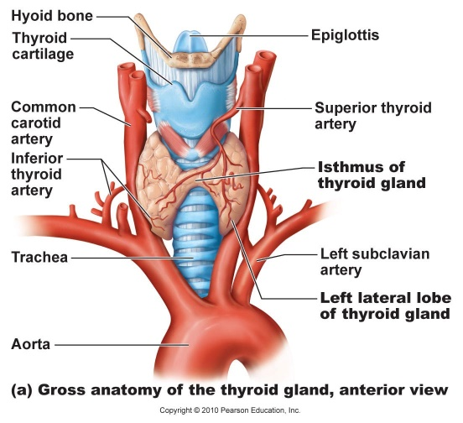
- The thyroid gland is composed of hollow spherical “follicles” surrounded by cuboidal or squamous epithelial cells called follicle cells; produce thyroglobulin(a glycoprotein).
- Follicles are filled with a colloid consisting of iodinated thyroglobulin which serves as the precursor for thyroid hormone.
- Parafollicular cells, interspersed between the follicles, produce calcitonin(secreted by thyroid gland )
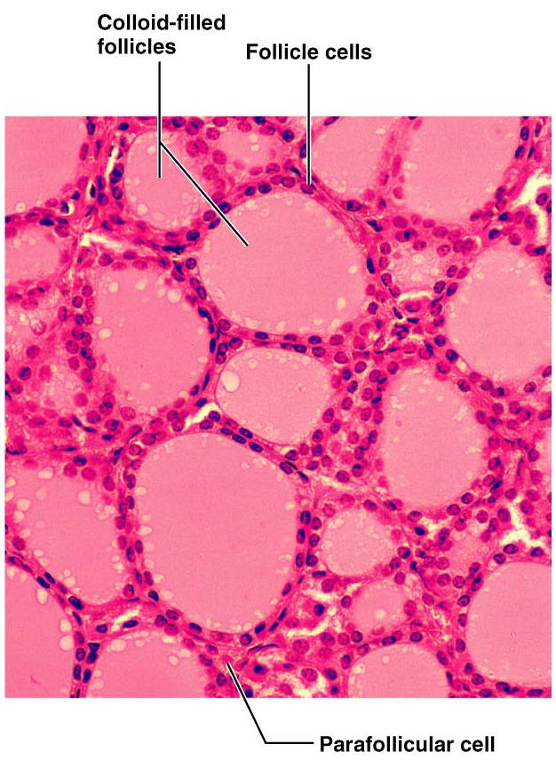
- Iode is to make the bioform of thyroidglobin

Thyroid gland is the source of the body’s major metabolic hormone, thyroid hormone. Actually comprised of two highly related molecules derived from two iodinated tyrosine amino acids.
(1) thyroxine = T₄; is the principal secretory product of the thyroid follicles – contains 4 iodine molecules
(2) triiodothyronine = T₃; is the more active thyroid hormone, and is derived largely from T4 at target cells.
With few exceptions (e.g. adult brain, spleen) thyroid hormone affects essentially every cell in the body.

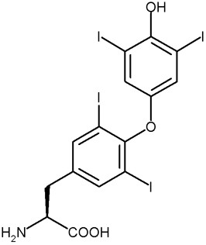
thyroxine

Fig. 16.9: 7 step synthesis of thyroid hormone
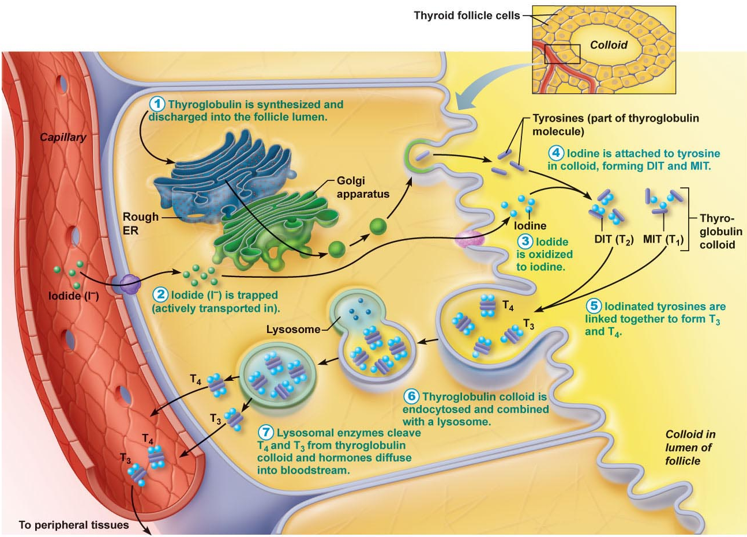

- Lysosomes -essential in breaking does the thyroid globulin to generate T3 and T4
Transport & Regulation of Thyroid Hormone:
- Secreted T4 & T3 (mostly T4) are transported in blood bound to thyroxine binding globulin (TBG) which transports them throughout the body
- Why do we need a transport protein for T3 or T4?
    - You need this transport protein to recognize T3 and T4
    - Small molecules will get lost /alone in circulation because they are bound to a bigger hormone

- At target cells, much of the T4 will be converted to T3 (most target cells have the enzymes necessary for this conversion).
- Within the nucleus of target cells T3 (and T4) bind to the Thryoid Hormone Receptor (TR), which results in the increased expression of target genes - T3 is approximately 10x more active than T4
- Why is T3 so much more potent?
-Lock and key theory
-T3 derived by T4
-Higher affinity -so they bind tighter

Transport & Regulation of Thyroid Hormone:
- Falling thyroid hormone levels lead to secretion of TSH (thyroid stimulating hormone) by the anterior pituitary; this elicits two general responses in the thyroid gland. The initial response of the thyroid gland to TSH is to secrete stored thyroid hormone. The second response it to resynthesize thyroglobulin and to replenish the colloid; there is typically enough hormone in colloid to support secretion for several months.
- What is unique about the storage and release mechanism of the thyroid gland?
-Where do we find T3 T4 precursors?
-Hormone/precursors stored outside of the cell
- Regulation of the secretion of thyroid hormone shows the classical negative feedback system. In this scenario, thyroid hormone production initially rises following stimulation by TSH (thyroid stimulating hormone) secreted from the anterior pituitary. Thyroid hormones then feed- back inhibit at two levels: (i) They inhibit TSH secretion by the anterior pituitary and; (ii) they inhibit secretion of thyrotropin releasing hormone (TRH) by the hypothalamus.
- TRH – to release TSH
- 62% metabolism goes to heat
- Some conditions, such as pregnancy, prolonged cold, etc. will override this inhibitory feedback at the level of the hypothalamus, leading to secretion of TRH and subsequent increase in the levels of thryoid hormones to increase metabolism and heat production.
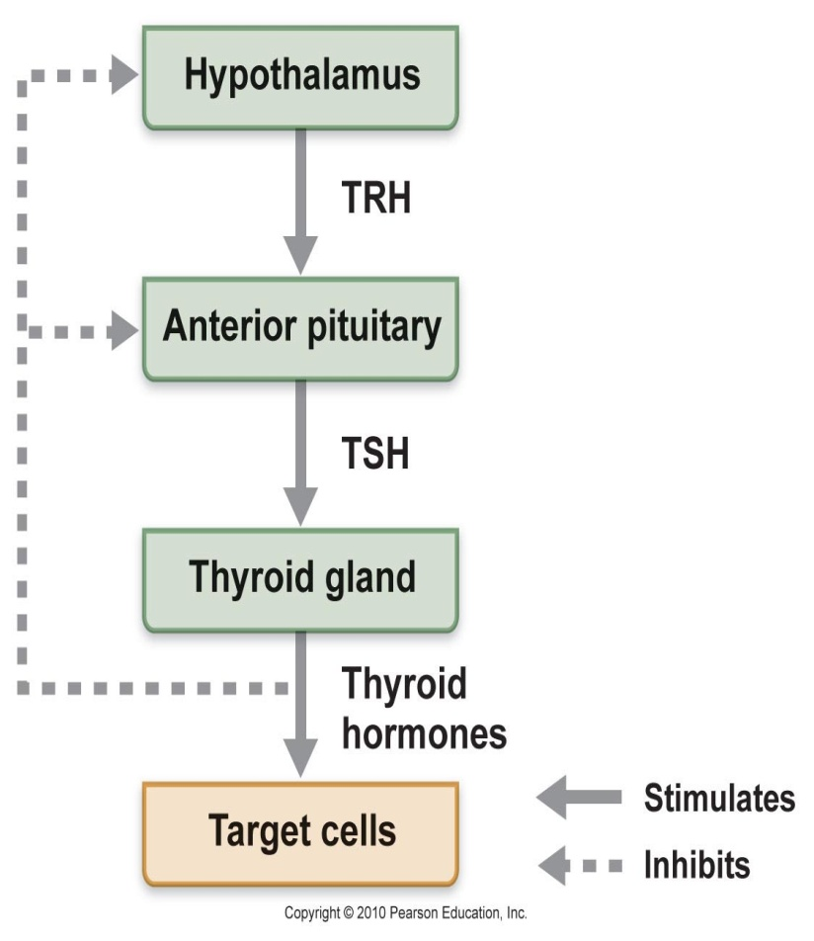

2.8 List the metabolic processes regulated by thyroid hormones
- TH affects essentially every cell of the body except adult brain, spleen, testes, uterus and thyroid gland.
- A major function is to regulate the basal metabolic rate/body heat production: calorigenic effect. TH does this in part through stimulating enzymes involved in glucose oxidation.
- Also play key roles in maintaining blood pressure through regulation of adrenergic receptor number.
- Regulates tissue growth and development, especially skeletal and nervous system development, maturation and reproduction.
- Fetal development of central nervous system- T3 and T4
***Recognize major roles ***
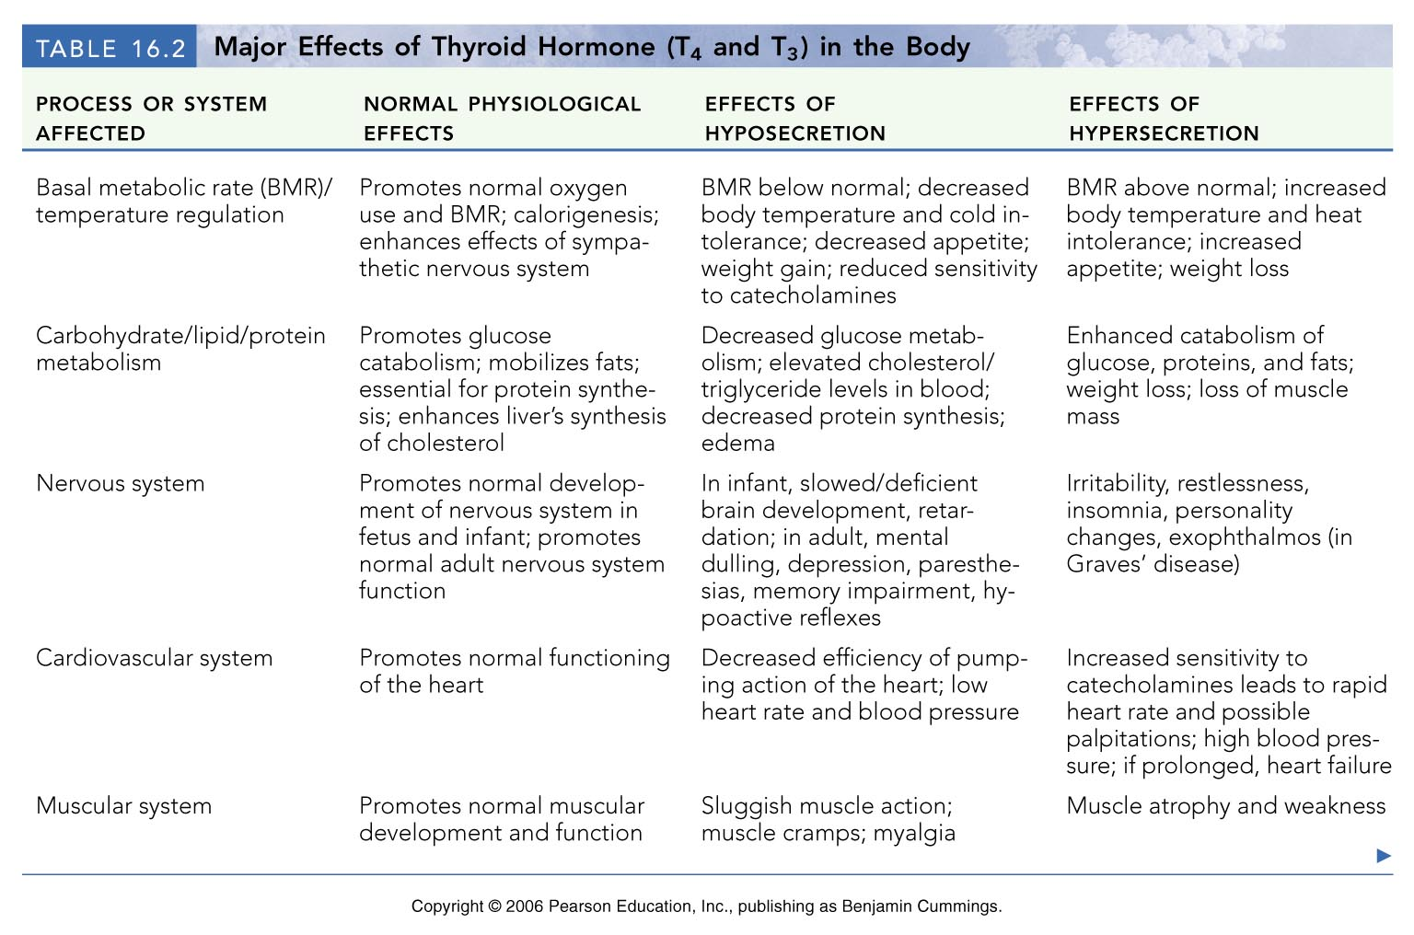
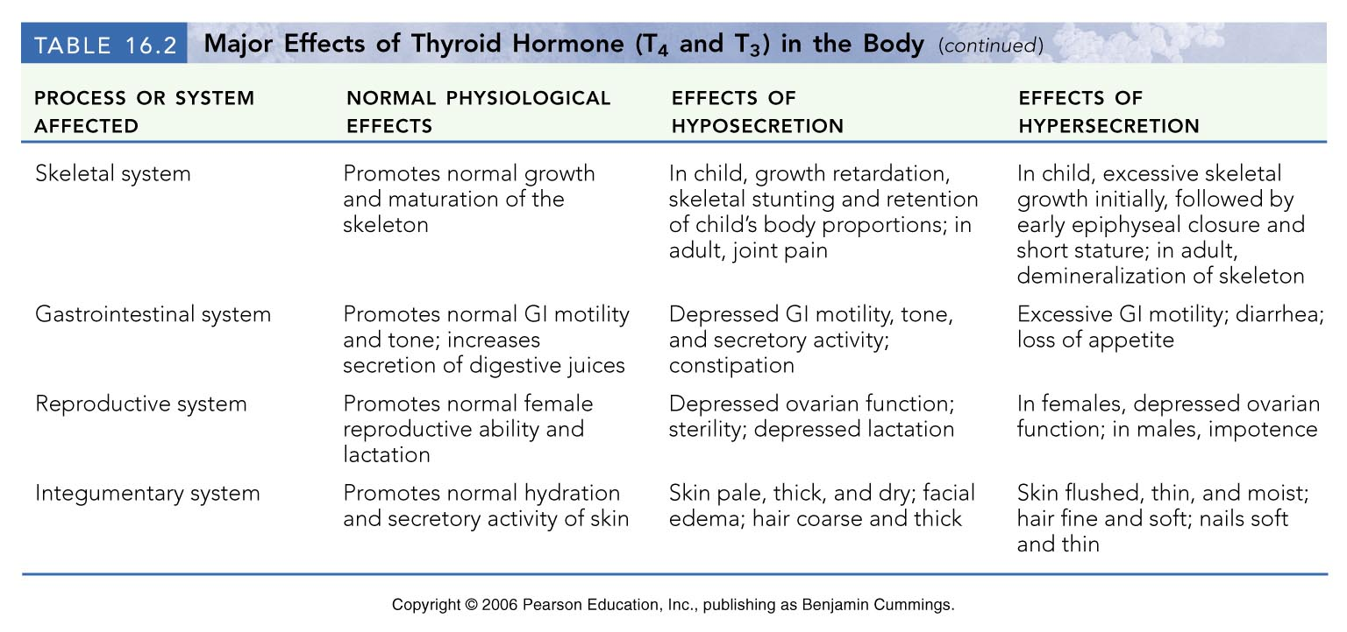

Disorders involving the thyroid hormones
Hypothyroidism:
hypo -not enough /under
Myxedema (“mucous swelling”) in adults
Can occur through inadequate TSH or TRH release, removal of thyroid gland or inadequate dietary iodine. Results in lethargy, low metabolic rate, “chills”, dry skin, edema, mental sluggishness

- In the case of inadequate dietary iodine, the follicle cells try to make colloid, but cannot iodinate it. TSH increases in order to try to induce secretion of T3/T4, resulting in more accumulation of inert colloid. Leads to an enlarged and protruding thyroid gland termed an endemic goiter (huge bump on the neck).
- No iodine =goiter
- Severe hypothyroidism in infants is termed cretinism due to a critical need for T3/T4 in CNS development. Mental retardation, thick tongue/neck, disproportionate body size. Preventable by replacement therapy but only if diagnosed early, not reversible once overt signs are present.Much more severe for infants and foetus
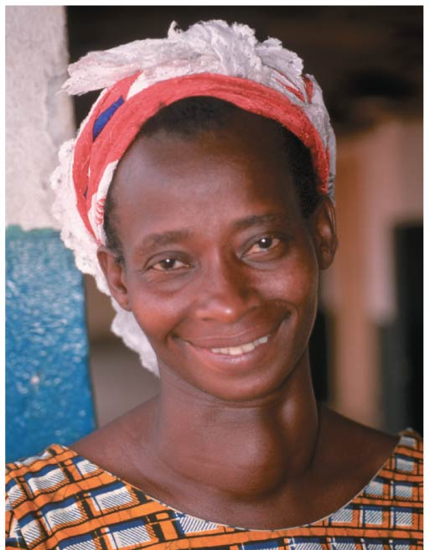

Hyperthyroidism: (excess)
• most common & puzzling form is Grave’s Disease
• autoimmune defect: e.g. patient has developed antibodies that mimic Thyroid stimulate hormone - bind to follicle cells & continuously stimulate output of thyroid hormones
symptoms include: elevated Basal metabolic rate, sweating, rapid & irregular heartbeat, nervousness, weight loss, exophthalmos (protruding eyes in the photos)
treatments: removal of thyroid or ingestion of radioactive iodine
(why the latter?)

-Colon (found iodine)
-High level of radiation in cell -kill the cell
-concentrate the thyroid gland (I1 25)

A (very) few words about Calcitonin (NOT IN ADULTS)
Calcium levels in children
polypeptide hormone produced by parafollicular cells or C cells of thyroid gland
lowers blood calcium
(1) inhibits bone resorption
(2) stimulates Ca⁺⁺ uptake & incorporation into bone
calcitonin secreted in response to an increase in blood levels of calcium; declining blood calcium inhibits calcitonin release
calcitonin most important during childhood (skeleton); minimal role in adults


