Lab #2

Purifying Chemicals by Distillation

Vanessa Fiore
300018068

Partner:
Daphne Richard
8628871

January 13, 2018

CHM 1321, A04

Demonstrator: Ogadimma Okagu

Procedure
Please refer to procedure described in CHM1321: Organic Chemistry Laboratory Manual 2018, pages 25-27. Tin foil was wrapped around the flask and the fractionating column used for the fractional distillation to better conserve heat.

Observations
- 50:50 solution of 2-propanol and 1-butanol consisted of a clear and transparent solution
- As the solution was heated up, bubbles began to form and effervescence occurs as the solution begins to boil
- Condensate can be observed on the sides of the flask and condenser
- For the simple distillation experiment, the distillation increased in speed as the temperature was risen
- For the fractional distillation experiment, the rate of distillation was much slower when compared to the simple distillation experiment

Tables
Simple Distillation

Volume (in mL) | Temperature (in °C)
0 | 25.0
1 | 87.3
2 | 88.3
3 | 88.7
4 | 89.5
5 | 90.2
6 | 90.3
7 | 91.6
8 | 92.6
9 | 94.1
10 | 95.3
11 | 97.1
12 | 98.7
13 | 100.3
14 | 103.2
15 | 105.9
16 | 107.9
17 | 110.7
18 | 112.8
19 | 114.4
20 | 115.3
21 | 116.0
22 | 116.6
23 | 116.6
24 | 115.6

Fractional Distillation

Volume (in mL) | Temperature (in °C)
0 | 25.0
1 | 81.9
2 | 82.4
3 | 82.9
4 | 83.1
5 | 83.6
6 | 84.1
7 | 84.8
8 | 85.6
9 | 86.8
10 | 88.8
11 | 90.6
12 | 96.2
13 | 102.5
14 | 108.8
15 | 113.9
16 | 115.7
17 | 116.4
18 | 116.8
19 | 116.9
20 | 117.0
21 | 117.0
22 | 117.0
23 | 116.4

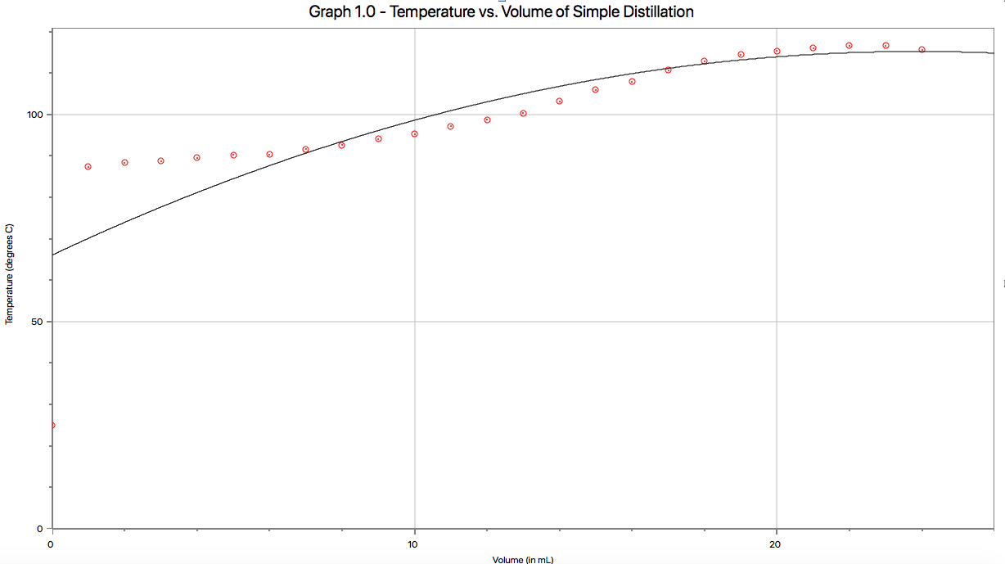
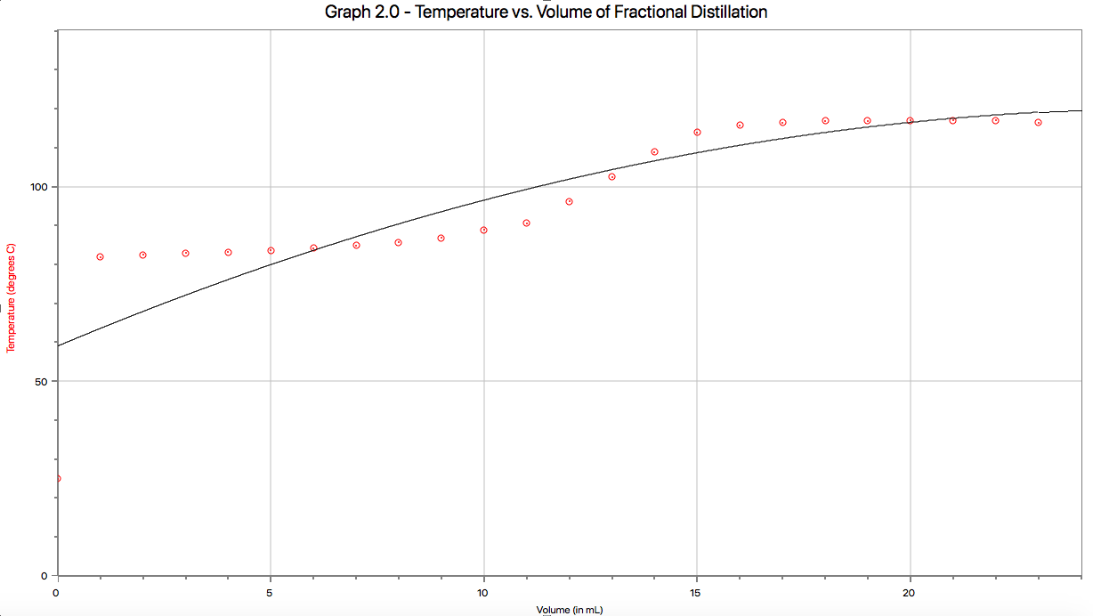
Graphics
Discussion
The experiment conducted involved the simple and fractional distillation of a 50:50 solution of 2-propanol and 1-butanol. The goal was to separate the two solutions from one another by causing the molecule with the lower boiling point to evaporate when heated, allowing for the separation between the two molecules as the compound with the higher boiling point will remain in the flask. The vapour will then pass through the distillation head into the condenser, where it will be cooled by the water that passed from the bottom to the top of the apparatus. The solution will then drip down into the receiving flask. All of the described processes were observed in the simple distillation text conducted throughout the experiment. Similarly, the fractional distillation incorporates all of the above steps, but there is an additional component where a fractionating column is added between the distilling flask and the distillation head. The fractioning column allows the vapour to of the molecule with the higher boiling point to condense and flow back into the receiving flask, thanks to the decrease in temperature in the upper part of the column. In addition, the compound with the lower boiling point is can re-evaporate, allowing for continuous separation of the two molecules. The condensation along the sides of the fractionating column were noted in the observations. Nearly most of the solution was evaporated into the receiving flask.

The simple distillation was carried out with the intent separating the molecule with a boiling point of 100°C, while also resulting in a faster distillation. In the case of the experiment, the molecule with the higher volatility would be 2-propanol with a boiling point of 83°C, indicating that it will be the one to evaporate first. As observed in the experiment, this process matches the description outlined in the procedure, which explains that the molecule with the lowest boiling point will be the first to evaporate. This was observed with the 2-propanol, which was the first to evaporate in the experiment. Although the simple distillation was much faster than the fractional distillation, it is not as effective seeing that it does not allow for substances to purify and it fails to show the moment before the second solution began to vaporize. Therefore, the fractional distillation was more effective because the difference in temperature required to separate the two molecules is comparatively smaller than what is exerted in the simple distillation. This difference in temperature is due to the fractioning column, which allows for the molecule with the lower boiling point to evaporate into the condenser as the temperature in the higher portion of the column decreases. The difference between the boiling points of the two molecules is only 35°C, so the smaller the change in temperature, the more effective the separation will be. Conversely, the lack of fractioning column in the simple distillation causes the molecule with the higher boiling point to evaporate without the chance to condense back into the distilling flask. This allowed for a more gradual distillation, whereas the distillation involved in the fractional distillation occurs promptly.

Typically, the graph of a simple distillation is expected to be more smooth and gradual, with a smaller incline as it increases down the x-axis. As shown on the sample graph obtained from the lab manual, the curve seems to flatten more towards the beginning and the end of the function. The flatter sections of the curves are a demonstration of the boiling points of the two molecules. The curve increases at a steady rate because the two molecules are not separated effectively due to the lack of a fractionating column. The molecule with the higher boiling point lacks the proper environment to cool and condense before the molecule with the lower boiling point is completely evaporated from the solution. The experimental graph obtained effectively corresponds to the sample graph that a simple distillation should resemble since both graphs consist of a gradual increase in the curve. Accordingly, the boiling points of both substances are clearly illustrated towards the beginning and end of the curves, as shown in the sample graph.
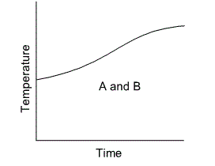
Figure 1: Obtained from the CHM1321 Lab Manual
Conversely, the graph of a fractional distillation should consist of two flatter portions towards the beginning and ends of the curve, but consists of a drastic increase towards the center. Similar to the graph of the simple distillation, the two flatter areas correspond to the boiling points of the two molecules. However, the distinct spike in the curve is the result of the complete separation of the two substances. As previously explained, the fractional distillation is much more effective in properly separating the two substances thanks to the addition of the fractionating column. This allowed for the molecule with the lower boiling point to completely evaporate first, before the molecule with the higher boiling point will have a chance to evaporate. The experimental graph corresponds to the sample graph of the fractional distillation since the increase observed in the center of the curve is much more distinct than the increase in the simple distillation. However, the curve is comparatively more gradual in the experimental graph due to the organization of the packing material within the column, which didn’t allow for the surface area of the vapour to distribute properly. Ultimately, the molecule with the higher boiling point was not condensed as effectively as anticipated.

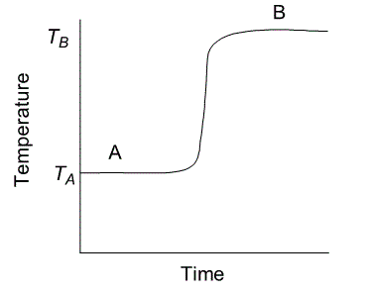
Figure 2: Obtained from the CHM1321 Lab Manual
As mentioned previously, one potential source of error can be the manufacturing of the fractional column. The packing material may not be properly distributed, resulting in the increase or decrease of surface area achieved by the evaporated solution; this can result in the ineffective separation of the two molecules. The flattened areas of the curves that are supposed to illustrate the boiling points of the two substances do not correspond to the supposed boiling points of the molecules (2-propanol with an anticipated boiling point of 83°C and 1-butanol with 118°C). In fact, the temperature does not even surpass 118°C. This may result from the loss of heat from the system, considering that there may have been some potential openings or the system was not fully insulated. Another potential source of error may be the improper placement of the thermometer within the distillation head, causing a distorted reading of the temperature. This is especially true if the thermometer did not properly seal the distillation head, causing some heat to escape.

Questions
- When the vapour travels higher up the fractioning column, the temperature gradient becomes cooler, causing the vapour with the higher boiling point to condense onto the packing material, allowing for it to liquefy and flow back into the receiving flask. This allows for the solution with the lower boiling point to travel up into the condenser before the solution with the higher boiling point has the chance to do so, allowing for the separation of the two compounds.

- It is essential to maintain a constant temperature gradient in the column in order to ensure that the solution with the higher boiling point is being condensed, while the other is vaporizing into the condenser and distillated. In the circumstance where the temperature gradient is increased, it will cause the compound with the higher boiling point to evaporate and enter the condenser, where it will mix with the compound with the lower boiling point. Similarly, if the temperature gradient were to decrease, the compound with the lower melting point will condense and return back into the receiving flask. The purpose of the fractioning column is to ensure the total separation of the two solutions by maintaining the same temperature gradient, so if necessary, the column should be insulated.

- The vapour pressure of benzene at its boiling point of 81°C is equal to the atmospheric pressure that is being exerted onto it, which is 101.325 kPa.

- If the atmospheric pressure were to increase, the boiling point of the solution would also increase. Temperature is proportional to pressure, so the solution must be heated until the vapour pressure is the same as the atmospheric pressure.

- The cooling water must enter from the bottom of the condenser because the water must fill up the chamber entirely in order to effectively cool down the vapour. If the water were to flow from the top of the condenser, then gravity will cause the water to get pulled towards the bottom of the glass and not fill up the chamber.

- P_{t} = N_{A/T}P_{A} + N_{A/T}P_{B}
P_{t} = $\frac{3}{4} \left(350mmHg\right)+\frac{1}{4}(150mmHg)$ = 300 mmHg at 95°C


