Extraction

CHM 1321

Section B06

Report By:
Joshua Fernandes
300014433

TA:
Yiran Lee
01/03/16

University of Ottawa

Faculty of Science

Department of Chemistry

Procedure: Began with Part B first due to length of the experiment. Please refer to the CHM 1321 lab manual, pages 28-33 for procedural steps.

Observations:
Part A-
- Methylene blue
  - Vibrant blue, clear
  - Found in bottom layer
- Ether
  - Clear and colourless
  - Pungent odour
  - Organic layer
  - Found in top portion
- Methyl red
  - Dark, opaque brown colour
  - Found in top layer
- Distilled water
  - Clear, colourless and odorless solution
  - Aqueous phase
  - Found in bottom layer
- Some blue blobs in top layer
- Salting out effect
  - NaCl is a white, crystalline solid
  - 1-butanol is a clear and colourless solution
  - Aqueous crystal violet is a clear and vibrant violet coloured solution
  - No NaCl: all of the solution is the same colour of dark violet
  - After adding NaCl: clear separation of colour
  - Clear and colourless at the bottom
  - Dark purple at the very top
- Solution is two distinct layers

Part B-
- Unknown Compound-
  - White, grainy, solid, opaque, crystal
- Extraction Solution-
  - Three distinct layers are visible
- Dichloromethane-
  - Sweet smelling, clear
- Separatory Funnel-
  - Gas can be heard escaping when stopcock is opened
- Aqueous solid extracted-
  - White, powder-like
- 12M Hydrochloric acid
  - clear, corrosive, irritating when inhaled

TLC’s:
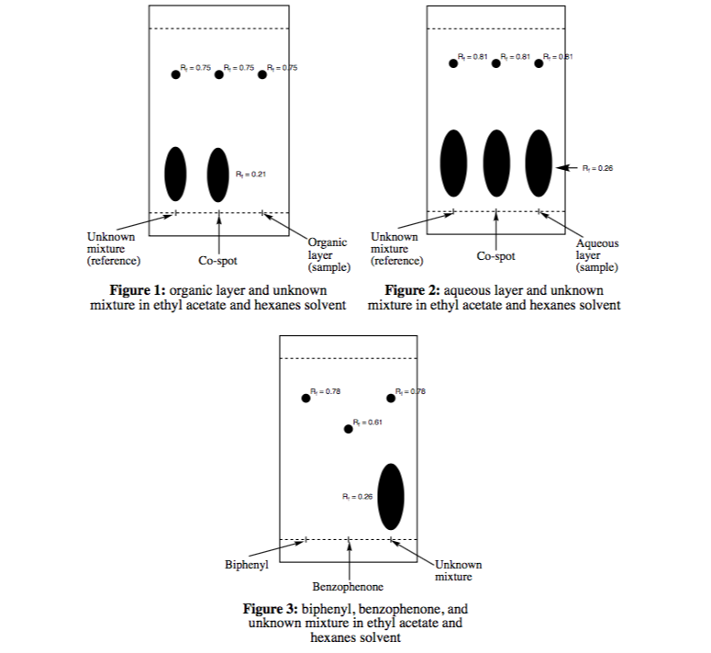

Flow Chart:
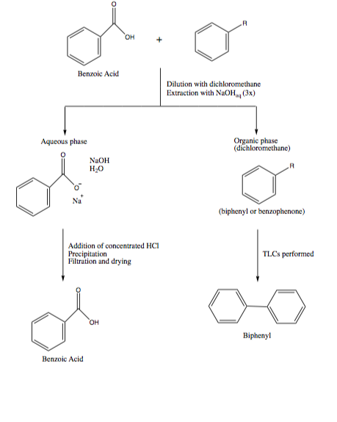

Results:
Table 1: Results of unknown sample before and after separating the mixture with a reactive extraction
Unknown sample #2 | Initial mass: 0.90 g
Unknown sample #2 | Mass obtained: 0.38 g
Unknown sample #2 | Composition (obtained from TLC plate #3): biphenyl + benzoic acid
Unknown sample #2 | Percent yield: 42.22%

Calculations:
RF Example Calculation for TLC Plate #1:
RF = d1 (displacement of compound) / dS (displacement of the solvent front) RF =3.15cm/4.20cm
RF = 0.75

Percent Yield Theoretical mass: 0.51 g Actual mass: 0.44 g
% yield = (actual mass / theoretical mass) x 100% % yield = (0.44 g / 0.51 g) x 100%
% yield = 86.27%

Therefore the percent yield of the precipitate was 86.27%

Discussion:
- Why sodium chloride was used for the salting effect
  - Adding sodium chloride increases the ionic strength of the solution and makes it more polar
  - Increasing polarity of the aqueous phase makes the organic compounds less soluble in this phase
  - The organic compounds (crystal violet) that were slightly soluble in the aqueous phase were pushed towards the ionic phase
  - NaCl also saturates the aqueous phase,which makes it unable to solubilize the crystal violet (or any other compound)
  - The crystals were therefore pushed into the organic phase
- Why sodium hydroxide was used for the extraction
  - NaOH is a base
  - According to the flow chart:
    - Benzoic acid must be separated from the unknown. The only way to separate the solution into the organic and aqueous phases is to add NaOH
    - Since benzoic acid is an acid, it can become deprotonated when a base is added
    - Once deprotonated, it becomes polar and is therefore in the aqueous phase
    - The unknown compound remains neutral and is in the organic phase
    - Adding the HCl after returns the proton and the molecule becomes benzoic acid again
    - In the end, there is a clean separation of the benzoic acid from the organic compound
Analysis
Part A: extraction of water soluble dyes
- Extraction between ether and water was effective
- Successfully separated methylene blue and methyl red based on polarity
- The methylene blue was on the bottom
  - The bottom layer was the aqueous layer containing the
  - water. It was polar and more dense
  - Methylene blue was concluded to be in the aqueous phase
- Methyl red was on top
  - The top layer was the organic ether layer. It was less dense than the water and nonpolar
  - Methyl red was concluded to be in the organic phase
- Salting out effect
  - The crystal violet was distributed in both the organic and aqueous phases
  - Adding salt increases the ionic strength of the water and saturated it, making it unable to hold the crystal violet. This pushed the dye into the organic phase and created a very distinct separation in colours and made the organic and aqueous layers obvious
Part B: separating a mixture with a reactive extraction
- TLC plates 1 and 2:
  - first lane (containing the unknown compound) has two different spots
  - One spot is lower and is therefore more polar and represents the benzoic acid because it is capable of forming a lot of hydrogen bonds
  - There is a higher spot in the lane that represents either benzophenone or biphenyl
  - Co-spot in the second lane has the same pattern because it contains the same two compounds
  - For lane 3 of TLC plate 1, there is no spot for the benzoic acid because it is the organic phase. Instead, there is a single spot for either the benzophenone or biphenyl. This means that the benzoic acid was completely eliminated from the solution
  - For lane 3 of TLC plate 2, there is a spot for the benzoic acid because it is the aqueous phase. There should not be a second spot in the lane representing biphenyl or benzophenone
  - There is a second spot in the third lane,so the extraction was not entirely successful and there was some of the organic compound left over
- TLC plate 3
  - Can draw the conclusion that the unknown solution contains biphenyl and not benzophenone
  - Benzophenone is more polar and has a smaller RF value and is lower on the plate
  - The same compounds will travel the same distance on the plate and have the same RF value, which is the case with the unknown sample lane and the biphenyl lane
  - Unknown mixture lane also has the second spot near the bottom that represents benzoic acid
  - Composition of the unknown is therefore biphenyl + benzoic acid

Sources of error
- Limited number of extractions were performed
- Not as clean of a separation of the organic phase from the aqueous phase
  - Compound not as efficiently transferred from one solvent to the other. Results in impurities in one or both phase
  - Can especially be seen in the aqueous phase in TLC plate 2 because there is a second, higher spot in the aqueous lane when there should only be a lower spot to represent the benzoic acid
  - Can be improved by performing more extractions, rather than just doing three
- While performing the suction filtration part of the experiment,there could have been a loss of the precipitate
- If the filter paper was not flush with the surface of the apparatus before the mixture was poured, some of the precipitate could have been lost
- It was difficult to pick up the filtration sheet afterwards and some of the precipitate could have been left over on the surface of the apparatus after removing the paper
  - This results in a lower percentage yield being calculated because the entire mass measured in the end will not be accurate due to loss of product
  - This error could be fixed by pouring water onto the filter paper to make sure that it is flush against the surface of the apparatus and also by rinsing off the surface and putting the wash onto the filter paper and then allowing the excess water to evaporate

Questions:

  - When performing an extraction, two immiscible phases must be used so that there are two distinct layers
    - The two layers allow for chemical compounds to be separated into one of the layers based on their solubility/polarity
    - Both water and ethanol are polar solutions and are therefore miscible in each other because like dissolves like
  - Since they are miscible, they will not form an aqueous and an organic layer and will not be effective at separating chemical compounds with different solubilities.

  - Adding NaCl to the test tube would increase the ionic strength of the water (the aqueous phase)
  - Methylene blue dye is a polar compound and is therefore soluble and exists in the aqueous layer
  - If this layer becomes saturated by the addition of NaCl, the layer will be unable to solubilize the dye
    - This will push the methylene blue out of the aqueous phase and decrease the amount of dye in the layer.
- W1/V1=2.0g/100mL W2/V2=20.0g/100mL
KD = (W1/V1) / (W2/V2)
KD =(2.0g/100mL)/(20.0g/100mL) KD = 0.10
In a solution of 1.8 g of Y in 100 mL of water extracted by 100 mL ether: 0.1 x 1.8g = 0.18 g in water
0.9 x 1.8 g = 1.62 g in ether
Therefore 0.18 g of compound Y would be removed

- Mass of Y removed from first extraction
m1= 0.1 x 1.8g x 0.50mL=0.09g
Mass of Y removed from second extraction
m2 = 0.1 x (1.8 g – 0.09 g) x 0.50 mL = 0.0855 g
Total mass of Y removed = m1 + m2
Total mass of Y removed = 0.09 g + 0.0855
Total mass of Y removed = 0.1755 g = 0.18 g
Therefore 0.18 g of compound Y would be removed by two extractions

  - Determine by adding a couple drops of water to the solution
  - Water is polar, so is the aqueous layer, and like dissolves like
    - Water will dissolve in the aqueous layer
    - Whichever layer the water is attracted to is the aqueous phase
    - The other one is the organic phase

  - Treat solution with an acid, such as HCl
    - Acid will protonate the benzyl amine because the nitrogen atom has a lone pair
    - This new solution becomes polar and therefore turns into the aqueous phase
    - Naphthalene will remain neutral and stay in its organic phase – lacks lone pairs/polarity
    - Now treat the benzyl amine + HCl solution with a base, such as NaOH, to deprotonate the benzyl amine and return it to its original form

Raw Data:


