BPS 2110 – Introduction to Biopharmaceutical Science
Lipitor and Other Cholesterol Drugs Notes

Lecture 13
Lecture 14
11/02/2017
11/09/2017

Cholesterol
- Cholesterol is an essential substance
- Found in ALL animal cells
- Important constituent of membranes
  - Provides strength
  - Helps create proper “liquidity”
- Continuously made and recycled in the body
- “Goldilocks” chemical
  - Minimum amounts required for good health
  - Too much causes problems
- Animals use something similar but not exactly cholesterol
- High blood cholesterol associated with heart attack (discovered in 1970s)
  - Since then, doctors started to monitor cholesterol levels
  - Diets used to control as no drugs were available until 1980s
- Cholesterol is a triterpene
  - Made up of 6 isoprene units
  - Terpenes are naturally occurring molecules that are constructed of terpene units (5 membered units with similar branching)
  - Stereochemistry not written in ring structures but hydrogen notation given via solid dots (wedge) and 2 small hash lines (dash)
  - Other atoms must be shown as regular
  - Terpenes
    - Secondary metabolites formed from isoprene units
    - Monoterpenes
      - Made from 2 isoprenes
    - Diterpenes
      - Made from 4 isoprenes
    - Triterpenes
      - Made from 6 isoprenes
    - Isoprene = 5 carbon with 2 double bonds, large family of natural products
      - Molecules with up to 30 molecules
      - Assembly of units = E1 elimination
- Sources of cholesterol
  - Diet makes a very small contribution
    - Animal sources
  - Majority of our cholesterol is made in liver from saturated fat
    - Saturated and trans fats
    - Cholesterol you eat very minimal amount passes through into blood
    - 23 different reactions in liver create cholesterol (from acetyl-CoA to cholesterol)
      - Synthesis of mevalonic acid (key enzyme system in inhibiting and controlling cholesterol)
      - 3 units of isopentenyl pyrophosphate come together to form farnesyl pyrophosphate
      - 2 units of farnesyl pyrophosphate create squalene
      - Squalene is then converted into cholesterol (enzyme uses double bonds to close rings)
    - Cholesterol biosynthesized in liver
    - Distributed to all cells in the body via blood
    - Complicated synthesis = significant biological investment precious chemical, not to be wasted
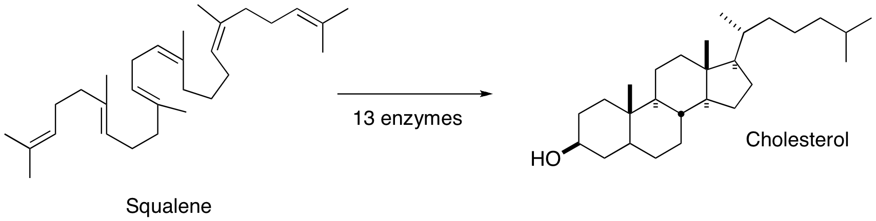
    - Precious nature = excess cholesterol is stored in arterial walls
    - Cholesterol builds up inside arterial lining = plaque causes arteries to bulge out (diameter of arteries remains the same)
      - As it is in arterial walls, circulating bloods causes cholesterol to get oxidized = cholestenone
      - Cholestenone seen as foreign substance in body and illicit immune response
      - Macrophages eat the cholesterol and eventually consume so much, they turn into foam cells
      - Macrophages secrete chemical substances that damage the arterial surrounding tissue
      - Tissue is then susceptible to being ruptured
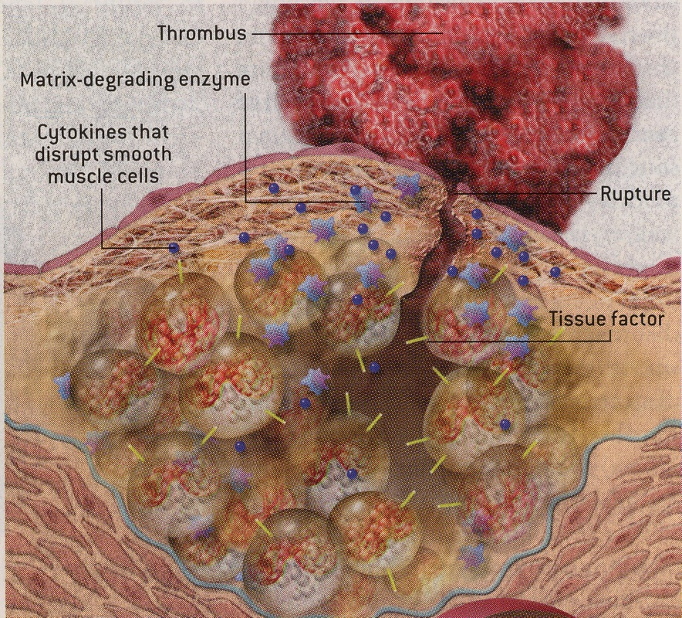
      - Inflammation in other parts of body can cause chemicals to circulate which will cause artery to rupture
      - Cholesterol deposit can cause tear, platelets think of it as real tear (injury) and form a blood clot over burst plaque
- Can prevent health effects through diet
  - Reduce risk of heart attack through diet
  - Reduce total fat in diet
    - Average North American eats 3X RDA
    - 2X food that is required
    - Reluctant to change eating habits
      - Quantity
      - Quality
      - Therefore, use drugs to block cholesterol biosynthesis
  - Avoid processed foods
    - Saturated fat
    - Trans fat
  - Reduce meat intake
  - Eat fruits and vegetables
  - Reduce total food intake

Drugs Lowering Cholesterol Levels/Blocking Cholesterol Biosynthesis
- Triparanol 1959
  - Effective in lowering blood cholesterol
  - Caused cataracts
  - Removed from market 1962
  - Used as an example in medical textbooks that caused physicians to be afraid of cholesterol lowering drugs
    - When better cholesterol drugs came out, doctors reluctant to prescribe
  - Inhibits penultimate enzyme
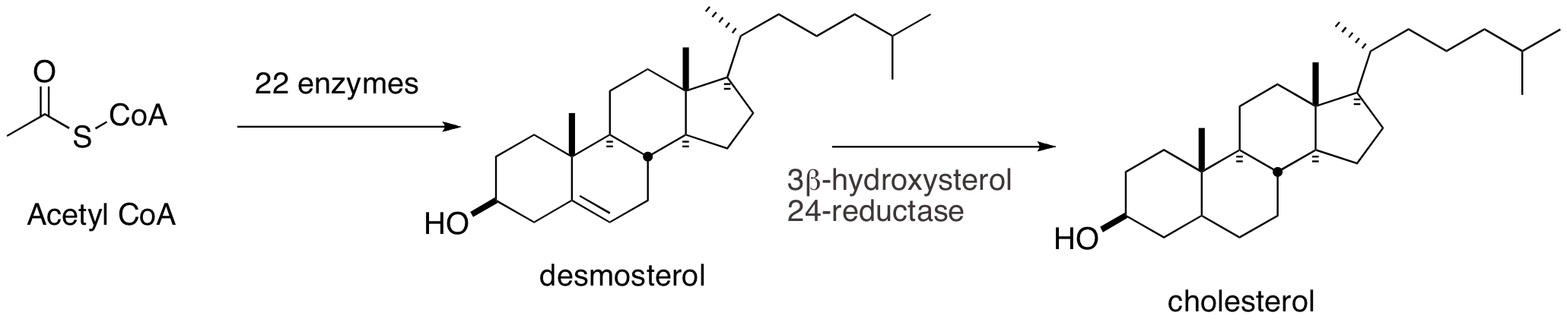
    - Blocked 2nd last enzyme in sequence (3B-hydroxysterol 24 -reductase)
    - Buildup of desmosterol in body
    - Desmosterol built up in lens and cornea of eye causing cataracts
    - Problem: enzyme that was inhibited, was too late in the reaction process
      - For safety, need to inhibit early in the sequence
      - Buildup of synthetic intermediates can cause toxicity
      - Block an early enzyme, fewer intermediates build
      - Earlier inhibition prevents build up of multiple by products
- Mevastatin
  - Discovered by Akiro Endo in 1970
  - Isolated from mold Penicillium citrinum
  - Competitive inhibitor of HMG CoA reductase
  - HMG CoA Coenzyme A circle
  - Drug has similar shape to CoA
  - HMG CoA reductase is 3rd in the sequence
    - Mevastatin blocks 3rd enzyme HMG CoA reductase
    - Less chance of side effects
  - Failed as a drug
    - Toxicity (not related to cholesterol biosynthesis which is the primary action)
    - Encouraged other companies to search for related compounds
- Lovostatin
  - Merck discovered Lovostatin
  - Aspergillus terrus (oyster mushroom)
  - Fungus that grew on tree bark similar to Mevastatin without toxicity
  - Lovostatin from Aspergillus terrus was the first statin drug
    - Statin = cholesterol lowering
    - “code-name”
- Other naturally occurring HMG-CoA reductase inhibitors
  - Red portion mimics HMG
  - Black = CoA lipophilic part
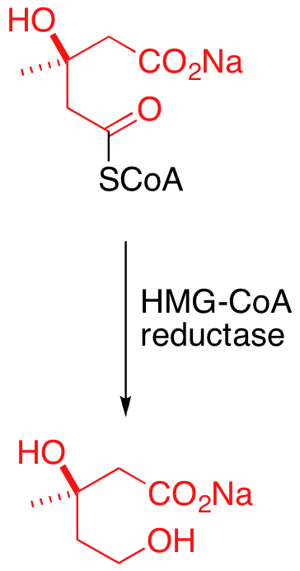
  - Ring structures = Diterpenes
- Doctors and Cholesterol Lowering Drugs
  - Triparanol made doctors afraid to prescribe statins
    - Suggested that inhibition of cholesterol biosynthesis might be dangerous
  - Drug companies had to “educate” doctors
  - New drugs inhibited a different enzyme
    - Enzyme target was early in the sequence
    - Avoids buildup problem
  - Four-S Study of Simvastatin
    - Scandinavian Simvastatin Survival Study
    - Educated doctors and marketed via clinical trial
    - Rate of side effects very low
    - 4,444 patients
    - 35 % reduction in cholesterol
    - 42 % less likely to die of heart attack
    - Non-heart related deaths at normal rates
    - Sales of all statin drugs rose
- Statins
  - Complex structures (as seen as above) due to lots of sterochem
  - Success caused other companies to be interested in making cholesterol drugs
  - However, many companies decided they did not want to wait for natural product to come along, but rather make an artificial version
  - Wanted to come up with synthetic versions
    - Can do rational drug design
    - Red part important
    - Black part is variable and able to be changed
  - Merck attempted to make artificial statin
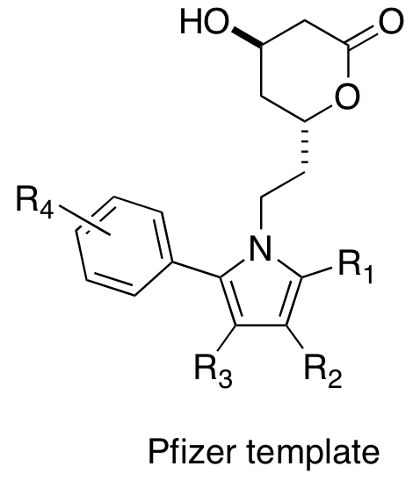
    - As it did not work well, published results and moved on
  - Pfizer designed a pyrrole-based ring system
    - Based on Merck publication
    - Pfizer decided to make something easier and quicker to make
    - Wanted to change 6 membered ring to 5 as it was quicker to make
    - Pfizer molecule designed for synthesis
    - Easy to make lots of different molecules, therefore can optimize structures faster
- Linker Optimization
  - Sequentially optimize each part of molecule (top, right, left, etc.)
  - IC Inefficient concentration want as small as possible represents dose required to inhibit enzyme
    - IC50 = inhibitory concentration for 50% inhibition
    - Right in the middle, consistent concentration number, right at inflection point
    - Gives consistent reproducibility
    - Tightest binding = lowest IC50
  - After establishing size, change small side chains of molecule
  - Make changes to only one part of molecule systematically changing one factor = easier to figure out what is contributing to making molecule better (applies to all types of science)
  - If possible, you want your drug to be racemic (assuming it is safe to use both enantiomers) because it is hard to develop single enantiomers
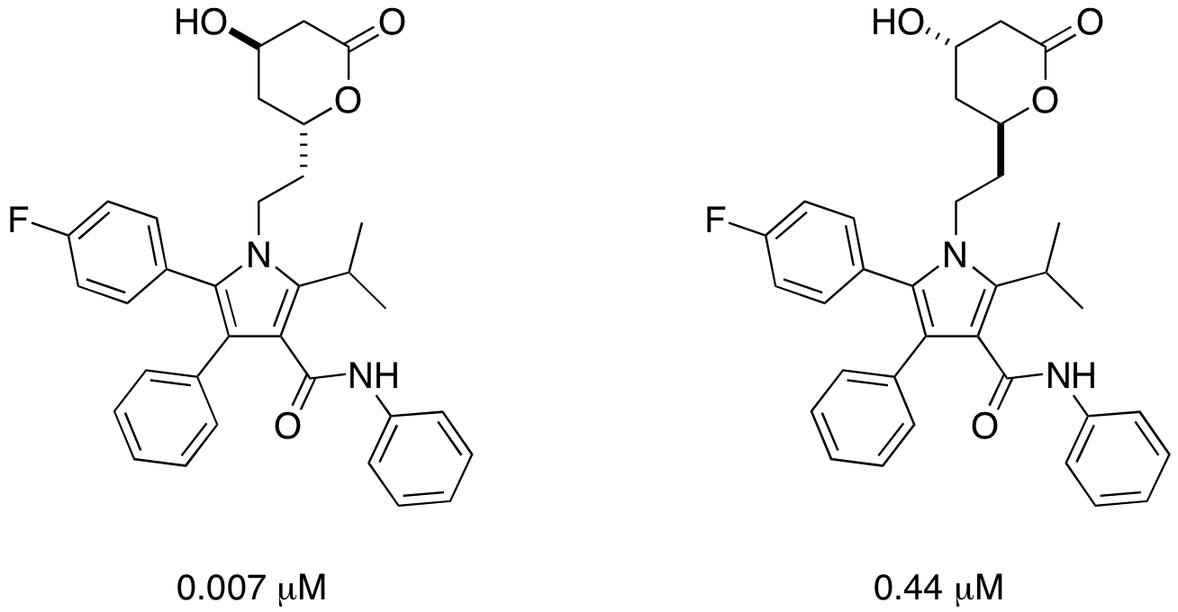
- Lipitor
  - Overall profiles showed racimate was safe however natural enantiomer had better results
    - Pfizer decided to develop single enantiomer = maximum potency
    - Worried they were not going to make enough money as they were late (4th) to the market so decided single enantiomer (more potent) would give them the best chance
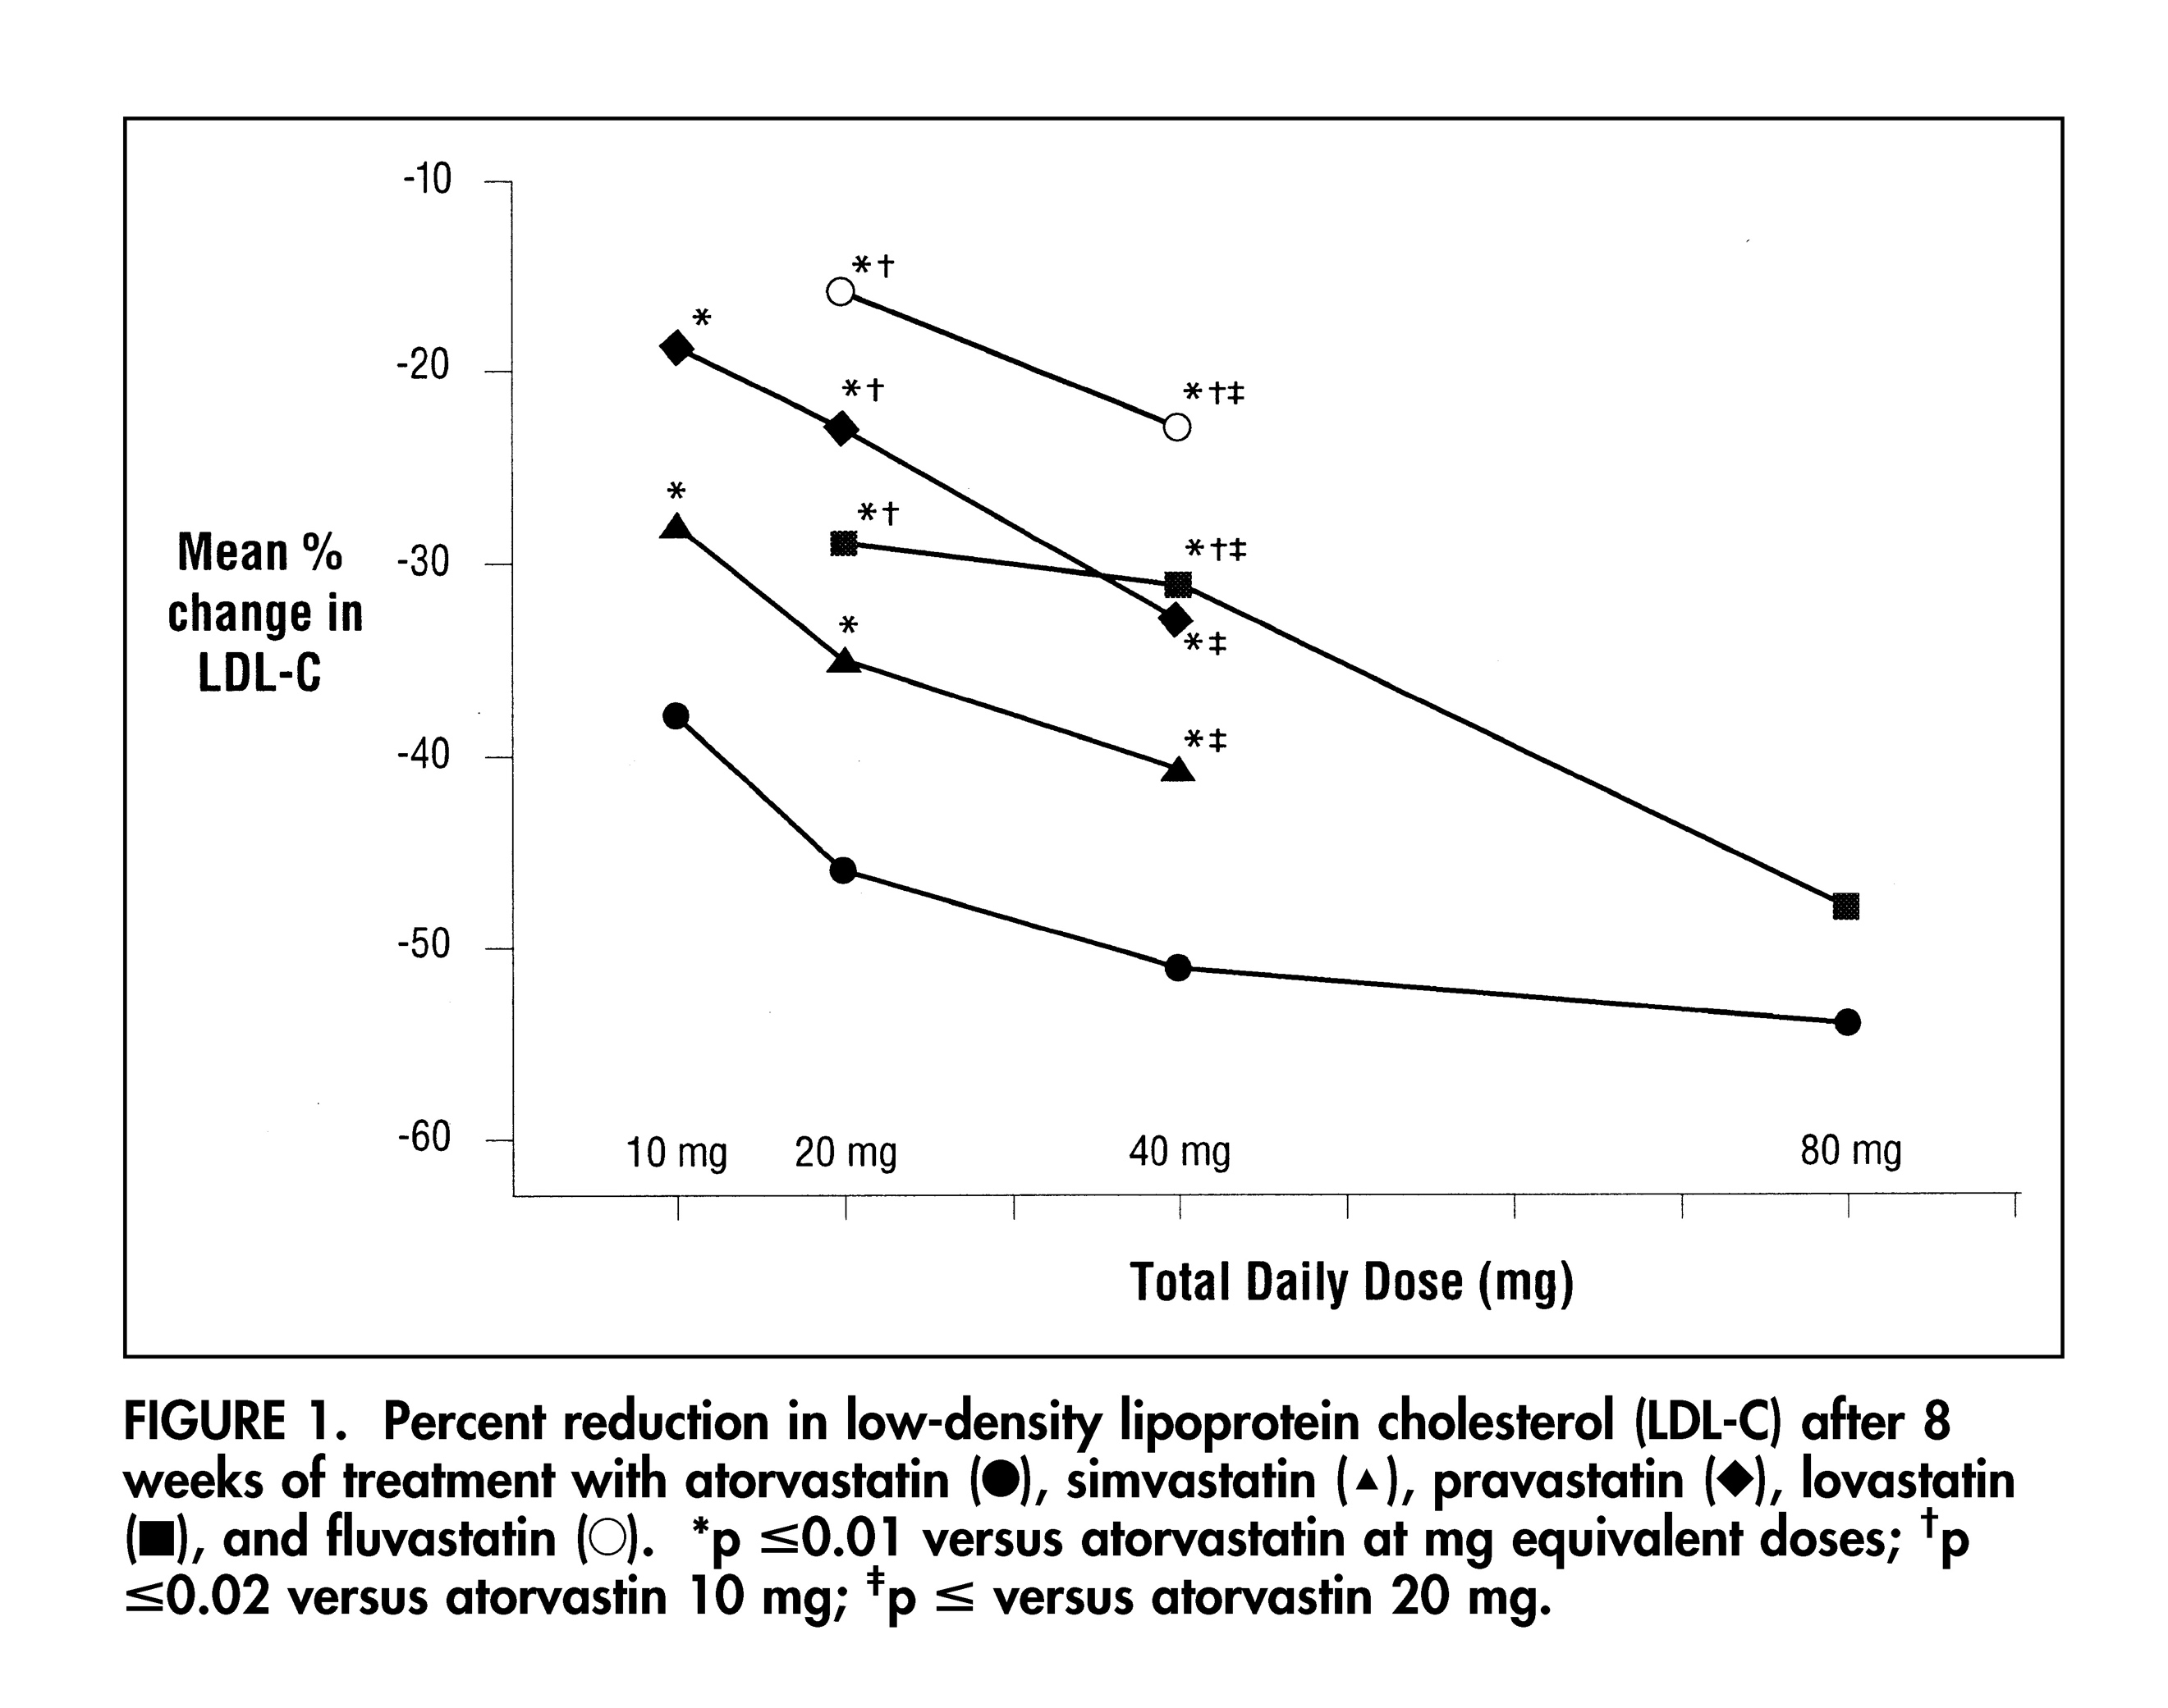
    - Doctors were afraid to prescribe statins so Pfizer wanted to use lowest dose possible = safer to doctors so more likely to prescribe single enantiomer version gave best chance for this
  - 4th drug on the market
    - Lovostatin (Merck)
    - Simvastatin (Merck)
    - Pravastatin (Sankyo)
  - Completed a clinical trial with 24 company employees
    - 38 % drop in cholesterol at 10 mg
    - Lipitor at lowest dose was better than other drugs at higher dose
  - Curve trials showed significant advantages
    - Used both higher dosage (to indicate safety) and lower dosage (to indicate potency and effectiveness)
  - Problem: Lipitor was no better than lovostatin in animals
    - Not better in any existing drugs
    - New drug when existing therapies exist = harder to do because you had to prove your drug was better than anyone else's to FDA
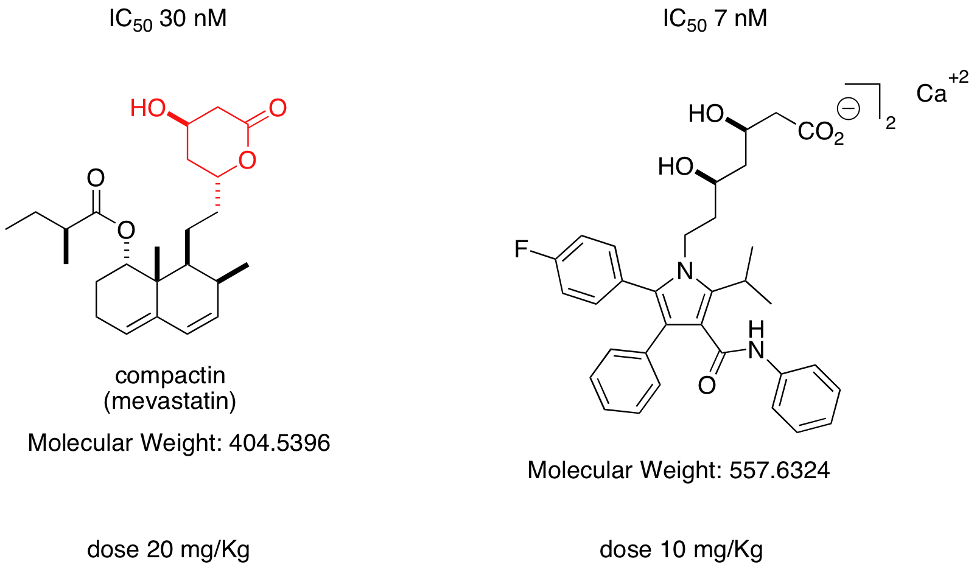
    - Pfizer gambled with the dose used dosage argument to get through FDA
      - Most statins given at 20 mg
      - Lipitor was more effective at 10 mg
      - Lipitor was safe at 80 mg
    - Passed Lipitor off as orphan drug from familial hypercholesterolemia
      - Orphan drug (very few people that get the disease)
      - Orphan Drug Act drug companies have extended market exclusivity and lower regulations
      - Pfizer found familial hypercholesterolemia (max 2000 people per year)
        - Body produces too much cholesterol which start to show as yellow deposits on knees, elbows, under eyes, etc.
      - Pfizer used this disease to say Lipitor would be used for this disease to get through FDA
      - Doctors can then use drug for whatever they judge it would be best for
      - Pharmaceutical companies now use Orphan Drug Act to get in under the radar (especially cancer drugs cancer drugs target specific type of cancer but then say it can be used for multiple types after it’s on the market)
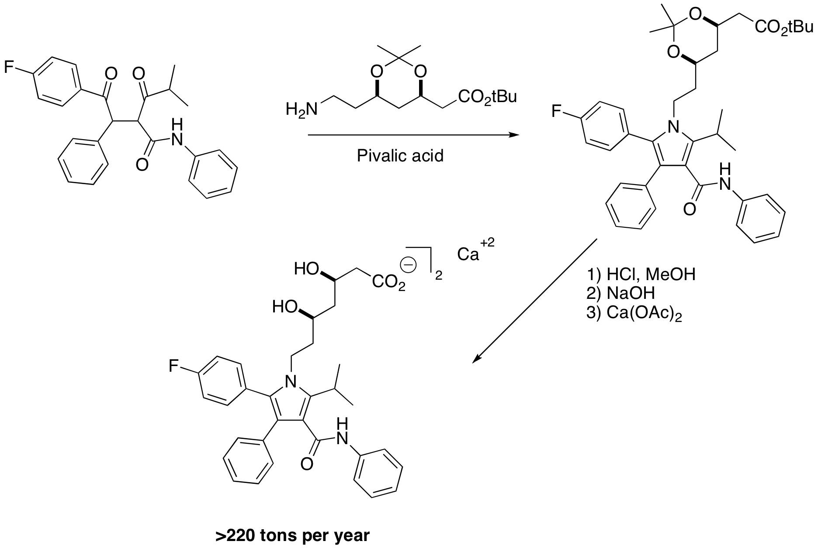
  - Lipitor = best-selling drug in history
    - Total sales since 1996
      - $131 Billion
    - Very effective
    - Extremely safe
      - Some liver toxicity but get around by monitoring
    - Patent expired 2011
      - Generics now available
  - Assembly to make Lipitor
    - 1, 4 carbonyl relation
    - Cost of goods = $500 million
    - Sales = $20 billion
    - Bio catalytic side chain synthesis
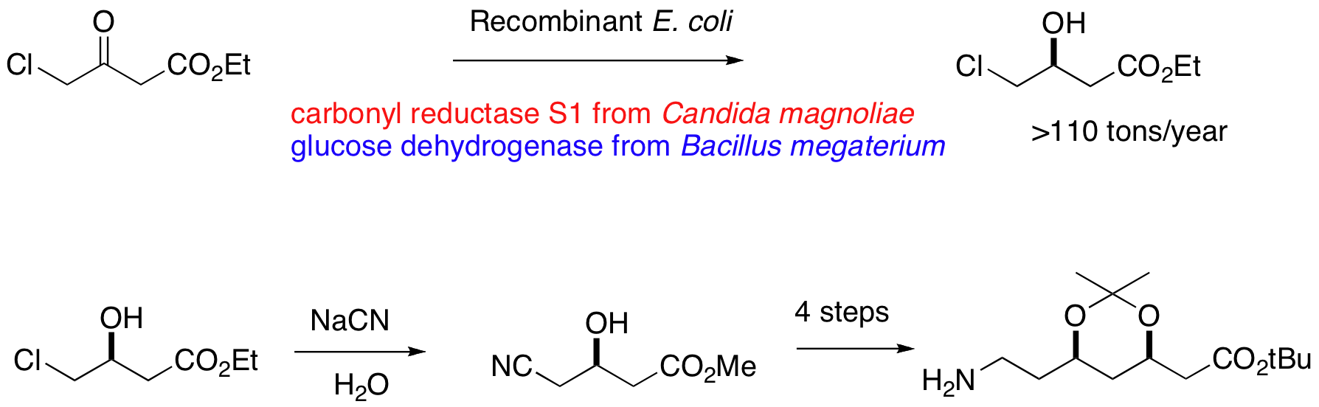
      - For first product, use two enzymes from different species
        - Engineered bacteria living factory
        - Genetically altered E. coli
        - Carbonyl reductase S1 from Candida magnoliae
        - Glucose dehydrogenase from Bacillus megaterium
        - Introduced genes for these enzymes into E. coli
        - Mix E. coli with drug to create living factory
        - Recombinant tech is being used increasingly
    - Generic versions from improved bio catalysis
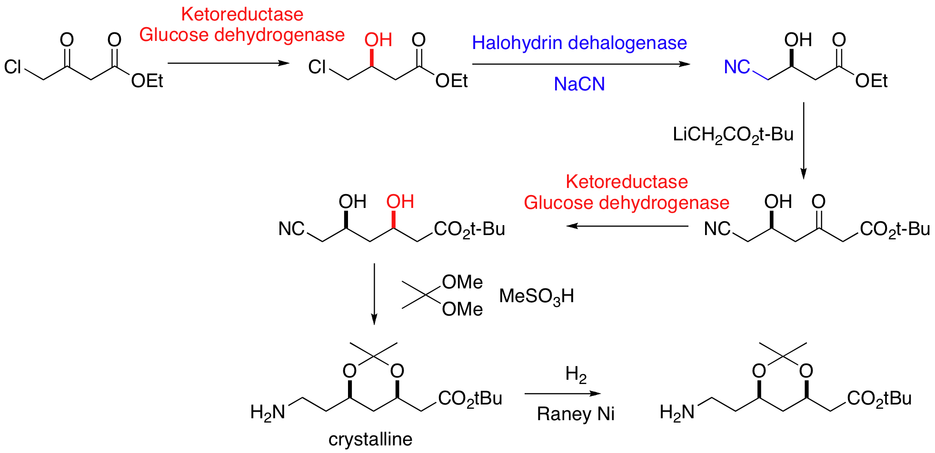
      - Companies had to come up with own generic catalysis

Costs of Pharmaceutical Drugs
- Cost of drug to consumer
- Number of patients
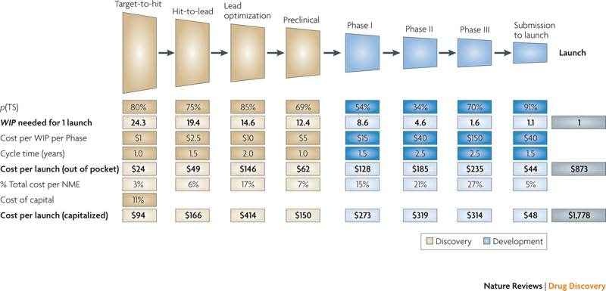
- Length of treatment
- Need to pay $1.7 billion development costs
- Need to pay manufacturing, shipping, marketing
- Need to make profit
- Need to make future investments
- 20 years of patent protection (8 years market exclusivity)
  - 12 years on average to go from idea to product
- Lipitor
  - Peak sales $9 billion (2010)
  - Introduced 1996
  - Off patent 2011
  - Sales $3 billion in 2014
  - Total sales $ 131 billion (1996 to 2014)
  - Cost $1940 per patient per year (2014)
    - $4/pill
    - 155,000,000 prescriptions per year
  - Reason for 3 billion in 2014 is because Pfizer did not change price point
  - Generic versions also cost the same (despite not needing to pay for RD costs)
  - Difference between generic and name brand has become cheaper because generic have raised price
  - Costs – numbers based on industry average
    - Discovery and development $1 billion
    - Manufacture $200 million per year ($4.4 billion over 22 years)
    - Marketing estimate $300 million per year ($6.6 billion)
    - Total costs $12 billion
  - Total Sales = $131 billion
- Recent price increases for drugs
  - Some drugs increased 200% overnight
  - Drug pricing is a black box (not transparent)
- Pricing Models
  - Price reflects costs CLAIM to use this
    - Development
    - Manufacturing, shipping, marketing etc.
  - Price based on alternate treatments
    - Drug is cheaper than alternatives (surgery)
    - Cost of cancer treatments in US
      - Non-invasive treatment
        - $14,000
      - Surgery
        - $123,000
      - Chemotherapy
        - $100,000
  - Price based on similar drugs
    - Orphan drugs not likely low price because there are no similar drugs
  - Price based on what the customer is willing to pay
- Turing Pharmaceuticals
  - Small biotech company started in 2013 from 3 off-cast R&D programs
  - Bought manufacturing rights to Daraprim 2015
  - Raised price from $13.5/pill to $750/pill
    - Pills cost less than $1 each to make
  - Argument used = money needs to be put into research
  - Daraprim = orphan drug (some cost $1000s, so $750 is not bad)
    - Pyrimethamine
    - Treatment of protozoan infections
      - Toxoplasmosis (spread in cat feces)
      - Malaria
    - Sold since 1953
    - WHO lists it as an essential medicine
    - Off patent since early 1960’s
    - Not used in NA but important in other parts of the world
  - There are no “rights” to off-patent drugs
    - Each drug must be custom manufactured
    - Process is FDA approved and inspected
    - Each process has set up costs
      - Right equipment
      - Procedures and inspections put in place
    - Difficult to make money from small market drugs
    - Many only manufactured in 1 place
    - Creating plant itself and then getting approval from FDA = hard
    - Company bought plant itself
    - Orphan drugs = margin profits (not worth it for other companies to compete as profit may be very small)
  - Market for the drug was small
    - Approx $ 670,000 total sales (2010)
      - Glaxo sold for $1/pill
      - 12,700 prescriptions
    - Approx $ 6,300,000 total sales (2011)
      - CorePharma purchased manufacturing
      - Sold for $10/pill
      - 12,000 prescriptions
    - Approx $9,900,000 total sales (2014)
      - CorePharma sold for $13.5/pill
      - 8,800 prescriptions
    - After purchasing manufacturing, CorePharma increases price by 10 (goes unnoticed)
    - Increase in price causes fall in sales but increased price still creates profit
    - No research or clinical trials performed so all profit
  - Bought manufacturing “rights” to Daraprim for $55 million
    - Total sales in 2014 $9.9 million
    - Should only generate 0.7 million/year
    - Pills cost less than $1/each to make
    - No patent, small market prevents competition
      - Costs to set up manufacturing capacity too high
        - $1-3 million
      - “Actual” market is about 0.7 million in sales
      - Investing in capacity won’t pay off
        - Market is too small
      - Company bet on the fact that small market would prevent other companies from investing and creating a new manufacturing compound
      - This is what you find in orphan drugs (companies increase price)
    - Raised price 5000 %
  - This trend is seen in a lot of old drugs
  - Companies hold patient hostage as they MUST pay for these illnesses
    - Example of tuberculosis drug price jump of 2000%
- Pharma companies prey on ignorance of science
  - Many new drugs are orphan drugs
    - Small markets (few thousand)
    - Must pay off huge development costs (billion)
    - Cost per treatment is huge ($100,000’s)
  - Public doesn’t know the difference between old and new
    - New orphan drugs are expensive
    - Old orphan drugs are not
      - R & D paid for long ago
      - Manufacturing costs usually low
- Soliris
  - World’s most expensive drug
  - Monoclonal antibody
  - $700,000 per patient per year
  - Developed for arthritis (failed)
  - Redeveloped as orphan drug for
    - Paroxysmal nocturnal hemoglobinuria (PNH)
    - Atypical haemolytic uremic syndrome (AHUS)
  - Approximately 2000 patients in North America
  - $2.1 billion total sales (2014)
  - Alexion Pharmaceuticals
    - Founded in 1992
    - Only product is Soliris
      - Marketed 2007
      - First year of sales made $66 million
    - Currently employ 2,400 people money put back into the company
    - Boehringer-Ingelheim (Laval)
      - Budget of approx. $25 million (1992)
      - Approx. 100 employees
      - Costs approx. $250,000 per employee
      - From 1992 to 2007 company made no money
        - Expenditures
          - Probably $25 million/year (R &D)
          - Probably $50 million/year (clinical)
        - First clinical trials 2002
        - During this time, company likely spent $300 to $600 million
      - Company did not significantly expand until after Solaris was on market
  - Total sales to date = 6 billion
    - $2.1 billion (2014)
    - $1.5 billion (2013)
    - $1.2 billion (2012)
    - $0.8 billion (2011)
    - $0.5 billion (2010)
    - $66 million (2009)
- Orphan Drugs introduced in 2014
  - Juxtapid most likely going to be used for widespread cholesterol issues in the coming future
- Unsustainable trend in medicine
  - Most health care spending happens in the last 30 days of life
  - Can easily spend $1 million

