BPS 2110 – Introduction to Biopharmaceutical Science
Antiviral Drugs Notes

Lecture 10
Lecture 11
Lecture 12
10/16/2017
10/19/2017
10/30/2017

Antiviral Drugs
- Most infectious disease in North America is caused by viruses
  - More than 95% of all respiratory disease
- All Class 4 pathogens (P4) are viruses
  - Ebola, Marburg, Lassa fever, Hanta virus, smallpox,
- Classification of Pathogens

  - Class 1
    - No risk or limited risk
    - Work on open lab bench
    - E. coli
    - Protection Level 1 (P1 Lab)

  - Class 2
    - Moderate risk
    - Limited access to lab
    - Lab coat required
    - Laminar hoods used
    - Herpes virus
    - Keycode system or lab always locked
    - Hoods designed to prevent escape of pathogen

  - Class 3
    - Risk of death or serious illness
    - Restricted access, special training required
    - Surgical gowns, gloves, respirators
    - Low pressure in lab (leaks will be IN), airlocks
    - All liquids/air coming in/out is filtered and/or treated
    - Everything coming out is autoclaved and incinerated
    - HIV, Y. Pestis
    - P3 Lab
    - Some exposed skin

  - Class 4
    - Lethal, highly infectious, untreatable
    - Lab accessed by airlock, special training required
    - “Space suit” worn, shower going in or out
    - All liquids filtered/treated going in and out
    - Ebola, Marburg, Lassa fever, Hanta virus, smallpox
    - P4 Lab
    - Almost all are viruses

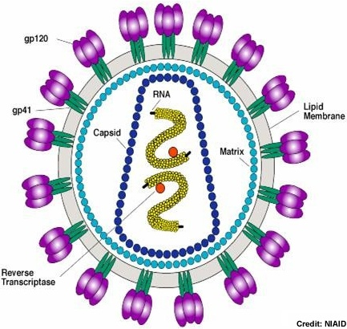
Virus Structure
- Genetic information
  - DNA or RNA
  - Double or single stranded, -ve or +ve strand
- Surrounded by a capsid
  - Capsule composed of protein
  - Many copies of one or 2 different proteins
- Some viruses carry additional proteins
  - Enzymes
  - Regulatory proteins
- Some viruses are Enveloped
  - Capsid is surrounded by a membrane
  - Remnant of the host cell membrane
  - Contains viral proteins
- 2 parts in all viruses
  - Genetic information
  - Capsid
  - Some contain other things like additional proteins, envelopes, etc.
- Self-replicating
  - Many viral proteins are structurally related to host proteins
    - Oncogenes
  - Viral proteins often bind to host protein and alter that protein’s function
    - Co-opting regulatory systems
  - Common elements
    - Duplication of genetic information
    - Production of viral protein
      - These processes utilize host proteins and machinery
      - Ribosome
      - Nucleic acid polymerases
  - Most viruses only have 10 genes (simplest bacteria = 200)
  - Proteins in viruses resemble host enzymes
  - Generally, use host machinery (ribosome) – obligate parasite
- Many can be crystallized
  - Mix together, do not need cell
  - Herpes virus = 80% of population have lifelong infection
- Papillomavirus
  - Causes warts
  - 5-point symmetry
- Tobacco mosaic virus
  - Can use protein to make synthetic virus
- Zika, West Nile, Polio, etc.

Developing Antiviral Drugs
- Each virus is unique
  - Each virus requires different drug
- Most viral proteins act by binding to host proteins
  - This is very difficult to control with drugs
  - Proteins tend to bind to each other very tightly
  - Utilize large contact surfaces
  - Need to avoid interfering with normal host cells
- Different drug needed for every single virus
- Selectivity problem = how do you kill a virus that interacts with your cells without harming your cells
  - Proteins stick together so well because large surface area with a lot of bonds
  - Must have bigger drug
- Cell signaling systems use protein binding
  - Protein A sticks to Protein B
  - Change shape of protein B allows it to stick to C which creates signal
  - Changed shape of protein B creates an enzyme

- Viral proteins operate by binding to host protein
  - Viral protein has structure that allows it to stick to protein B which activates
  - Normally protein B would be inactive
  - Virus then uses this to create its own proteins

- Protein binding is difficult to prevent with drugs
  - Small drug cannot separate proteins as it does not create strong enough non-bonded interactions
  - Large surface area of A and B stuck together

- Can block protein binding in the lab
  - Big drug can block protein binding, however large molecules are not bioavailable
  - Even with IV, does not reach cell
  - Work in the lab but do not work in the real world

- Viral enzymes as drug targets
  - Viruses carry very few enzymes
  - Most involve nucleic acid replication
  - Host cells also replicate nucleic acids
  - Substrates, mechanisms and structures are similar
  - Selectivity problem
    - How do you block viral enzyme without blocking host enzyme?
- Limited number of targets
  - Most viruses have small genomes
  - As few as 10 genes
  - On average, one 1 or 2 are enzymes
    - Most involve nucleic acids (host selectivity problem)
  - How to kill virus without killing host
- Modern day antiviral drugs
  - Only few good ones exist
  - Hepatitus C (cure)
  - Herpes (treat & manage)
  - HIV (manage)
- Major problems with antiviral drugs
  - Selectivity
    - Kill virus without killing host
  - Diagnosis
    - Most drugs specific to a virus
    - Many viruses produce similar symptoms
      - More than 200 viruses cause colds
    - Only way to know for sure is biochemical test
  - Resistance
    - Mutation rates in viruses very high
    - Viruses quickly develop resistance to drugs
- Immunization
  - Very successful for viruses
  - Possibly all-time greatest achievement in medicine
    - Smallpox eliminated in 1977 except in labs
    - Polio only 11 cases in 2017
    - Measles
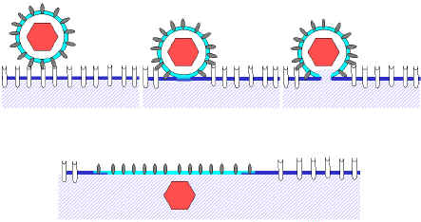
    - Mumps
    - Influenza

Virus Life Cycle
- Adsorption and penetration into cell
  - Virus binds to host proteins on outside of membrane
    - Capsid binds directly and is passed inside before opening
    - Envelope fuses with host cell membrane releasing capsid inside the cell
  - Genetic info is injected into the cell
    - Virus may also inject viral protein (enzyme or regulatory protein)
  - Poor drug targets
    - Binding involves protein-protein interactions
      - Protein contact surface areas are very large
      - Difficult to inhibit protein-protein binding with small molecules
    - Limited success in HIV
      - Fuzeon – peptide with 36 amino acids
      - Maraviroc – small molecule
- Uncoating of viral nucleic acid = expose nucleic acids
  - Capsid opens releasing genetic information into the cell
    - Difficult to target (protein interactions)
    - Two successful drugs
      - Both drugs target influenza
      - Block ion channel that is involved in capsid formation of virus
- Synthesis of regulatory proteins
  - Many viral proteins are regulatory
    - “Take over” normal cell systems
      - Nucleic acid replication
      - Expression of viral protein
      - Suppression of host cell defenses (apoptosis)
  - No drugs currently exist for this phase
  - Some viruses have proteins preventing apoptosis
  - No drugs as all this is protein-protein interactions
- Synthesis of RNA or DNA
  - Viral genome is replicated using host enzymes
  - Some viruses have their own enzymes for this (drug targets)
  - Most anti-viral drugs target this phase
    - Require unique viral enzymes
  - Drugs only work if virus has unique enzymes for synthesis (if not, then host will be harmed)
- Synthesis of structural proteins
  - Utilize the host Ribosome
    - Poor drug target
  - Some viruses utilize specific enzymes for protein maturation
    - Protease drugs
      - HIV
      - Hep C
  - Ribosome needed for host cell function
- Assembly of viral particles and release from host cell
  - Capsid proteins self-assemble
    - Nucleic acid inside
    - Viral proteins outside
  - Release may destroy cell
    - Lytic virus HIV, influenza
  - Cell may remain intact
    - Papilloma, herpes
  - Only a few drug targets (HIV, influenza)
  - Few drugs because no enzymes to go after
    - Antiviral drugs require viral enzyme targets
      - Enzyme should be structurally unrelated to host enzymes
      - Most viral enzymes are involved in nucleic acid replication
      - Do not want to inhibit function of human ribosome or human enzyme synthesizing DNA, RNA, etc.

4 Examples of Viruses
- Method used to create drug = rational drug design (start with something nature already uses)
- Herpes
  - Virus causes chronic recurrent infections
  - Virus can escape immune system
    - Latency in neurons
  - HSV-1
  - HSV-2
    - Other sub-types less prevalent
    - Up to Herpes Virus 10
  - Virus lives in nerve cells where they are separated from white blood cells that can destroy them
  - HSV-1
    - Cold sores and fever blisters on the mouth and nose, sometimes eye
    - More than 80% of population is infected
    - Only 10 to 20% experience outbreaks
    - Virus escapes eradication by latency in neurons
      - Inaccessible to immune system
      - Stress, sunlight, immune suppression trigger outbreaks
      - Virus travels down axon to epithelial cells
    - Lytic infection
      - Only in epithelial cells, does not damage neurons
      - Outbreak
        - Viral activity is short (less than 24 hours)
        - Viral damage is minimal
        - Most damage is caused by the immune system
          - Over-stimulated and destroys most of the tissue
          - Drug must be administered quickly
        - Immune system can destroy virus very quickly
        - Virus does not destroy many cells but immune system destroys tissue
  - HSV-2
    - Sores and fever blisters on the anus and genitals
    - Infects 15 to 20% of population
    - Infection is much more virulent than HSV-1
      - Painful
    - Usually one outbreak per year (less prevalent)
    - Most common type of STD
  - Virus Structure
    - Genetic information is double stranded DNA
    - Very complex virus
      - More than 70 genes
      - Most viruses have less than 10
      - Virus has its own polymerase
        - DRUG TARGET
  - Drug Development
    - Nucleic Acid
      - Components
        - Nucleosides (no phosphate)
        - Sugar (2-deoxyribose in DNA or ribose in RNA)
        - Base – nitrogen containing aromatic heterocycle (basic heterocycle)
          - Heterocycles are ring structures incorporating heteroatoms
          - Four different bases (ATCG)
          - Each base is “recognized” by other molecules because of its shape and hydrogen bonding pattern
          - Enables binding of only certain structures to each base
      - Structure
        - Polymers formed by connecting nucleosides together using phosphate esters
        - The individual units are now called nucleotides (phosphate containing)
        - Forms a long strand
        - Backbone of sugars and
phosphates
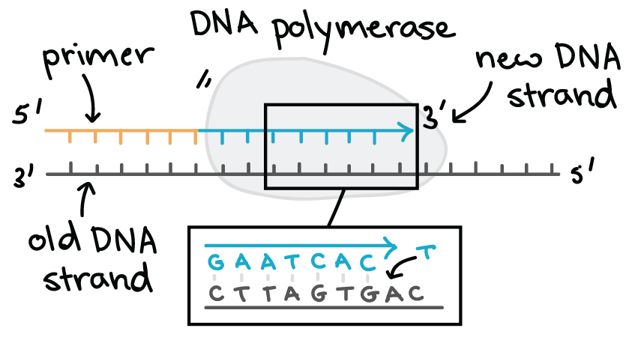
        - Linear molecule
        - Each sugar has different base on it
        - Nucleic acid strand
          - Nucleic acid encodes information in its structure
          - Info is stored as the sequence of bases
          - Can form double strands
            - Stabilize the structure
            - Second strand provides an easy way to replicate of read information
      - Polymerases copy nucleic acids
        - Use one strand as a template to make another strand
        - Nucleotides are added one at a time, matching each added base against its compliment on the other strand
        - Nucleic acids are added to 3’ hydroxyl group
        - Black = template strand
        - Polymerase replicates template strand by adding bases one at a time
        - Use H bond pattern for recognition and 3’ OH group as nucleophile

      - Rational drug design
        - Use knowledge of enzyme mechanism and substrate
        - Must keep in mind the selectivity problem
          - Nucleic acids are same between host and virus
          - Poor selectivity = toxicity
        - Strategy 1: Non-Natural Base
          - Develop drug that has almost the same shape as the regular base
          - Result in strand with wrong base
          - Ribosome cannot read and will not make viral protein
          - Resulting nucleic acid strand is non readable by host enzymes
          - Requirements for non-natural base
            - Drug is a substrate for viral polymerase
              - Gets incorporated into viral nucleic acid
            - Viral nucleic acid containing abnormal bases is not a substrate for ribosome
              - Viral proteins don’t get made
            - Drug must NOT be a substrate for host polymerase
              - Side effects!
            - Virus must accept it
            - Structure = similar enough to virus so it accepts it but not too similar that host accepts it
          - Idoxuridine
            - Introduced in 1960’s
            - Substrate for viral and host polymerase
            - Highly toxic
            - Topical use only
              - Limits exposure to body
              - Eye infections of Herpes
            - Proof of principle – antiviral drug is possible
            - Shuts down herpes virus replication
            - Toxic as it shuts down host functions too
            - Only used as proof of principle – can make a drug that will inhibit viral enzyme
        - Strategy 2: Chain Termination
          - Make a drug that terminates chain by removing piece of it so no further things can be attached, such as 3’ OH
          - Nucleic acid replication stops
          - Requirements for chain termination
            - Drug is a substrate for viral polymerase
              - Gets incorporated into viral nucleic acid
              - Stops replication, get a short piece of nucleic acid
              - Viral proteins don’t get made
            - Drug must NOT be a substrate for host polymerase
              - Side effects!
            - Replace with isostere
            - Something that is incapable of acting as a nucleophile
          - Selectivity is a problem
            - Drugs have structures that are too similar to normal substrate
            - Occasionally, these drugs get incorporated into host nucleic acid by the host polymerases
            - Many chain terminators are toxic
            - Very similar to host so can create problems for host function
            - Work but not ideal
            - Improve selectivity by changing the sugar
          - Acyclovir
            - Very high selectivity for virally infected cells
            - Low incidence of side effects
            - Low severity of side effects
            - Selectivity is primarily due to selective bioavailability
            - Formulations
              - Pills (severe infections)
              - Eyes
              - Systemic (immunocompromised)
              - Shingles
              - Topical cream (sores)
            - Topical cream in North America is non-efficacious (does not work)
            - Not much antiviral activity
            - Drug cannot penetrate skin
            - Topical cream in Europe works
            - Contains DMSO which allows it to penetrate the skin
            - Acyclovir is a prodrug
              - Acyclovir must metabolize 3 phosphate groups to transform to active form
            - Only activated in virally infected cells = good selectivity
            - Phosphorylation of acyclovir
              - Thymidine kinase = kinase in herpes virus that attaches first phosphate group
            - Diffuses in and out of normal cell
              - In neutral form, soluble in water and membrane
              - When in host cell, no enzyme found, so diffuses back out
              - Phosphorylation traps acyclovir in infected cells
              - Low pKa so it can dissolve in cytoplasm but cannot diffuse through membrane
            - Acyclovir concentrates in infected cells (virus traps drug into cell)
            - Clean drug
              - Circulates randomly in the body
              - Accumulates only in virally infected cells
              - Drug concentration in normal cells is too low to cause problems
              - Few side effects
              - Low incidence of side effects
- Gertrude Elion
  - 1918-1999
  - B.Sc. in 1937
    - Turned down for graduate assistantships because she was female
    - Volunteered in a chemistry lab (New York University)
  - M.Sc. in chemistry 1941
  - War created a shortage of chemists, got a job as food chemistry analyst in 1942
  - Moved to Burrows-Welcome 1944 as a medicinal chemist
    - Became one of the most prolific medicinal chemists of all time
  - 1967 first woman to head the R&D department of a major pharmaceutical company
  - “Drug Hunter”
  - Discoveries
    - 1950 Purenithol, first chemotherapy for leukemia
    - 1959 Imuran, first immunosuppressant
    - Used in first organ transplant (dog)
    - Used in first human organ transplant (kidney, 1961)
    - 1964 Allopurinal, gout
    - 1968 Daraprim, malaria
    - 1969 Trimethoprim, septicemia
    - 1974 Acyclovir, first Herpes drug
    - 1960’s Nelarabine, cancer
    - 1984 AZT, first AIDS drug
  - 1988 Novel Prize in Medicine
    - 579 Novel Prizes
      - Physics, Chemistry, Physiology or Medicine, Economics, Literature
      - 579 prizes to 911 people
      - 48 women
        - 18 in sciences
        - Marie Curie won twice
- Influenza
  - Seasonal respiratory infection
  - High mutation rate
    - Virus changes yearly
    - Virus infects humans and animals
  - Most forms not dangerous
    - Elderly and very young children are exceptions
  - Occasional pandemics
  - Brand new virus every year – new vaccine every year
  - High mutation rate due to that fact that it infects variety of species
  - Prediction of vaccine = start with strain during Spring in Asia
  - Pandemics
    - Very virulent strain occasionally arises
    - 1918 20,000,000 deaths Spanish Flu due to severity of virus and WWI with lack of food and sanitation
    - 1957 1,000,000 deaths
    - 1968 700,000 deaths
    - Regularly 250 000 deaths per year
  - Sub Types
    - Type A
      - Most dangerous
      - Pigs, horses, seals, whales, birds, humans
      - Lots of genetic variation
    - Type B
      - Only humans
      - Little genetic variation
    - Type C
      - Does not cause serious disease
    - Pigs and birds create a lot of human disease as a lot of interaction between farm animals and humans (pigs, chickens, ducks)
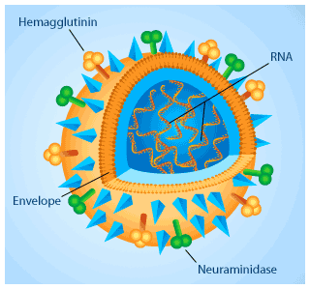
  - Structure
    - Enveloped virus
    - Envelope embedded with two viral proteins
      - Hemagglutinin (viral entry) – binding protein
      - Neuraminidase (viral maturation) – enzyme involved in escape of virus from host cell
    - Inner capsid = ball of protein that surrounds genetic material
    - Envelope on the outside = human membrane that contains viral and human proteins (virus steals a little bit of membrane as it buds out)
  - Classification
    - Classified by serotype
      - Antibody reaction to the envelope proteins
      - Hemagglutinin (H)
      - Neuraminidase (N)
    - Hemagglutinins 16 types H1 to H16
    - Neuraminidases 9 types N1 to N9
    - Most human flu is N1/N2, H1/H2/H3
  - Life Cycle
    - Starts with binding
      - Virus hemagglutinin binds to host glycoproteins containing sialic acid
      - Hemagglutinin has affinity for protein called sialic acid which is present on outside of human cells
    - Viral proteins induce endosome formation
      - Endosome forms
      - Virus envelope and cell membrane fuse
      - Contents spill into cell
    - Viral RNA and proteins are replicated
    - Capsids self-assemble with RNA
      - Capsids form inside cell complete with RNA
      - Viral envelope proteins accumulate on cell membrane
        - Hemagglutinin
        - Neuraminidase
    - Virus particles bud from the cell
      - Proteins accumulate on membrane of host cell
      - Proteins on membrane recognize proteins on capsid which allows for budding
    - Virus particles still contain host proteins
      - Host proteins may contain sialic acid
      - If sialic acid remains on the virus, hemagglutinin from other virus particles will stick
      - This will cause virus particles to clump together
      - To prevent this, neuraminidase removes sialic acid from host proteins on the virus envelope
      - Virus particles don’t stick together
  - Neuraminidase
    - Essential enzyme
      - Highly conserved – other viral proteins variable
    - Does not show a lot of variation in structure
    - Neuraminidase cleaves off sialic acid

    - Mechanism of hydrolysis
      - Water molecules reverse chemical reaction in Step 4
      - Enzyme binds to the transition state
      - Transition state is similar to oxonium ion
      - Drug = transition state mimic
        - Design drug that looks like transition state, enzyme will bind to drug
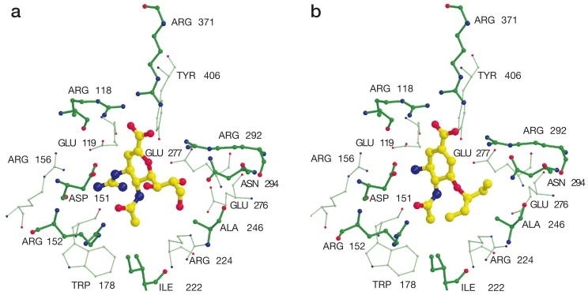
        - Move pi bond over by one position to be between C and CO2H
        - Did inhibit drug but not well enough to be a drug
  - Enzyme crystal structure
    - 1983
    - Get a picture of what the enzyme active site looks like
    - Show side chain orientations of different amino acids
    - Empty pocket/gap in enzyme structure and inhibitor
    - Gap contained specific amino acid residues
    - Had aspartic acid and glutamic acid that is charged at physiologically level
    - Positively charged arginine so it creates electrostatic interaction between negatively charged amino acids

  - Zanamivir
    - Mild antiviral effect
    - Not orally bioavailable
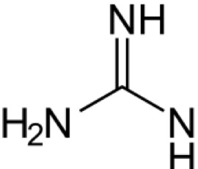
      - Acid sensitive
      - Rule of 5
    - Drug was administered as a nasal spray
    - Proof of principle
  - Tamiflu
    - Inhibitor designed for chemical stability
    - Time line
      - 1966 – high throughput screening gives no hits
      - 1969 – rational drug design starts
      - 1974 – proof-of-principle (lab)
      - 1983 – X-ray structure
      - 1993 – Zanamivir
        - Proof-of-principle (humans)
      - 1997 – Tamiflu first synthesized
      - 1999 – Tamiflu enters market
    - Very academic drug
    - Ends up being a very poor druf
      - Very expensive
      - Limited supply (manufacture)
      - Must be given in first 24 – 48 hours
        - Diagnosis problem
        - Only works for influenza
          - 20 % of colds
      - Reduces course of disease by approx. 1 day
      - Benefit/risk analysis indicates clinical use is questionable
      - Little effectiveness
    - Sales expanded after 2009 flu panic
      - In 2008
        - 400,000 treatments per year
        - Approx $800 million in sales
      - After 2009 has averaged $3 billion/year
      - Benefits are highly questionable
        - Reduces course of disease by 1 day IF administered properly
        - Toxicity issues
      - Patent expiring in 2017
        - Patents expire so other people can make the invention better
- Hepatitis C
  - Chronic liver infections
    - Cirrhosis
    - Liver cancer
  - Infects approx. 2 % of U.S. population
  - Major route of transmission is illegal intravenous drugs (> 60%)
    - About 15 % of cases are sexually transmitted
  - Hepatitis C causes chronic liver infection cirrhosis liver cancer
  - Virus Structure
    - Single stranded RNA
      - 9600 bases long – small
      - One protein is expressed – 3011 amino acids long
    - Protein is cut into 10 smaller proteins
      - First few are released by host proteases
      - Remaining are cut out by viral protease
    - Virus has an RNA dependant RNA polymerase
      - Copies the viral RNA
    - Virus proteins spontaneously assemble around viral RNA
  - Virus is closely associated with lipids
    - Transported in blood to liver as a complex with lipopolysaccharaides
    - Virus is replicated inside membrane of the endoplasmic reticulum
    - Virus uses lipopolysaccharaides to move around body
    - Replicates in a very specific part
  - Viral Enzymes
    - RNA dependant RNA polymerase
      - Makes copies viral RNA
    - Protease
      - Cuts viral polypeptide into small proteins
    - All proteins do more than one job
  - Sofobuvir
    - Inhibition of viral polymerase
    - Prodrug
    - Active drug is a chain terminator
      - OH functional group is a nucleophile – electron donor
      - F functional group is an electron withdrawing group, pulls electrons away from OH, OH becomes a poor nucleophile
      - Poor nucleophile terminates chain
      - Methyl group creates steric hindrance
  - Virus contains an enzyme which is formed from more than one protein
  - Large protein must bind to a small protein to form a functional enzyme
  - Ledipasvir
    - Sticks to the small protein
    - Prevents protein association and formation of viral enzyme
    - Drug = very large, as it must destroy protein-protein interactions
  - Harvoni
    - Approved in 2014
    - Combination of Ledipasvir and Sofobuvir
    - Capable of curing HCV infection in 8 to 24 weeks
- AIDS
  - First AIDS cases diagnosed in 1981
    - Immune collapse
    - Kaposi’s sarcoma – rare form of cancer
  - Patients suffered from T-cell depletion
    - Key components of the immune system which body uses to fight antiviral infections
  - Victims die from opportunistic infections
    - Normally be controlled by a healthy immune system
  - AIDs = late stage
  - HIV = virus itself
  - HTP screening used for some drugs but mainly rational drug design
  - Opportunistic infections in young people discovered (it was due to weaker immune system)
  - 80% of population carries cytomegalovirus, does not cause symptoms/problems but people with HIV were dying of this = cause of concern
  - Human Immunodeficiency Virus
    - Agent that causes AIDS
    - Discovered 1984
      - Luc Montagnier
      - Robert Gallo
    - Spread
      - Unsafe sexual practice
      - Intravenous drug use
      - Congenital infection of
newborns
    - Targets CD4 cells of immune system
    - Babies born pre-infected with virus when born from mother
    - Virus targets cells that destroy HIV cells
  - Origin of AIDS
    - First diagnosis in 1981
      - San Francisco
    - Oldest known sample from 1959
      - Blood sample from the Belgian Congo
    - Virus may have spread to humans from chimpanzees
    - PCR reaction used to find oldest sample – was a Dutch sailor
    - Chimpanzees have SIV virus (similar to HIV)
    - HIV does not infect animals at all, only humans
  - AIDS Today
    - AIDS is the world’s most deadly infectious disease
      - Malaria was #1 until late 1990’s
      - 0.8 % of all adults on this planet are HIV positive
    - Fourth leading cause of death after heart disease, stroke and respiratory failure
      - 1 million deaths/year
    - More than 36 million people currently infected
      - 70 million total infections since 1981
    - AIDS is completely heterosexual
      - 50 % men
      - 50 % women
    - Not treated = 100% fatal
    - No cure, but regimes available for management of disease
  - HIV Infection Timeline
    - 3 phases
    - Acute phase
      - Lasts 6 to 10 weeks
      - Flu-like symptoms
      - High viral titers
      - Phase ends when immune system reduces viral load
      - Immune system combats the disease and reduces numbers
    - Chronic phase
      - Lasts 8 to 12 years if untreated
      - Use to be called latency phase
      - Asymptomatic
        - Person is fully infectious
        - Viral replication is very high
        - Immune system destroys most viral particles (>99.999%)
        - A few virus particles escape to continue infection
        - CD4 cells in the immune system are slowly depleted
        - Phase ends when immune system runs out of CD4 cells
      - 8-12 years is now closer to greater than 20 years if one has access to proper medical care (Europe, North America, Japan, etc.)
      - Called latency because no symptoms but now realize it is time when virus is replicating at high rates
      - Leakage of virus attacks immune system that wipes out cells that are going against it (T Cells) = depletion of T cells
    - AIDS phase
      - 2 to 4 years if untreated
      - Also, known as terminally phase
      - Lots of secondary infections
      - Person is fully infectious
      - Viral replication is very high
      - High viral titers
      - Immune system is destroyed
      - Secondary infections cannot be cleared by immune system
      - Person dies of a secondary infection
      - Secondary infections can be cancer as well
    - Way the virus operates contributes to the way it spreads
    - Timeline is for North America
  - Retrovirus
    - Retroviruses synthesize DNA from RNA
    - Viral genome is carried in RNA
    - Viral enzyme called reverse transcriptase copies the RNA into DNA
    - Reverse transcriptase destroys the RNA template (RNAse H domain) as it is copied
    - RT then uses the single strand DNA template to prepare double stranded viral DNA
    - RNA destroyed to help virus escape immune system
    - Introns seen as way to protect DNA from random damage
    - Inside introns are fossilized retroviruses
  - Replication Cycle
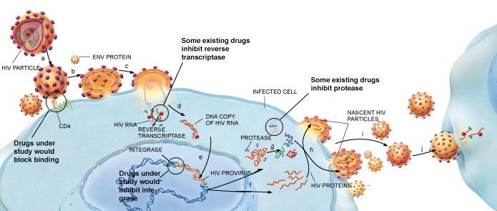
    - Virus particle gets into cell
    - Virus converts genetic information from RNA single stranded to DNA double stranded
    - Enzyme (integrase) comes from virus, inserts DNA into chromosome which creates permanent infection in cell
    - Viral DNA becomes activated and replicates virus
    - Giant virus protein created
    - HIV/viral protease cleaves large protein to create virus
  - Viral Drug Targets
    - 4 enzymes
    - Several good drug targets
      - Reverse transcriptase
        - Only virus has reverse transcriptase so good target as humans don’t have it
        - Chain terminator used
          - Nucleophilic 3 prime hydroxyl group change it
      - Protease
      - GP41 – not an enzyme, it is a binding protein
    - Other targets
      - Integrase
      - RNAse H
      - GP120
    - HIV = 10/11 genes
    - High proportion of enzymes
    - GP41 used when virus gets into cell
      - HIV pulls apart and unwinds GP41 to fuse with membrane
  - AZT
    - Discovered in 1960’s
      - Failed as a cancer drug
      - Highly toxic
    - Based on the mechanism of action, was tested against HIV
      - Gertrude Elion
    - Gained FDA approval after a truncated clinical trial
      - Trial was scheduled to run for 10 months
      - Patients improved after 2 – 3 months
      - Company terminated clinical trial on ethical grounds
    - Later clinical work showed drug was ineffective
      - Short period of antiviral activity
      - Resistant virus appears in few weeks and drug no longer works
      - No change in AIDS deaths after AZT is introduced
    - Used today for HIV
    - Drug failure due to resistance
      - Reverse transcriptase is error prone
        - Enzyme destroys the template RNA as it is copied
        - No error checking
        - Sloppy replication
      - Very high mutation rate
        - 1 alteration/genome (~9000 base pairs)
        - Every virus particle is different
      - Company knew resistance was going to be a problem
      - Reverse transcriptase is small, therefore not a lot of surface contact for recognition
        - Causes it to misread, create errors very easily
      - RNAse H domain destroys RNA template, therefore no error checking
  - 3TC
    - First made as a racemic mixture
      - Company found that both enantiomers inhibit reverse transcriptase
    - “Natural” enantiomer is highly toxic
      - Substrate for host polymerase
    - “Un-natural” enantiomer has low toxicity
      - Not recognized by host enzymes
    - Introduced shortly after AZT
    - Both enantiomers being recognized and viable = very rare, but worked because reverse transcriptase is very small
    - Discovered by Bernard Belleau 1989
      - Drug sold is the “un-natural” enantiomer
      - Low toxicity
      - Professor
        - University of Ottawa (1961 – 1971)
        - McGill (1971 – 1989)
    - Patent was poorly written
      - 3TC was described as a racimate
      - Patent claimed that the isomers could be separated, but did not describe how
      - This patent was filed in 1989
      - Company later discovered that both enantiomers were active
      - Filed another patent in 1991
      - Patented the pure enantiomers but did not describe how to make them
      - Company proceeded with clinical trials
        - Compound entered the clinic in 1991
        - Clinical work completed in 1995
        - Drug had very low toxicity
        - Effectiveness was limited
          - Resistance appeared quickly
        - Was more effective if combined with AZT
        - Approved for market in 1995
        - By 2000 drug was selling $1 billion per year
      - Dennis Liotta discovered oversight in company patent
        - Professor at Emory University
        - Noticed that the 3TC patents did not explicitly describe how to make the enantiomers of 3TC
        - Discovered method of preparing the enantiomers in pure form
        - Patented both enantiomer syntheses
          - Company’s original patent described the racemic mixture
        - Liotta now held the rights to the company’s drug
        - Negotiated license agreement with original company
        - ALSO: Noticed that original company patent had “missed” a key compound
          - The fluorinated analogue was a common change when non-natural base anticancer drugs were developed
          - Liotta patented the fluorinated drug = FTC
          - Licensed the patent to Triangle, and later Gilead
          - Drug approved for sale in 2003
          - FTC = front line for HIV defense
  - HIV Protease
    - Essential enzyme
    - Cleavage of gag and gag-pol gene products
    - Aspartyl protease
      - Active site has 2 conserved aspartic acids as part of catalytic domain
    - Hydrolysis by Protease

    - Rational Design of Drugs
      - Enzyme bind tightest to transition state which lowers activation energy
      - Competitor binds tighter to transition state
      - Create non-cleavable peptide bonds on transition state
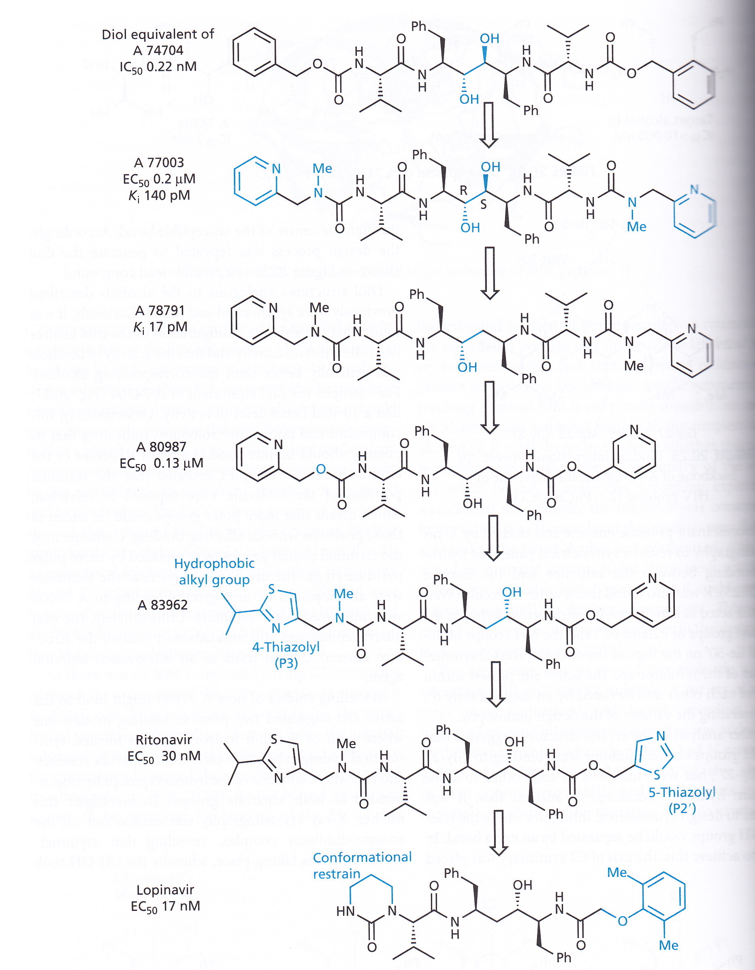

      - Non-cleavable peptide isosteres
        - Transition state mimic sticks to enzyme and jams it
      - Protease SAR History
        - Summary of optimization of drug
        - 2000 separate molecules tested
        - Green = key part that is changed
      - Approved protease inhibitors
        - All look like peptides but have other architectures that allow for tighter binding of enzymes
        - Ritonavir, iopinavir, amprenavir
  - Cost of Drug
    - Usually very small
    - Most of the cost of drugs is not the active ingredient
    - Marketing
    - Research
    - Infrastructure
    - Until AIDS, no drug program had ever been cancelled because the drug itself was too hard to manufacture
  - Protease drugs = very complex
    - Large molecules
      - Lots of stereogenic centres
      - Acyclic molecules
    - Very poor bioavailability
      - Rule of 5
    - High doses were required
    - Might be impossible to manufacture economically
    - Some companies stopped before development
      - Afraid to be forced to continue if drug was good
    - Merck proved it could be done
      - Crixivan
        - Indinavir
      - Utilized brand-new catalytic methods to construct stereocentres
      - Making the right portion of the molecules was discovered by professor, a month before drug was synthesized
      - Allowed for drug to be made in large quantities which allowed other companies to get back on the market
      - Other protease drugs followed
  - Protease Inhibitors
    - Large structures
      - Complex and expensive synthesis
    - Poor oral bioavailability
      - Low absorption
      - Rapid elimination
      - High doses
        - 1 kg of drug / patient / year
      - Complex regimens
    - High cost: > $8,000 per annum
    - Resistance
  - HIV Resistance
    - HIV replicates rapidly
    - 10 billion new viral particles every day
    - Replication sloppy
      - The genome of each virus is different
      - Resistant mutants generated every day
    - Anti-HIV agents select resistant strains unless all viral proliferation is blocked
    - No single anti-HIV agent is powerful enough to do this
    - Mechanism of Resistance
      - Create a super family of viruses that are resistant to drug put in
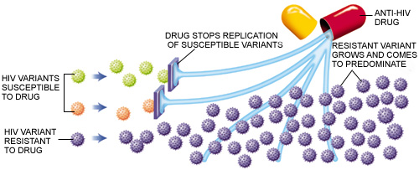

  - Combination Therapy
    - Give drugs in combination
    - If one drug fails, second picks up slack
    - Third drug provides insurance
    - Virus resistance more difficult
    - Results
      - 50% of patients achieve viral loads below 500 copies/mL within 6-52 weeks
    - HAART
      - Highly Active Antiretroviral Therapy
      - Combination of 3 drugs
        - 2 nucleosides + 1 NNRTI
        - 2 nucleosides + 1 protease
      - Significant decrease in AIDS related deaths after introduction of HAART
      - Drawbacks to HAART 1st Generation
        - Compliance
          - 16 or more HIV pills a day
          - Complex regimen
          - With/without food, empty stomach, without other drugs etc…
          - Side effects: rash, nausea, nightmares, diarrhea, headache, anemia, hepatitis, lipodistrophy
        - Compliance problems produce resistance cure was more uncomfortable than the disease
        - Cost ~ $ 10,000 / year
      - Patient Compliance
        - HAART therapy initially very successful
          - Improved quality of life
        - Appearance of resistance and increased spread
          - Side effects severe, patients skipped doses
          - Regression to high risk behaviours
        - Current therapies based on “clean” drugs
          - Pseudoenantiomer
Nucleosides
          - Few side effects
          - Good patient compliance
        - When drugs are skipped, virus can replicate and create resistant versions
        - Current therapies allow for 20 year survival time
  - Integrase
    - Essential viral enzyme
    - Inserts viral DNA into host genome
      - Permanent infection and only has to do it once
      - Many human introns contain vestigial retroviral DNA
    - Mg⁺² required for activity
      - Chelate to the enzyme and to DNA strands
    - HTS identifies leads against enzyme
    - Oxygen = Lewis base to attract Lewis acid Mg
    - Replacement of various Mg binding isosteres
      - Red lines = line up different functional groups
      - Can I replace this with something else?
      - Structure at the top is affected but increase metabolism add electronegative atoms to prevent metabolism
      - Molecule at the bottom = in the clinic
    - Elvitegravir
      - Approved in 2012
      - Now part of standard combination therapy
      - Used with pseudoenantiomer nucleosides
        - Side effects moderate
        - Low incidence of side effects
        - Once or twice a day dosing
      - Front line combo
      - Combined with integrase inhibitor
      - Drug like
  - HIV now a manageable infection in the developed world
    - Lifespan now more than 20 years
    - Disease cannot be cured
    - Mild side effects
    - Can manage the progression of the illness
    - Current therapies
      - Pseudoenantiomer nucleosides
        - 3TC
        - FTC (Liotta)
      - Clean drugs
      - Integrase inhibitors
      - Second generation Protease inhibitors
        - Improved properties
      - Stereochemistry allowed this to be possible as non natural have low toxicity

