Laboratory 001
FULL NAME
STUDENT ID
February 2nd, 2018

Objectives
- Construct simple combinational logic circuits from a schematic.
- Experimentally determine the functional operation of simple combinational logic circuits.
- Identify equivalent logic gates to those produced by various circuit configurations from the resulting truth table.
- Connect various gates together to create simple logic functions.
- Analyse combinational logic circuits and predict their operation.
- Construct and test more complex combinational logic circuits.

Equipment and components
Quartus II 13.0 Service-Pack 1
Altera DE2-115 card

Circuit diagram
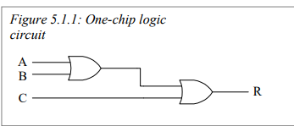
Figure 5.1.1. One chip logic circuit
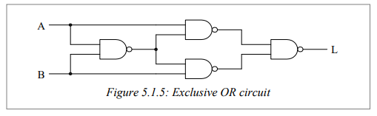
Figure 5.1.5 Exclusive OR circuit
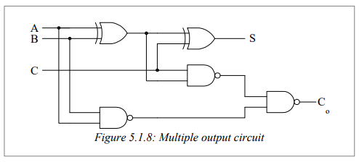
Figure 5.1.8 Multiple output circuit

Experimental Data and data processing
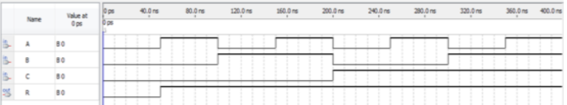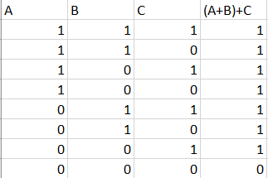
Result for figure 5.1.1

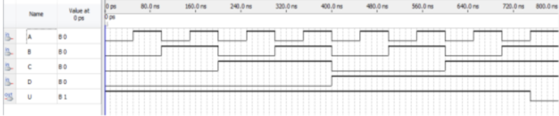
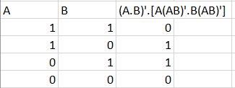
Truth Table for Figure 5.1.5

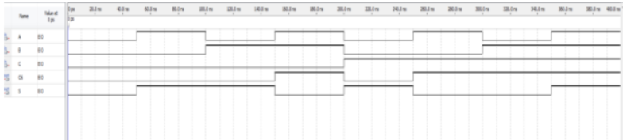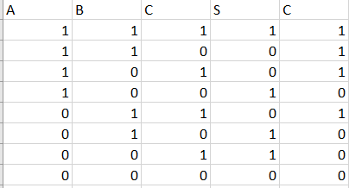
Truth Table for Figure 5.1.8

Comparison of expected data and experimental data
Figure 5.1.1. The hypothesized truth table was the same as the collected data from the laboratory.

Figure 5.1.5

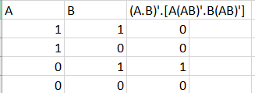
hypothesis vs. result.
What went wrong was our usage of the NAND gate. It was accidentally applied to both A and B separately rather than applying it to both A and B after the operation.

Figure 5.1.8. The hypothesized truth table was the same as the collected data in the laboratory.

Discussion and conclusion
The main objective, to test the truth value of each logical gate, was met. Through constructing, adjusting and analyzing a series of logical constructors, we were able to confirm our initial thought process as well as find out where our errors lie. When conducting Figure 5.1.5, we were able to sort out our issue with the NAND operator and learned how to use it effectively.

