LECTURE 1
General principles of Microbiology:
- Micro: small
- Bio: life
- Logy: study of science
- Endo: inside
- Immunology: study of our protection from foreign macromolecules or invading organisms and our responses to them

Different classes of organisms:
- Viruses/ chlamydia (grow only in living cells)
- Mycoplasma (grown on non-living media)
- Bacteria (no separate nucleus; unicellular)
- Parasites
- Small (microscopic)
  - 1-2 microns (1mm = 1000 microns)
  - address them by their proper names
    - correct wat to address these “germs” UNDERLINE THE WHOLE WORD FOR MARKS
      - Listeria monocytogens
      - species
      - Listeriae
      - Listeriosis

What are they made of?
- Viruses
  - Nucleic acid (either RNA or DNA…. Never both!)
  - Surrounded by protein shell (capsid)
  - Attach, inject nucleic acid (penetration), highjack synthetic processes inside cells to make more viruses, package, get out while going is good
- Bacteria
  - Rigid cell wall to keep things in place
  - Genetic material – circular chromosome
  - No nucleus (nucleoid)
  - Both DNA and RNA
  - Binary fission
** Some bacteria do not have a rigid cell wall and are more fragile (ex. Mycoplasmas)

- Eukaryotes
  - Unicellular and multicellular animals and plants
  - Genetic material is organized into a nucleus

    - Are all bacteria bad?
      - Biotechnology, spoilage of foods, bioremediation, functional foods, etc…
    - Can we live without bacteria?
      - No we can not
    - What places in your body don’t have bacteria:
      - Brain (CNS)
      - Circulatory system
      - Lymphatic system
      - Eyes
      - Skin
      - Penis
    - What places in your body have bacteria:
      - Female vaginal hotel (not for males)
        - Clean
          - The skin is the most important physical mechanical barrier
“Normal” flora… the good guys
- Resident vs transient
- GI-tract: colon is inhabited by anaerobes and coliforms
- Skin: mostly coagulase negative staphylococci
- Where should there be NO bacteria?

What can they do for us?
- protection from invasive (bad) bacteria
- metabolism (Vitamin K), immune stimulation

What protects us from the bad guys?
- Mechanical barriers
  - Skin, saliva, mucous, tears, hair, etc
- Other helpers include
  - Antibodies
  - Complement
  - Immune cells (T –cells, NK cells, macrophages)
  - Immune system (cell mediated; humoral)

How do the bad guys get in?
- Adherence
- Toxin production (destroy some of our defenses
- Opportunism
- Compromised host (how does this happen?)

- Bacteremia vs septicemia? (aemia= blood)

Infectious disease and the human (immune) response

Microbial disease
- Interaction between mircoorganisms and the host (us) is continuous battle
  - They need to enter-live-multiply
- To enter, they need to colonize (establish and multiply) in/on body; clinical infection (disease) can result when damage occurs to host [contamination = deposition without multiplication]
- Clinical disease = easy to recognize
- Sub- clinical infection = hard to diagnose (no symptoms)

How do we measure how dangerous a bacteria/virus/parasite is?
- Pathogenicity = ability to produce disease
- Virulence = relative capacity to cause damage (ex. The degree of pathogenicity)
- Opportunistic = do not normally cause disease but can do so when defense mechanism(s) breached or compromised

Pathogenesis of infectious diseases
- A pathogenic microorganism enters your body… two things happen
- Microorganism (invader) tries to multiply/invade and cause disease (2-degree event)
- Host tries to prevent #1
- Whether the invader wins or not is dependent on several factors
- Transmission:
  - Inhalation, ingestion, break in protective barrier, direct deposit
  - Pathogenicity
  - Invasiveness (adherence, persistence, avoidance of immune system)
  - Toxigenicity (ability to make toxins)

How does a pathogen adhere to us?
- A bacteria needs to adhere, evade and invade the host
- Tools used to achieve these huge objectives:
  - Surface structures (pili, fimbriae)
  - Capsules
  - Enzymes

Toxinogenicity:
- Toxins are substances (usually proteins) secreted by bacteria with the hope to cause damage
- Two classes:
  - Exotoxins
    - Excreted by living cells
    - Specific affinities
    - Tempolabile
    - Potent
  - Endotoxins
    - Liberated when cell wall disintegrates
    - Less specific, cause fever, malaise, shock
    - Thermostable
    - Less potent than exotoxins

2 most common ways to come into contact with infectious diseases:
- Inhalation
- Ingestion
**important to know the two different classes of toxinogenicity
Bacteremia:
Presence of bacteria in blood
Septicemia:

Things discussed:
- basic structures (viruses, bacteria and eukaryotes)
- resident versus transient flora
- us vs them
  - what do they need to do
  - what do they have
  - what can we do
- colonization (active process where the bacteria has to adhere or attach) vs contamination (midterm question)
- what type of flora do we get when you give birth
  - having a normal flora
    - good bacteria in gastral tract
- endotoxins
- exotoxins
  - sensitive to heat
  - go to a specific host and cause a problem

LECTURE 2

What is immunity?
- Immunity = the protection against infectious disease conferred either by the immune response generated by immunization or previous infection or by other non immunologic factors… aka body’s ability to resist infection
- 2 types of immunity
  - non- specific (innate)
    - born with front line of defense
    - does not discriminate
SOMETIMES THAT NOT ENOUGH AND WE NEED A SPECIFIC RESPONE:
  - specific (adaptive, acquired)

Innate Immunity: Protects against any invader
- skin
  - what characteristics of skin make it an effective mechanical barrier?
    - Most important part of innate immune system
    - Dry
    - Impermeable to most thing
    - Ph (acidic)
    - Secretes
- Mucous membranes (mechanical)
  - Cilia in respiratory tract
  - Lysozymes, PH
- Iron-binding proteins
  - Some bacteria require iron for growth
  - Transferrin, lactoferrin
- Phagocytes (WONT ASK NAMES)
  - PMNs, monocytes and macrophages
  - We have WBC that is a good general vacuum cleaner
- Complement
  - What it is, and 2 things it can do
  - Set if circulating proteins in the blood
  - Functions
    - Can bind to antibodies
      - If it binds, it makes whatever the antibody is bound to, way more opsonized
    - Able to bind certain sugars on a cell wall of bacteria and form a port
      - Membrane attack complex (MAC)
        - Do So, by recognizes certain bacteria on bacterial cell walls

When innate immune system can do its job, we need:

Specific Immunity: Directed against one specific type of invader
- Humoral and cell- mediated (CMI)
- What is the difference between innate and immunity and adaptive immunity
  - Innate: protect against ANY invader, does not discriminate
  - Adaptive: directed against one type of invader, dependent on past expose

Where do immune cells come from?

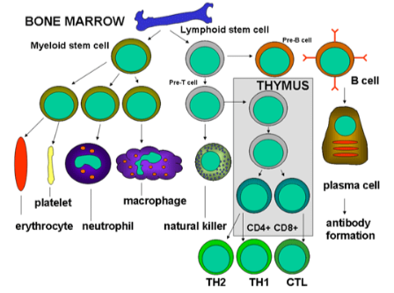
RBC: transfer of o
Platelet: block
NEED TO KNOW:
B cells:
- Make antibodies
  - Need to be turned on
TH2 cells:
- Binds to B cell, and allows antibody production
TH1 cells:

Humoral Immunity:
- Circulating antibodies

- Antibody: protein that binds specifically to a substance (its antigen)
  - Igs or immunoglobulins
  - Produced by B-lymphocytes upon stimulation from antigen presenting T-cells
  - Recognize toxins, capsules and some viral proteins
    - Recognize something called an antigen
- Antigen:
  - “non-self”
protein, glycoprotein, lipoprotein, polysaccharide
  - what structures could be “antigenic” in bacteria? Virus?

Antibody Binding: how does it occur?
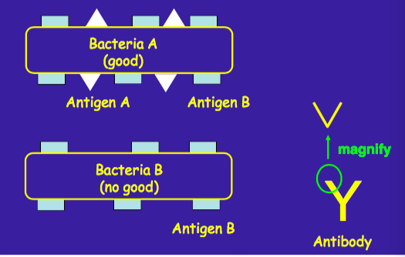
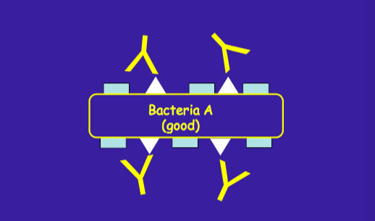

antibodies can bind antigens and bring bacteria together (agglutination) which is a signal for you immune system

Immunoglobulins (Ig) aka Antibodies
- antibodies: Ig produced in response to stimulation by an antigen and reacting specifically with it
- distinguish “non-shelf” from “shelf”
- constant and variable region
  - variable region is responsible for antigen recognition

Classes of Ig
- 5 classes: IgG, IgA, IgM, IgE, IgD
  - IgG:
    - Host defense
    - Crosses placenta and protects newborn
  - IgD:
    - Role is unknown
  - IgA:
    - Host defense
    - Found in secretions
      - Tears, saliva, milk, respiratory, GI and Genitourinary tract
    - Dimer
  - IgM (first antibody that is made)
    - Host defense
    - Early immune response
    - Pentamer
  - IgE
    - Hypersensitivity (allergies)
    - Defends against parasites
1° or 2 ° Immune Response
- 1 ° response: the first time your immune system sees an antigen
  - Ab production triggered on first antigen introduction
  - latent period of several days
  - circulating antibody detectable after 5-10 days
  - antibody in serum is max at approx. 21 days, then drops to low levels
- 2° response: when your immune system sees the exact same antigen days, months, years after (**REASON PEOPLE ARE VACCINATED)
  - ** basis for immunization
  - occurs when Ab (NOT AB) is introduced 2nd, 3rd, 4th … time
  - lag, rapid Ab increase (2-3 days), slow decrease
  - booster injections to maximize Ab levels
    - Why do we need booster shots?
      - After 8-9 years, the secondary immune system is not as fast, therefore the booster shot is BOOSTED
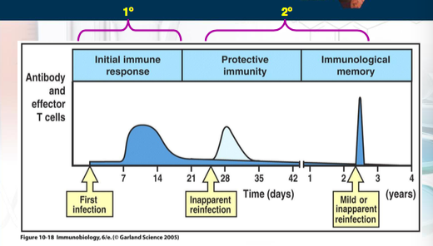

Antibody Detection:
- Serological reaction
  - detects presence of antibodies in serum sample
  - antigen and antibody interact; agglutination
  - antibody titration
  - detect unknown microorganism using known antisera
what is the first antibody that is made? IgM (EXAM QUESTION)

so far…
- innate immunity
- adaptive immunity
- (humeral)

Cell- mediated Immunity (CMI)
- T- cells NOT antibodies!
  - Helper, suppressive, cytotoxic (killer) generated from memory T-cells
- Exposure to antigen induces response from trained t-cells
- Essential for defense against intracellular organisms, parasites, tumors and other foreign cells (ex. Transplants, grafts)
- Immune-suppressive medication for transplant recipients

ANTIGEN PRESENTING CELL WILL KNOW WHAT TO DO (IF IT NEEDS TO PRESENT THE ANTIGEN TO TH1 OR TH2)

Disorders of Immunity
- Allergy and hypersensitivity
  - OVER- reaction to antigens in absence of true infections
  - Can be fatal……. ANAPHYLAXIS
- Auto-immune diseases
  - Immune system reacts to its own “self” antigens
  - “auto-antibodies”
  - type 1 diabetes, MS, rheumatoid arthritis, lupus
- Immunodeficiency states
  - Inability to produce antibodies and/or dysfunctional CMI
  - Congenital, disease, AIDS
- Graft rejection
  - NORMAL immune reaction to “non-self”
  - Control by immune- suppressive medication

Immunization
- Passive Immunization
  - Administration of pre-formed antibody against a specific microbial agent
  - IgG animal origin: short lives, risk of hypersensitivity reaction
  - IgG human origin: short live, no risk of reaction
  - Gamma Globulin (IgG): pooled from large grouped of blood donors and has antibodies to many common infections
  - Hyperimmune globulins (IgG): specific for a particular microbe

Active Immunization:
- Stimulates immune system by administration of antigen
- LONGER LASTING
- Live-attenuated vaccine
  - Sub-clinical or mild illness mimicking the disease
  - Local (IgA) and humoral (IgG) immunity
  - Rapid immunity development
  - Serious illness in immune-compromised individuals
- Killed vaccines, sub-unit vaccines and toxoids
  - Antigens without infectivity
  - May require boosters
  - Adjuvant with toxoids
  - Polysaccharide vaccines can be conjugated to proteins (see conjugate vaccines)
- Recombinant vaccines
  - DNA recombinant technology
  - Attenuates microorganisms
  - Hep B vaccine
- Adsorbed vaccine
  - Vaccine mixed with inorganic salt for slower adsorption and longer lasting immunity
  - Tetanus, diphtheria
- Conjugate vaccines:
  - Designed for poorly antigenic microorganisms
  - Conjugate antigen of interest to immunogenic, non- toxic protein
  - Haemophilus inflenzae type B
- Combined vaccines
  - For ease of administration
- Combined active-passive immunization
  - Immediate protection after possible exposure
  - Hyperimmune Igs and vaccines injected at DIFFERENT sites
  - Tetanus, Rabies, Hep B

Antibiotic Resistance
Introduction:
- The first antibiotic made was penicillin
  - Discovered in 1929 by Sir Alexander Fleming
- World war II
  - Penicillin used to treat staphylococci and streptococci (1946)
- How effective was penicillin?
  - Immediately

- Resistance to penicillin recognized almost immediately

  - 80% of all strains of Staphylococcus aureus
  - Staphylococcus pyogenes (Group A strep) still treated with penicillin
  - Interestingly, penicillin has never been effective against Gm-negatives (Salmonella, Shigella, Bordetella pertussis, Yersinia Pestis, pseudomonas) – why?
  - Late 1940s and early 1950s?
Antibiotic Therapy:
- Effective chemotherapy depends on selective toxicity
  - Good against pathogen, does not affect host..
- Exploit pathogen processes not seen in human
  - Cell wall, metabolism, etc
- Knowledge of likely microorganism is crucial
  - Site
  - Organism
  - Allergy to host?
- Other considerations…
  - Route of administration
- Monitoring therapy

- Adverse effects
  - GI-tract, skin, hemopoietic system, renal system, liver

Acquired resistance:
- Three major mechanisms of resistance:
  - Alteration drug target
  - Production of inactivating enzymes
  - Decreased uptake of antibiotic
    - Can make the cell wall less permeable or produce efflux proteins

Antibiotic resistance
- Resistance occurs when a susceptible microorganism is no longer inhibited by an antibiotic agent
- Many reasons why this can happen
  - Intrinsic – characteristic of microorganism vis-à-vis antibiotic’s mechanism of action (inherent or “natural”
  - Acquired – new or added (driven by two genetic processes in bacteria… mutation and selection (vertical evolution); and exchange of genetic material (horizontal evolution)

The chromosomes: role in antibiotic resistance…
- Mutations lead to
  - Change it site of antibiotic target (but protein for bacterial still works fine!)
- Regulatory genes
  - Turn on alternative path
  - Turn on efflux mechanisms
- Change cell permeability

Post- antibiotic era: is it possible?
- With current overuse of antibiotics, we are forcing bacteria to change (evolve) to survive
- How is this achieved/helped by us?

Decreasing antimicrobial resistance?
- Withhold antibiotics
  - Self-limited viral infections (ex. The “common cold”)
- Use narrowest spectrum antimicrobial agents
- Base decision about broadness of empiric antibiotic coverage on severity of illness
  - Clinically stable and not at risk for significant morbidity... may be appropriate to wait culture results and MIC testing
- Prevention of infection
  - Hygiene, handwashing
- Education
  - Helps to achieve therapeutic and preventative goals
  - When are antibiotics needed?
  - How to take them?
  - proper duration!!
- Earlier detection of therapeutic failure
  - Good for patients with antibiotic-resistant pathogens

LECTURE 3:

Diagnostic Microbiology
- Isolation of pure culture from specimen
  - Why?
- Culture media
  - Why?
  - Who?
  - What?
- Inoculation methods
  - Streak, spread, or pour

Preservation of pure cultures:
- Why would we want to keep a “copy” of a bacteria we isolated from a patient?
- Short term vs long term
  - Liquid nitrogen (-195 C)
  - FREEZERS
  - Lyophilization (freeze-drying)

Identification:
- Now that you have a pure culture..
  - Colony morphology
  - Cellular morphology
- The microscope is your friend
  - Resolving power (resolution) = ability to distinguish two closely located objects as separate, distinct entities
Identification: Staining techniques:
- Generally 3 steps:
  - Make a smear
  - Fix dried smear by head
  - Stain with desired dye

Simple vs. Differential staining:
- Simple stain
  - Single dye normally used
  - All organisms same colour
  - Size, shape, number, arrangement, etc.
- Differential stain
  - Two or more dyes
  - Differences between microorganisms or parts of cells
  - Acid fast, gram

Cell wall is the key!
- Essential for cell growth and division
- Shape of bacteria related to peptidoglycan layer
- Gram negative usually thinner than Gram positive

Other stains:
- Endospore
- Capsule
- Flagella

Florescence microscopy:
- Dye fluoresces at specific wavelength
- Antibodies tagged with dyes are common (immunofluorescence microscopy)

Electron microscopy
- Electron beam (instead of light)
- Million times magnification possible (0.003 um)
  - TEM (stain with heavy metals)
  - SEM (3D image of cell surface)

Characteristics of bacteria
- Small
- Higher surface area/volume ration
  - Higher metabolism
  - Faster growth
  - Replication rate (approx. 20 mins)

Shape and size of bacteria
- Bacteria are usually arranged in specific patterns
  - Single cell (spiral and or rod shaped)
  - Diplococci (pairs) – single plane
  - Chain (divide in one plane and remain attached)
  - Tetrads (cocci dividing at right angle to first plane of division)
  - Division in three planes (grapelike clusters)
  - Cubical packet of 8 cells (sarcinae)

General media requirements
- Bacteria – requirements vary
- Yeasts – high sugar and lower Ph
- Anaerobes – must remove oxygen

Selective, differential and S/D media:
- Selective media
  - Enhance growth of one bacterial species or suppression of another
- Differential media:
  - Differentiate bacteria based on their nutritional requirement sand phenotypic characteristics
- Selective / differential media:
  - Very useful in clinical labs

Temperature definitions:
- Psychrophiles
  - Grow best at temperatures 15-20 C
- Mesophiles
  - Grow best at temperatures 25-40 C
  - Most bacteria belong here
- Thermophiles
  - Grow best at temperatures 40-85 C

pH and water requirements:
- Optimal pH varies from bacteria to bacteria
- Intracellular pH must be approx. 7.5
- Growth observed at pH values from 4-9 (optimum 6-8)
- Water (light) can be important for certain microorganisms
- Osmotic pressure (hypertonic, hypotonic, isotonic)

LECTURE 4:

Gram Positive Cocci

- Staphylococcus aureus
  - “staphule” means grape in Greek
  - toxins are quite the problem:
    - cytotoxins
    - haemolysins
    - enterotoxins (A-E, G-I)
    - Exfoliative toxins
    - Toxic shock syndrome toxin 1 (used to be exotoxin C and enterotoxin F)
  - Enzymes:
    - Coagulase (coagulation of fibrin)
      - Made by almost all pathogenic staphylococci
      - Used in laboratory test to differentiate from S. epidermidis, S. capitis and S. saprophyticus
    - Beta – lactamase (penicillinase)
      - Destroys penicillin
  - Many S. aureus strains are found in normal population (approx. 15%)
  - Carried in anterior nares, axilla, perineum and hands
  - Problem:
    - 85-90% of strains isolated in hospital are penicillin resistant
    - localized purulent infections (pustules, boils, styles, conjunctivitis, otitis, etc.)
    - pneumonia, osteomyelitis, septicaemia, endocarditis
    - food poisoning, toxic shock syndrome, scalded skin syndrome
  - important cause of hospital acquired nosocomial infections from stitch abcesses, infected wounds, or generalized infections
  - preventative measures include:
    - aseptic technique in ER and OR, wound precaution
    - education of health personnel
    - handwashing
  - part of normal skin/ mucius membrane flora
  - non-pathogenic, expect in compromised patients where can cause post-operative infections (brain, open heart, endocarditis, shunt infections)
  - considered an opportunistic pathogen
- streptococci
  - arranged in pairs or forming chains
  - “streptos” – Greek work for twisted
  - subdivided into “groups” based on
    - haemolytic properties (alpha, beta)
    - carbohydrate C antigen (Lancefield classification)
    - M-protein
      - Divides beta-haemolytic
      - Mostly group A
- Streptococcus pyogenes
  - Group A, beta-hemolytic, S. pyogenes causes:
    - Acute tonsillitis (strep throat) – can lead to rheumatic heart disease
    - Impetigo, cellulitis, etc. (skin infection)
    - Fever and septicaemia
  - Caused by toxins
    - Neutrophils and macrophages
  - Streptococcal pyrogenic exotoxins (Spes)
    - Scarlet fever rash
  - Enzymes
    - Hyaluronidase (helps spreading of bacteria)
  - Virtually all are penicillin G sensitive (vs. S. aureus)
  - Education of health personnel
  - Aseptic obstetric procedures
  - Early detection and treatment
- Flesh- eating disease… aka necrotizing fasciitis
  - Streptococcus pyogenes culprit
  - Does not actually “eat” anything
  - Toxin is responsible for damage
  - Research indicates that
    - Hijacking human plasminogen from blood, attach to surface and activate it into protease .. good for spreading
    - Bacteriophage has gene encoding for enzyme allowing bacteria to escape entrapment and killing by neutrophils (WBC)
- Streptococcus agalactiae
  - Group B
  - Found in vagina of healthy women (can cause neonatal infections)
    - Early septicaemia
      - Respiratory distress or shock at birth
      - High fatality rate (serious)
    - Delayed meningitic form
      - 1-12 weeks post- partum
      - sequelae
- other streptococci
  - streoticuccus faecalis
    - group D, aka enterococcus
    - part of normal flora of GI-tract
    - prey on compromised individuals
  - viridens streptococci
    - found in oral cavity of healthy individuals
    - can cause endocarditis in individuals with damaged heart valves
  - streptococcus pneumoniae
    - aka pneumococcus
    - polysaccharide capsule has antiphagocytic properties
      - approx. 90 distinct capsular serotypes
      - found in naso-pharynx of healthy individuals
      - can cause
        - lobar pneumonia
        - meningitis
    - prevention strategies (elderly, alcoholics, crowded living, vaccination)

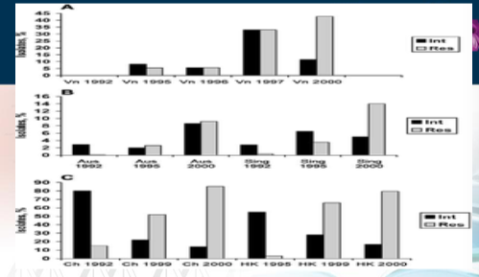

Gram Negaitve Cocci
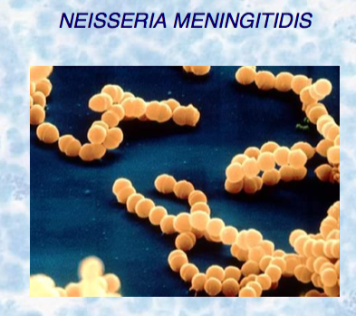

- N. meningitdis
  - Gram negative diplococci
  - Laboratory isolation using cholate agar
    - Use selective media (ex. Thayer-Martin) when isolating from nasopharyna
  - Frequently found in the naso-pharynx of healthy individuals
  - Antiphagocytic polysaccharide capsule
    - 13 different serogroup
    - A, B, C X, Y AND W135 most prevalent
  - Carries can occasionally develop infection or pass organism to non-immune individuals who develop infection
- Only infects human!!!
  - Usually children or those living in croweded living quarters
  - Occasional epidemics
- Infection can result in
  - Meningitis
  - Septiaemia (starts as skin rash)
  - Waterhouse – Friderichsen Syndrome (complication of septicemia…most severe form of septicaemia by N. meningitdis)
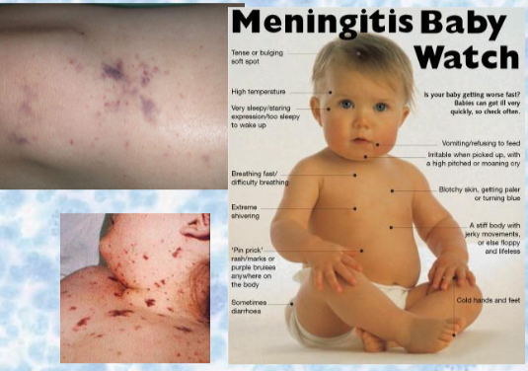

… first described in 1894 by Arthur Francis Voelcker
… then in 1901 by the Britsh dermatologist Ernest Gordon Graham Little
…it was first reported as an entity by Waterhouse in 1911, and the subject was comprehensively reviewed in 1918 by the Danish paediatrician Carl Friderichsen
…so it was called Waterhouse-Friderichsen syndrome

- Prevention and treatment
  - Penicillin is primary antibiotic used
  - Vaccination is recommended for children, teens, and college and un I students in dormitories
    - Conjugated vaccine for serogroups A, C, Y and W135
    - Now have meningococcus vaccine for infants at 2-5 months (serogroup C)
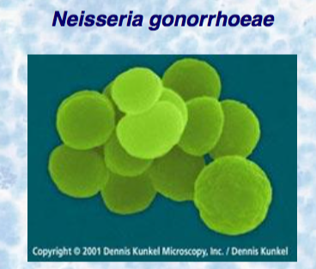

- N. gonorrgoeae
  - Gram negative diplococci
  - In clinical lab, grow in Thayer-Martin plates, in damp environment with CO2
    - VERY sensitive to drying and changes in temperature
  - Causative agent of STG gonorrhea
  - In US, it is the second highest reported STD, after chlamydia
    - >350,000 cases/year reported in US
    - number of cases is now decreasing every year

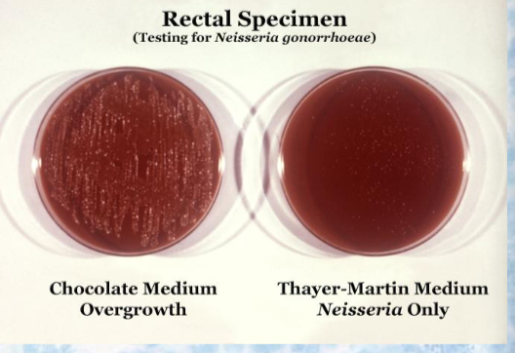
- N. gonorrhoeae
  - Clinical gonorrhea
  - MEN: causes acute infection of urethra (90-95%)
  - WOMEN: 50% ARE asymptomatic!!!
    - Cervicitis
    - If untreated can cause PID, sterility
  - Disseminated Gonococcal Infection (DGI)
    - 1-3% cases, usually women
    - fever, skin, infection, arthiritis
  - neonatal infections
    - rare, but newborns can acquire infection from mother during birth
    - causes gonococcal ophthalmia neonatorum (acute purulent conjunctivitis)
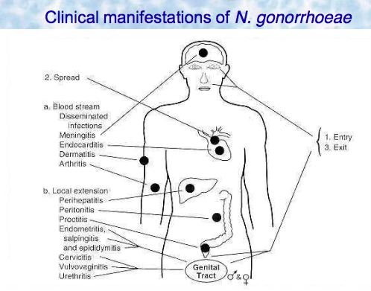

- N. gonorrhoeae
  - Diagnosis
    - MEN: use microscopy to directly observer swabs of urethral discharge
    - WOMEN: culture is necessary from endocervical, urethral and anal swabs
- PREVENTION AND TREATMENT
  - Penicillin resistance is emerging
    - Treat using ceftriaxone, cefixime, ciprofloxacin or ofloxacin combined with doxycycline/azithromycin
    - Resistance to ciproflaoxacin (quinolones) emerging
    - SIMULTANEOUS treatment of partners is ESSENTIAL
    - No vaccine available


