Mark 201
CHAPTER SEVEN
Designing a Customer-Driven Marketing Strategy and Marketing Mix
Ch. 7.1 Marketing Segmentation
Targeting: The process of evaluating each market segment attractiveness and selecting one or more segments to enter
Differentiation: Actually differentiating the market offering to create superior customer value.
Positioning: Arranging for a market offering to occupy a clear, distinctive, and desirable place relative to competing products in the minds of target consumers.
Four Important Segmentation Topics:
- Segmenting consumer markets
- Segmenting business markets
- Segmenting international markets
- Requirements for effective segmentation
Segmentation Consumer Markets
Major variables used in segmenting consumer markets:
- Geographic
- Demographic
- Psychographic
- Behavioral
Demographic Segmentation: Divides the market into segmentations based on variables.
- Demographics factors are the most popular bases for segmenting customer groups.
  - Consumer needs, wants and usage rates are often vary closely to demographic variables.
  - Demographic variables are easier to measure
Age and Life-cycle segmentation: Dividing a market into different age and life-cycle groups
Gender Segmentation: Dividing a market into different segments based on gender
Household income HHI Segmentation: Dividing a market into different income segments
- Segmenting the market according to HHI is one of the main ways car marketers divide the market
- Consumers of all income levels, primarily seek value from their purchases – however they personally define value.
Psychographic Segmentation: Dividing a market into different segments based on social class, lifestyle, or personality characteristics.
Products people purchase usually reflect their lifestyles. Marketers often segment their markets by consumer lifestyles and base their marketing strategies on lifestyle appeals.
Behavioral Segmentation: Dividing a market into segments based on consumer knowledge, attitudes, users, or responses to a product.
- Many marketers believe that Behavioral variables are the best starting point for market segments.
Occasion segmentation: dividing the market into segments according to occasions when buyers get the idea to buy, actually make their purchases, or use the purchased item.
- Can help build product usage
Benefit Segmentation: dividing the market into segments according to the different benefits that consumers seek from the product.
Usage Rate: Segmented into light, medium and heavy product users
- Heavy: small percentage of the market but account for a high percentage of total consumption.
  - Sometimes referred to by marketers as the “heavy half” or the “80/20 rule” – 80% of the volume of the product is consumed by 20% of its customers.
  - Figuring out members of the heavy user segment = Holy Grail
Major Segmentation Variables for Consumer Markets | Examples
Geographic Segmentation: | - World region  - Country  - Region of the country  - Population size  - Type of region
Demographic Segmentation: | - Age  - Gender  - Family Size  - Life Cycle  - Household income  - Occupation  - Education  - Ethnic or cultural group  - Generation
Psychographic Segmentation | - Social Class  - Lifestyle  - Personality
Behavioural Segmentation | - Occasions  - Benefits  - User status  - Loyalty status  - Readiness stage  - Attitude toward product

Using Multiple Segmentation Bases
One of the leading segmentation systems: The Nielsen Company’s PRIZM.
- Classifies households based on a host of demographic factors – such as age, educational level, income, occupation, family composition, ethnicity, and housing – and behavioral and lifestyle factors – such as purchases, free-time activities, and media preferences.
- Then, it classifies and names each segment.

Segmenting Business Markets
Business marketers use additional variables such as customer;
- Operating characteristics
- Purchasing approaches
- Situational factors
- Personal characteristics
Segmenting International Markets
Segment by geographic location – grouping countries by regions such as Western Europe, the Pacific Rim, and the Middle East, or Africa.
- Assumes that the nations close to one another will have many common traits and behaviour.
Countries can be segmented by; Political and Legal factors, Cultural factors, and economic factors.
Intermarket (cross-market) segmentation: Forming segments of consumers who have similar needs and buying behaviour even though they are in different countries.
Requirements for Effective Segmentation
To be useful, market segments must be the following:
- Measureable: The size, purchasing power, and profiles of the segments can be measured.
- Accessible: The market segments can be effectively reached and served.
- Substantial: The market segments are large or profitable enough to serve.
- Differentiable: The Segments are conceptually distinguishable and respond differently to different marketing-mix elements and programs.
- Actionable: Effective programs can be designed for attracting and serving the segments.

Ch. 7.2 Market Targeting
Evaluating Market Segments
- Marketers must look at three factors:
- Segment size and growth
- Segment structural attractiveness
- Company objectives and resources
- Done by collecting and analyzing data on current segment sales, growth rates, and expected profitability for various segments.
Examining major structural factors that affect long-run segment attractiveness:
- Done by analyzing the “five forces”.
- Competitors
- New entrants
- Substitute products (other products that they may buy that serve same purpose)
- Relative power of buyers
- Relative power of suppliers
Selecting Target Market Segments
Target market: A set of buyers sharing common needs or characteristics that the company decides to serve.
Levels of marketing:
- Broad: undifferentiated marketing
- Very narrowly: micromarketing
- In between: differentiated or concentrated marketing
Undifferentiated (mass) marketing: A market-coverage strategy in which a firm decides to ignore market segment differences and go after the whole market with one offer.
Differentiated (segmented) marketing: A market-coverage strategy in which a firm decides to target and designs separate offers for each.
- No brand practices differentiated marketing quite like Hallmark Cards
Concentrated (niche) marketing: a market-coverage strategy in which a firm goes after a large share of one or a few segments or niches.
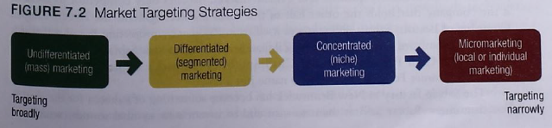
Micromarketing: The practice of tailoring products and marketing programs to the needs and wants of specific individuals and local customer segments – includes local marketing and individual marketing.

Local Marketing: A small group of people who live in the same city or neighborhood or who shop at the same store.
- Some drawbacks:
  - Drive up manufacturing and marketing costs by reducing economies of scale
  - Create logistic problems as companies try to meet the varied requirements of different regional and local markets.
- Advances of local marketing, due to increasingly fragmented markets and new supporting technologies, often outweighs the drawbacks.
Individual Marketing (mass customization): Tailoring products and marketing programs to the needs and preferences of individual customers.
Choosing a Targeting Strategy
Factors to pay attention to when choosing a targeting strategy:
- Product variability:
  - Undifferentiated marketing is more suited for uniform products such as grapefruit or steel
  - Differentiation or Concentration marketing is more suited for products that can vary in design, such as cameras and cars.
- Life-cycle stage
- Market variability
  - If same taste, some amount and reaction – undifferentiated marketing.
- Competitors’ marketing strategies are important
  - If competitors use differentiation or concentrated marketing, using undifferentiated marketing is suicidal.
  - Though if the competitors use undifferentiated marketing, it’d be beneficial to use differentiation or concentrated.

Ch. 7.3 Differentiation and Positioning
Value proposition: how it will create differentiated value for targeted segments, and what positions it wants to occupy in those segments.
Product Position: the way the product is defined by consumer son important attributes – the place the product occupies in consumers’ mind relative to competing products.
- The less differentiated the product actually is, the more important positioning becomes.
Positioning Maps
In planning their differentiation and positioning strategies, marketers often prepare perceptual positioning maps.
Choosing a differentiation and positioning strategy
Three steps:
- Identifying a set of differentiating competitive advantage upon which to build a position
- Choosing the right competitive advantages
- Selecting an overall positioning strategy
Identifying Possible Values Differences and Competitive Advantages
A Company can differentiate itself or its market offer thought the differentiation of;
- Product
- Services
- Channels
- People
- Image

Product differentiation: Brands can be differentiation on features, performance, or style and design.
Service differentiation: Speedy, convenient or careful delivery
Channel differentiation: gain competitive advantage through the way they design their channel’s coverage, expertise, and performance.
People differentiation: Hiring and training better people than their competitors do.
Choosing the right Competitive Advantages
USP = Unique selling proposition

A difference is worth establishing to the extent that it satisfies the following criteria:
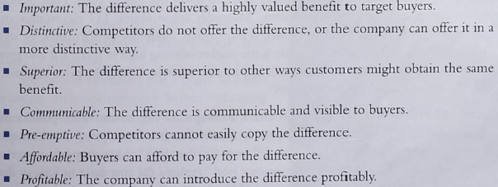
Value Proposition: The full mix of benefits upon which the brand is differentiated and positioned.
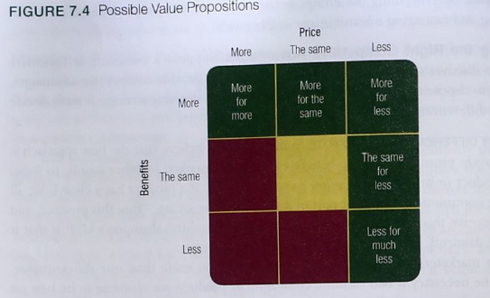
Positioning statement: a statement that summarizes company or brand positioning – it takes this form: To (target segment and need) our (brand) is (concept) that (point of difference).

