Descriptive stats are used to summarize  and describe quantitative info. Inferent,  stats are used to make inferences for a  pop based on sample info.  Statistic: descriptive index for sample  Parameter: descriptive index for the pop.  Discrete V: separate categories ex:  Hospital visits, # of siblings  Cont. V: infinite # of values between 2  pnts ex: time gone by since birth  Data Analysis:  1)Ask a research question  2)Define variables (ind vs dep)  3)Operationalize variables (meas. pro)  4)Measurements (collect data)  5)Stat. Analysis (draw conclusion)  Qualitative Data: (Bar graph)  -Nominal: names w/o order ex: color  of car, major in college  -Ordinal: values have some natural  order; ex: HS class, military  Quantitative Data: (Histogram)  -Interval: numeric data with no  natural zero point; intervals are  meaningful, but ratios are not  ex: Temp in F degrees; 80F is 20F hot  than 60F, but it is not 150% as hot.  -Ratio: Numeric data for which  there is a true zero; both intervals and  ratios are meaningful; ex: weight  Univariate: one variable ex: avg HR  Bivariate: 2 variables examined  simultaneously; ex: resting HR for ppl  who are overweight or normal weight  Multivariate: 3 or more variables are  looked at simultaneously  Distribution Shapes:  1)Modality: how many peaks  -Unimodal: one peak  -Bimodal: 2 peaks  -Multimodal: multiple peaks  2)Skewness  -Pos skew: long tail to the rt ex income  -Neg skew: long tail to the lft ex death  3)Shape  -Kurtosis: how pointy or flat  -Lepto: very thin, sharp peak  -Platy: flat peak  -Meso: neither pointy nor flat (norm)  Central Tendency: center of distribut.  1)Mean: the average (%)  2)Mode: most pop number (f)  3)Median: middle #  Range: diff between high and low score  IQR: Q3(75%)-Q1 (25%)  1) Put #’s in order 2) Find the mean 3) Place ()  around #’s above and below median 4) Find Q1  (median of lower bracket) + Q3 (median of  upper data) 5) Subtract Q3-Q1=IQR  IQR are most often used to describe outliers. Mild outlier: value between 1.5-3.0 Extreme outlier: data value 3x more than the IQR  Sampling Error: The error in the estimate of a pop parameter when the estimate is based on only a portion of the pop  Standard Dev: index that captures how much a score deviates from the mean  -In a normal dist., 95% o all scores fall withing 2 SD’s below and above the mean  Deviation score: sub. Score from mean (the sum of the deviations of all scores from their mean always equals 0)  Variability: how spread out the data is  Standard Score (z-score): relative distance from the mean | Z-Table Instructions:  1) If I ask you for the proportion of the distribution that falls above a positive z score, then just find the z score (first column) and give me the proportion in the second column.  2) If I ask you for the proportion of the distribution that falls below a positive z score, then find the z score (first column) and subtract the proportion in the second column from 1.00.  3) If I ask you for the proportion of the distribution that falls below a negative z score, then just find the z score (first column) and give me the proportion in the second column.  4) If I ask you for the proportion of the distribution that falls above a negative z score, then find the z score (first column) and subtract the proportion in the second column from 1.00.  Ignore the third column  Z-score: values in the distribution in terms of their relative distance from the mean. Relative to the SD.  H_{O}: No relationship  H₁: There is a relationship  -if less than 5%, we reject the H_{O}  Sampling Distribution of the Mean: theoretical probability distribution of the means of an infinite number of samples of a given size from a population (=pop μ)  Central Limit Theorem: the mean of the sampling distribution is identical to the population mean.  Standard Error of the Mean: index of the avg amnt of error in a sample mean as an estimate of the population mean  Hypothesis Testing: begins with an assumption that the H_{O} is true.  H_{O}: The accused is innocent of committing the crime  H₁: The accused is guilty of committing the crime.  Type I error: Incorrectly reject the H_{O} (false positive). Can be controlled through the level of significance (α=alpha)  -most accepted level of sig. is 0.05 and 0.01. With α = 0.05, H_{O} will be rejected when it is TRUE.  Type II error: Incorrectly accept the H_{O} (false negative) (β=beta)  -affected by: sample size, measurement quality, strength of underlying rel. between variables.  -Type II error increases as Type I decreases. To reduce Type II you need to increase the sample size  Critical region: the decision to reject the H_{O} if the stat being tested falls at or beyond 5.0.  t-distribution: bell shaped, unimodal, symmetrical. Mean of 0.0. Proportions are diff. More scores in tail and fewer in the middle. The more ppl in the sample the closer to normal distribution. Once sample =30, normally shaped.  Critical t-value: the size of the t value for a mean that would have less than 5% chance of occurring.We set our alpha level and want to see if our mean will exceed this. If t greater than tabled value (critical t); reject the H_{O}Statistically significant: if the absolute value of the test statistic is greater than the tabled value  Statistically insignificant: p value greater than 0.05. Obtained by chance.  One-sample t test: researcher tests the H_{O} that the sample mean is equal to a specified value  Two-sample test: comparing 2 means to each other  One-tailed test: critical region is in only one end of distribution  Two-tailed test: uses both tails of sampling distribution to determine the critical region for rej the H_{O}. (2.5% on each side)  Dependent Samples t Test: Same participants in both samples  Independent Samples t Test: Different participants in the two samples
Steps in Hypothesis Testing:
0. State the null and alternative hypotheses
H₀: μ = 5
H₁: μ = 5 (non-directional hypothesis – two tailed test)
μ > 5 (directional hypothesis – one tailed test)
1. Select the test statistic (t)
2. Specify level of significance (α=5)
3.Decide on one-tailed versus two-tailed test (two)
4.Calculate test statistic using appropriate formulas
5.Calculate degrees of freedom(n-1)
6.Compare test statistic to tabled value for appropriate df and α
7.Decide whether to accept or reject the null hypothesis
Different = a very low probability of occurrence by chance if the mean truly is 5.0
-Average sampling error is the standard error of the difference (SE_{D}). The mean of a sampling distribution of the difference between means is equal to the difference between the two population means
Independent t-test: 2 groups of diff ppl
Dependent t-test: 2 groups of same ppl
Leven’s Test: Tests the null hypothesis that the variances in the two populations are equal
-Homo: When sample size is the same, variance is typically the same. But when sample size is different, variances are often different.
Kolmogorov-Smirnov Test: Statistical test that evaluates the null hypothesis that a distribution of values in the pop is normal.
T-stat is used instead of a z-score when SD and variance are unknown.
Single sample t-test ex:
A researcher believes that in nursing studies, the proportion of females that act as participants is greater than 50%
-Take a sample of research studies n = 25
-Record the proportion of females in each study
-Compute the mean and standard deviation of the proportion of females in research studies
  - X = 61%
  - s = 15
We want to test if this mean is different from 50%
Answer:
0) State the null and alternative hypotheses
  - H₀: μ = 50%
  - H₁: μ > 50%
1) Select the test statistic: t
2) Specify the level of significance: 5%
3) Decide one tailed or two tailed: One tailed (directional hypothesis)
4) Calculate the test statistic: (use one sample)
5) Calculate degrees of freedom
df = n -1 = 25 -1 = 24
6) Compare test statistic to tabled value (df, alpha, one tailed)
-Critical t = 1.71
-The t is greater than the critical t
7) Accept or reject the null hypothesis: Reject
Independent t-test ex:
0) State the null and alternative hypotheses
-H₀: μ₁ = μ₂ -H₁: μ₁ = μ₂:
1) Select the test statistic: t
2) Specify the level of significance: 5%
3) Decide one tailed or two tailed: Two tailed
4) Calculate the test statistic
5) Calculate degrees of freedom:df = n₁ + n₂ – 2
6) Compare test statistic to tabled value (df, alpha, two tailed) Critical t = -2.10
7) Accept or reject the null hypothesis: accept

Degrees of freedom: df=n-1 (one sample t-test and dependent t-test)
Independent t-test Formulas:
Pooled Variance: Need first to find SE_{D} SE_{D}=√s²₁ + s²₂
n₁ n₂
Independent t-test:
t= X₁ – X₂
SE_{D}
X₁-X₂=diff in means of 2 samples
SE_{D}=estimated stand. Error of diff.
df for independent t-test: df=n₁+n₂-2
Dependent t-test:
t= ∑D
√ (nΣD²) – (ΣD)²
n-1
T-test:

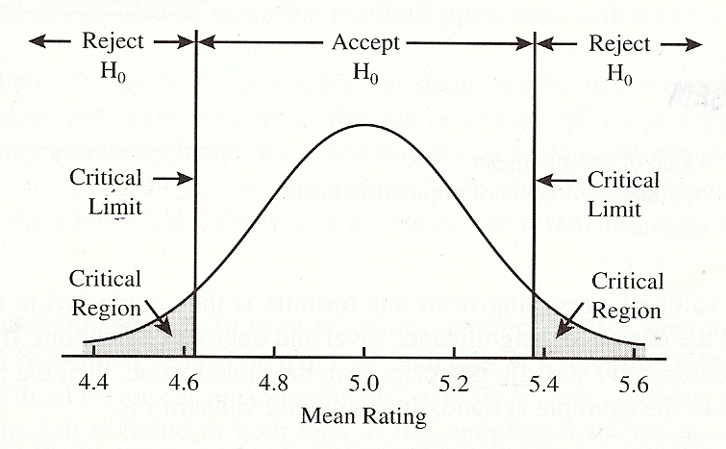
Ex: What proportion of the normal distribution corresponds to z score values greater than z = 1.00?
Answer: p(z > 1.00) = 0.16 or 15.87%
What proportion of the normal distribution corresponds to z score values less than z = 1.50?
Answer: p(z < 1.50) = 0.93 or 93.32%

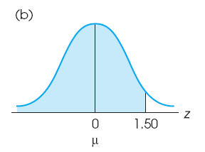
Probability of an event: p (always=1)
p(event)=# ways event can occur
total # possible events
ex: Prob of drawing an Ace from a deck
p(ace)=ace can occur
total # cards
=4/52 =1/13
Prob. of Consecutive Events
p(A then B)= p(A)xp(B)
ex: Prob of obtaining heads twice in a row
p(heads and heads)=p(heads) x p(heads)
=0.50 x 0.50 =0.25(25% chance)

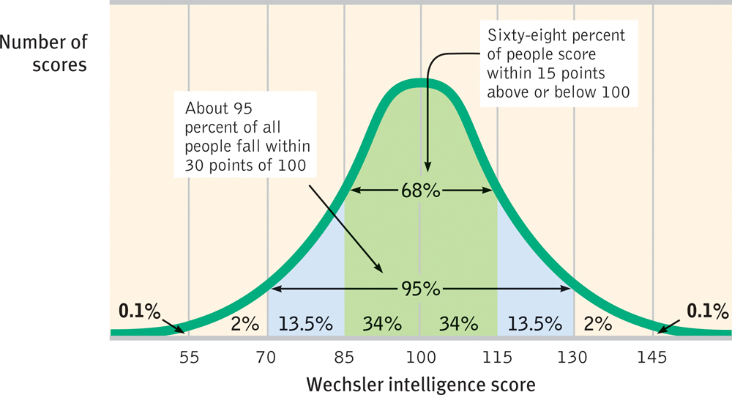
Standard Error of the Mean (SEM): S_{X}
S_{X}=SD SD=standard d. of sample
√n n= sample size
*The larger the sample size the smaller the SEM
Type I and Type II Errors
 | Null True | Null False
Reject Null | Type I | Correct
Fail to Reject | Correct | Type II

T-statistic: t (one sample t test)
t= X-μ
S_{X}

Cum. Rel. Freq. Distrib. ex:
X | f | % | Valid % | Cum. %
1 | 1 | 2.5 | 2.5 | 2.5
2 | 2 | 5 | 5 | 7.5
3 | 4 | 10 | 10 | 17.5
4 | 5 | 12.5 | 12.5 | 30.0
5 | 7 | 17.5 | 17.5 | 47.5
6 | 8 | 20 | 20 | 67.5
7 | 5 | 12.5 | 12.5 | 80.0
8 | 4 | 10 | 10 | 90.0
9 | 3 | 7.5 | 7.5 | 97.5
10 | 1 | 2.5 | 2.5 | 100
T: | 40 | 100 | 100
Population Mean: μ
μ=∑x
N
Population Variance: σ²
σ²=∑(x−μ)²
N
Pop. Standard Deviation: σ
σ=√ σ²

Standard score (z-score):
Z =x- μ
σ

Ex: Following ages (in years) of
all 4 zebras at your local zoo:
7,20,1,2
μ=7+20+1+2
4 =7.5 yrs
Find squared dev from mean
X | Dev. | (x−μ)²
7 | -0.5 | 0.25
20 | 12.5 | 156.25
1 | -6.5 | 42.25
2 | -5.5 | 30.25
σ²= 0.25+156.25+42.25+30.25
4
=57.25
σ= √57.25 =7.6 years
Sample Mean: x
x=∑x
n
Sample Variance: s²
S²=∑(x−x)²
n-1
Sample Stand. Deviation: s
s=√s²
Standard Score (z-score)
z=x-x
s

