Lecture 2: Intermolecular interactions, Acids and bases

Readings: Ch 2, online assignment Friday

2) Hydrogen Bonds (cont.)
- Hydrogen bonds are strongest when linear, angle is 180
- Typical H-bonds on slide
- NH are good H donors
- Should be able to pick out places where H-bonds can occur, where the acceptor is and donor, etc.
- H-bonds are seen in the interactions between base pairs in DNA
  - ex. Guanine and Cytosine
  - ex. Adenine and T
- Bonds play a major role in biopolymers
- DNA base pairs: G and C have 3 H bonds and A and T have 2 H bonds
3) van der Waals attraction
- All non ionic and non H bonds
- London force (dispersion force) is one of the most important types
  - rely on induced dipoles, induced by some charge in a molecule
  - First molecule is neutral and a non permanent transient dipole, next molecule becomes an induced dipole if close to the first one and not has a small force
- There has to be an induced dipole for these forces
- Dispersion forces are stronger between molecules that are more easily polarized (ex. Heavier atoms) and who can fit together snugly
- I2 is the strongest london forces since its easiest to polarize compared to Cl2 and Br2
- Leaflet from Lipid Bilayer
  - The packed fatty acid tails cause lots of london forces attraction, the head is polar
- Other van der Waals
  - Ion-dipole
    - Can help stabilize positive charges
    - Like water dissolving a salt
  - Dipole-dipole
    - Not transient, instead permanent
- Dipole of solvent impacts dielectric constant
  - Dielectric constant: the ability of a solvent to stabilize charge
  - Water has a very high dielectric constant
  - Water can displace another biological molecule very easily in ionic, H, and dipole charge bonds therefore water is usually excluded in biological systems to increase strength of forces
    - ex. water is excluded from the inside of folded proteins to increase forces therefore strength
Hydrophobic interactions
- non polar groups cluster together
  - ex. Grease and water
- Not an attractive interaction between hydrophobic molecules
- Due to water
- Major driving force in formation of membrane?
- Hydrophobic vs Hydrophilic
- Bonding is much stronger than london forces
- Disrupt H bonding network in water when a hydrophobic molecule is placed in there
  - H2O at surface has fewer H bonds and is therefore less stable
Hydrophilic organic functional groups
- ionic groups (acids and bases)
- alcohols
- amines
- carbonyls
Hydrophobic organic functional groups
- hydrocarbon chains
- aromatic and heterocyclic rings
Amphiphilic molecules
- have both hydrophobic and hydrophilic functions/part
  - ex. Leaflet with polar head group and non polar tails
- they form micelles, embrace bilayers, and vesicles
- it will form spontaneously
Table showing relative strengths of forces
- Slide 15
Acid-base Chemistry
- Homeostasis of internal ionic composition, including pH, is critical for structures and functions of biomolecules
- Structure enables function
Bronzed Acids and Bases
- Acid is a substance that can donate a proton
- Base is a substance that can accept a proton
- Acid Base chemistry always follows Le Chateliers principle (go over this)
  - Ex. Add more Ha then eq is pushed to the right

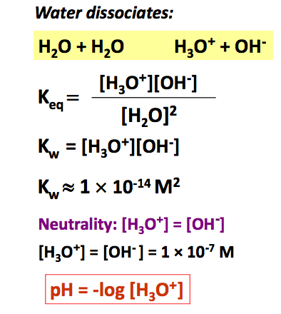

- Equilibrium constant
- Kw = Ionic product of water

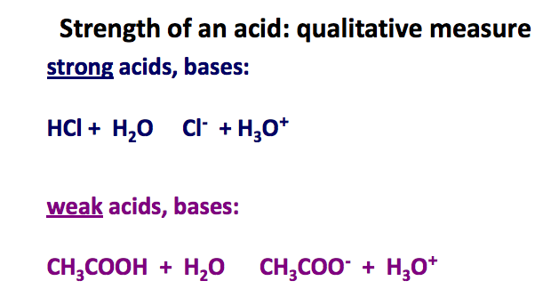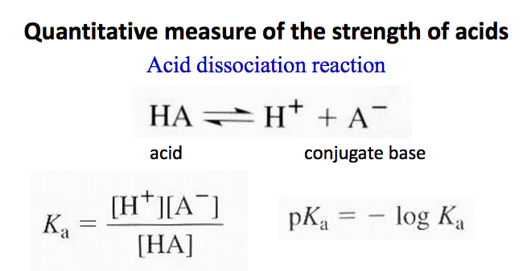
- Strong acids completely dissociates in water therefore all of HCL is consumed
- Weak acids partially dissociate in water so come of it is leftover
- Ka = acid dissociation constant
- pKa = the most common measure of acid strength
- Strong acids: pKa < -2
- Conjugate base is strong base: pKa > 16
- Monoprotic Acids: one proton may be lost


