Lecture 1: Chemical origin of life, Basic building blocks, Water

Readings: Ch 1, Ch 2

What is Biochemistry?
- fundamentally controlled by chemical principles
- way biology evolves is taking chemical principles and made them control and directed to the process of evolution
- can explain and predict what happens to biological processes in the molecular level
Origin of life: from chemical to living
- radioactive dating of rocks ex. 238U decays slowly to 206 Pb
- evidence for life on earth is not nearly as good as evidence of the age of earth
- no direct evidence for living processes that are that ancient
- no true paths to show how we went from a chemical world to a living world
Primordial earth
- Reducing atmosphere had no oxygen and was too reactive
- Now our atmosphere has stable molecules ex. Water, N2, CO2, NH3, CH4, SO2
- Oxygen can only stay around if there is some way to replenish it well
- primordial earth had simple molecules only
- Opaline & Haldane hypothesis: suggested energy and atmosphere made complex organic molecules
  - They set up an experiment of the reducing atmosphere of earth
  - Mimic energy being added, ex. lightning strikes or UV light
  - Overtime they formed complex organics ex. AA, HCN,nucleotides
  - Close approximation of what it was like but not purely accurate
Urey-Miller experiment: Products
- Nucleic acid bases and AA are building blocks of life
- ex of prebiotic chemistry: Adenine
  - Took HCN gas, heated it and produced in a yield of 1% adenine (1 of 4 bases in DNA and RNA)
Chemical Evolution
- Simple building blocks combine chemically to make polymers at high concentrations
- Polymers have to somehow become self replicated
- Scientific hypothesis for this is called the RNA world hypothesis
RNA World Hypothesis
- RNA can fold and template its own formation
- Nucleic acids have loops and stems
- When folded they are less sensitive to degradation
- Folded nature gives it a fix structure and protects it, keeps it more stable
- Ribozymes: folded RNA structures that can catalyze chemistry
  - Tom Cech nobel 1989 discovered Ribozymes catalytic activity
  - Ribozymes can template its own formation (base pair) because it is a nucleic acid
  - Ribozymes are not stable in the environment, Rnases? degrades them
- Once you compartmentalize something you can control the concentrations of other chemicals present and this is an essential element of evolution of life
  - reduces environmental variation
- Need to understand fundamental chemical principles that control the way the molecules react
Cells are extraordinary complex
- All organelles are constructed by many different types of molecules and their interactions
- How can we hope to have a fundamental chemical understanding of what is happening?
Biomolecules are polymers of a limited number of building blocks
- Monomers: 10 building blocks for lipids and carbs, 20 for proteins, 5 for nucleic acids
- Properties of polymers are controlled by monomers
Properties of Water
- Water is the clear requirement for life
- Everywhere there is water there is life
- 104.5 degree angle, sp3 hybridized oxygen @ 2 lone pairs, oxygen is highly E.N, dipoles
- sum of dipoles from bonds gives a net dipole of the molecule
Water dissolves polar compounds
- Positive end of dipole (Anions) interacts with the negative charge (Cations)
- Number of molecules interacting and dipoles are there, and they are built up around forming a salvation/hydration shell: Dipole-ion interactions
- Dipole-ion interaction has to be stronger than ion-ion reactions otherwise the substance would not be dissolved
Properties of Water
- Water can be a hydrogen donor and acceptor which is very important
Hydrogen Bonding of Water
- Ice: Static bonds vs Water: much more dynamic
Properties of Water
- High bp, mp, heat of vaporization, surface tension
Biomolecules
- Interaction of all biomolecules are governed by a limited number of non covalent interactions
- Thereon covalent bonds are responsible for shapes of biomolecules and interactions among them
- These interactions can be modified by thermal energy
- Non CB are weaker than CB
1) Electrostatic interactions

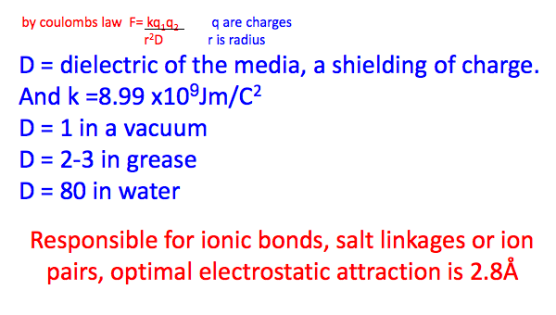
Closer = stronger attraction, distance dependent
ex. Carboxylate (ex. Aspartic acid) -ive and Ammonium (ex. Lysine) +ive “salt bridge”

2) Hydrogen Bonds
- occur between donor and acceptor
- has polarized bond so must have a larger E.N difference
- weak bond
- high EN atoms required
- Acceptor has to have lone pair of electrons
- Polarized bond interacting with acceptor
- Very strong angle dependence, need to be straight to be strong
- Orbital disruption gives angle dependence
- Strong non covalent interaction between..

