Course Introduction: Scientific Method

REVIEW MADE FOR MIDTERM 2
Slide 4
SCIENCE: verifiable through experimental methods. Acquisition of new knowledge
⇒ respects link between acquisition of knowledge and science

- Inductive Reasoning$≼$
  - Observation ⇒ Generalization
  - DESCRIPTION-BASED (describing nature)

  - ex: this orange is sweet (starts with observation) , therefore all oranges are sweet (generalization)
  - ex: these dogs have brown spots. All dogs have brown spots.

- Deductive Reasoning $≻$
  - Generalization ⇒ Observation
  - HYPOTHESIS-BASED (explaining nature)
  - Drawing conclusions after experiementation
  - If...then...
  - ex: All cats have whiskers. Sam has whickers. Therefore, Sam has to be a cat.

Slide 8
- Observation
  - Qualitative/ Quantitative
- Hypothesis
  - Can NEVER be proven to be scientific truth
  - After this, a prediction can be made
- Prediction
  - Testable, give clear result
  - Verififying hypothesis (try to falsify)
  - “If… then…” statement
- Tests
- Falsify/ Don’t Falsify Hypothesis

Slide 9
Hypothesis Refuted: new hypothesis
Hypothesis Confirmed: more tests (always trying to falsify) ⇒ corroboarate

Slide 10: Framework for Good Science
Contract between acquiring knowledge + proper science (or the ability to know)

- Skepticism
  - Initial skepticism on facts
  - We ask honest questions (not denial) on facts and hypothesis (tangible/real things)
  - Always re-test previous findings
- Realism
  - The world is older and exists independently from my perception of it (the realm of ideas does not have the priority over the real world)
    - Ideologies
    - Objectivity (not perception)
    - Relates to discussion about evolution vs religion
- Rationality
  - Logic: demonstrations from a scientist must be the result of coherent steps.
  - Parsimony: Simplest Explanations
    - methodological principle which states that acceptable theories are hypothetically the most economical in assumptions.

    - ex: standing in field, hear gallop behind me- must be horse, not zebra
    - ex: crop circles: 2 guys overnight or aliens?

- Methodological Materialism
  - All that is experimentally accessible
  - No supernatural explanations to explain nature
    - God does not equal science

CHAPTER 3: CHARLES DARWIN (p. 495-508)

3.3 Evolution and Natural Selection
- First phylogenetic tree
- (1837) First mention that :Species resemble because they share a common ancestor
    - (not a common environment)
  - Rejects fixity of species and accepts the concept of descent with modifications (evolution)
  - Very materialistic vision, in contradiction to the religious dogma of the time
  - Rejects Lamarck’s environmental determinism (inheritance of acquired traits)

- Then he begins the search for an evolutionary mechanism
  - He used the term “descent with modification” instead of “evolution” to avoid confusion between social advances

- Finches: Not created independently on islands- common ancestor
  - Finding answers to morphological gaps
  - 99% of species that have lived on earth are extinct
  - Most evolutionary branches end in a dead end

Thomas Malthus (Economist)
- In 1838, Darwin read “An Essay on the principle of population”
  - Every human population has a tendency to increase geometrically, populations increase arithmetically
- Population increases faster than its capacity to feed itself. This leads itself to chaos (famine, sickness, war etc) and eventually to a substantial reduction in population size
  - ⇒ ⇒ important influence on theory of natural selection
- Crisis due to lack of resources ⇒ Human population will crash (winners+losers)

Darwin’s First Observation:
  - Every species created more offspring than their environment can sustain and many of these offspring fail to survive and reproduce
  - Concept of winners + losers interested Darwin
  - ex: Mola mola fish produce 200 million eggs
    - If all eggs are fertilized, the ocean would be filled. Only a few survive
  - Humans are exception (we care for progeny)

Darwin’s Second Observation:
  - Members of a population often vary in their inherited traits
  - Traits inscribed in genes, transmitted to next generation
  - Similarity between parents + progeny
  - Variability important to Darwin

Two Inferences:
  - Inherited traits favouring survival and reproduction for individuals leave more offspring
  - Accumulation of favourable traits from generation to generation; results from these individuals unequally capacity to reproduce (differential reproductive success)
  - This is NATURAL SELECTION. Enables the emergence of adaptations
    - Inherited traits with a genetic basis
    - Differential Reproductive Success (individuals w a trait proportionally more common in next environment)
    - Acts based on Selective Pressure (which changes in time + space)

Ex: white tailed deer in costa rica much smaller than local white tailed deer. Different selective pressure (ecology, habitat, temperature)

Ex: How natural selection acts:
- Environment affects population
- Visual Predation: Predator eats individuals easy to see (high-contrast w environment)
- Colour is hereditary (blue colour favours reproductive success in blue environment)

Important Notions linked with Natural Selection:
- Individuals do not evolve, populations evolve.
  - evolution cannot be measured with one individual
- Only hereditary traits are subject to natural selection
  - Contrary to Lamarck’s theory
- Genetic variability is needed for evolution to occur
  - If al individuals are the same, they are gonna be extinct
- Corresponds to differential reproductive success within a population from generation to generation
- With time, enables individuals to be better adapted to their environment
  - Population with adaptation = higher reproductive success
- Environmental factors vary in time and space- selective forces are variable
  - species will be affected by many factors
- Traits in populations will change and can modify the species
  - Species now vs 100000 years ago are morphologically different

Mechanism is Valid to Darwin because:
- Respects principle of uniformity of Lyell and Hutton
    - Processes + forces that shaped the earth are the same now
- Results of natural selection are visible in nature
- Mechanism can be verified on current populations (eg artificial selection)
  - Can be seen. Ex: artificial selection
- Materialistic concept (no need for divine intervention)
  - Not random: individuals better adapted to environment become more abundant (differential reproductive success)
    - Specific process
  - Not a quest for perfection: (not a directed process). Organisms adapted to environment, not “perfect”
    - Natural Selection is Not Finalized - long time for changes to occur (geological time scale)

Artificial Selection is Finalized - the goal, fixed well in advance, precedes the causes. End result can be obtained in a few generations
- Past 10000 years, humans have bred plants and animals for our needs/domestication
- Ex: Wild mustard plant is selected for different parts (cabbage, kale, broccoli, brussel)
- Not Random

Ex: Peppered Moth
- Two shapes/forms: Dark morph and Grey morph
  - Colour is hereditary
- Coal burning, lots of pollution making environment dark vs clean countryside
- Moth active at night (prime target for visual predation)
- Grey morphs far more abundant in countryside
- Dark morphs far more abundant in city
  - When city gets cleaned, grey morph becomes more abundant

Ex: Climate and the Medium Ground Finch
- Seed-eater: size/height of beak very important
- Pedigree: record of descent of an individual
- Drought in 1977 (also in 1980, 1982) ⇒ (Daphne Major island)
- Population drops from 1200 adults to 80
- Selection favouring individuals that have bigger and stronger beaks to break available seeds during the drought
- Selection for stronger beak in that population (variability still exists)
- Continuous traits: polygenic inheritance (many genes will affect them)
- 74% of the trait has a genetic basis. 24% is environmental

Ex: Humans and Mountain Life (Adaptation to Altitude)

Altitude Sickness: Over 2000 m, partial pressure of O2 is insufficient for normal saturation of hemoglobin for a traveller in high altitudes. (Oxygen still at 21%, but less enters your system and body reacts to this). Deeper breaths, easily exhausted as body tries to get O2 but there’s none.

Tibetan Plateau: (increased blood flow; not increased RBC but higher BP w circulatory system
to match)

- Francois Chapleau: visited from 100m above sea level to 3500m above sea level. Immediate altitude sickness. Walk high sleep low to adapt to altitude. Rapidly out of breath- trying to acclimatize.
  - Increased concentration of red blood cells over time (starts at 1500m)
    - Acclimatization (physiological response): Increased [ ] of RBC in body
    - Health risks: higher risk of stroke, thrombosis, pulmonary edema
    - RBC last three months (better performance in marathons right after)
  - Over 5000m must take oxygen bottles
- Guide from Ladakh: running up mountain. Possesses adaptation from his population/
  - Adaptations do not appear to solve issues
  - Humans came out of Europe 100000 years ago. FIrst humans on Tibetan plateau 22000 years ago: 110 generations.
  - Important Concept: set of mutations (genetic makeup) allows survival at high altitude. Already present in lowland populations (mutation appears at random in original and all populations).
  - Proportion may be the same at the start, but then individuals with the mutation allowed for higher proportion of offspring due to survival and high altitudes
  - Strict, rapid selective process

Many regions in high altitudes were independently colonized by humans. On the Qinghai-Tibet Plateau, differs from the Andes.

Andes: (increased hemoglobin concentration)
- Individuals with mutation are at an advantage for survival and production of offsprings

Mutation existed in population before, then mutation was favoured (higher reproductive rate) than individuals without the mutation- not a result of environmental pressure

Evolution and Natural Selection
- In three cases (moths, finches humans), the hereditary traits that gie a reproductive advantage (ied adaptation) to individuals in a population will be favoured. Thus, from generation to generation, there will be ahiger percentage of individuals carrying the adaptation. This is natural selection (desent with modification; EVOLUTION)
- These adaptations can someitmes redefine a species, and sometimes, define a new species

Adaptation: solution to prevent extinction. When you can no longer adapt, you go extinct.

Natural Selection Recap
**adaptation to altitude at qinghai-tibet plateau
- Adaptation still unknown in Ethiopian people (may be andes, himalaya, completely unique)

In the 2 cases the hereditary traits (moths, finches, etc) that give a reproductive advantage (ie adaptation) to individuals in a population will be favoured. Thus, from generation to the next, there will be a higher % of individuals carrying the adaptation. This is natural selection.
- Darwins descent with modification.

These adaptations can sometimes redefine a species and, in certain circumstances, define a new species.
Individuals with the mutation at advantage for survival and reproduction
CHAPTER 4, GENETICS, NEO-DARWINISM, AND MODERN SYNTHESIS

4.5 Modern Additions to Mendel’s Laws
- Incomplete dominance- 2 pure lineage (homozygous for recessive:white and dominant:red ), F1 genertration will be pink
  - Three phenotypes, three genotypes
  - Each genotype has a phenotype
  - Ex: snapdragon coulours (white $C^{w}C^{w}$, pink $C^{w}C^{R}$, red $C^{r}C^{R}$)
  - Ex: Chestnut horse (CC chesnut, Cc palomino, cc cream coloured)

Codominance- both alleles are dominant
Both alleles show themselves in F1 generation
Ex: checkered chicken (both alleles expressed)

1. Polygenism- when a phenotypic trait is under the combined impact of two or multiple genes (continous- no big gaps in phenotype)
- Very common phenomena with regards to expression of genes
- Ex: skin colour

2. Epistasis- when the effect of a gene blocks/hides the effect of another gene (2 alleles for one character)
- Ex: Labrador
- Black is dominant
- Chocolate: homozygous recessive
- Epistatic manifests only when gene “e” is homozygous recessive

3. Pleiotropy- effect more than one character (certain pleiotropic genes are lethal when homozygous)

M
p
M
m
m
m
m
m
M
M
M
M
m
Normal cat with tail
Cat will die in utero
- Ex: Manx cat
  - Manx cat (M) shows an incomplete dominance compared to the normal gene (m) (with tail)

CHAPTER 5: THE EVOLUTION OF POPULATIONS

5.1 HARDY-WEINBERG’S PRINCIPLE
**practice with equation

- CONDITION: No evolution
- Selecting alleles at random from a gene pool
  - Dominant alleles (red): frequency of P
  - White allele: Q
  - P+Q=1 ⇒ Allele frequency
- Population of red+white + pink/incomplete plants (500 plants= 1000 alleles in population)
  - Find frequency of genotypes in a population
  - Frind frequency of alleles in a population (2 red alleles in each red plant)
  - Good diagram on slide 4
- A population is in Hardy-Weinberg’s equilibrium when:
  - Frequency of alleles and genotype within a population will remain constant (according to the equation $p^{2}+2pq+ q^{2}=1$) ($q^{2}$ homozygous recessive, $p^{2}$homozygous dominant) from generation to generation as long as the following conditions are respected:
    - There are no mutations
    - Mating is done randomly
    - Extremely large population size
    - No genetic flow (no migration of alleles between populations)
- Hardy-Weinberg’s principle describes a hypothetical population that does not evolve
  - Compare populations (in terms of 2pq, $p^{2}$, $q^{2}$) before and after several generations to determine if population is is H-W equilibrium

5.2 MUTATION
Mutation: changes in the DNA sequence of an organism

Mutations are:
- The source of genetic variability
- Random
- Transmissible (only if there are gametes)
- Frequent throughout the gene pool, but rare at each locus ⇒ weak evolutionary factor
- Will influence allele frequencies but is a weak evolutionary force from generation to generation, especially in large population
- Point mutations (addition, deletion or substitution of a base; A-T instead of A-C)
- Negative effect (eg Ehlers-Danlos Syndrome)
- Lethal effect
- Neutral effect
  - Effect:
    - Synonymity of codons for the formation of amino acids; particularly in the 3rd position
    - non-coding part (protein of the genetic code)
    - May impact timing or expression of genes
- Positive effect (when the effect enables the populations to be better adapted to the environment)

Example: Sickle Cell Anemia
  - Difference of one amino acid in formation of one subunit of hemoglobin shape
  - Wild type hemoglobin
  - Sickle Cell type hemoglobin

- Mutations can be chromosomal (DNA segment loss, repetition of DNA segments, addition or loss of chromosomes)

- Mutation Rate
  - Varies greatly according to groups of living beings or genes
  - Occur when Submitted to Mutagens (substance that increase mutation rate)
  - Mutation on humans:
    - Diploid (2 copies of chromosomes) 6.4x10^9 base pairs
    - Baby: approx 175 mutations in his genome
    - ~2.5 x 10^-8 mutations by base pairs
    - If 2.5% of the genome contain coding genes (as opposed to junk DNA/ non-coding genes), then 4.3 mutations by baby have the potential to alter proteins and influence the phenotype
    - Population of 500 000 humans: 2 000 000 mutations by generations
- Even if a small portion of these mutations is advantageous, it offers a good genetic basis for evolution over millions of years.

5.3 ASSORTATIVE MATING
Random mating: panmixia (maintains Hardy-Weinberg equilibrium)
- American eel: Species spread-out in all large rivers and lake son the Eastern coast of North America.
  - Reproduction site: somewhere in the Sargasso Sea (panmictic populations)
    - very little genetic variability between populations

Positive Assortative Mating:
- Choice of partner in relation to phenotype (modifies H-W eqm)
- Favours homozygosity (lose alleles in a population)
- Autogamy or self-fertilization (pure lineage of Mendel)
- Geographical proximity of individuals (eg: population of mice in a barn)
- In humans: mating according to height+skin colour

Negative Assortative Mating:
- More frequent mating between individuals that don’t look alike than expected by chance
- Increase heterozygosity- more genetic variability
- Very little probability of plant mating with itself
- Eliminate chance of self-fertilization if plants are only female (ex: male bees getting pollen on themselves)

Assortative mating does not change allele frequencies, however it changes genotypic frequencies

Ex: Cards from a deck
Positve- black cards go with blackcards
Negative- red cards go with black cards
⇒ number of cards doesn’t change

When paired with natural selectio, poisitive assortative mating can lead to an increase in homozygosity and loss of genetic variability
- Phenomena of endogamic depression (inbreeding, decreased health) since the harmful alleles will express themselves
- Natural selection will purge the population of a portion of its Harmful alleles
Thus, a loss of genetic variability compared to panmixia

5.4 GENE FLOW
- Breaks Hardy-Weinberg Equilibrium
- Migration between populations (individual moves populations, changes genetic makeup of the new population, bring new alleles)
- Has a tendency to standardize the genetic pool of the populations involved
- Can play a similar role a similar role as mutations by introducing new genes in one of the populations
- Semi-long term effect: genetic composition of one population can become the same as the others if there are migrants

5.5 THE GENETIC DRIFT
- Result of chance
  - Usually affects small populations
  - Impact on genotypic/ allelic frequencies
    - (ultimate end: fixation of one allele, elimination of all others)
- Example: 10 individuals, cow randomly eats 5, so only 5 leave offspring
  - Happens again, randomly eliminating (much more frequency in small population)
  - By chance: generation 3 has p=1.0, meaning all other alleles will disappear (q=0)

- If genetic drift will eventually result in the fixation of an allele and the elimination of all

Frequency of Genetic Drift Simulation (link)

- Population Bottleneck: In small populations, genetic-drift can lead to the fixation of deleterious alleles and a loss of genetic variability. Thus, this correspond to increased risk of extinction
  - Consequences: Case of the Greater Prairie Chicken
    - Increase # of allele (introducing healthy individuals from other population)
    - Stopping extinction

- Founder effect: when a few individuals from a large population create a new colony, the genetic makeup of the colony differs from the source population
  - Ex: settlers with myotonic dystrophy
    - Frequency in Charles-Voix +Lac St-Jean region in Quebec
      - 189/100000
    - Frequency in Europe: 4/100000
    - Inbreeding, low genetic variability

5.6 THE NATURAL SELECTION
- A process by which individuals with certain hereditary particularities survive and reproduce in larger numbers than other individuals
- Alleles favored by selection are more abundant in offsrping than in the paretnal generation
- The action of natural selection on the frequency of an allele can be cancelled by the action of mutation, genetic drift, and migration
- The only evolutionary mechanism that aids survival and reproduction of organisms in their environment

- Important: only hereditary variations constitute the basis of natural selection
  - Ex: spring+summer variations of a population of butterflies is not natural selection

- Adaptive value (selective value, fitness)
  - Definition: Contribution of an individual to the genetic pool of an individual when compared to the contribution of other individuals
  - Allows to calculate genotypic frequencies from generation to the next
  - 3 genotypes in a population
    - $A_{1}A_{1}$ (adaptive value 0.5)
    - $A_{1}A_{2}$ (highest fitness, alleles will remain in population, adaptive value 1)
    - $A_{2}A_{2}$(adaptive value 0.5)

- Types of hereditary traits:
  - Qualitative (discrete variation: colour, not measurable)
  - Quantitative (continuous variation: height, weight , there is genetic variation)
  - Polymorph populations showing distinct morphological types of genetic variability
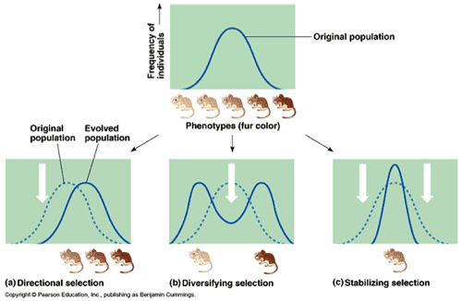
- Selection for a continuously variable trait: Average value is the middle of normal distribution bell curve (3 types)
    - Directional Selection
      - CHANGES AVERAGE VALUE OF A POPULATION:
      - ex: adaptation to altitude, Darwin’s finches
      - Ex: DDT insecticides, in less than 2 years mortality of mosquitos went from 95% to 2% (new abundance of ddt resistance in progeny, same phenomenon as antibiotic resistance)

    - Disruptive Selection
      - AVERAGE VALUE OF PHENOTYPES IS THE SAME IN ORIGINAL AND EVOLVED POPULATION
      - might lead to speciation
      - Ex:width of lower jaw in a bird closely correlated with size of beak and seed they are eating

    - Stabilizing Selection:
      - FAVOURS INDIVIDUALS CLOSE TO THE AVERAGE OF ORIGINAL COLOURATION
      - ex: in 1930’s newborns that weighed 8 pounds had a higher rate of survival than smaller or larger new born
        - Today, this stabilizing selection has almost disappeared in wealthy countries
      - ex: All mammals have seven cervical vertebrae (pleiotropic effect- one gene impacts several traits)
        - Step of development that will cause fetus to die if there are 6 or 8 vertebrae instead of 7)

5.7 THE PRESERVABILITY OF GENETIC VARIABILITY
For each extinct species, something didn’t work (genetic drift hay have acted etc)

- Maintaning genetic variability (polymorphism)
  - Diploid and genetic load

- Diploidy:
  - Considerable portion of allele in hidden in heterozygous vs homozygous recessive
    - The mass of little expressed or unexpressed genes in heterozygotes (genetic load)
    - It is the cost associated with maintaining and storing genetic variation

- Balanced polymorphism:
  - The heterozygote advantage
    - Extreme example: interaction between sickle cell anemia + malaria
      - Sickle Cell Anemia: Punctual mutation (switch of nucleotide changes shape of red blood cells), recessive allele, high mortality before reproductive age
      - Allele frequency “s” is particularly high in regions where cases of malaria are high
      - Heterozygous Ss is more resistant to malaria than SS
      - Codominant Relationship between red blood cell shape and parasite attraction: Heterozygous have sickkle shape+ normal shape red blood cells (sickle cells attract parasite, but normal RBC deter parasite quickly)

- Selection-dependent frequency:
  - Inverse frequency in fishes
    - Advantage of the rare (example in textbook fig 23.17)
    - The rarest phenotype is favored by selection
    - Some fish (Perissodus mircolepis) crooked to the left, some crooked to the right to attack and take scales of prey
      - Frequency of attack on one side
      - Right-mouthed attackers more rare, more successful due to surprise effect
        - Abundance of left vs right varies through time as prey become aware of most common type
  - Positive frequency:
    - The more abundant phenotype is always faovured (stablizing seleciton on eahc mountain)
    - Selectionleading to multiple stable equilibriums (adaptive landscape)
    - Perspective of whole spcies: multiple stable EQM within species, provides genetic variability
    - Case of mullerian mimicry

- Neutral Variation
  - Good portion of the genetic variability found in genes do not show selective advantages or is not affected by natural selection (eg pseudogenes)

- External mechanism (or ecological)
  - Result of simultaneous impacts of different selective pressures
  - Temporal changes in selection pressure
    - Ex: size difference in white-tailed deer in Canada vs Costa Rica based on environmental pressures
  - Habitat mosaic
  - Non-assortative mating
    - (negative assortative mating)- mating with individuals that are different, favour heterozygote

5.8 SEXUAL SELECTION
- Charles Darwin: initial formulation of the concept
- Form of evolution in which individuals that possess some specific hereditary traits are more susceptible to find partners
  - Ex: male peafowl with extravagant tail feathers more prone to predation, also found attractive by females
    - Quality of the male show by his feathers
    - Short lifespan, but high chance of mating

- Intersexual selection (choice of sexual partners based on traits indicating the quality of the genetic baggage of the other sex):
  - Widowbird: females prefer long tail feathers in males
  - Long tail is indicator for health- prioritized by females

Sexual dimorphism: difference of shape between sexes

Intrasexual selection: Selection between individuals of the same sex
Confrontational behavoiour betweeen members of the same sex is often a ritualized combat

Penis bone:
- Cats: erection after penetration (locking mechanism)
  - Big cats- ovulation occurs at same time as mating

- Penis Bone of walrus quite large
- Chimps have small penis bone, humans do not
  - Why did human lose penis bone? Hypothesis: intersexual selection- capacity of male to have an erection is indication of its quality
  - Prevents artificial erection (no penis bone necessary)

CHAPTER 6: ADAPTATION

6.1 ADAPTATION
- A result of natural selection
- Sometimes complex, complex functions and complex histories (evolutionary compromises, symbiosis)

Evolutionary Compromise: maybe there’s a cost associated with some adaptations
Adaptations cannot be looked at in isolation

- ex: Anatomy of human pharynx: why are humans the only primates to choke on food?
- Chimpanzee have longer snout, relatively large tongue
- Back of mouth: epiglottis cartilage that shuts trachea (will cover trachea in chimps when swallowing)
  - Humans have space between distal tip of soft palate + epiglottis itself
    - Vulnerable to choking as a result

- BUT: Evolution of speech is unique to humans
  - Much lower vocal cord relative to mouth: allows to pronounce vowels + consonants
  - Small space between vocal cord and mouth short in chimps: emit sounds
  - May be unique to Homo sapiens (evidence that neanderthals unable to speak)
  - Advantages outweigh the disadvantage

6.2 STUDYING ADAPTATIONS
- Exaptation: Traits of a living being are not necessarily adaptations of the current environment. Current function original function

- Morphology associated with history of ancestor, not species

Exaptation: have a historical outlook to adaption
- (what we’re looking at in terms of function now is not the same as when they first evolved)

- Limbs in tetrapods: useful for propulsion, but maneuverability of fishes in water
  - Origin of limbs: maintaining equilibrium in water
  - The original function of fins was to stabilize the fish body in its environment (adaptation)
  - In terrestrial animals (tetrapods), the limbs (evolved from fins) are used to support the body in an aerial environment. The limbs of the tetrapods are thus an exaptation from terrestrial mobility (locomotion)

- Hair evolution
  - Adaptation or exaptation to conserve heat?
  - How did the first hair evolve?
  - Ex: studies on elephants: measuring heat in high+low density hair areas
    - very large animals in tropical, open habitats that absorb a lot of heat)
    - DIssipate a lot of heat (some areas of body have thinner skin- “hot spots”)
    - Dispersed hair on skin (not fur), varying hair density
      - Helps thermoregulation, Dense hair= lower capacity to lose heat
      - Pin Theory: source of heat under pin will lose heat a lot faster than flat surface due to increased surface area
      - Origin of hair: may have been used to lose heat, structure then helped preserve heat as hair becomes more dense
      - We cannot say that hair has evolved to preserve heat, or was sensory structure to allow organism to detect, or dissipate heat

- Feathers: adaptation or exaptation for flight?
  - Feathers come from scales
  - Sexual selection, or preservation of heat (problem: small dinosaurs not endotherms, feathers won’t work if you don’t produce heat)

Slide 7-25, 43-53
CHAPTER 7 GEOGRAPHIC VARIATION AND SPECIATION

7.3 ADAPTIVE VALUE OF GEOGRAPHICAL VARIATION

-WHY AND WHEN HUMANS HAVE LOST THEIR FUR
- Fur is vestigial structure in humans
- 6-7 million years ago, the hominins (all human species) shared a common ancestor with the chimpanzee (pale skin covered of a dark fur)
- Oldest hominin known: Sahelanthropus tchadensis
  - Discovered in Chad
  - Homo sapiens only remaining hominin species
  - All human species have some bipedal stance
  - Humans have hole underneath cranium for spinal cord
  - In chimps gorillas, hole is oriented towards the back
  - Traces of Neanderthal in Human genome ⇒ there was interbreeding at some point

- How many human species of humans existed 2 MYA?
  - (min. 5 species in africa at same time)
  - 2 MYA brains began to get much larger

- Australopithecus afarensis (3.7-3 million years ago)
  - Fossil known for his species: Lucy
  - Brain about ⅓ size of human brain
  - Tropical forests in Africa
  - Bipedal and Arboreal (indicated by very long arms)
  - Diet of fruits, tubers and leaves
  - Sedentary way of life

- Climate Changes
  - Last 65 million years ago- one general trend for cooling down
  - Droughts in East Africa
  - Formation of savannahs
  - Impact on hominin species: reduction of main food source (fruit)
  - East Africa very active in tectonic activity
    - Caused geological changes: mountain, desert, some freshwater lakes regions) habitats created
- Homo ergaster (=Homo erectus) 1, 2 MYA
  - Less furit available, meat added to diet
  - Walks longer distances for prey and water
  - Adapt to life on the plains
  - More active lifestyle (hunter-gatherer)

- Natural Selection acts on the shape of the body (ability to run)
  - More active lifestyle in open habitat ⇒ facing more sun, heat
    - Principle of Thermoregulation to dissipate heat increase sweating has important consequences on other characteristics:
      - Less fur for active lifestyle (fur slows down evaporation when wet)

- What is sweating in mammals?
  - Furry Animal Glands
    - Especially sebaceous and apocrine
    - Oily Sweat
    - Perspiration difficult
  - Human Glands
    - Especially eccrine
    - Watery sweat
    - Easy perspiration (up to 10 liters per day)
  - 2 types of Sweat Glands in Mammals:
    - Apocrine Sweat Gland (associated with heiar, oily sweat includes some chemicals, molecules, volatile molecule ie feramone)
      - most furry mammal have them all over their fur
      - Not efficient (creates oily layer over skin
    - Eccrine Sweat Glands (tubular gland open directly at surface o the skin, watery salty sweat, millions of them in humans, dogs only have a few)

Ex: horse: sweating difficult, few eccrine glands (protein of eccrine and apocrine sweat glands (latherine)

Ex: carnivore thermoregulation: panting and eccrine sweat glands found only on the pads of paws

Ex: human perspiration: potential for losing 10-12 litres per day. 2-4 litres per hour. A lot of eccrine sweat glands (loss of fur to facilitate sweat evaporation)

-EVOLUTION OF SKIN COLOUR IN HUMANS
Result of natural selection- what kind of selective pressure led to different skin colour?
- Selection in favour of darker skin (1.2 MYA) at the same time as fur loss
- Natural selection favored the individuals having thicker, darker and more acid skin (more melanosomes= more melanins)
- Protection against: ultraviolet rays (UV), drought, bacterial attacks and vitamin deficiencies

- Fur is a means of Communication
  - ex:Aggressive mood in Chimps: peculiar fur pattern in defensive vs dominant situations. Scared cat raising fur to look bigger and more dominant
  - Humans lost fur, gained facial expression to indicate emotion instead
    - May have been driver of verbal communications
    - SKin became thicker + darker

- For over 1 Myr (between 1,2Myr to 100000 years): the skin of all hominins species Including Homo Sapiens was dark.
  - Mammoth killed by spear fossil found- dated at 40 000 years old
  - Artifacts found sometimes do not match with chronological migrations we thought we knew
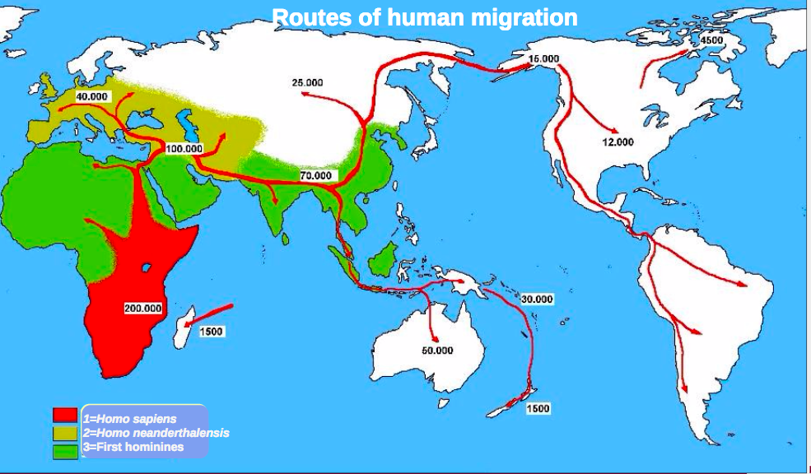

- Hypothesis to explain evolution of skin colour:
  - Reminder: we need to find an inherited trait that gave those who had it a positive survival and reproduction differential (adaptation) from generation to generation compared to other members of the population

  - Skin Cancer?
    - ⇒ Problem: Skin conly kills individual once they have already reproduced

  - Folic Acid and dark skin:
    - FOlic acid (vit B9) is destroyed in skin by excessive UV rays
    - B9 deficiency: serious and possibly lethal developmental malformations (spina bifida), poor wound healing, disturbed immune system, sperm malformation
    - A vitamin deficiency at a young age and, particularly, in pregnant women would have a direct impact on the survival and reproductive success of the individual
    - Thus, we can say that dark sin offers a protection against the UV rays that offers a survival reproductive advantage (that’s an adaptation)
      - Explains dark skin immediately after we lost our fur

  - Vitamin D3 and dark skin
    - Invasion of North America (settlement in these areas accompanied by diet to supplement Vit D ie cod liver oil, fishing
    - Links between quantity of UV rays and human skin colour

Summary
  - Great human migration started 100000 years ago
    - Humans invade increasingly northern environments
  - Adequate synthesis of Vit D3 by the skin
  - In areas where there’s an annual deficit of UV rays

Conclusion
- Loss of fur in hominids is linked to lifestyle change due to climate change, more than 1,2 MYA
- Skin colour became dark after the loss of fur. The skin of human species remained dark for more than 1 Million years
- Pale skin allows healthy synthesis of Vit D3 during colonization of northern regions in the last 100 000 years
  - Note: individuals with darker skin in high UV intensity reions synthesize vit D at a slower rate than pale individuals
- A selective advantage of darker skin in regions of high UV is to Minimize degradation of folic acid by UV rays
- IMPORTANT: Skin Colour reflects where population lived for a long time (not immigration)

The colour of skin is:
- A variable polygenic hereditary trait, which explains the variability of pigment intensity
- Only an adaptation to UV radiation
- Only an indicator of the environment in which populations have lived

7.5 ORIGIN OF SPECIES

- Phyletic Speciation (anagenesis): Gradual evolution or “linear” succession of species in a way that the changing species shows different phenotypes through time
  - Linear evolution doesn’t make sense for humans
  - Gradual change in invertebrate marine fossils
  - Modifies itself through time to produce a new species

- Multiplication of species (cladogenesis): Creation of species by establishing a reproductive barrier between them
  - Cladogenesis: only mechanisms responsible for the creation of biodiversity
  - At one point where was interruption of gene flow (migration of individuals) between the populations

- From a genetic standpoint, a premise for the multiplication of species interruption of migration or gene flow between populations, allowing populations to eveolve independently

Allopatric Speciation: a population with continuous distribution divided in two or multiple populations by a geographical barrier:

Steps:
- Passive isolation of populations in space (while they are isolated, slightly different environmental pressure in each habitat) ⇒ no more gene flow
- A genetic modification, under the combined effect of isolation and selective pressures, replaces a co-adaptive system enes by another, more suitable to different ecological conditions
- Acquisition of reproductive isolation before the subsequent overlapping areas

Complete speciation: no viable hybrids in the contact zone (sympatric area) between areas

- Eastern Meadowlark (Sturnella Magna) and Western Meadowlark (Sturnella neglecta)
  - Minimal phenotypic differences (distinct song and behaviour)
  - Evolved different songs while isolated- no hybrids observed in contact zones in field since females can identify song differences
  - In lab settings hybrids will occur, this doesn’t count as speciation
    - (reproductive barrier still present)

Reproductive barrier:
- Acquired when species in isolation
- When area of sympatry re-occurs, they are unable

Sympatric Speciation: new species appears within a population (speciation without geographical isolation)
- ex: Polyploidy (30%-40% of plants): mulitplying the normal # of chromosomes. Can happen when the chromosomes do not separate during the meiosis which produces diploid gametes (instead of halpoids)
  - Gene flow stoppage: plants with triploidy cannot reproduce with diploid plants. Though Rare in animals

- ex: Thornapple maggot is native to N. America. Flies deposit eggs inside the apples. Eggs hatch, develop, feed inside fruit.
  - Positive assortative mating in flies- same habibtat reproduction only
  - Two morphs of Rhagoletis pomonella in the process of sympatric speciation
  - Divergent Selection: selection in terms of habitat use (apple tree vs thornapple)
  - Positive Assortative mating: habitats

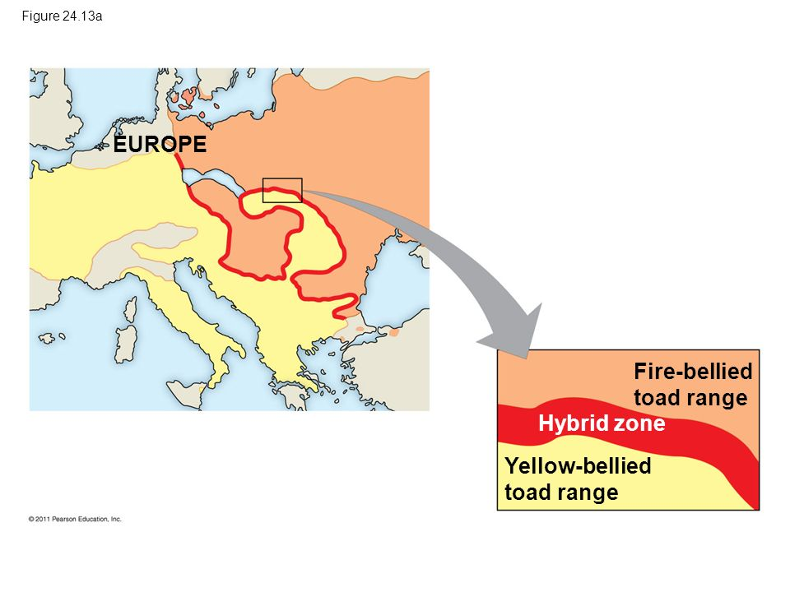
7.6 HYBRID ZONES
Alleles proper to fire-bellied toad, absent in yellow-bellied toad. Allele goes down very quickly from one end of the hybrid zone to the other.
- No fusion of the species outside hybrid zone
  - hybrids have weird morphology, some sterile individuals, developmental issues, associated with a specific intermediate habitat

- Reinforcement of reproductive barriers: fusion of the species
  - Ex: polar bear & grizzly bear live in different habitats
    - Grolar bear: rupture of reproductive isolation between grizzly and white bear. Exception: COnsequence of global warming?
    - If polar get used to life on the continent instead of ice, they may get in contact and produce hybrids
    - Common ancestor 400000 years ago

Enhancement of reproductive Barriers in the Contact Area (Hybrid Zone)

  - Character Displacement: the differences between two related species are often greater in sympatric areas (eg 2 species of Galapagos finches)
    - Species separated: allopatric
    - Two species on same island: character displacement
    - Different beak size on the same island: females are then able to indentify the males of their own species

- Ex: enhancement of reproductive barriers in flycatchers
  - Females always choose males of their own species when the morphology of males is different (sympatric areas)
  - Females make mistakes when the females look the same (allopatric zones)
  - Reproductive barriers between two species

- Turbid water for 20 years: progressive fusion gene pools (hybridization) of the two cichlid species ⇒ lower visibility, females make mistakes in choosing males
  - Sexual dimorphism within the species
  - Female recognize their male based on colour pattern
  - “Turbid water” hybrid offspring from location w dirty water

If the reproductive isolation is incomplete, there could be the creation of a stable of hybrid zone that contains hybrids. In these narrow geographical zones, there are genes or alleles of a species that pass freely into the gene pool of another species (gene introgression)

7.7 TEMPO OF SPECIATION
- Process of speciation: 4000 years to 40 million years average:
- 6,500,000 years ⇒ seems very high (avg life of species about the same length)
- rarely less than 500,000 years

Punctuated pattern (Punctuated EQM): ancestral species submitted to allopatric/sympatric speciation; mostly morphological change in daughter species will occur at speciation time

Gradual pattern (phyletic gradualism): when speciation occurs, the act of speciation when barrier is formed, there’s very little morphological change that will occur. All morphological change will occur in the lifetime of the individual, AFTER speciation
- Species are always adapting to their environment
- Darwinian

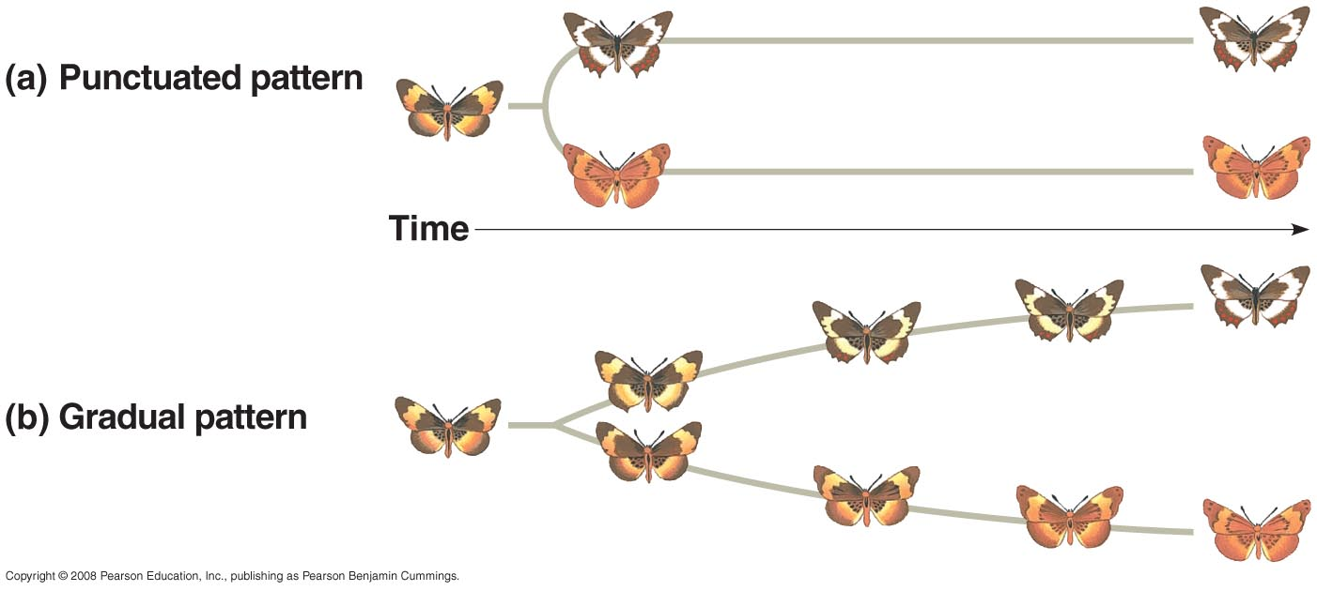

CHAPTER 8 PHYLOGENETICS

- Systematics: A scientific discipline focused on classifying organism and determining their evolutionary relationships
  - Phylogeny: evolutionary history of a species or group of species

- Taxonomy: scientific discipline concerned with naming & classifying the diversity of life

  - Taxon (pl. taxa): A named taxonomic unit at any level of the phylogenetic hierarchy or classification

8.1 GRAPHICAL REPRESENTATION OF LIFE
Exam question: Who is more evolved, bacteria or humans?
⇒ according to spherical bush, we are the same. Different way of life, exploit environment differently. Equal in evolution, share common DNA with all species.

Bonnet 1745:
- Ladder of life (begun with Aristotle)
- Humans on top

Darwin 1837
- All species of life share a common ancestor
- Destroyed Great Chain of Being
- Life now seen as a tree (lasted through 20th century)

Haeckel 1879
- Tree of life
- Trunk: unicellular organisms ⇒ PROBLEM- CREATES FALSE IMAGE OF LIFE
  - No inferior forms of life
  - Anthropocentric perception of life
- Branches: More complex animals
- Twigs become even more complex ⇒ Mammals near top of tree; humans are on top

REALITY:
- Life is a spherical bush
- Three branches: Archea, Eukarya, Bacteria
- LUCA not at the centre: archea more closely related to eukarya than bacteria
- Centre of bush: common ancestor of life:
  - Last Universal
  - Common Ancestor
- How did life evolve from non-life? How do living beings come from inorganic material?
- Timeline: 3500 millions years since LUCA
- Human species is only one terminal twig in the bush of life
8.2 HOMOLOGY AND HOMOPLASY
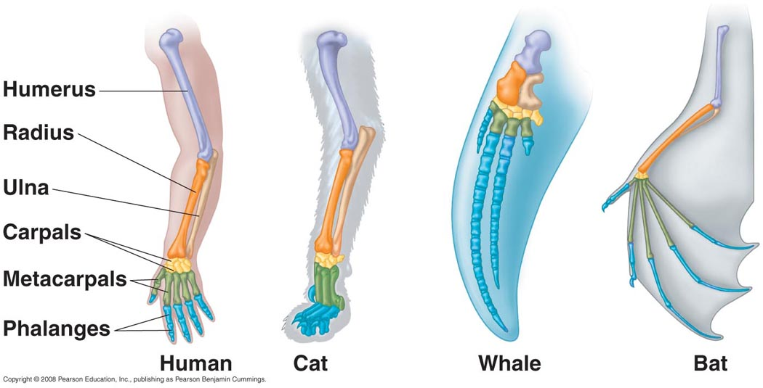
- Homologous structures:
  - indicative of a common ancestor & data used to reconstruct phylogenies. Ex: presence of humerus is indicator of homologous structure

- Homoplasy:
  - Convergence:
    - Do not share an immediate common ancestor
    - Evolved this feature totally independently
    - Ex: abiilty to hover in sugar gliders (a marsupial) vs flying squirrels (placental animals)

  - Evolutionary Reversion:
    - Ex: absence of fur in whales
      - 6 characteristics associating whales with mammals, 1 characteristic associating it with fish. Most Parsimonious explanation= whale is mammal

8.3 TAXONOMY AND CLASSIFICATION
- Biologists use the biological systems to identify living organisms
- Homo= name of the genus
  - Signifies <,man>>
- Sapiens = name of species
  - Signifies: intelligent, wise and reasonable

- Classification: System of words used to group species into categories
- Hierarchical system (ie sequential and orderly arrangement of categories)
- Needs to Reflect the Phylogeny
  - Species, genus, family, order, class, phylum, kingdom, domain
8.4 PHYLOGENETICS
- Phylogenetic tree with dichotomous branches (cladogram) indicates sequence of appearance of taxa
- Bifurcation point (branching point): common ancestor, denotes related groups
- Cladogram indicates the sequence of appearance of taxa
- No time frame incorporated in cladogram
- Classification reflects ramifications of the cladogram

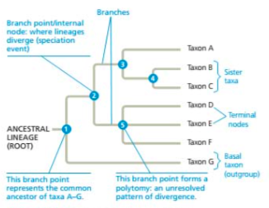
Branching point/node: where lineage diverge- speciation event

Polytomy: branch point with multiple descendants

- Cladistics: taxa should be based on shared derived characters (synapomorphy, homology)
  - Not shared ancestral characters (symplesiomorphy)

- MAIN OBJECTIVE OF PHYLOGENETIC STUDY: to define monophyletic groups with shared derived characters (contains all and only descendants from a common ancestor)

MONOPHYLETIC GROUPS | NON-MONOPHYLETIC:
Contains all and only descendants from a common ancestor | - Polyphyletic: contains descendants from several ancestors  - Paraphyletic: does not contain all descendants from common ancestor  - Ex: class of reptiles (do not contain birds)  - Consequence: cannot define one morphological feature that defines reptiles as a monophyletic group (this is a subjective concept)  - Ex: fish a paraphyletic group  - Not one character can be used to define a fish  - Still used in textbooks due to authoritarian approach instead of scientific

- Reference group (outgroup, fundamental group): used to distinguish the derived character traits from an ancestral characters traits
  - Ingroup: group being studied contains derived characteristics

- Eg: vertebral column
  - Shared derived character that defines vertebrates as a monophyletic OR Common ancestral traits that do not define mammals as monophyletic

In case of conflict in distributions of cladograms:

- Parsimony: phylogeny must offer the simplest explanation based on the facts.
  - Hypothesis with the fewest evolutionary steps is considered the most parsimonious and this hypothesis is presumed the best approximation of the true relationships

  - e.g: 4-chambered heart in mammals and birds evolved independently (fewest number of character change)

Branching point age: fossils or by an estimation of the rate of change from a molecular clock
(length of branches on cladogram can indicate time)

Did dinosaurs take care of their offspring?
  - Historical context must be taken into account with evolution of traits
  - Something protecting amphibians from extinction (dinosaurs gone extinct, mammals take over daytime (diurnal) niche)
  - Crocodiles: care for
  - Dinosaurs: Bones of parents and assumed eggs in middle of bones
    - Assumption: parent died sitting on nest
    - Difficult to test any sort of behaviour in dinosaurs due to extinction
    - Look at exaptation/adaptation (with cladogram it becomes possible to elaborate hypotheses to a effect

CHAPTER 9: BIOSPHERE AND ECOLOGY
interaction of species with environment translates in adaptations (link ecology-evolution)

9.1 Ecology: Definitions, Concepts and Issues
- Ecology: Scientific study of interaction between organisms and between organisms and their environment
  - Organism:

- Environment:
  - Abiotic factors: non-living chemical + physical parts of an environment
    - Ex: temperature, light, type of soil, external to animal

  - Biotic factors: Living components of an ecosystem
    - Organisms

Scope of Ecology:
- Organismal Ecology: interaction between organism and environment (evolution, physiology, behaviour)

- Population ecology: Group of organisms of one species living together in same area (dynamics of population size fluctuations)

- Community ecology: groups of populations of different species living together in an area (how interactions between species {predation, competition} affect the structure and organization of communities)

- Ecosystem ecology: Community of organisms in an area and the interaction of organisms with physical factors (study of energy flow, chemical cycling)
  - We should prioritize ecosystems containing many endangered species

- Landscape ecology: Mosaic of connected ecosystems (study of factors controlling of energy, materials and organisms across multiple ecosystems)
  - Study of corridors
    - Ex: Greenbelt in Ottawa (conscious attempt keep belt of forest around city)
    - Interesting consequences: maintain population of deer, skunks. Maintain fauna in our country
    - Shanghai has few parks/no greenbelt. Only 4-5 bird species present

- Global ecology: study of the biosphere: sum of all ecosystems (study of regional exchange of energy and materials its global impact on the biosphere
  - Ex: impact of human activity on environment

Precautionary Principle: strategy to cope with possible risks where scientific understanding is yet incomplete (better be safe than sorry)

⇒ the Earth’s climate is warming due to human activity
⇒ ex: warning that populations of cod would not survive without measures to preserve the resource. Ended when there was no more cod and cost the federal government a lot to aid the affected fishing communities. Populations now at 10% of what it was in the 1960s. Stock will never be fully replenished.
⇒ scientific principle indicates that if we continue to contribute carbon to the atmosphere, the temperature will rise between $1^{∘}$ - $6{}^{∘}$celsius.

9.2 The Climate: ABIOTIC FACTORS

LIGHT
- In polar regions:
  - Solar rays are slanted VS rays are vertical in equatorial regions
  - The solar energy spreads over a large surface area

  - The Earth is tilted on its axis at 23.5 degree angle
    - Extratropical regions have seasons, whereas the tropical regions have very little differences between seasons and days
    - If Earth would be put straight, there would be no more seasons

    - Air circulation and precipitations at a global scale
    - Winds: atmosphere between atmosphere and planet
      - Not straight; result of round planet. Interaciton between speed of planet and atmosphere

  - Hadley Cells: At the equator,heat will make water evaporate. Air slowly filling with water vapor slowly climbs in atmosphere. Condensates and forms clouds. Starts to rain as it grows higher in the atmosphere. Then absorbs are the humidity from the ground

  - Circulation of surface water in the oceans influences climate. Imagine river in middle of ocean: currents.
    - Greenland melting at rapid rate: fresh water entering mainland, could eliminate gulf stream
    - Simple shift in Gulf Stream, could have repercussions around the world.
    - Being closely monitored

TEMPERATURE

  - Any changes to sea curent have impact on climate
    - Loss of fur in humans: change climate, impact on habitat, impact on species

WIND
  - Mountain range near ocean (prevaliling winds from east/west)
  - Cool air from the ocean comes over the land (land emits more heat, warms air)
  - Gets cooler (cooler atmosphere at high altitude)
  - Condensation (rain forest, often found in tropics, but also West of Rockies in BC)
  - Ex: in California (nevada desert) all humidity has been absorbed
  - Dry tropical forest in Costa Rica
    - Create habitat diversity
    - Prevailing winds bring air on the coast
    - Air goes up into mountain range in middle of country
    - Rainy region constant (mist) on the Atlantic side of mountain range

PRECIPITATION
  - The effects of large bodies of water on the climate: local effects (not broad)
  - Lake Superior: sunny day, no wind but constant slight breeze coming from lake going on land
    - Produce rain 2-3x per afternoon
    - Little impact on species distribution

9.3 Terrestrial and Aquatic Biomes (combination of temperature and climate)

- Types of terrestrial communities (biome)
  - Tropical Forest
  - Desert
    - (Hadley Cells- dry air circulation is found to be towrads ground at 30 degress latitude north and south to create desert at these latitudes)
  - Temperate Grassland (steppe)
    - Mostly transformed into agriculutral land throughout central canada
    - Most species endangered- since land s have been recycled
    - Seasonal precipitations, frequenct droughts
  - Northern Confierous Forest (Taiga)
    - Largest terrestrial biome: large bad just souht of the tundra
    - Temperature: cold in winter (sometimes -50) and warm summer
  - Temperate broadleaf forest:
    - Characterized by deciduous trees
    - Our biome
  - Arctic (tundra)
    - Made of small plants well-adapted to cold climates
    - (Alpine Tundra): patches of vegetation but in mountains

Graph of temperature and precipitation together

The climate has an important role in determining the geographic distribution and structures of biomes

- Aquatic Biomes:
  - Oceanic Pelagic (blue open water) and Marine Benthic Zones (ocean floor)
    - Earth 70% water
    - Deepest water of ocean is 10 km deep
    - Oceanic Pelagic Zone

  - Intertidal Zones
    - Zone between high + low tide
    - Flora+Fauna exposed to air and moving water
    - Typical to ocean shore
    - Firt zones impacted by human activity

  - Estuaries
    - Junction between river + ocean
    - Main driver of fauna: resilience towards salinity
    - Varying salinity in failry short distance
    - Plasticity, variabilty in terms of change of salt content
    - Greatly affected by pollutioin

  - Coral Reef
    - Most found between 30 degrees north and 30 degrees south
    - Coral: very diverse, exploited for long time
      - Fishing with dynamite (stick of TNT in coral reef, collect dead fish)
      - International outcry against this: discovered that coral reef can recuperate in 10-20 years with good biodiversity if any life remains
      - Coral Reef do not tolerate temperature change

  - Rivers
  - Wetlands (ex: Mer Bleue)
  - Lakes
    - Can be categorized by strucuter, depth
      - Oligotrophic: clear lake, poor in nutrients and rich in oxygen, very little producitvity, potable water
      - Eurotrophic: Rich in nutrients, poor in oxygen, lots of life and plants, algae. Often turbid water.

    - Seasonal turnover in lakes with winter ice cover
      - Spring: mixing of the lake (temperature same in top and bottom
      - Summer: vegetation present offers some cover, sun stronger to warm surface of lake, thermocline (1m-2m deep, major temp drop); stratification of lake. Cold water more dense (accumulation of nutrient in thermocline.
      - Autumn: Mixing of water due to lost leaves and dominant winds
      - Winter: Ice forms
        - Not an issue in oligotrophic lake
        - Eutrophic Lake: danger that ice formation biodegradation of vegetation, consumption of oxygen, species (like fish) that need oxygen can’t survive
          - Winter Kill: phenomena in fish biology, when fish die in forzen over lake due to lack of oxygen, no O2 input into lake
            - Caould also be cuased by pollution that kills larger fish

- Zonation Lake
      - Littoral zone (shallow, lots of activity)+ limnetic (cannot percieve bottom at certain depth, extends towards centre of lake)zone
      - Photci: photosynthesis
      - Aphotic zone: no light (a few meters- 20,30m zones)
        - Varies by turbidity of water
      - Benthic Zones: at bottom of lake
      - Pelagic ZOne: Open water (some fish specialized ex: flatfish, then move to benthic zone when ther eyes moe)

- Zonation of Ocean
  - Same as lake except:
    - Intetdial + neretic zone (up to 200m metres, associated with photic zone) + ocenic
    - Abyssal zone between 2000m-6000m (unique to oceans)

9.4 Species Distribution
- Study of biogeography: study of species distribution
  - History of our planet is important to understand why species are where they are
- Tectonic Plate very dynamic system
  - Nearctic, Palearctic, Afrotropic, Indomalaysia, Australasia, Neotropic, Oceania and Antartic
  - Continents used to be together, then separated and species evolved in isolation

Why are species fround in some areas and not in other places?

- Factors that impact distribution of species:LIMITING FACTORS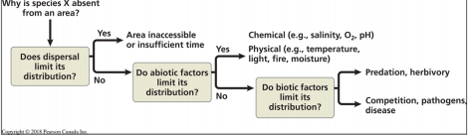

- Ex: Distribution of Wood Turtle (Glyptemys insculpta)
  - Temperature limits its northern distribution
  - Atlantic ocean and prairies are limiting its distribution
  - Ectothermic cannot surivive far north
  - Not found in PEI: salinity is a barrier (can’t swim in ocean)
  - Not found in prairies: inadequate water (physical barrier)

- Ex: species with limited distribution, Cyprinodon diabolis
  - No potential to expand (lives only in unique chemistry of Devil’s Hole, middle of desert)
  - 2010: 400-500 adult individuals
  - 2016: 115 individuals
  - Government built aquarium identical to natural habitat: only hope to preserve species itself
  - Problem: Area inaccessible

- Abiotic factor: factors (chemical or physical): temperature, water, oxygen, salinity, sunlight

- Biotic factors: interaction between species
  - Parasitism: moose, white tailed deer and meningeal worm
    - Moose mainly northern species in forested areas
    - Deer prefer open habitat
    - Small areas of overlap between the two species

    - Meningeal worm: two hosts
      - Not much impact on deer survival
      - Deer accidentally eats snail/slug on grasses
      - Parasite easts through stomach, works its way into neural column, works up to meningeal tissue in brain, lays eggs
      - Eggs get into bloodstream, once they reach lungs, eggs some coughed out, some excreted in feces of animal
      - Feces prime food source for snails and cycle begins again

      - Moose eats vegetation that might have infected snail
      - Vegetation end up in stomach. Snail dies. Parasite gets to brain. Blockage, eggs do not end up in the blood. Eggs develop in the brain, disorients moose, moose loses equilibrium
      - Presence of parasite doesn’t help southern expansion of moose (not an open habitat species)
- Coyotes are currently expanding their range since humans created new habitat for them (agricultural field and suburbs) and elimination of main competitor (wolves)
  - Most wolves killed
  - Coy-wolf (hybrid between coyote and eastern wolves)
  - Elimination of biotic factor: competition with wolf

CHAPTER 10 ECOLOGY OF POPULATIONS
how do populations interact with their environment

10.1 DEFINITION
Population- a group of individuals of the same species living in a given geographical area

Study of biological cycles- study of characteristics that influence the survival and reproduction
of a population

10.2 DENSITY
- Density- Number o findividuals by unit area or volume. The density is the result of a dynamic interaction between:
  - Processes of addition (immigration and birth)
  - Processes of elimination (emigration and mortality)

- Determination density
  - Direct counting
    - Aerial survey
    - By their song (song birds of our forests)

- Density (by sampling)
  - Capture-recapture: estimation of the total population
  - $N_{1}/ X$= $N_{2m}/ N_{2}$ OR $X=N_{1}N_{2}/{ N}_{2M}$
    - X= estimation of the number of individuals in a population
    - $N_{1}$= captured individuals, marked and released
    - $N_{2}$= individual captured during the second sampling period
    - $N_{2m}$= individuals with marks during the second sampling period
  - Conditions to respect:
    - Marking has no health effect of the animal
    - Marked or non-marked individuals are distributed randomly in the population
    - No immigration or emigration in the populations
    - Chances of catching marked or unmarked individuals are equal

  - Example of capture and recapture:
    - Lake in Gatineau Park (monospecific lake; 2,3 hectares)
    - Two days of sampling in 2009 (one week between dates)
      - Day 1: total number of captured, marked and released individuals ($N_{1}$= 170)
      - Day 2: Total number of captured individuals (2nd capture) ($N_{2}$= 120)
      - Day 2: Number of captured individuals with a mark ($N_{2m}=2$)

    - $X=N_{1}N_{2}/{ N}_{2M}$= (170x120)/2 = 10 200 fishes
    - Density: approx. 5000 fishes per hectare

10.3 DISPERSION
- Dispersion (spacing of individuals inside geographical limits of the population):
  - Clumped (aggregate in patches: feeding mating, predation or defense
  - Uniform (competition for resources, territoriality)
  - Random (unpredictable spacing)

10.4 DEMOGRAPHY
- Models of population growth:
  - Exponential Growth (curve shaped like a J)
    - Eg: newly introduced species; no limit on resources
      - Ex: elephants in Kruger National Park (s. Africa) given unlimited resources. More elephants could’ve affected other species within hte environment, or how many the environment could maintains
      - Ex: Sea Otters almost hunted to extinction. Due to protection and no limitation in terms of resources in Canada’s west coast.
    - Always ends up becoming Logisitc growth, or collapses

  - Logistic Growth (sigmoid curve)
    - The plateau corresponds to the carrying capacity of the environment
    - Plateau created linked to “carrying capacity of environment”
      - ⇒ population autoregulates
    - When trying to define how many individuals can be sustained in an environment to maintain population near carrying capacity,
      - Difficult to determine in natural environment
    - Looks like exponential growth at the start, then plateau when carrying capacity of environment is reached
      - Ex: deers in Gatineau Park. Coyotes are predators, deers sometimes escape park, population autoregulates
      - Ex: bighorn sheep. Small population that’s been monitored for 25-30 years. Cougars hunt sheep, significant diminish due to predation.
      - HUMAN: exponential Growth. Annual percent of increase is slightly slowing down (mechanism to regulate this: birth control). Same amount of agricultural land, bigger yield can sustain up to 12 billion people. Distribution of food bigger problem than production of food.

10.5 BIOLOGICAL CYCLES
- LIfe history traits: traits that affect an organism’s schedule of reproduction and survival
  - Result of natural selection
  - Some combination of traits provide a reproductive advantage (link between how many young you produce and your survival)
  - Affect an organism’s schedule for reproduction and survival
- Trade-off between reproduction and survival:
  - Frequent of reproduction, number of offsrping or investment in parental care.
    - Dandelion: millions of seeds in the wind with hopeof germinations and survival of a few
    - Ex: seahorse: male gives birth to up to 1800 young, but few survive.No parental care. Female lays eggs inside male.

    - Coconut trees: Investment in a few eeeds per year. Contains nutrient secretions that helps seed to germinate, gives it time to find proper habitat: produce fewer offspring, but take care of them
    - Other fish species: a few baby eggs hatch in male’s mouth. Any threat, they rush back inside the mouth. Male does not eat during this period.

- Examples of BIological Cycles:
  - Semelparity (pacific salmon, agave): one reproduction, so much energy put into process, only one chance under the proper reproductive conditions)
    - Agave: unpredictable environment, many years of growth, massive investment in a giant flowering stalk, produces seed then dies

  - Itéroparity (grizzlys, humans): several reproductive events. Reproduction every year. No matter the environmental

- Experimental study of the trade-off between survival and reproduction:
  - A high investment of parents in the production of offspring can have a negative impact on the survival of the parents or the offspring
  - Large brood size, parents spend more time caring for them and are too tired to survive the winter. Small brood size, parents more rested and survive the winter.
    - Compromise to maximise reproductive output and survival

  - Ex: Eider Ducks in Canada.
    - Female eiders that produced more offspring were much less likely to survive to breed again the next year, demonstrating that reproduction had a significant cost

10.6 POPULATION DYNAMICS

- The study of population dynamics can be applied to complex interactions between biotic and abiotic factors responsible to variation of population size
  - Aspect of environment that triggers limiting population growth (ex: decreased birth, increased mortality etc)
  - Ex: Migratory Locust. Normally solitary grasshopper. Quite dispersed in environment, feeds on plants. When food source diminished, they are transformed from solitary to social (gregarious) ⇒ swarming mode: reaction of population to a certain condition. (Density Dependent in this case)
    - Reaction to over-crowding
    - MOrphological changes to becomes good at flying

- Factors that regulate populations densityL DENSITY-DEPENDENT or DENSITY-INDEPENDENT:
  - A birht rate (b) or death rate (m) that does not change

Figure 53-17 (exam)

Mechanisms of Density Dependent Regulation:
Cheetahs territorial animals: marked territory with urine marking  Territoriality⇒ regulates density | Gannets defend small nesting territory by calling and pecking at one another (needs 1 square meter to reproduce)

- Fluctuations of moose & wolf populations on the Isle Royale (lake superior)
  - Moose lived on island alone for 50 years. Wolf pack crossed into island in 1950’s
  - Wolf population crashed when moose populations got too low form too much predation from the wolves
  - Wolf population never recuperated from this crash despite moose numbers going back up (perhap due to low genetic fitness, lots of inbreeding)
- Demographic Cycles: Snowshoe hare and Lynx
  - When hare population get high, lynx population get higher one year later. Hare collapse, lynx collapse. Lynx density directly affects hare density.
  - Repeats in 11 years cycle ⇒ SUN CYCLE
  - Plants create repellant chemicals at certain points in the sun cycle to lower rates of herbivory (then lower hare numbers ⇒ lower lynx numbers one year later)

  - Hare affected by stress in presence of predator (does this affect reproductive output?)
  - Exposure to predators causes hares to produce higher levels of stress hormones
  - Stressed hares are less likely to give birth to live offspring, and if they do, their offspring are smaller
  - Predator stress thus contributes to the decline phase of the hare population

- Metapopulations: small local populations that occupy a particular area of a n appropriate habitat (patches) for the survival of a population
  - Dynamics of emigration, immigration, extinction and recolonization of patches (founder effect)
  - Important in species conservation (protect habitats with potential to have populations)
    - Essential portion of habitat of species may not be occupied at time when survey is done

CHAPTER 11 Conservation BIology

11.1 THREE LEVELS OF BIODIVERSITY

Human activity threatens biodiversity
- Genetic Diversity in a population
- Species Diversity in a ecosystem(metrics most used)
- Community and ecosystem diversity

- Genetic Diversity (Cheetahs, example)

  - Recall: low genetic variability within a population
  - Even if here are over 10 000 individuals in a habitat still endangered. No resilience to disease.

Importance of intra- and inter-populational genetic variation
- Ex: Northern elephant Seals.
- Hunted almost to extinction
- Example of bottleneck (population reduced to a few individuals, small portion of genetic variability
- Sex Ratio- not 1:1. Many females, few males

- Ecosystem Biodiversity
  - Role of Keystone species in the population
    - NOt necessarily dominant, but important
    - Ex: Intertidla communieites that live between low and high tide (partyly exposed to air and water) sea stars and mussels very important. 25 species in terms of biodiversity.
    - Manipulate habitat to prove that a keystone species (ex: when sea star removed, biodiversity significantly reduced. Sea star keeps mussel from dominating the entire ecosystem)
  - Ecosystem engineers- species that modify their habitat (ex: beaver)
  - Disruption of interaction networks
- Food webs
  - Ex: Lemmings are the main food source for many Arctic predators. Lemmings eat plants/mosses, are food for animals.
    - Bottom-up model: start at plants, impact of lemmings, impact on predator population
    - Top-down: Predator Prey relaitonship
      - Ex: Case of the Sea Otter
        - Feed on sea urchins (which feed on algae/ kelp forest)
        - Kelp forest become smaller with abundance of sea urchin
        - Define the abundance of a group based on the abundance of its predator
    - Density-dependent factor. Autoregulation when population is very dense
    - Main factor regulating lemming population: either predator abundance or availability of food

11.2 THREATS TO BIODIVERSITY
- Destruction of habitats
  - Dams, deforestation, agriculture

- Introduction of species
  - Predator or species who are successful in obtaining resources
  - Exponential Growth- perhaps no predators, or it’s a strong competitor for local species
    - Common starling: introduced in North America around 1890.
      - Today 100 000 000 individuals
      - Nesting: basically everywhere. Tree holes- displacing woodpeckers
  - Taking measures to stop species introductions resources
    - Species that entered the ballast in Europe/Asia introduced new species into the Great Lakes when it emptied ballast water. Ex: zebra mussel
    - Flushing tanks with seawater before entering the St-Lawrence Seaway in 2005.
    - Example: Zebra Mussel. Each female lays 1000000 eggs per year- exponential growth. Attach themselves within pipes and cities must clean pipes to supply enough water to the population. Lake Erie became transparent due to filtration by mussels- desertifies the lake with newfound low turbidity. Several local mussels became endangered due to habitat loss.
    - Example: Brown tree snake introduction to the Island of Guam, South Pacific, from cargo during WW2. Consequences: 12 species of bird and 6 species of snakes: extinct.

- Overexploitation:
  - Atlantic Cod
  - Red tuna (top predator caught in great numbers, high sushi demand)
    - Less than 20% of fish stocks remain healthy
    - Some groups are helahty: more difficult to catch than other groups. Subject to change with more advanced fishing techniques
  - Elephants, whales, rhinoceros

- Global Climate Changes (Greenhouse Effect)
  - Without the greenhouse effect, the Earth’s average temperature would be -18C
  - Change in temperature being done in hundreds of years- no time for species to properly adapt to change in temperatures
  - There has been a rise in temperature in the last 150 years linked with human activity (hockey stick graph)
  - Increase in temperature is linked with an increase in CO2 in the atmosphere during the past 150 years.

- Decrease in albedo (reflectivity of surface)
  - Faster warming of the oceans
    - Loss and modifications of the oceanic ecosystem
      - Loss of Arctic ecosystem
        - (lots of primary productivity, species in ice ecosystems, species relying on this for survival)

      - Loss of coral reefs
        - Not resilient to increase in temperature, only to physical damage

      - Acidification of the sea
        - Ocean is enormous sponge for CO2- reacts with water to produce a weak acid (carbonic acid) ⇒ impacts access to calcium for invertebrates like zooplankton, plankton. Species unable to buffer when shells are calcified, thinner

      - Rising of sea levels
        - Impact of hundreds of millions of people living near ocean

  - To limit global warming, we must first avoid emitting large amounts of carbon in the atmosphere
    - Global economy dependent on fossil fuels
    - Transition (when used by government, word means little)

  - This objective is incompatible with a global economy dependent on fossil fuels (=60% of the greenhouse gas effects is anthropic)

11.3 CONSERVATION OF POPULATIONS
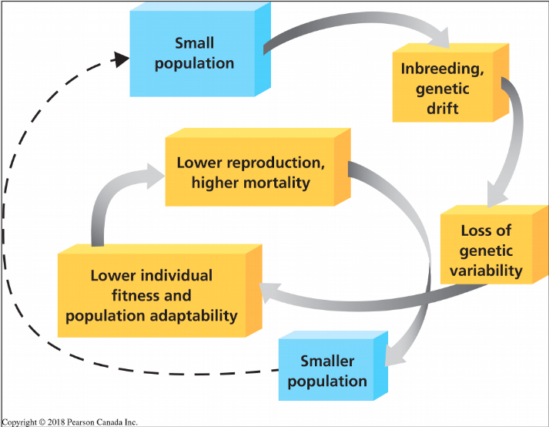
Small populations
-The extinction vortex

Related individuals mate with each other. Recessive allele usually hidden in heterozygotes may become more common.

Individual less fit for environment will disappear

Genetic Drift- any random effect could affect population itself. Ultimate goal: fixation of one allele

⇒ LOSS OF GENETIC VARIABILITY
        - Lower adaptive value, lower fitness (capacity of having high reproductive output)
        - HIgher mortality, lower reproduction
          - Population gets smaller, goes extinct without action taken against this

    - Case of extinction vortex
      - The effective pop. size of a population:
        - Genetic drift is powerful is pop size is reduced
        - Effective population size ($N_{e}$) represents the breeding potential of a population at a given time
        - If the sex ratio is unbalanced, the effective population size will be small and the impact of genetic drift will be felt
        - $N_{e}=4(N_{m}N_{f})/(N_{m}+N_{f})$
          - Where $N_{m}$= number of reproductive males
          - $N_{f}$= number of reproductive females
          - $N_{e}$= effective size of the population

      - Consequence of a bottleneck on a population: Greater prairie chicken
        - Population has lost genetic variability
        - Many homozygotes with lower fitness
        - Loss of habitat in Illinois:millions of individuals (1800s) ⇒ 50 (1993)
        - Loss of fertility in remaining population
        - 1993: Transplantation of 271 individuals from other American States (introduce new alleles to fix extinciton vortex)
        - Results: increase fertility and increase in population size

    - Minimum viable population size (size that will be self-sustained)
      - Case of girzzlies in the continental US excluding Alaska
        - Yellowstone:
          - Actual pop: 500 bears
          - Vaible population:
            - 70-90 individuals in a favourable habitat has 95% chance to survive 200 years
      - Genetic varibliaty: Yellowstone pop. lower than other populations
        - Ne= 125 bears
        - Introduction of 2 unrelated indiiduals every 10 years would reduce the loss of genetic variability by half. May introduce more

CHAPTER 12 THE ORIGIN OF LIFE

12.1 Perception Of Time

- Age of the Universe
  - 13 700 million years
  - Count to 1 million: 11 days, 1 number/second
  - Count to 1 billion: 31 years, 1 number/second

- Marion AUD to Japan: distance if 1km=1million years

12.2 Age And Origin Of The Earth

With the application of radiometric dating technique based on the decay of radioactivity isotope in the 1950’s, it was determined that Earth was approximately 4600 million years ago

SINGULARITY: started with a single point, a big portion of the universe was formed at the big
Bang. Universe still expanding today.

- THe origin of the solar system (Kant 1724-1804; Laplace 1749-1827)
  - Solar nebula
    - Size 100 AU
      - Astronomical units (AU) is defined as the distance between the earth and the sun 149 597 870 700 m
    - Mass = 2 to 3 times that of the sun today
  - Following the action of diverse forces spread over 100Myr, a protoplanetary disk

Along proroplateary disk, particles agregated to form planets (aggregation of dust particles with higher graviataional structures)

- Asteroid 2005Yu55
  - Novmeber 8th 2011 at 23h28 TU, this asteroid passed at around 0.85 times the lunar distance, thus 0.00217 UA

- Comet Ison
  - Photo taken on Nov 6 2013. On Nov 28 2013 after travelling at 1 000 000 km behind the sun, it dissappears (melted)

- Mass extinction: major evolutionary force on this planet
- Important volcanic acivity at very high temperature
- After 500+ million years of transformations, the terrestrial environment became suitable for life
- Planet was colling down: found rocks to show this
  - 4000 MYR
    - The oldest metamorphic rocks : northwest territories
  - 3800-3500 MYR
    - The oldest sedimentary

12.3 The Origin Of Life
- Stromatolites: similar disk-shaped structures in the rocks composed of sediments deposited by many successive layers of bacteria (mainly cyanobacteria)
  - These fossils come from living beings
- Life started when the planet was very warm, perturbed (4800 Myr)
  - Added complexity to finding the origin of life

- Oparin and Haldane: biochemical theory of life (1920)
  - We have all the elements in the environment to produce life, wejust ned the right conditions
    - Primitive atmostphere was an environment in which the organic compounds could be proued from simple inorganic compounds
    - Energy sources: lightning and ultraviolet
    - There would hae been a

Possible scenairo in four stages:
- Abiotic synthesis and the accumulation of small organic moecules (monomers) such as amino acids or nitrogenous bases
- Joining small molecules to form macromolecules, notable proteins and nucleic acids
- Packaging of macromoleucles into protocells, droplets with membranes that maintained an internal chemistry different from that of their surroundings
- Origin fo self-replicating

- S. Miller (1930-2007) and H. Urey (1893-1981)
- 1853: Replicate the origincal atmospheric conditions and verify that complex organic molecules (eg amino acids) can be produced
- Results: procution of amino acids and fatty acid chains
  - Glycine + Alanine produced
- Experimental conditions realistic?
  - Combination of gas used not necessarily environmental conditions at time of oringin of life
  - Proportions of gas
    - Several experiments using proportions near volcnao, etc
- Recent analysis of other samples of Miller’s experiments:
  - The atmosphere of volcanoes+ steam : 17 amino acids
  - (2007) Atmosphere of volcanoes+ hydrogen sulfide: 21 amino acids

- Other hypothesis:
  - 4500 MY meteorite
    - Murchinson meteorite with amino acids, lipids, simple sugars and nitrogenous bases (extraterrrestrial)
    - Warm hyrdothermal vents

STEPS

- HOw to Obtian maromoleucles (polymers) from simple moecules (monomers)
  - Proteins= polymers of amino acids. The formation of polymers requires the action of enzymes thatdid not exist at the time
  - Amino acid solutions on very hot sand and clay (170 degrees C) for many hours ⇒ instant development (protenoids)

STEPS 3

- LIfe: A living organism is nothing more than a stack of complex organic molecules
  - Metabolsim: can transform nutrients into energy (enzyme acitvity)
  - Replication (ability to pass information form one generation to another (genes))

- Protocells:
  - Reprodution and rudimentary metabolism. Ex: liposomes
  - Liposomes: hydrophobic vesicles form a double membrane, capable of swelling or contract. Membrane show selectivity for the absorption of polymers
    - Has a membrane, some metabolic activity, possibility for replication
    - Primitive cells may have somewhat formed

- Dynamics of Replication:
  - Gorup of nucelotide canpromorte catalytic properties wihtout need for enzymes (ribozymes)

12.4 Geological Archives
**table willl be given in exam
Eons ⇒ eras ⇒ periods ⇒ epochs

Cambrian Explosion: first fossils. Great increase in the diversificaiton of life

12.5 Mass Extinctions
Mass extinctions: (5; bt 3 over a short period of time)
Probable causes:
- Ordovician: sudden and intense glacial period
- Permian: volcanic acitivty inSiberia,
- Cretaceuos: asteroid impact

Asteroid: 10 km of diameter
Crater: 180 km of diameter in Yucatan Peninsula
Extinction of all vertebrates weighing more than 10 kg

Craters
- Evidence of impact of asteroid in Canada
  - 1.4 millions years ago- 3km wide asteroid in northern quebec (crater=lake) Pingualuit Crater
  - 210 millions years: Manicouagan Crater, 100 km crater,

**listen to first 10 minutes of lecture and watch mass extinctions video
- Video:
  - Tobar eruption 70 000 years ago
  - Suleria with a gamma ray hypothesis: difficult to associate with science
    - Deep and prolonged glacial period
  - Comet hitting planet couple hundred years from now: not clear whether comet will come into contact with Earth

Ecological Impacts of Mass Extinctions

CHAPTER 13 Bacteria and Archaea (Prokaryotes)

13.1 Bacteria and the oxygen revolution
- Major steps in evolution of life (most ancient occupant of Earth)
- Bacteria and Archaea: only living beings between 3500 myr and 2200 Myr
  - Archae more closely related to eukaryotes than bacteria
  - Prokaryotes are a paraphyletic group

- Stromatolites: fossilized bacterial mats
- Mounds made of fossilized bacteria

- First organisms: probably anaerobic ($H_{2}S$) heterotrophs
- Cyanobacteria: first organisms to use oxygen from H2O to fix C$O_{2}$ and synthesize organic compounds
    - By product of photosynthesis is $O_{2}$ (beginning of oxygen revolution)
    - Most oxygen on Earth has biological origin
    - No naturally occuring $O_{2}$ in atmosphere ⇒ comes from living activity

Oxygen Revolution:
At first, oxygen formed an oxide with iron: iron oxide.

- Afterwards (in a few Myr):
  - – Depletion of iron in solution. –
  - saturation of $O_{2}$in water
  - emission of $O_{2}$ in the atmosphere (started about 2,700 Myr ago)
  - $O_{2}$ goes from 1% to 21 % of atmospheric gasses.
- Life revolution on Earth (because of oxidation)
  - – Mass extinction of anaerobic prokaryotes
  - First mass extinction: $O_{2}$ is poison for anaerobic bacteria

13.2 Prokaryote Forms and Function
- Unicellular
- Microscopic (Usually 1-5 micrometers)
- Essential to life
  - More bacterial cells than cells in human body
- Abundant and everywhere
- Several pathogenic forms
  - E.g. Listeria (Listeria monocytogenes)
- 10000 species known (potentially millions)
  - Each doesn’t have its own species name, but unique DNA is known
- Group with the greatest diversity of adaptations

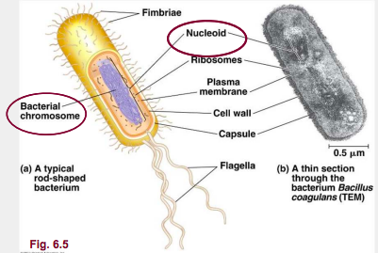
- MICROBIOME: Bacterial flora in and on humans
  - 100 trillion bacteria in and on humans
  - 500-100speices
  - Parasitism, Commensalism and mutualism
  - Important role in human physiology and health
    - PRO: Provides vitamin, helps digest
    - CON: certain bacteria associated with obesity

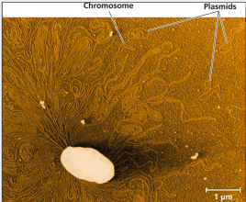

- Ruptured E. coli showing
- The cells large, circular chormostome
- Three of the cells plasmids, the much smaller rings of DNA
- Antibacterial resistance found on plasmids

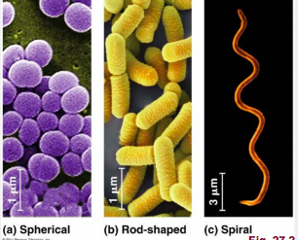
- Specialized membrane of prokaryotes:
  - Infolding of the plasma membrane (respiration)
  - Thylakoid membranes (photosynthesis)

SHAPES OF PROKARYOTES
- Spherical: coccus, diplococci, staphylococci
- Rod: Bacillus or Streptobacillus
- Spirals: spiriles and spirochaetes

- When some bacteria are in abundance, there will be a characteristic in the environment to indicate their presence (ex: water turning pink in presece of archae Haloquadratum walsbyl)
- Great SA for small volume, good for animal that feeds and breathes thorugh membrane. Vacuoles inside cell to store nutrients ⇒ smaller organism means more efficient
  - Most bacteria live in environment that will rpide continous food and respiration (no storage necessary)

TRANSPORT
- 50% of prokaryotes are mobile
- Speed: 50 Times their body lenght per second
- Capable of taxis
- Basal body is the engineof the flagellum
  - Bacterial example of exaptation: recycling of evolutionary traits to serve new function (was not evolved for locomotion)

- Gram is a type of colouration
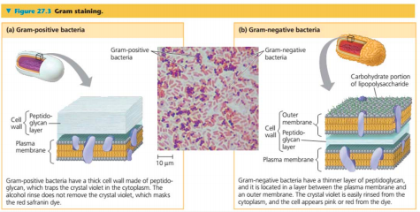
Peptiodoglycan: absent in Archea and Eukaryotes

This layer unique to bacteium, target of most antibiotics (these meds won’t affect any other cells in body) ⇒ more efficient for gram positive bacteria wiht no membrane protecting the peptidoglycan.

DIVERSITY OF CAPSULE ADAPTED TO MODES OF ATTACHMENT TO A SUBSTRATE
- Capsule shows structure which enable the bacteria substrate attachment

Helicopabter pylori:: Interesting bacteria associated with stomach ulcers
- First two guessed causes: Spicy food & Stress
  - No way to heal other than changing stomach acidity ⇒ Antacids gain popularity
  - Maybe we can find a cause to stomach ulcers and find a way to heal it!
  - 1974: observation that a bacteria

Postulates 1: (association) The microorganism must be found in abundance in all organisms suffering from the diesase, but should not be founds in healthy organisms
In 1983, Marshall had compiled dataa from many patients showing the continous

Postulate 2 (Isoliation) The microorganism must be isolated from a diseased organism and grown in pure culture in the lab
1982: bactreia isolated.
After several unsuccessful attempts. He succeeds (by accidnet) to grwo a colony
in the lab

1984: preliminary results are presented at a conference: skepticism
Postulate 3 (innoculate) The cultured microorganism should cause the diesease when introduced into a healthy organism
No lab animals (rat or guinea pig) were successfullt infeted by th bacteria
June 12th, 1984: Marshall and a volunteer drank a solution of the bacteria
Result:

Postulate 4: Microorgnaims must be reisolated from the inoculated exprimental host and identified as being identical to the original specidifc causative agent
Bacteria were recovered from the stomach of scientist and volunteer.

Conclusion:
IN early 1990s, three independent studies done on hundreds of patients corroborated
the fact that prescribing an antibiotic can cure most inflammed stomach or stomach
ulcers
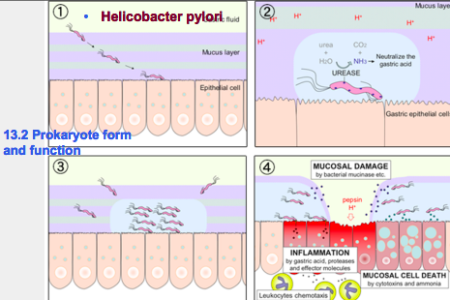Half the human population has this bacteria in their stomach, though not all develop. Goes into areas of least acidity (cell linining that secretes neutral mucous.) ⇒ finds theses areas using chemotaxis. End Result: creates microenivonment arond bacteria with higher pH, secretes more enzymes to affect stomah lining. Possible correlation between treatment for Helicobacter pylori and obesity: getting rid of it may cure problems unrelated to stomach ulcers

13.3 Adaptations

- AUTOTROPH
  - Photoautotroph
    - Energy: light
    - Carbon: $CO_{2}$
      - Photosynthetic prokaryotes
        - Found pretty much everywhere in environment (ex: blue green algae ⇒ often health indicator of an ecosystem,their presence means stress)
  - Chemoautrotroph
    - Energy: Gain energy form inorganic chemicals: sulfur hydrogen, ammonia and ferrous ions
      - Extremophiles (no oxygen)
    - Carbon: $CO_{2}$
      - Some archaea

- HETEROTROPH
  - Photoheterotroph
    - Energy: light
    - Caron: organic compounds (Chloroflexus Rhodobacter)
      - Found in hot springs
  - Chemoheterotroph (decomposers)
    - Energy: organic
    - Carbon: organic
      - More prokaryotes(e.g Clostridium)
        - Bacillus anthracis ⇒ Anthrax bacteria
          - Production of spores, when stressed due to environment, capsule surrounds chromosomes, dries up can stay dormant for centuries
          - Skin= proper environment for their development, will cause necrosis
          - Sent to senator as white powder in envelope, inhaled & victims died
        - Clostridium botulinum
          - If you eat the eggs containing this bacteria, antibiotics needed immediately
          - Anaerobic bacteria
          - Botox derived from this to eliminate wrinkles

- Metabolism and dioxygne
  - Prokaryotes organisms:
    - Obligate anaerobes
    - Facultative anaerobes

- Aracheas
  - Extremophiles
    - Extreme thermophiles (Sulfo
    - Extreme halophiles
    - Methanogens (anaerobic that produces methane: marsh gases)
      - Ex: in landfill, methane produced

- Decomposers and transformers
  - Break down molecules into simplest form
  - Accelerates growth of some plants

- Bioluminescence
  - Bioluminescent protein produced by bacteria
  - Used by fish for reporudtion (role in sexua selection)
  - Mutualistic interaction: bacteria gets food from successful fish

- Pathogenic bacteria Transferred from an intermediate host
  - ex: Lyme Disease
    - Transferred by tick (white-tailed deer)
    - Tick come more north as it gets warmer
    - Biologists in field work always check exposed skin for ticks
    - When parasite enters bloodstream, tick injects product to disable immune system (quick reaction needed to prevent ailment)
- Toxicity:
  - EXOTOXIN: bacteria secretes protein toxins (e.g. strain O157:h7 of E. coli)
  - ENDOTOXIN: Accumulated in cell walls and liberated when bacteria dies

13.4 Reproduction and genetic transfer

Vertical transfer of genetic information:
- FISSION: doubling of cell size and divided in two (main way of reproduction)
  - Generation time: 2-3 hours

Horizontal transfer:
- Gene transfer between members in same generation (can be between species)
- Frequent in bacteirum
- Complicated phylogenetic tree
Three methods of horizontal gene transfer:
- Transformation: absorption of environmental DNA molecule

- Transduction:
  - Virus intermeiate (cell-to-cell transfer)
  - transfer of a DNA segement

- Conjugation
  - Plasmid OR Portion of Bacterial Chromosomes transferred cell to cell
  - Mating bridge formed, duplication of plasmid transferred to new cell. Cell that receives …
  - Plasmid ocontrains gnes to build sex pylus AND resistance to bacteria

circular
archaea
extremophile
circular
peptidoglycan-absent

CHAPTER 14 Protists

14.1 Introduction

Polytomy: more than two lines from a single ancestor, we don't’ know

- Larger and more complex cells than prokaryotes (presence of orangalles)
- Very diversifeid life styles
- Most ancient eukaryote fossil known: algae Grypania spiralis ⇒ 2100 million years ago
- First multicellular 1500 MYA ⇒ first eukaryotes 1550 MYA
- Feeds through membrane, limits max. Body size
  - Don’t usually have a rigid membrane

14.2 Eukaryote Cell: Origin and Structure

- Presence of a cytoskeleton and a generally non-rigid cell wall: capacity to change shape and move its internal structures to facilitate mitosis.
- Formation of a nuclear envelope which is probably the result of infolding of the plasma membrane
- Endosymbiosis- cell engulfed by another cell, lives inside this new cell

- Ancesotrs of mitochindria:
  - Alpha proteobacteria
    - Example: Rhyzobium lives inside the root nodules of legumes
- Ancestors of Chloroplasts:
  - Cyanobacteria

- Primary and secondary endosymbiosis
  - Red algae engulfed by another eukaryotes (became endosymbiont)
    - Chloroplast has a new function inside new
    - Resulting endosymbiont becomes engulfed itself
  - Complicated DNA packages

14.3 Evolution of Multicellularity and Sexual Reproduction

- Multicellularity is a homoplasy in protists
  - (evolved separately between 25-40 times)
  - LIfts the constraint associated with diffusion
  - Longer cell life
  - Capacity to create cells with very specific functions
    - Allows cells to develop with multiple functions

  - Intermediate stage between single-cell & multi-cell organism
    - COLONIES
    - Ex: Volvox- Green Algae
      - Big, empty ball of individuals linked by cytoplasmic strands
      - Presence of cells with eye spots especially on one side (able to use taxis)
      - Cell differentiation is minimal
      - Associated (form mini colonies within large colony) ⇒ freed when large colony falls apart

- PATHENOGENESIS
  - Species that produces haploid gametes, but doubles it. Female doubles her own chromosomes in diploid egg ⇒ Creates all-female species
  - e.g Whiptail Lizards: hybrid between two species, all offspring are clones of mom

- HERMAPHRODITISM
  - Individual have both sexes
  - Rivulus marmoratus fish : self-fertilization (only done in absence of mate), living in mangroves

- SEQUENTIAL HERMAPHRODITISM
  - One sex for part of life, change sex for other part of life
  - Blue head wrasse fish species: population one male and many females. If large male dies, one of the females becomes a male to compensate (loses ovaries)

  - Clownfish can change from male to female when female dies. So in finding Nemo, Marlin should have become female when his wife dies

Why sexual reproduction?
- Asexual reproduction offers advantage in numbers
- Asexual offers an advantage in terms of hereditary transmission to the next generation
- Sexual reproduction offers an adaptive advantage (by the production of genetic variability and the elimination of recessive alleles)
- Sexual reproduction is a complex trait that probably evolved only once very early in the evolution of eukaryotes ⇒ SEXUAL REPRODUCTION = MONOPHYLETIC

Stick bugs:
Female stick bugs can reproduce parthenogenetically, but sexually if male present

Androgenesis- sperms will be feconded. When it enters into eggs, sperm double itself and
eliminates female chromosomes. Sperm will enter eggs, eliminate maternal chromosomes, doubling of sperm chromosomes. Several sperm have access inside egg

Bangiomorpha pubescens: Most ancient multicellular eukaryote fossil showing the capacity of sexual reproduction (age : 1,200 Ma)

14.4 Diversity of Protists

- Diplomonads
  - Characterized by multiple flagellates
  - Intestinal parasites (diarrhea)
  - Reservoir: mammals such as beaver (beaver fever)
  - Affects 10-20% of populations living
  - in temperate or tropical environments
  - 70% of carriers are asymptomatic

- Fllagella with crystalline rod
- Parasite defecates on your face, when you swipe away the bug it spreads the poo
- Strong infection near bite sit, then spreads thorughhout bloodstrem
- Other organs (heart, brain, kidney etc) infected if not quikcly treated

- Alveolates (7000+ species)
  - Alveoli under the plasma membrane
  - Plasmodium and malaria
  - 300 million people infected
  - Linked with sickle cell anemia (see point mutation and heterozygote dvantage)
  - **know plasmodium life cycel silde 19

- Stramenopiles
  - Ex: Diatoms (100 000 species)
  - Unicellular algae (prt of the phytoplankton) with a unique glass-like wall made of hydrated silica in an organic matrix
  - Characterizd by larvae with one hairless + one hairy flagella
  - Due to their high level of activity, absorb 25 CO2
  - Shell is quite heavy, so CO2 sinks to the bottom of the ocean
  - Important component of phytoplankton

- Amoebozoa
  - Species with pseudopodia lobe forms to trap prey
  - Cilia: extensions of the plasma
  - Ex:

- Golden Algae (part of marine and freshwater plankaton- unknown # of species)
  - Presence of yellow and borwn ccaretonoids
  - Cells are usually biflagellated forming

- Brown Algae (seaweed)
  - Approx. 2000 species
  - Multicellular and complex
  - Color associated with carotenoids in plastids
  - Can become very large
  - Make up kelp forests (very similar to land forests, but brown algae morphology unique from plants)

- Red Algae (6000 species)
  - No flagellate stage in life cycle
  - Presence of ________
  - Red pigment allows them to do photosynthesis in areas with very little light

- Green Algae
  - Ancestor of plants, share same plastid
  - Chlorophytes (7000 species), Charophytes (700 species)
    - Lives in freshwater or in soil
    - Group related to plants (charophytes)
    - Ex: lychen

  - Tri-Symbiosis (long lychen)
    - Fungi (mushroom), green algae, cyanobacteria
    - Association of 3 species ot make a plant
  - E.g volvox with different levels of organization (larger + complex individuals): colonies, multicellular bodies and no cytoplasmic division
CONCLUSION
- Complex paraphyletic group
- Well-defined nucleus and several organelles and cytoskseleton
- Serial endosymmbiosis explains the oriign of mitochonria and chloroplasts in

- Among chanoflagellates contains the sister group of animals

CHAPTER 15 Cambrian Explosion

15.1 Introduction
To put things into context:

15.2 The ediacaran
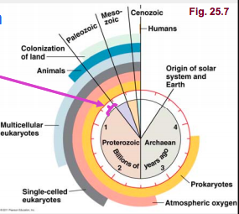
- Not much iinfo fromt his period
- Deep glaciation (snowball Earth- cold)
- First fossils: 600 MYa
  - Fossils so rare becasue no aniamal fossils, only imprint
- Ediacaran Community (575-543 MYA)
  - Bilateral symmetry starting to appear
- Fossils from 600- 535 MYA
- Diveisified fauna, multicellular espceically soft body, can be large size (ex: Charnia spp: 2 m)
- Preseation process was proabbaly hlped by _____________

15.3 Cambrian explosion
- Period of multiplication of body forms
- Sucessfull ones (last more than 500 MY)

- Viewed as an explosion due to:
  - Hard Structure (skeleton) characterized by the beginning of the Phanerozoic Eon
    - Cambrian period (542 MYA)

  - Associated with appearance of more complex endo/exoskeleton
    - Internal among chordats (endoskeleton)
    - On body surfaece in otehr animals
  - Skleeotn funtions
    - Attachment site for muscles (tendons and ligaments)
    - Mineral reserve
  - In CHordates: hydroxyapetite or Ca(PO4)2 in a collagen matrix
  - Other strucutralsupport substances: silica, chitin etc

- Appeared durin 100MY long perido
- Sponges may have appeared 750 million years ago
  - We have evidence of sponge secretions from 750 million years ago

Causes
- Skeleton Structure diversification (calcium abundance)
  - ⇒ Evolutionary Catalyzer, structure to improve efficiency in catching prey
- Increase in atm Oxygen (in oceans, evolution of life has been linked)
- Mass extinction ediacaran fauna followed by an adaptive radiance
- Complexification of the food chain
  - More predator
    - Arms race (predaotr-prey relationships as a catalyzer for evolution)
    - More effiecient predation as all species become more mobile

CHAPTER 16 Evolution of Animals: General Concepts

16.1 Introduction
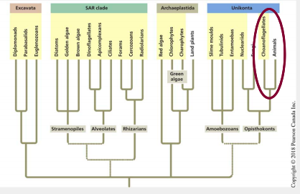

- Animals are monophyletic (sister group: choanoflagellates/protists)

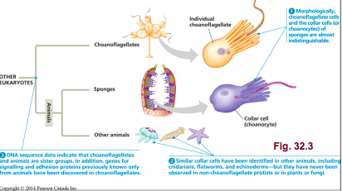
- Steroid produced by sponges: 700+ million years found in fossils $⇑$$⇑$$⇑$$⇑$

- 1.3 million catalogued animal species
- Possible total: 10 million
- According to molecular clock, 770 million years for animals (much odler than ffossils found)
  - Insects lacking in taxonomy as of date, as well as tropics bugs and deep ocena fauna

16.2 What is an animal?
- Heterotrophic Eukaryotes
  - Sponges: (most primitive animals) suspensivores ie feeding on particles, no real tissue/very little cell differentiation, sequential hermaphrodites

- Ameoboyte: can transfrom into any other type of cells wihtin the organism ⇒ TOTIPOTENT

16.3 Major changes in animal bodies
- All animals except sponges in monophyletic group:
  - Characterized by presence of tissue
  - Metazoan phylogeny based on morpholgy
  - 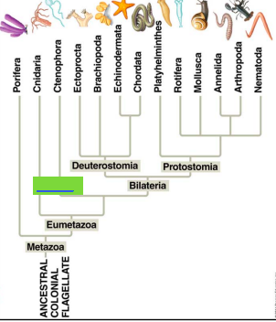fill in: radial
Meatzoan phylogeny based on molecular data
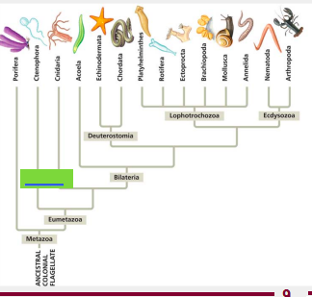

- Evolution of bilateral summetry
  - Cnidarians and Ctenophora: radial symmtery
  - Other Eumetazoa: bilateral symmetry
    - Independaent developmen of teh various regions of the body
    - Facilitates mobility (useful for feeding, breeding and avoid predators)

  - Celamic cavity: associted with evolution of a new germ layer

  - Radials: diplobastic (2 embyonic germ layers: ecto and endotherm)
  - Bilateral: triploblastic (3 embyroninc germ layets, ecto, endo, mesoderm)

Embronic LAyers:
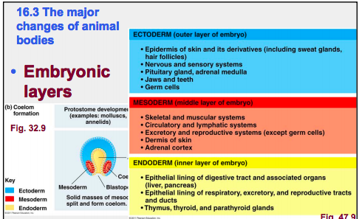

- Ectotherm produces the nervous system
- IMportant evo transition: grouping of nerve cells in the anterior part of the obody (cephalization)
- Note the ventral nerve cord in worms

- Evolution of a Body Cavity
  - Evolution of specialized organs
    - Digestive tract (food reserve + efficient digestion = more time allocated to other tasks)
      - Filter feeders (suspensivores): exampla lamprey sitting with moth open contans mouth, pharynx and gizzard, not stomach, intestine. These were later evolved:
        - Storage
        - Acidity
        - Enzymes
Stomach allowed vertebrates to do other things than just eat, other features can be evolved, don’t need to be constantly feeding
    - Development of gonads (greater storage capacity and massive production of gametes)

- Evolution in embryogenesis
  - Spiral Cleavage: oblique to the axis of the body
  - Radial Cleavage: All cells parallel to the axis

  - Determinate cleavage: each cell defines a part of the embryo
  - Indeterminate cleavage: each cell has the potenetial to produce a complete embryo

  - Mesoderm formation differs
    - Mouth=blastopore= protostome
    - Mouth= second opening = deuterostome

16.4 Conclusion

Molecular PHylogeny of Animals
770 myr
680 myr
670 myr
CHAPTER 17 Evolution of Animals: Echinoderms and Chordates

17.1 Introduction
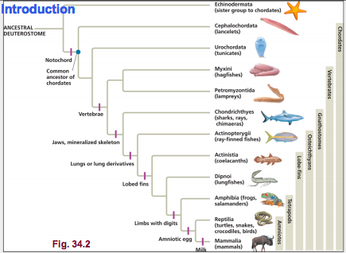

- First animals fossils : 570 Myr
- Firt chordates fossil: Cambrian
- COlonization of Land by insects, arthropods
- First animals with Jaws
- First fossils

17.2 Echinoderms
Chordate and echinoderms share characteristics of deuterostomes :
-radial and indeterminate cleavage
-development of the coelom from the archenteron
-Formation of the mouth at the opposite end of blastopore.

- Marine animals that move slowly or are sessile
- Radial adult form, but the larvae shows a bilateral symmetry
  - Ex: Seastar has Bilateral larvae, but as adults evolutionary reversion to radial shape
  - Ex: fossils of echinoderms: some adult stage of bilateral. Bilaterality lost at adult stage, radial shape replaces

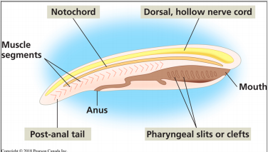
17.3 The Chordates

4 common derived characteristics in all Chordates:
- Notochord (present in humans until day 20 of embryo growth- replaced by vertebral column)
- Post-anal tail
- Pharyngeal slits or clefts
- Dorsal, hollow nerve cord

- Cephalochordates
  - Small animals dig themselves into sediment. Strucutres let them eat passing food particles, that go directly to small intestine. invertebrates

- Urochordates:
  - Big, pierced filtering bag. Closest invertebrate to vertebrates (due to mobility). Chordates features visible only in the larvae
  - Paedomorphosis hypothesis of the evolution of craniates - (acquisition of gonads at larvea stage)
  - Mobile larvae ensure dispersion of group

17.4 The Craniates
- Vetebrates: active predatory animals having a vertebrateal column and more complex nervous system
- Derived characters:
  - Portions of the notochord solidify into a vertebral centrum
- Hagfish and lamprey share a monophyletic group: _____

17.5 Jawless Vertebrates
- Embryonic development of a vertebra
  - Notochord or cor surrounds itself with cartilage or bone, the centrum
  - Neural tube surrounded by a neural arch
  - Flexible and strong vertebral column on which muscles of locomotion will attach

  - Origin of Vertebrates: must look at fossils
    - Hagfish and Lamprey (remnants of once important fauna)
      - Hagfish jawless, feed on carcass, small particles. Adaptation: slime glands permit it to have existed over 500 Myr (unpalatable by predators- defense mechanism)
      - Lamprey: feed on small particles. Spends its life burying into sediments with head stickingout, filter feeding. Gonads go upriver to spawn and die. Can adopt parasital lifestyle
Fossil vertebrates without jaws (paraphyletic group, extinct very quickly when jawfish evolved)

Abundant form the Cambrian to teh Devonian

17.6 Gnathostomes
Jawed Vertebrates
- Main Derived Characteristics:
  - Big brain (more sensory organs: sight and smell)
  - Lateral Line (can detect changes in water pressure, especially in aqautic gnathostomes)
  - Mineralization of the endoskeleton (calcium in skeleton)
  - Jaws
  - Two gill arches are modified to create jaws and the support structure
  - Initial function: respiration, not eating

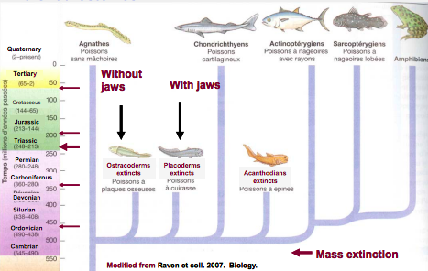
- First fsih fossils (470-360 Myr)
  - Placoderms: no teeth yet, but lower and upper jaw with sharp borders to cut food. Fish with armour, 1m -10m long
  - Acanthodians (freshwater and slatwater)

17.6 Cartilaginous Fishes
- Cartaligaginous Fishes (choredrihthyans 1000 species)
  - 3 large groups:
    - Sharks (400 Myr)
    - Rays and chimaeras (200 Myr)

  - Derived characters: caritlegenous skeleton (reinforced with Ca(Po4)2)
    - Other triats: spiral valve in teh intestine
    - Excellent sense of smell
    - Dentititon:
      - Modified scales (replaceable, a few lost whenver a bite is taken)
      - Teeth over 20 rows
      - Contiuos replacement
      - Internal jaw structure allows the forward projection (suspensorium allows this- jaw isn’t attached to cranium)
    - Hydrodynamic profile
      - Pair of muscular fins that allows to “hover”
      - Caudal heterocercal fin (orientation and propulsion)
    - Reproduction
      - Internal fertilization
        - Oviparous (produce shark eggs)
        - Ovoviviparous (eggs that hatch within uterus, feed on its own nutritious reserves in sac, then given birth)
        - Viviparous (in utero secretions absorbed by fetus)
        - Tiger shark: first one to hatch eats its siblings for nutrients
    - Larger species are planktivorous

17.8 Bony Fishes
(osteochthyes)
Fishes with radiated fins (actinopterygians): ossified endoskeleton (calcium phosphate)

17.9 Sarcopterygii
- Fishes with lobed fins
  - Coelocath
    - Homology of fins elements witht eh bones of tetrapods

  - Lungfish (freshwater species found in 3 continents)
    - Lungs and Gills equivalent to tetrapods
    - Capable of estivation (lethargy during warm and dry season)

  - Tetrapods
    - Evolution of 4 terrestrial limbs
    - First tetrapods: mixture of aqautic and terrestrial life during the Devonian period
    - Digits = main characteristic
    - First fossil that’s confusing: Tiktaalik roseae <<fishapod>>

